Retail Store Sales – Data Cleaning Project
Excel + Power Query | Portfolio Report

Objective
Clean a messy, real-world-style retail transactions dataset (12,575 rows) using Excel Power Query — fixing missing values, validating calculated fields, and documenting every assumption made along the way.

Dataset
- Source: Retail Store Sales – Dirty for Data Cleaning (Kaggle)
- Size: 12,575 rows, single table
- Known issues: missing values in Item, Price Per Unit, Quantity, Total Spent, and Discount Applied

Tools Used
- Excel Power Query (M language)
- Pivot Tables for validation

Step 1 — Assess the raw data
Before touching anything, the raw table was profiled column by column to see exactly how dirty it was. Item was 91% valid (9% empty), Price Per Unit / Quantity / Total Spent were 95% valid (5% empty), and Discount Applied was only 68% valid (32% empty).
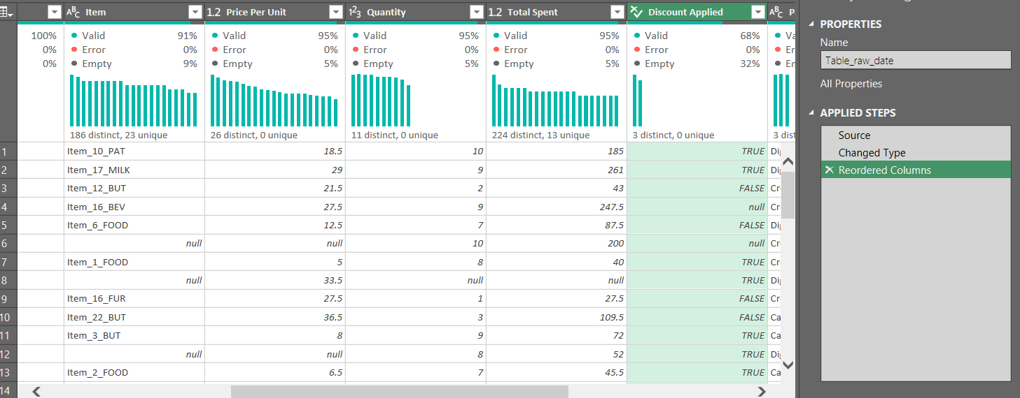
Column quality profile of the raw data — before cleaning

Step 2 — Rebuild Quantity, Price Per Unit and Total Spent
These three fields follow one rule:
Total Spent = Quantity × Price Per Unit
This relationship was used to rebuild missing values through three cascading custom columns, each one falling back to the others when a value was missing:
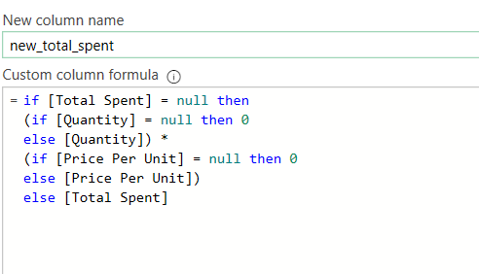
new_total_spent — rebuilt from Quantity × Price when Total Spent was missing
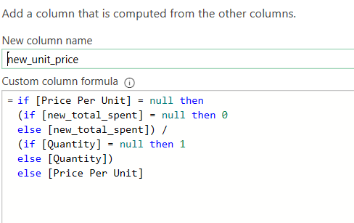
new_unit_price — rebuilt from Total Spent ÷ Quantity when Price was missing
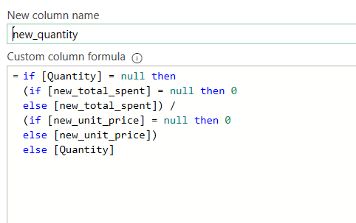
new_quantity — rebuilt from Total Spent ÷ Price when Quantity was missing

Step 3 — Validate the rebuilt numbers
An error_flag_in_spent column checks that new_unit_price × new_quantity = new_total_spent across every row.
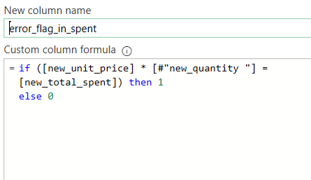
Validation formula — flags any row where the numbers don't reconcile
Result: 0 mismatches across all 12,575 rows — confirming the cascading formulas rebuilt the numbers correctly.

Step 4 — Recover missing Item names
Price Per Unit is fixed per Item within each Category, so a lookup table of unique (Category, Item, Price) combinations was built from rows where Item was already known — 200 distinct, 200 unique combinations, confirming no price clashes between items.
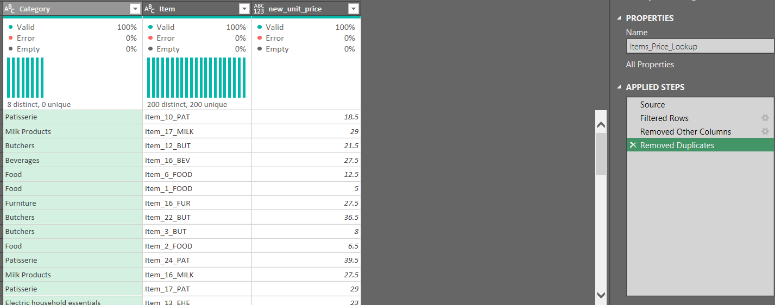
Items_Price_Lookup — deduplicated Category + Item + Price reference table
The lookup table was then merged back onto the full dataset on Category + Price. All 12,575 rows matched successfully.
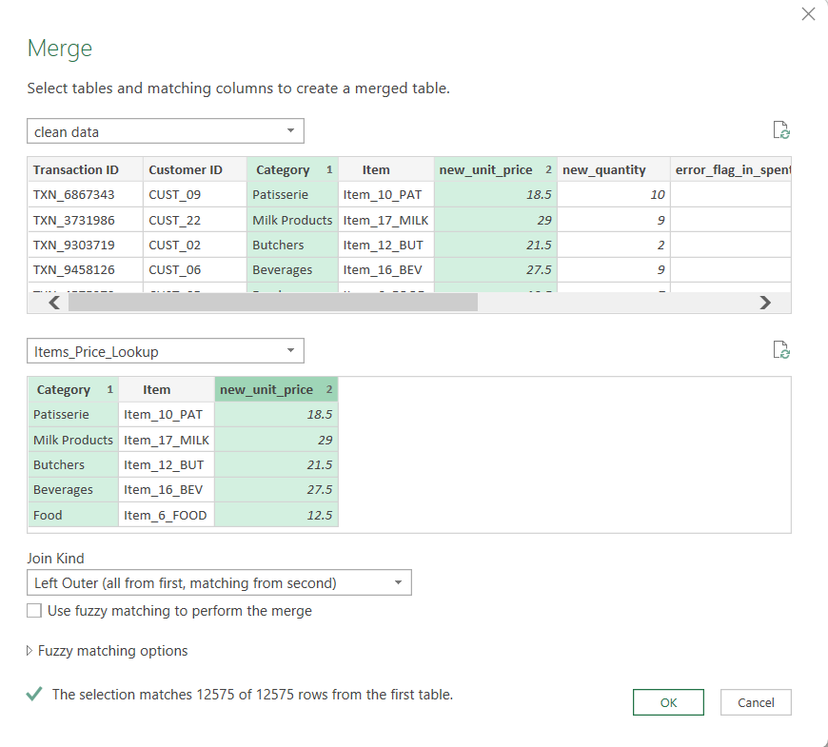
Merge Queries — joining on Category and new_unit_price, 12,575 of 12,575 rows matched
Missing Item values were filled from the match. A row is only left as a gap when Price Per Unit is also missing — meaning there's no reference point at all to recover it from.

Step 5 — Handle Discount Applied
Missing Discount Applied values were replaced with n/a — a missing discount simply means no discount was recorded, not an error.
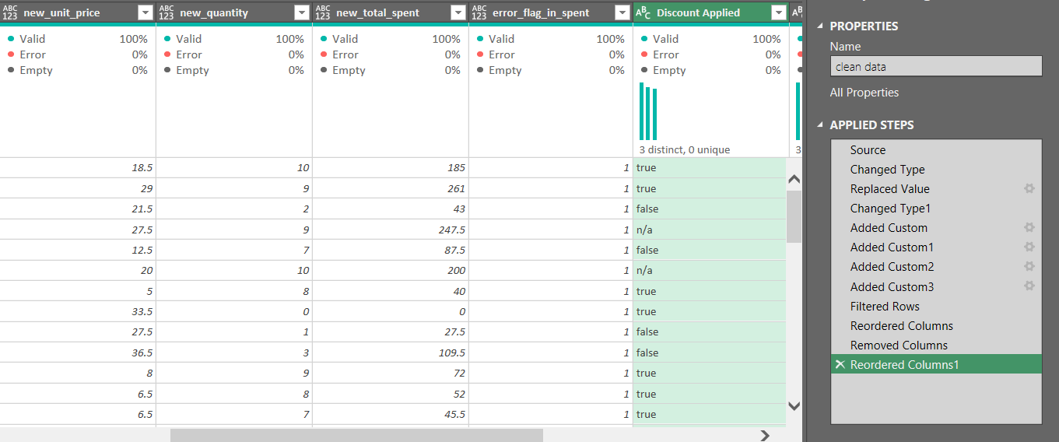
Cleaned columns with Discount Applied nulls replaced by n/a

Final Result
After all transformations, every rebuilt column reached 100% valid with 0% empty and 0% errors.
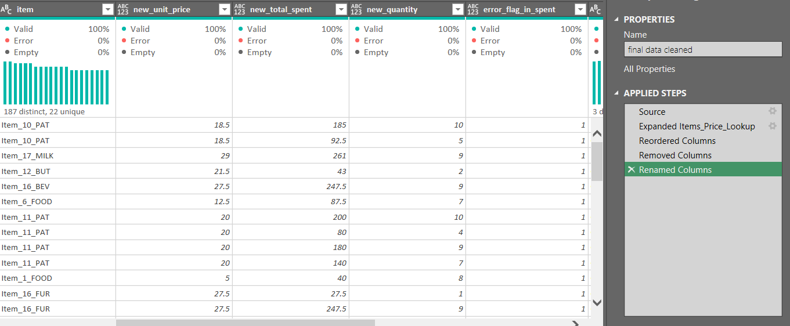
Final cleaned dataset — 100% valid across all rebuilt columns

Summary
Column | Before | After
Item | 91% valid | 100% valid (recovered via price + category)
Price Per Unit | 95% valid | 100% valid
Quantity | 95% valid | 100% valid
Total Spent | 95% valid | 100% valid
Discount Applied | 68% valid | 100% valid (nulls → n/a)

Key Takeaway
Instead of dropping or guessing missing values, this project used relationships already inside the data — Quantity × Price = Total, and a fixed Price per Item — to recover real values, and clearly flagged every assumption for transparency.

Author: Abdelrahman — Data Analyst & AI Automation Specialist

