Nexatel Customer Churn Analysis
Turning contract data into a retention strategy
SQL Server + Power BI | Prepared by Abdelrahman

The business problem
Nexatel (a telecom brand used for this project) loses 26.5% of its customer base to churn each period, costing an estimated $139,000 in monthly recurring revenue. Leadership needed more than a churn percentage — they needed to know which customers are leaving, why, and where a limited retention budget would have the largest measurable impact.
This project answers that with a SQL-based analysis and a Power BI dashboard built for a business audience, not a technical one.

Data
- Source: IBM Telco Customer Churn dataset, taken from IBM's own GitHub repository (not Kaggle)
- 7,043 customers across 21 attributes: contract, billing, services, and demographics
- Tools: SQL Server for analysis, Power BI for the dashboard

Approach: how the thinking was structured
Rather than jumping straight into “who churns,” the analysis was deliberately staged so each step built on the last, and so the final recommendations would be ranked by actual business impact rather than by which pattern was easiest to find first.
1. Baseline — establish what churn looks like overall before segmenting anything. Every later number is compared back to this baseline.
2. Segmentation — test contract type, tenure, services, payment method, and demographics one at a time to find where churn concentrates.
3. Combined risk profiling — cross the strongest individual factors together (contract × internet service × payment method) to find the highest-risk segments, not just the highest-risk single variable.
4. Financial impact — convert churn from a customer count into lost revenue, and rank segments by cost to the business rather than by size.
This order matters: a factor affecting 5% of customers in the highest-value tier can matter more than one affecting 20% of low-value customers. Ranking by revenue impact, not headcount, is what turns the analysis into a prioritized plan instead of a list of observations.

Key findings
The single strongest pattern in the data: contract type and payment method compound rather than acting independently. A month-to-month customer paying by electronic check churns at more than double the company average — and that segment alone accounts for a disproportionate share of the revenue lost.
Metric | Value
Overall churn rate | 26.54%
Highest-risk segment (month-to-month + fiber optic + electronic check) | 60.37% churn
Fiber optic churn rate vs. DSL | 41.89% vs. 18.96%
Revenue lost from the high-value customer tier | $113K of $139K total
Churn rate among customers in their first 6 months | 52.94%

Dashboard: overview
The first page of the dashboard is built to answer “what is the problem” in a single glance — four headline metrics, followed by the three factors with the clearest relationship to churn: contract type, internet service, and tenure.
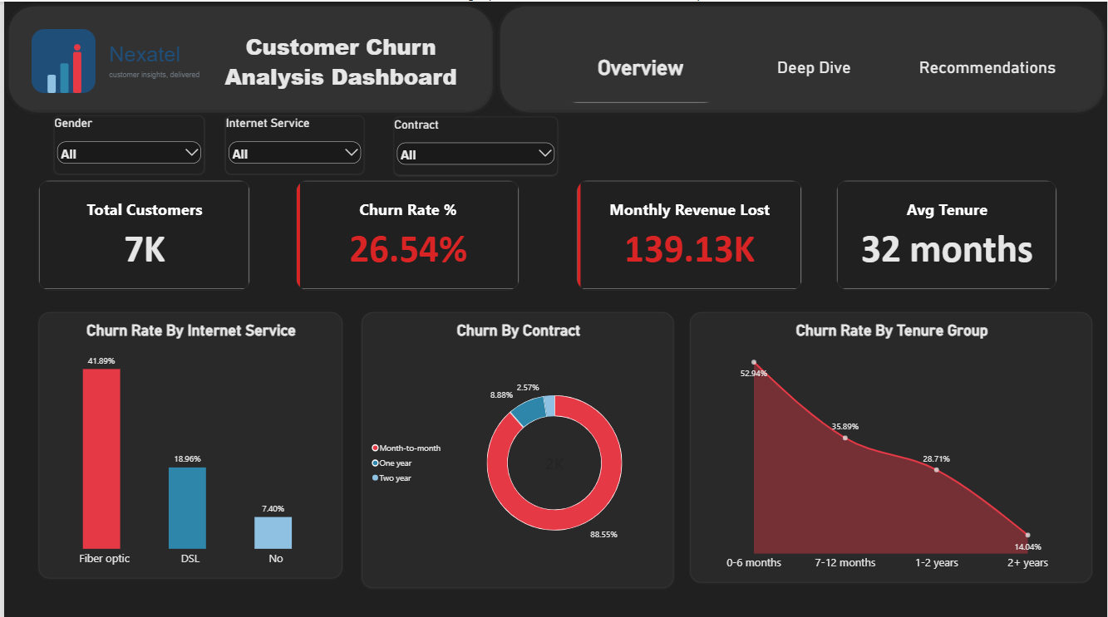
Overview page — baseline metrics and the three strongest single-variable drivers of churn.

Dashboard: deep dive
The second page moves from single factors to combined risk: the highest-risk segments table crosses contract, internet service, and payment method together, alongside the revenue lost by customer value tier and by social status.
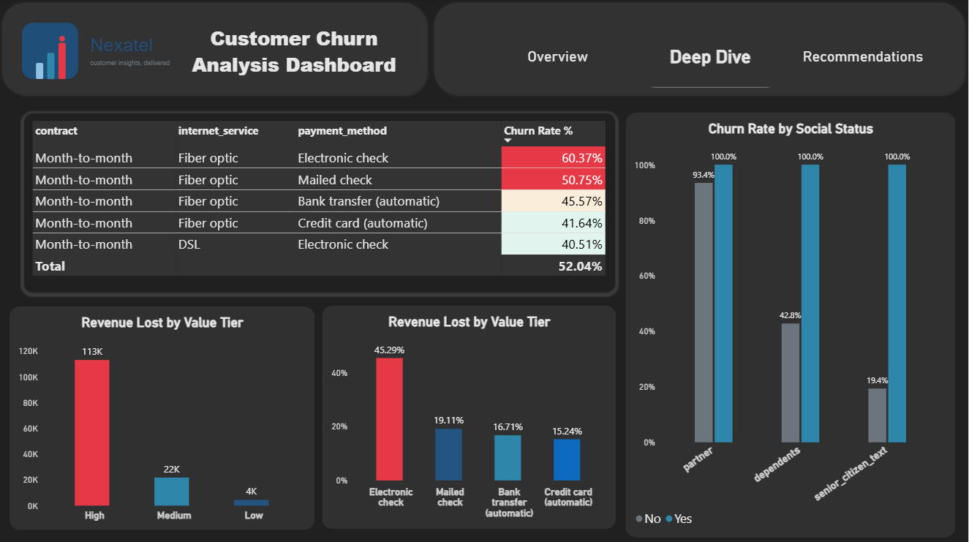
Deep dive page — combined risk segments and financial impact by customer value tier.

Recommendations
1. Target month-to-month, fiber optic, electronic-check customers first. This segment churns at 60%, the highest of any combination found in the data. A discounted annual-contract offer or a proactive retention call before renewal addresses the single largest risk pocket.
2. Move electronic-check customers to automatic payment. Electronic check has the highest churn rate of any payment method across every segment tested. A one-time incentive to switch to bank transfer or credit card auto-pay removes a recurring point of friction that correlates with cancellation.
3. Protect high-value customers without a partner or dependents. High-value accounts drive the largest share of lost revenue, and customers with no family ties churn more than those with partners or dependents. A loyalty perk aimed at this exact overlap protects the most exposed revenue first.
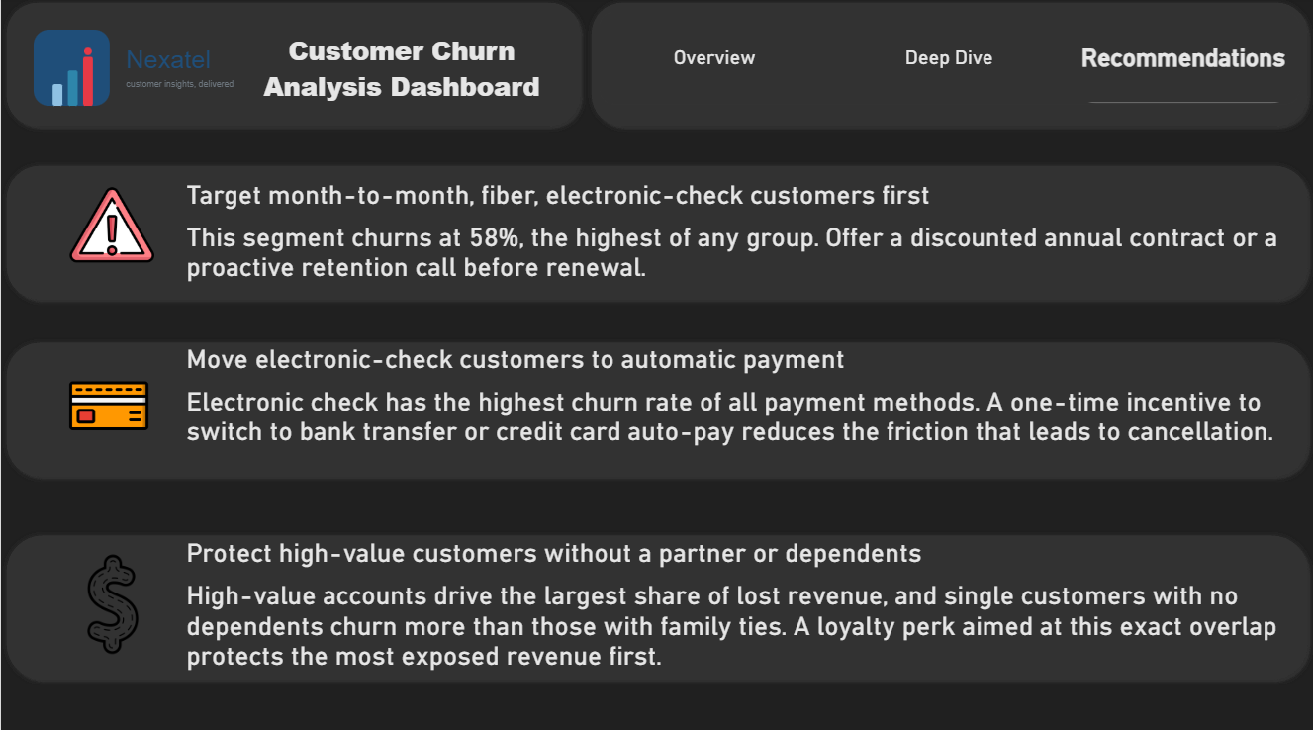
Recommendations page — the three priorities above, as presented to a business audience.

Conclusion
Churn at Nexatel is not random — it concentrates in a specific, identifiable, and addressable segment: new, month-to-month, fiber-optic customers paying by electronic check. Because this analysis ranks findings by revenue impact rather than customer count, the three recommendations above represent the highest-value places to start, not simply the largest groups of at-risk customers.

