XYZ Retail Company
SQL Data Cleaning Report
Identifying and resolving data quality issues using T-SQL
Prepared by Abdelrahman Bahaa
Freelance Data Analyst & AI Automation Specialist
SQL Server (T-SQL) · SSMS

1. Project Overview
XYZ Retail is a synthetic retail company dataset — branches, employees, customers, products, orders, and order items — built with intentionally dirty data to simulate real-world data quality challenges.
This report documents a complete SQL-only data cleaning workflow: creating the schema, inserting deliberately dirty records, profiling the data to detect issues, and applying targeted cleaning logic before validating the results.

Objective
Identify and fix data quality issues using pure T-SQL — no external ETL tools — to produce a dataset that is consistent, valid, and ready for reliable reporting and analysis.

Workflow
- Step 1 — Create tables with documented dirty-data columns
- Step 2 — Insert intentionally uncleaned sample data
- Step 3 — Explore and profile data to detect quality issues
- Step 4 — Clean, standardize, and validate the data

Dataset Scale
Table | Rows
Branches | 5
Customers | 15
Employees | 18
Products | 15
Orders | 18
Order Items | 22

2. Data Quality Issues Identified
Issue Type | Examples
Inconsistent casing/formats | gender (M / male / Female), category (electronics / Electronics)
Invalid formats | phone numbers with symbols/spaces, mixed date formats
Invalid values | negative/zero salaries, negative stock, prices below cost
Duplicates | duplicate employees & customers (same email/phone)
Broken references | orphan branch_id, customer_id, product_id
Missing data | NULL names, emails, genders
Logical errors | delivery date before order date, discount > 100%

3. Cleaning Approach
- Standardization — unified gender, category, boolean, and status values
- Formatting — normalized phone numbers, emails, and dates (yyyy-MM-dd)
- Validation — replaced invalid foreign keys with safe defaults, capped invalid discounts, fixed prices below cost
- De-duplication — detected and removed duplicate customer/employee records
- Null handling — applied sensible defaults (N/A, Unknown, average salary)

4. Before → After Results

4.1 Branches Table
Trimmed names/cities/regions and standardized the opened_date format.
Before
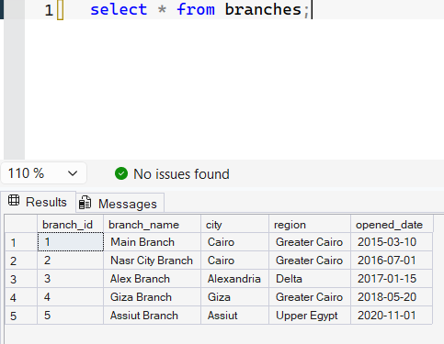
After
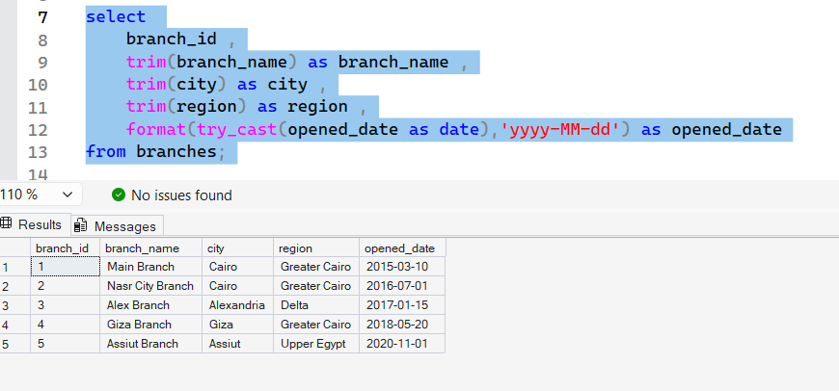

4.2 Employees Table
Standardized gender and phone formats, fixed invalid emails and hire dates, replaced invalid salaries with the average, and removed duplicate records.
Before
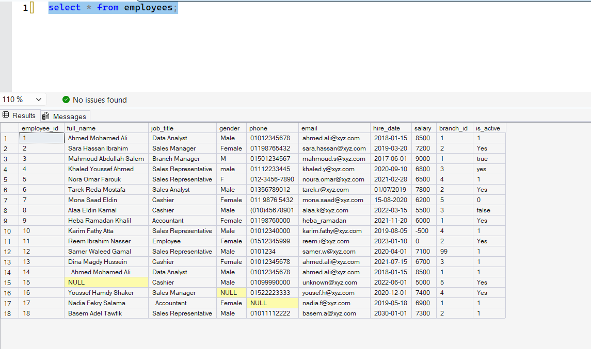
After
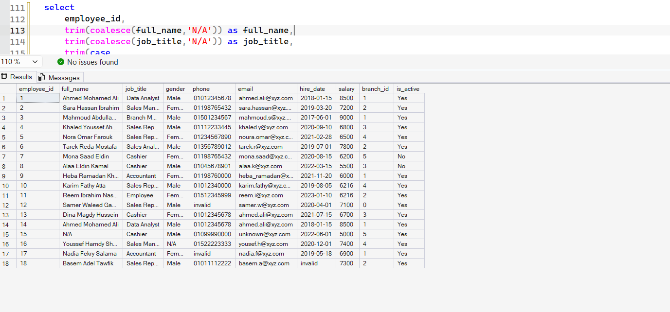

4.3 Customers Table
Standardized gender, phone, email, and city values; capped unrealistic loyalty points; removed a duplicate customer record.
Before
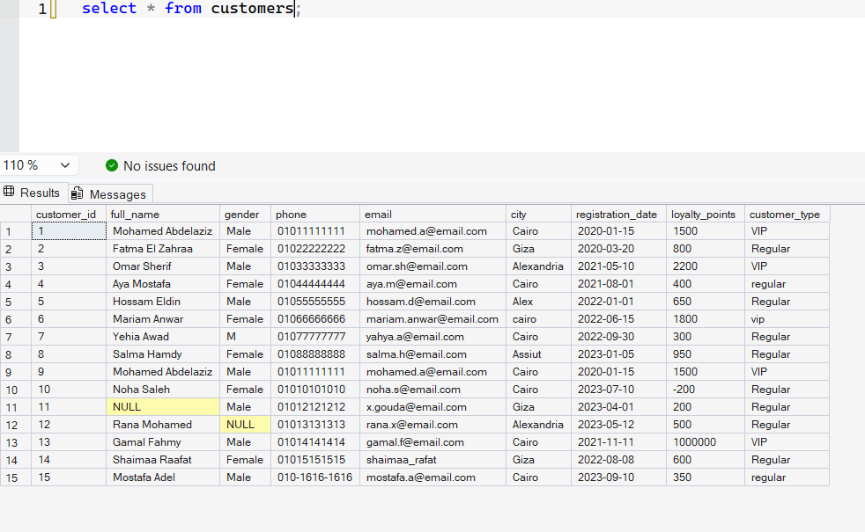
After
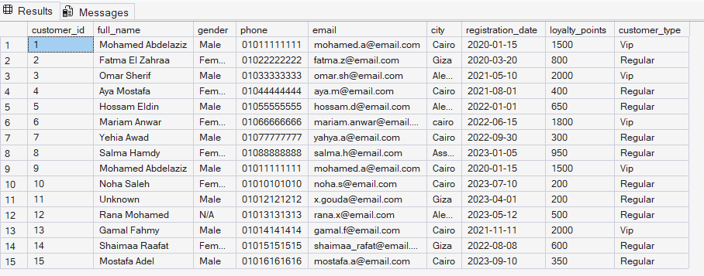

4.4 Products Table
Filled missing names/categories, corrected negative costs/prices/stock, fixed prices below cost, and standardized availability flags.
Before
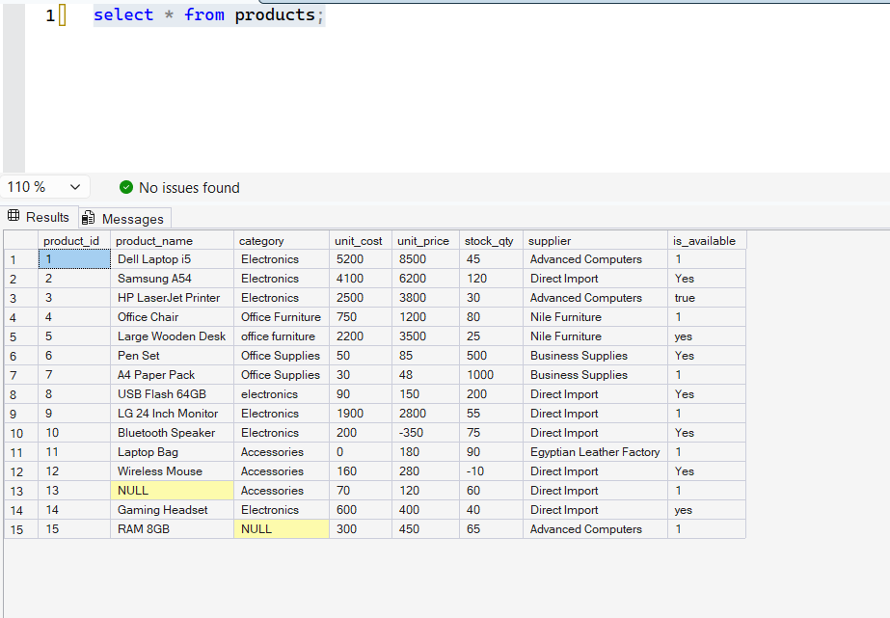
After
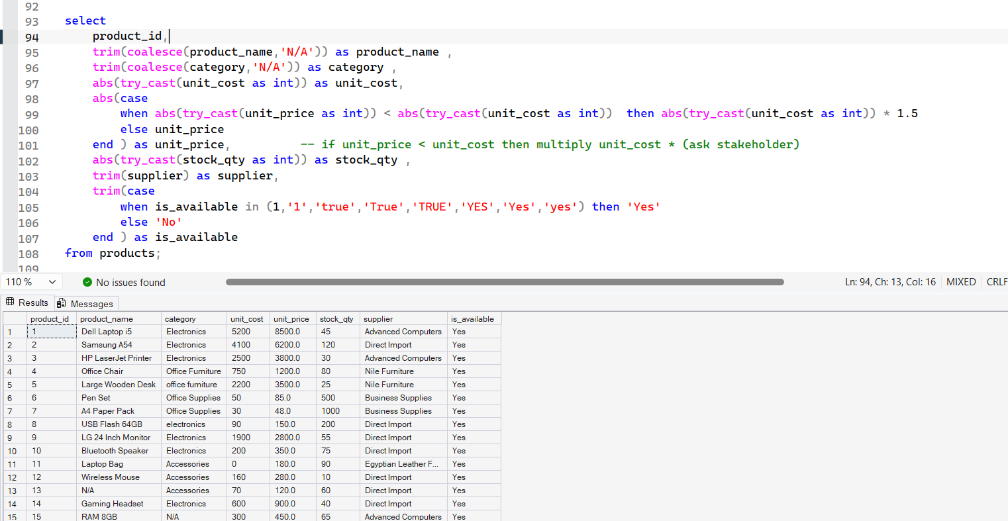

4.5 Orders Table
Validated customer/employee/branch references, standardized date formats and logic, and cleaned payment method, amount, status, and notes fields.
Before
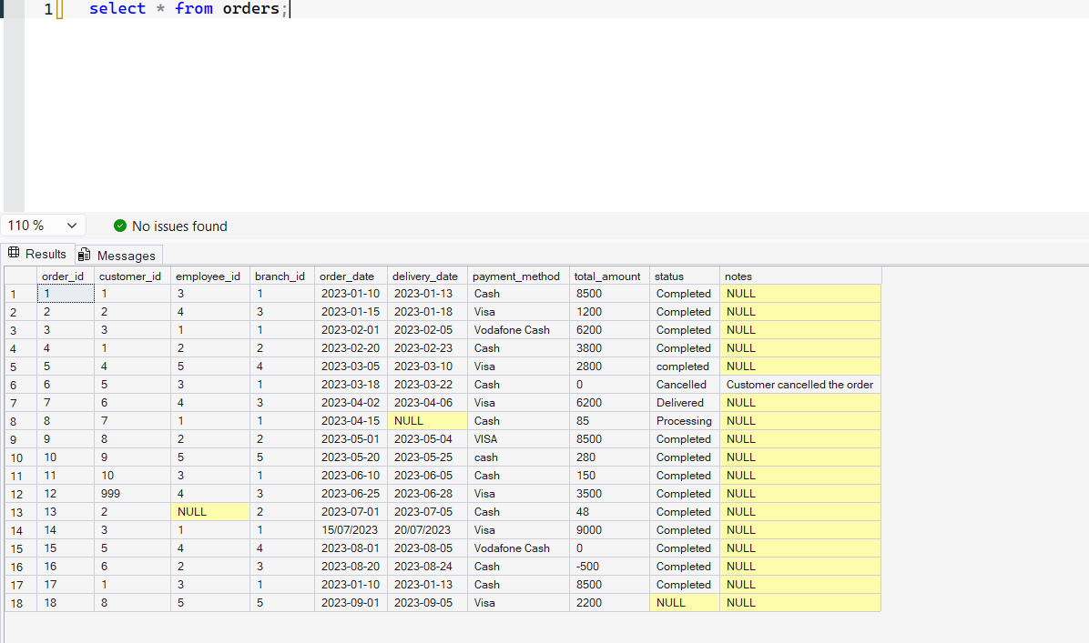
After
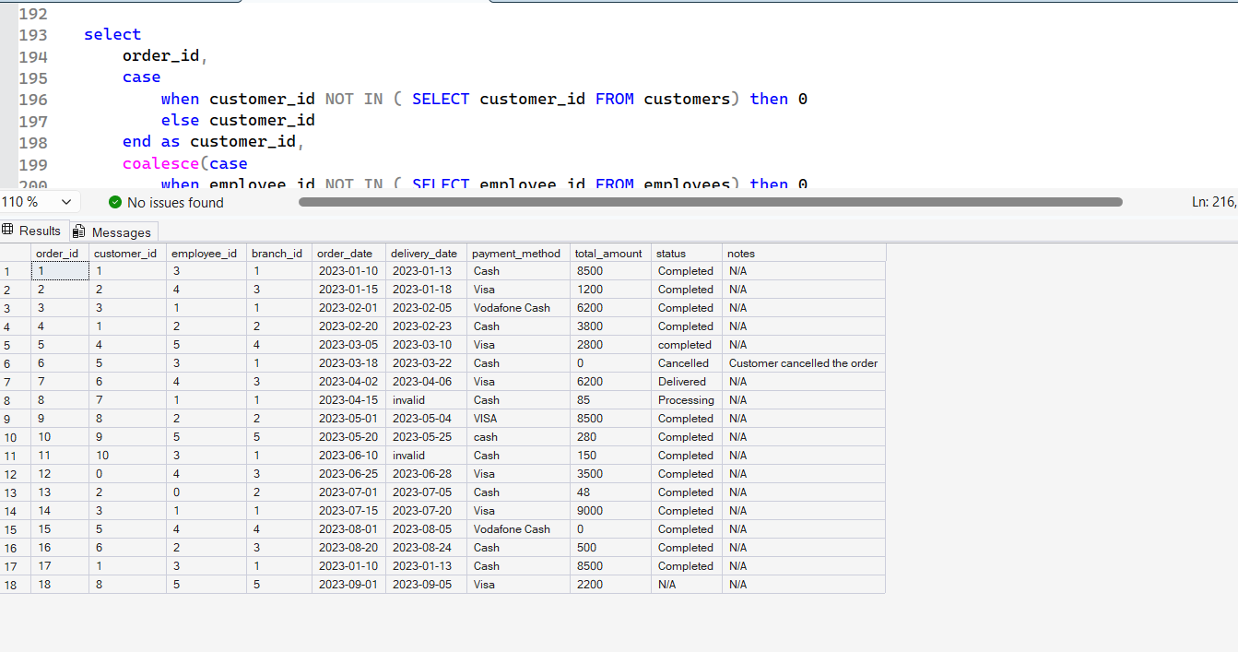

4.6 Order Items Table
Validated order/product references, corrected negative quantities, reconciled unit prices against the products table, and capped invalid discounts.
Before
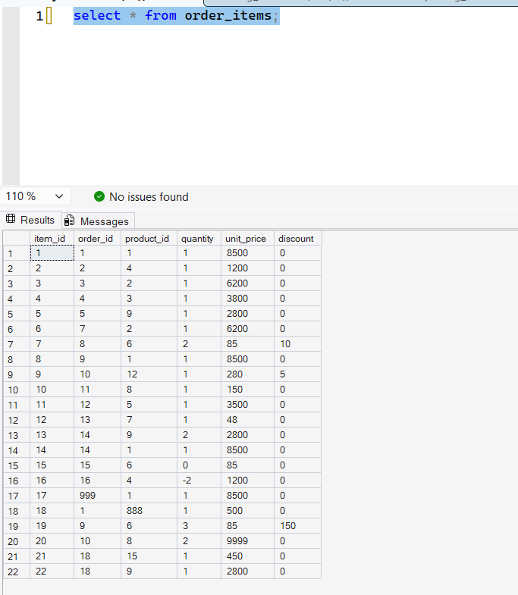
After
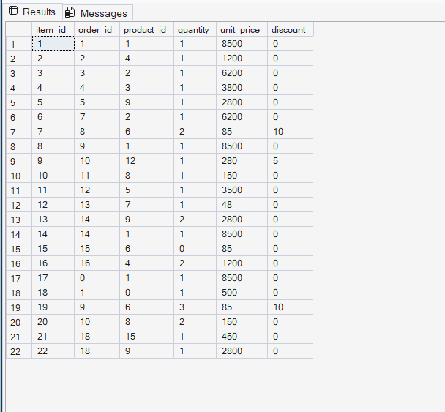

5. Conclusion
Every table in the XYZ Retail dataset was profiled, cleaned, and validated using T-SQL alone. The result is a consistent, standardized, and referentially valid dataset ready for downstream reporting and analysis.

Author
Abdelrahman Bahaa — Freelance Data Analyst & AI Automation Specialist
GitHub: github.com/abdelrahmanbahaa-lotfy
LinkedIn: linkedin.com/in/abdelrahman-bahaa-lotfy-8ba35131b

