P R O J E C T A N A L Y S I S R E P O R T
RequirementPilot
Project Analysis
An in-depth supervisory review of the requirements engineering platform
Source: RequirementPilot Project Reference Document
Research snapshot: 30 September 2026
Prepared for: Graduation Project Supervisor and Committee
Scope: Novelty - Architecture - Evaluation - Feasibility
Date: October 2026

RequirementPilot Independent Analysis October 2026

Table of Contents

1. Executive Summary 1
2. Introduction: Scope, Sources, and Assessment Method 2
3. Project Overview and Strategic Positioning 3
4. Novelty and Research-Gap Analysis 3
5. Technical Architecture Review 5
6. Evaluation Methodology Review 6
7. Feasibility and Schedule-Risk Analysis 7
8. Consolidated Assessment and SWOT Synthesis 8
9. Recommendations and Action Plan 9
10. Proposed Thesis Skeleton 10
11. Concluding Assessment 11

Note: This Table of Contents is generated via field codes. To ensure page number accuracy after editing, please right-click the TOC and select "Update Field."

1. Executive Summary
This report presents an independent, in-depth analysis of the RequirementPilot project as specified in its reference document dated 30 September 2026. RequirementPilot is proposed as an evidence-grounded, human-in-the-loop, agentic requirements engineering platform: rather than generating polished requirements from a prompt, the system conducts structured stakeholder interviews, distinguishes explicit statements from inferences, detects ambiguities and conflicts, selects clarification questions using a deterministic utility model, and maintains a versioned, traceable requirements graph in which every requirement remains linked to its evidence, stakeholder positions, decisions, and downstream artifacts. The analysis covers four dimensions requested by the project team: novelty and research gap, technical architecture, evaluation methodology, and feasibility and schedule risk.
The overall verdict is a conditional go. The reference document is an unusually mature piece of pre-implementation planning: it benchmarks the idea against eight recent research systems (RECOVER, LENS, OntoAgent, ReqElicitGym, ProReFiCIA, AraREQ, MAAD, and MedNegotiator), explicitly forbids overclaiming novelty, defines seven research questions with quantitative metrics, and prescribes a disciplined build order. The evaluation design is the strongest part of the proposal; it compares system strategies rather than only models and includes a twenty-type error taxonomy that many published work lack.
Four headline findings emerge from the analysis. First, the defensible novelty concentrates in two contributions: the impact-aware question-selection mechanism (N2) and the Egyptian Arabic / code-switched requirements benchmark (N7); the remaining eight contributions are useful engineering but individually incremental. Second, the technical architecture is sound and deliberately conservative, though several engineering questions (long-conversation context management, concurrency control, and retrieval-quality measurement) remain unspecified. Third, the evaluation methodology is rigorous on paper but under-specified in statistical execution: sample sizes, inter-annotator agreement, and significance testing are not defined. Fourth, the schedule is the weakest dimension: the eight phases sum to 18-26 weeks against a 24-week window with no buffer, and the largest single work item, the Arabic benchmark, is scheduled in month 5, leaving no slack before evaluation.
The consolidated scores are: strategic positioning 4.0, novelty and research gap 4.0, technical architecture 4.0, evaluation methodology 4.5, feasibility and schedule 3.0, and reference-document quality 5.0, on a five-point scale. The project should proceed, subject to four conditions: freeze the research questions and minimum viable research contribution before Phase 3; begin benchmark scenario production and annotation-guideline work in month 2 rather than month 5; define the statistical analysis plan, including sample sizes and inter-annotator agreement thresholds, before any data collection; and adopt the documented descope ladder so that change-impact analysis and requirement-debt features are sacrificed before the question planner, evidence model, or benchmark are touched.

2. Introduction: Scope, Sources, and Assessment Method
The purpose of this report is to give the graduation project supervisor and committee a structured, critical, and evidence-based view of the RequirementPilot proposal before implementation resources are committed. Graduation projects of this ambition typically fail in one of three ways: they claim more novelty than a fast-moving literature allows, they build infrastructure instead of the research contribution, or they run out of time because evaluation was designed after the system rather than with it. The reference document already guards against several of these failure modes; this analysis verifies where those guards are adequate and where they are aspirational, so that supervision effort can be directed at the genuine weak points.
The single source analyzed is the RequirementPilot Project Reference Document, a 111-section research, product, and implementation blueprint dated 30 September 2026. The document contains a literature benchmark of work through September 2026, ten candidate novelty contributions (N1-N10), a formal problem statement, a system architecture with a recommended stack, a core data model of 22 entities, prompt contracts for the main agents, seven research questions (RQ1-RQ7), seven baselines (B1-B7), a three-level dataset strategy, a phased implementation plan, a six-month timeline, a four-person team division, and a risk list. All quantitative claims cited in this report are taken from that document; where the document itself flags a number as provisional (for example, the question-utility weights), this report treats it as provisional as well and says so explicitly.
The assessment applies four lenses, each mapped to a chapter of this report. The novelty lens asks whether each claimed contribution would survive a committee question about prior work, and scores each contribution on expected impact and feasibility. The architecture lens asks whether the proposed stack, orchestration design, and data model can carry the required behaviour with student-level resources. The evaluation lens asks whether the research questions are answerable with the proposed metrics, baselines, and datasets. The feasibility lens asks whether the plan fits six months and four people, and what should be cut first when it does not. Scoring uses a 1-5 scale where 3 means adequate with reservations, 4 means strong, and 5 means excellent; scores are analyst judgments grounded in the document text, not measurements.
Two limitations bound the conclusions. This analysis did not re-run the literature search: it evaluates the internal consistency and defensibility of the document, including its own novelty warnings, but a fresh systematic search before the final thesis remains the team responsibility, exactly as the document itself demands. Second, feasibility judgments assume the stated team of four senior-level students and no external funding constraints beyond those the document states; a materially different team profile would change the schedule conclusions and should trigger a re-read of Chapter 7.
Table 1 summarizes the four-lens verdict. The pattern is consistent across lenses: this is a strong research plan attached to an optimistic delivery plan. Nothing found in the analysis argues for abandoning or fundamentally redesigning the project; most findings argue for sequencing, statistical discipline, and honest descope triggers.
Table 1: Four-lens assessment summary
Assessment lens | Score (1-5) | Verdict in one line
Strategic positioning | 4.0 | Integration-first positioning is defensible and honestly framed
Novelty and research gap | 4.0 | Two strong cores (N2, N7); eight useful but incremental contributions
Technical architecture | 4.0 | Sound, conservative stack; several engineering gaps to close early
Evaluation methodology | 4.5 | Best-practice design; statistical execution under-specified
Feasibility and schedule | 3.0 | Phases sum to 18-26 weeks against 24; no buffer; late benchmark
Reference-document quality | 5.0 | Exceptional pre-implementation planning artifact

3. Project Overview and Strategic Positioning
RequirementPilot targets a real and well-chosen problem: real stakeholders rarely state requirements cleanly. The document opens with a single Egyptian Arabic stakeholder utterance that contains multiple requirement candidates, an undefined policy boundary, an actor distinction, and an implied business rule, and correctly observes that a conventional LLM would respond by generating polished user stories whose polish hides the missing information. The eleven-step problem decomposition that follows (identify what was stated, separate explicit needs from inference, detect missing, ambiguous, and conflicting information, choose the next best question, preserve evidence, transform validated answers into structured requirements, connect them to downstream artifacts, detect change impact, and maintain history) is an accurate statement of what professional requirements engineering actually involves, and it is the correct anchor for both the product and the thesis.
The most important strategic move in the document is its own Section 0, which abandons the generic claim of an AI requirements engineer and repositions the work as a human-in-the-loop, evidence-grounded, change-aware system whose contribution is the integration of requirements controls into one auditable lifecycle. This is the right call, and the document deserves credit for making it against the natural temptation to oversell. It explicitly acknowledges that requirement extraction from conversations (RECOVER), latent-requirement discovery (LENS), ontology-guided interviewing (OntoAgent), Arabic conflict detection (AraREQ), change-impact analysis (ProReFiCIA), and multi-agent architecture and negotiation (MAAD, MedNegotiator) are all published. The result is a claim structure that a committee can accept without a single act of faith: the novelty is the combination plus two focused mechanisms, not the individual capabilities.
The closest-work matrix in Section 101 of the document is a useful prioritization instrument, but it must be read as what it says it is: a conceptual, self-reported comparison rather than a verified systematic review. The document is candid about this, instructing the team to read the original sources before writing the final literature review, and the matrix itself marks several cells as partial or limited rather than absent. The analysis in this report agrees with the document's implicit conclusion that no reviewed single work combines conversation-grounded elicitation, evidence provenance, uncertainty management, conflict ledgers, change impact, and a code-switched Arabic benchmark; the residual risk is not that one paper does everything, but that the integration claim is demonstrated only by a working system rather than by a measured integration benefit. Chapter 6 returns to this point: the evaluation plan should include at least one condition that isolates the value of integration itself, for example the full system versus a feature-ablated pipeline, which the current ablation list partially covers.
The formal problem statement and the human-role policy are also well judged. The system is defined as assistive rather than autonomous: AI may extract, propose, classify, detect, rank, and draft, but it may never silently approve a requirement, resolve a stakeholder conflict, promote an inference to explicit status, delete evidence, or rewrite an approved baseline without an audit trail. This policy is repeated consistently in the architecture, the prompt contracts, the validation rules, and the evaluation design, which is exactly the kind of conceptual discipline that distinguishes a serious requirements-engineering system from a demo. The one-sentence rule that anchors the document, never let the LLM silently fill a requirements gap, is memorable, testable, and should appear verbatim in the thesis.
Two positioning weaknesses deserve attention. First, the project identity spans three distinct communities (NLP and language resources, agentic AI, and software engineering systems), and the document itself offers four alternative framings (Configurations A-D). The team should choose one primary framing before coding, because the framing determines which venue the benchmark and evaluation serve and which related work the committee will pull from. Second, the phrase requirements operating system in the project identity is marketing language that adds no academic value and invites ridicule in a viva; the defensible one-liner in Section 102 of the document (the system uses an LLM to conduct and control the requirements-engineering process while keeping every requirement tied to evidence, uncertainty, decisions, and impact) is strictly better and should replace it in all formal materials.

4. Novelty and Research-Gap Analysis
The document lists ten candidate novelty contributions and, unusually for a project proposal, orders them from central to optional and attaches a candidate research question to the most important one. This chapter assesses each contribution and then consolidates the verdicts into a scored matrix. The scoring rubric is deliberately practical: impact measures how much the contribution would strengthen the thesis and any resulting paper if it works as described; feasibility measures the probability that a four-person team can deliver it inside six months at evaluation quality.
N1, evidence-first requirement objects, requires every requirement to carry provenance metadata: source spans, evidence level, speaker, rationale, assumptions, confidence, and approval status, with a controlled vocabulary of eight evidence levels that never allows validated to be used as a synonym for generated. The committee-relevant precedent is LENS, which already pairs inferred requirements with rationale and transcript traceability; N1 is therefore best framed as an engineering formalization at system level rather than a discovery. Its real research value is that it makes RQ3 (does provenance-first generation reduce unsupported requirements) measurable, and the eight-level vocabulary is more disciplined than most published pipelines. Verdict: high impact, high feasibility, keep.
N2, adaptive question selection, is the strongest contribution. The system treats the interview as active uncertainty reduction: candidate questions are scored by a transparent formula combining information gain, requirement impact, ambiguity reduction, conflict-resolution value, and coverage gain, minus user effort and redundancy, with the LLM generating candidates and deterministic code performing final selection. The document correctly identifies that information gain itself is established and that the novelty must live in the requirements-engineering objective function and the downstream-impact weighting; the dependency fan-out argument in its Section 25 (a payment-failure unknown touches six artifact classes while a button-color unknown touches one) is exactly the kind of concrete, testable motivation committees respond to. The risk is evaluation cost: proving superiority over an LLM-choice baseline and an ontology-guided baseline requires many simulated interviews, and the initial weights are admitted guesses. Verdict: highest impact, medium feasibility, protect.
N3, ambiguity branching with behavioral divergence, is the most intellectually interesting mechanism: for an ambiguous statement the system constructs a small set of interpretations, derives the downstream behavioral consequence of each, and asks the stakeholder a question that separates the branches. Related work (ClarifyGPT, the Orchid benchmark) addresses ambiguity for code generation; branching at the requirements-model level with explicit downstream divergence is a genuine angle. It is also the most research-heavy item after N7, because scoring downstream divergence requires a defensible model of behavioral difference. Verdict: high impact, medium-low feasibility, keep but time-box.
N4 (uncertainty ledger), N5 (requirement debt score), and N9 (requirements time travel) form the measurement-and-history cluster. The uncertainty ledger converts project health into a countable state distribution; the debt score aggregates eight weighted defect signals into a 0-100 index; time travel reconstructs what was known at any version. All three are valuable product features and all three are derivative of established concepts (requirements uncertainty, requirements debt, and versioning respectively), a fact the document states plainly. Their thesis value is supportive rather than central: they demonstrate the living-model claim and feed the dashboard storyline, but none should consume core research time. N5 in particular should ship with visibly arbitrary-but-documented weights and a calibration note. Verdicts: medium impact, high feasibility for N4 and N9; medium impact, high feasibility for N5 with the caveat that its thresholds must never be presented as validated constants.
N6, stakeholder voice preservation, keeps who wanted what and why attached to the final requirement, including unresolved positions; the document correctly scopes the contribution to provenance-preserving consolidation rather than conflict detection, which AraREQ and MedNegotiator already occupy. N7, the Egyptian Arabic and code-switching benchmark, is the second strongest contribution and the one with independent publication potential: matched scenario versions in English, MSA, Egyptian Arabic, and code-switched Arabic-English with identical gold requirements, annotated for explicit and latent requirements, ambiguities, conflicts, actors, constraints, and resolution status. The document correctly positions it against AraREQ (27K pairs, MSA, document-oriented, classification task) as the first multi-turn, conversation-level, evidence-annotated benchmark for this language mix. The risk is pure effort: 100-200 annotated scenarios is a large annotation project by itself. Verdict: high impact, medium-low feasibility, protect and start early.
N8 (end-to-end change propagation into downstream artifacts) and N10 (explain-why question rationales) close the list. N8 is a strong integration demo that visualizes the impact chain from a spoken change to tests and tasks; its research framing must cite ProReFiCIA and claim only the cross-artifact, provenance-aware variant inside the project's own lifecycle. N10 is cheap, popular with users, and gives RQ-era trust evaluation a handle; it is a feature, not a contribution, and should be built last from components that already exist. Table 2 consolidates the ten verdicts and Figure 1 plots them.
Table 2: Scored verdict matrix for the ten novelty contributions
ID | Contribution | Impact | Feasibility | Verdict
N1 | Evidence-first requirement objects with 8-level evidence vocabulary | 4.5 | 4.2 | Keep; frame as system-level formalization of LENS-style provenance
N2 | Impact-aware adaptive question selection (deterministic utility scoring) | 4.8 | 3.4 | Protect; core research contribution; ablation-critical
N3 | Ambiguity branching with downstream behavioral divergence | 4.2 | 3.2 | Keep but time-box; divergence model needs a defensible scoring rule
N4 | Requirement uncertainty ledger (certainty states + reasons) | 3.8 | 4.0 | Keep lightweight; dashboard-facing
N5 | Requirement debt score (0-100 composite) | 3.0 | 4.1 | Keep lightweight; document weights as engineering choices
N6 | Stakeholder voice preservation ledger | 3.9 | 3.6 | Keep; scope to provenance-preserving consolidation
N7 | Egyptian Arabic / code-switched requirements benchmark | 4.6 | 3.0 | Protect; independently publishable; start production early
N8 | Cross-artifact change propagation with impact graph | 4.0 | 2.8 | Phase B; first descope candidate after debt features
N9 | Requirements time travel (version comparison) | 2.8 | 3.8 | Defer to Phase B; demo value only
N10 | Explain-why-question rationales | 3.2 | 4.4 | Cheap add-on after the planner works
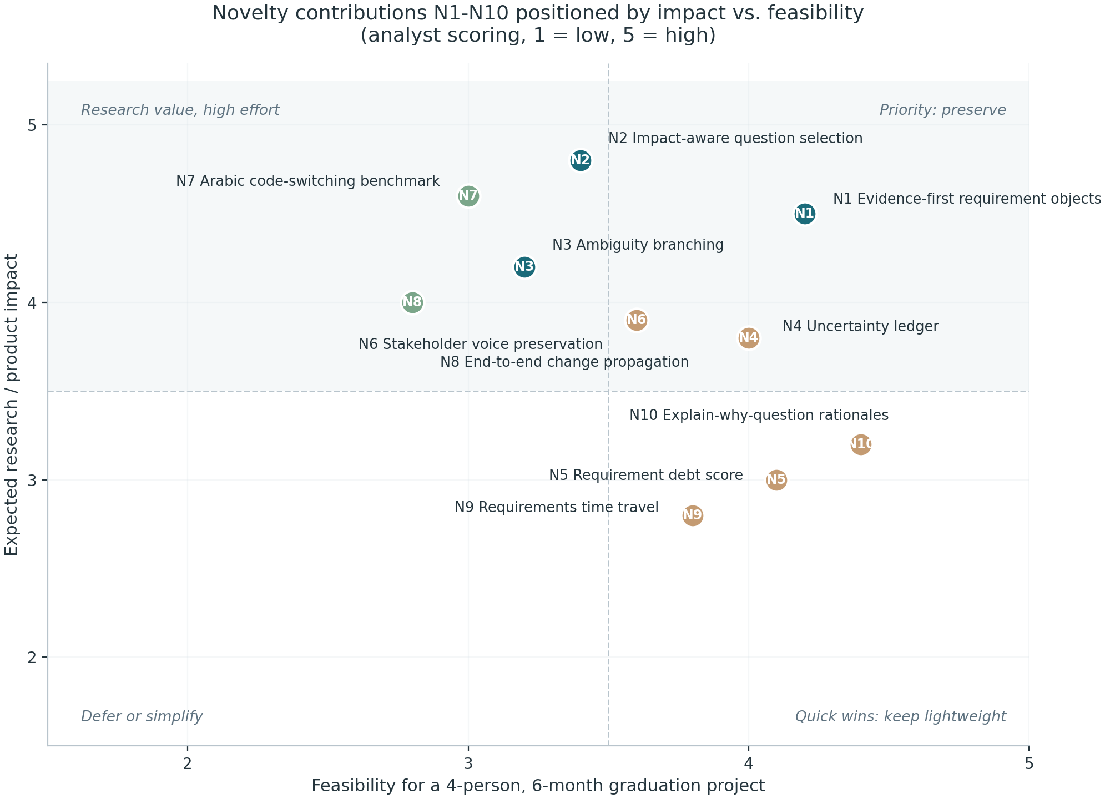
Figure 1: Novelty contributions N1-N10 positioned by expected impact versus feasibility (analyst scoring)
Two weaknesses run across the novelty case. First, the closest-work matrix is self-assessed; the document plans a final systematic search but defines no protocol for it (databases, query strings, inclusion criteria, cutoff date). A one-page search protocol written now would convert the novelty warning from a disclaimer into a method. Second, the framing of N1-N3 leans on internal mechanism quality, and committees increasingly ask for an external yardstick; the planned comparison against an OntoAgent-inspired baseline (B3) is therefore not optional decoration but the load-bearing wall of the novelty argument, and it must be scheduled even if the benchmark shrinks.

5. Technical Architecture Review
The proposed architecture is a conventional and well-matched five-layer design: a Next.js and React frontend with chat, requirements, graph, conflicts, traceability, change, debt, and decision-history views; a FastAPI layer owning auth, projects, sessions, requirements, and decisions; an orchestrator running an explicit agent state machine; a model-and-retrieval tier consisting of a model-agnostic LLM gateway and a project-context retrieval service; and a PostgreSQL data layer with pgvector for semantic search. Figure 2 reproduces the target architecture with the MVP consolidation path annotated. None of these choices is exotic, which is precisely their virtue: for a six-month student project, every unfamiliar component is a schedule risk, and this stack is composed almost entirely of boring, well-documented technology.
The most architecturally mature decision in the document is the rejection of a heavyweight agent framework in favor of an explicit state machine (Conversation, Evidence, Requirement, Uncertainty, Question, Validation states). Multi-agent frameworks would add hidden non-determinism to a system whose entire thesis is determinism where it matters: the document rule that the LLM proposes and deterministic logic verifies is implemented structurally by this choice. Equally sound is the instruction that the ten logical agents are responsibilities, not services, and that the MVP should combine them into three to five components (supervisor; interview plus question planner; requirement plus evidence analyst; validation, conflict, and ambiguity checker; traceability plus change-impact worker), splitting only when metrics show specialization helps. The committee should recognize this for what it is: an appropriate refusal to let architecture astronautics consume the semester.
The data model is strong where it matters for the research claims. The 22-entity model makes evidence a first-class object, versions requirements event-style (never overwrite; every version stores author, source, reason, timestamp, approval, and impacted artifacts), and encodes typed trace links with confidence, creator, and last-verified metadata. Eight formal validation rules (R1-R8) are specified as deterministic checks, including the load-bearing R5 (a latent requirement cannot become validated without human approval) and R8 (a requirement cannot be deleted while downstream artifacts depend on it; it must be superseded). Two structural choices deserve early scrutiny: representing the requirement graph in relational tables is correct for the MVP and the document is right to defer Neo4j, but the team should write the five graph queries the UI needs (impact closure, dependency fan-out, evidence lineage, conflict neighbourhood, and version diff) against the relational schema in Phase 1 as a spike, because retrofitting graph traversal onto SQL after the UI exists is a classic source of late-stage rework.
The retrieval design contains the most original engineering idea in the document: authority-aware retrieval, in which every retrieved item carries source identity, version, authority score, and status, and approved policies or signed decisions (authority 1.00 and 0.95) cannot be silently overridden by AI inference (0.30) or general web knowledge (0.10). Combined with the eight hallucination controls (evidence required, explicit-latent distinction, human approval, structured outputs, deterministic validation, cross-agent verification, source-span linking, and no silent baseline modification), this is a coherent answer to the question committees now ask every LLM system: what stops the model from inventing requirements? The honest answer in the document is that nothing stops generation, but several mechanisms make invention visible, reversible, and non-authoritative, which is the correct engineering posture.
The stack assessment in Table 3 is positive overall, with reservations concentrated in four gaps. First, long-conversation context management is never addressed: multi-turn interviews with growing requirement sets will exceed practical context windows, and the document specifies neither a summarization strategy nor what state is re-injected per turn. Second, concurrency and consistency are unspecified: two stakeholders clarifying the same requirement simultaneously is a normal event in the target domain, and the versioning model needs an optimistic-locking or merge rule. Third, observability is thinner than the project needs: the cost-and-latency section (Section 82) correctly prescribes model tiering and caching, but there is no mention of structured logging of agent decisions, per-run cost accounting, or prompt-version traceability beyond a checklist item; for a research system these are not luxuries, they are how the ablation studies will be debugged. Fourth, the API design lists endpoints but no versioning or error contract; minor for a thesis, but it costs nothing to fix now. None of these gaps threatens the design; all of them are cheap to close in Phase 1 and expensive to close in Phase 6.
Table 3: Stack component assessment
Component | Documented choice | Assessment
Backend framework | Python, FastAPI, Pydantic, SQLAlchemy, Alembic | Strong fit; typed schemas align with structured-output validation
Primary database | PostgreSQL with pgvector | Correct simplification; defer Neo4j; verify pgvector recall on Arabic text early
Cache / state | Redis (optional) | Adequate; specify what session state is authoritative in the database instead
LLM access | Model-agnostic provider adapter | Essential and well-motivated; add per-call cost and latency logging from day one
Orchestration | Explicit state machine, no framework | Correct; keeps deterministic verification structural
Frontend | Next.js, React, TypeScript, Tailwind, React Flow | Standard; React Flow matches the graph UI requirement
Deployment | Docker Compose for demo; managed services optional | Right-sized; avoid Kubernetes per the document's own advice
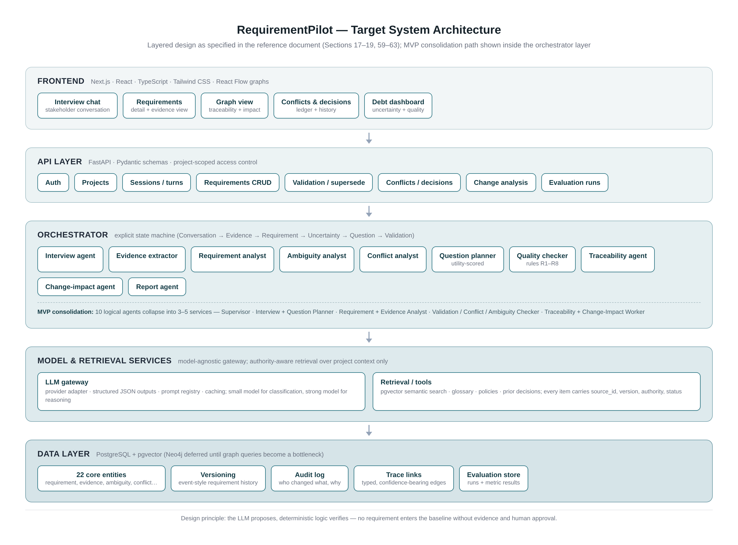
Figure 2: Target system architecture as specified in the reference design, with the MVP consolidation path

6. Evaluation Methodology Review
The evaluation design is the part of the proposal that most distinguishes it from a typical graduation project, and the document says so itself: do not evaluate the system using only the impression that it “looked good in the demo”. Seven research questions are defined, each with named metrics: extraction accuracy (RQ1, precision, recall, F1), question effectiveness (RQ2, coverage, turns-to-threshold, redundancy, stakeholder effort), evidence reliability (RQ3, evidence precision and recall, unsupported-requirement rate, citation correctness), ambiguity resolution (RQ4, detection F1, interpretations remaining, behavioral divergence), conflict management (RQ5, conflict F1, position-preservation accuracy, false-resolution rate), change propagation (RQ6, impact recall and precision, stale-artifact detection), and cross-language performance (RQ7, extraction, ambiguity, and conflict F1 across English, MSA, Egyptian Arabic, and code-switched input). Table 4 summarizes the assessment. Every metric is computable from the data model, which is not an accident: the evaluation store is an entity in the schema, and the API includes evaluation-run endpoints. This is design-for-evaluation, and it is exemplary.
The baseline plan is equally disciplined. Four interview-strategy baselines (single-shot generation, unrestricted conversational LLM, an ontology-guided interviewer inspired by OntoAgent, and the proposed impact-aware planner) are crossed with a four-language experimental matrix, and three artifact-validation baselines (LLM-only conflict detection, embedding-plus-LLM classification, and LLM plus deterministic validator) target the conflict and validation pipeline. The explicit instruction to compare system strategies rather than only models is the single most important methodological sentence in the document, because it converts the project from a model benchmark into an architecture claim. Five ablations (remove evidence tracking, remove impact from question scoring, remove ambiguity branching, remove RAG, remove stakeholder-voice preservation) map one-to-one onto the claimed contributions, which is exactly how ablations should be derived.
The dataset strategy is layered sensibly: public requirements corpora (PURE with 79 documents and 34,268 sentences, plus PROMISE and SWARD resources where licensing permits) for foundational material; the existing ReqElicitGym environment (101 elicitation scenarios with a simulated stakeholder and judge) for baseline replication and regression testing; and a self-built benchmark of 100-200 scenarios as the main contribution. The benchmark-construction ethics are handled with unusual care: three tracks (public-source-derived with hidden gold specifications, expert-designed scenarios, and real conversations only with documented permission and anonymization), plus a blunt prohibition on fabricating data and calling it industrial. The synthetic-stakeholder oracle is well designed (it knows hidden requirements, persona, and forbidden assumptions) and the document correctly warns that interviewer and oracle sharing one model creates correlated bias, mandating a human-evaluated subset; the nine-dimension Likert protocol with binary factual checks is appropriate.
The Arabic benchmark design is the strongest single element: matched scenario versions in four language conditions with identical gold requirements, evaluated for cross-language consistency of extracted requirement, conditions, exceptions, actor identity, and introduced assumptions. This directly operationalizes the Arabic hypothesis (explicit handling of Egyptian Arabic and code switching reduces errors relative to English-only or translate-then-process pipelines) and would be a citable artifact regardless of how the agent performs. The twenty-type error taxonomy (E1-E20) completes a picture that is, on paper, better than the evaluation sections of many published RE papers.
Four methodological gaps must be closed before data collection. First, statistical power is nowhere addressed: with 100-200 scenarios split across four baselines and four languages, per-cell sample sizes may be too small for the differences that matter, and the plan should state, per research question, the minimum detectable effect and the number of runs (including whether each scenario is repeated with multiple seeds, since LLM stochasticity inflates variance). Second, inter-annotator agreement is never mentioned: the benchmark is annotated by the team, and RQ4-RQ7 all depend on gold labels whose reliability should be reported with a chance-corrected agreement coefficient and an adjudication procedure. Third, translation equivalence for the matched language versions needs a stated method (forward-plus-back translation with independent review is sufficient at this scale); otherwise RQ7 differences are confounded by scenario drift. Fourth, the question-utility weights are presented with suggested starting values and an honest disclaimer, but the ablation plan should be extended to a small weight-sensitivity sweep on a pilot subset before the main runs, because a five-component additive score with guessed weights is the most likely place for a hidden confounder. None of these gaps weakens the design; all four are one-week fixes if done now and unfixable if done after the runs.
Table 4: Research-question assessment
RQ | Focus | Metric quality | Principal risk
RQ1 | Extraction accuracy | Strong (P/R/F1) | Gold-standard construction effort; label drift on latent items
RQ2 | Question effectiveness | Strong and original | Turns-to-coverage depends on oracle answer style; fix oracle prompts
RQ3 | Evidence reliability | Strong | Citation correctness judging is labour-intensive; sample it
RQ4 | Ambiguity resolution | Good | Behavioral-divergence metric needs a defined scoring rule
RQ5 | Conflict management | Good | Position-preservation accuracy requires multi-stakeholder scenarios
RQ6 | Change propagation | Good | Downstream gold artifacts must be hand-verified per scenario
RQ7 | Cross-language performance | Strong design | Translation-equivalence method unstated; annotation IAA unreported

7. Feasibility and Schedule-Risk Analysis
The reference plan consists of nine phases (0-8) whose stated durations sum to 18 weeks at minima and 26 weeks at maxima, set against a six-month, roughly 24-week window. Figure 3 maps the phases onto the 24-week limit using the sequential interpretation (each phase starting when its predecessor ends, with the Arabic track overlapped against the evaluation phase as the month-by-month table implies). The conclusion is immediate: at minimum durations the plan fits with about six weeks of slack; at maximum durations it overshoots by two weeks with zero buffer for the integration debugging, dataset licensing checks, ethics permissions, and write-ups that every real project encounters. A plan whose median estimate equals the deadline is, for scheduling purposes, a plan that finishes late.
The composition of the plan compounds the arithmetic problem. The two most valuable contributions are also the two most expensive items: the impact-aware question planner needs the interview engine (Phase 3) stable before its ablations can run, and the Arabic benchmark (Phase 7) is scheduled in months 5-6, immediately before the evaluation phase that consumes it. If annotation starts in month 5, a single two-week delay in Phase 6 compresses the benchmark to whatever can be annotated in the time remaining, and the project loses its strongest publishable asset. The document's own minimum-viable-research section (protect the question planner, the evidence-grounded requirement model, and a benchmark with rigorous evaluation) is the correct priority order; the schedule should be rebuilt so that those three items are finished first, not last.
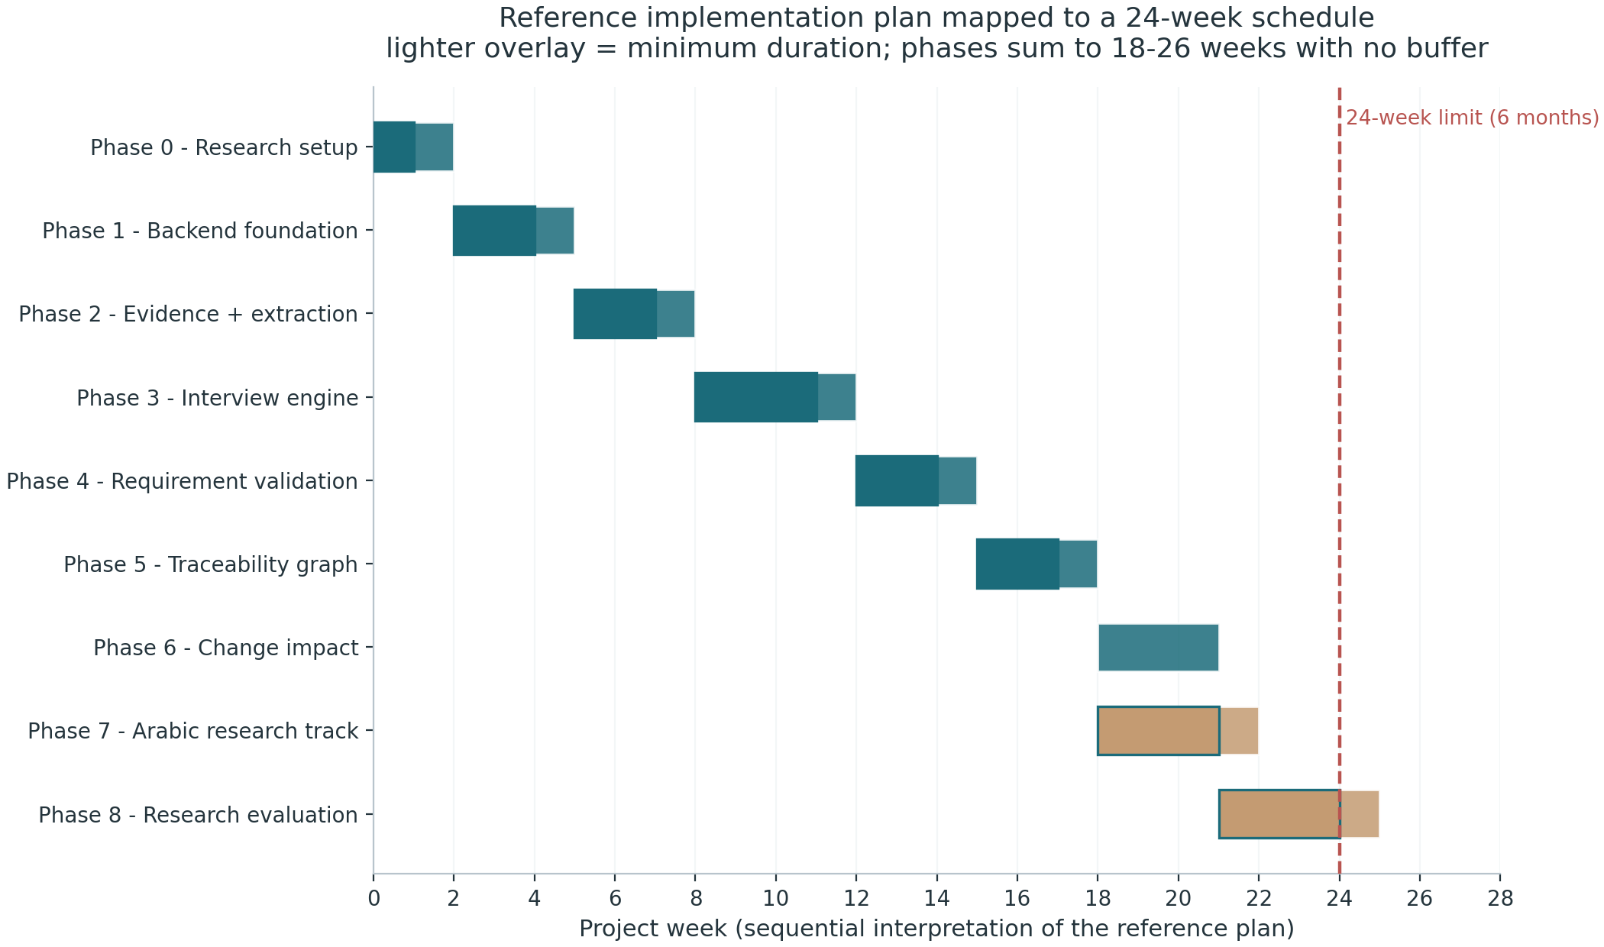
Figure 3: Reference implementation plan mapped to the 24-week window (sequential interpretation)
The team division is sensible and complete: LLM and interview agent; NLP, Arabic, and dataset; backend, data, and graph; frontend, QA, and DevOps, with all members contributing to experiments and documentation. Two structural risks are inherent to it. The question planner is single-owner critical path: if Member 1 falls behind, RQ2, the headline ablation, and the demo storyline all stall, so a second member should co-own the planner from Phase 3. Member 2 carries the benchmark end-to-end alone (scenario writing, annotation, normalization, language evaluation), which is the largest volume of undifferentiated work in the project; the annotation guidelines and a batching plan should be treated as shared deliverables, not personal ones. The cost posture (model tiering, caching, small models for classification, deterministic code for scoring) is appropriate for an unfunded student project and conveniently doubles as an experimental variable.
Table 5 presents the consolidated risk register: the seven risks stated in the document (R1-R7) plus four undocumented risks identified by this analysis (R8-R11). The document's risk list is honest and well-mitigated on paper; what it underweights is execution-side risk. R8, annotation quality, is rated likely and major: a benchmark built fast by four non-expert annotators without agreement statistics will be attacked in any review. R9, human-evaluator recruitment, is the classic last-month failure: the protocol exists but no recruitment pipeline is planned, and practitioners are the hardest population to schedule. R10, the late benchmark, is the schedule risk described above, and R11, ethics and privacy approval for the real-conversation track (Track C), is rated unlikely but severe because it is fully external to the team control; if Track C is desired, permission requests belong in week 1. Figure 4 plots the register on a probability-severity grid; the upper-right cluster (R1 scope explosion and R10 late benchmark) is where supervision attention should concentrate.
Table 5: Consolidated risk register (R1-R7 stated in the document; R8-R11 identified by this analysis)
ID | Risk | P | S | Mitigation | Source
R1 | Scope explosion across 10 contributions and 3 configurations | 4 | 4 | Freeze MVP and RQ set before integrations; use descope ladder | Doc
R2 | LLM cost and latency in evaluation runs | 3 | 3 | Model tiering, caching, small-model classification | Doc
R3 | Synthetic benchmark bias (shared model with oracle) | 3 | 4 | Public data plus expert scenarios plus human-reviewed subset | Doc
R4 | Novelty challenge in a fast-moving field | 3 | 4 | Dated search log, conservative claims, artifact release | Doc
R5 | Agent swarm without measurable benefit | 2 | 3 | Every agent must have a measurable responsibility | Doc
R6 | Arabic claims broader than the evidence | 2 | 3 | Define exact dialect, task, and benchmark boundaries | Doc
R7 | Hallucinated requirements | 2 | 5 | Evidence-first design, validation rules, human approval | Doc
R8 | Annotation quality and no inter-annotator agreement protocol | 4 | 3 | Written guidelines, double annotation on a sample, report kappa | New
R9 | Human-evaluator recruitment fails in month 6 | 4 | 3 | Recruit and schedule evaluators in month 2; pay or credit | New
R10 | Benchmark produced too late to be evaluated properly | 4 | 4 | Start scenario production month 2; evaluate on first 50 | New
R11 | Ethics or privacy approval blocks the real-conversation track | 2 | 4 | Request permissions week 1; design Track A to stand alone | New
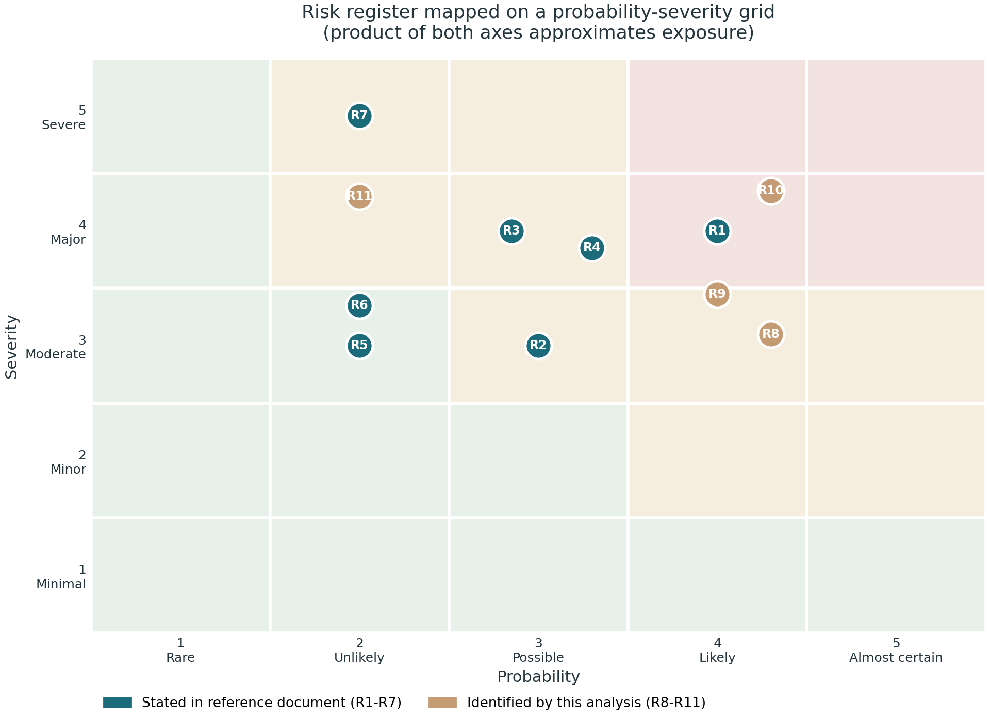
Figure 4: Risk register on a probability-severity grid; teal points are stated in the document, tan points are added by this analysis
Three feasibility strengths are worth recording so they are not lost in the criticism. The what-not-to-build list (no voice, no autonomous coding, no SSO, no Kubernetes, no fine-tuning, no agent swarms, no web-scale scraping) is a rare and valuable act of self-restraint that directly protects the timeline. The M1 milestone definition (fourteen verifiable behaviours of the evidence-grounded interview core) gives the team an unambiguous first done-gate. And the demo storyline (thirteen steps from an Arabic utterance to a debt dashboard) doubles as an integration test plan, which means the project can be demoed honestly at every stage rather than only at the end.

8. Consolidated Assessment and SWOT Synthesis
Bringing the four lenses together, the project scores 4.0 on strategic positioning, 4.0 on novelty and research gap, 4.0 on technical architecture, 4.5 on evaluation methodology, 3.0 on feasibility and schedule, and 5.0 on reference-document quality, for an overall 4.0 (Figure 5, Table 6). The profile is characteristic of a research-strong, delivery-tight plan: the two dimensions the team controls by writing (positioning, evaluation design, documentation) are excellent, while the dimension controlled by calendar arithmetic (feasibility) is the risk. The correct reading of the 3.0 is not that the plan is bad but that it has no redundancy: every strong outcome requires the median case to hold everywhere at once.
Table 6: Consolidated dimension scores
Dimension | Score | Principal strength | Principal weakness
Strategic positioning | 4.0 | Integration-first, honestly framed | Primary framing (A-D) not yet chosen
Novelty and research gap | 4.0 | N2 and N7 are defensible cores | Self-assessed matrix; no search protocol
Technical architecture | 4.0 | Determinism-first design; authority-aware retrieval | Context, concurrency, observability unspecified
Evaluation methodology | 4.5 | Strategies not models; full ablation map | No power analysis or IAA plan
Feasibility and schedule | 3.0 | Clear MVP and M1 gate | 26 weeks of work in 24; benchmark last
Reference-document quality | 5.0 | Comprehensive, honest, actionable | None material
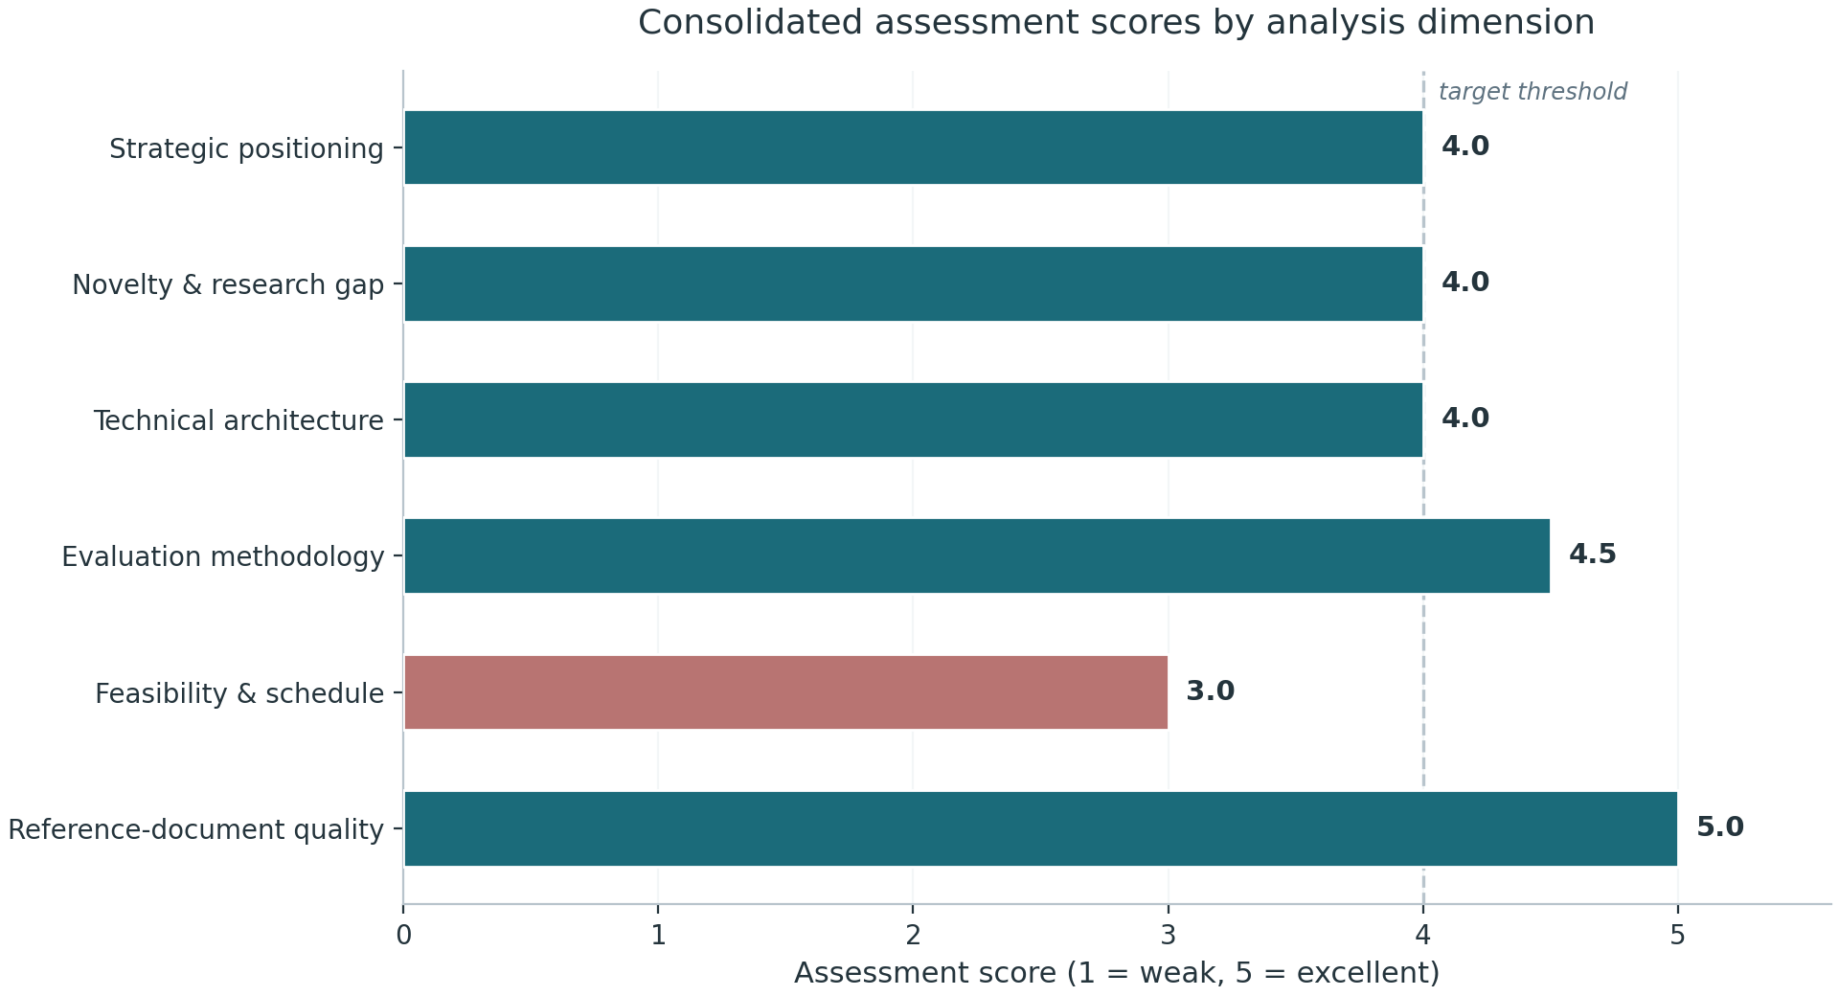
Figure 5: Consolidated assessment scores by analysis dimension
The SWOT synthesis in Table 7 makes the trade explicit. The strengths are real and rare at this level: an integration-first claim structure that survives scrutiny, an evaluation design with baselines, ablations, and an error taxonomy, a data model that makes the claims checkable, and authority-aware retrieval as a genuine engineering contribution. The weaknesses are equally concrete: unproven scoring weights, a benchmark that exists only as a plan, unspecified statistical mechanics, and a schedule without slack. The opportunities (a publishable Arabic benchmark, the MCP direction where coding agents query a validated requirements source of truth, and tool-integration demos) are all downstream of shipping the core. The threats are mostly exogenous (a crowded, fast-moving literature and LLM vendor instability) with one endogenous member: the temptation, in month 4, to widen scope instead of finishing.
Table 7: SWOT synthesis
Strengths | Weaknesses
• Integration-first positioning with explicit novelty discipline  • Evaluation compares strategies; ablations map to contributions  • Evidence-first data model with versioning and audit rules  • Authority-aware retrieval and eight hallucination controls  • Rare self-restraint: an explicit what-not-to-build list | • Question-utility weights are unjustified guesses pending ablation  • Benchmark and IAA exist only as plans; produced last  • No statistical power analysis or significance plan  • Context management, concurrency, observability unspecified  • Schedule has zero buffer at maximum durations
Opportunities | Threats
• Arabic code-switching benchmark is independently publishable  • MCP direction: coding agents query a validated requirements source  • Tool integrations (Jira, GitHub, Slack) as demo differentiators  • Benchmark release invites community follow-up and citations | • Fast-moving literature can overlap N2-N8 at any time  • LLM vendor or pricing changes destabilize experiments  • Scope temptation in month 4 (integrations before evidence)  • Single-owner critical path on the question planner
The synthesis also clarifies what kind of contribution this project can legitimately claim at graduation. It cannot claim a proven production system with validated scores, and the document never claims one. It can claim: a defensible architecture for evidence-grounded, human-in-the-loop requirements engineering; a measured comparison of interview strategies on a controlled benchmark; a released multi-language benchmark with documented annotation; and an honest error analysis. That package, delivered at evaluation quality, is a strong graduation project and a credible workshop or short paper. The failure mode to manage is not quality of thought but completion of evidence: every week that the benchmark slips converts a measurable claim into an anecdote.
One final cross-cutting observation: the document repeatedly makes the correct but unusual move of weakening its own claims (novelty warnings, provisional weights, thresholds as engineering choices). The thesis should preserve this voice. Committees trust measured statements with stated limitations more than strong statements with hidden ones, and the reference document already writes in exactly the register that examiners reward.

9. Recommendations and Action Plan
The recommendations follow directly from the four findings and are ordered by the deadline by which they stop being cheap. They are grouped into three horizons: immediately (weeks 1-2, before Phase 1 coding), in the medium term (months 2-4, while the core is being built), and in the late stage (months 5-6, when evaluation pressure peaks). Table 8 assigns each action an owner consistent with the document team division and an expected outcome.
Immediate horizon. First, freeze the research contract: select one primary framing from Configurations A-D, freeze RQ1-RQ7 wording, and write the descope ladder into the project charter so that later cuts are executed by rule rather than by fatigue. Second, write the one-page systematic-search protocol now (databases, query strings, inclusion and exclusion criteria, cutoff date) so the final novelty check is a method, not a memory. Third, produce the annotation guidelines and the statistical analysis plan together: the guidelines fix what a requirement, ambiguity, conflict, and evidence span are; the plan fixes sample sizes, seeds, the minimum detectable effects, the inter-annotator agreement target with double annotation on a sample, and the test to be used per research question. Fourth, start Track C permissions in week 1 if real conversations are wanted at all; Track A must be designed to stand alone. Fifth, write the five graph-query spikes against the relational schema before the frontend exists.
Medium horizon. Sixth, begin benchmark production in month 2 at a fixed cadence (for example, ten scenarios per week across the four language conditions) rather than as a month-5 block, so that by the end of month 4 at least 60-80 annotated scenarios exist and the evaluation phase consumes a finished asset. Seventh, run a pilot of the question-utility ablation on the first 20 scenarios: it will expose weight sensitivity, oracle-prompt fragility, and metric bugs while they are still cheap to fix, and it gives the thesis a preliminary-results section that committees read favourably. Eighth, co-assign a second owner to the question planner and put prompt versioning, structured logging, and per-run cost accounting into the LLM gateway in the same sprint it is built. Ninth, schedule the human evaluators in month 2 (students are easy; practitioners need notice), so the month-6 evaluation runs against booked calendars.
Late horizon and guardrails. Tenth, hold the line the document itself draws: nothing from the what-not-to-build list enters the project, and integrations (Jira, GitHub, Slack, MCP) are demo videos, not features, until the benchmark evaluation is complete. Eleventh, apply the descope ladder in order if time compresses: cut N9 time travel, then N8 change-impact depth (retain a read-only impact view), then N5 debt calibration, then reduce benchmark scale to 60 scenarios with unchanged annotation quality; never cut the question planner, the evidence model, or the evaluation itself. Twelfth, target the publication realistically: the Arabic benchmark plus the strategy comparison is a strong resource or short paper; a full architecture paper needs the ablation results and should be written after the thesis defense, not during the last month.
The action plan requires no additional resources beyond what the document already assumes; its cost is almost entirely sequencing. If only three of the twelve actions are taken, they should be the frozen research contract, benchmark production from month 2, and the statistical analysis plan, because those three convert every other part of the plan from intention into evidence.
Table 8: Prioritized action plan
# | Horizon | Action | Owner | Expected outcome
1 | Weeks 1-2 | Freeze framing (A-D), RQ wording, and descope ladder | All | Stable research contract; rule-based cuts
2 | Weeks 1-2 | Write systematic-search protocol (queries, criteria, cutoff) | Member 1 | Novelty check becomes a method
3 | Weeks 1-2 | Annotation guidelines + statistical analysis plan (power, seeds, IAA target) | Members 1-2 | Defensible labels and tests
4 | Weeks 1-2 | Request Track C permissions; design Track A to stand alone | Member 2 | Ethics risk retired early
5 | Weeks 1-3 | Graph-query spikes against relational schema | Member 3 | No late-stage graph rework
6 | Month 2 on | Benchmark production cadence (10 scenarios/week, 4 conditions) | Member 2 + all | 60-80 scenarios ready by month 4
7 | Month 3 | Pilot utility ablation on first 20 scenarios | Member 1 | Weights validated; metrics debugged
8 | Month 3 | Co-assign planner; add prompt versioning, logging, cost accounting | Members 1+3 | De-risked critical path
9 | Month 2 | Book human evaluators (students and practitioners) | Member 4 | Evaluation runs on real calendars
10 | Months 5-6 | Hold what-not-to-build list; integrations as demo videos only | All | Scope protected at the endgame
11 | As needed | Descope ladder: N9, then N8 depth, then N5 calibration, then benchmark scale | Supervisor + all | Quality preserved under compression
12 | Month 6 | Publication: benchmark + strategy comparison as resource/short paper | Members 1-2 | Citable artifact after defense

10. Proposed Thesis Skeleton
The reference document contains almost all the raw material a thesis needs, but in blueprint order rather than argument order. The skeleton in Table 9 re-sequences that material into six chapters that follow the standard requirements-engineering thesis arc: problem, related work, design, evaluation, results, and conclusion. The mapping is conservative: every chapter can be written from existing document sections, which means the writing plan adds no new research work, it only reorders and deepens what exists.
Three writing notes accompany the skeleton. Chapter 2 should be written from the literature matrix plus the search protocol from Action 2, and should end with the document's own Section 93 gap statement, which is already correctly worded and defensible. Chapter 3 should lead with the single most important rule (never let the LLM silently fill a requirements gap) and derive the architecture from it, so that design decisions read as consequences of a principle rather than a list of components. Chapter 4 should present the benchmark construction as a method contribution in its own right, with the annotation guidelines, agreement statistics, and language-condition design, because that chapter is what makes the thesis citable independently of the system results.
The estimated body length is 70-90 pages at standard formatting, dominated by Chapter 4 (benchmark and method) and Chapter 5 (results and analysis). If the thesis must be shortened, the correct victims are Chapters 3 detail sections (prompt contracts can move to an appendix) and the N5, N9 feature descriptions; the benchmark chapter and the strategy-comparison results should never be compressed, because they are the evidence everything else refers to.
Table 9: Six-chapter thesis skeleton mapped from the reference document
Ch. | Title | Content drawn from reference sections | Est. pages
1 | Introduction | Sections 0-1, 15 (problem, positioning, formal problem statement, human role) | 8-10
2 | Background and related work | Sections 2-3, 100-103 (benchmark of eight systems, gap statement, search protocol) | 12-14
3 | System design | Sections 4-13, 16-38, 50-65 (contributions, architecture, data model, prompt contracts, retrieval) | 18-22
4 | Benchmark and evaluation design | Sections 39-49, 66-68, 84-85 (RQs, baselines, dataset tracks, annotation, ablations, error taxonomy) | 14-18
5 | Results and analysis | Phases 8 outputs; baseline report template, ablation results, human evaluation, Arabic comparison | 12-16
6 | Conclusion and future work | Sections 86-89, 93-96, 102-111 (limitations, MCP direction, threat-to-validity) | 6-8

11. Concluding Assessment
RequirementPilot is, on the evidence of its reference document, an exceptionally well-prepared graduation project: honest about the literature, precise about its mechanisms, disciplined about evaluation, and explicit about what it will not build. The analysis finds no structural flaw that would justify redirecting the project. Its two core contributions, impact-aware question selection and an Egyptian Arabic code-switching benchmark, are defensible, complementary, and matched to a four-person team; its architecture is conservative in the right places and original where it counts; and its evaluation design compares system strategies with a completeness that the final thesis can inherit almost verbatim.
The project risks are concentrated, not diffuse: schedule arithmetic with no buffer, a benchmark scheduled too late, statistical mechanics not yet specified, and a critical path with a single owner. All four are management problems with known solutions, and Chapter 9 provides them. The conditions attached to the go recommendation in Chapter 1 are therefore not reservations about the idea but a delivery contract for it: freeze the research contract, move the benchmark forward, define the statistics now, and protect the core by ladder when time compresses.
If the team holds the standard its own document sets, the single-sentence rule that no requirement gap is ever silently filled by a model, and applies the same discipline to its own project plan (no gap silently filled by optimism), the result should be a graduation project that is not only accepted with distinction but also leaves behind a citable benchmark and a replication-ready evaluation harness. That is a realistic outcome, and it is the right one to aim for.

