Task 3

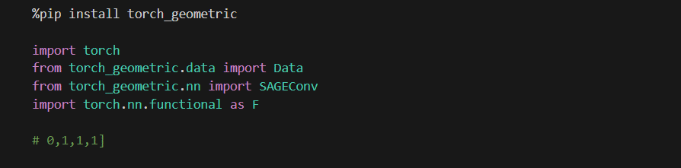
This cell installs torch_geometric library and imports the required modules. The torch library provides basic operations, Data stores the graph structure, SAGEConv implements GraphSAGE layers, and F provides activation functions.

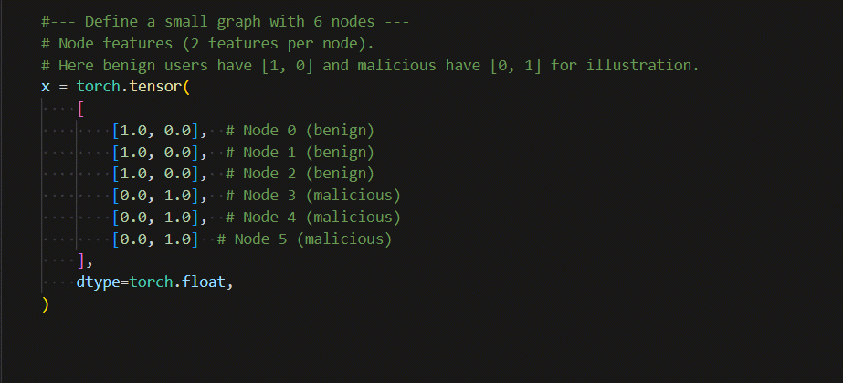
This cell creates features for 6 nodes in the graph. Benign users are represented with features [1.0, 0.0] while malicious users have [0.0, 1.0]. The graph contains 3 benign nodes (0, 1, 2) and 3 malicious nodes (3, 4, 5). Each node has 2 features.

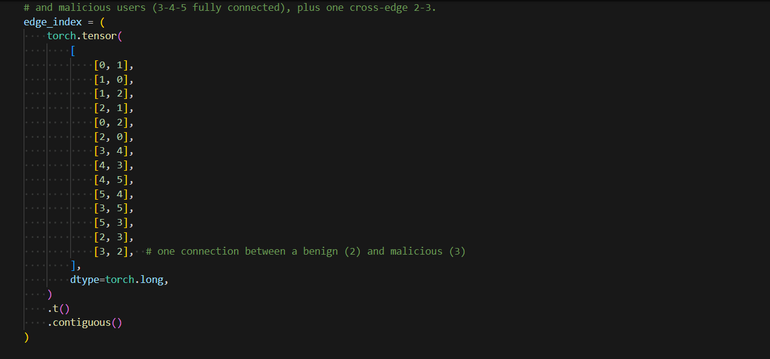
This cell defines the edges between nodes. The benign users (0, 1, 2) are fully connected to each other, and malicious users (3, 4, 5) are also fully connected. There is one connection between node 2 and node 3 linking the two groups. All edges are bidirectional.

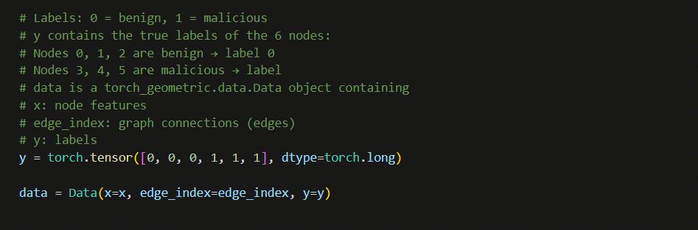

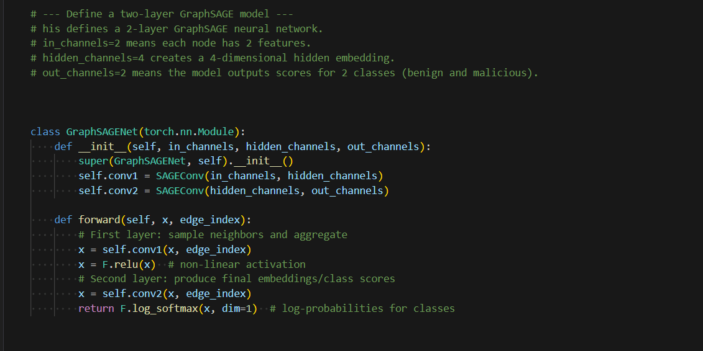
This cell creates the labels where 0 represents benign users and 1 represents malicious users. All components (features, edges, labels) are combined into a Data object. The GraphSAGE model class is defined with two layers: first layer processes 2 input features to 4 hidden features, second layer outputs 2 class scores.

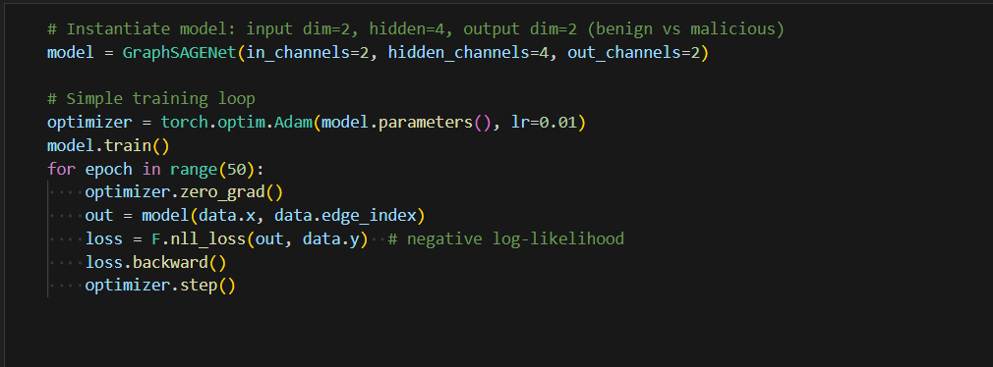
This cell initializes the model and trains it for 50 epochs. During each epoch, the model processes the graph, calculates predictions, computes loss, and updates weights. Adam optimizer is used with learning rate 0.01.

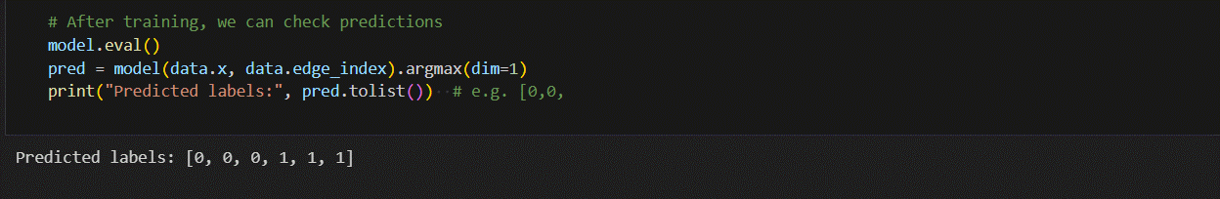
This cell evaluates the trained model. The output [0, 0, 0, 1, 1, 1] shows perfect classification - correctly identifying the first three nodes as benign and last three as malicious.

