This is the dream computer of all the gamers want
Firstly we start of the hard drive
The best hard drive of gaming right now is…………
Seagate BarraCuda Internal Hard Drive
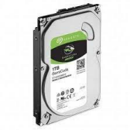
With Capacity equal 1 tera bite
& RPM speed equal 7200

● Store more, compute faster, and do it confidently with the proven reliability of BarraCuda internal hard drives
● Build a powerhouse gaming computer or desktop setup with a variety of capacities and form factors
● The go to SATA hard drive solution for nearly every PC application—from music to video to photo editing to PC gaming
● Confidently rely on internal hard drive technology backed by 20 years of innovation
With the best price of……
1325 EGP.

Secondly we see the best CPU for gaming
The best CPU for gaming right now is…………
Intel Core i5-13400
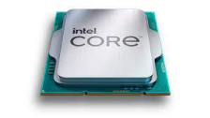
● 10 cores (6 P-cores + 4 E-cores) and 16 threads. Integrated Intel UHD Graphics 770 included
● Performance hybrid architecture integrates two core microarchitectures, prioritizing and distributing workloads to optimize performance
● Up to 4.6 GHz. 20M Cache
● Compatible with Intel 600 series and 700 series chipset-based motherboards ● Turbo Boost Max Technology 3.0, and PCIe 5.0 & 4.0 support. Intel Optane Memory support. Intel Laminar RH1 Cooler included
●
With the best price of……
6,834.35 EGP.
Then we continue with the best memory card(RAM).
The best RAM for gaming right now is ………
DDR5 RAM
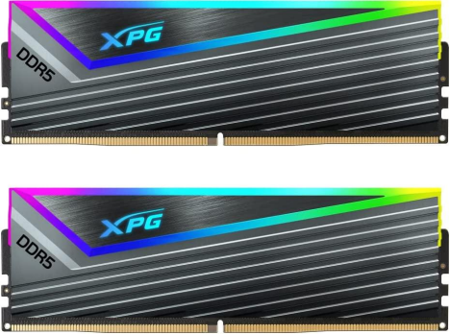● DDR5 High-Speed Performance - Running at 7000 MT/s, the XPG CASTER RGB is a new breed of DDR5 that's over two times faster than your standard DDR4 memory ● Futuristic Flair - With its steel gray heat sink, bold triangular RGB light, and streamlined
shape, the XPG CASTER RGB exudes a sense of high performance and futuristic styling ● RGB Your Way - Set the RGB lighting the way you want it. Choose from different effects (static, breathing, and comet) or sync the lights with your favorite jams via Music Mode ● Performance You can Rely On - The XPG CASTER RGB is equipped with built-in On-Die EEC for real-time error correction and Power Management Integrated Circuits (PMIC) for enhanced stability and reliability
● Overclocking Made Easy - With support for Intel XMP 3.0, get overclocking easily without the need to hassle with BIOS settings. There is no need to repeatedly adjust and fine-tune overclocking parameters
With the best price of………
12,500 EGP.
And we complete with the best memory card for gaming Right now is………
Nvidia GeForce RTX 4070 Ti
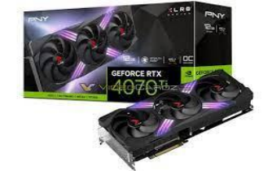
● Powered by NVIDIA DLSS 3, ultra-efficient Ada Lovelace arch, and full ray tracing ● NVIDIA Ada Lovelace, with 2310MHz core clock and 2610MHz boost clock speeds to help meet the needs of demanding games
● 12GB GDDR6X (192-bit) on-board memory, plus 7680 CUDA processing cores and up to 504GB/sec of memory bandwidth provide the memory needed to create striking visual realism.
● PCI Express 4.0 interface - Offers compatibility with a range of systems. Also includes DisplayPort and HDMI outputs for expanded connectivity.
● NVIDIA GeForce Experience - Capture and share videos, screenshots, and livestreams with friends. Keep your drivers up to date and optimize your game settings. It's the essential companion to your GeForce graphics card.
With the best price of………
25,407 EGP.

And the best case for computer gaming right now is

Corsair Obsidian Series 1000D Super-Tower Case
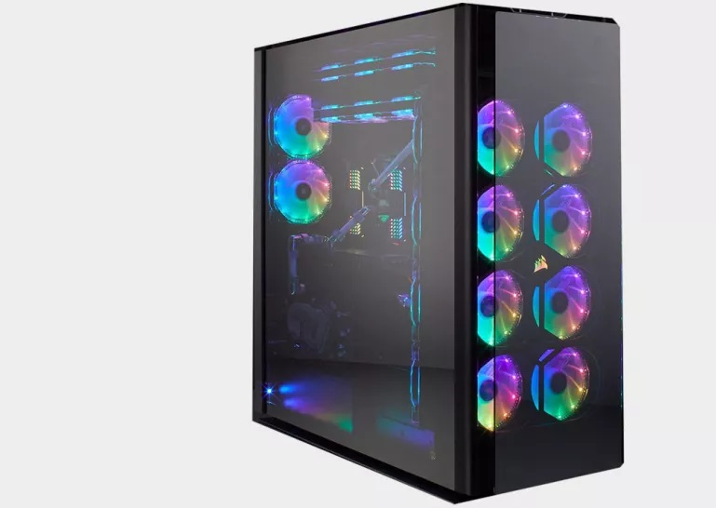

About this item
- THE ULTIMATE SUPER-TOWER PC CASE: Iconic and clean exterior lines, four smoked tempered glass panels and seamlessly integrated RGB lighting make the Obsidian 1000D the best-looking Obsidian Series case yet.
- STREAM AND GAME SIMULTANEOUSLY: The Obsidian 1000D can fit both a complete E-ATX and Mini-ITX system concurrently, so you can stream and game smoothly from one enclosure. Two motherboards, two power supplies, two full PCs in one case.
- MASSIVE COOLING OPTIONS: Up to 18 fan mounts and room for up to four 480mm radiators simultaneously.
- DIMENSIONS: 12.1" W x 27.3" L x 27.4" H
- BUILT-IN SMART LIGHTING AND FAN CONTROL: An integrated CORSAIR Commander PRO fan and lighting controller grants superior control over almost every aspect of your system via CORSAIR iCUE software.
- TRIPLE-CHAMBER DESIGN: Keeping a 1000D PC build tidy is effortless with the included French-door-style rear storage compartment, E-ATX motherboard and dual-purpose Mini-ITX motherboard tray and PSU cover.
- FUTURE-PROOF FRONT PANEL: An RGB LED lit front panel includes two USB 3.1 Gen-2 Type-C ports alongside four USB 3.0 ports, for future-proof and backward
And finally we end up with the best motherboard
For gaming right now is……….
LGA1700 motherboard

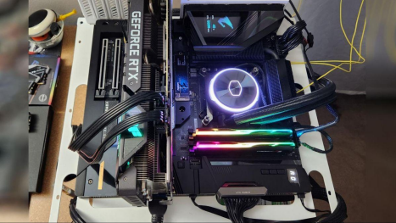● Intel LGA 1700 Socket: Supports 12th Gen Intel Core Series Processors ● DDR4 Compatible: Dual Channel Non-ECC Unbuffered DDR4
● Commanding Power Design: 16 plus1 plus2 Digital VRM Design with 70A Power Stage with Tantalum Polymer Capacitors
● Cutting-Edge Thermal Design: Fully Covered Thermal Design and High Coverage MOSFET Heatsinks, Enlarged Thermal Guards
● Next Gen Connectivity: PCIe 5.0. Quad NVMe PCIe 4.0 x4 M.2, SuperSpeed USB 3.2 Gen 2x2 Type-C
● Fast Networking: 2.5 GbE LAN, WiFi 6 802.11ax, BT5
● Dynamic Audio: Amp-Up Audio with ALC4080 and WIMA Audio Capacitors ● Fine Tuning Features: RGB FUSION 2.0, Supports Addressable LED & RGB LED Strips, Smart Fan 6, Q-Flash Plus Update BIOS without installing CPU, Memory, and GPU ● Only Compatible with Intel LGA1700 Cooling Brackets
With the best price of……..
12,499 EGP.

