**Library Management System (LMS) – (SRS)+Digrams**

**1. Specific Requirements**

**1.1 User Requirements**

**1.1.1 Search for Books**

* Users can search for books by entering title, author, genre, or ISBN in a search bar.
* The search should be case-insensitive and handle partial matches.
* The search results should display a list of books with basic information (title, author, genre).
* Clicking on a book title should display detailed information about the book.

**1.1.2 View Book Details**

* The detailed book view should display information like title, author, genre, ISBN, publication year, description, average rating, and potentially availability status.
* The system should display an appropriate message if a searched book is not found.

**1.1.3 User Account Management (Optional)**

* Users can view their account information, including username, email address, and potentially registration date.
* Users can view their checkout history, including a list of borrowed books and their due dates.

**1.2 Admin Requirements**

**1.2.1 Login**

* Admins can log in to the system using a username and password.
* The system should implement secure password hashing and storage.
* The system should display an error message for invalid login credentials.

**1.2.2 Logout**

* Admins can log out of the system to terminate their session.

**1.2.3 Book Management**

* Admins can add new books to the system by entering title, author, genre, ISBN, publication year, and description. Optionally, they can upload a cover image.
* Admins can edit information for existing books.
* Admins can delete books from the system with a confirmation prompt.

**1.2.4 User Management**

* Admins can view a list of all registered users.
* Admins can approve new user registrations (potentially, depending on workflow).
* Admins can edit user information (username, email address) and reset passwords.
* Admins can delete user accounts with a confirmation prompt (excluding the admin account)

**1.2.5 Book Ratings Management**

* Admins can view all book ratings submitted by users.
* The functionality for managing book ratings (editing or deleting) needs to be defined during project planning. The SRS will be updated based on the chosen functionalities.
  + **Option 1: View-only Ratings:** Admins can only view book ratings but cannot edit or delete them.
  + **Option 2: Edit/Delete Ratings:** Admins can view, edit, and delete book ratings submitted by users.
* Admins can potentially add book ratings for sample data or managing user ratings (functionality to be defined).

**2 System Requirements**

**2.1 Performance**

* The system should respond to user actions promptly, especially for search functionalities.
* Search results should be displayed within a reasonable timeframe.

**2.2 Security**

* The system should implement secure password hashing and storage mechanisms to protect user passwords.
* User authentication and authorization should be enforced to restrict access based on user roles (user vs. admin).
* Secure session management techniques should be used to prevent unauthorized access after successful login.

**2.3 Usability**

* The user interface (UI) should be intuitive and user-friendly for users with varying technical skills.
* The UI should be well-organized and easy to navigate.
* Error messages should be clear and informative, guiding users to resolve issues.

1-Use case diagram

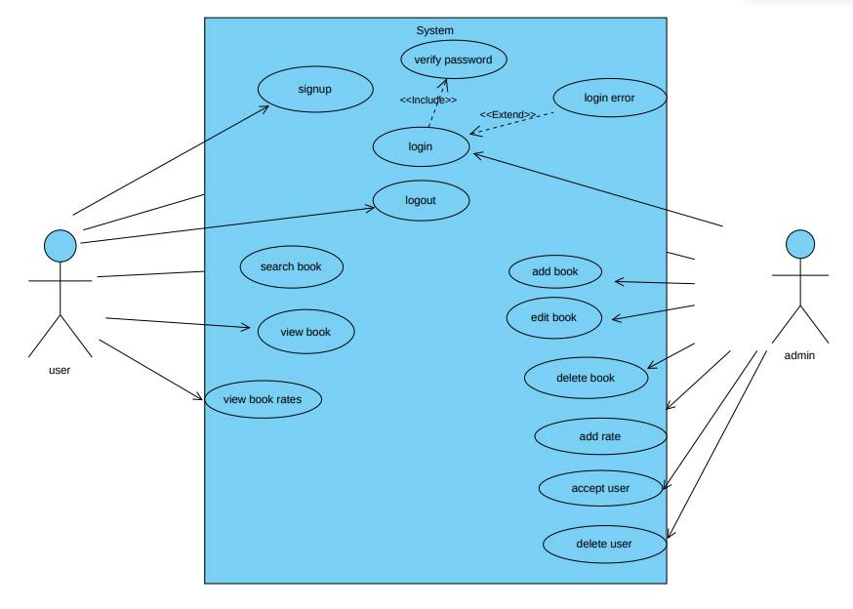

2- Class Diagram 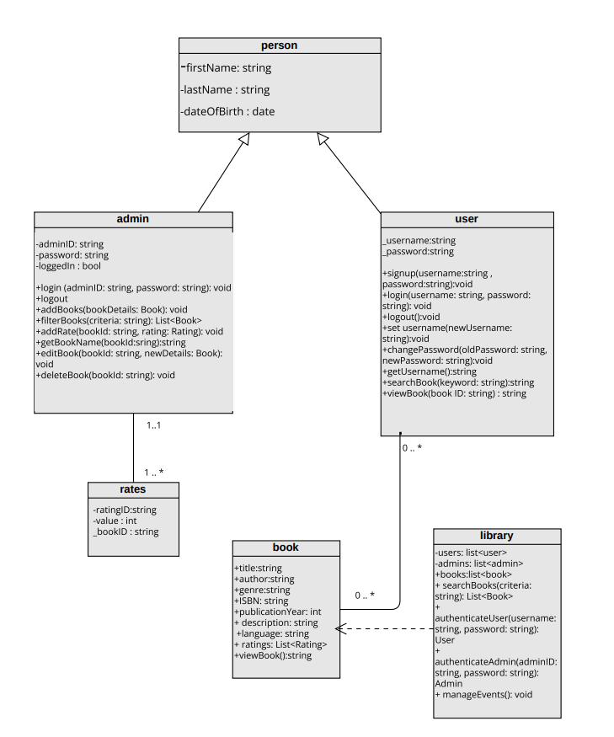

3-OCL Constrains

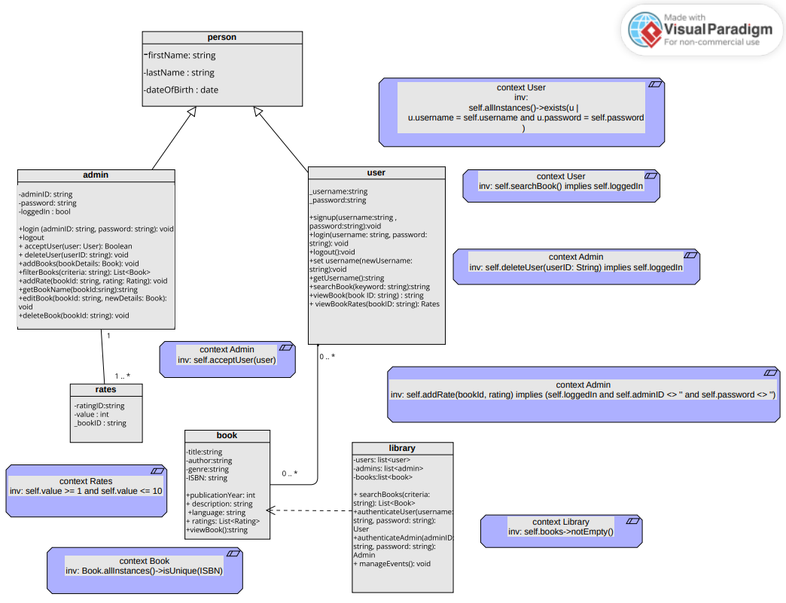

4-Activity Diagram

Login:

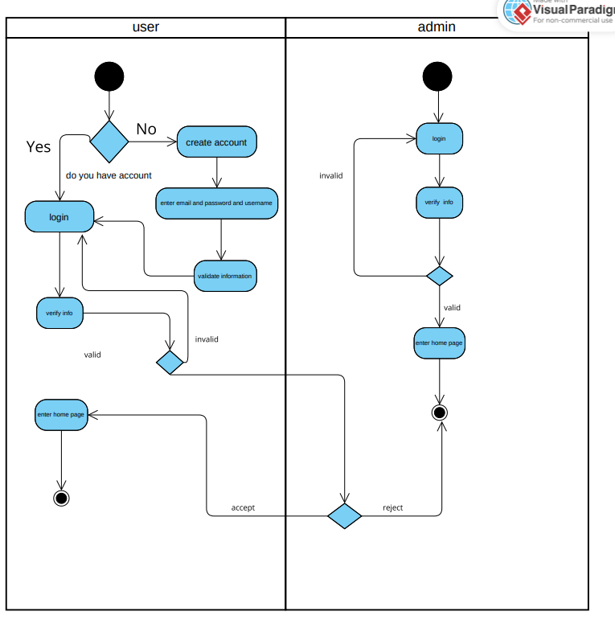

Home page: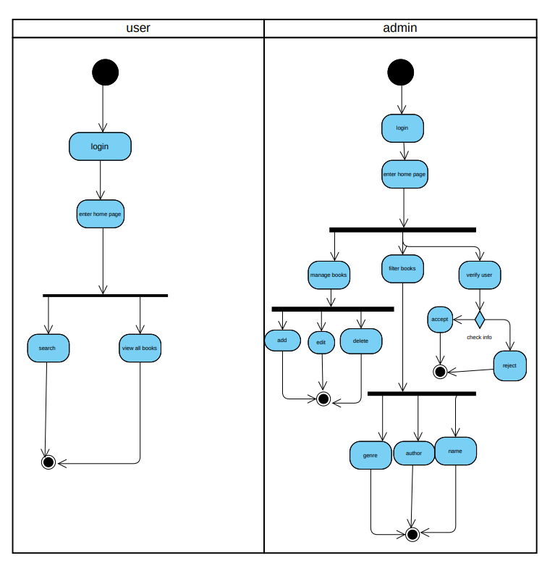

Search by author/book name:

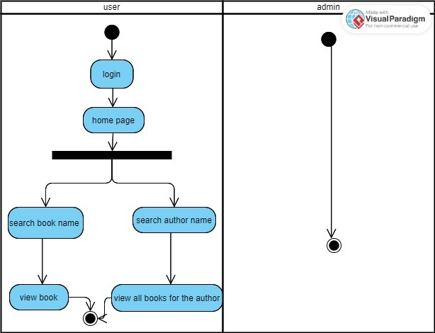

Book rate:  
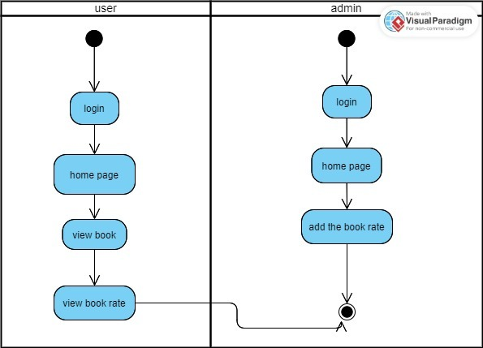

Add book to favorite:  
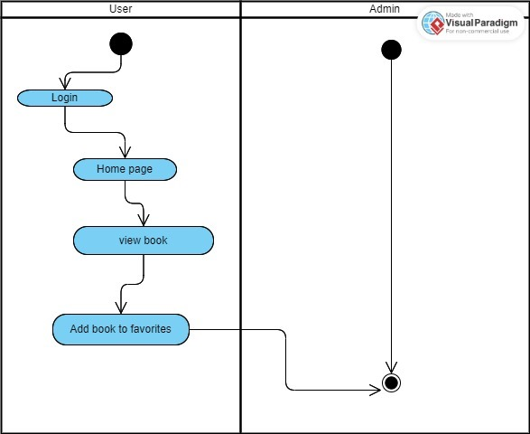

5-ERD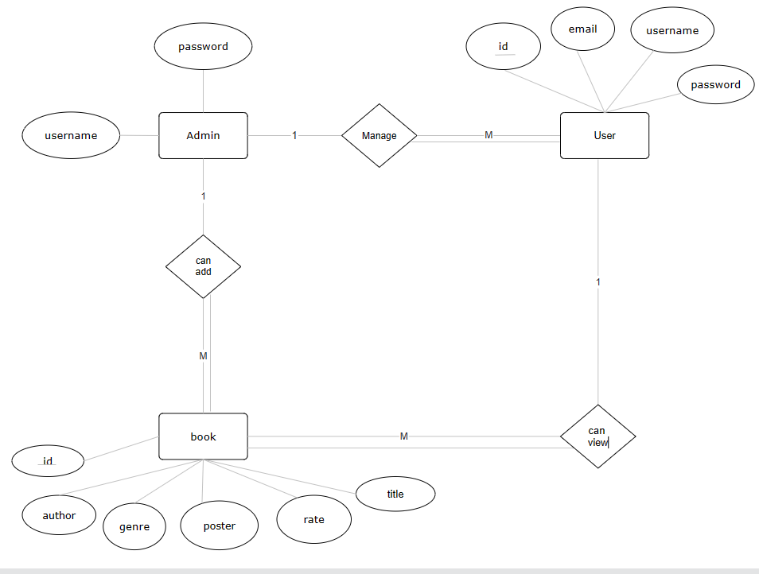

6-Sequence Diagram

Login: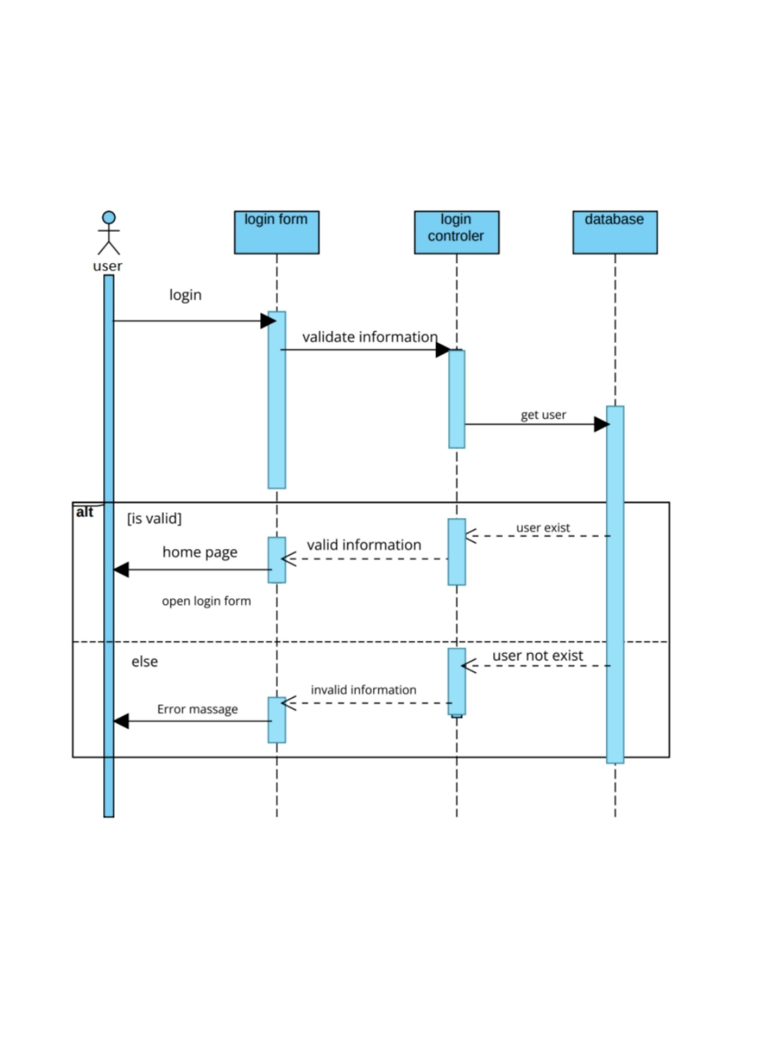create account:  
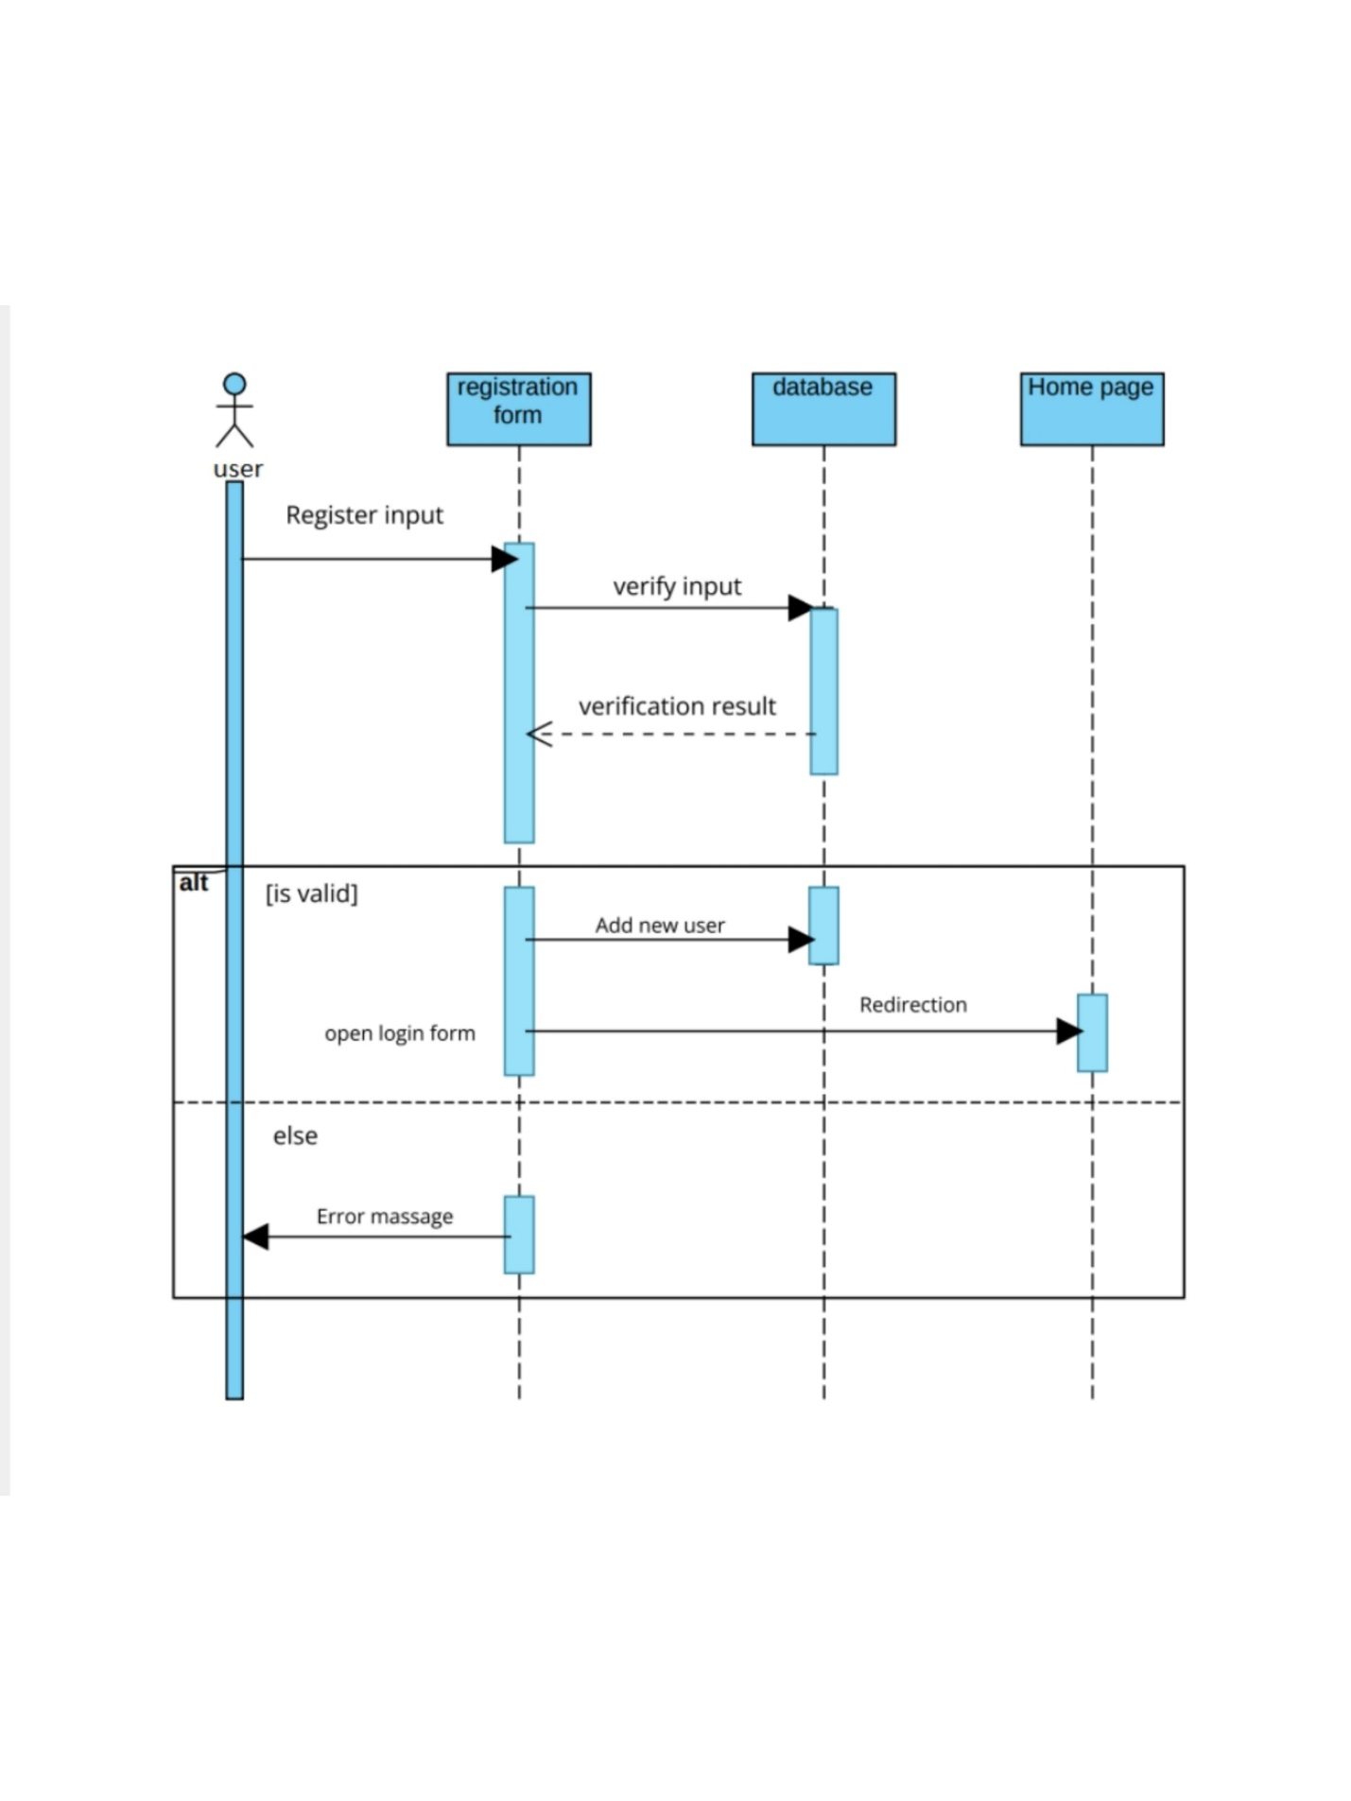delete profile:  
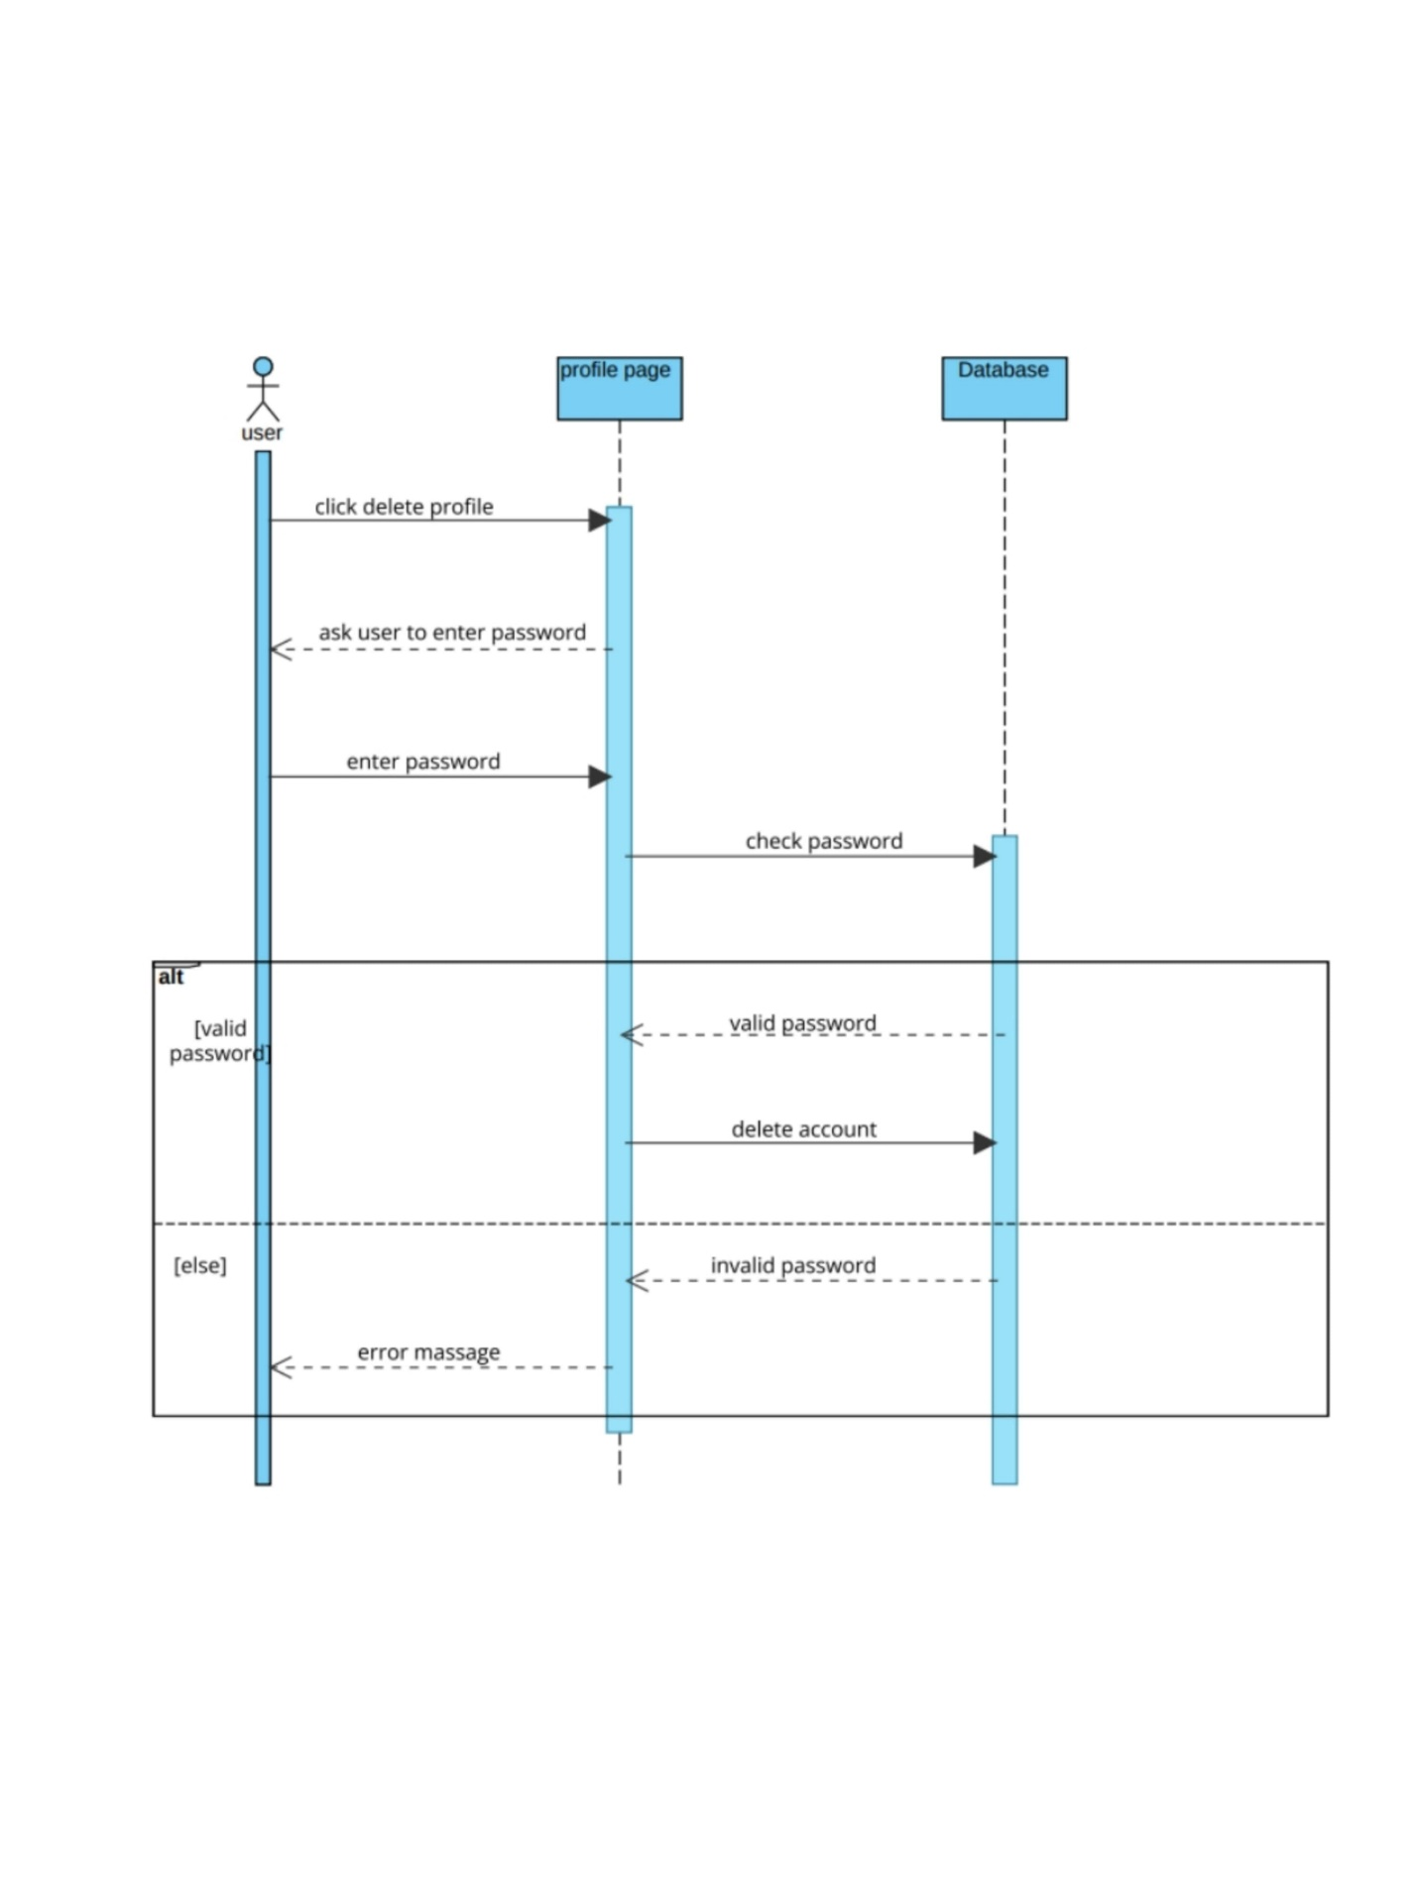view book:  
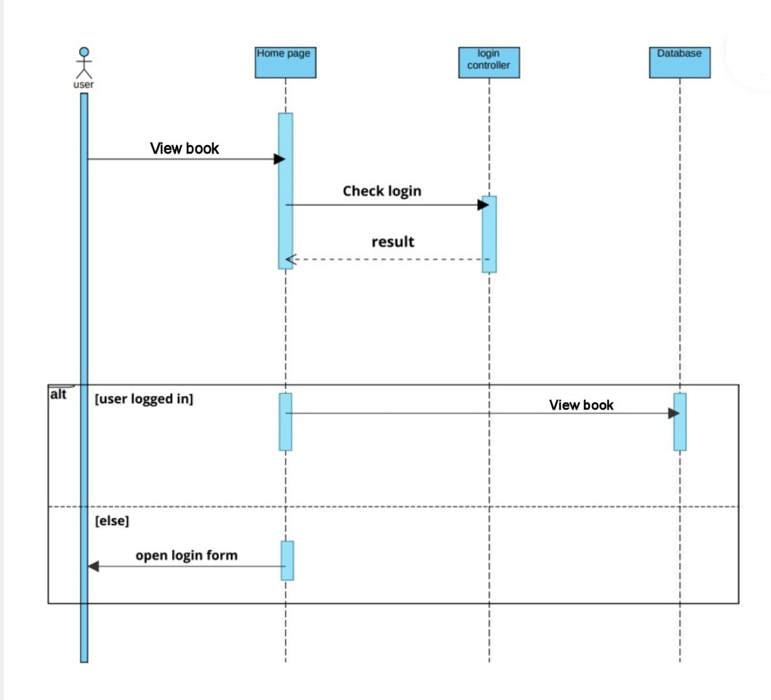

Search:  
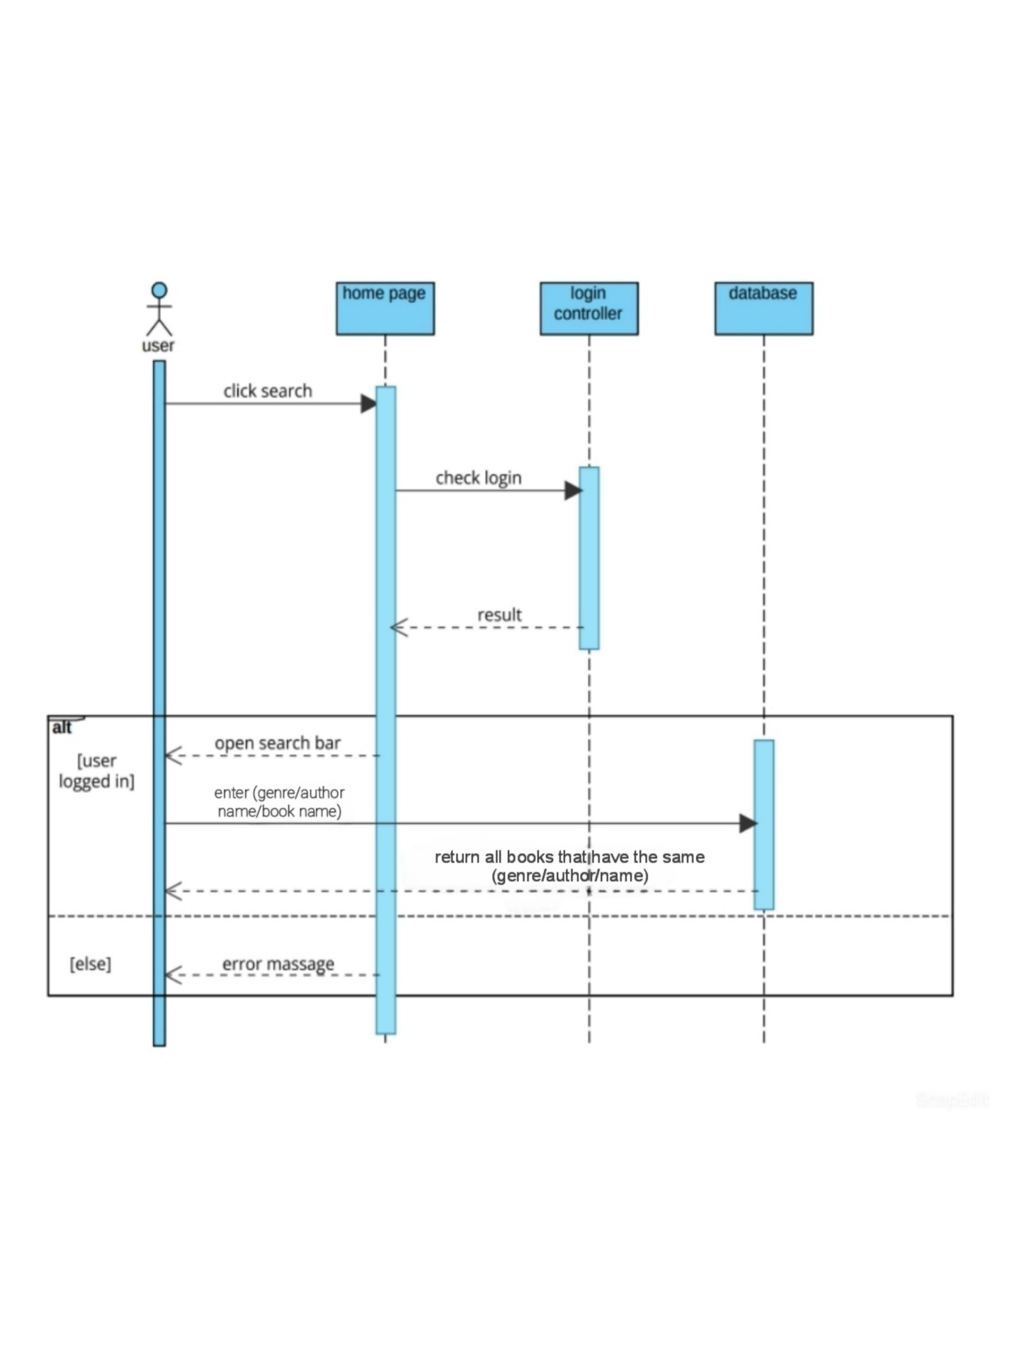

Add book to favorite:  
