1-actions u can make an action be sperated every one in a button or u can collect them in a ActionGroup

2-

This function will put the value we write on name in the slug on blur the field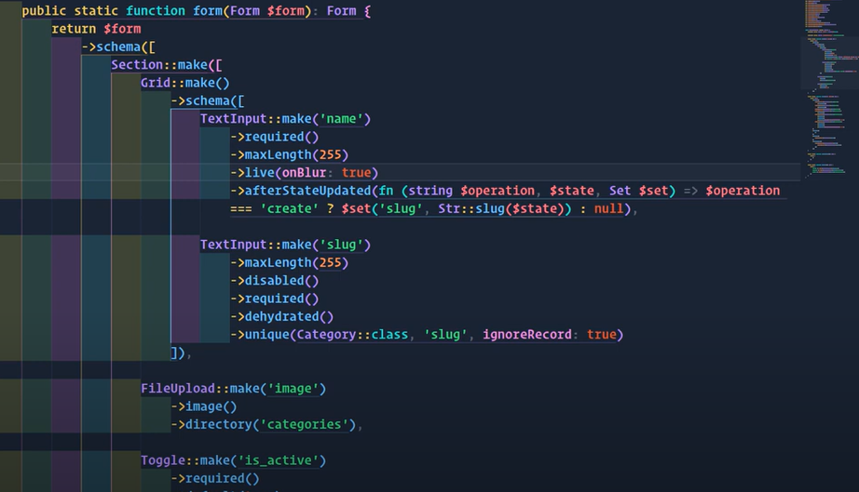

3-

This contain the col in table but I control display it or not

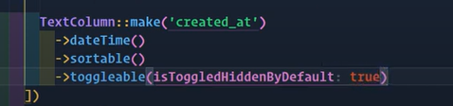

4- video 5 26:

5-

This make the color change on codition

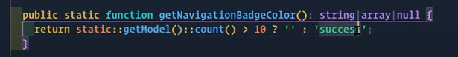

6-

Video 6 including a form of model inside page of another model

7-

Video7 widgets and tabs