Names | IDs
Ahmed Hesham Abdel-Razzak | 19015378
Abdel-Rahman Ibrahim Abdel-Halim Saad | 19015880
Hassan Ali Hassan | 19015603

Lab 1
Face Recognition

1. Download Data
steps:
1. we download the data form Kaggle website as zip file
2. we upload the data to drive to access it from kaggle to read the data
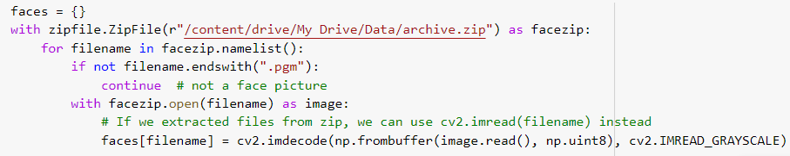
2. Generate the Data Matrix and Label Vector
steps:
1. we read the data using cv2 and turn each image to a gray scale and turn it to an numpy array
2. we spread the data of all the images and reshape the data to 400(#images) * 10304 (#features)
3. we get the label for each image by extracting it from the folder of each image
4. we save the whole data in a dataframe of shape (400(#images) * 10305 (#feature + label)
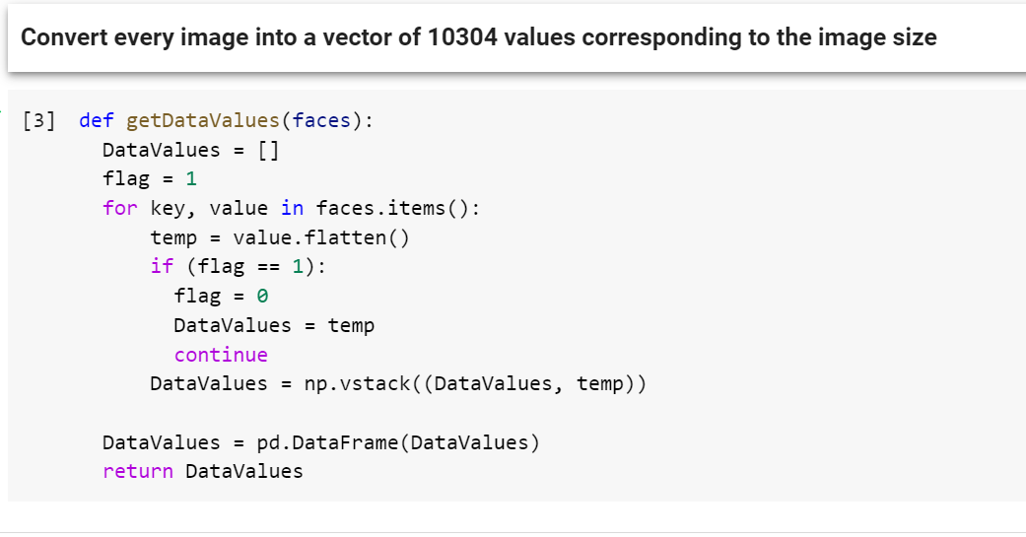
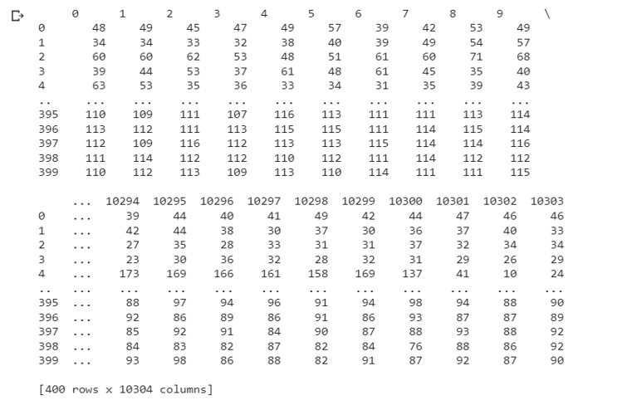

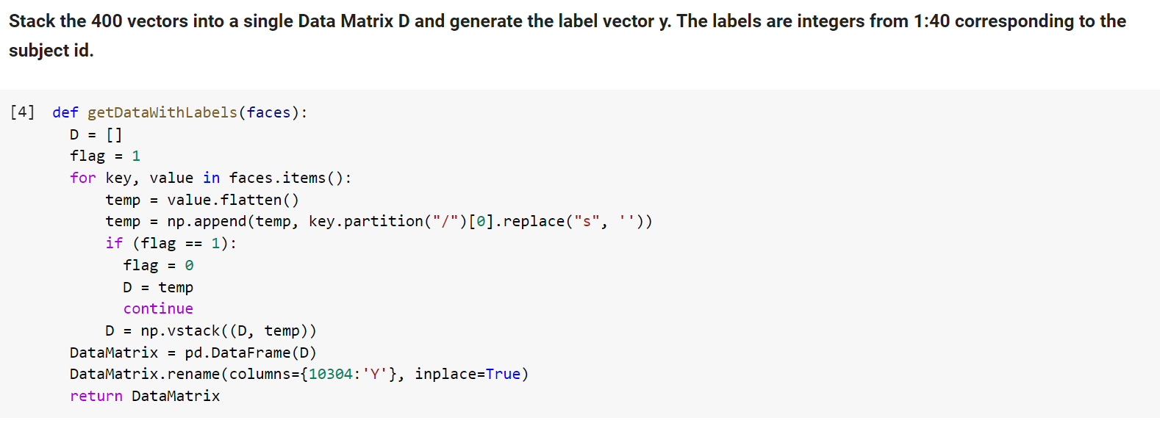
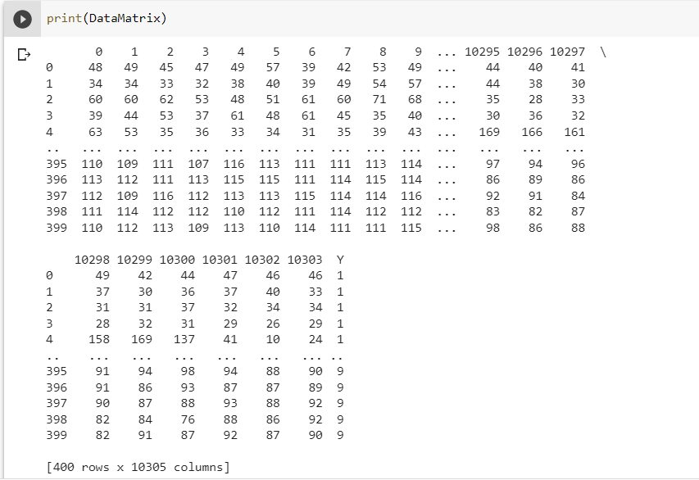

3. Split the data
steps:
1. we split the data by half(each half contains the half of each class images):
the odd half is for training
the even half is for testing

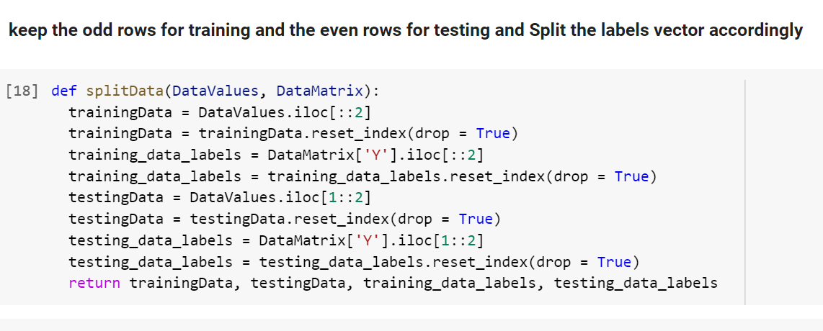

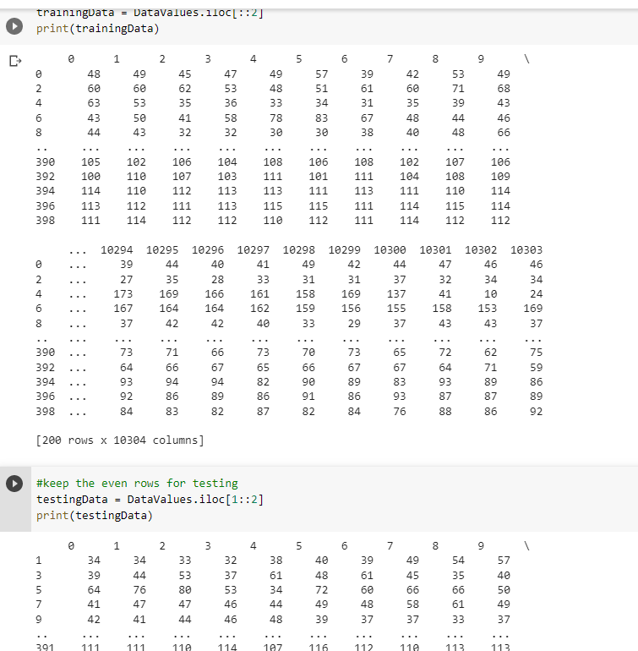

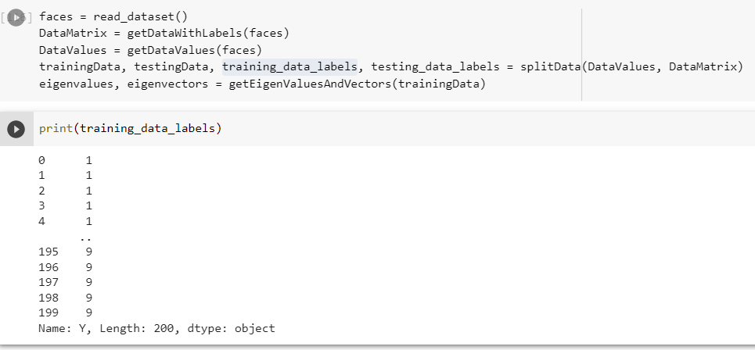
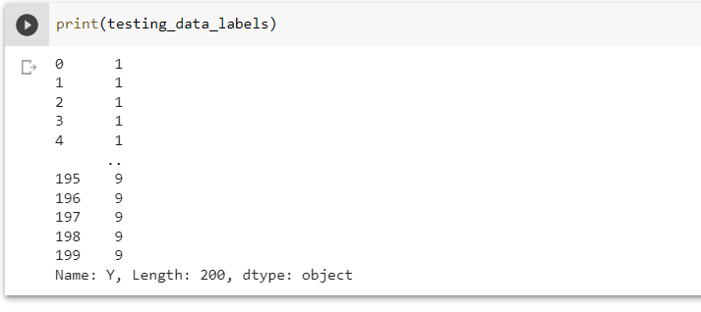

4.Classification using PCA

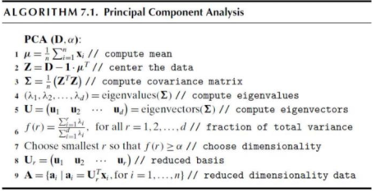

steps(we follow the previous algorithm):
1. we calculate the mean of each feature in the data
2. we centralize the data be subtracting the mean from the whole data
3. we compute the Co-variance matrix by multiply the centralized data matrix with its transpose
4. we get the eigenvalues and eigenvectors of the co-variance matrix
5. using F function we choose the suitable number of eigenvectors to project the data on them
6. using the new basis we get the new data by project the old data on this basis

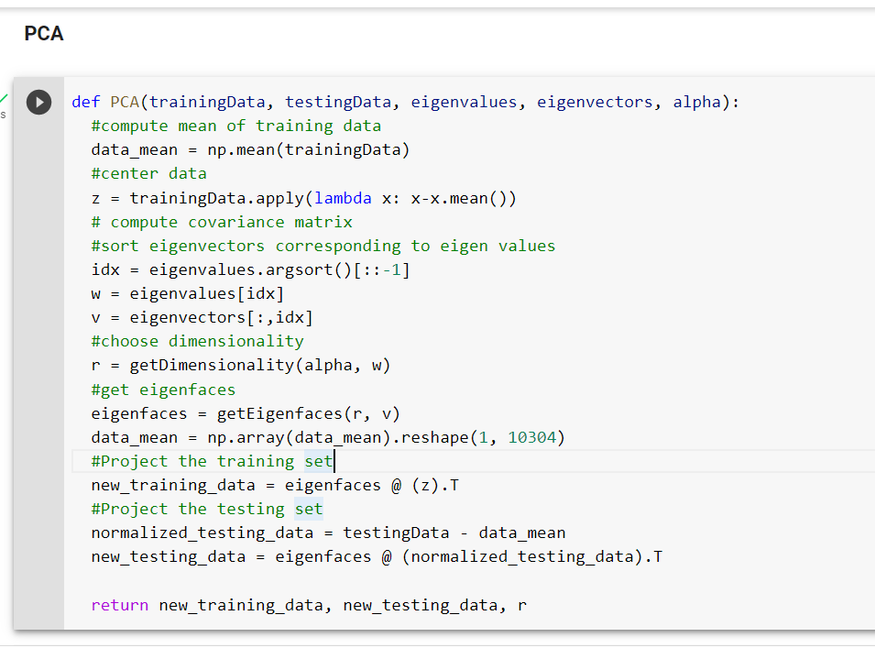
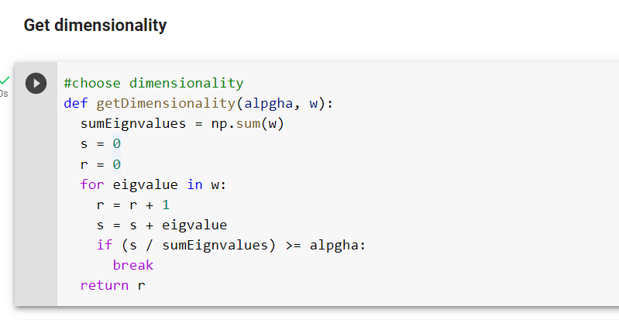
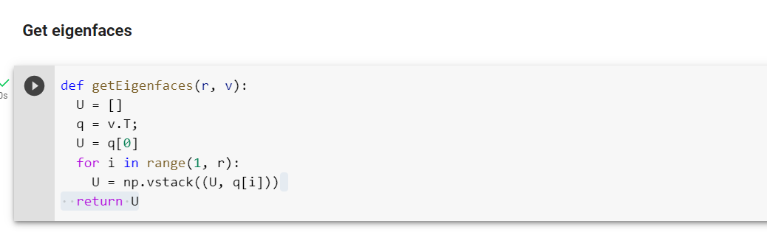
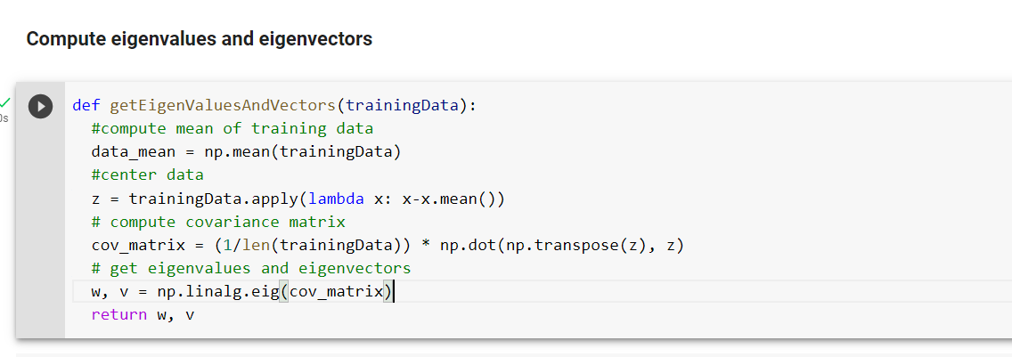
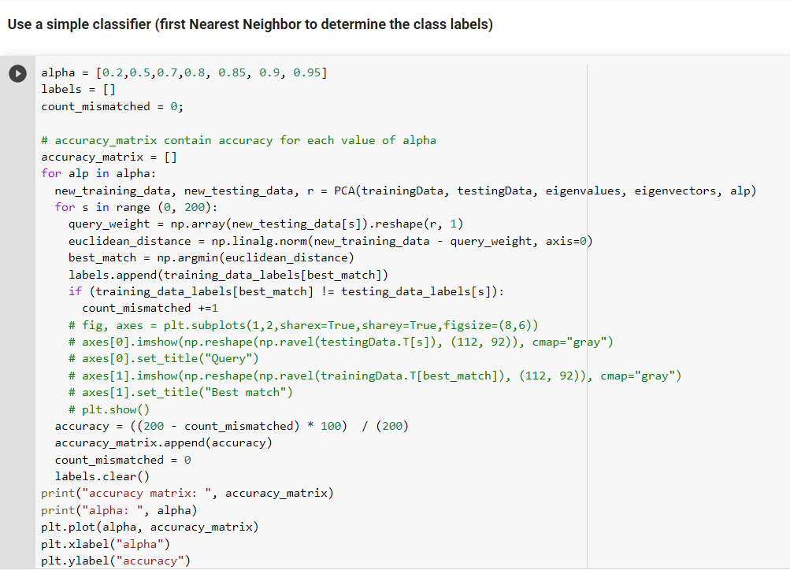

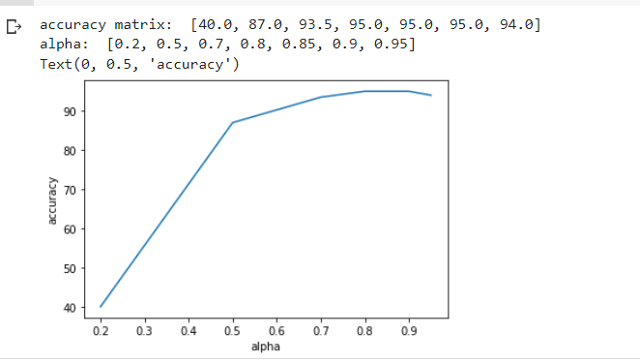

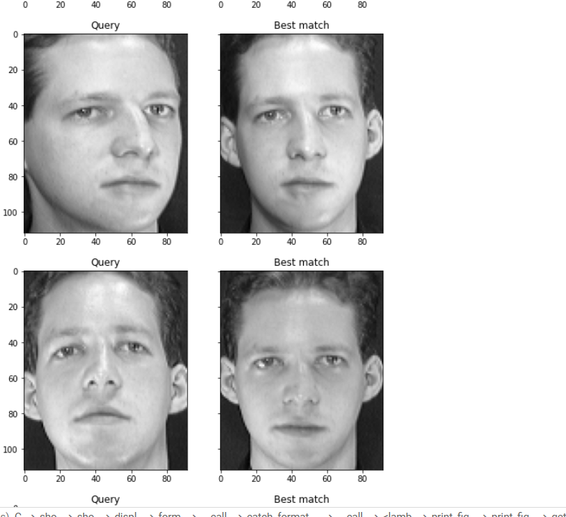

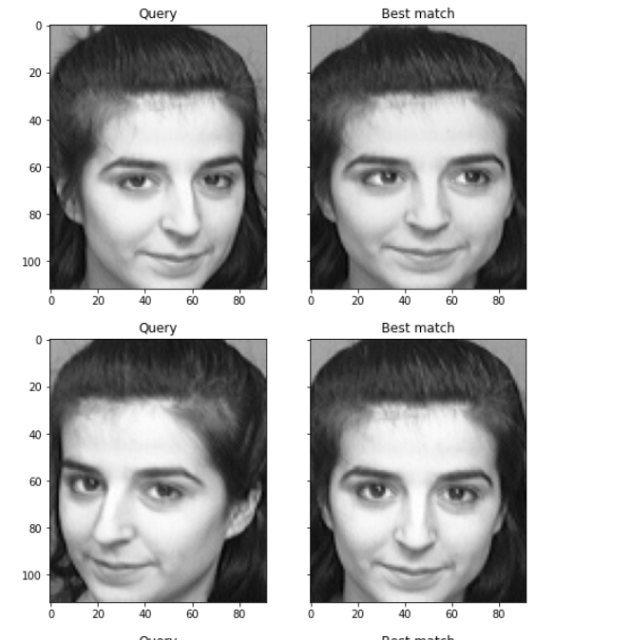
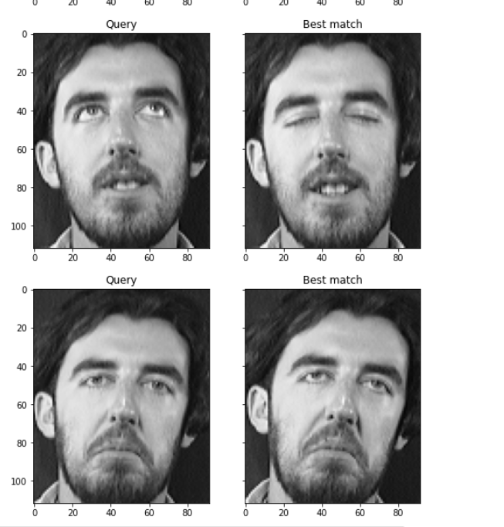

classification steps:
1. we built a KNN model with n-neighbors =
2. we train the model with the train data after reducing its dimensions
3. we test the model accuracy using the test data after reducing its dimensions
the model gave us the accuracy =

5. Classification using LDA
steps for LDA:
1. we calculate the mean of each class (we have 40 class)
2. we calculate the overall mean for whole data
3. we get the between class scatter matrix(sb) by multiply the 33difference matrix(matrix of the class mean – the overall mean)
4. we get within scatter matrix by getting the sum of scatter matrix for each class (S = S1 + S2+ ….S40)
5. to obtains the eigenvalues and eigenvectors we first calculate the inverse of within scatter matrix(S-1) then multiply it by Sb
6. from the previous matrix we get the eigenvalues and eigenvectors and order them according to descendingly according to the eigenvalues
7. getting the new basis that consisting of the first 39 eigenvectors corresponding to the biggest 39 eigenvalues
8. we reduce our data dimension by project train and test data on the new basis (our new data has shape (200+200)(#images) * 39(#new feautres)
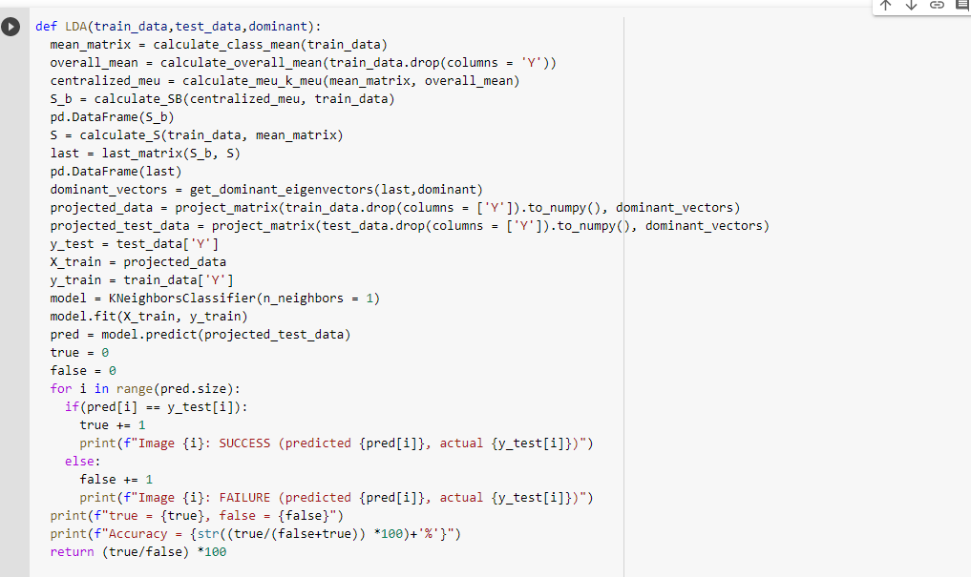

classification steps:
1. we built a KNN model with n-neighbors = 1
2. we train the model with our train data after reducing its dimesion
3. we test the model accuracy using test data it gave accuracy = 0.95 = 95%

6. Classifier Tuning
1. we used Knn model with different values for n=neighbors [the values are: 1, 3, 5, 7]
we found that as the k-neighbors increase the accuracy of the model decrease
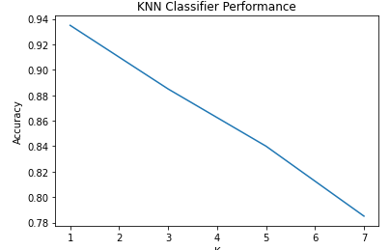

7. Compare vs Non-face images
1. we downloaded a flowers images dataset from Kaggle converted it to PGM type using Rea-Converter 7 pro
2. uploaded converted images to drive
3. resized images to 92*112
4. updated classifier column of faces dataset to 1,nonface to 2
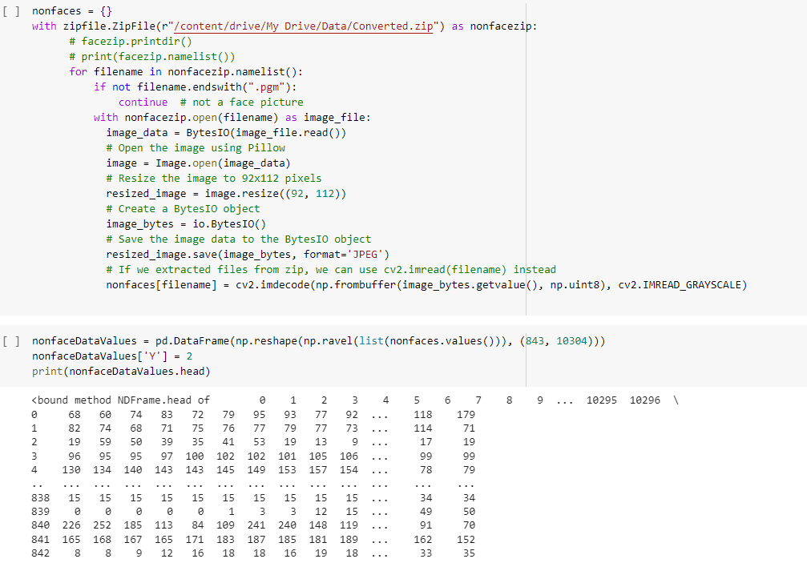

5. calculated best dominated-eigenvectors 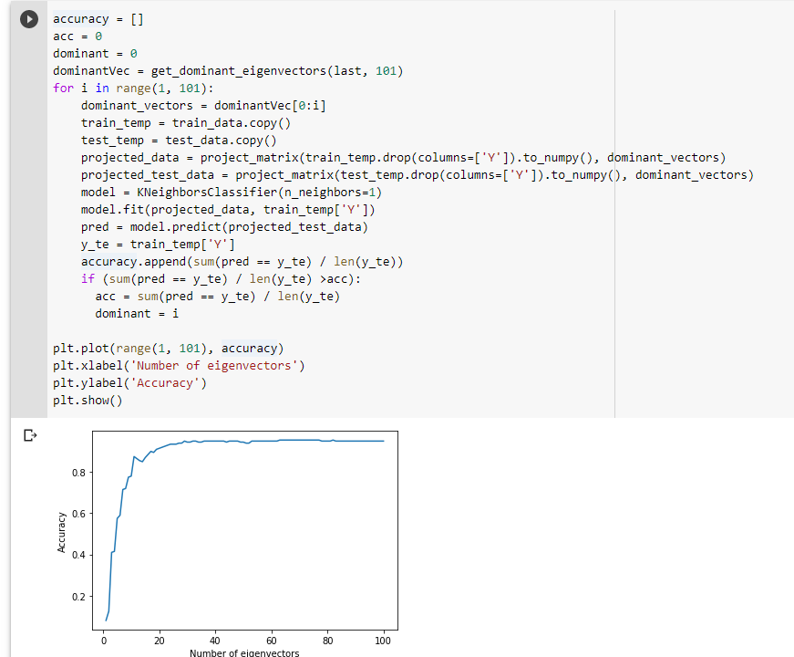
6. use different numbers of nonface images with fixed number of faces (200 train,200 test)
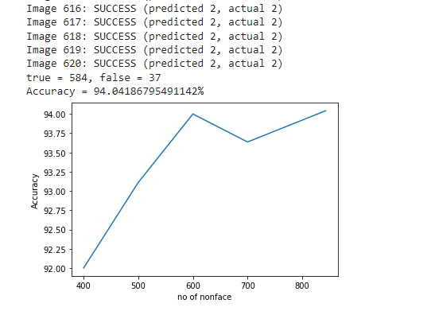
Bonus Part

