Your Project Name

Graduation Project, Part-I (CS )
Computer Science Department
FCI, LUXOR

Project Advisors:
Your advisor’s name

Submitted by
Student Name, Student ID
Student Name, Student ID

Date submitted

ABSTRACT

Write your abstract here.
Table of Contents

1. Introduction 1
2. Domain Analysis 1
3. Risk/Constraints 2
4. Project Plan 3
5. Quality Assurance Plan 3
6. Requirements 4
6.1 Functional Requirements 4
6.2 Non-Functional Requirements 4
7. System Use-Cases 4
7.1 Use Case1 5
7.2 Use Case2 5
8. Analysis Class 5
9. Interaction Diagram 6
10. Design Class 8
11. System Architecture 8
12. User Interface Mockup 8
13. Database Schema 8
14. Algorithms 8
15. Expected Deployment 8
16. Sample Test Scenario 9
17. Project Status 9
18. Conclusion 9
19. Reference 9

List of Figures

Figure 1. Smart room use cases 4
Figure 2. Successful order placement 6
Figure 3. Successful order placement 7
Figure 4. Successful face recognition log in 7
Figure 5. System deployment diagram 9

List of Tables

Table 2. Test Table 9

Introduction

[The following is a sample introduction from another resource]
Our customer’s grand vision for home automation requires significant investment which can not be completed within a single step. Given the resource available to our team, we have adjusted the project scope accordingly. The objective of this project is to develop the software infrastructure that can provide the user with personalized services. Such services could include the latest news feeds, personal calendars, and remote access to household appliances.

The emphasis of this project is to develop a common standard for the smart appliances to interact. Having a standardized model for home automation would help keep the project complexity under control, but more importantly, it would also provide our customer with a solid platform for future projects. With the advent of the Extensible Markup Language (XML) and Web Services, the technology industry is flourishing with technological standards that are implementation and platform neutral. Our goal is to develop the home automation standard by leveraging the existing open standards. Ultimately, everything from the bathroom lights to the coffee machine could be controlled through a standardized interface.

In order to effectively demonstrate the viability of the home automation infrastructure, a futuristic smart mirror will be developed. After authenticating the user using face recognition, the mirror would provide the user with personalized data feeds and access to the other household appliances. The user could interact with the device naturally either by voice or the touch screen. For this project to be considered successful, the system has to be intuitive enough that a new user could learn how to use it within the first thirty minutes of interaction. The system should also be able to interoperate with other smart devices on the same network regardless of the underlying platform.

Domain Analysis
[This is a sample from other resources. Ideally here you analyze the domain of your proposed work area. You can review existing approaches here and summarize your thoughts]

Home automation is a high potential market that is still under heavy development. There is no shortage of proprietary solutions and conceptual designs from companies of various sizes.

One existing solution for home automation that is already available on the market is the LonWorks Control Network from Echelon Corp. Similar to a Local Area Network (LAN), a LonWorks Control Network has a group of devices working together to “sense, monitor, communicate and control” Error: Reference source not found. In addition, the LonMark Interoperability Association exists to provide tools and components for manufacturers to integrate their devices into a LonWorks Network and currently has over 300 manufacturers on board. From their website:

Intelligent LONMARK products coupled with the Internet offer a whole new class of services to the home owner including; better control of energy usage, remote monitoring and control of devices in the home such as appliances, security, lighting, and sunblinds. Error: Reference source not found

This solution has many strengths, including a “Visio Standard drawing and diagramming tool” for configuration of LonMark devices, automatic installation of newly attached devices, and the ability to network all devices through existing power circuits Error: Reference source not found. However, the device standard is outdated and does not offer any wireless solution nor access to online XML data (Internet interaction is limited to remotely controlling devices). In addition, Echelon Corp. is targeted towards the enterprise market – integration support for home appliances is very limited. The LonMark Starter Kit retails for US$1,999.95 Error: Reference source not found.

Hitachi has recently announced a solution that integrates a touch screen computer into a mirror. The device is called “Miragraphy” and it can display digital information (text, photos, video, websites, etc.) on a mirror surface using an LCD projector. The mirror integrates sensors, RFID readers, barcode readers and cameras that are used to personalize digital content based on the identities of the user. The product is currently only available in Japan. It is targeted at public locations (restaurants, hotels, airports, etc.) instead of consumer homes Error: Reference source not found. No information was available on the pricing. Unfortunately, this solution is hardwired and does not have a well-defined home automation protocol that can be extended to other devices.

In January 2006, Bill Gates showcased a system at the 2006 Consumer Electronics Show that used a large touch screen to display the time, a calendar, family photos, a map with GPS locations of family members, and even a live TV feed. "Consumers are getting more and more connected. They're getting richer experiences, and software is really at the center of that.", explained Gates Error: Reference source not found. He stated the product would be a reality for consumer living rooms within the next four years. While the product does not compete directly with the home automation solution we are developing, it does confirm the future demand for online data in home displays and the need for a well-built infrastructure to facilitate the control of a network of such devices.

Risk/Constraints
[Provide a short description on the following risk factors. These should later be listed and tracked in your project status reports.]
- What engineering challenges will need to be solved, addressed, or managed in building the system?
- What organizational challenges, in terms of your group and working environment will need to be solved, addressed, or managed in order to build the system?
- What deployment challenges will need to be solved, addressed, or managed in order to demonstrate progress and deploy the system to your customer?

Project Plan

The planning phase is an important step for any project.

The students should produce at least a rough estimation of the project size as well as a project work plan.

The project work plan can be shown by using Gantt Chat to illustrate all the phases, tasks within the phases and who will be working.

Quality Assurance Plan

The planning phase is an important step for any project.

- Inspections: Should be done before formal reviews and should be used at the end of each major phase/iteration. Participants in an inspection are members of the team (without the adviser). Part of the work done by 1 student is reviewed by 1, 2 or all the members of the team. There must be a written report of the findings and follow up on the inclusion/correction of all findings. A template can be used to record findings from an inspections session.

In summary: this is like when the students divide their work among the team members and once they finish their assigned task, they check each other’s work and give feedback to the person initially responsible for that part.

A sample written inspection report can be put in appendix in the project report as a proof that students conducted inspection sessions.

- Formal Reviews: Should follow an inspection and should be used at the end of each major phase and/or iteration (Requirements specs, design, test plan, etc.). Formal reviews should be conducted in a formal way with the presence of students and the adviser (and eventually the exam committee). There must be a written report documenting all findings from the formal review session. The adviser is responsible to follow up with students. The report must be filled by the advisor and eventually the member of the exam committee.

The written report can be put in appendix in the project report as a proof that students conducted formal review sessions with their adviser and eventually the exam committee members.

- Testing: For this, there is a section before the end of this report where the students’ should put their test-related content. At this part of the project, the students can prepare a rough test plan and include that in their report. The test plan should include various test cases.

Requirements

Functional Requirements
List all the functional requirements here.

Non-Functional Requirements
List the non-functional requirements here.

System Use-Cases
This section lists use cases or scenarios to represent some significant, central functionality of the final system. Following is a sample use case- you replace it with yours.
Also important that you only put 2/3 critical use case in this section and put other use cases in the Appendix.

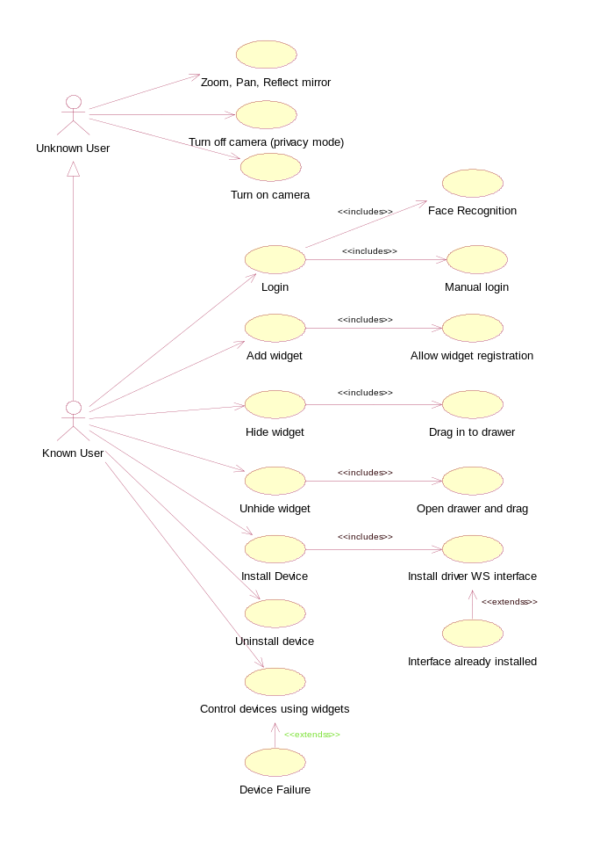
Figure 1. Smart room use cases

Use Case1
[Every use case should be described using use case template that should contain a brief description, flow of events - basic flows and alternative flows, pre-conditions and post-conditions]

Use Case2

[Every use case should be described using use case template that should contain a brief description, flow of events - basic flows and alternative flows, pre-conditions and post-conditions]

…..
….

….

…..

Analysis Class
Here you identify all the boundary class, control class and entity class for all the use cases. You should also identify the attributes ad methods in the classes.

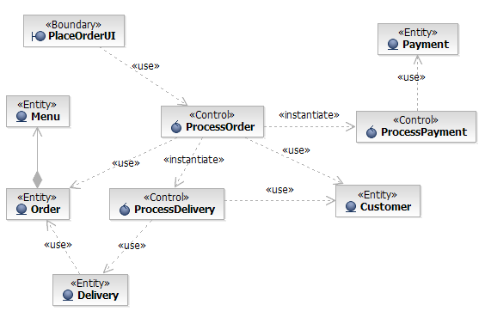
Figure 2. Successful order placement

Interaction Diagram
Here you show the interaction in terms of sequence or communication diagram between the objects/classes for different use case scenarios. You may ignore the trivial use cases. You can also show the interaction in case of exceptional flows in a use case. Exceptional flows include the following:
  - Error handling. What should the system do if an error is encountered?
  - Time-out handling. If the user does not reply within a certain period, the use case should take some special measures.
  - Handling of erroneous input to the objects that participate in the use case (for example, incorrect user input).

Delivery Service use case

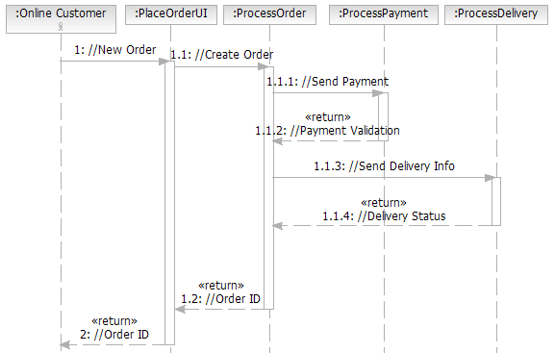

Figure 3. Successful order placement

Face recognition use case

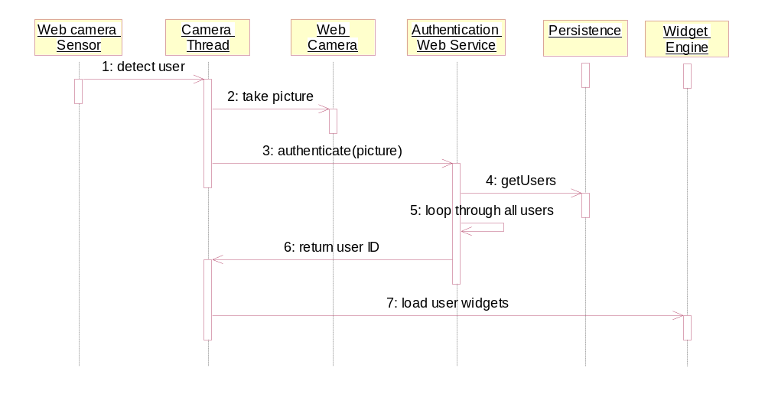
Figure 4. Successful face recognition log in

…………………………
…………………….
……………………….
……………………….

Similarly, do it for the others.

Design Class
[Here you give the diagram of the design classes, that is more refined than the analysis class model- it should also include the attributes and the methods.]

System Architecture
Here you should desc

User Interface Mockup

Provide screen shots of the developed user interfaces, or mockups to illustrate the looks and feel of the system for critical scenarios.

Database Schema
If you need to use database, define the relevant schemas or file formats. Illustrate how your example data will be stored.

Algorithms
Give brief overview of any special algorithms you will use e.g. image processing, game strategy, scheduling etc.

Expected Deployment

Global Overview
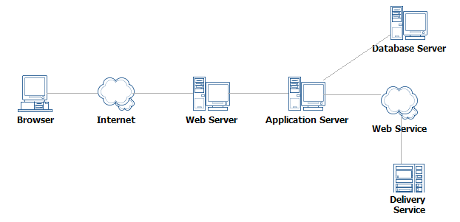
Figure 5. System deployment diagram

Test Scenario
You need to specify some important test cases for some scenarios by identifying sample input and expected output of the system’s core component/classes.

Table 1. Test Table
Col1 | Col2 | Col3

Project Status
[Give the current status of the project following the status report template—mention the different issues you have worked on and the issues that you plan to work on in the subsequent iterations]

Conclusion
Write the conclusion here.

Reference
Write the references here that you used..

