10/17/2020

Analysis and Insights of WeRateDogs Twitter archive

Abdelrazek Rizk

Analysis and Insights of WeRateDogs Twitter archive

1. Most used Twitter sources

In that visualization we will get insight about what is the most device use to reach twitter app

User use I phone device to reach twitter for rate their dogs in the go

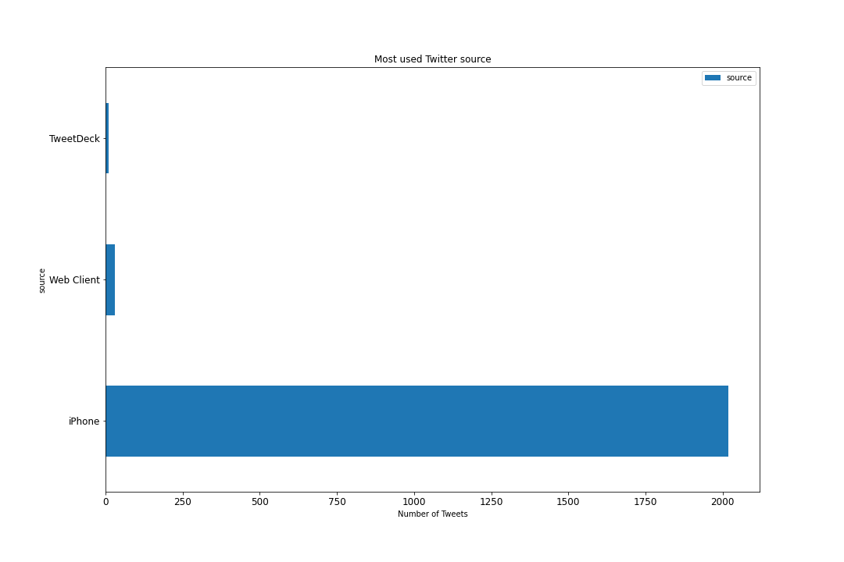

1. Popularity of Dog Stage for **Weratedogs** users

Dog in the stage of puppo is most stage getting retweet and favorite, pupper stage came in second and doggo came in the last place

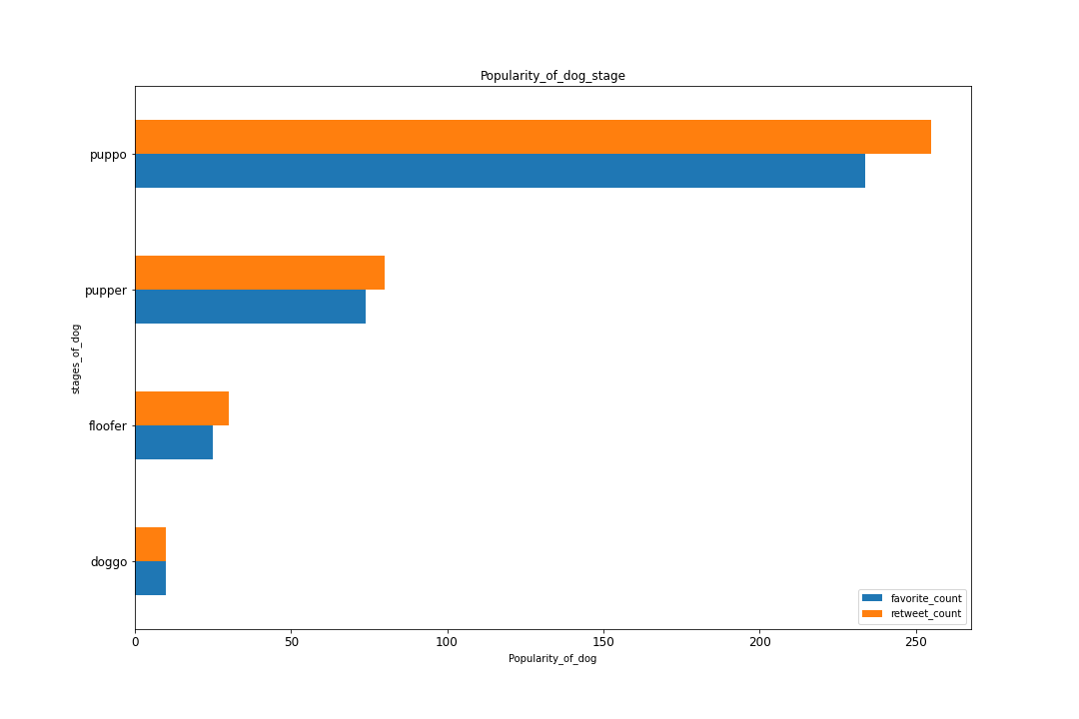

1. the Share of Dog Stage for **Weratedogs** users:

Dog in the stage of pupper is most stage owns by Weratedogs users, doggo stage came in second but it has the minimum

of retweet and favorite if we look to previse graph

