**- User stories -**

**as a (normal person, diabetic, high or low pressure patient)**

I want an application

so I can follow the right diet and be fit.

**- as a user -**

I want to login

so I can explore the application

and its features.

**- as a user –**

I want to have my own account

so I can put my data in it.

ٍ

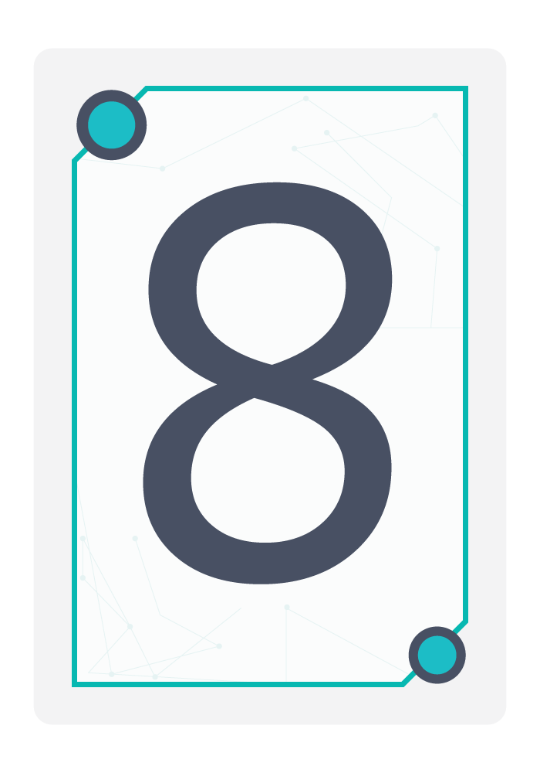

**- as any person -**

I want to calculate my body mass index according to my weight and height

so I can have the perfect body weight.

**- as a user -**

I want the home page to contain buttons that lead me to specific page

so I can reach my destination fast.

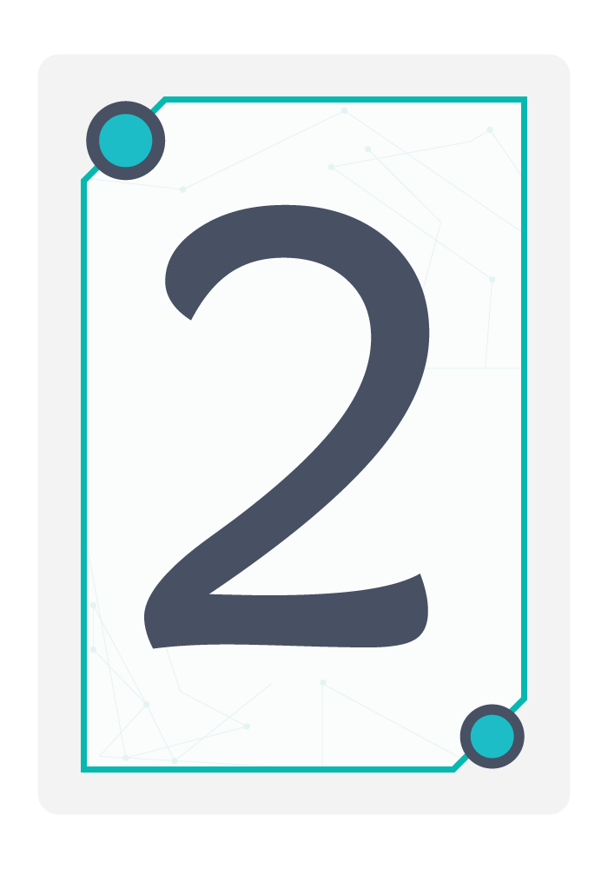



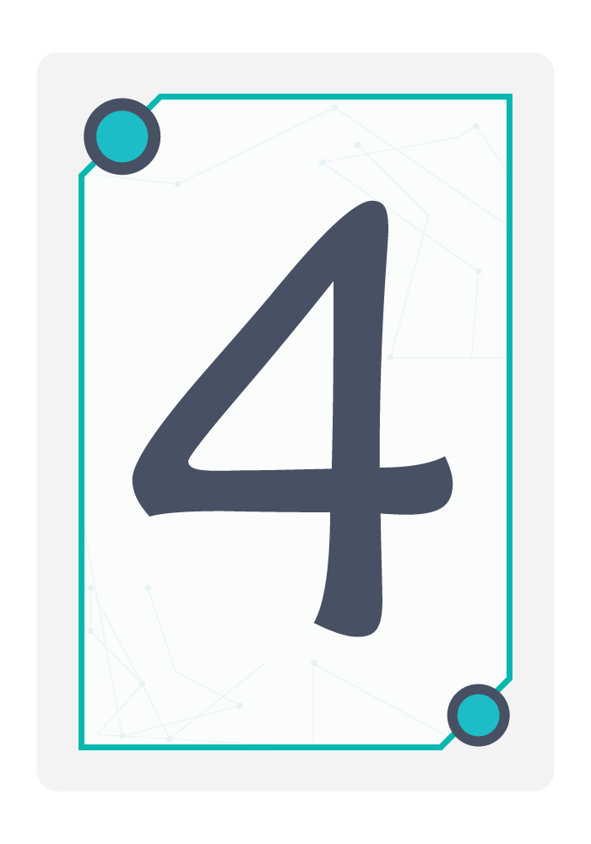

**- as a high pressure -**

I want healthy diet based on my pressure

so I can control my pressure and keep fit with the correct diet.

**- as a user -**

I want workout videos

so I can be fit.

**- as a user -**

I want to be remind and motivated to eat healthy, drink water and play sports every day

so I can continue and reach my goal to be healthy person.

**- as a user -**

I want feedback space

so I can say my opinion and suggestion.

**- as a normal person -**

I want healthy diet

so I can gain weight or lose weight.

**- as a diabetic -**

I want healthy diet based on sugar rate

so I can control my sugar rate and follow the correct diet.

**- as a user -**

I may want to logout from the app at the end.

**- as a user -**

I want a help button

so if I get lost or can’t find my destination this help button would guide me.

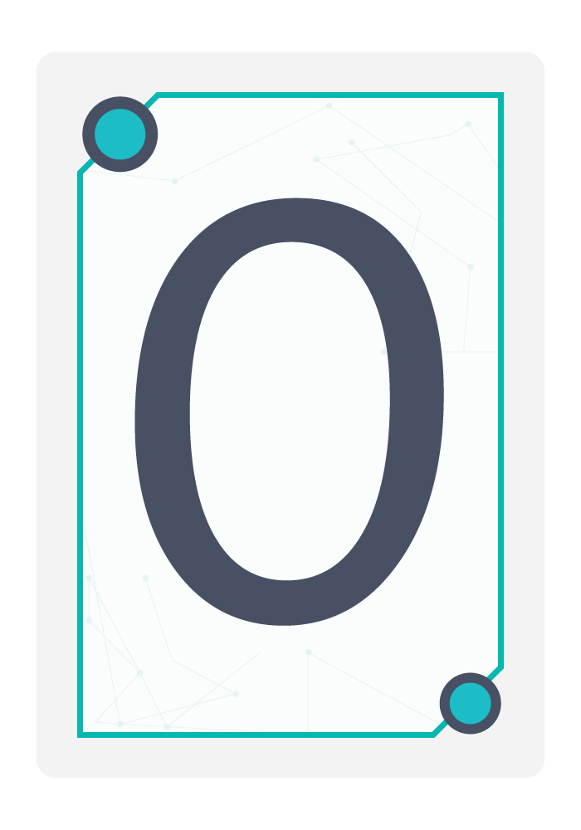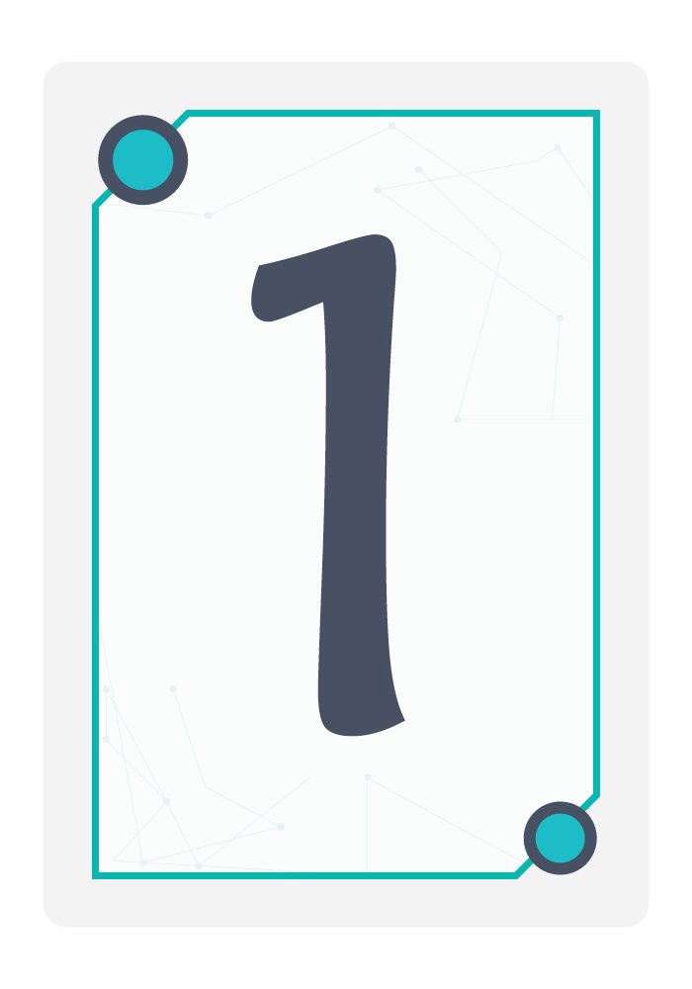

**Sprints schedule:**

|  |  |
| --- | --- |
| **Schedule** | **Events** |
| By Wed28.2.2018.  By Thu1.3. – Thu 8.3.  By Tue 6.3.2018. | -Set up and Role assigned.  **-1st Sprint (registration).**  -In 1st sprint we managed to make a splash screen, registration view and login view doing all the required analysis, sketching, design, android implementation and connecting the views with firebase to store and retrieve data. |
| By Sat 10.3. 2018.  By Mon 12.3. – Mon 26.3.  By Wed 24.3.2018 | -We have meet to review sprint 1 once to know what we have finished and what to be continued so we can continue working and start in sprint 2.  **-2nd Sprint (home page and profile view).**  -In 2nd sprint our main goal is to do the home page and the user profile view by doing analysis, sketching, designing and android implementation.  -Connecting android implementation with the firebase to store and retrieve only for user profile view.(delay in this sprint)  -So far in the **home page** view when you click its buttons these buttons lead you to empty views that will be finished in the coming sprints. |
| By Sun 1.4.2018.  By Tue 3.4. – Wed 18.4.  By Mon 16.4.2018. | -Sprint review meeting for Sprint2  -We have meet to know what was been done in sprint2 what’s not and why, also we have changed to sprint schedule.  **-3rd Sprint (normal person).**  - In 3rd sprint our main goal is to do “three of the empty views in the 2nd sprint ‘home page’”.  -In normal person first view the user will be asked if he/she wants to lose or gain weight, according to the user choice another view will be opened (gain weight view or lose weight view) also these views will be accomplished in this sprint.  -In 3rd sprint also we want to do sports view and feedback view.  -Our final requirement to be done is to send notifications to users to remind them to drink water and eat healthy.  -All these views will be accomplished by doing the required analysis, sketching, designing, android implementation.  -These views doesn’t require any firebase connection.  -The delayed point from sprint 2 which is connecting the firebase in the profile view is done. |
| By Thu 19.4.2018  By Fri 20.4. – Mon 30.4.  By Sat 28.4.2018 | - Sprint review meeting for Sprint3.  **- 4th Sprint(patients).**  - Reserved sprint review meeting for Sprint2. |

|  |  |  |  |  |
| --- | --- | --- | --- | --- |
| **sprints** | **Schedule** | **Ideal weeks** | **Fudge Factor** | **Project Velocity** |
| 1st Sprint  (registration). | By Thu1.3. – Thu 8.3.  By Tue 6.3.2018. | 4 days | 3days |  |
| 2nd Sprint  (home page and profile view). | By Mon 12.3. – Mon 26.3.  By Wed 24.3.2018 | 10 days | 4 days |  |
| 3rd Sprint  ( normal person). | By Tue 3.4. – Wed 18.4.  By Mon 16.4.2018. | 12 days | 2 days |  |
| 4thSprint  (patients). | By Fri 20.4. – Mon 30.4.  By Sat 28.4.2018 | 8 days | 2 days |  |