Power & speaker/audio — design notes
Component selection rationale for the Tree'd History Guide handset

1. Purpose and scope
This note documents the components selected for the handset's power subsystem and its speaker/audio subsystem, and the reasoning behind each choice.

2. Working assumptions
- Two external power entry points are supported: cradle pogo-pin contacts (primary, daily fleet charging) and a USB-C bench/service port (PWR-04).
- The cradle interface uses three pogo contacts two V+ and one GND arranged so the handset docks and charges correctly in either orientation, without a keyed, single-orientation slot.
- A single 1S Li-ion/Li-Po cell is used, per PWR-03.
- Voice capture uses two digital MEMS microphones one on the main PCB, one on a satellite PCB elsewhere in the enclosure, linked by a wiring harness into the codec's digital mic input as a pair, for far-field noise cancellation (see 6.4); playback drives a single earpiece/receiver channel through the Class-D amplifier.
- The compute platform is ESP32-C5, selected primarily for NET-01's dual-band Wi-Fi requirement; its RISC-V core does not carry the vector/DSP-style extensions available on ESP32-S3, so audio DSP work sits in the codec's embedded miniDSP instead of MCU firmware (see 6.2).

3. Architecture overview — power
The cradle pogo contacts are protected individually by AO3401A before the power mux. The connector's two-V+/one-GND layout is symmetric that allows reverse polarity .

TPS2116DRL then merges the two 5V paths cradle as VIN1/priority, USB-C as VIN2/secondary — onto one rail feeding BQ25601, which charges the cell and feeds the buck-boost regulator, holding a constant 3.3V system rail across the full battery discharge range.

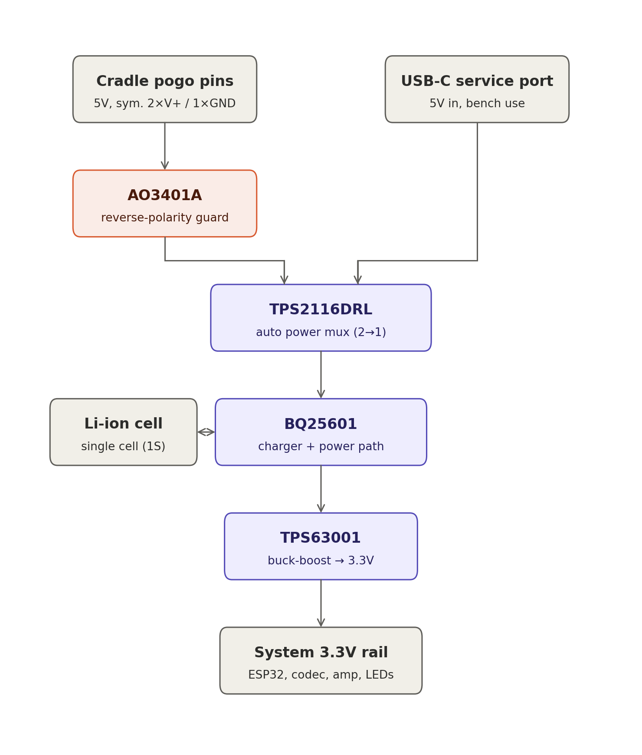

4. Component selection rationale — power

4.1 BQ25601 — single-cell Li-ion/Li-Po battery charger
I2C-controlled, up to 3A NVDC (Narrow VDC) power-path management charger with an integrated input reverse-blocking FET, JEITA-profile NTC thermistor monitoring, programmable input current limit (100mA–3.2A, 100mA resolution), and USB SDP/DCP/non-standard-adaptor auto-detection. The datasheet lists IEC 62368-1 end-equipment safety approval directly.
Why chosen:
- NVDC power-path management lets the system run directly from input power while docked, instead of cycling the battery every time the handset sits in the cradle — supports PWR-01 and PWR-02 by reducing unnecessary charge/discharge cycles.
- Built-in NTC/JEITA thermal profiling satisfies the “temperature-aware” charge management called for in PWR-03 without extra firmware logic.
- I2C status/fault flags give firmware the visibility needed for the charging/low-battery/error indicator states required in UI-02.
- Instant-on operation with no battery, or a deeply discharged one, fitted means the system can still power up from the cradle or USB-C input at first assembly or if a unit is ever collected fully dead — no separate jump-start step.
- BATFET ship-mode control lets the battery be electrically isolated from the system during transport/storage, which is useful given the −20–60°C storage range and UN 38.3 transport requirement.
- Open item: BQ25601 manages charging, not cell-level over-voltage/over-discharge/short-circuit protection.
- Open item: The default I2C register state at power-up (before firmware configures charge current/voltage) should be confirmed safe for first power-on.

4.2 TPS2116DRL — 2:1 auto-switching power mux
1.6–5.5V, 2.5A continuous, ~40mΩ N-channel switches; automatic-priority or manual switchover selected by the MODE pin, with a resistor divider on PR1 setting the priority threshold in automatic mode; reverse current blocking when VOUT exceeds either input; ~1.32µA quiescent current, ~50nA VIN2 standby current; controlled output slew rate (1.3ms typical at 3.3V) limits inrush on switchover.
Why chosen:
- The brief calls for both cradle-contact charging (primary, PWR-04) and a serviceable USB-C bench port, without a mechanical switch or two separate charger front-ends. TPS2116DRL merges the two 5V inputs into one rail feeding BQ25601, auto-selecting whichever source is present.
- Automatic priority mode with USB-C on VIN1 and pogo pins on VIN2 means the USB-C always wins when both are connected at once, and the pogo pins only supply power when the USB-C is absent.
- Low quiescent current means no meaningful battery drain while undocked and idle.

4.3 TPS63001 — single-inductor buck-boost regulator
Input voltage from 1.8 to 5.5V, automatic buck/boost transition, up to 96% efficiency, 1200mA output in step-down mode (VIN 3.6–5.5V) and up to 800mA in boost mode (VIN>2.4V), power-save mode for light-load efficiency, load disconnect during shutdown, overtemperature protection.
Why chosen: a Li-ion cell spans roughly 2.5V (empty) to 4.2V (full) both above and below a 3.3V logic rail. A simple buck converter can't regulate once VBAT drops below about 3.4–3.5V, which would leave the ESP32, codec, and amplifier under-volted for the last part of every battery cycle. The buck-boost holds 3.3V constant across the full discharge curve, supporting the PWR-01 runtime target and stable audio/Wi-Fi behaviour as the battery ages.

5. Architecture overview — speaker & audio
Voice capture and playback are handled by a dedicated codec with its own embedded DSP, rather than in MCU firmware. The microphone feeds the codec's digital mic input; the codec's miniDSP performs echo cancellation, noise suppression, and voice-activity detection (DSP-01/02/03) before the cleaned audio is handed to the ESP32-C5 over I2S for streaming to the edge server. On playback, reply audio arrives over Wi-Fi, is rendered by the codec's DAC, and is driven to the earpiece through the TPA2012D2 Class-D amplifier.
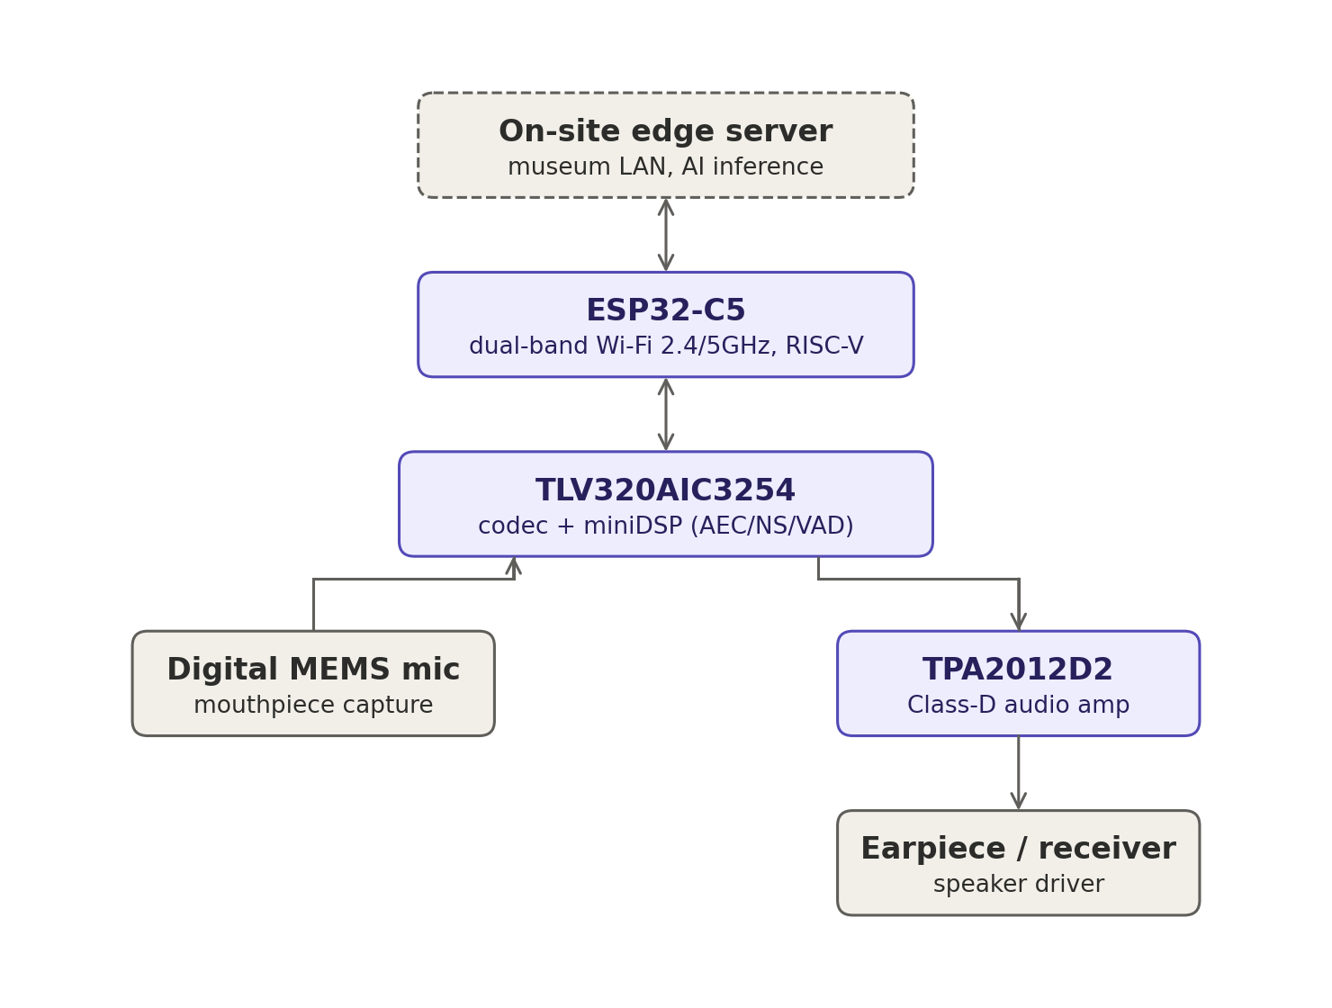

6. Component selection rationale — speaker & audio

6.1 TLV320AIC3254IRHBR — stereo audio codec with embedded miniDSP
100dB SNR stereo DAC (4.1mW at 48ksps stereo playback), 93dB SNR stereo ADC (6.1mW at 48ksps stereo record), PowerTune scalable power/performance modes, a user-programmable embedded miniDSP, six single-ended or three fully-differential analog inputs, stereo analog AND digital microphone inputs, stereo headphone and line outputs, programmable mic bias and PLL, integrated LDO, 5×5mm 32-pin QFN.
Why chosen:
- The embedded, programmable miniDSP lets AEC/noise-suppression/VAD (DSP-01–03) run inside the codec itself rather than on the ESP32 the direct consequence of choosing ESP32-C5 (6.2), whose RISC-V core doesn't carry S3-style vector extensions for on-chip signal processing. This directly answers DSP-05's request to justify codec-vs-SoC-integrated DSP on cost/power/latency grounds.
- Native digital microphone input lets the MEMS mic (MIC-03) connect on a digital bus without a separate ADC front-end, keeping the microphone signal path short and less exposed to handset noise.
- The stereo headphone output stage drives the earpiece/receiver directly (SPK-01, SPK-03) with on-chip gain stages, without needing an external op-amp ahead of the power amplifier.
- PowerTune's scalable operating points help the all-day runtime target (PWR-01), since audio processing runs continuously through a visit.
- Integrated LDO and programmable PLL reduce the external component/rail count needed around the codec.

6.2 ESP32-C5 — compute/connectivity platform
ESP32-C5 is Espressif's current RISC-V part supporting dual-band 2.4GHz and 5GHz Wi-Fi 6 — the only Espressif chip that does, at present. That dual-band radio directly satisfies NET-01 (Must: dual-band Wi-Fi, no cellular), and is useful in busy gallery environments where the 2.4GHz band is congested by visitor phones and other equipment.
Trade-off: the RISC-V core doesn't carry the Xtensa vector/SIMD-style extensions that ESP32-S3 has for on-chip signal processing and AI-adjacent workloads. Since the handset still needs AEC, noise suppression, and VAD somewhere in the chain (DSP-01–03), that processing was placed in the codec's own miniDSP (6.1) instead of an MCU-side DSP library. This is the CPU-02/DSP-05 platform trade-off made explicit: dual-band Wi-Fi headroom was weighted over on-MCU DSP capability, and a codec with its own DSP closes the gap.

6.3 TPA2012D2RTJR — stereo Class-D audio power amplifier
The RTJR order-code suffix is TI's WQFN package: 2.1 W/Ch into 4Ω at 5V, 1.4 W/Ch into 8Ω at 5V, ~720 mW/Ch into 8Ω at 3.6V. Filter-free Class-D topology needing only two external components, 2.5–5.5V supply range, gain selectable to 6/12/18/24dB via G0/G1, independent per-channel shutdown (SDL/SDR), high PSRR and differential inputs for noise immunity, thermal and short-circuit protection.
Why chosen:
- The 2.5–5.5V supply range runs directly from the 3.3V system rail (4.4) with no separate audio supply.
- Output headroom well beyond a single earpiece driver's needs gives margin to hit “loud enough for hard-of-hearing visitors, no harsh clipping” (SPK-03) without running the amp near its rail.
- Independent per-channel shutdown lets firmware power down the unused channel for a mono earpiece, and thermal/short-circuit protection support the no-unexpected-heat requirement (PWR-05).
- TI's own CC3200 Audio BoosterPack reference design pairs this exact amplifier with the TLV320AIC3254 codec — a useful known-good starting point for the analog layout.

6.4 Dual-microphone array — far-field noise cancellation
Revising the single-MEMS-mic assumption in Section 2: the handset uses two digital MEMS microphones rather than one. The primary mic sits on the main PCB; a second mic sits on a small satellite PCB elsewhere in the enclosure and connects back to the main board over a short wiring harness rather than a board-to-board connector. Both feed the codec's digital mic input as a two-channel digital mic pair, giving the miniDSP a second, spatially-separated signal to work with for adaptive noise cancellation (ANC) ahead of AEC/VAD, rather than relying on a single-channel noise-suppression algorithm alone.
Why chosen:
- A second, physically-separated mic gives the miniDSP a reference of ambient/handling noise that isn't strongly correlated with the near-field voice signal at the primary mic, which is what a dual-mic ANC path needs to work — a single mic can suppress stationary noise but can't do true spatial cancellation.
- TLV320AIC3254's digital mic input already supports a stereo/two-channel digital mic pair (6.1), so this doesn't add an ADC front-end or a second codec input path — the two mics share the existing digital mic bus.

7. UI indicators — LED and button subsystem
Eight indicator LEDs are split across two groups with different jobs and different physical locations, plus two front-panel buttons. Because the ESP32-C5 doesn't have eight spare GPIOs to dedicate to LEDs on top of everything else on the pinout (see the pin-assignment image, Section 4), all eight LEDs are driven from a single 74HC595 serial-in/parallel-out shift register rather than direct GPIO drive — the ESP32 only needs to own the shift register's data/clock/latch lines (SER, SRCLK, RCLK).

7.1 Battery-level LEDs (rear of enclosure)
Four LEDs (BAT_LED1–BAT_LED4) are mounted on the back of the handset and show battery state of charge in roughly 25% steps. They stay off in normal use so the device isn't lit up and drawing current for no reason; a dedicated front-panel button wakes them on demand pressing it lights the LED bar at the current charge level for a few seconds and then lets it go dark again, rather than leaving it lit continuously.
While the handset is on the charger, the same four LEDs also serve as the charge indicator: firmware blinks the LED bar (rather than holding it steady) to show that charging is actively in progress, while still encoding the current charge level in how many of the four are lit so a glance at the back of the unit on the cradle shows both "is it charging" and "how full is it" at once. See Section 8 for how firmware reads charge level and charging status from BQ25601 to drive this.
7.2 Status LEDs (handset face)
A second set of four LEDs (READY, Listening, Thinking, offline) sits on the front face of the handset, in the middle where the visitor is already looking while holding it to their ear — so device state is visible at a glance without turning the handset over or holding it away from their ear. These indicate, respectively: idle and ready for a press-to-talk press; actively capturing audio; waiting on a response from the edge server; and no active connection to the edge server/network.
7.3 Shift register wiring and bit order
All eight LEDs share one 74HC595, addressed in this bit order: Battery LEDs 1-4, Listening, Thinking, offline. Firmware should treat this as a single 8-bit output word written on every update (shift 8 bits in on SER/SRCLK, then pulse RCLK to latch), rather than trying to update individual LEDs independently, since the register has no per-bit addressing.
7.4 Buttons
- Battery-check button: momentary press-to-check button, wired separately from the shift register/GPIO pair used for volume (7.5). On press, firmware reads charge level and lights the rear Battery LEDs bar accordingly for a short timeout period before turning them back off, so the LEDs aren't left burning power continuously.
- Talk button: momentary press-to-talk button (TALK, already on the pin-assignment sketch) that firmware uses to start/stop voice capture and drive the Listening/Thinking/READY status LEDs accordingly.

8. Firmware interface notes — power and volume control
This section is written for whoever is implementing firmware against this hardware, covering three things firmware needs to do that aren't obvious from the schematic alone: powering the system down under firmware control, taking an accurate battery-voltage reading while the charger is active, and reading the volume buttons off a shared analog input.
8.1 Powering the system off
Firmware powers the handset down by sending a command to BQ25601 over I2C to put it into BATFET ship mode (referenced as an open capability in 4.1), rather than by any GPIO-level power switch. This electrically disconnects the battery from the system rail, which is the same mechanism used for transport/storage shutdown, now triggered by firmware instead of only by manual assembly-time setup.
8.2 Accurate battery-voltage reading while charging
Reading battery voltage on an ADC while BQ25601 is actively charging measures the cell terminal voltage under charge current, not the cell's resting voltage — the charge current across the cell's internal resistance and any front-end filtering skews the reading, which makes state-of-charge estimates unreliable while docked. To get a clean reading, firmware briefly suspends charging over I2C, waits for the cell to settle, takes the ADC reading (VBAT = VADC * 1.727), then re-enables charging — a short enough interruption that it doesn't meaningfully affect total charge time, repeated periodically rather than continuously. The same I2C link also exposes BQ25601's other status/fault registers (charge state, input source detected, fault flags) referenced in 4.1, which firmware should poll or use as the interrupt source for the same charge-status logic driving the rear LED bar in 7.1.

8.3 Volume buttons on a shared ADC input
Volume up/down are two buttons resolved on a single ADC input via a resistor-divider network, rather than on two separate GPIOs — each button pulls the shared node to a different characteristic voltage when pressed. Firmware distinguishes which button is pressed by band: an ADC reading of roughly 1.65V ± 0.2V is read as volume-up, and a reading of roughly 2.27V ± 0.2V is read as volume-down; readings outside both bands are treated as no button pressed.

9. Requirement traceability
ID | Requirement (summary)
PWR-01 | Full-day runtime, target ≥10–12h
PWR-02 | Full recharge in ≤3–4h
PWR-03 | 1S Li-ion/Li-Po, protection circuit, temperature-aware
PWR-04 | Cradle (pogo) charging + serviceable USB-C port
PWR-05 | No unexpected heat, on enclosure or on charge
PWR-07 | Clear low-battery signalling before shutdown
REG-05 | Battery safety, IEC 62133-2 / UN 38.3
MIC-03 | Digital MEMS microphone, high SNR
MIC-04 | Wideband capture ≥16kHz/16-bit, 12+ languages
SPK-01–SPK-04 | Clear earpiece audio, full speech band, loud enough, silent idle
DSP-01–03 | Echo cancellation, noise suppression, VAD
DSP-05 | Justify codec DSP vs SoC-integrated, on cost/power/latency
CPU-01 | Audio-endpoint compute only, no AI inference on handset
CPU-02 | Recommend platform with cost/power/latency/OTA rationale
NET-01 | Dual-band 2.4/5GHz Wi-Fi, no cellular

10. Receiver (Earpiece Speaker) Requirement

10.1 Acoustic target.
- The device must deliver high-volume audio suitable for hard-of-hearing users without distortion or harsh clipping.
- The target audio level at the ear must range between 88 and 94 dB SPL.
- This represents an 18 to 24 dB increase over standard telephone volume levels, in accordance with the regulatory codes and standards (FCC 47 CFR §68.317) and (ANSI/TIA-4965) for Hearing-Aid Compatibility (HAC).
- Impedance: 8 Ω (standard telephone handset receiver).
- Amplifier Output: Operating at a 3.3 V supply, the TPA2012D2 amplifier delivers 500–650 mW per channel.

11. Power Budget Methodology
The handset's operating day is divided into a small number of representative electrical states; each state is assigned a current draw from component datasheets, and a time-weighted average current is computed. That average is converted from the 3.3V rail to battery-referred current through the buck-boost power-path efficiency, then to a required capacity using the target runtime, a depth-of-discharge (DoD) limit, and an ageing margin. The same capacity is used to size the charge current against the target overnight recharge window (PWR-02).

11.1 Formulas used
- Per-state contribution: current × % time
- Weighted average rail current: Iₐᵥᵍ = Σ(current × %time) ÷ Σ(%time)
- Battery-referred current: I_batt = Iₐᵥᵍ(rail) ÷ η_power-path (η = TPS63001 conversion efficiency)
- Required capacity: Capacity = (I_batt × target runtime) ÷ (usable DoD × ageing margin)
- Charge current: I_chg = (Capacity × 1.25) ÷ target charge time, checked against the cell's max C-rate
- The 1.25× factor is a design margin covering the tapering CC/CV charge profile and fleet-charging inefficiency.

11.2 Mission profile
Four states are used: idle/connected while carried between exhibits, active listening (microphone + VAD/AEC + uplink streaming), active playback (speaker + downlink streaming), and Wi-Fi roaming transients between access points (NET-03).
State | % of time | Rail current (3.3V) | Dominant load
Idle / connected (modem-sleep, network keep-alive) | 55% | ≈ 25–35 mA | ESP32-C5 modem-sleep + periodic beacon wake
Listening (mic capture, AEC/NS/VAD, uplink stream) | 20% | ≈ 110–140 mA | ESP32-C5 Wi-Fi RX active (~95–105 mA) + codec/mic front end
Playback (speaker active, downlink stream) | 20% | ≈ 130–165 mA | ESP32-C5 Wi-Fi RX active + TPA2012D2 driving receiver
Roaming transient (AP scan / re-association) | 5% | ≈ 220–270 mA | ESP32-C5 Wi-Fi TX active burst (~250–265 mA peak, datasheet)

- Per-state currents are biased toward the upper half of each part's datasheet range (worst-realistic-case, not best-case).

11.3 Component current reference (datasheet-sourced)
Component | Key figures used
ESP32-C5 (Wi-Fi 6 MCU) | 2.4GHz Wi-Fi TX active: ≈249–265 mA peak (datasheet). RX active: ≈94–102 mA. Modem-sleep: ≈20–30 mA.
TLV320AIC3254 (audio codec) | DAC ≈4.1mW, ADC ≈6.1mW ≈ 3–6 mA at 3.3V — a small contribution relative to the radio.
TPA2012D2 (amplifier, 1 ch. used) | Quiescent ≈6–9 mA at 5V / 5–7.5 mA at 3.6V; shutdown ≈1.5µA. Rated 720mW/ch into 8Ω at 3.6V (≈500–650mW/ch scaled to 3.3V). Unused channel held in shutdown.
TPS63001 (buck-boost power path) | Quiescent <50µA; conversion efficiency up to 96%. η ≈ 90% used as the conservative design figure (12.2).
BQ25601 (Li-Po charger) | Charges up to 3–3.5A; JEITA/NTC thermal profile addresses PWR-03's temperature-aware charging requirement. Charge current is set by the target charge time (13), not limited by the charger IC.

12. Battery Capacity Calculation

12.1 Weighted average current

Based on the mission profile (11.2), the time-weighted average rail current is 100–120 mA at 3.3V. This load is primarily driven by active audio states (40% duty cycle) and Wi-Fi roaming transients, while the idle state (55% duty cycle) has a negligible power impact.

12.2 Battery-referred current
The 3.3V rail is powered by a single-cell Li-Po via the TPS63001 buck-boost regulator. To account for real-board losses (PCB trace resistance, connector drops, and ripple), a conservative efficiency of 90% is used for current calculations, derated from the datasheet's 96% maximum.
Quantity | Value
Average rail current (3.3V) | ≈ 100–120 mA
Power-path efficiency (design figure) | 90%
Average battery current | ≈ 110–135 mA

12.3 Required capacity
The battery capacity is sized to meet a 10–12 hour design target (8-hour QC minimum per PWR-01). The total required capacity factors in a 92% usable Depth of Discharge (DoD) to preserve cycle life and accommodate the PWR-07 low-battery warning, alongside an 80% end-of-life (EOL) ageing margin to ensure the runtime target is sustained under daily fleet operation.
Quantity | Value
Target runtime | 12 hours (design target; 8h is the QC floor)
Usable DoD | 92%
Ageing margin | 80%
Required capacity | ≈ 1.8–2.0 Ah

Recommended cell: single-cell Li-Po, 1800–2000 mAh — meets the 12-hour design target with the DoD and ageing margins above, and clears the 8-hour QC minimum with margin even at end-of-life capacity fade.

13. Charge Current Sizing
To meet the 3–4 hour recharge requirement (PWR-02) for the recommended 1.8–2.0 Ah cell, the required average charge current is:
Target charge time | Required average charge current | Approx. C-rate (at 1.9 Ah nominal)
4.0 hours | ≈ 0.59 A | ≈ 0.31C
3.5 hours | ≈ 0.68 A | ≈ 0.36C
3.0 hours | ≈ 0.79 A | ≈ 0.42C

The BQ25601 charger supports up to 3.0–3.5A, well exceeding the required charge current and removing the IC as a charging bottleneck. The actual charge time is constrained solely by the selected cell's maximum C-rate. The required 0.3–0.4C rate is well within standard Li-Po limits, with the BQ25601's JEITA/NTC thermal management (PWR-03) ensuring safe operation.

14. Summary of Recommendations
Item | Recommendation
Receiver (earpiece) | 8Ω, 0.5–1W rated telephone-type receiver, driven by TPA2012D2 (single channel, unused channel in shutdown) at 3.3V
Actual drive power | <300 mW typical — well inside the amplifier's ≈500–650 mW/ch headroom at 3.3V
Target loudness | 88–94 dB SPL at the ear (HAC / ANSI-TIA-4965 reference)
Battery cell | Single-cell Li-Po, 1800–2000 mAh, equipped with a built-in protection circuit and an NTC thermistor to ensure temperature-aware safe charge management (per PWR-03).
Average battery current | ≈ 110–135 mA (rail avg. ≈100–120 mA ÷ 90% power-path efficiency)
Charge current | ≈ 0.6–0.8 A (≈ 0.35C) via BQ25601 to meet a 3–3.5 hour overnight recharge

