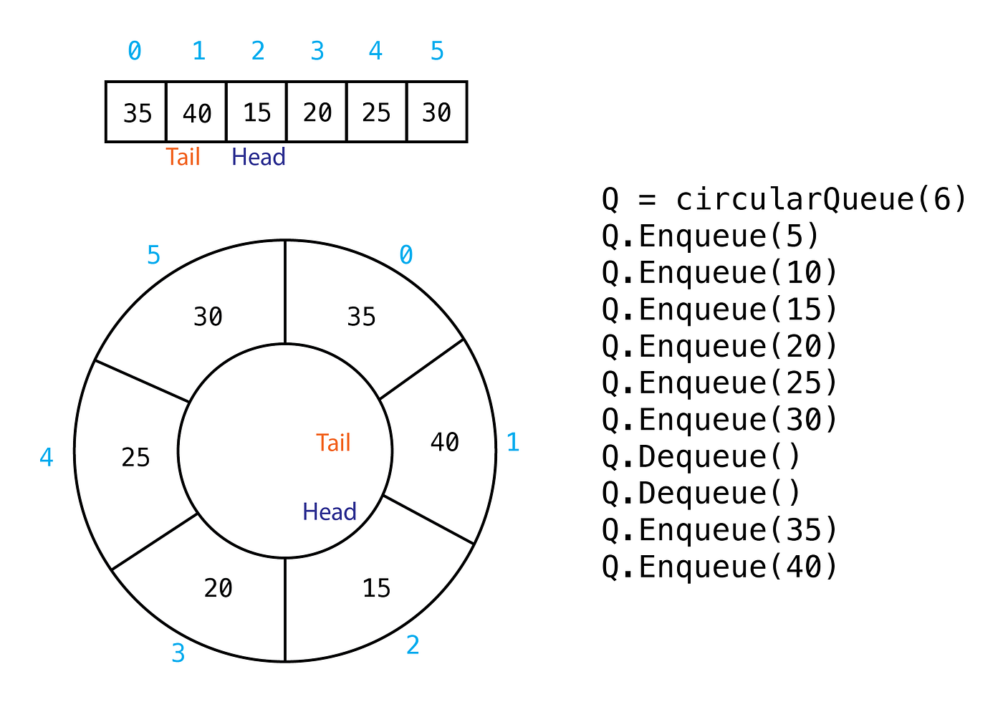

**What is Array Circular Queue move index?**

In an Array Circular Queue, the move index operation refers to the process of updating the front and rear pointers when enqueueing or dequeueing elements. These pointers indicate the positions of the front and rear elements in the circular queue.

When enqueueing an element, the rear pointer is moved to the next available position in the array. If the rear pointer reaches the end of the array, it wraps around to the beginning using the modulo operation. This ensures that the circular nature of the queue is maintained.

Similarly, when dequeueing an element, the front pointer is moved to the next position in the array. If the front pointer reaches the end of the array, it wraps around to the beginning using the modulo operation.

Here's an example to illustrate the move index operation in an Array Circular Queue:

Let's assume we have an array with a capacity of 5, and the circular queue is initially empty:

```

Array: [_, _, _, _, _]

Front: -

Rear: -

```

1. Enqueue operation (adding elements):

- Enqueue 10:

```

Array: [10, _, _, _, _]

Front: 0

Rear: 0

```

- Enqueue 20:

```

Array: [10, 20, _, _, _]

Front: 0

Rear: 1

```

- Enqueue 30:

```

Array: [10, 20, 30, _, _]

Front: 0

Rear: 2

```

- Enqueue 40:

```

Array: [10, 20, 30, 40, _]

Front: 0

Rear: 3

```

- Enqueue 50 (wrapping around):

```

Array: [50, 20, 30, 40, 10]

Front: 4

Rear: 0

```

2. Dequeue operation (removing elements):

- Dequeue:

```

Array: [50, 20, 30, 40, 10]

Front: 0

Rear: 0

(Element 50 is removed)

```

- Dequeue:

```

Array: [50, 20, 30, 40, 10]

Front: 1

Rear: 0

(Element 20 is removed)

```

- Dequeue (wrapping around):

```

Array: [50, 20, 30, 40, 10]

Front: 2

Rear: 0

(Element 30 is removed)

```

- Enqueue 60:

```

Array: [50, 20, 60, 40, 10]

Front: 2

Rear: 1

```

By moving the front and rear pointers appropriately, the circular queue allows efficient enqueueing and dequeueing operations without the need to shift elements in the underlying array. The modulo operation is used to wrap the indices around when they reach the end of the array, ensuring the circular behavior of the queue.

**Here's a detailed explanation of how index management works in a circular array queue:**

**Key Concepts:**

* **Circular Array:** Instead of a regular array, a circular array is used to store elements. This means the end of the array "wraps around" to the beginning, creating a circular structure.
* **Front and Rear Indices:** Two indices track the front and rear of the queue:
  + **Front:** Points to the element at the front of the queue, ready to be dequeued.
  + **Rear:** Points to the position where the next element will be enqueued.

**Enqueue Operation (Adding Elements):**

1. **Check for Full Queue:** If (rear + 1) % array_size == front, the queue is full.
2. **Insert Element:** If not full, place the new element at the rear index.
3. **Increment Rear:** Update rear = (rear + 1) % array_size to point to the next empty slot, using modulo arithmetic to wrap around.

**Dequeue Operation (Removing Elements):**

1. **Check for Empty Queue:** If front == rear, the queue is empty.
2. **Retrieve and Remove Element:** If not empty, retrieve the element at the front index and remove it.
3. **Increment Front:** Update front = (front + 1) % array_size to point to the next element, using modulo arithmetic to wrap around.

**Circular Movement of Indices:**

* The modulo operation (%) in both enqueue and dequeue operations ensures that the indices "wrap around" when they reach the end of the array, effectively simulating a circular structure.
* This eliminates the need for physical shifting of elements, improving efficiency compared to simple array-based queues.

**Example:**

Consider a circular array queue with a size of 5:

* **Initial state:** front = 0, rear = 0 (empty queue)
* **Enqueue 3 elements:** 10, 20, 30
  + rear becomes 3 (index of 30)
* **Dequeue 1 element:** 10 is removed
  + front becomes 1 (index of 20)
* **Enqueue 2 more elements:** 40, 50
  + rear wraps around to 0 (index of 40)
  + rear becomes 1 (index of 50)

The queue now contains 20, 30, 40, 50, with front = 1 and rear = 1.