
Phase_2

Submitted to:
Dr. Mahmoud Mounir
TA: Esraa Karam

Submitted by:
Nagy Ahmed Nagy | 23p0365
Abdelrhman Mohammed Mahmoud Salah | 23p0370
Ahmed Mosta Gomaa | 23p0375
John George Mikhael | 23P0266
Peter Maged Shokry | 23p0192

Table of Contents
1.Introduction 1
Dataset Description: 2
Objective: 2
2. Data Preprocessing 2
2.1 Feature Selection 2
2.2 Feature Scaling & Encoding 3
3. Model Implementation 3
3.1 Decision Tree 3
3.2 Naive Bayes 5
3.3 K-Nearest Neighbors (KNN) 7
3.4 Support Vector Machine (SVM) 9
3.5 Logistic Regression 12
3.6 Random Forest 15
4.Used Libraries 18
5.Comparison of Models 18
6.Conclusion 19

Github Repo:

1.Introduction
Diabetes is one of the most common and hazardous diseases worldwide. It is a metabolic disorder that requires careful monitoring, regular medication, and lifestyle adjustments to keep it under control. Early diagnosis is crucial for preventing severe complications such as cardiovascular disease, kidney failure, and vision loss.
This project explores the Pima Indians Diabetes dataset (or a similar dataset), which contains patients’ medical and laboratory information, to implement and evaluate different machine learning classification models. The aim is to predict whether a patient is Non-Diabetic, Predict-Diabetic, or Diabetic based on their medical measurements.
Dataset Description:
The dataset contains the following attributes:
- Patient ID – Unique identifier
- Age – Patient’s age
- Gender – Male/Female
- Sugar Level – Blood sugar measurement
- Creatinine (Cr) – Kidney function indicator
- Urea – Blood urea nitrogen
- Body Mass Index (BMI) – Weight/height² ratio
- Cholesterol (Chol) – Total cholesterol
- Fasting Lipid Profile – Including LDL, HDL, VLDL, Triglycerides (TG)
- HbA1c – Glycated hemoglobin (long-term sugar indicator)
- Class – Target label (Non-Diabetic, Predict-Diabetic, Diabetic)

Objective:
- Clean and preprocess the data
- Identify the most significant features
- Implement and evaluate six classification models:
  - Decision Tree
  - Naive Bayes
  - K-Nearest Neighbors (KNN)
  - Support Vector Machine (SVM)
  - Logistic Regression
  - Random Forest
- Evaluate models using 5-Fold Cross-Validation, GridSearchCV, accuracy, precision, recall, F1-score, and confusion matrices
- Visualize results to understand feature importance and model performance
- Provide insights into factors affecting diabetes onset (age, gender, BMI, HbA1c, etc.)

2. Data Preprocessing

2.1 Feature Selection
- Selected strong features: AGE, BMI, HbA1c
- Kept all features for comparison.

2.2 Feature Scaling & Encoding
- Used MinMaxScaler or StandardScaler where needed (especially for KNN, SVM, Logistic Regression).
- Discretization of continuous features for Naive Bayes using KBinsDiscretizer

3. Model Implementation

3.1 Decision Tree
- Hyperparameter tuning using GridSearchCV and 5-Fold CV:
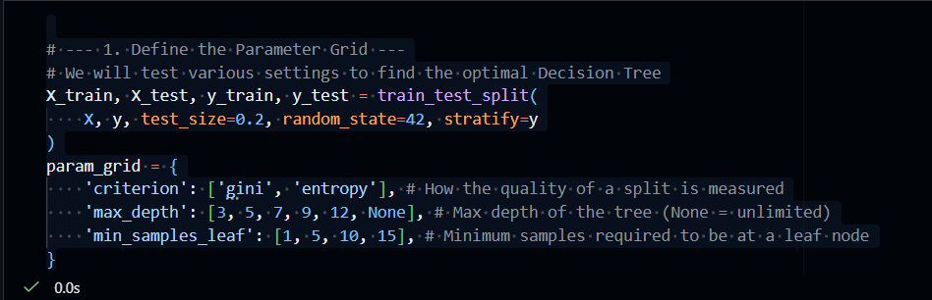
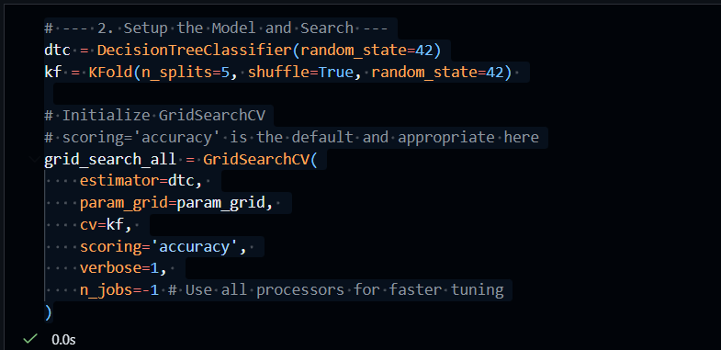

- Evaluation:
For All Features:
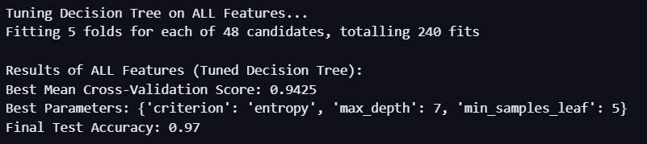
Confusion Matrix:
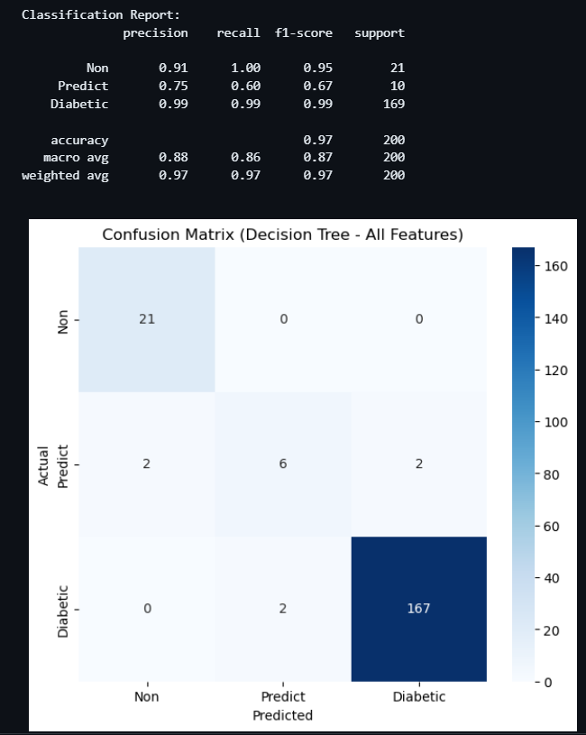
For Strong Features:
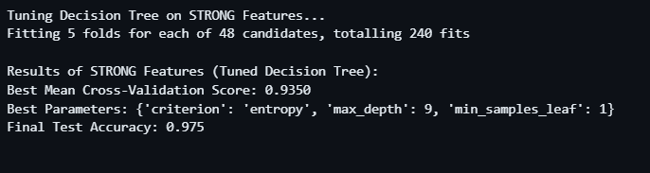
Confusion Matrix:
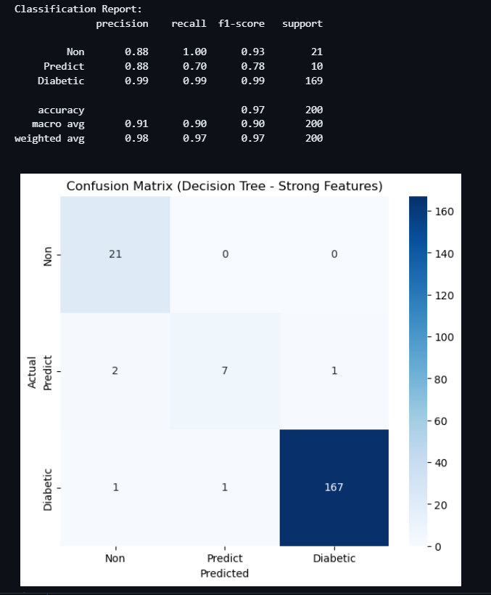

3.2 Naive Bayes
- Used CategoricalNB after discretization:
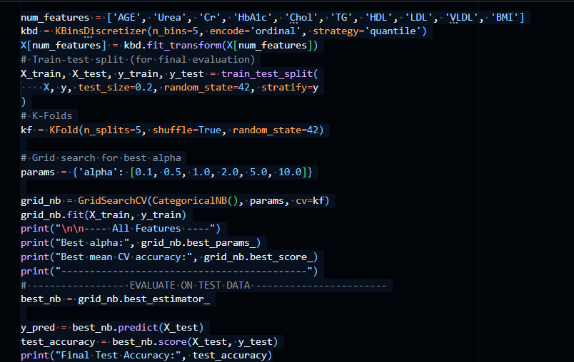
- Evaluation:
For All Features:
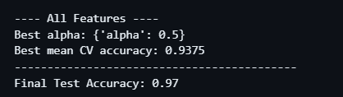
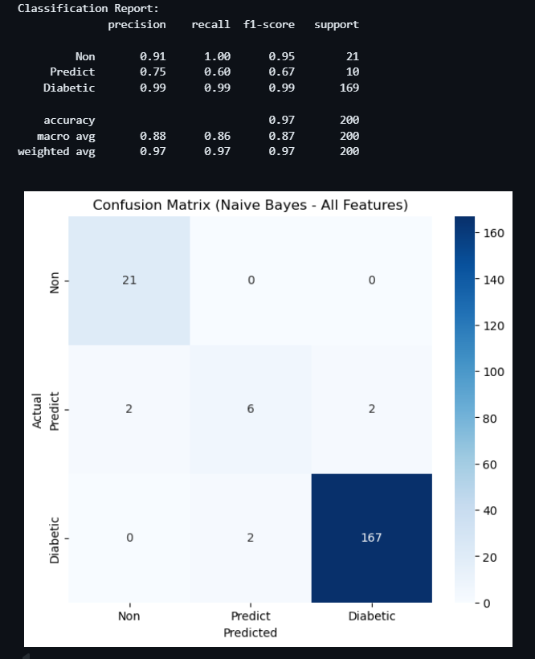
Confusion Matrix:

For Strong Features:
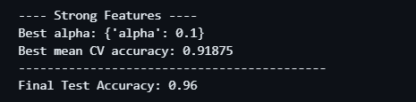
Confusion Matrix:
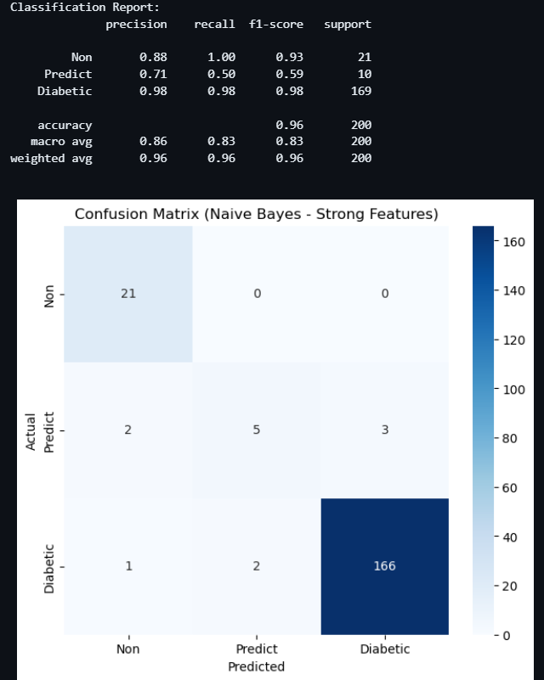

3.3 K-Nearest Neighbors (KNN)
- Applied MinMax scaling:
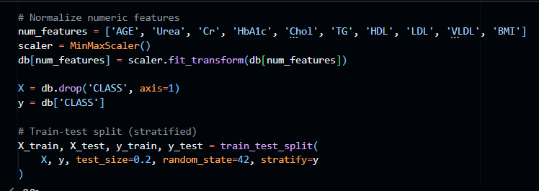
- Evaluation:
For All Features:
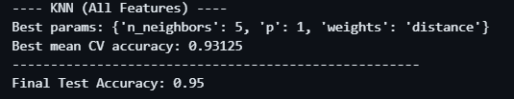
Confusion Matrix:
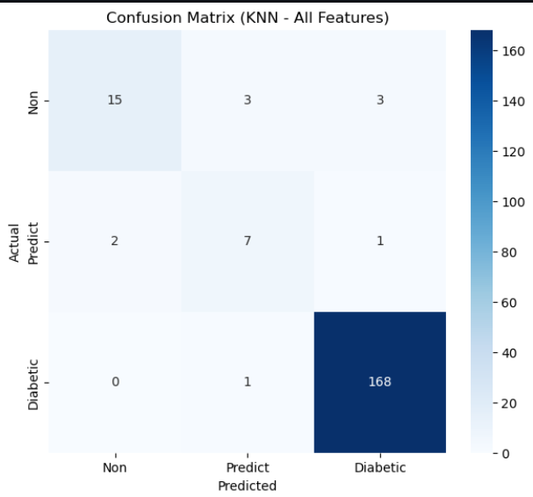
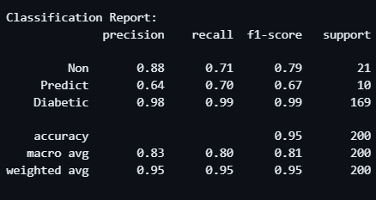

For Strong Features:
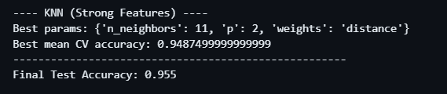
Confusion Matrix:
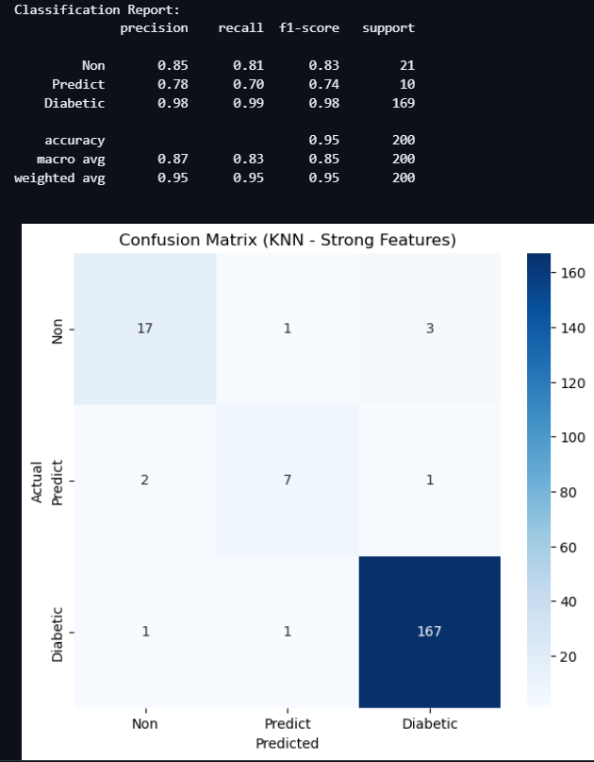

3.4 Support Vector Machine (SVM)
- Feature scaling is critical:
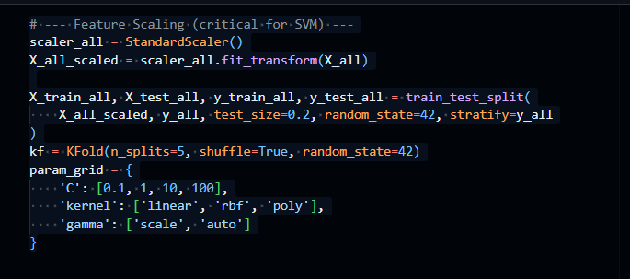
- Evaluation:
For All Features:
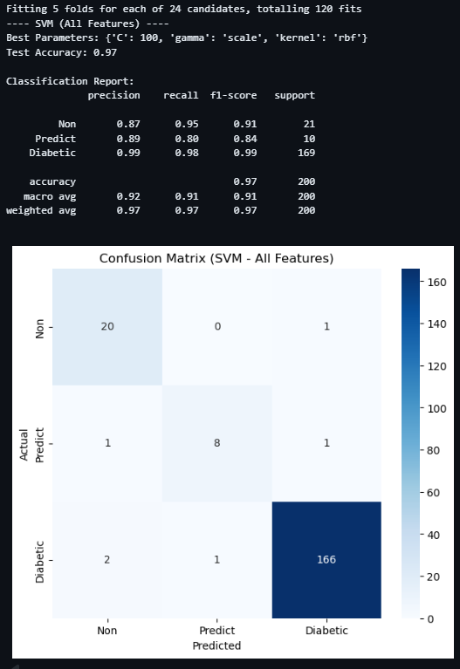

Confusion Matrix:
For Strong Features:
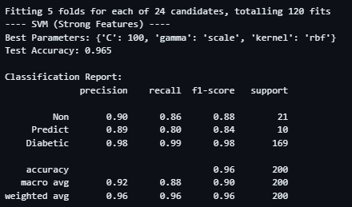

Confusion Matrix:
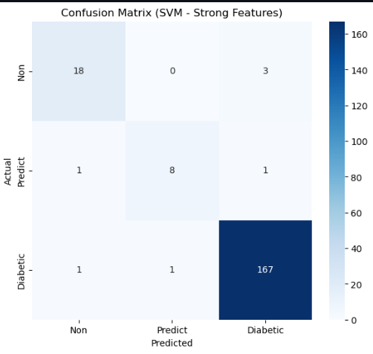

3.5 Logistic Regression
- Standard scaling applied:
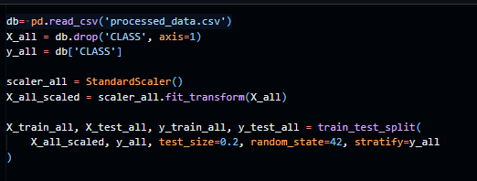

- Evaluation:
For All Features:
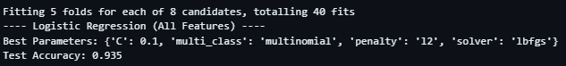
Confusion Matrix:
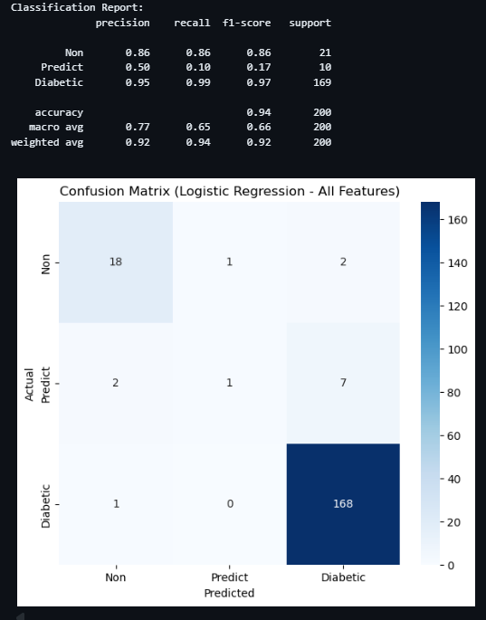

For Strong Features:
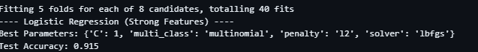
Confusion Matrix:
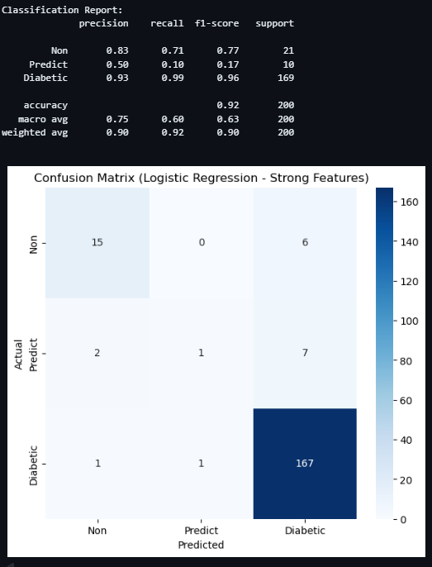

3.6 Random Forest
- Ensemble method; robust to non-linear features:
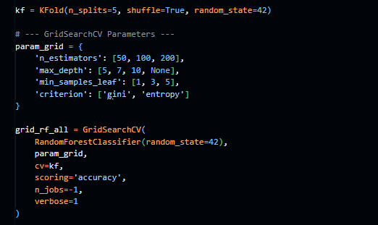
- Evaluation:
For All Features:
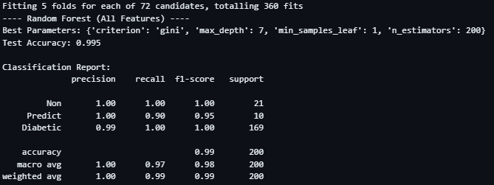

Confusion Matrix:
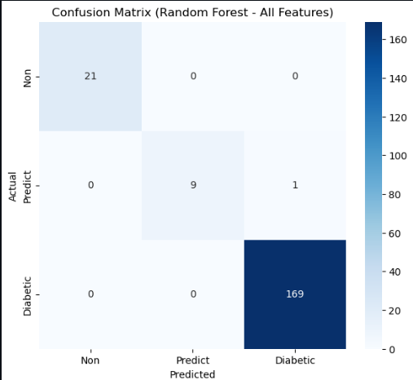
For Strong Features:
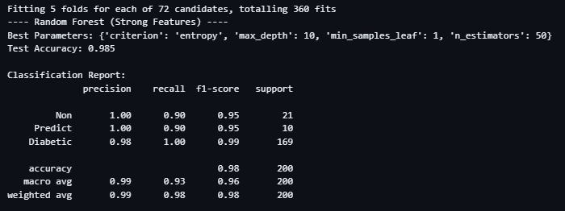

Confusion Matrix:
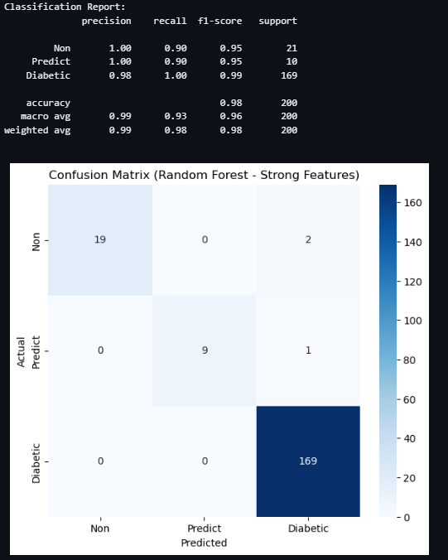

4.Used Libraries
Model | Python Library / Module
Decision Tree
Naive Bayes (Categorical)
K-Nearest Neighbors (KNN)
Support Vector Machine (SVM)
Logistic Regression
Random Forest

5.Comparison of Models

Model | Features | Test Accuracy | Precision | Recall | F1-score
Decision Tree | All | 0.97 | 0.88 | 0.86 | 0.87
Decision Tree | Strong | 0.975 | 0.91 | 0.90 | 0.90
Naive Bayes | All | 0.97 | 0.88 | 0.86 | 0.87
Naive Bayes | Strong | 0.96 | 0.86 | 0.83 | 0.83
KNN | All | 0.95 | 0.83 | 0.80 | 0.81
KNN | Strong | 0.955 | 0.87 | 0.83 | 0.85
SVM | All | 0.97 | 0.92 | 0.91 | 0.91
SVM | Strong | 0.965 | 0.92 | 0.88 | 0.90
Logistic Regression | All | 0.935 | 0.77 | 0.65 | 0.66
Logistic Regression | Strong | 0.915 | 0.75 | 0.60 | 0.63
Random Forest | All | 0.995 | 1.0 | 0.97 | 0.98
Random Forest | Strong | 0.985 | 0.99 | 0.93 | 0.96

6.Conclusion
Based on the results of the different machine learning models applied to the dataset, several important observations can be made:
Random Forest outperforms all other models.
- Using all features, it achieved the highest test accuracy (0.995), perfect precision (1.0), and very high recall (0.97) and F1-score (0.98).
- Even with the strongest features only, Random Forest still performed excellently, showing its robustness.
SVM and Decision Tree models also perform well.
- SVM with all features achieved high precision (0.92) and recall (0.91), making it a strong choice for balanced performance.
- Decision Tree improves slightly when using only the strongest features, achieving a test accuracy of 0.975.
Naive Bayes and KNN show moderate performance.
- Naive Bayes maintains consistent results with all features, but its performance drops with strong features.
- KNN shows a slight improvement when using strong features, but its overall performance is lower than Random Forest and SVM.
Logistic Regression performs the worst among all models.
- Both with all features and strongest features, it has lower precision, recall, and F1-score, indicating it may not capture the complexity of the data as well as other models.
The Random Forest model is the most accurate and reliable for this dataset, particularly when using all features. It consistently balances precision, recall, and F1-score better than other models. SVM and Decision Tree can also be considered as good alternatives, while Logistic Regression is the least suitable for this task.

