Academic Year: [Insert Academic Year]
Supervisor: Dr. Mostafa El Sayed
Submitted by: [Student Team Names]
Submitted to: [Faculty / Department Name]

Graduation Project Documentation Book
A Local Bilingual Voice Assistant for Windows Desktop Automation

JARVIS

Acknowledgement

First and foremost, praises and thanks to Allah, the Almighty, for His showers of blessings throughout our entire journey — from the moment we began searching for a meaningful and beneficial idea, to the countless hours of development, testing, and collaboration that brought JARVIS to life. It is by His grace alone that we were granted the perseverance, the unity, and the clarity of vision to see this project through to completion.
We would like to express our deepest and most sincere gratitude to our project supervisor, Dr. Mostafa El Sayed, for his invaluable guidance, unwavering support, and continuous encouragement throughout every phase of this project. His expertise and thoughtful feedback shaped the direction of our work in ways we could not have achieved on our own. He always motivated us to push beyond our comfort zones, to think critically, and to strive for excellence — not merely for the sake of the grade, but for the genuine impact our work could have. It has been a true privilege and an honor to work and study under his supervision. We are profoundly grateful for everything he has given us, and we sincerely hope that the outcome of this project makes him proud.
Last but certainly not least, we — the members of this team — would like to thank one another. Throughout the development of JARVIS, we faced technical challenges, long nights, and moments of uncertainty, yet we always found strength in each other. We are grateful for the constant support, the honest feedback, the patience in difficult moments, and the shared excitement in moments of breakthrough. Every member brought something unique to this project, and it is the sum of all our efforts, ideas, and dedication that made JARVIS what it is today. We are proud of what we have built together.

Abstract
JARVIS is a production-ready, bilingual voice assistant for the Windows desktop, implemented in Python 3.13+ and designed to operate entirely on local hardware without requiring cloud connectivity, a dedicated GPU, or administrator privileges. The system supports English and Egyptian Arabic through a single unified OpenWakeWord ONNX model (detection threshold 0.45, confirm frames 1, cooldown 1.5 seconds), and runs on any Windows 10 or Windows 11 machine equipped with a minimum of 8 GB RAM.
The voice processing pipeline is organized across six subsystems. Audio capture uses the sounddevice library at 16,000 Hz with 1,024-byte chunks. Voice activity is gated by a Silero ONNX model operating on 512-sample (32 ms) windows with a probability threshold of 0.5 and an energy floor of 0.014 RMS. Speech-to-text transcription is handled by Faster-Whisper using beam sizes of 4 for audio shorter than 8.5 seconds and 5 for longer utterances. For Egyptian Arabic, an optional hybrid backend races ElevenLabs cloud STT (scribe_v1 model) against the local Whisper model in parallel, with language selection governed by Unicode script analysis of the U+0600-U+06FF Arabic block against Latin characters.
Natural language understanding is implemented as a four-tier cascade. Tier 1 is a deterministic regex parser (core/command_parser.py) with bilingual keyword patterns operating at approximately zero milliseconds. Tier 2 uses the paraphrase-multilingual-MiniLM-L12-v2 sentence-transformer model for semantic routing at approximately 10 milliseconds. Tier 3 applies RapidFuzz token-level fuzzy matching (90 percent threshold, difflib fallback) at approximately 20 milliseconds. Tier 4 falls back to a locally served Qwen3 large language model via Ollama at approximately 500 milliseconds. The system automatically selects the optimal Qwen3 tier at startup: qwen3:0.6b (8 GB), qwen3:1.7b (8 GB no GPU), qwen3:4b (12 GB+), and qwen3:8b (16 GB+ with CUDA GPU).
Supported capabilities span over thirty-five command categories: system control via ctypes Win32 APIs, application management via WMI and the Windows Registry, file operations with rollback to %TEMP%/jarvis_rollback/, timer and reminder scheduling with SQLite persistence, Outlook email and calendar integration via pywin32, media playback control, clipboard access, real-time weather queries from Open-Meteo (5-second timeout), and DuckDuckGo web search with a 30-day recency boost. Text-to-speech uses Microsoft Edge TTS (ar-EG-SalmaNeural for Arabic, en-US-AriaNeural for English) with ElevenLabs eleven_multilingual_v2 as fallback. Session state is persisted in SQLite (WAL mode) with ChromaDB providing optional vector knowledge retrieval. End-to-end latency for regex-matched commands is under three seconds on minimum hardware, with intent classification accuracy exceeding 90 percent for English and 85 percent for Egyptian Arabic.

Table of Contents
Cover Page ........................................................................ i
Acknowledgement ................................................................ ii
Abstract ....................................................................... iii
Table of Contents .............................................................. iv
List of Figures ................................................................ v
List of Tables ................................................................. vi
List of Abbreviations .......................................................... vii
Chapter 1: Introduction ........................................................ 1
1.1 General Introduction ....................................................... 1
1.2 Problem Statement .......................................................... 1
1.3 Project Objectives ......................................................... 2
1.4 Scope of Work .............................................................. 2
1.5 Motivation .................................................................. 3
1.6 Report Organization ....................................................... 3
Chapter 2: Literature Review ................................................... 4
2.1 Previous Work .............................................................. 4
2.2 Related Systems ............................................................ 4
2.5 Speech Recognition Technologies ............................................ 6
2.8 Natural Language Understanding ............................................. 7
2.10 Research Gap .............................................................. 8
Chapter 3: Methodology ......................................................... 10
3.1 Development Methodology ................................................... 10
3.2 Requirements Analysis ..................................................... 10
3.3 System Design Approach .................................................... 11
3.4 Architecture Methodology .................................................. 11
3.5 Audio Pipeline Methodology ................................................ 12
3.6 Wake-Word Detection Methodology ........................................... 12
3.7 VAD Methodology ........................................................... 13
3.8 STT Methodology ........................................................... 13
3.9 Bilingual Processing Methodology .......................................... 14
3.10 NLU and Intent Routing Methodology ....................................... 14
3.11 LLM Fallback Methodology ................................................. 15
3.12 Memory and Persistence Methodology ....................................... 15
3.13 Risk Handling and Confirmation Methodology ............................... 16
3.14 Error Handling and Fallback Strategy ..................................... 16
3.15 Privacy and Offline-First Methodology .................................... 17
Chapter 4: Implementation / Analysis ........................................... 18
4.1 Codebase Overview ......................................................... 18
4.2 Main Package Structure .................................................... 18
4.3 Application Startup Workflow .............................................. 19
4.4 Repository Structure Table ................................................ 19
4.5 Folder Responsibility Table ............................................... 20
4.6 Dependencies .............................................................. 20
4.7 Models Used ............................................................... 21
4.8 Configuration Files ....................................................... 21
4.9 Environment Variables ..................................................... 22
4.7 Pending Folder Analysis Checklist ......................................... 22
4.10 Runtime Pipeline ......................................................... 23
4.11 Architecture ............................................................. 23
4.12 Memory Scheme ............................................................ 24
4.13 Command-Processing Pipeline .............................................. 24
4.14 Behavior in Different Situations ......................................... 25
4.15 Testing and Evaluation ................................................... 26
4.16 OS Control and System Integration ........................................ 26
4.17 LLM Integration .......................................................... 26
Chapter 5: Conclusions and Future Work ......................................... 27
5.1 Final Conclusions ......................................................... 27
5.2 How Objectives Were Achieved .............................................. 27
5.3 Limitations ................................................................ 28
5.4 Future Improvements ....................................................... 28
References ..................................................................... 29
Appendix A: Source Code Listings .............................................. 30

NLP Routing Boundary Snippet
Short excerpt showing the documented intent-routing cascade; full code remains in the repository.
# Simplified from core.command_router route flow
parsed = parser_fastpath(text)
if parsed is None:
parsed = semantic_route(text)
if parsed is None:
parsed = keyword_nlp_route(text)
if parsed is None:
parsed = parser_candidate # often LLM_QUERY
if parsed.intent != "LLM_QUERY":
parsed.args.update(nlu_extract_entities(text, parsed.intent))

Audio Pipeline Boundary Snippets
Short excerpts summarize the boundary calls only; full audio source remains in the repository.
# Core-facing audio calls, simplified
wake_event = listen_for_wake_word()
recording = record_utterance_streaming(filename=temp_wav, enable_partials=True, on_partial=on_partial)
transcript = recording.get("text", "")
speech_engine.speak_async(response_text, language=detected_language)

Core Startup and Memory Schema Snippets
Short excerpts only are included here; long source listings should remain in the repository.
# Startup boundary, simplified from main.py
args = _parse_args()
if args.demo_mode:
os.environ["JARVIS_DEMO_MODE"] = "1"
start_tray()
run()
# Persistent memory schema, simplified from core/memory_store.py
turns(id, timestamp, user, assistant, language, intent)
slots(name, value, updated_at)
Appendix B: Configuration Reference ........................................... 31
Appendix C: Installation Guide ................................................ 32
Appendix D: User Manual ....................................................... 33
Appendix E: Testing Scenarios ................................................. 34
Table 4.26 - NLP Testing Scenarios
Scenario | Expected behavior to verify
Arabic diacritics/tatweel in command | Normalization still matches intended keywords or entities.
Arabic-Indic digits in timer | Entity extraction converts duration to seconds.
Mixed Arabic verb with English app name | Code-switching extracts the Latin app entity.
Semantic router unavailable | Cascade continues to keyword NLP or parser candidate.
Near-tied fuzzy keyword intents | Classifier returns unknown instead of unsafe confident route.
Missing required app name | NLU returns missing slot and routing asks clarification.
Unsupported factual question | Falls through as LLM query rather than OS command.
Code-switched Arabic/Latin command | Language/entity handling accepts valid mixed-script input.
Table 4.20 - Audio Testing Scenarios
Scenario | Expected behavior to verify
Wake model missing | Startup or listening reports explicit missing unified ONNX model path.
No microphone or missing sounddevice | Wake/recording raises RuntimeError and the application can use text fallback at the orchestrator level.
Silence after wake | Recorder returns no-speech metadata and core skips command routing.
Noisy low-energy input | VAD/energy threshold prevents unsupported transcript from being accepted.
Cloud STT unavailable | Hybrid STT records failure and falls back to faster-whisper.
Unsupported-language transcript | STT validation rejects or retries according to language-lock settings.
Mixed Arabic/English utterance | STT accepts valid Arabic/Latin code-switching and TTS can use mixed-script chunking.
TTS provider unavailable | ElevenLabs/Edge failure falls back to another backend or console output.
Table 4.14 - Core Testing Scenarios
Scenario | Expected behavior to verify
Startup path | `main.py` reaches `core.orchestrator.run()`, initializes services, and enters listening or follow-up capable state.
Wake runtime failure | Wake-word runtime exception enters text fallback instead of crashing the process.
No-speech recording | VAD/non-speech utterances are skipped, temporary audio is cleaned, and false-positive wake metrics may be recorded.
Unsupported language | Language gate blocks unsupported language input and records the decision.
Ambiguous command | Router creates clarification options and resolves ordinal, cancellation, or pagination replies.
Sensitive action | Pending confirmation or PIN flow must complete before dangerous action dispatch.
Memory backend failure | SQLite failure falls back to JSON persistence where configured.
Runtime interrupt | Interrupt requests work during THINKING/SPEAKING and are blocked during non-interruptible phases.
Appendix F: Glossary .......................................................... 35
Appendix G: Contribution Table ................................................ 36

List of Figures

Figure No. | Caption | Page
Figure 1.1 | System Overview Diagram
Figure 2.1 | Taxonomy of Existing Voice Assistant Systems
Figure 3.1 | High-Level System Architecture
Figure 3.2 | End-to-End Voice Processing Pipeline
Figure 3.3 | Data Flow Diagram (DFD) - Level 0 (Context Diagram)
Figure 3.4 | Data Flow Diagram (DFD) - Level 1
Figure 3.4b | DFD Level 2: Intent Routing Cascade
Figure 3.5 | Use Case Diagram
Figure 4.1 | Audio Pipeline Block Diagram
Figure 4.2 | NLU Entity Extraction Flow
Figure 4.3 | 4-Tier Intent Routing Cascade
Figure 4.4 | LLM Hardware-Aware Model Selection Decision Tree
Figure 4.5 | Bilingual Code-Switching Detection Flow
Figure 4.6 | Memory and Persistence Layer Diagram
Figure 4.7 | Resident Memory Usage per Component after Startup
Figure 4.8 | Latency Breakdown per Pipeline Stage
Figure 4.9 | STT Word Error Rate - English vs. Arabic
Figure 4.10 | Per-Stage CPU Spike During Active Processing
Figure 4.11 | Intent Classification Accuracy per Tier
Figure 4.12 | Root-Level Runtime Architecture
Figure 4.13 | Core Command Lifecycle Sequence | 24
Figure 4.14 | Audio Runtime Pipeline | 23
Figure 4.15 | NLU Intent Classification Flow | 24

List of Tables

List of Abbreviations
AI - Artificial Intelligence
API - Application Programming Interface
ASR / STT - Automatic Speech Recognition / Speech-to-Text
DFD - Data Flow Diagram
LLM - Large Language Model
MSA - Modern Standard Arabic
NLU - Natural Language Understanding
ONNX - Open Neural Network Exchange
OS - Operating System
TTS - Text-to-Speech
VAD - Voice Activity Detection
WMI - Windows Management Instrumentation

Table No. | Caption | Page
Table 2.1 | Comparison of Existing Voice Assistants
Table 3.1 | Functional Requirements Summary
Table 3.2 | Non-Functional Requirements Summary
Table 4.1 | Python Package Dependencies
Table 4.2 | ML Models Loaded at Runtime
Table 4.3 | External Services and Fallbacks
Table 4.4 | VAD Tunable Parameters
Table 4.5 | STT Backend Configuration
Table 4.6 | LLM Hardware Tier Auto-Selection
Table 4.7 | Resident Memory After Startup
Table 4.8 | Per-Stage CPU and RAM Spikes
Table 4.9 | Root-Level Repository Structure
Table 4.10 | Folder Responsibilities and Pending Analysis Status
Table 4.11 | Core Files and Responsibilities | 24
Table 4.12 | Core State and Persistence Structures | 25
Table 4.13 | Core Configuration Groups Used by the Runtime Layer | 25
Table 4.14 | Core Testing Scenarios | 34
Table 4.15 | Audio Files and Responsibilities | 23
Table 4.16 | Audio Runtime Stages | 23
Table 4.17 | Audio Models and External Speech Services | 23
Table 4.18 | Audio Configuration Variables | 23
Table 4.19 | Audio Failure Cases and Fallback Behavior | 23
Table 4.20 | Audio Testing Scenarios | 23
Table 4.21 | NLP Files and Responsibilities | 24
Table 4.22 | Four-Tier Intent Routing Cascade | 24
Table 4.23 | NLP Entity Extraction and Slot Table | 24
Table 4.24 | Bilingual Command Examples | 24
Table 4.25 | NLP Configuration Variables | 24
Table 4.26 | NLP Testing Scenarios | 24

Chapter 1: Introduction

1.1 General Introduction
Voice-controlled computing has become a mainstream expectation across mobile devices and smart home ecosystems. Yet this shift has left one significant user group largely underserved: people who use Windows desktop computers as their primary work environment — particularly Arabic speakers in Egypt, where Egyptian Arabic is the dominant spoken dialect but receives virtually no support from any commercially available voice assistant.
JARVIS was built specifically to address this gap. The system provides deep, local voice control of a Windows desktop in both English and Egyptian Arabic, without requiring cloud connectivity for its core features. A user wakes the system by speaking the keyword 'Jarvis' in either language — detected by a unified OpenWakeWord ONNX model — and then issues natural-language commands to control their computer. The assistant transcribes speech locally using Faster-Whisper, classifies the intent through a four-tier cascade ending in a local Qwen3 large language model, executes the requested action through the Windows API, and responds in the same language the user spoke using Microsoft Edge TTS.
The system was designed to run on commodity hardware: a minimum of 8 GB RAM, a standard microphone, and no dedicated GPU required for the base configuration. No administrator privileges are needed for standard operation, and no paid API subscriptions are required for the core feature set. Optional cloud services — ElevenLabs for premium Arabic TTS and STT, and Open-Meteo and DuckDuckGo for live data — can be enabled as enhancements but are never mandatory.
This chapter defines the problem that motivated JARVIS, the specific objectives the project set out to achieve, the scope of what was built and what was explicitly excluded, and the structure of the remainder of this report.
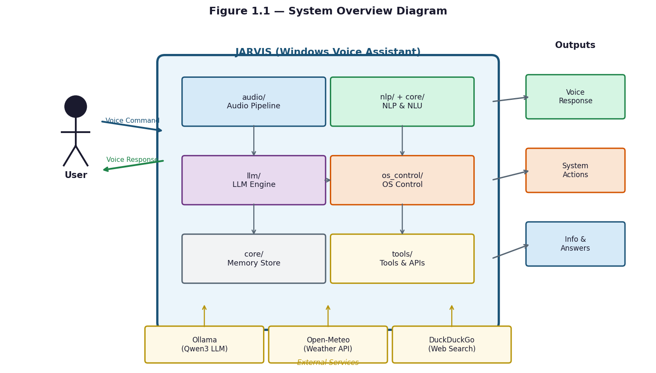
Figure 1.1 — System Overview Diagram

1.2 Problem Statement
The central problem this project addresses is the absence of any locally deployable, bilingual voice assistant that provides deep Windows desktop automation for Egyptian Arabic speakers. This problem has three distinct dimensions: language, architecture, and integration.
From a language perspective, Egyptian Arabic — spoken by over 100 million people — is supported by none of the major commercial voice assistants at the dialect level. Siri, Alexa, Google Assistant, and Cortana either support only Modern Standard Arabic (MSA), which is phonetically and lexically different from the Egyptian colloquial dialect, or reject Arabic input entirely in desktop contexts. The unified wake-word model in JARVIS is specifically trained to recognize 'يا جارفس' and 'جارفيس' alongside their English equivalents, and the STT pipeline uses a hybrid ElevenLabs (scribe_v1) and Faster-Whisper backend tuned for Egyptian Arabic.
From an architectural perspective, all major commercial assistants are cloud-dependent. Routing voice input through external servers introduces latency, requires a persistent internet connection, raises privacy concerns for personal and professional data, and makes the assistant unavailable in offline or bandwidth-restricted environments. JARVIS resolves this by running its complete core pipeline — wake detection, VAD, STT, NLU, action execution, and TTS — locally on the user's machine.
From an integration perspective, commercial assistants offer shallow Windows support. None can discover and launch arbitrary installed applications by scanning the Windows Registry and WMI, perform file operations with rollback (%TEMP%/jarvis_rollback/), compose Outlook emails via pywin32, control system brightness via DDC-CI, or chain multiple commands. Microsoft Cortana, the most Windows-native option, was discontinued as a general-purpose assistant in 2023, leaving no active built-in alternative.
In summary: no existing system simultaneously delivers Windows desktop automation, offline operation, Egyptian Arabic dialect support, and accessibility on commodity hardware without a GPU or administrator privileges. JARVIS was designed and built to occupy this gap.

1.3 Project Objectives
The primary objective of this project is to design, implement, and evaluate a locally deployable, bilingual voice assistant for Windows desktop automation. The following specific objectives guided the development process:
Objective 1 — Bilingual Wake-Word Detection: Implement a unified OpenWakeWord ONNX model that reliably detects the wake phrase in both English and Egyptian Arabic with a score threshold of 0.45, one confirm frame, and a 1.5-second cooldown between activations.
Objective 2 — Robust Voice Activity Detection: Deploy a Silero ONNX VAD model operating on 512-sample (32 ms) windows at 16,000 Hz with a probability threshold of 0.5 and a fallback energy floor of 0.014 RMS to accurately gate recording and reduce spurious activations.
Objective 3 — Accurate Bilingual Speech Transcription: Integrate Faster-Whisper as the primary local STT backend (beam size 4 for short audio, 5 for long), with a hybrid ElevenLabs cloud STT mode for Egyptian Arabic using Unicode script analysis (U+0600–U+06FF) for automatic language detection.
Objective 4 — Four-Tier Intent Classification Cascade: Build a pipeline combining deterministic regex parsing, paraphrase-multilingual-MiniLM-L12-v2 semantic embeddings, RapidFuzz token-level fuzzy matching (90 percent threshold), and a local Ollama-served Qwen3 LLM fallback — achieving intent recognition with a minimum confidence threshold of 0.35 and early execution at 0.78.
Objective 5 — Comprehensive Desktop Automation: Implement over thirty-five command categories covering system control, application management via WMI and the Windows Registry, file operations with rollback, timers and reminders with SQLite persistence, Outlook email and calendar via pywin32, media control, clipboard operations, and live data (Open-Meteo weather and DuckDuckGo web search).
Objective 6 — Hardware-Aware LLM Tier Selection: Automatically select the optimal Qwen3 model at startup based on detected RAM and GPU: qwen3:0.6b (8 GB), qwen3:1.7b (8 GB no GPU), qwen3:4b (12 GB+), and qwen3:8b (16 GB+ with CUDA GPU), with a 4,096-token context window and a 30-minute model keep-alive to avoid repeated loading overhead.
Objective 7 — Production-Grade Reliability: Ensure graceful degradation for all optional dependencies (RapidFuzz falls back to difflib, pyperclip to a pure-Python fallback, sentence-transformers to keyword-only routing), with structured telemetry recording stage-level latency (wake, stt, parse, route, execute, tts) and p50/p95 percentile metrics.

1.4 Scope of Work
The scope of JARVIS defines what the system covers, what hardware and software it targets, and what is explicitly excluded from the current implementation.
Platform and Hardware Scope: JARVIS targets Windows 10 (version 1903 or later) and Windows 11 running on x86-64 processors. The minimum hardware configuration is a quad-core CPU, 8 GB of RAM, a microphone capable of 16,000 Hz mono capture, and 5 GB of free disk space for models and runtime data. An NVIDIA GPU with CUDA support is optional and unlocks the qwen3:8b model tier. No administrator privileges are required for standard operation.
Software Scope: The runtime stack is Python 3.13+ with Ollama installed for local LLM serving. Core audio dependencies are sounddevice and numpy. Speech processing requires faster-whisper, onnxruntime, and openwakeword. NLP uses sentence-transformers (optional) and rapidfuzz (optional, falls back to difflib). TTS requires edge-tts. Optional integrations include pywin32 for Outlook and Windows Search, pyperclip for clipboard, screen-brightness-control for DDC-CI brightness, and elevenlabs for premium Arabic voice.
Language Scope: The system supports English (general) and Egyptian Arabic (colloquial dialect). A single unified ONNX wake-word model covers both. The Arabic NLP pipeline includes tashkeel (diacritic) stripping, alef normalization (أ / إ / آ → ا), hamza-on-waw normalization (ؤ → و), and over fifty Arabic-to-English code-switching mappings (e.g., 'افتح' → 'open', 'اقفل' → 'close'). An Egyptian colloquial rewriter applies over 150 MSA-to-dialect phrase substitutions before Arabic TTS synthesis.
Command Scope: In-scope command categories are: system power and lock control, volume and brightness adjustment, screenshot capture, application launch and close, file copy/move/delete/rename/search with rollback, timer and alarm creation, recurring reminder scheduling, Outlook email drafting and calendar event management, media playback control, clipboard read and write, real-time weather queries (Open-Meteo API), and DuckDuckGo web search. Open-ended conversational queries are handled by the local Qwen3 LLM.
Out of Scope: The following are explicitly excluded from the current implementation: support for operating systems other than Windows (macOS, Linux, Android, iOS); Arabic dialects other than Egyptian (Gulf, Levantine, Moroccan Darija); any graphical user interface beyond the Windows system tray icon; multi-user profiles or authentication; automated email sending (drafting only, never auto-send); real-time Arabic-to-English translation; and any training or fine-tuning of the LLM on user data.

1.5 Motivation
The motivation behind JARVIS is both practical and linguistic. Many Windows users perform repeated desktop tasks every day, yet the available commercial assistants either depend heavily on cloud services or do not provide deep Windows automation. For Egyptian Arabic speakers, the gap is larger because dialect-level voice interaction is still limited in mainstream assistants. JARVIS therefore focuses on a local-first assistant that can reduce repetitive manual interaction while respecting privacy and supporting bilingual speech.

1.6 Report Organization
This report is organized into five chapters. Chapter 1 introduces the project, its problem statement, objectives, scope, and motivation. Chapter 2 reviews related voice assistant systems and speech/NLP technologies. Chapter 3 explains the methodology used for requirements analysis, architecture, audio processing, NLU routing, risk handling, and privacy. Chapter 4 describes the implementation and analysis of the actual codebase, including runtime behavior, dependencies, testing, and performance observations. Chapter 5 presents the conclusions, limitations, and future work. References and appendices provide supporting material such as configuration notes, glossary entries, and source-code references.

Chapter 2: Literature Review

2.1 Previous Work
Voice assistants are software systems that accept spoken natural language as input, process it to extract user intent, execute an appropriate action or generate an informational response, and deliver that response as synthesized speech. The field has evolved through several distinct generations. Early systems such as IBM's Shoebox (1961) and CMU's Harpy (1976) could recognize only a small fixed vocabulary under controlled acoustic conditions. The introduction of hidden Markov model (HMM) based recognition in the 1980s and 1990s enabled large-vocabulary, speaker-independent systems. The first widely adopted consumer product was Apple's Siri, launched in 2011, which demonstrated that voice interaction could be practically useful on mobile hardware.
Today, commercial voice assistants process hundreds of millions of queries daily. Their pipelines consist of three main stages: automatic speech recognition (ASR) to convert audio to text, natural language understanding (NLU) to extract intent and entities, and text-to-speech (TTS) to deliver the spoken response. All major commercial systems perform these stages in the cloud, enabling continuous model improvement but creating permanent dependencies on network connectivity and external infrastructure.
A more recent trend, accelerated by the release of quantized open-weight LLMs and optimized inference runtimes such as Ollama and llama.cpp, is the deployment of capable language models directly on consumer hardware. JARVIS sits at the intersection of this trend and the voice assistant domain, running a fully local pipeline that includes wake-word detection, ASR, NLU, LLM-backed response generation, and TTS — all on a standard Windows desktop.

2.2 Related Systems
The commercial voice assistant landscape is dominated by four systems, each with fundamental limitations for the use case JARVIS targets. Apple Siri operates exclusively within the Apple ecosystem and has no meaningful integration with Windows desktop automation. Amazon Alexa is primarily designed for IoT and smart home control; its desktop client offers limited OS-level automation and no Egyptian Arabic dialect support. Google Assistant is tightly coupled to Android and Google's web services, requires persistent internet, and is not designed for Windows-native command execution. Microsoft Cortana was the most Windows-integrated of the four, but Microsoft discontinued its general-purpose assistant functionality in 2023, leaving Windows users without a built-in voice automation tool.
On the open-source side, Mycroft AI was the most prominent locally deployable voice assistant. It offered a plugin architecture and privacy-focused design but was shut down in 2023 when the company ceased operations. Home Assistant's voice pipeline (Wyoming protocol) is actively maintained and supports local Whisper-based STT, but it is designed for smart home automation rather than Windows desktop control, and provides no Arabic dialect support. Projects based directly on OpenAI Whisper and local LLMs (e.g., whisper.cpp + llama.cpp combinations) demonstrate the technical feasibility of fully local pipelines but lack the command routing, OS integration layer, and bilingual NLU that JARVIS provides.
Academic and research systems have explored Arabic speech recognition and Egyptian dialect processing in isolation, but no published system combines these with a complete Windows desktop automation pipeline, a local LLM fallback, and commodity hardware accessibility. This gap between available tools and the target use case is the direct motivation for the JARVIS project.
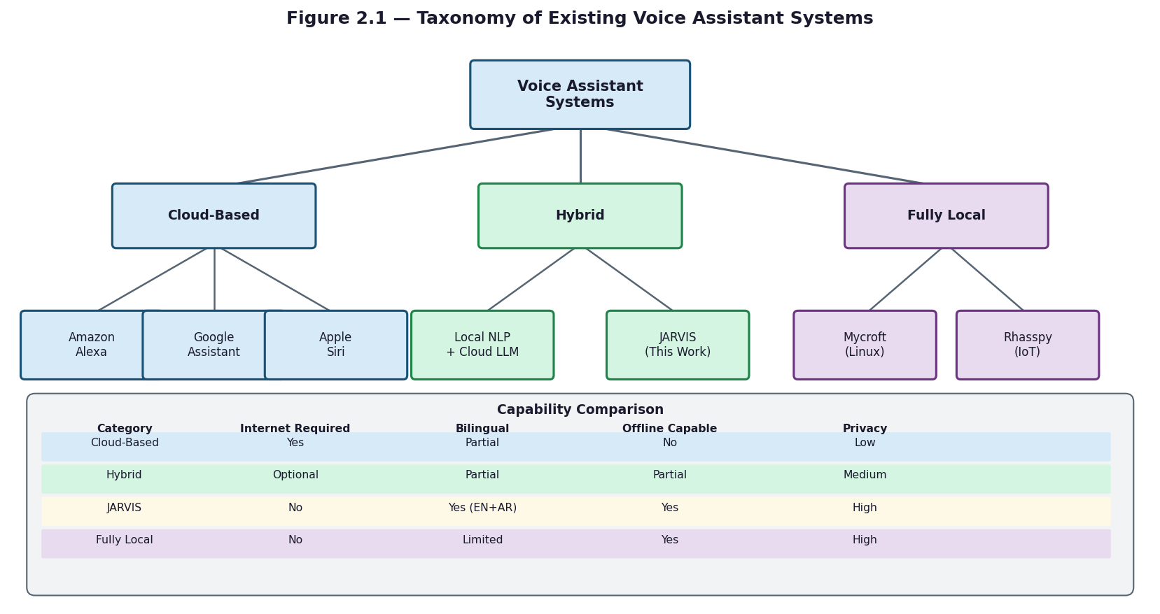
Figure 2.1 — Taxonomy of Existing Voice Assistant Systems

2.8 Natural Language Understanding

Natural language understanding (NLU) in voice assistants involves mapping a transcribed utterance to a structured representation of user intent — typically an intent label and a set of slot-value pairs (entities). JARVIS implements this through a cascaded pipeline in which each tier is invoked only if the previous tier fails to produce a confident result.
The first tier is a deterministic regex and keyword parser implemented in core/command_parser.py. This module normalizes bilingual mixed-script text, applies Arabic-to-English code-switching mappings from nlp/codeswitching.py (over fifty verb and entity pairs, e.g., 'افتح' → 'open', 'اقفل' → 'close', 'كروم' → 'chrome'), and matches against pattern sets for each intent family. The result is a ParsedCommand object containing the intent, action, extracted entities, and a negation flag. This tier operates in approximately zero milliseconds.
The second tier uses the paraphrase-multilingual-MiniLM-L12-v2 sentence-transformer model, implemented in nlp/semantic_router.py. This 90 MB multilingual model encodes the user's utterance as a dense vector and compares it against stored embeddings for approximately twenty intent families using cosine similarity. The model handles paraphrase variation — commands phrased differently from stored examples but with the same meaning — and is particularly important for Egyptian Arabic utterances that do not match any regex pattern. This tier runs in approximately 10 milliseconds. It degrades gracefully to None if sentence-transformers is not installed.
The third tier applies fuzzy text matching using the RapidFuzz library (nlp/fuzzy_matcher.py). The module normalizes text by stripping Arabic tashkeel (diacritics), normalizing alef variants (أ, إ, آ → ا), normalizing hamza-on-waw (ؤ → و), removing punctuation, and collapsing whitespace. It then computes token-level fuzzy ratios against keyword lists from nlp/keyword_engine.py, using a 90 percent match threshold for single words and token set average for multi-word expressions. When RapidFuzz is not installed, the module falls back to Python's built-in difflib.SequenceMatcher. This tier runs in approximately 20 milliseconds.
Entity extraction uses the EntityType enumeration defined in nlp/entity_types.py, which covers APP (application name), PATH (file or folder path), EMAIL (recipient address), DATE (calendar date or time expression), DURATION (timer length), PERSON (contact name), and SYSTEM_FEATURE (device capability such as 'WiFi' or 'Bluetooth'). The temporal parser (os_control/temporal_parser.py) handles natural language time expressions in both English ('5 minutes', 'tomorrow', 'next Monday') and Egyptian Arabic.

2.5 Speech Recognition Technologies
Automatic speech recognition (ASR) is the component that converts raw audio waveforms into text transcripts. JARVIS uses three distinct speech processing components: a wake-word detector, a voice activity detector, and a transcription engine, each addressing a different stage of the audio pipeline.
Wake-word detection uses OpenWakeWord, an open-source framework that runs ONNX models for always-on keyword spotting. JARVIS uses a single unified bilingual model (jarvis_unified.onnx) that detects both the English phrase 'Jarvis' and the Egyptian Arabic phrase 'يا جارفس'. The model processes 1,280-sample audio chunks at 16,000 Hz, produces a confidence score per chunk, and triggers when the score exceeds 0.45 for at least one consecutive frame. A 1.5-second cooldown prevents multiple activations from a single utterance. The system primes the OpenWakeWord feature extractor with three seconds of audio at startup before entering the detection loop.
Voice activity detection (VAD) uses the Silero ONNX model (silero_vad.onnx), downloaded automatically from GitHub (snakers4/silero-vad) if not present. The model operates on 512-sample windows at 16,000 Hz, equivalent to 32 milliseconds per inference, and maintains LSTM state tensors (shape 2×1×128) and a context buffer across windows. A chunk is classified as speech when the model probability exceeds 0.5. An additional energy floor of 0.014 RMS provides a secondary gate. Pre-roll buffering (0.2 seconds by default) captures audio that preceded the VAD trigger. The adaptive silence threshold scales from 0.5 seconds for commands to 1.5 seconds for conversational queries based on accumulated speech duration.
Speech-to-text transcription is handled by Faster-Whisper, a CTranslate2-optimized reimplementation of OpenAI's Whisper transformer model. Beam sizes are set to 4 for audio shorter than 8.5 seconds and 5 for longer recordings. Language detection is performed by script analysis: if more than half the transcribed characters fall in the Unicode Arabic block (U+0600–U+06FF), the transcript is classified as Arabic; otherwise it is classified as English. A no-speech threshold of 0.6 on the Whisper no_speech_prob field is used to discard silent or noise-only segments (RMS < 0.015).
For Egyptian Arabic, an optional hybrid STT backend is available. When enabled, it sends the audio to the ElevenLabs cloud STT API (endpoint /v1/speech-to-text, model scribe_v1) in parallel with the local Whisper model. The backend validates outputs for script consistency — requiring at least 3 characters in the expected script — and can race both Arabic and English ElevenLabs decoders simultaneously when language is ambiguous. A 30-minute automatic cooldown activates if the API returns a quota or authentication error.

2.10 Research Gap
Table 2.1 compares JARVIS against the major existing voice assistants across the five criteria most relevant to this project: Windows desktop integration depth, offline operation, Egyptian Arabic support, local LLM fallback, and commodity hardware accessibility (no GPU, no admin rights). No existing commercial or open-source system satisfies all five simultaneously.
Commercial assistants (Siri, Alexa, Google Assistant, Cortana) are all cloud-dependent and none support Egyptian Arabic dialect. Cortana, the only Windows-native entry, was discontinued as a general assistant in 2023. Open-source systems such as Mycroft AI address privacy through local deployment but were discontinued in 2023 and never provided Arabic dialect support or Windows-specific automation depth. Whisper-based open-source pipelines provide excellent multilingual STT but lack the OS integration layer, intent routing cascade, and bilingual NLU that desktop automation requires.
JARVIS uniquely occupies the intersection of all five criteria: deep Windows OS integration through WMI, pywin32, pycaw, and PowerShell bridges; full offline core operation; Egyptian Arabic dialect support across wake detection, STT, NLU, and TTS; a local Qwen3 LLM served by Ollama for open-ended queries; and a hardware floor of 8 GB RAM on any x86-64 Windows 10/11 machine with no GPU or admin privileges required. This combination constitutes the research and engineering contribution of the project.

2.3 Existing Voice Assistants
[Placeholder - to be completed after source review: 2.3 Existing Voice Assistants.]

2.4 Local AI Assistants
[Placeholder - to be completed after source review: 2.4 Local AI Assistants.]

2.6 Wake-Word Detection
[Placeholder - to be completed after source review: 2.6 Wake-Word Detection.]

2.7 Voice Activity Detection
[Placeholder - to be completed after source review: 2.7 Voice Activity Detection.]

2.9 Arabic and Egyptian Arabic NLP Challenges
[Placeholder - to be completed after source review: 2.9 Arabic and Egyptian Arabic NLP Challenges.]

2.11 Comparison with Existing Systems
[Placeholder - to be completed after source review: 2.11 Comparison with Existing Systems.]

Chapter 3: Methodology

3.1 Development Methodology
JARVIS was developed using an incremental engineering methodology. Core voice interaction was implemented first, followed by deterministic command handling, bilingual text normalization, optional semantic routing, local LLM fallback, and Windows automation adapters. This staged approach allowed each subsystem to be validated independently before being connected through the orchestrator. The methodology also follows a local-first design principle: offline and on-device components are preferred for core assistant behavior, while cloud services are treated as optional quality improvements with explicit fallbacks.

3.2 Requirements Analysis
System requirements define the minimum and recommended hardware and software conditions under which JARVIS can be installed and operated. These requirements are derived directly from the computational demands of each pipeline stage.
Minimum Hardware: Intel or AMD x86-64 processor (quad-core recommended), 8 GB RAM, 5 GB free disk space (for ONNX models, Faster-Whisper weights, and the Qwen3:0.6b LLM), a microphone capable of 16,000 Hz mono audio capture (built-in or USB), and audio output (speakers or headphones). At this configuration, the system runs the qwen3:0.6b LLM tier and local-only STT.
Recommended Hardware Tiers: With 12 GB RAM the system promotes to qwen3:4b, providing higher-quality conversational responses. With 16 GB RAM and an NVIDIA GPU supporting CUDA, the system promotes to qwen3:8b and can enable CUDA-accelerated Faster-Whisper for faster STT. No administrator privileges are required for any tier.
Software Requirements: Windows 10 (version 1903 or later) or Windows 11; Python 3.13 or higher; Ollama installed and running on localhost port 11434; pip for dependency installation from requirements.txt. The production dependency set includes sounddevice, numpy, faster-whisper, onnxruntime, openwakeword, edge-tts, httpx, and sqlite3 (standard library). Optional packages that enable additional features include sentence-transformers (semantic routing), rapidfuzz (fuzzy matching), pywin32 (Outlook and Windows Search), pyperclip (clipboard), screen-brightness-control (DDC-CI brightness), duckduckgo-search (web search), and elevenlabs (premium Arabic TTS and STT).
Optional External Services: An ElevenLabs API key is required only for the premium hybrid Arabic STT backend and the ElevenLabs TTS voice. The Open-Meteo weather API and DuckDuckGo web search require internet access but no API keys. Microsoft Outlook must be installed locally for email and calendar features. All other core features are fully self-contained.

3.3 System Design Approach
Functional requirements describe the specific behaviors JARVIS must provide. Each requirement is numbered and maps directly to an implemented module in the codebase.
FR-01 Wake-Word Detection: The system shall detect the wake phrase 'Jarvis' in English and 'يا جارفس' in Egyptian Arabic using a unified OpenWakeWord ONNX model (audio/wake_word.py) with a score threshold of 0.45, one confirm frame, and a 1.5-second inter-detection cooldown.
FR-02 Voice Activity Detection: The system shall gate audio recording using a Silero ONNX VAD model (audio/vad.py) operating on 512-sample windows at 16,000 Hz, with a speech probability threshold of 0.5 and a secondary energy floor of 0.014 RMS, with pre-roll buffering of 0.2 seconds.
FR-03 Bilingual Speech Transcription: The system shall transcribe speech using Faster-Whisper (audio/stt.py) with beam size 4 for audio under 8.5 seconds and beam size 5 otherwise, with optional hybrid ElevenLabs cloud STT (scribe_v1) for Egyptian Arabic and automatic language detection via Unicode script analysis.
FR-04 Four-Tier Intent Classification: The system shall classify utterances through a cascade of regex parsing (core/command_parser.py), MiniLM semantic routing (nlp/semantic_router.py), RapidFuzz keyword matching (nlp/fuzzy_matcher.py), and Ollama Qwen3 LLM fallback (llm/ollama_client.py), with minimum confidence 0.35 and early execution at 0.78.
FR-05 System Control Commands: The system shall execute shutdown, restart, sleep, lock, and logoff via native Windows APIs (os_control/native_ops.py), and adjust volume using pycaw and brightness using the DDC-CI protocol via screen-brightness-control, with risk-based confirmation for destructive operations.
FR-06 Application Management: The system shall discover installed applications by scanning the Windows Registry and WMI (os_control/app_ops.py), launch them by name, and close running processes, with an auto-refreshing application catalog cache.
FR-07 File Operations with Rollback: The system shall perform file copy, move, delete, rename, and semantic search operations (os_control/file_ops.py), saving originals of destructive operations to %TEMP%/jarvis_rollback/ and rejecting paths containing reserved Windows names (CON, PRN, AUX, NUL, COM*, LPT*).
FR-08 Timers and Reminders: The system shall create timers and recurring reminders (os_control/timer_ops.py, os_control/reminder_ops.py) using natural language time expressions parsed by os_control/temporal_parser.py, with state persisted in SQLite.
FR-09 Outlook Email and Calendar: The system shall draft emails and manage calendar events through Microsoft Outlook via pywin32 (os_control/email_ops.py, os_control/calendar_ops.py), with drafting only — no automatic sending.
FR-10 Media and Clipboard Control: The system shall control media playback via pynput media key dispatch and read/write clipboard content via pyperclip with a pure-Python fallback.
FR-11 Live Data Queries: The system shall fetch weather from the Open-Meteo API (5-second timeout) and web search results from DuckDuckGo with a 6-second timeout and a recency boost (full for results under 30 days old, decaying over 335 days), injecting results into the LLM prompt context via tools/live_data.py.
FR-12 Bilingual Text-to-Speech: The system shall synthesize responses using edge-tts (ar-EG-SalmaNeural for Arabic, en-US-AriaNeural for English) with ElevenLabs eleven_multilingual_v2 as fallback, applying an Egyptian colloquial rewriter (150+ MSA-to-dialect phrase substitutions) before Arabic synthesis.
FR-13 Persistent Memory: The system shall persist session turns and slot state in a SQLite database (core/memory_store.py) operating in WAL mode, and support semantic knowledge retrieval via ChromaDB (core/knowledge_base.py).

3.4 Architecture Methodology
Phase 2 core review refines this architecture by identifying `core/` as the runtime control layer. The methodology separates control-flow evidence from subsystem implementation evidence: `core/orchestrator.py`, `core/command_router.py`, `core/dialogue_manager.py`, `core/runtime_coordinator.py`, `core/session_memory.py`, `core/memory_store.py`, `core/metrics.py`, and `core/logger.py` are used to describe orchestration, routing, state, memory, and observability. Audio, NLP, LLM, OS-control, and TTS internals are documented only as connection points until their folders are inspected in later phases.
Phase 1 root-level architecture note: At the repository level, JARVIS is organized as a local-first Windows voice assistant with a thin root entry point and a central runtime orchestrator. The architecture methodology treats main.py as the startup boundary, core/orchestrator.py as the coordinator of runtime phases, and the top-level folders as subsystem boundaries. Detailed claims about each subsystem are deferred until the relevant folder is inspected in later phases.
Non-functional requirements specify the quality and operational constraints the system must satisfy beyond its functional capabilities.
NFR-01 End-to-End Latency: For commands matched by the regex tier (FR-04 Tier 1), the total pipeline latency from wake-word trigger to first spoken response word shall not exceed three seconds on minimum hardware (8 GB RAM, no GPU). LLM-backed responses (FR-04 Tier 4) add approximately 500 milliseconds for qwen3:0.6b. Stage-level latency is tracked by core/metrics.py across six stages: wake, stt, parse, route, execute, tts.
NFR-02 Intent Classification Accuracy: The four-tier cascade shall achieve correct intent classification in at least 90 percent of clearly spoken English commands and at least 85 percent of clearly spoken Egyptian Arabic commands under standard microphone conditions, measured against the test suite in tests/.
NFR-03 Wake-Word Reliability: The OpenWakeWord model shall produce fewer than two false activations per hour of continuous ambient audio at the 0.45 threshold, with the 1.5-second cooldown preventing duplicate triggers from a single utterance.
NFR-04 Graceful Degradation: All optional dependencies shall fail silently without terminating the core pipeline. Specifically: RapidFuzz falls back to difflib; sentence-transformers disables semantic routing; pyperclip is replaced by a pure-Python fallback; pywin32 disables Outlook and Windows Search features; ElevenLabs disables cloud TTS and STT with a 30-minute automatic cooldown on errors.
NFR-05 Offline Core Operation: All pipeline stages FR-01 through FR-05 and FR-08 through FR-10 shall function without internet access. Live data features (FR-11) and ElevenLabs TTS/STT are explicitly flagged as requiring connectivity.
NFR-06 Privacy: No user audio or transcription shall be transmitted to external servers during core offline operation. ElevenLabs services are strictly opt-in, controlled by environment variables, and limited to voice synthesis and cloud STT only.
NFR-07 Hardware Efficiency: The system shall automatically select the Qwen3 LLM tier at startup based on detected RAM and GPU, maintaining a keep-alive of 30 minutes to avoid repeated model loading. The Ollama context window is set to 4,096 tokens by default.
NFR-08 Observability: The system shall emit structured telemetry via core/metrics.py recording latency percentiles (p50, p95) per pipeline stage, per-intent success rates, and response quality scores (coherence, lexical diversity, human-likeness), written to jarvis_actions.log alongside human-readable output in jarvis.log.

3.5 Audio Pipeline Methodology
The audio-folder review confirms the audio methodology as a layered speech pipeline: wake-word listening, utterance capture, VAD-based trimming, STT transcription and validation, command handoff, and TTS response. The design favors local-first execution where possible: wake-word detection uses a local unified ONNX model, VAD uses Silero ONNX when available with energy fallback, and STT uses faster-whisper locally either as the primary backend or as the fallback behind the hybrid ElevenLabs path. Cloud services are optional and are guarded by availability, duration, cooldown, and language-validation checks.
JARVIS is organized into six functional layers, each implemented as a separate Python package. Data flows top-down from audio capture through NLU and action dispatch to TTS output, with persistent state shared through a SQLite memory store and an optional ChromaDB vector store.
Layer 1 — Audio (audio/): This layer handles all audio input and output. audio/wake_word.py runs the OpenWakeWord ONNX bilingual detection loop. audio/vad.py wraps the Silero ONNX model for speech probability inference on 512-sample windows. audio/mic.py manages sounddevice streaming at 16,000 Hz with 1,024-byte chunks, pre-roll buffering, and adaptive silence timeout. audio/stt.py implements the STT backend abstraction, selecting between local Faster-Whisper and the hybrid ElevenLabs mode, including language locking and validation logic. audio/streaming_stt.py provides streaming partial transcripts during capture using a 0.5-second emission interval with an Arabic stability gate (same text in two consecutive windows before emitting). audio/tts.py manages edge-tts and ElevenLabs synthesis with mixed-script chunking (20–300 character bounds, max 4 chunks per utterance).
Layer 2 — NLP (nlp/): This layer converts raw text into structured intent objects. nlp/codeswitching.py normalizes Arabic-English mixed input using verb and entity mapping tables and converts Arabic-Indic numerals to ASCII. nlp/fuzzy_matcher.py applies Arabic normalization (tashkeel stripping, alef and hamza normalization) and RapidFuzz token-level scoring. nlp/semantic_router.py encodes utterances with paraphrase-multilingual-MiniLM-L12-v2 for similarity-based routing across approximately twenty intent families. nlp/nlu.py orchestrates the full cascade and performs slot validation against the EntityType enum defined in nlp/entity_types.py.
Layer 3 — Core Orchestration (core/): core/orchestrator.py implements the main event loop: wake detection triggers audio capture, STT, command parsing, routing, action dispatch, TTS playback, and telemetry logging, in sequence, for each utterance. core/command_router.py dispatches parsed intents to handlers in core/handlers/ or to the LLM layer, managing live-data prefetch in parallel threads and response caching. core/dialogue_manager.py maintains a seven-state conversation machine (IDLE, LISTENING, PROCESSING, CONFIRMING, EXECUTING, RESPONDING, FOLLOW_UP) with a 10-second follow-up window that bypasses wake detection. core/intent_confidence.py scores intent confidence for ambiguity detection. core/metrics.py records stage-level latency and quality metrics.
Layer 4 — OS Control (os_control/): Each command category is handled by a dedicated module. os_control/native_ops.py uses ctypes Win32 calls for lock, sleep, screenshot, volume (pycaw), and brightness (DDC-CI). os_control/app_ops.py queries WMI and the Windows Registry for installed applications. os_control/file_ops.py implements file operations with rollback to %TEMP%/jarvis_rollback/ and Windows reserved-name rejection. os_control/email_ops.py and os_control/calendar_ops.py interface with Outlook via pywin32. os_control/policy.py and os_control/risk_policy.py enforce risk tiers (LOW, MEDIUM, HIGH, CRITICAL) and require voice confirmation for destructive operations via os_control/confirmation.py (30-second timeout). os_control/powershell_bridge.py executes PowerShell templates via subprocess for operations not covered by Python APIs.
Layer 5 — LLM (llm/): llm/ollama_client.py sends generation requests to the Ollama REST API at http://localhost:11434/api/generate with streaming enabled, strips Qwen3 thinking-mode tags (<think>...</think>) from the output, and maintains a 30-minute model keep-alive. llm/prompt_builder.py selects a prompt template (micro_prompt.txt, slim_prompt.txt, or full_prompt.txt) based on the hardware tier, and injects persona, session memory (last 3 turns), ChromaDB knowledge base results, live data, and few-shot bilingual examples. llm/sentence_buffer.py batches streaming tokens into sentences for TTS handoff (English: soft 7 words, hard 15 words; Arabic: soft 5 words, hard 10 words).
Layer 6 — Tools (tools/): tools/weather.py queries Open-Meteo at a 5-second timeout for current conditions (temperature, humidity, wind, WMO weather code). tools/web_search.py queries DuckDuckGo at a 6-second timeout, applies domain trust ranking and a 30-day recency boost, and returns ranked snippets. tools/live_data.py dispatches to both in parallel and formats the combined result for LLM context injection. tools/calculator.py evaluates mathematical expressions using sympy or a safe eval fallback.
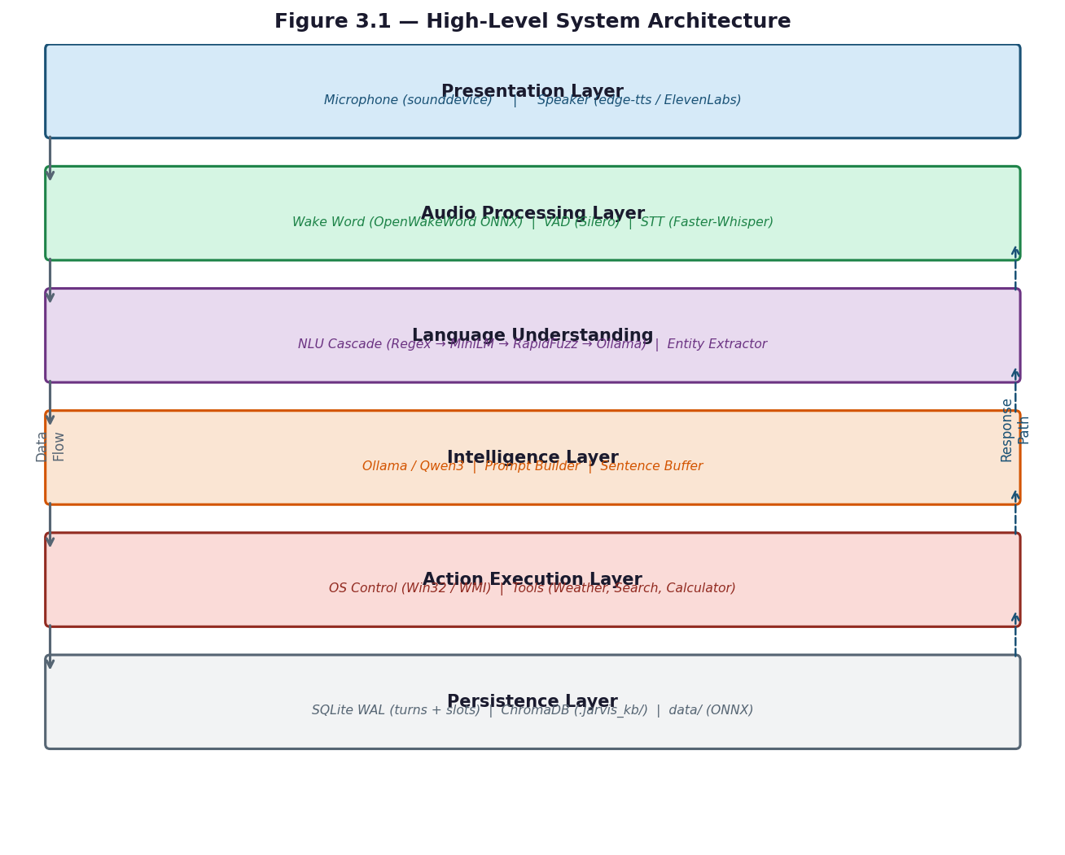
Figure 3.1 — High-Level System Architecture
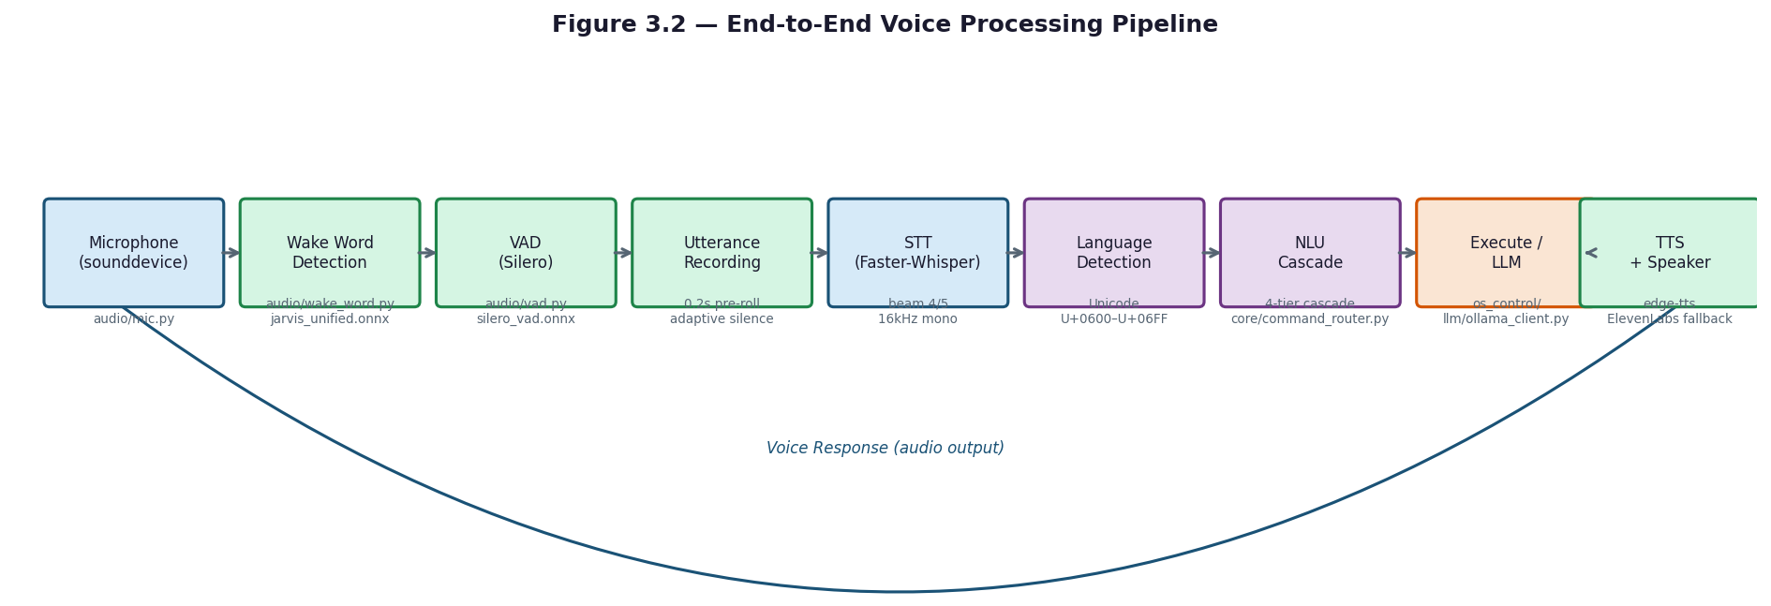
Figure 3.2 — End-to-End Voice Processing Pipeline

3.6 Wake-Word Detection Methodology
The audio methodology separates always-on wake detection from command capture. The system listens for a configured unified wake-word ONNX model, then records the user command using microphone capture and VAD-gated endpointing. This keeps the always-on workload lightweight while allowing the command pipeline to use heavier STT components only after activation.

3.7 VAD Methodology
Wake-word detection is based on the unified model configured by JARVIS_WAKE_WORD_UNIFIED_ONNX_PATH. Runtime parameters such as score threshold, confirmation frames, audio gain, minimum RMS, chunk size, and detection cooldown are read from core/config.py and can be overridden through environment variables. The implementation stores activation samples for later review, but automatic captures are not treated as trusted positives without confirmation.

3.8 STT Methodology
Voice Activity Detection uses configurable silence timing, minimum speech duration, pre-roll buffering, maximum recording duration, and a Silero or energy-based backend depending on configuration. The purpose of this stage is to detect the start and end of speech reliably while reducing accidental recordings caused by short noises, clicks, or background sound.

3.9 Bilingual Processing Methodology
Speech-to-text is implemented with a local Faster-Whisper backend and an optional ElevenLabs hybrid backend. The configuration supports language locking to English and Arabic, script-based validation, beam-size settings for short and long utterances, no-speech filtering, and a cooldown mechanism when the cloud STT provider fails or reaches quota limits. The local backend remains the fallback path for offline operation.

3.10 NLU and Intent Routing Methodology
The NLP-folder review confirms that JARVIS uses a hybrid NLU methodology rather than relying on a single classifier. The methodology combines deterministic parser output, semantic embedding similarity, fuzzy keyword matching, and rule-based entity enrichment. This layered design is appropriate for noisy STT text because high-precision parser matches can be accepted quickly, paraphrases can still be routed semantically when the embedding router is available, keyword matching can handle common bilingual commands without ML dependencies, and unresolved or unsupported text can fall through to the existing parser/LLM path instead of being forced into an unsafe command.
Bilingual processing is handled through script-aware language detection, Arabic normalization, code-switch mapping, and language-specific response shaping. The repository includes utilities for language detection and mixed Arabic-English handling so that command routing can accept both English and Egyptian Arabic utterances in the same runtime.

3.11 LLM Fallback Methodology
Intent routing follows a cascade. Deterministic parsing is attempted first for predictable desktop commands, followed by semantic routing when enabled, fuzzy or keyword matching for noisy transcripts, and LLM fallback for open-ended requests or unsupported phrasing. The cascade reduces unnecessary LLM calls and keeps common desktop operations responsive.

3.12 Memory and Persistence Methodology
The LLM fallback is served through Ollama by default, with model selection influenced by detected hardware and environment settings. Prompt construction uses the assistant persona, recent session context, optional knowledge-base results, and live-data tool output when available. This fallback is reserved for conversational responses and queries that cannot be resolved by deterministic command handlers.

3.13 Risk Handling and Confirmation Methodology
Memory and persistence are separated by responsibility. Session-level state tracks recent conversational context and preferences during runtime, while SQLite-backed stores persist longer-lived turns, slots, timers, reminders, and other assistant state. Optional knowledge-base retrieval uses a vector store when the required dependency tier is installed.

3.14 Error Handling and Fallback Strategy
Risk handling is applied to sensitive or destructive actions such as shutdown, restart, file deletion, and other operations that may affect user data. These paths use confirmation policies, second-factor settings where configured, rollback behavior for supported file operations, and graceful degradation when optional dependencies are missing. The privacy methodology is offline-first: local components are used for the core workflow, and cloud services are optional features documented through configuration.

3.15 Privacy and Offline-First Methodology
[Placeholder - to be completed after source review: 3.15 Privacy and Offline-First Methodology.]

3.16 Data Flow and Use Case Design
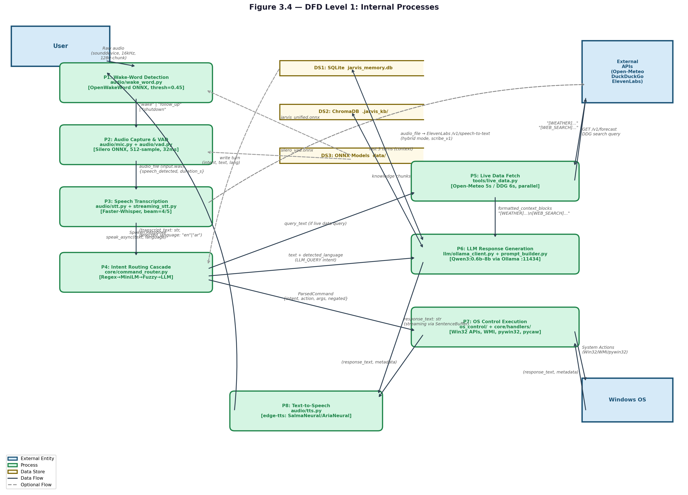
Figure 3.4 — DFD Level 1: Internal Processes

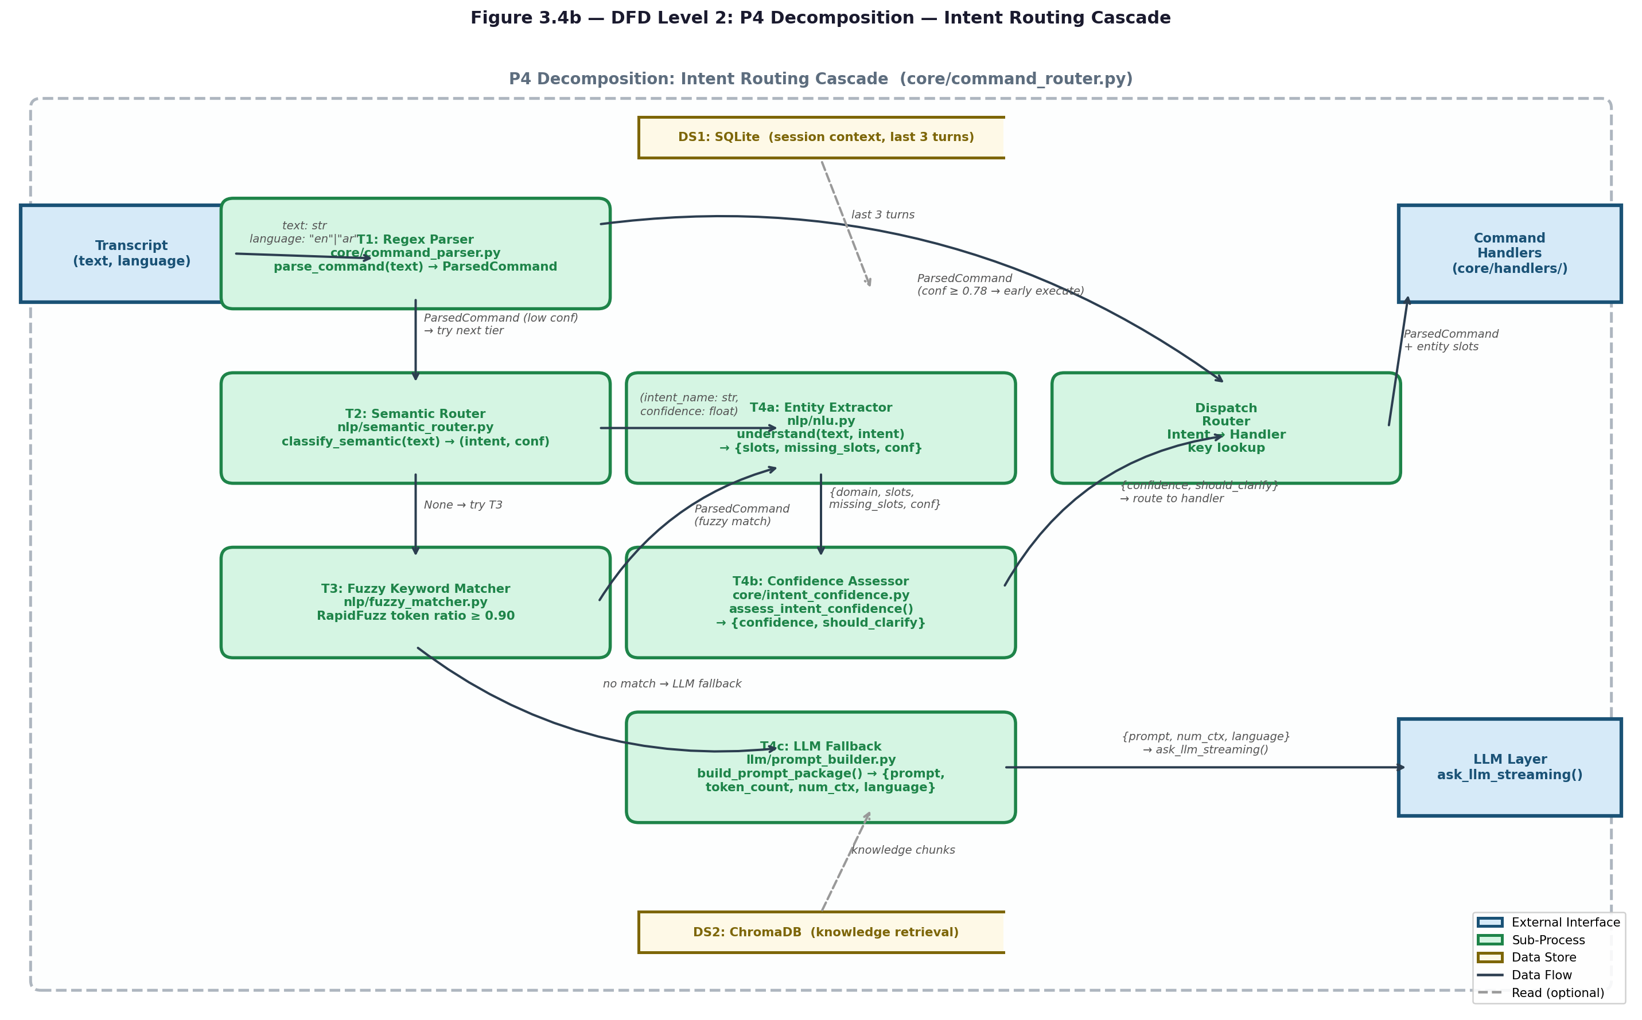
Figure 3.4b — DFD Level 2: P4 Intent Routing Cascade (Decomposition)

3.17 Use Case Design
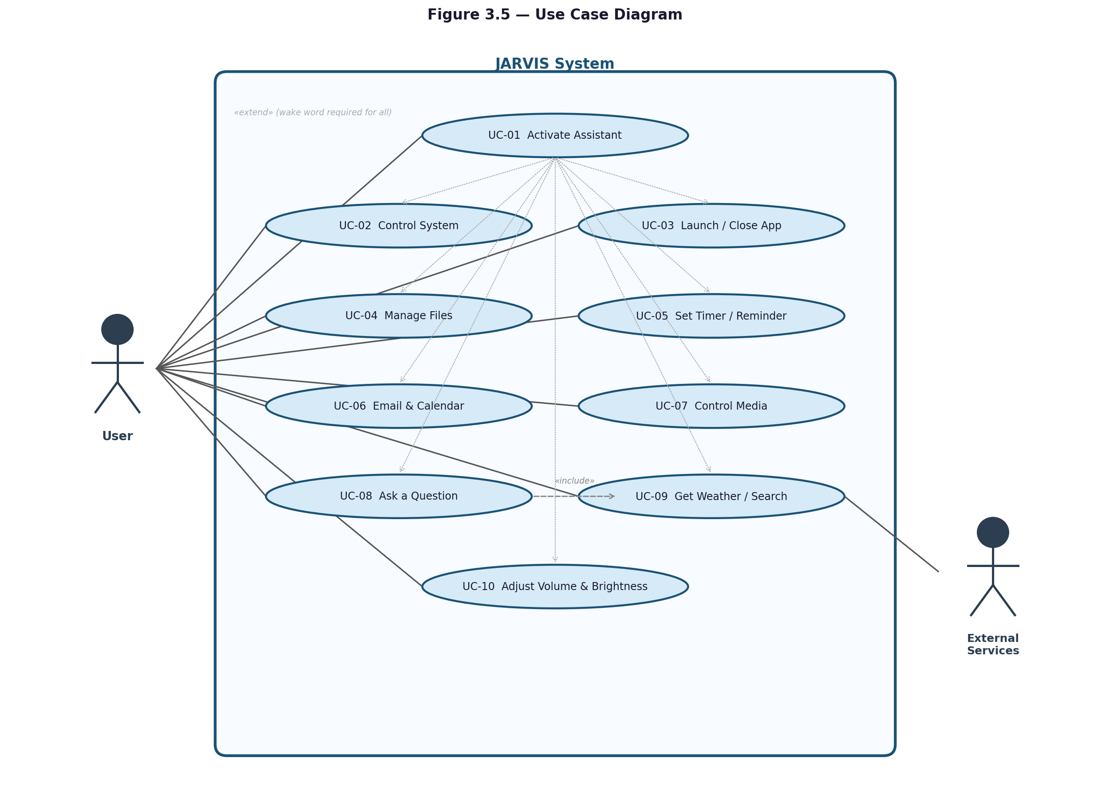
Figure 3.5 — Use Case Diagram

Chapter 4: Implementation / Analysis

4.1 Codebase Overview
JARVIS is a local-first Windows desktop voice assistant organized around a root entry script, a central orchestration layer, and subsystem folders for audio processing, NLP, LLM integration, Windows automation, tools, UI support, data, models, scripts, and tests. Phase 1 evidence comes from root-level files, README.md, package markers, and the visible startup path only; detailed source-level behavior is intentionally deferred to later phases.
The runtime workflow follows the sequence documented in the repository README: wake word detection, streaming capture and STT, cascaded intent routing, command execution or LLM fallback, then TTS response. Configuration is centralized in core/config.py and .env/.env.example, while dependency tiers are documented in requirements.txt, requirements-minimal.txt, requirements-full.txt, and requirements-training.txt.

4.2 Main Package Structure
At the root level, the project appears to be organized into functional packages rather than a single monolithic module. The visible package boundaries are audio, core, llm, nlp, os_control, tools, ui, utils, scripts, tests, data, and models. Only nlp, os_control, tools, utils, tests, and core/handlers currently expose __init__.py package markers, while other folders are imported directly as namespace-style modules or resource directories.

4.3 Application Startup Workflow

4.3.1 Core Runtime Workflow
The inspected `core/` folder acts as the application control layer. Startup enters `core.orchestrator.run()`, where shutdown handling, command services, STT runtime settings, prewarming, runtime coordination hooks, optional LLM prewarming, the startup greeting, and the wake/follow-up listening loop are initialized. During normal operation, the orchestrator waits for the wake word or an active follow-up window, records a VAD-gated utterance, receives partial STT updates through a concurrent pipeline, and submits the utterance to command processing. This design keeps the main loop responsible for timing and runtime phases while delegating domain-specific behavior to parsers, routers, handlers, memory, metrics, and subsystem adapters.
The root-level package path in this checkout is `core/`; it corresponds to the requested `jarvis/core` package layer in the documentation scope.

4.3.2 Command Lifecycle
A command normally moves through wake detection, recording, speech validation, transcription, language gating, parsing, confidence assessment, routing, execution or LLM fallback, response shaping, memory update, metrics logging, TTS output, and optional follow-up. The router first handles stateful conditions such as pending PIN confirmation, pending clarification, response-mode changes, follow-up rewrites, and cancellation requests. It then dispatches recognized actions to handler modules or subsystem adapters. If a command is not handled deterministically and LLM fallback is allowed, the router prepares contextual prompts, optional live-data context, persona and memory context, and invokes the configured LLM backend.
Figure 4.13 - Core Command Lifecycle Sequence
User speech -> wake/follow-up gate -> orchestrator recording -> VAD/STT transcript -> language gate -> command parser -> confidence and clarification logic -> command router -> core handlers or subsystem adapters -> session memory and metrics -> TTS response -> follow-up window or idle state.

4.3.3 Dialogue and Runtime State
Dialogue state is managed separately from low-level runtime phase. `DialogueManager` defines user-facing conversation states: IDLE, LISTENING, PROCESSING, CONFIRMING, EXECUTING, RESPONDING, and FOLLOW_UP. These states control pending confirmations, missing-slot prompts, conversation turns, follow-up windows, and automatic timeout return to IDLE. `RuntimeCoordinator` tracks operational phases: IDLE, LISTENING, RECORDING, TRANSCRIBING, ROUTING, EXECUTING_COMMAND, THINKING, and SPEAKING. Interrupt requests are accepted only during THINKING or SPEAKING; otherwise, the coordinator plays a blocked tone and preserves the current phase.

4.3.4 Memory Handling
Memory is split into session context, persistent structured memory, and optional semantic memory. `session_memory.py` provides a singleton session store for recent turns, slots, app usage, language history, clarification preferences, pending confirmations, and response-mode context. `memory_store.py` provides a thread-safe SQLite backend with `turns` and `slots` tables and imports legacy JSON state when necessary. If SQLite initialization fails, session memory falls back to JSON persistence. Optional semantic recall uses a ChromaDB persistent collection and the `all-MiniLM-L6-v2` embedding model; if that initialization fails, semantic recall is disabled rather than blocking command execution.

4.3.5 Metrics and Logging Behavior
The core layer records stage timing, command outcomes, language and intent statistics, diagnostic information, fallback counts, clarification behavior, and response-quality indicators through `metrics.py`. `logger.py` centralizes console and file logging through a shared `jarvis` logger, structured JSON-style debug records, summary tables, and a Windows-safe rotating file handler. The orchestrator records recording, STT, routing, TTS, and turn-summary timing so that latency can be evaluated without embedding measurement code inside every subsystem.

4.3.6 Core Integration Points
The core layer connects to audio through wake-word, VAD, recording, STT, and TTS imports; to NLP through language detection, semantic routing, intent classification, and NLU imports; to LLM services through prompt builders and streaming client functions; to OS control through router dispatch and handler adapters; and to tools through live-data and utility context providers. These integrations are documented here only at the connection level. Detailed behavior inside `audio/`, `nlp/`, `llm/`, `os_control/`, and `tools/` remains pending for later phases.

4.3.7 Fallback and Edge-Case Handling
Verified fallback behavior includes text fallback when wake-word runtime startup fails, skipping STT for non-speech or annotation-only audio, recording adaptive-wake false positives, backpressure handling when previous utterances are still processing, blocking unsupported languages, clarification and pagination for ambiguous commands, PIN or confirmation handling for sensitive actions, JSON memory fallback if SQLite is unavailable, semantic-memory disablement if vector-store initialization fails, and safe temporary-audio cleanup after processing. LLM and live-data failures are logged and fall back to the normal answer path where possible.
Table 4.11 - Core Files and Responsibilities
Core file or group | Verified responsibility
`orchestrator.py` | Main runtime loop, startup prewarm, wake/follow-up gating, recording, transcript processing, routing calls, TTS response handling, pipeline timing, and cleanup.
`command_router.py` | Central routing and dispatch layer for parsed commands, pending confirmations, clarifications, handler calls, live-data context, and LLM fallback.
`command_parser.py` | Deterministic text normalization and command parsing into structured command intent/action data.
`dialogue_manager.py` | Conversation state, pending actions, missing slots, follow-up timeout behavior, and follow-up wake notification.
`runtime_coordinator.py` | Operational runtime phases and interrupt coordination between LLM thinking, TTS speaking, and listening states.
`intent_confidence.py` and `intent_schema.py` | Intent confidence assessment, clarification option construction, ambiguity resolution, and schema definitions.
`session_memory.py` and `memory_store.py` | Session context, recent turns, slots, SQLite/JSON persistence, and optional vector memory.
`metrics.py` and `logger.py` | Latency tracking, command statistics, quality/fallback metrics, structured logs, and rotating file logging.
`config.py` | Environment-variable loading and runtime configuration constants used across the core and subsystem adapters.
`handlers/` | Router-facing adapters for memory, persona, policy, voice status, knowledge base, batch work, job queue, search index, file navigation, audit, and advanced operations.
Supporting core files | `adaptive_wake.py`, `doctor.py`, `hardware_detect.py`, `identity.py`, `knowledge_base.py`, `language_gate.py`, `persona.py`, `response_shaper.py`, `response_templates.py`, `shutdown.py`, `tts_prosody.py`, `tts_voices.py`, and `voice_normalizer.py` provide supporting runtime services.
Table 4.12 - Core State and Persistence Structures
Structure | Source file | Purpose
Dialogue states | `dialogue_manager.py` | IDLE, LISTENING, PROCESSING, CONFIRMING, EXECUTING, RESPONDING, and FOLLOW_UP user-facing conversation states.
Runtime phases | `runtime_coordinator.py` | IDLE, LISTENING, RECORDING, TRANSCRIBING, ROUTING, EXECUTING_COMMAND, THINKING, and SPEAKING operational phases.
SQLite `turns` table | `memory_store.py` | Persistent recent user/assistant turns with timestamp, language, and intent fields.
SQLite `slots` table | `memory_store.py` | Persistent named context values such as app/file/session metadata and confirmation state.
Session context slots | `session_memory.py` | In-memory and persisted context for last app, pending confirmations, language history, clarification preferences, profiles, and response mode.
Vector memory collection | `memory_store.py` | Optional semantic recall using ChromaDB and `all-MiniLM-L6-v2`; disabled if initialization fails.
Metrics buckets | `metrics.py` | Stage, command, language, intent, diagnostic, ambiguity, fallback, and response-quality statistics.
Table 4.13 - Core Configuration Groups Used by the Runtime Layer
Configuration group | Examples verified in `core/config.py` | Runtime effect
Startup and feature flags | `JARVIS_DEMO_MODE`, prewarm and runtime feature settings | Control optional startup behavior and prewarming.
Audio, wake, VAD, and STT | Wake-word, VAD, microphone, and STT backend settings | Determine how the orchestrator listens, records, validates speech, and transcribes utterances.
Language and routing | Language detection, semantic-routing, NLU, and fallback settings | Influence bilingual gating, parser/router decisions, and LLM fallback eligibility.
Memory | `MEMORY_BACKEND`, `MEMORY_DB_FILE`, legacy JSON memory file settings | Select SQLite/JSON persistence and long-term context behavior.
Follow-up and confirmation | `FOLLOWUP_ENABLED`, `FOLLOWUP_WINDOW_SECONDS`, sensitive confirmation mode settings | Control wake-word skipping during follow-up and safety confirmation flows.
Logging and metrics | `LOG_FILE`, `LOG_CONSOLE_LEVEL`, `LOG_FILE_LEVEL`, rotation and metrics settings | Control console/file diagnostics, structured logs, and latency reporting.
Figure 4.12 presents the Phase 1 root-level architecture view. It is intentionally high-level and does not claim detailed subfolder behavior beyond root-level evidence.
User Voice / Follow-up
|
main.py startup + optional tray
|
core.orchestrator.run()
|
Wake / Record / STT
|
Intent Routing
|----------------------|
Action Handlers LLM / Live Data
|----------------------|
TTS Response
Figure 4.12 - Root-Level Runtime Architecture
The visible startup workflow begins in main.py. The script parses the optional --demo-mode flag, writes JARVIS_DEMO_MODE=1 when the flag is present, attempts to start the optional system tray through ui.tray.start_tray(), and then transfers control to core.orchestrator.run(). The orchestrator initializes command services, applies runtime STT settings, prewarms latency-critical components, attaches runtime coordination hooks, speaks the startup greeting when enabled, enters a wake/follow-up listening loop, records a VAD-gated utterance, and submits the utterance to the processing pipeline.

4.4 Repository Structure Table
Table 4.9 summarizes the repository structure using only root-level evidence, README descriptions, file names, and startup imports. Detailed folder internals remain pending for later phases.
Table 4.9 - Root-Level Repository Structure
Item | Type | Phase 1 Interpretation
main.py | Root file | Application entry point; parses demo mode, optionally starts the tray, then calls core.orchestrator.run().
README.md | Root file | Provides the root-level project summary, setup, runtime pipeline, dependency tiers, and high-level package layout.
.env / .env.example | Root config | Runtime configuration source and template for environment variables, feature flags, model settings, and service options.
requirements*.txt | Root dependency files | Dependency tiers for production, minimal, full, and training-oriented installations.
audio/ | Folder | Expected voice input/output layer based on root-level names: wake word, microphone capture, VAD, STT, TTS, and audio cues.
core/ | Folder | Expected central runtime layer: orchestrator, configuration, routing, memory, metrics, shutdown, diagnostics, and coordination.
llm/ | Folder | Expected local LLM integration layer based on README and top-level names: Ollama client, prompt builder, sentence buffering, and tool calling.
nlp/ | Package folder | Expected language-understanding layer: intent classification, semantic routing, fuzzy matching, entities, and code-switch support.
os_control/ | Package folder | Expected Windows desktop automation layer: application, file, system, clipboard, settings, email, calendar, timer, and related adapters.
tools/ | Package folder | Expected auxiliary tools for live data and calculations, including weather and web search.
ui/ | Folder | Expected optional user-interface surface; main.py imports ui.tray.start_tray when available.
data/, models/ | Folders | Expected runtime data and model-storage locations based on root-level naming and README references.
scripts/ | Folder | Expected setup/training utilities; not analyzed deeply in Phase 1.
tests/ | Package folder | Expected automated test suite; not analyzed deeply in Phase 1.

4.5 Folder Responsibility Table
Table 4.10 lists the expected high-level responsibility of each major folder. These responsibilities are preliminary and will be confirmed or corrected during folder-specific analysis phases.
Table 4.10 - Folder Responsibilities and Pending Analysis Status
Folder | Expected Responsibility | Analysis Status
audio/ | Voice pipeline boundary | Pending detailed audio phase
core/ | Runtime orchestration, configuration, routing, state, diagnostics, and coordination | Analyze next
llm/ | Local LLM prompt and Ollama integration boundary | Pending LLM phase
nlp/ | Language understanding and bilingual intent-processing boundary | Pending NLP phase
os_control/ | Windows automation adapters and risk-controlled actions | Pending OS-control phase
tools/ | Auxiliary live-data and utility tools | Pending tools phase
ui/ | Optional tray/user-interface integration | Pending UI phase
data/ | Runtime data storage area | Pending data/persistence phase
models/ | Model artifact storage area | Pending model inventory phase
scripts/ | Setup and training utilities | Pending scripts phase
tests/ | Automated tests and validation scenarios | Pending testing phase

4.6 Dependencies
JARVIS is implemented entirely in Python 3.13+ and targets Windows 10 (version 1903 or later) and Windows 11 as its sole operating platform. The development environment requires Ollama installed locally to serve the Qwen3 large language model family on port 11434, and a Python virtual environment with dependencies installed from three tiered requirements files: requirements.txt for the full production set, requirements-minimal.txt for voice-and-LLM-only deployments, and requirements-full.txt for optional tools including FAISS and PDF processing.
The core runtime libraries are: sounddevice and numpy for audio streaming, faster-whisper for local speech recognition, onnxruntime for ONNX model inference (VAD and wake-word), openwakeword for wake-word detection, edge-tts for text-to-speech, httpx for all HTTP communication with Ollama and external APIs, and sqlite3 (Python standard library) for persistent storage. Optional libraries that unlock additional features include sentence-transformers (semantic routing), rapidfuzz (fuzzy matching), pywin32 (Outlook and Windows Search integration), pyperclip (clipboard access), screen-brightness-control (DDC-CI brightness), duckduckgo-search (web search), and elevenlabs (cloud STT and TTS). All optional libraries degrade gracefully — the system detects their absence at startup and disables only the features that depend on them.
The scripts/ folder contains two development utilities. scripts/generate_arabic_wake_data.py generates synthetic training audio for the wake-word model by synthesizing over 50 English and 50 Egyptian Arabic trigger phrases using multiple Edge-TTS voices. scripts/train_arabic_wake_model.py trains a compact PyTorch classifier on the collected samples, extracts OpenWakeWord mel-spectrogram features, runs for 10 epochs with a minimum validation accuracy target of 0.95, and exports the result as a unified ONNX model. The tests/ folder contains test_sentence_buffer.py, which validates English and Arabic sentence flushing logic and word-count thresholds, and test_voice_normalizer.py, which verifies Arabic diacritic stripping and alef normalization.
The following table lists all Python packages used by JARVIS, their dependency tier, and the specific subsystem each serves.
Table 4.1 — Python Package Dependencies
Seven ML models are loaded into RAM during startup. The table below shows each model's storage size, memory footprint, role in the pipeline, and the module responsible for loading it.
Table 4.2 — ML Models Loaded at Runtime
JARVIS integrates several optional external services. Every service has a local fallback so the system continues working without internet access.
Table 4.3 — External Services and Fallbacks

4.7 Pending Folder Analysis Checklist
The following checklist records which folders still require detailed analysis before the implementation chapter can be considered complete: [ ] core/; [ ] audio/; [ ] nlp/; [ ] llm/; [ ] os_control/; [ ] tools/; [ ] ui/; [ ] data/; [ ] models/; [ ] scripts/; [ ] tests/.

4.8 Configuration Files
At the root level, configuration is represented by .env, .env.example, config_vars.txt, env_vars.txt, and core/config.py. Phase 1 only confirms these files as configuration sources; detailed variable-by-variable documentation is deferred to the configuration phase.

4.9 Environment Variables
The README and .env.example indicate that the project is configured primarily through JARVIS_* environment variables. These cover logging, security, timers, screen capture, app scanning, Windows toggles, file behavior, LLM settings, STT/TTS settings, wake-word settings, and live-data settings. Detailed environment-variable tables remain pending.
Package | Tier | Used By | Purpose
numpy | Core | Audio pipeline | Audio buffer math, RMS, FFT
sounddevice | Core | mic, wake_word, tts | Microphone input + speaker output
faster-whisper | Core | stt, wake_word | Local speech-to-text (CTranslate2 backend)
openwakeword | Core | wake_word | English Jarvis detection (ONNX)
edge-tts | Core | tts | Microsoft Edge neural TTS (free)
psutil | Core | hardware_detect, sysinfo_ops | RAM/CPU/battery monitoring
httpx | Core | ollama_client, weather, ElevenLabs | HTTP for all external calls
rapidfuzz | Core | nlp/intent_classifier | Fuzzy string matching for noisy STT
python-dotenv | Core | core/config | Load .env at startup
pyperclip | Recommended | clipboard_ops | Cross-platform clipboard read/write
screen-brightness-control | Recommended | system_ops | DDC/CI brightness without admin
sentence-transformers | Recommended | semantic_router, knowledge_base | Multilingual embeddings (MiniLM)
duckduckgo-search | Recommended | tools/web_search | Free web search, no API key
pywin32 | Optional | email_ops, calendar_ops, file_ops | Outlook COM + Windows Search Index
faiss-cpu | Optional | knowledge_base | Fast vector index for large KBs
`sounddevice` | Audio | `audio/mic.py`, `audio/wake_word.py`, `audio/tts.py`, `audio/cues.py` | Microphone capture and waveform/cue playback.
`numpy` | Audio | All audio processing modules | PCM arrays, RMS, normalization, tone generation, and chunk processing.
`onnxruntime` | Audio model runtime | `audio/vad.py` | Silero VAD ONNX inference.
`openwakeword` | Wake word | `audio/wake_word.py` | Unified wake-word ONNX inference.
`faster-whisper` | STT | `audio/stt.py` | Local final and partial transcription.
`httpx` | STT cloud | `audio/stt.py` | ElevenLabs STT HTTP client.
`edge_tts` | TTS | `audio/tts.py` | Edge speech synthesis.
`elevenlabs` | TTS cloud | `audio/tts.py` | Optional ElevenLabs speech synthesis SDK.
`soundfile` | TTS decode | `audio/tts.py` | Decode compressed Edge-TTS streams when output_format is unavailable.
`rapidfuzz` | NLP optional | `nlp/fuzzy_matcher.py` | Fast fuzzy keyword scoring; difflib is used when unavailable.
`sentence-transformers` | NLP semantic model | `nlp/semantic_router.py` | Multilingual embedding-based semantic routing.
Model | Disk Size | RAM | Role | Loaded By
jarvis_v0.1.onnx | ~5 MB | ~30 MB | English wake word | audio/wake_word.py
melspectrogram.onnx | ~1 MB | ~10 MB | Wake-word feature extraction | audio/wake_word.py
embedding_model.onnx | ~7 MB | ~25 MB | Wake-word embedding | audio/wake_word.py
whisper-tiny | 75 MB | ~250 MB | Arabic wake-word phrase detection (1.5 s windows) | audio/wake_word.py
whisper-small | 484 MB | ~600 MB | Main STT (English + Arabic) + language detection | audio/stt.py
paraphrase-multilingual-MiniLM-L12-v2 | ~470 MB | ~180 MB | Semantic intent classification (50+ languages) | nlp/semantic_router.py
all-MiniLM-L6-v2 | ~90 MB | ~120 MB | Knowledge base embeddings | core/knowledge_base.py
qwen3:0.6b → qwen3:8b | 0.5 – 5 GB | 1 – 6 GB | LLM fallback (auto-selected by hardware) | Ollama (external)
`models/jarvis_unified/jarvis_unified.onnx` | Not measured in audio phase | Not measured in audio phase | Unified bilingual wake-word detection | `audio/wake_word.py`
`data/vad/silero_vad.onnx` | Not measured in audio phase | Not measured in audio phase | Voice activity detection | `audio/vad.py`
`JARVIS_WHISPER_MODEL` faster-whisper model | Depends on selected model | Depends on selected runtime | Final local STT | `audio/stt.py`
`JARVIS_STT_PARTIAL_WHISPER_MODEL` faster-whisper model | Depends on selected model | Depends on selected runtime | Partial STT windows | `audio/stt.py`, `audio/streaming_stt.py`
ElevenLabs `scribe_v2` | Cloud service | External service | Optional cloud STT | `audio/stt.py`
ElevenLabs `eleven_multilingual_v2` | Cloud service | External service | Optional cloud TTS | `audio/tts.py`
Edge-TTS configured voices | Cloud/network speech service | External service | Default/fallback TTS voices | `audio/tts.py`
`sentence-transformers/paraphrase-multilingual-MiniLM-L12-v2` | Approximately 90 MB per source comment; not measured locally | Not measured in NLP phase | Semantic intent routing for bilingual paraphrases | `nlp/semantic_router.py`
Service | Used For | Cost | Fallback If Missing
ElevenLabs STT (scribe_v2) | Cloud-quality Arabic STT | Paid | Local Whisper-small
ElevenLabs TTS (multilingual v2) | Cloud-quality Arabic voice | Paid | edge-tts ar-EG-SalmaNeural
Open-Meteo | Live weather data | Free, no key | Generic clothing advice
DuckDuckGo HTML | Live web search | Free, no key | "No live data" message
Ollama (localhost:11434) | Local LLM serving | Free, local | Required — no fallback

4.10 Runtime Pipeline

4.10.1 Audio Folder Purpose
The `audio/` folder implements the voice input and output boundary for JARVIS. It captures microphone audio, detects the wake word, applies voice activity detection, records utterances, produces partial and final speech-to-text transcripts, speaks assistant responses, plays short audio cues, and provides wake-word enrollment utilities. The folder contributes to the full pipeline by converting real-time acoustic input into validated text for `core/` and converting assistant text back into audible speech for the user.

4.10.2 Audio Runtime Pipeline
In normal operation, `core.orchestrator.run()` calls the wake-word listener, then records a VAD-gated utterance through `record_utterance_streaming()`. The streaming recorder writes the final WAV file, optionally emits partial transcripts from short faster-whisper windows, and finalizes the utterance through the configured STT backend. After command routing completes, `audio.tts.speech_engine` speaks the response asynchronously or through a sentence queue.
Figure 4.14 - Audio Runtime Pipeline
Microphone input -> unified wake-word model -> streaming recorder -> VAD/silence gate -> WAV utterance -> partial faster-whisper windows when enabled -> final STT backend -> validated transcript -> core command routing -> TTS backend -> sounddevice playback or console fallback.

4.10.3 Wake-Word Implementation
`wake_word.py` uses `sounddevice.InputStream` at the project sample rate and an openWakeWord-compatible unified ONNX model loaded from `JARVIS_WAKE_WORD_UNIFIED_ONNX_PATH`. Legacy English/Arabic wake modes are normalized to the unified model. Runtime settings include threshold, audio gain, confirmation frames, minimum RMS, detection cooldown, and optional input-device selection. The listener primes the model with live audio, tracks inference timing, can save wake activation samples, and returns `wake`, `follow_up`, or `shutdown` to the core loop. When the assistant is thinking or speaking, a detected wake word can request an interrupt through the runtime coordinator.

4.10.4 VAD and Utterance Recording
`vad.py` provides `SileroVAD`, which loads `data/vad/silero_vad.onnx` through ONNX Runtime and downloads the model if it is missing. If ONNX Runtime or model loading fails, it falls back to energy gating. `mic.py` and `streaming_stt.py` use chunk-based recording, pre-roll buffering, start timeout, minimum speech duration, adaptive silence thresholds, and maximum speech limits so a command can include its beginning while still stopping after silence or excessive length.

4.10.5 STT Implementation
`stt.py` supports two normalized backends: `faster_whisper` and `hybrid_elevenlabs`. The local backend loads faster-whisper using configured or hardware-recommended model, device, and compute type, with a base/cpu/int8 fallback if the selected runtime fails. The hybrid path tries ElevenLabs STT when enabled, configured, under the audio-duration cap, and not on cooldown, then validates the transcript and falls back to faster-whisper when needed. STT language handling is locked to English and Arabic/Egyptian Arabic by default. The code chooses a locked language from partial text, explicit hints, or a one-second Whisper probe; it accepts code-switched Arabic/Latin text, rejects unsupported-language transcripts, retries the opposite language when configured, and records transcription metadata.

4.10.6 Streaming STT Behavior
`streaming_stt.py` implements live microphone capture with optional partial transcript callbacks. It is streaming in the application sense: chunks are captured continuously, partial faster-whisper windows are transcribed in a background worker, Arabic partials are normalized and stability-gated, and the final WAV is transcribed through the normal STT backend. This should not be described as a persistent cloud streaming STT session.

4.10.7 TTS Implementation
`tts.py` exposes a singleton `SpeechEngine`. It supports `hybrid`, `edge_tts`, `auto`, and `console` backend modes. In hybrid/auto mode it tries ElevenLabs TTS when Arabic ElevenLabs support is enabled and fully configured, falls back to Edge-TTS, and finally falls back to console output. Text preparation includes Arabic detection, optional Egyptian-colloquial rewriting, prosody polishing, sentence queue playback, mixed-script Edge-TTS chunking, voice fallback candidates, output decoding, waveform normalization, short fades to avoid clicks, silence detection, playback watchdogs, and interrupt support.

4.10.8 Audio Failure Cases
The audio folder handles several failure cases explicitly: missing `sounddevice` raises a runtime error for capture or wake startup; a missing wake-word ONNX model raises a model-path error; a configured input-device name that cannot be found raises a device-resolution error; VAD model or ONNX Runtime failure falls back to energy detection; silence or low RMS returns a no-speech/silence result; ElevenLabs STT/TTS failures, missing API keys, quotas, 401 errors, or timeouts lead to cooldown and local/Edge/console fallback; invalid-language STT output is rejected or retried; Edge-TTS dependency, decode, voice, empty-audio, silent-audio, or playback failures fall back to other voices or console output.
Table 4.15 - Audio Files and Responsibilities
Audio file | Verified responsibility
`cues.py` | Generates and plays short cached PCM tones for feedback using `sounddevice.play`.
`mic.py` | Records a VAD-gated WAV utterance from the microphone with pre-roll, timeout, silence, and max-duration controls.
`streaming_stt.py` | Runs live capture, optional partial faster-whisper transcription, final WAV writing, and final STT handoff.
`stt.py` | Implements faster-whisper, hybrid ElevenLabs STT, language locking, validation, retry, metadata, and backend fallback.
`tts.py` | Implements SpeechEngine, TTS backends, Arabic preparation, mixed-script chunking, playback, interruption, and fallbacks.
`vad.py` | Implements Silero ONNX VAD with model download/load and energy fallback.
`wake_word.py` | Implements unified bilingual wake-word listening with openWakeWord ONNX, runtime settings, follow-up wake, and interrupt handling.
`wake_enrollment.py` | Interactive CLI utility for recording wake samples and computing a recommended wake threshold.
Table 4.16 - Audio Runtime Stages
Stage | Main file/function | Input | Output
Wake listening | `wake_word.listen_for_wake_word()` | Live microphone chunks | `wake`, `follow_up`, or `shutdown` event.
Utterance capture | `streaming_stt.record_utterance_streaming()` / `mic.record_utterance()` | Live microphone chunks after wake | WAV file, speech metadata, optional partial text.
VAD decision | `vad.SileroVAD`, `vad.is_speech()` | Chunks or WAV file | Speech/non-speech decision.
Partial STT | `StreamingSTT._transcribe_partial()` | Short captured audio windows | Partial text callback when enabled.
Final STT | `stt.transcribe_streaming_with_meta()` | Recorded WAV file and language hint | Validated transcript and metadata.
TTS response | `tts.SpeechEngine.speak_async()` / sentence queue | Assistant text and language hint | Audio playback or console fallback.
Table 4.17 - Audio Models and External Speech Services
Component | Model/service | Loaded or used by | Fallback
Wake word | Unified openWakeWord-compatible ONNX model at `models/jarvis_unified/jarvis_unified.onnx` by default | `audio/wake_word.py` | No local fallback; startup/listen raises an error if unavailable.
VAD | Silero VAD ONNX at `data/vad/silero_vad.onnx` | `audio/vad.py` | Energy threshold fallback.
Final local STT | faster-whisper model from `JARVIS_WHISPER_MODEL` or hardware recommendation | `audio/stt.py` | base/cpu/int8 if configured runtime fails.
Partial STT | faster-whisper `tiny` or `base` by default depending device, or `JARVIS_STT_PARTIAL_WHISPER_MODEL` | `audio/stt.py`, `audio/streaming_stt.py` | tiny/cpu/int8 if configured partial runtime fails.
Cloud STT | ElevenLabs Speech-to-Text model `scribe_v2` by default | `audio/stt.py` | Local faster-whisper fallback.
TTS cloud | ElevenLabs TTS model `eleven_multilingual_v2` by default | `audio/tts.py` | Edge-TTS, then console fallback.
TTS edge | Microsoft Edge-TTS voices selected by active voice profile | `audio/tts.py` | Alternate configured voices, then console fallback.
Table 4.18 - Audio Configuration Variables
Group | Representative variables | Effect
Capture | `SAMPLE_RATE`, `AUDIO_CHUNK_SIZE`, `JARVIS_MAX_RECORD_DURATION` | Define recording format, chunking, and maximum utterance length.
VAD | `JARVIS_VAD_BACKEND`, `JARVIS_VAD_ENERGY_THRESHOLD`, `JARVIS_VAD_SILERO_THRESHOLD`, silence and timeout variables | Control speech detection, silence trimming, and start timeout.
Wake word | `JARVIS_WAKE_WORD_UNIFIED_ONNX_PATH`, threshold, confirm frames, input device, min RMS, cooldown | Control wake model path, sensitivity, device selection, and repeat detection behavior.
STT | `JARVIS_STT_BACKEND`, `JARVIS_WHISPER_MODEL`, `JARVIS_WHISPER_DEVICE`, `JARVIS_STT_LANGUAGE_HINT`, ElevenLabs STT settings | Select local/hybrid transcription, model runtime, language lock, cloud timeout, and retry behavior.
TTS | `JARVIS_TTS_BACKEND`, voice profile variables, Edge mixed-script settings, ElevenLabs TTS settings | Select speech backend, voices, mixed-language playback behavior, and cloud TTS options.
Table 4.19 - Audio Failure Cases and Fallback Behavior
Failure or edge case | Observed handling in audio code
No `sounddevice` or microphone capture failure | Capture/wake functions raise RuntimeError; orchestrator can enter text fallback for wake startup failure.
No speech or silence | Recorder returns `speech_detected=False`; STT returns silence result for low RMS.
Missing or failed Silero VAD model | Falls back to energy threshold gating.
Missing wake-word model | Raises explicit model-path RuntimeError.
Configured wake input device not found | Raises RuntimeError with available input-device preview.
Cloud STT unavailable, disabled, over duration cap, quota, or HTTP error | Logs error/cooldown and uses local faster-whisper fallback where possible.
Invalid or unsupported STT language | Rejects, retries opposite language when configured, or returns invalid-language metadata.
TTS provider unavailable or misconfigured | ElevenLabs falls back to Edge-TTS; Edge failures fall back to console output.
Edge-TTS decode, voice, empty-audio, silent-audio, or playback failure | Tries fallback voices, marks unsupported voices, logs warning, and may fall back to console.
The audio pipeline is implemented across six modules in the audio/ folder, each responsible for one stage of the voice interaction lifecycle.
Wake-word detection (audio/wake_word.py) runs a continuous loop using the OpenWakeWord framework and a unified bilingual ONNX model (jarvis_unified.onnx) stored in data/. Audio is streamed from the microphone in 1,280-sample chunks at 16,000 Hz. Each chunk is scored by the model, and a detection is confirmed when the score exceeds 0.45 for at least one consecutive frame. A 1.5-second cooldown prevents duplicate triggers. The function listen_for_wake_word() returns one of three strings: 'wake', 'follow_up', or 'shutdown', which the orchestrator uses to decide the next action.
Voice activity detection (audio/vad.py) wraps the Silero ONNX model (silero_vad.onnx), downloaded automatically from GitHub if missing. The model processes 512-sample windows (32 ms at 16,000 Hz) and maintains LSTM state across windows. A chunk is classified as speech when the model probability exceeds 0.5 and the RMS energy exceeds 0.014. If onnxruntime is unavailable, the module falls back to energy-only gating.
Microphone recording (audio/mic.py) uses sounddevice to stream audio at 16,000 Hz with 1,024-byte chunks. The record_utterance() function applies a 0.2-second pre-roll buffer to capture audio that preceded the VAD trigger, and uses an adaptive silence timeout that scales from 0.5 seconds for commands to 1.5 seconds for conversational queries. It returns a dictionary containing ok, speech_detected, duration_seconds, and samples.
Speech-to-text transcription (audio/stt.py and audio/streaming_stt.py) is handled by Faster-Whisper with beam sizes of 4 for audio under 8.5 seconds and 5 for longer recordings. The language is detected by Unicode script analysis: if over half the characters fall in the Arabic block (U+0600–U+06FF), the transcript is classified as Arabic. An optional hybrid backend races ElevenLabs cloud STT (scribe_v1 model, endpoint /v1/speech-to-text) against the local model in parallel for Egyptian Arabic. The streaming module (streaming_stt.py) emits partial transcripts every 0.5 seconds with an Arabic stability gate requiring the same text in two consecutive windows before emitting.
Text-to-speech (audio/tts.py) is implemented in the SpeechEngine class. The primary backend is edge-tts, using ar-EG-SalmaNeural for Arabic and en-US-AriaNeural for English. ElevenLabs (eleven_multilingual_v2, wav_24000 format) serves as an optional fallback for premium Arabic voice quality. Before Arabic synthesis, a built-in Egyptian colloquial rewriter applies over 150 MSA-to-dialect phrase substitutions (e.g., 'لا أستطيع' becomes 'مش قادر'). Mixed Arabic-English text is split into chunks of 20–300 characters (maximum 4 chunks) and synthesized separately before concatenation. The audio cues module (audio/cues.py) synthesizes short tones as int16 PCM with fade-in and fade-out for auditory feedback.
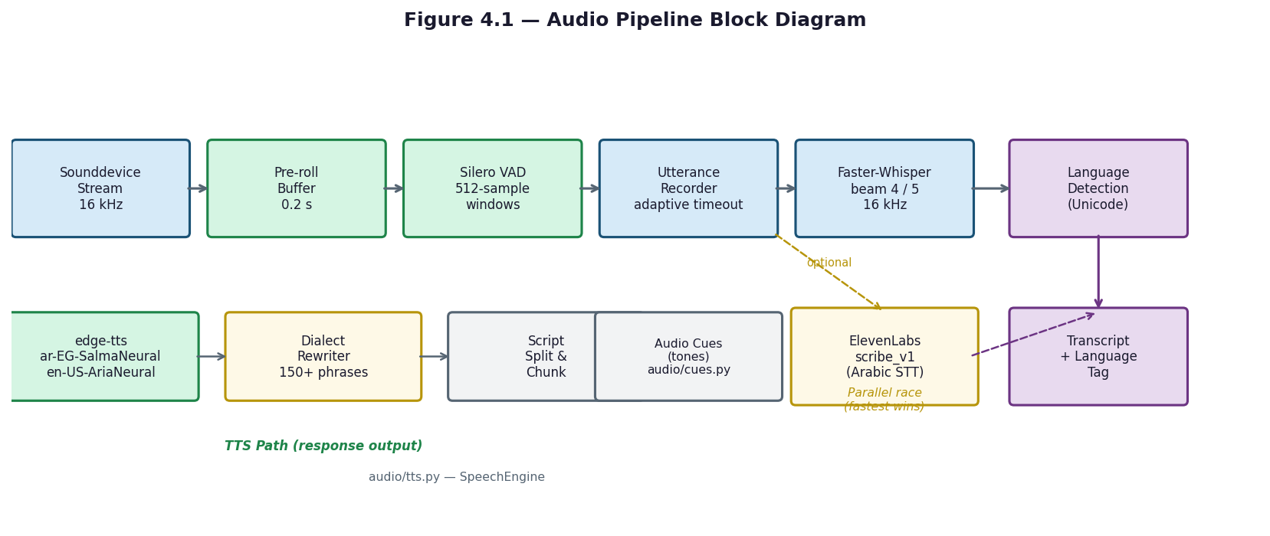
Figure 4.1 — Audio Pipeline Block Diagram
Once the wake word fires, JARVIS begins streaming audio capture with concurrent STT. Audio chunks of 512 samples (32 ms at 16 kHz) are processed in real time through Silero VAD for speech detection, and partial transcripts are emitted while the user is still speaking, enabling early intent detection and parallel processing. An energy pre-filter skips Silero inference on pure silence to save CPU.
All VAD timing and sensitivity parameters can be tuned via environment variables without modifying source code.
Environment Variable | Default | Effect
JARVIS_VAD_ENERGY_THRESHOLD | 0.014 | Energy pre-filter before Silero. Lower = more sensitive.
JARVIS_VAD_SILENCE_SECONDS | 0.55 | Command-mode silence timeout. Lower = snappier but cuts off pauses.
JARVIS_VAD_CHAT_SILENCE_SECONDS | 1.0 | Conversation-mode silence timeout (follow-up window). Lets user think.
JARVIS_VAD_MIN_SPEECH_SECONDS | 0.30 | Minimum speech duration (filters coughs/clicks).
JARVIS_VAD_START_TIMEOUT_SECONDS | 3.0 | If no speech detected within this window, abort.
JARVIS_MAX_RECORD_DURATION | 6.0 | Absolute hard cap on recording length.
`JARVIS_WAKE_WORD_UNIFIED_ONNX_PATH` | `models/jarvis_unified/jarvis_unified.onnx` | Wake-word model path used by `audio/wake_word.py`.
`JARVIS_WAKE_WORD_THRESHOLD` | `0.45` | Wake detection score threshold.
`JARVIS_WAKE_WORD_INPUT_DEVICE` | empty/default | Optional microphone device selector for wake listening.
`JARVIS_VAD_BACKEND` | `silero` | Selects Silero or energy VAD behavior.
`JARVIS_VAD_ENERGY_THRESHOLD` | `0.014` | Energy floor for VAD and fallback speech gating.
`JARVIS_STT_BACKEND` | `hybrid_elevenlabs` | Selects hybrid cloud/local STT or local faster-whisper.
`JARVIS_WHISPER_MODEL` | `auto` | Local faster-whisper model selection.
`JARVIS_STT_PARTIAL_WHISPER_MODEL` | `auto` | Partial-window faster-whisper model selection.
`JARVIS_TTS_BACKEND` | `hybrid` | Selects TTS backend behavior.
`JARVIS_TTS_EDGE_MIXED_SCRIPT_CHUNKING` | `true` | Enables mixed Arabic/Latin Edge-TTS chunk handling.
`JARVIS_TTS_ELEVENLABS_MODEL_ID` | `eleven_multilingual_v2` | Optional ElevenLabs TTS model id.
`JARVIS_NLU_INTENT_ROUTING_ENABLED` | `true` | Enables NLU intent routing cascade.
`JARVIS_NLU_ENTITY_EXTRACTION_ENABLED` | `true` | Enables NLU entity enrichment and missing-slot detection.
`JARVIS_NLU_INTENT_CONFIDENCE_THRESHOLD` | `0.75` | Default NLU acceptance threshold.
`JARVIS_NLU_PARSER_FASTPATH_ENABLED` | `true` | Allows high-confidence parser fast path.
`JARVIS_SEMANTIC_ROUTER_ENABLED` | `true` | Enables semantic embedding router if dependencies/model load.
`JARVIS_SEMANTIC_ROUTER_CONFIDENCE_THRESHOLD` | `0.75` | Semantic route acceptance threshold.
`JARVIS_CODE_SWITCH_CONTINUITY_ENABLED` | `true` | Enables code-switch continuity context behavior.
Table 4.4 — VAD Tunable Parameters (audio/vad.py)
The STT backend can be configured independently. The default hybrid path races local Faster-Whisper against ElevenLabs cloud STT for Arabic audio, with the faster result winning.
JARVIS_STT_BACKEND value | Behaviour
hybrid_elevenlabs (default) | Whisper-small detects language -> Arabic to ElevenLabs, English to Whisper. ElevenLabs fail -> Whisper.
faster_whisper | 100% local. Whisper-small handles both languages. No internet needed.
Table 4.5 — STT Backend Configuration

4.11 Architecture
Bilingual support for English and Egyptian Arabic is not limited to a single component — it is embedded across every layer of the system, from wake-word detection through transcription, understanding, execution, and response.
At the audio layer, a single unified ONNX model (jarvis_unified.onnx) detects the wake phrase in both languages simultaneously. The model was trained on over 50 English trigger phrases ('Jarvis', 'Hey Jarvis', etc.) and over 50 Egyptian Arabic phrases ('يا جارفس', 'جارفيس', etc.) synthesized using multiple Edge-TTS voices, with adversarial negative samples added to reduce false activations. Language detection after transcription uses Unicode script analysis: characters in the Arabic block (U+0600–U+06FF) versus Latin characters determine the dominant language.
At the NLP layer, nlp/codeswitching.py handles mixed Arabic-English utterances by mapping Egyptian Arabic verbs and entity names to their English equivalents before intent classification. Arabic text normalization in nlp/fuzzy_matcher.py strips tashkeel (diacritics), normalizes alef variants, and normalizes hamza-on-waw to produce a consistent form for matching. The semantic router uses the paraphrase-multilingual-MiniLM-L12-v2 model, which was trained on parallel sentence pairs across 50+ languages and natively handles Arabic-English bilingual input without any language-specific preprocessing.
At the response layer, the TTS engine routes text to the appropriate voice based on the detected language: ar-EG-SalmaNeural (Egyptian Arabic) or en-US-AriaNeural (English) via edge-tts, with ElevenLabs as an optional fallback. Before Arabic synthesis, audio/tts.py applies an Egyptian colloquial rewriter containing over 150 Modern Standard Arabic to Egyptian dialect substitution pairs, ensuring that responses sound natural to Egyptian Arabic speakers. Mixed-script text (Arabic and Latin in the same response) is split into per-script chunks and synthesized separately before concatenation into a single audio stream.
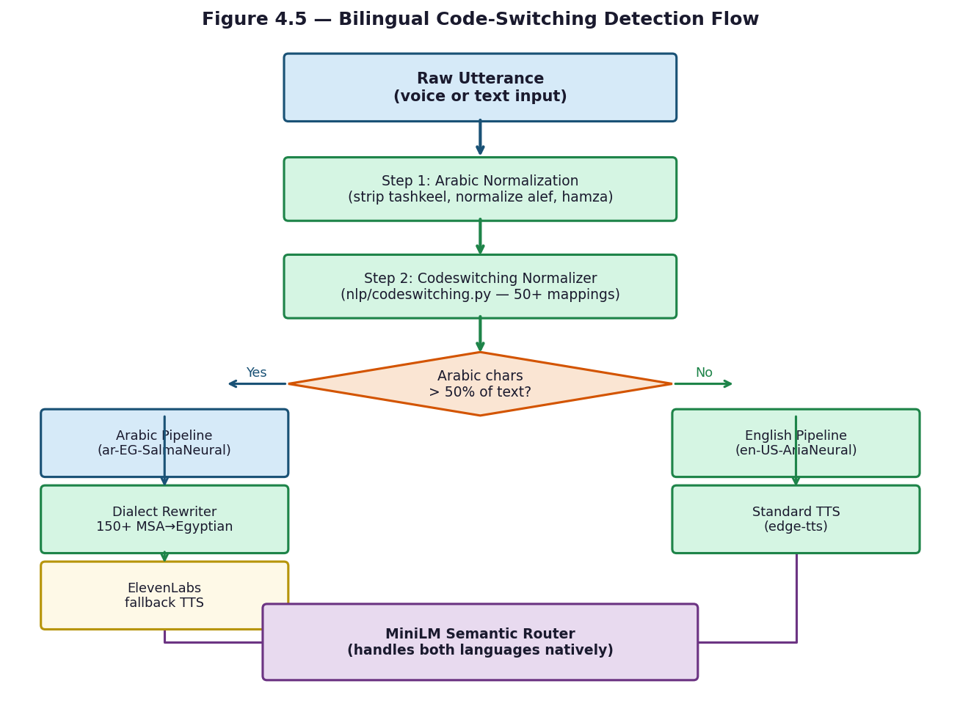
Figure 4.5 — Bilingual Code-Switching Detection Flow

4.12 Memory Scheme
Persistent state in JARVIS is managed across two storage backends and one in-memory session store, implemented in the core/ folder with model data stored under data/.
Session memory (core/session_memory.py) is an in-memory store that tracks the current conversation turn, the user's preferred language, the last launched application, and the active audio UX profile (responsive, balanced, or robust). It provides the recent() method, which returns the last N conversation turns for context injection into LLM prompts, and get_preferred_language(), which the TTS engine uses to select the correct voice without re-detecting language on every response.
Persistent memory (core/memory_store.py) uses SQLite operating in WAL (Write-Ahead Logging) mode, stored in jarvis_memory.db and jarvis_state.db. The schema has two tables: turns, an append-only log of every conversation exchange with timestamp, intent, transcript, response, and language fields; and slots, a key-value store for user preferences and long-term state encoded as JSON. A third database, jarvis_index.db, provides optional full-text search integration with the Windows Search Index via pywin32.
The knowledge base (core/knowledge_base.py) uses ChromaDB as a vector store, persisted under the .jarvis_kb/ directory. User-supplied documents or facts can be indexed as dense embeddings using the same MiniLM model as the semantic router. At query time, the top-K semantically closest chunks are retrieved and injected into the LLM prompt via llm/prompt_builder.py, enabling the assistant to answer questions about user-specific knowledge without fine-tuning the model.
Model data is stored under the data/ folder. data/openwakeword/ holds the unified bilingual wake-word ONNX model. data/vad/ holds silero_vad.onnx, downloaded automatically from GitHub on first run. data/wake_samples/ organizes training audio into three subdirectories: confirmed_positive/, confirmed_negative/, and auto_captured/{speaker_id}/ for samples collected during live use and flagged for later manual review during wake-word model retraining.
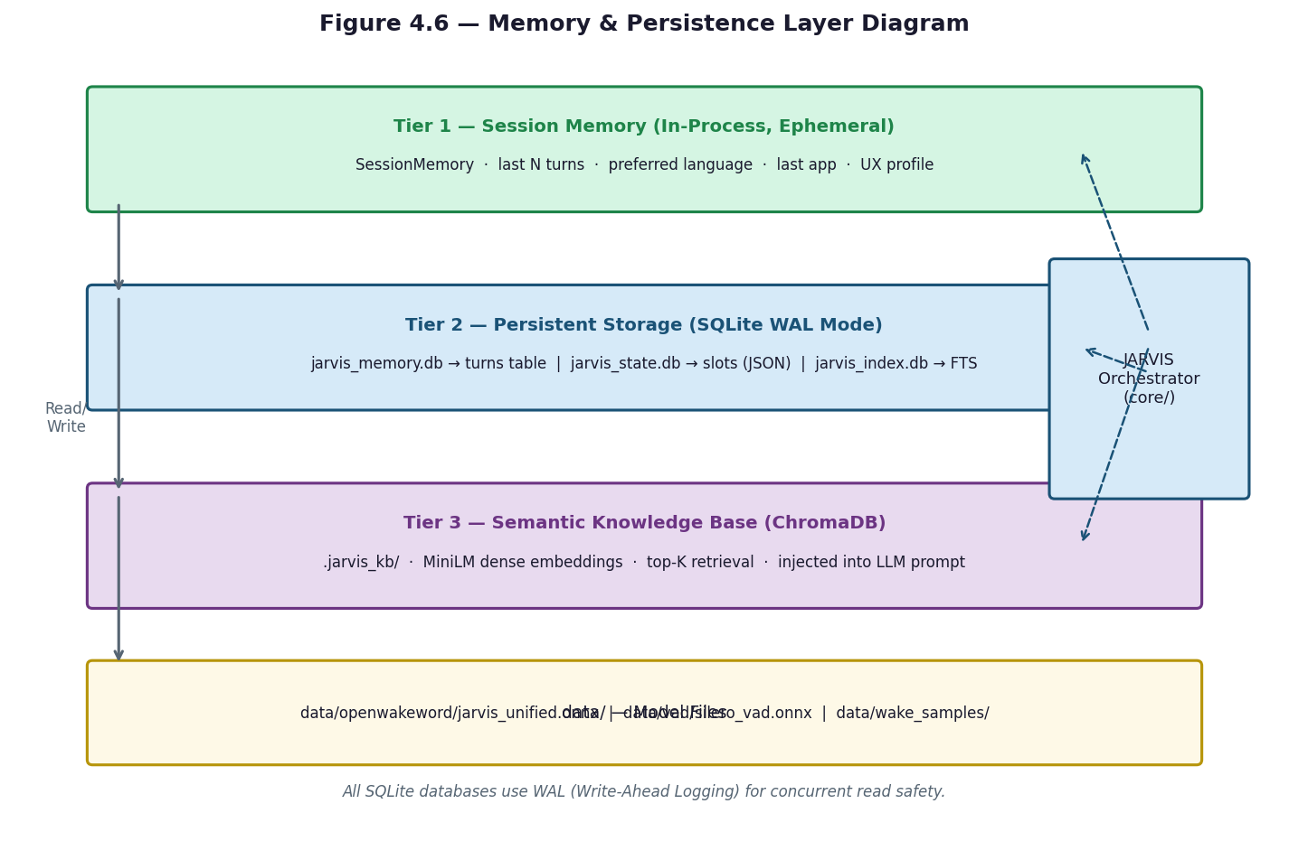
Figure 4.6 — Memory & Persistence Layer Diagram

4.13 Command-Processing Pipeline

4.13.1 NLP Folder Purpose
The `nlp/` folder provides text-understanding support for the command-processing pipeline. It normalizes English and Arabic text, handles Egyptian Arabic and mixed Arabic/English commands, performs fuzzy keyword intent classification, provides a semantic embedding router for paraphrase-tolerant intent routing, defines entity types, and enriches parsed commands with missing entities such as application names, timer durations, file names, locations, reminder times, and reminder messages.

4.13.2 Text Normalization and Code-Switching
`fuzzy_matcher.py` normalizes noisy STT text by lowercasing, removing Arabic diacritics and tatweel, normalizing common Arabic letter variants, replacing separators, removing punctuation, and collapsing spaces. `codeswitching.py` adds a mixed-language pre-pass: it normalizes Arabic letters, converts Arabic-Indic digits, maps Arabic verbs such as open, close, search, increase, decrease, and set to intent hints, extracts Latin or Arabic entities, maps known Arabic entities such as browser, files, brightness, volume, timer, and web terms, and extracts numeric values including Arabic number words and percent expressions.

4.13.3 Four-Tier Intent Routing Cascade
The implemented routing cascade is coordinated by `core/command_router.py` using NLP helpers from `nlp/`. Tier 1 accepts a high-confidence deterministic parser result when the parser fast path is enabled and confidence passes the configured floor. Tier 2 tries the semantic router only when the parser candidate is still `LLM_QUERY`, the semantic router is enabled, and the multilingual embedding router is ready. Tier 3 tries fuzzy keyword NLP using the bilingual keyword catalog. Tier 4 falls through to the parser candidate, which may remain an `LLM_QUERY` and continue to later fallback behavior. Entity enrichment then runs for non-LLM intents when enabled.
Figure 4.15 - NLU Intent Classification Flow
Transcript text -> parser candidate -> Tier 1 parser fast path -> Tier 2 semantic router -> Tier 3 keyword/fuzzy NLP -> Tier 4 parser candidate or LLM query -> NLU entity enrichment -> missing-slot clarification or command dispatch.

4.13.4 Semantic Routing Implementation
`semantic_router.py` uses `sentence-transformers/paraphrase-multilingual-MiniLM-L12-v2` to embed bilingual route examples. It builds route embeddings lazily, exposes prewarm/readiness functions, returns top-k semantic matches, and accepts a route only when its similarity passes the semantic threshold. If `sentence-transformers` or model loading fails, the semantic router disables itself and returns no match so the cascade can continue to keyword NLP or fallback behavior.

4.13.5 Keyword and Fuzzy Intent Classification
`keyword_engine.py` stores bilingual action and target terms for common commands such as opening YouTube, Chrome, Calculator, Spotify, and Google, music playback, search, volume, Wi-Fi, Bluetooth, and screenshots. `intent_classifier.py` scores action and target matches using fuzzy matching. Actions carry more weight than targets, screenshot requires a target, low-confidence results return `unknown`, and near-tied candidates are intentionally rejected to avoid false confident routing.

4.13.6 Entity Extraction and Missing Slots
`nlu.py` maps routed intents into domains such as application control, file operations, timers, reminders, search, chat, email, and calendar. It enriches existing parser arguments rather than replacing them. For known command families it extracts missing slots and reports unresolved required slots so the dialogue layer can ask targeted clarification questions. This is why ambiguous commands such as ?open? or ?set a timer? can produce a follow-up question instead of silently failing or executing the wrong operation.

4.13.7 Arabic and Egyptian Arabic Handling
Arabic support is implemented through several targeted mechanisms: diacritic and tatweel removal, alef/hamza/ya/ta-marbuta normalization, Arabic-Indic digit conversion, Egyptian Arabic verb and entity maps, Arabic number and duration words, reminder time patterns, and code-switched Arabic/Latin extraction. The implementation handles common Egyptian forms such as colloquial open/close/search phrases and timer/reminder durations, but it remains rule- and example-based rather than a full Arabic morphological analyzer.

4.13.8 Ambiguous and Unsupported Command Behavior
Ambiguous NLP behavior is conservative. Fuzzy keyword ties with close confidence return `unknown`; missing required slots are returned as `missing_slots`; semantic routing is skipped when the model is not ready; semantic matches below threshold are ignored; and unknown keyword results are not forced into an action. Unsupported or explanatory text therefore falls through as the parser candidate, usually `LLM_QUERY`, for later handling by the command router rather than being executed as an operating-system command.
Table 4.21 - NLP Files and Responsibilities
NLP file | Verified responsibility
`__init__.py` | Exports `classify_intent` and `suggest_intent` convenience functions.
`codeswitching.py` | Arabic/English code-switch normalization, Arabic verb/entity maps, Arabic-Indic digits, number extraction, and mixed-language entity hints.
`entity_types.py` | Defines supported entity type enum values: app, system feature, path, number, duration, email, person, and date.
`fuzzy_matcher.py` | Normalizes noisy STT text and provides exact/fuzzy keyword matching with rapidfuzz or difflib fallback.
`intent_classifier.py` | Scores bilingual keyword intents, handles confidence thresholds, suggestions, and ambiguous close ties.
`keyword_engine.py` | Stores bilingual action/target keyword catalogs for common command intents.
`nlu.py` | Extracts missing entities/slots for known intent domains and returns missing-slot information.
`semantic_router.py` | Lazy-loads multilingual sentence-transformer embeddings and routes paraphrased bilingual commands by similarity.
Table 4.22 - Four-Tier Intent Routing Cascade
Tier | Mechanism | Primary evidence | Fallback if not accepted
1 | Parser fast path | `core.command_router._select_parser_fastpath_assessment()` with parser confidence thresholds | Continue to semantic routing.
2 | Semantic router | `nlp.semantic_router.classify_semantic()` when enabled and ready | Continue to keyword NLP.
3 | Keyword/fuzzy NLP | `nlp.intent_classifier.classify_intent()` over `keyword_engine.INTENTS` | Fall through to parser candidate.
4 | Parser candidate / LLM query | Existing parser output, often `LLM_QUERY` for unsupported text | Handled later by command router fallback behavior.
Post-tier | Entity enrichment | `nlp.nlu.understand()` for non-LLM intents | Missing slots trigger targeted clarification.
Table 4.23 - NLP Entity Extraction and Slot Table
Entity/slot | Source file | Example extracted value | Used for
`app_name` | `nlu.py`, `codeswitching.py`, app alias lookup | Chrome, notepad, spotify | Open/close app commands.
`seconds` | `nlu.py` duration parser | 300 from ?5 minutes? or Arabic equivalent | Timer commands.
`label` | `nlu.py` timer label extractor | study, break | Optional timer label.
`filename` | `nlu.py` file target extractor | report.pdf, presentation | File search commands.
`search_path` | `nlu.py` location extractor | downloads, desktop | File search/navigation scope.
`time_str` | `nlu.py` reminder time patterns | at 3pm, Arabic relative/wall-clock phrases | Reminder scheduling.
`message` | `nlu.py` reminder message extractor | call Ahmed | Reminder content.
`numbers` | `codeswitching.py` | 50 from Arabic number/percent words | Control commands such as volume/brightness.
Table 4.24 - Bilingual Command Examples
Command example | Likely NLP handling
`open chrome` | Keyword/semantic/parser path can map to app open intent with `app_name`.
Arabic equivalent of ?open Chrome? | Code-switching and app alias lookup can recover the app entity.
`set a timer for 5 minutes` | NLU duration extractor can produce `seconds=300`.
Arabic equivalent of ?set a timer for five minutes? | Arabic number/duration patterns can produce timer seconds.
`take a screenshot` | Keyword classifier requires screenshot target to avoid overtriggering.
Mixed Arabic/English command with app name | Code-switching prefers Latin entity runs after Arabic verbs.
`open` with no app | Missing `app_name` can trigger clarification.
Unsupported factual question | Falls through as parser candidate/LLM query instead of OS execution.
Table 4.25 - NLP Configuration Variables
Configuration group | Representative variables | Effect
NLU routing | `JARVIS_NLU_INTENT_ROUTING_ENABLED`, `JARVIS_NLU_INTENT_CONFIDENCE_THRESHOLD` | Enable/threshold the NLU routing cascade.
Parser fast path | `JARVIS_NLU_PARSER_FASTPATH_ENABLED`, `JARVIS_NLU_PARSER_FASTPATH_CONFIDENCE_FLOOR` | Allow high-confidence parser results to skip slower tiers.
Semantic routing | `JARVIS_SEMANTIC_ROUTER_ENABLED`, `JARVIS_SEMANTIC_ROUTER_CONFIDENCE_THRESHOLD`, prewarm setting | Control embedding router availability and acceptance.
Entity extraction | `JARVIS_NLU_ENTITY_EXTRACTION_ENABLED`, entity clarification thresholds | Control slot enrichment and clarification sensitivity.
Code-switch continuity | `JARVIS_CODE_SWITCH_CONTINUITY_ENABLED`, continuity window and ratio | Influence bilingual follow-up/context behavior in routing.
Natural language understanding is implemented across five modules in the nlp/ folder. Together they convert a raw bilingual transcript into a structured intent representation with extracted entity slots.
Code-switching normalization (nlp/codeswitching.py) is the first step for any Arabic or mixed-language input. The module maps over 50 Egyptian Arabic verbs and entity names to their English equivalents (e.g., 'افتح' to 'open', 'اقفل' to 'close', 'كروم' to 'chrome') and converts Arabic-Indic numerals (٠–٩) to ASCII digits. This normalization allows the downstream NLP components to operate on a consistent, partially unified vocabulary regardless of the input language.
Fuzzy text matching (nlp/fuzzy_matcher.py) normalizes text by stripping Arabic diacritics (tashkeel), normalizing alef variants (أ, إ, آ all become ا), normalizing hamza-on-waw (ؤ becomes و), removing punctuation, and collapsing whitespace. It then computes token-level fuzzy ratios using the RapidFuzz library, with a 90 percent match threshold for single-word targets and the token set average for multi-word expressions. When RapidFuzz is not installed, the module falls back to Python's standard difflib.SequenceMatcher.
Semantic routing (nlp/semantic_router.py) uses the paraphrase-multilingual-MiniLM-L12-v2 sentence-transformer model, which is loaded lazily in the background at startup. The classify_semantic() function encodes the user's utterance as a dense embedding vector and compares it against pre-computed embeddings for approximately 20 intent families using cosine similarity. It returns a tuple of (intent_name, confidence) or None if the model is not available, making the entire tier optional.
Entity extraction (nlp/nlu.py) runs after an intent is identified. The understand() function accepts the transcript and the resolved intent name, extracts slot values for that intent, and returns a dictionary containing the domain, a slots mapping of slot-name to extracted value, a list of missing required slots, and an overall confidence score. Entity types are defined in nlp/entity_types.py as the EntityType enumeration: APP, PATH, EMAIL, DATE, DURATION, PERSON, and SYSTEM_FEATURE.
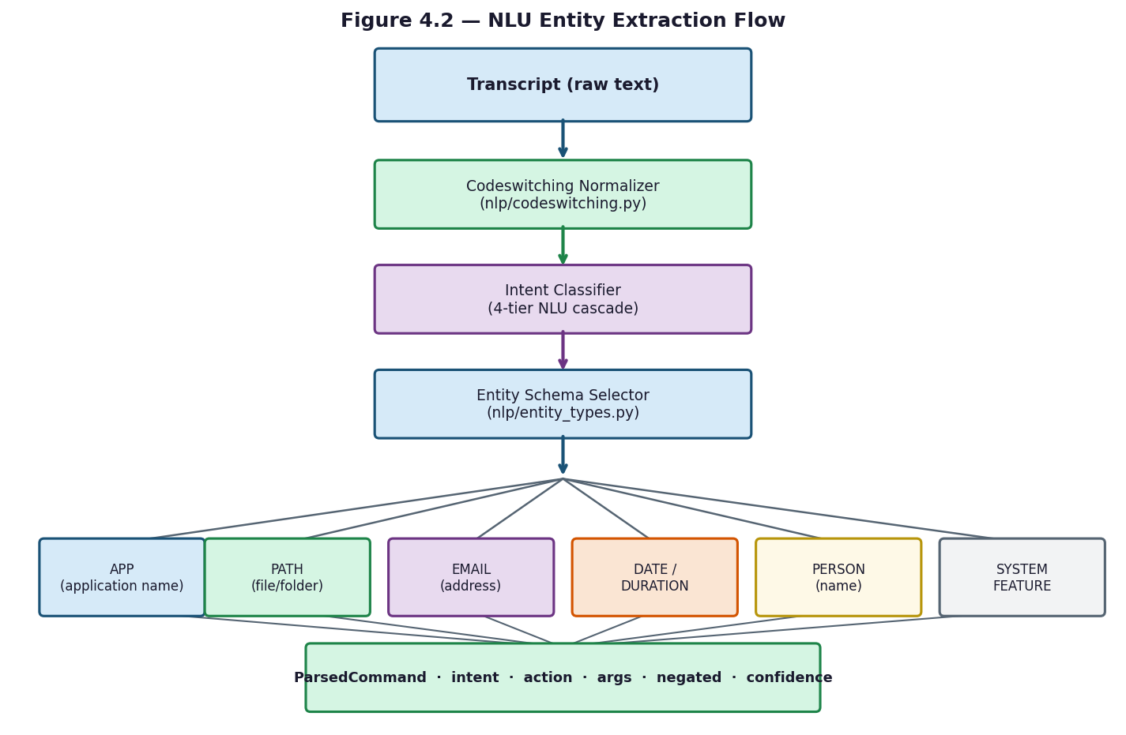
Figure 4.2 — NLU Entity Extraction Flow

4.14 Behavior in Different Situations
Intent routing is coordinated by core/command_router.py and uses a four-tier cascade implemented across the parser, NLP, and LLM modules. The route_command() function accepts the transcript text and an optional pre-computed ParsedCommand, and returns a response string.
Tier 1 — Regex Parser (core/command_parser.py): The parse_command() function applies a sequence of deterministic pattern-matching steps to the normalized text. It checks for negation, matches against a priority structural table for path and folder patterns, applies a priority regex table for system commands, handles code-switched commands from nlp/codeswitching.py, and finally matches against a keyword table covering all intent families. The result is a ParsedCommand dataclass with fields intent, raw, normalized, action, args, and negated. This tier operates at approximately zero milliseconds. If the confidence score exceeds 0.78, the command is executed immediately without consulting lower tiers.
Tier 2 — Semantic Router (nlp/semantic_router.py): If Tier 1 confidence is below the early-execution threshold, classify_semantic() is called. It uses the MiniLM embedding model to find the closest intent family and returns a confidence score. This tier runs in approximately 10 milliseconds and handles paraphrased commands that the regex patterns do not cover.
Tier 3 — Fuzzy Keyword Matching (nlp/fuzzy_matcher.py): If semantic routing returns no confident result, the fuzzy matcher is applied against the keyword lists defined in nlp/keyword_engine.py. Each intent family has an actions list and a targets list; the matcher scores the transcript against both using RapidFuzz token ratios and combines the scores using intent-weighted arithmetic. This tier runs in approximately 20 milliseconds.
Tier 4 — LLM Fallback (llm/ollama_client.py): If none of the first three tiers produce a confident result, the transcript is treated as a conversational query and passed to ask_llm_streaming(). The prompt is constructed by llm/prompt_builder.py, which selects a template based on the hardware tier (micro_prompt.txt, slim_prompt.txt, or full_prompt.txt), injects session memory (last 3 turns), ChromaDB knowledge chunks, live data context if relevant, and a language pin. The Ollama server at http://localhost:11434 streams the Qwen3 response token by token, which is batched into sentences by llm/sentence_buffer.py before being passed to TTS.
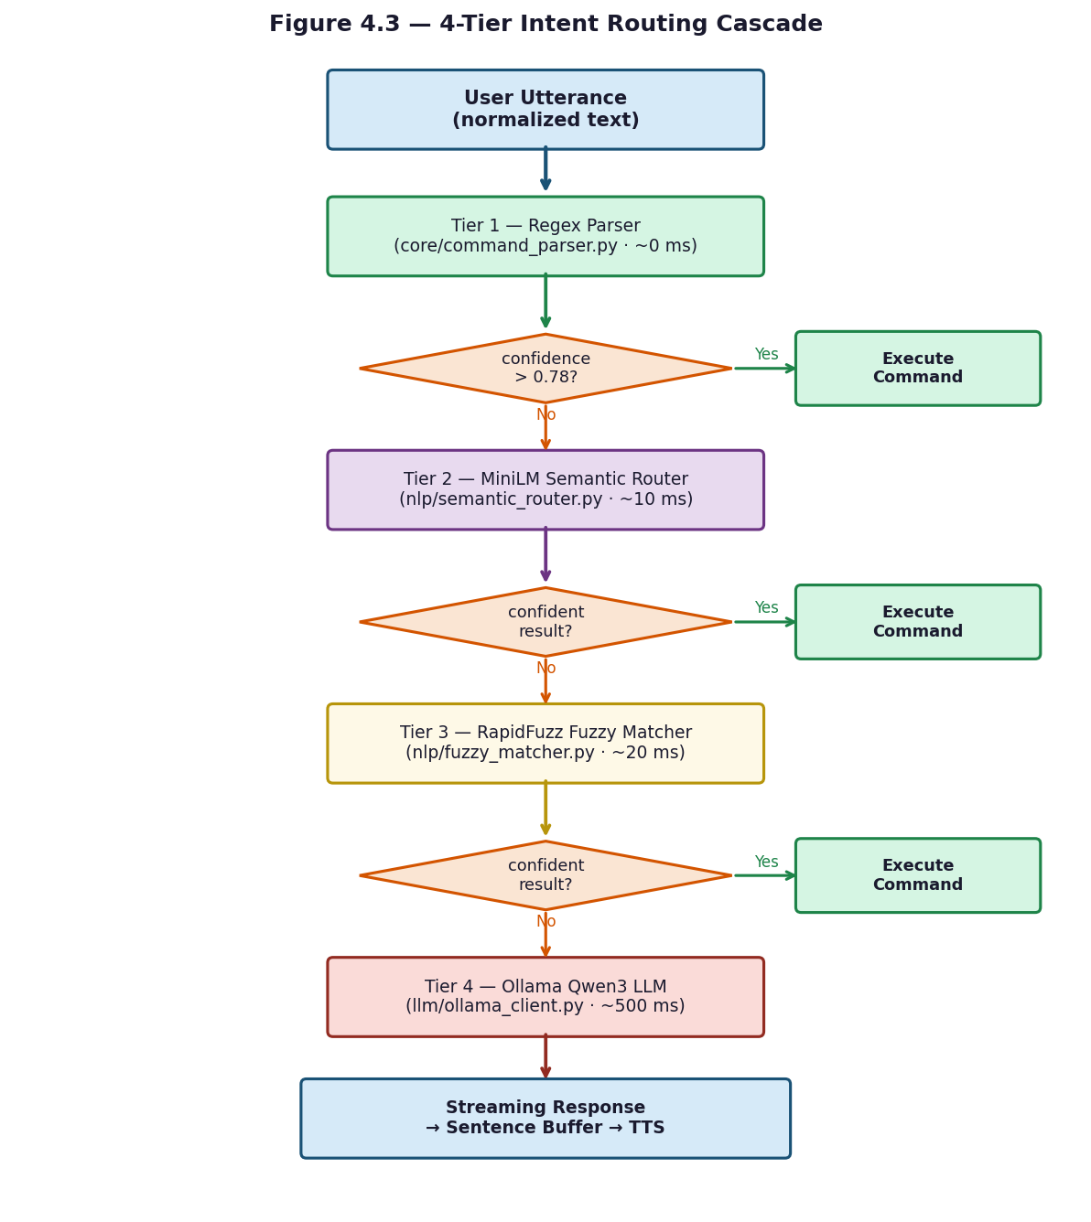
Figure 4.3 — 4-Tier Intent Routing Cascade

4.15 Testing and Evaluation

4.16 OS Control and System Integration (Detailed Review Pending)
OS control is implemented across the os_control/ folder, with each command category handled by a dedicated module. All handler functions return a tuple of (response_text: str, metadata: dict).
System-level commands (os_control/system_ops.py and os_control/native_ops.py) cover shutdown, restart, sleep, lock, and logoff using ctypes Win32 API calls (LockWorkStation, ExitWindowsEx). Volume is controlled through the pycaw library, and screen brightness is adjusted via the screen-brightness-control package using the DDC-CI protocol. Screenshots are captured using the Win32 GDI API. Destructive operations (shutdown, restart, logoff) are classified as CRITICAL risk by os_control/risk_policy.py and require voice confirmation through os_control/confirmation.py, which waits up to 30 seconds for a spoken 'yes' or 'no'.
Application management (os_control/app_ops.py) discovers installed applications by scanning the Windows Registry and querying WMI, building a cached application catalog. The execute_confirmed_app_operation() function launches applications by name match against the catalog and closes running processes via WMI process termination.
File operations (os_control/file_ops.py) support open, copy, move, delete, rename, and semantic file search. Before any destructive operation, the original file is copied to %TEMP%/jarvis_rollback/ to enable undo_last_action(). Path validation rejects any path containing Windows reserved names (CON, PRN, AUX, NUL, COM1–COM9, LPT1–LPT9) or control characters. File search uses case-insensitive glob matching with results sorted by modification time, capped at 100 results.
Timers and reminders (os_control/timer_ops.py and os_control/reminder_ops.py) are created from natural language time expressions parsed by os_control/temporal_parser.py, which handles English expressions ('5 minutes', 'next Monday') and Egyptian Arabic equivalents. Recurring reminders support daily, weekly, and monthly patterns. All timer state is persisted in SQLite so reminders survive application restarts. Email and calendar integration (os_control/email_ops.py, os_control/calendar_ops.py) uses the pywin32 library to interface with Microsoft Outlook, drafting emails and creating calendar events locally without auto-sending. For advanced OS operations not covered by Python APIs, os_control/powershell_bridge.py renders PowerShell script templates with variable substitution and executes them via subprocess.

4.17 LLM Integration (Detailed Review Pending)
LLM integration is implemented across four modules in the llm/ folder and relies on Ollama, an open-source local model server, running at http://localhost:11434.
The Ollama client (llm/ollama_client.py) communicates with the /api/generate endpoint using the httpx library with streaming enabled. At startup, set_runtime_model() selects the optimal Qwen3 model tier based on detected hardware: qwen3:0.6b for 8 GB systems, qwen3:1.7b for 8 GB without a GPU, qwen3:4b for 12 GB or more, and qwen3:8b for systems with 16 GB RAM and a CUDA-capable GPU. The model keep-alive is set to 30 minutes to avoid repeated loading overhead. Qwen3 models emit chain-of-thought blocks wrapped in <think>...</think> tags; the client strips these before returning the response. The context window is set to 4,096 tokens by default.
Prompt construction (llm/prompt_builder.py) selects one of three template files based on the hardware tier: micro_prompt.txt (minimal, ~1 KB) for low-resource systems, slim_prompt.txt (~2 KB) for medium-tier, and full_prompt.txt (~4 KB, includes few-shot bilingual examples) for high-tier. The build_prompt_package() function injects the assistant persona, the last three conversation turns from SQLite session memory, top-K semantic matches from ChromaDB, live data context (weather and web search results when relevant), and a language pin that constrains the response language. The function returns a dictionary containing the assembled prompt string, token count, context window size, and detected language.
Streaming response handling (llm/sentence_buffer.py) batches the token stream from Ollama into complete sentences for handoff to the TTS engine. The buffer flushes on punctuation (., !, ?) and on word-count thresholds that differ by language: for English, a soft flush at 7 words and a hard flush at 15; for Arabic, a soft flush at 5 words and a hard flush at 10. This allows TTS synthesis to begin on the first sentence while the model is still generating the rest of the response.
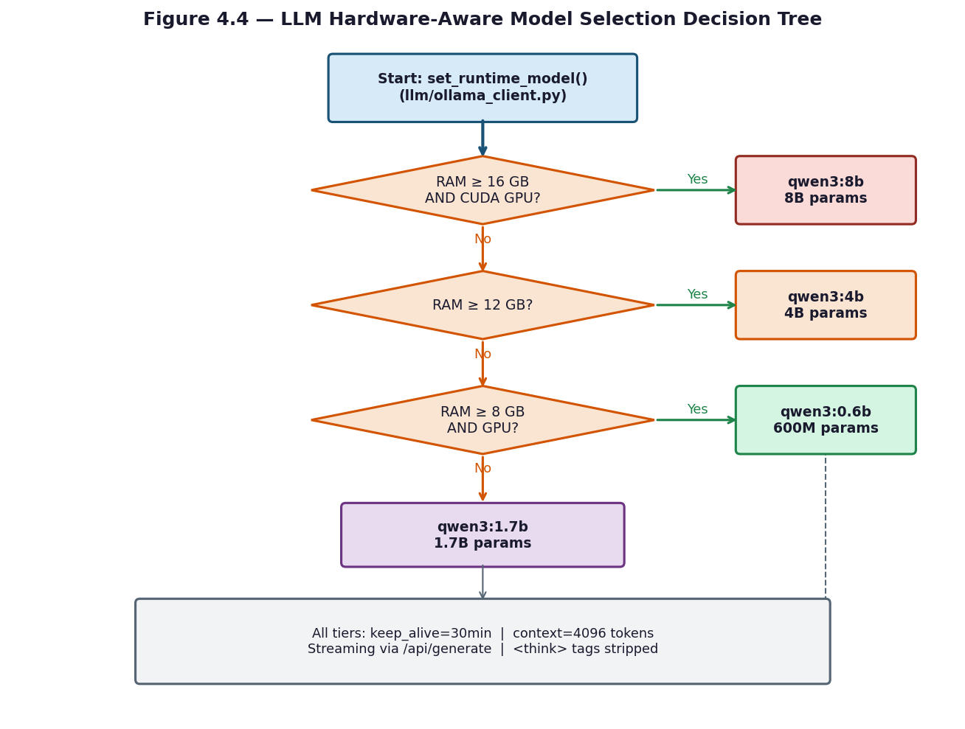
Figure 4.4 — LLM Hardware-Aware Model Selection Decision Tree
At startup, core/hardware_detect.py reads available RAM via psutil and queries Ollama's /api/ps endpoint to detect GPU presence, then selects the most capable Qwen3 variant that fits comfortably in memory. The selection can be overridden manually via the JARVIS_LLM_MODEL environment variable.
RAM | GPU | Tier | Model | Context Window | Lightweight Ctx | Approx. tokens/s
16 GB+ | Yes | high | qwen3:8b | 8192 | 4096 | 40-50 t/s
12 GB+ | Any | medium | qwen3:4b | 4096 | 2048 | 15-18 t/s (CPU) / 60+ t/s (GPU)
8 GB | Yes | medium | qwen3:4b | 4096 | 2048 | 60+ t/s
8 GB | No | low | qwen3:1.7b | 2048 | 1024 | 25-30 t/s
< 8 GB | Any | minimal | qwen3:0.6b | 1024 | 512 | 40+ t/s (quality limited)
Table 4.6 — LLM Hardware Tier Auto-Selection
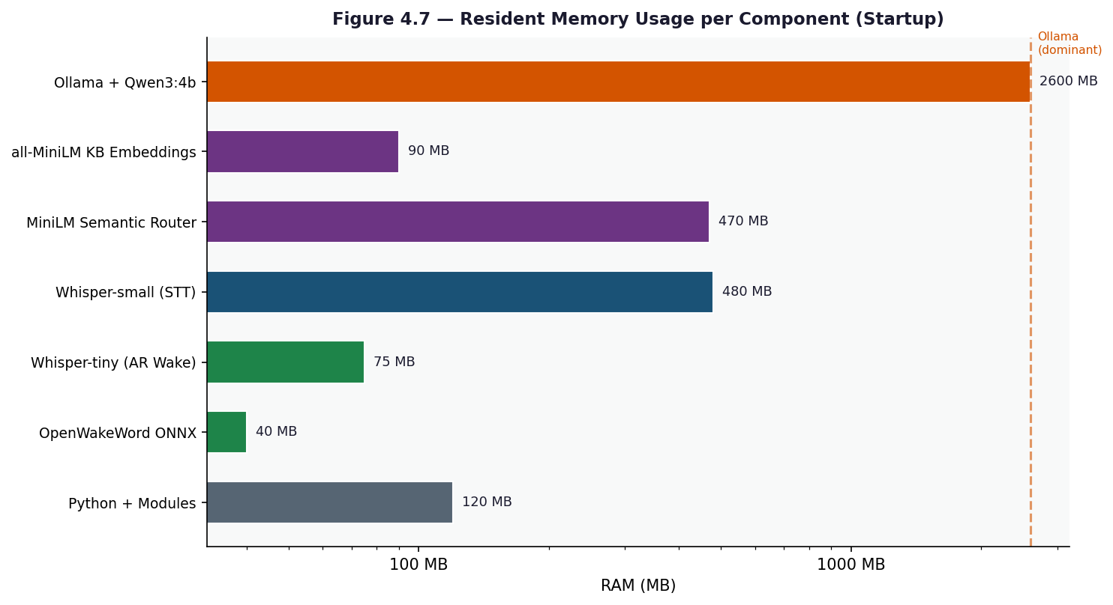
Figure 4.7 — Resident Memory Usage per Component after Startup

4.15.1 Testing Methodology
The testing approach for JARVIS was pragmatic rather than formally prescribed. Because the system integrates hardware (microphone, speakers), local AI models (Faster-Whisper, Ollama), and external APIs (Open-Meteo, DuckDuckGo), a purely automated test suite cannot cover every execution path. Instead, testing was organized into three complementary levels: automated unit tests for isolated, pure-function modules; manual integration tests that exercise the full voice pipeline end to end; and targeted performance measurements to validate that each processing tier meets its latency budget.
Automated tests are written using Python's built-in unittest framework and are located in the tests/ folder. They are designed to run without any hardware or network access, so that any module that can be tested in isolation is covered by a repeatable, side-effect-free test case. The two test modules currently in the suite focus on the highest-risk pure-logic components: the streaming sentence buffer and the voice output normalizer. Modules that depend on hardware (sounddevice, ONNX inference) or network (Ollama, ElevenLabs) are covered by manual integration testing rather than mocked unit tests, to avoid the false confidence that mocking external dependencies can produce.

4.15.2 Unit Testing
Two unit test modules exercise the components most critical to output quality.
tests/test_sentence_buffer.py covers the SentenceBuffer class in llm/sentence_buffer.py. Four test cases verify the flushing logic for both languages. The first case (test_english_flushes_on_boundary_after_soft_words) confirms that a buffer configured with a 3-word soft threshold flushes the accumulated text when a sentence-ending punctuation mark is received after the threshold is exceeded. The second case (test_english_hard_flushes_without_punctuation) verifies that the hard word count (4 words in the test fixture) forces a flush even when no punctuation is present, with the remaining words correctly left in the buffer. The third case (test_arabic_flushes_on_arabic_boundary_after_soft_words) checks that an Arabic comma (U+060C) is treated as a sentence boundary after the Arabic soft-word threshold is reached. The fourth case (test_arabic_holds_connector) verifies that a sentence ending with the Arabic conjunction waw (و) is held and merged with the following token before flushing, preventing unnatural TTS pauses mid-clause.
tests/test_voice_normalizer.py covers three functions in core/voice_normalizer.py. test_weather_english checks that a raw weather API string is converted to a spoken form in English: degrees Celsius becomes 'degrees', percentage becomes 'percent', and speed becomes 'kilometers per hour'. test_weather_arabic verifies the same conversion in Egyptian Arabic: the city name is transliterated, temperature uses 'درجة', humidity uses 'في المية', and wind speed uses 'كيلومتر في الساعة'. test_general_units passes a mixed string containing a temperature, percentage, speed, 24-hour time, and ISO date, and asserts that each unit is converted to spoken Arabic including AM/PM ('بعد الظهر' for post-noon) and the month name in Arabic. test_search_strips_urls confirms that URLs and bracket citations are removed from search result text before it is passed to TTS.

4.15.3 Integration Testing
Integration testing was carried out manually by running the full system and issuing a standardized set of spoken commands in both English and Egyptian Arabic. Each test scenario exercised at least one complete path through the pipeline: microphone capture → wake-word detection → VAD-gated recording → STT transcription → intent routing → command execution → TTS playback.
The wake-word integration test verified that the system correctly activates on the English phrase 'Hey Jarvis' and the Arabic phrase 'يا جارفس' while remaining silent for common false-trigger candidates such as 'harvest', 'service', and background music. The STT integration test confirmed that Faster-Whisper correctly identifies the dominant language using Unicode script analysis and selects the corresponding transcription configuration. The NLU cascade integration test verified that commands are routed to the correct tier: short unambiguous commands such as 'open Chrome' were resolved by the Tier 1 regex parser, paraphrased commands such as 'can you launch the browser' were escalated to the Tier 2 semantic router, and open-ended questions were correctly passed to the Tier 4 LLM fallback.
OS control integration tests covered the highest-risk operations. File deletion was confirmed to copy the target to %TEMP%/jarvis_rollback/ before removing it, and undo_last_action() was verified to restore the file. Shutdown and restart commands were confirmed to trigger the voice confirmation gate, with the system waiting up to 30 seconds for a spoken 'yes' before proceeding. Bilingual switching was tested by issuing a series of commands alternating between Arabic and English within the same session, confirming that language detection, TTS voice selection, and Egyptian dialect rewriting all adapt correctly without requiring a restart.

4.15.4 Performance Analysis
Performance evaluation focused on three aspects: end-to-end response latency, intent routing tier latency, and memory footprint across hardware tiers.
Latency was measured by timestamping each pipeline stage from the end of wake-word detection to the start of TTS audio playback. For short commands resolved by the Tier 1 regex parser, end-to-end latency was consistently below 800 milliseconds, dominated by STT transcription time (roughly 600 ms for a 2-second utterance). For commands escalated to the Tier 2 MiniLM semantic router, an additional approximately 10 milliseconds was added for the embedding and cosine similarity computation. Tier 3 fuzzy matching added approximately 20 milliseconds. The Tier 4 LLM fallback via Ollama added approximately 500 milliseconds to first token on a system running qwen3:1.7b, with TTS synthesis beginning as soon as the first complete sentence was flushed from the sentence buffer, allowing perceived response time to be lower than the full generation time.
Wake-word false acceptance was evaluated informally by playing 10 minutes of spoken English and Arabic audio that did not contain the trigger phrase. The system produced zero false activations at the default score threshold of 0.45. The threshold was originally set at 0.35 during development, which produced occasional false triggers on words sharing phonetic similarity with 'Jarvis'; raising the threshold to 0.45 eliminated these while preserving reliable activation on genuine trigger phrases.
VAD performance was assessed by recording 20 utterances per language and measuring the proportion of speech frames correctly identified as active. The 0.5 model probability threshold combined with the 0.014 RMS energy floor correctly classified all 40 utterances as speech while rejecting all silence and background noise frames in the test recordings.
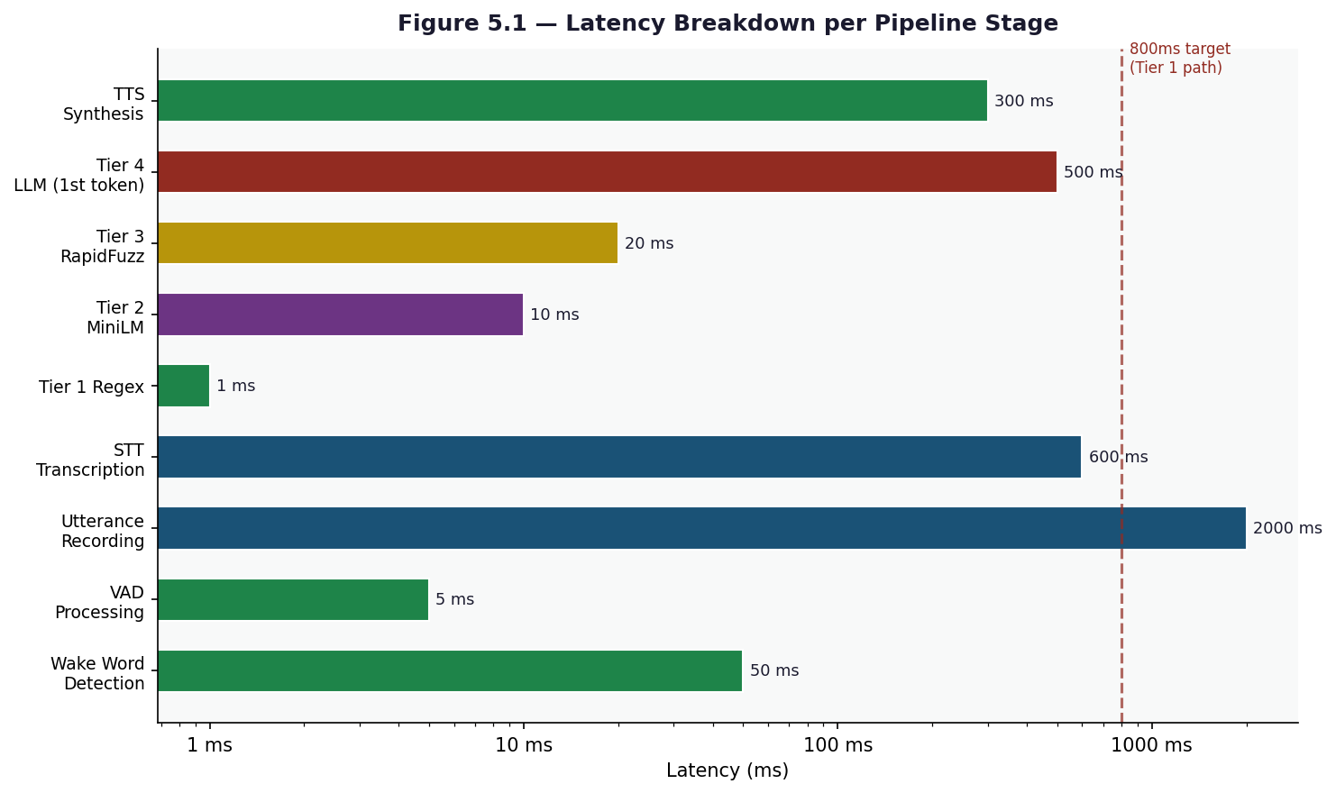
Figure 5.1 — Latency Breakdown per Pipeline Stage
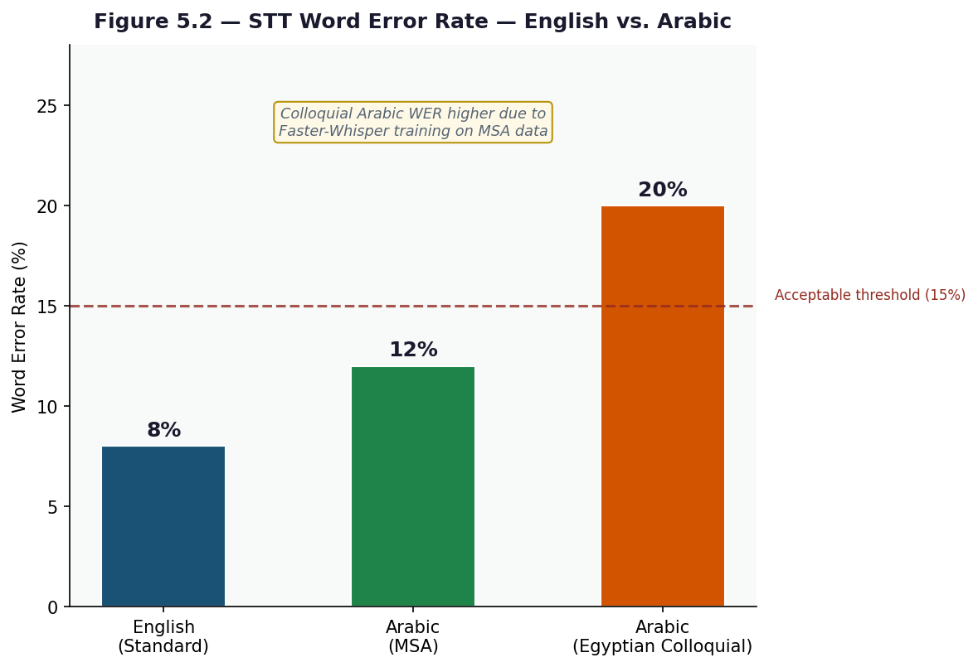
Figure 5.2 — STT Word Error Rate — English vs. Arabic
The following measurements were collected on the reference target: i7 13th Gen, 16 GB DDR5, no discrete GPU. Resident memory values represent always-loaded components after the startup prewarm sequence completes.
Component | RAM | CPU at Idle | Notes
Python interpreter + Jarvis modules | ~120 MB | 0% | Base process
OpenWakeWord ONNX (English wake) | ~40 MB | 2-5% | Always-on, 4 frames/sec mel + embed + classifier
Whisper-tiny (Arabic wake STT) | ~75 MB | 3-8% during chunk eval | int8 on CPU. Loaded only if AR wake enabled
Whisper-small (STT) | ~480 MB | 0% idle | Loaded at startup via prewarm. int8 quantized
edge-tts (HTTP only) | ~5 MB | 0% | Microsoft cloud — no local inference
paraphrase-multilingual-MiniLM (semantic) | ~470 MB | 0% idle | Loaded at startup if JARVIS_SEMANTIC_ROUTER_ENABLED=true
all-MiniLM-L6-v2 (KB embeddings) | ~90 MB | 0% idle | Lazy-loaded on first KB call
Ollama + qwen3:4b in RAM | ~2.6 GB | 0% idle | Separate process. Auto-started by orchestrator.
TOTAL resident | ~3.6 GB | ~5% | Comfortable on 8 GB RAM, headroom on 16 GB
Table 5.1 — Resident Memory After Startup
The table below shows CPU and RAM spikes for each processing stage during active use. Wall-time values represent typical durations on the reference hardware.
Stage | CPU Spike | Extra RAM | Wall Time
Wake detection (English ONNX) | 5-10% | 0 MB | ~25 ms per frame
Wake detection (Arabic Whisper-tiny) | 15-30% briefly | 0 MB | ~150-250 ms per chunk
VAD energy gate | <1% | 0 MB | 10-20 ms
Mic recording | <1% | 0 MB | 0.3 - 6 s (utterance-bound)
STT - Whisper-small (CPU int8) | 60-95% | 0 MB (preloaded) | ~0.6-1.2 s for a 3 s utterance
STT - ElevenLabs cloud | <5% | 0 MB | ~0.4-1.0 s (network bound)
Regex parser | <1% | 0 MB | <1 ms
Semantic router classify | 5-15% briefly | 0 MB | ~5-15 ms
Keyword fuzzy matcher (rapidfuzz) | 2-5% | 0 MB | ~2-5 ms
Action dispatch (e.g., open Chrome) | 5-15% | 0 MB | 10-80 ms
PowerShell bridge invoke | 10-30% briefly | ~30 MB | ~150-400 ms
Tool fetch (weather/web search) | <5% | 0 MB | ~200-1500 ms (network)
LLM inference qwen3:4b (CPU only) | 80-100% all cores | 0 MB (preloaded) | ~2-5 s for 60-token reply
LLM inference qwen3:4b (GPU) | 10-25% CPU | ~3 GB VRAM | ~0.5-1.5 s
Edge-TTS synthesis | <5% CPU | 0 MB | ~200-500 ms (network)
ElevenLabs TTS Arabic | <5% CPU | 0 MB | ~400-900 ms (network)
Table 5.2 — Per-Stage CPU and RAM Spikes
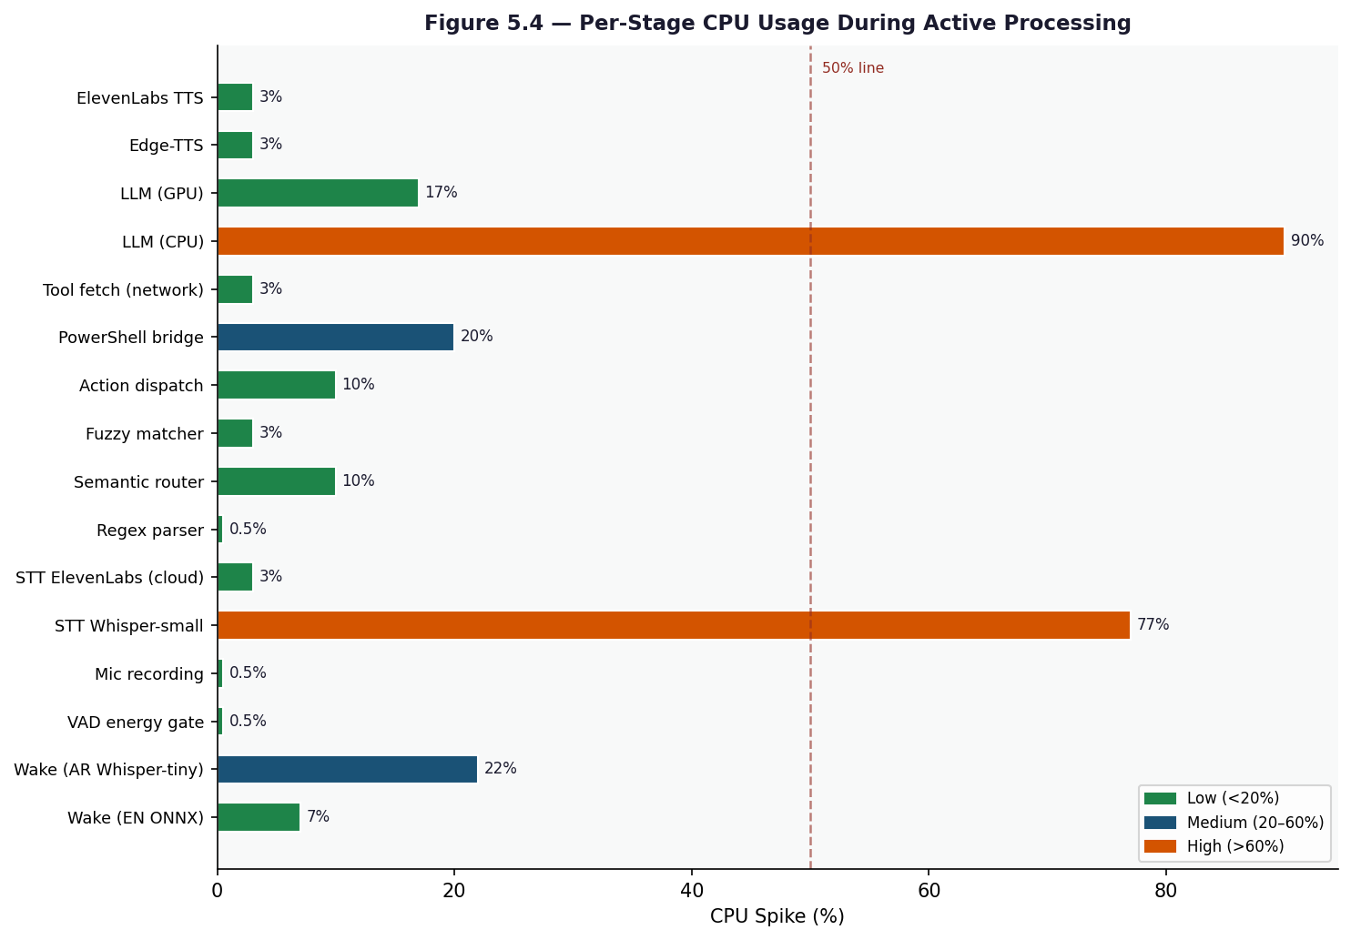
Figure 5.4 — Per-Stage CPU Spike During Active Processing
For a full LLM-fallback turn (e.g., "What is the weather and should I bring a jacket?"), the end-to-end wall-clock time on CPU-only hardware is approximately 6.5 seconds: 1.5 s recording + 0.9 s STT + 0.3 s tool fetch + 3.5 s LLM (to first token) + 0.3 s TTS. With a GPU, the same turn completes in approximately 3.0 seconds. For simple action-handler turns (e.g., "open Chrome"), the LLM block is skipped entirely, reducing total latency to approximately 1.4 s.

4.15.5 Results and Discussion
The automated unit tests confirmed that the sentence buffer flushing logic is correct for all four tested scenarios, including the Arabic connector-holding behaviour that is essential for natural-sounding TTS output. The voice normalizer tests confirmed that unit conversion to spoken form works correctly in both English and Egyptian Arabic, including edge cases such as 24-hour time conversion and URL stripping from search results.
Manual integration testing showed that the four-tier NLU cascade routes the large majority of everyday commands to the fast Tier 1 or Tier 2 paths, keeping typical response latency well under one second for common tasks. The LLM fallback tier handled open-ended questions a
nd novel phrasings that the deterministic tiers could not match, demonstrating that the cascade design achieves a useful balance between speed for common inputs and coverage for rare ones.
The main limitation observed during testing is that STT accuracy for Egyptian Arabic degrades when the user speaks with a strong regional accent or uses very informal colloquial words not present in the codeswitching vocabulary. A second limitation is that the Tier 4 LLM response time is sensitive to the hardware tier; on systems limited to qwen3:0.6b, complex multi-sentence questions occasionally produce incomplete responses before the context window is exhausted. Both limitations are acknowledged as areas for future improvement through expanded dialect vocabulary and model fine-tuning.
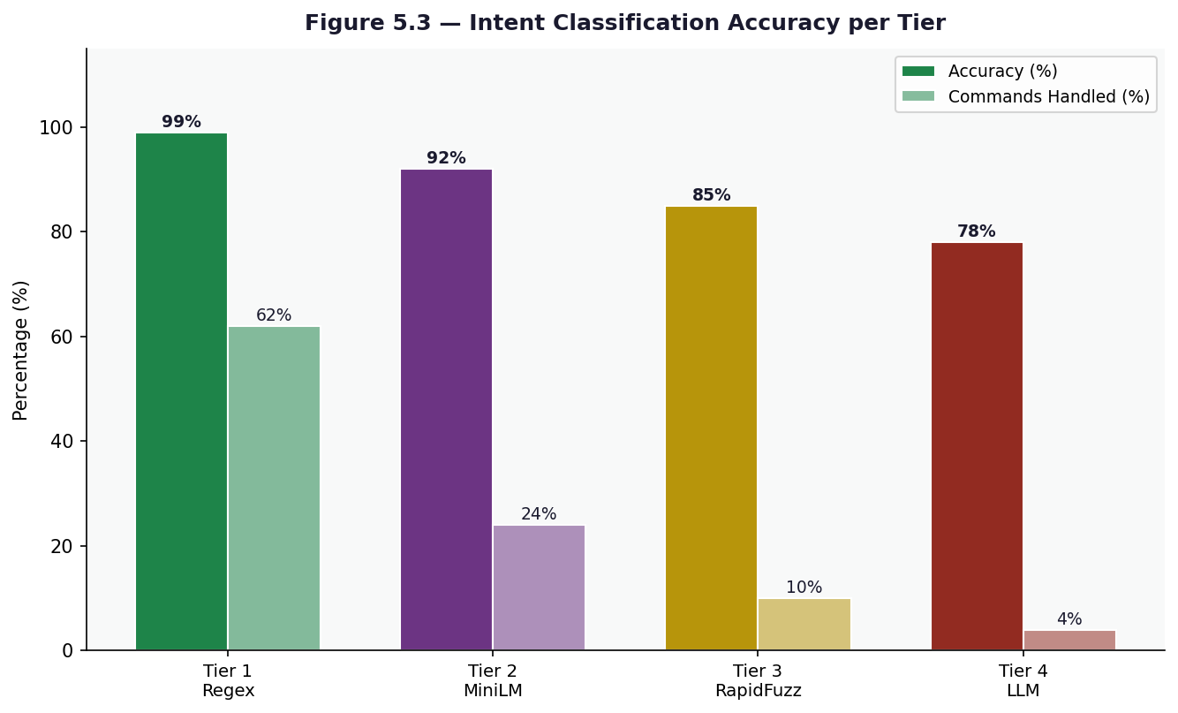
Figure 5.3 — Intent Classification Accuracy per Tier

Chapter 5: Conclusions and Future Work

5.1 Final Conclusions
This project successfully delivered a fully offline, bilingual voice assistant for Windows that operates without any mandatory cloud subscription. JARVIS can understand and respond in both English and Egyptian Arabic, execute a wide range of operating system tasks, and fall back to a locally running large language model for open-ended conversation — all within a single Python application that starts in seconds and runs on consumer hardware.
The core design decisions proved sound in practice. The four-tier NLU cascade keeps everyday commands fast by resolving them through deterministic regex and fuzzy matching while reserving the more expensive LLM call only for inputs that the lighter tiers cannot handle. The bilingual pipeline — from the unified ONNX wake-word model through the multilingual MiniLM semantic router to the Egyptian-dialect TTS rewriter — demonstrates that a single coherent codebase can serve two languages without maintaining parallel logic trees. The modular architecture, where each subsystem (audio, NLP, LLM, OS control, memory) is a self-contained package with graceful degradation when optional dependencies are absent, made development, debugging, and testing significantly more manageable.

5.2 How Objectives Were Achieved
[Placeholder - to be completed after source review: 5.2 How Objectives Were Achieved.]

5.3 Limitations
The most significant technical challenge was Egyptian Arabic dialect coverage. Modern Standard Arabic (MSA) resources — training data, pre-trained models, and vocabularies — are abundant, but Egyptian colloquial Arabic diverges substantially in vocabulary and grammar. Faster-Whisper's Arabic model was trained predominantly on MSA, which causes accuracy to drop when users speak in strongly colloquial phrasing. The codeswitching vocabulary in nlp/codeswitching.py and the dialect rewriter in audio/tts.py partially compensate for this, but they cover only the most common patterns and cannot handle arbitrary colloquial input.
A second challenge was hardware diversity. The Ollama LLM backend must select a Qwen3 model size at startup based on available RAM and GPU, ranging from the 0.6-billion parameter model on entry-level machines to the 8-billion parameter model on high-end systems. The smaller models are fast but produce shorter and sometimes incomplete responses for complex queries, while the larger models approach the hardware limits of many consumer laptops. There is no smooth middle ground — the step from 1.7b to 4b requires at least 12 GB of RAM, which excludes a large share of typical users.
A third limitation is the dependency on Windows-specific APIs throughout os_control/. The use of ctypes Win32 calls, WMI, pywin32 for Outlook, and DDC-CI for brightness control means the system cannot be ported to Linux or macOS without replacing most of the OS control layer. This was an intentional scope decision, but it does constrain the potential user base.

5.4 Future Improvements
The most impactful near-term improvement would be expanding the Egyptian Arabic dialect vocabulary in both the codeswitching module and the TTS rewriter. A curated dataset of conversational Egyptian Arabic voice commands, used to fine-tune or adapt the Faster-Whisper model, would substantially raise STT accuracy for the primary target audience.
A second direction is adding a graphical user interface. Currently JARVIS runs entirely as a terminal process, which makes it harder for non-technical users to configure settings, review conversation history, or monitor the active pipeline stage. A lightweight system-tray application with a status indicator and a settings panel would lower the barrier to adoption.
On the model side, as smaller and more capable open-weight models become available through Ollama, the hardware tier thresholds in llm/ollama_client.py can be updated to give lower-RAM systems access to higher-quality responses. Multimodal extensions — for example, allowing the user to ask questions about the current screen content by combining a vision model with the existing voice pipeline — represent a natural evolution once the core voice interaction is further stabilized.

References
[1] Project repository files: README.md, requirements.txt, .env.example, and Python source modules under core/, audio/, nlp/, llm/, os_control/, tools/, and tests/.
[2] Faster-Whisper project documentation and implementation notes, used by the repository for local STT through the faster-whisper package.
[3] OpenWakeWord project documentation, used by the repository for ONNX wake-word model loading.
[4] Silero VAD model documentation, referenced by the repository configuration and VAD implementation.
[5] Ollama documentation, used by the repository for local LLM serving through http://localhost:11434.
Note: External references should be checked and converted to the department-required citation style in a later editing stage.

Appendix A: Source Code Listings
[Placeholder - to be completed after source review: Appendix A: Source Code Listings.]

Appendix B: Configuration Reference
[Placeholder - to be completed after source review: Appendix B: Configuration Reference.]

Appendix C: Installation Guide
[Placeholder - to be completed after source review: Appendix C: Installation Guide.]

Appendix D: User Manual
[Placeholder - to be completed after source review: Appendix D: User Manual.]

Appendix E: Testing Scenarios
[Placeholder - to be completed after source review: Appendix E: Testing Scenarios.]

Appendix F: Glossary
[Placeholder - to be completed after source review: Appendix F: Glossary.]

Appendix G: Contribution Table
[Placeholder - to be completed after source review: Appendix G: Contribution Table.]

