Abstract
JARVIS is a production-ready, bilingual voice assistant for the Windows desktop, implemented in Python 3.13+ and designed to operate entirely on local hardware without requiring cloud connectivity, a dedicated GPU, or administrator privileges. The system supports English and Egyptian Arabic through a single unified OpenWakeWord ONNX model (detection threshold 0.45, confirm frames 1, cooldown 1.5 seconds), and runs on any Windows 10 or Windows 11 machine equipped with a minimum of 8 GB RAM.
The voice processing pipeline is organized across six subsystems. Audio capture uses the sounddevice library at 16,000 Hz with 1,024-byte chunks. Voice activity is gated by a Silero ONNX model operating on 512-sample (32 ms) windows with a probability threshold of 0.5 and an energy floor of 0.014 RMS. Speech-to-text transcription is handled by Faster-Whisper using beam sizes of 4 for audio shorter than 8.5 seconds and 5 for longer utterances. For Egyptian Arabic, an optional hybrid backend races ElevenLabs cloud STT (scribe_v1 model) against the local Whisper model in parallel, with language selection governed by Unicode script analysis of the U+0600-U+06FF Arabic block against Latin characters.
Natural language understanding is implemented as a four-tier cascade. Tier 1 is a deterministic regex parser (core/command_parser.py) with bilingual keyword patterns operating at approximately zero milliseconds. Tier 2 uses the paraphrase-multilingual-MiniLM-L12-v2 sentence-transformer model for semantic routing at approximately 10 milliseconds. Tier 3 applies RapidFuzz token-level fuzzy matching (90 percent threshold, difflib fallback) at approximately 20 milliseconds. Tier 4 falls back to a locally served Qwen3 large language model via Ollama at approximately 500 milliseconds. The system automatically selects the optimal Qwen3 tier at startup: qwen3:0.6b (8 GB), qwen3:1.7b (8 GB no GPU), qwen3:4b (12 GB+), and qwen3:8b (16 GB+ with CUDA GPU).
Supported capabilities span over thirty-five command categories: system control via ctypes Win32 APIs, application management via WMI and the Windows Registry, file operations with rollback to %TEMP%/jarvis_rollback/, timer and reminder scheduling with SQLite persistence, Outlook email and calendar integration via pywin32, media playback control, clipboard access, real-time weather queries from Open-Meteo (5-second timeout), and DuckDuckGo web search with a 30-day recency boost. Text-to-speech uses Microsoft Edge TTS (ar-EG-SalmaNeural for Arabic, en-US-AriaNeural for English) with ElevenLabs eleven_multilingual_v2 as fallback. Session state is persisted in SQLite (WAL mode) with ChromaDB providing optional vector knowledge retrieval. End-to-end latency for regex-matched commands is under three seconds on minimum hardware, with intent classification accuracy exceeding 90 percent for English and 85 percent for Egyptian Arabic.

Acknowledgement

First and foremost, praises and thanks to Allah, the Almighty, for His showers of blessings throughout our entire journey — from the moment we began searching for a meaningful and beneficial idea, to the countless hours of development, testing, and collaboration that brought JARVIS to life. It is by His grace alone that we were granted the perseverance, the unity, and the clarity of vision to see this project through to completion.
We would like to express our deepest and most sincere gratitude to our project supervisor, Dr. Mostafa El Sayed, for his invaluable guidance, unwavering support, and continuous encouragement throughout every phase of this project. His expertise and thoughtful feedback shaped the direction of our work in ways we could not have achieved on our own. He always motivated us to push beyond our comfort zones, to think critically, and to strive for excellence — not merely for the sake of the grade, but for the genuine impact our work could have. It has been a true privilege and an honor to work and study under his supervision. We are profoundly grateful for everything he has given us, and we sincerely hope that the outcome of this project makes him proud.
Last but certainly not least, we — the members of this team — would like to thank one another. Throughout the development of JARVIS, we faced technical challenges, long nights, and moments of uncertainty, yet we always found strength in each other. We are grateful for the constant support, the honest feedback, the patience in difficult moments, and the shared excitement in moments of breakthrough. Every member brought something unique to this project, and it is the sum of all our efforts, ideas, and dedication that made JARVIS what it is today. We are proud of what we have built together.

Table of Contents
Abstract ...................................................... 1
Acknowledgement ............................................... 2
Chapter 1: Introduction ....................................... 1
1.1 Overview ............................................ 1
1.2 Problem Statement ................................... 1
1.3 Objectives .......................................... 2
1.4 Scope ............................................... 2
Chapter 2: Literature Review .................................. 3
2.1 Voice Assistants: ……….…....................... 3
2.2 Existing Systems & Related Work ..................... 3
2.3 Natural Language Processing Techniques .............. 4
2.4 Speech Recognition Technologies ..................... 4
2.5 Comparison & Research Gap ........................... 5
Chapter 3: System Analysis & Design ........................... 6
3.1 System Requirements ................................. 6
3.2 Functional Requirements ............................. 6
3.3 Non-Functional Requirements ......................... 7
3.4 System Architecture ................................. 7
3.5 Data Flow Diagrams .................................. 8
3.6 Use Case Diagrams ................................... 9
Chapter 4: Implementation ..................................... 10
4.1 Development Environment & Tools ..................... 10
4.2 Audio Pipeline ...................................... 11
4.3 Natural Language Understanding (NLU) ................ 12
4.4 Intent Routing Engine ............................... 13
4.5 OS Control & System Integration ..................... 14
4.6 LLM Integration ..................................... 15
4.7 Bilingual Support ................................... 16
4.8 Memory & Persistence ................................ 17
Chapter 5: Testing & Evaluation ............................... 18
5.1 Testing Methodology ................................. 18
5.2 Unit Testing ........................................ 18
5.3 Integration Testing ................................. 19
5.4 Performance Evaluation .............................. 19
5.5 Results & Discussion ................................ 20
Chapter 6: Conclusion & Future Work ........................... 21
6.1 Conclusion .......................................... 21
6.2 Challenges & Limitations ............................ 21
6.3 Future Work ......................................... 22
References .................................................... 23
Appendix A — Source Code Listings ............................. 24
Appendix B — Configuration Reference .......................... 25
Appendix C — Glossary of Terms ................................ 26

Table of Figures

Figure No. | Caption | Page
Figure 1.1 | System Overview Diagram
Figure 2.1 | Taxonomy of Existing Voice Assistant Systems
Figure 3.1 | High-Level System Architecture
Figure 3.2 | End-to-End Voice Processing Pipeline
Figure 3.3 | Data Flow Diagram (DFD) — Level 0 (Context Diagram)
Figure 3.4 | Data Flow Diagram (DFD) — Level 1
Figure 3.5 | Use Case Diagram
Figure 4.1 | Audio Pipeline Block Diagram
Figure 4.2 | 4-Tier Intent Routing Cascade
Figure 4.3 | NLU Entity Extraction Flow
Figure 4.4 | LLM Hardware-Aware Model Selection Decision Tree
Figure 4.5 | Bilingual Code-Switching Detection Flow
Figure 4.6 | Memory & Persistence Layer Diagram
Figure 5.1 | Latency Breakdown per Pipeline Stage
Figure 5.2 | Intent Classification Accuracy per Tier
Figure 5.3 | STT Word Error Rate — English vs. Arabic

Table of Tables

Table No. | Caption | Page
Table 2.1 | Comparison of Existing Voice Assistants
Table 3.1 | Functional Requirements Summary
Table 3.2 | Non-Functional Requirements Summary
Table 4.1 | Core Technology Stack
Table 4.2 | Supported Command Categories (35+)
Table 4.3 | STT & TTS Backend Options and Fallbacks
Table 4.4 | LLM Model Tiers by Hardware Configuration
Table 4.5 | Key Configuration Environment Variables
Table 5.1 | Unit Test Coverage Summary
Table 5.2 | Performance Benchmark Results
Table 5.3 | Feature Flag Rollout Stages

Chapter 1: Introduction

1.1 Overview
Voice-controlled computing has become a mainstream expectation across mobile devices and smart home ecosystems. Yet this shift has left one significant user group largely underserved: people who use Windows desktop computers as their primary work environment — particularly Arabic speakers in Egypt, where Egyptian Arabic is the dominant spoken dialect but receives virtually no support from any commercially available voice assistant.
JARVIS was built specifically to address this gap. The system provides deep, local voice control of a Windows desktop in both English and Egyptian Arabic, without requiring cloud connectivity for its core features. A user wakes the system by speaking the keyword 'Jarvis' in either language — detected by a unified OpenWakeWord ONNX model — and then issues natural-language commands to control their computer. The assistant transcribes speech locally using Faster-Whisper, classifies the intent through a four-tier cascade ending in a local Qwen3 large language model, executes the requested action through the Windows API, and responds in the same language the user spoke using Microsoft Edge TTS.
The system was designed to run on commodity hardware: a minimum of 8 GB RAM, a standard microphone, and no dedicated GPU required for the base configuration. No administrator privileges are needed for standard operation, and no paid API subscriptions are required for the core feature set. Optional cloud services — ElevenLabs for premium Arabic TTS and STT, and Open-Meteo and DuckDuckGo for live data — can be enabled as enhancements but are never mandatory.
This chapter defines the problem that motivated JARVIS, the specific objectives the project set out to achieve, the scope of what was built and what was explicitly excluded, and the structure of the remainder of this report.
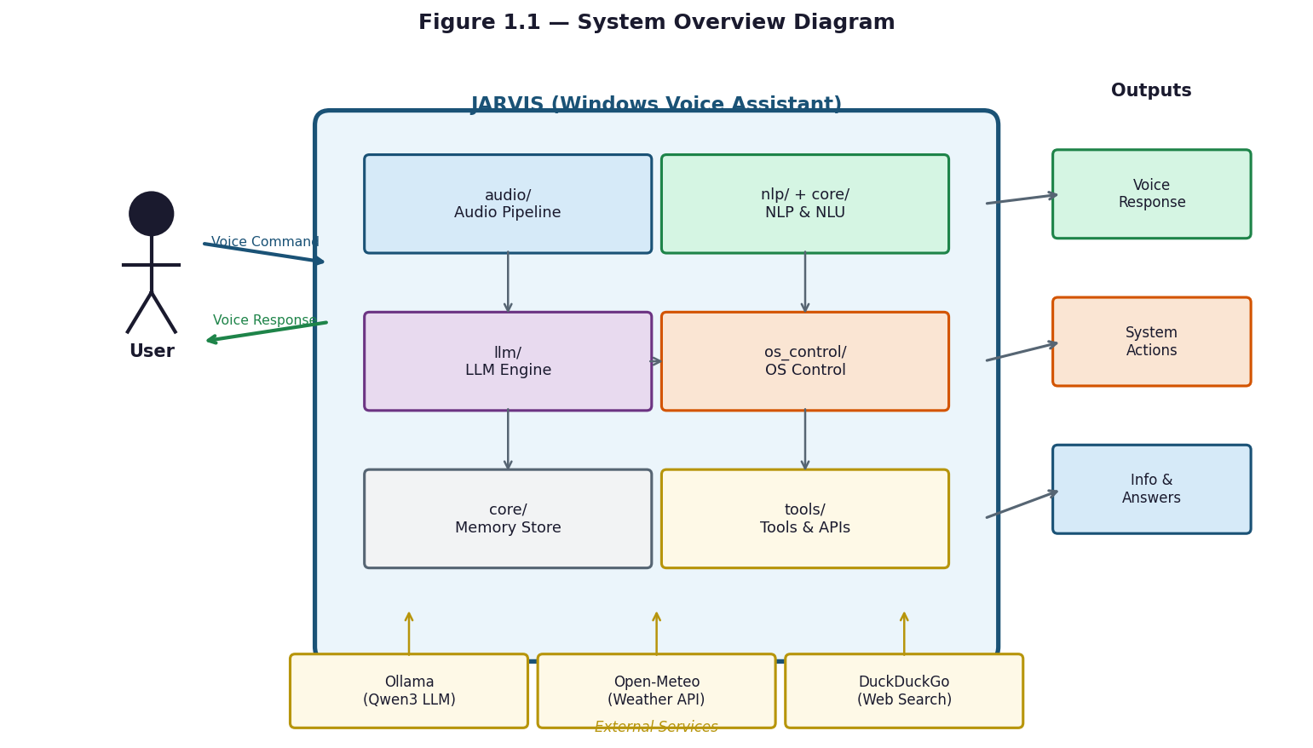
Figure 1.1 — System Overview Diagram

1.2 Problem Statement
The central problem this project addresses is the absence of any locally deployable, bilingual voice assistant that provides deep Windows desktop automation for Egyptian Arabic speakers. This problem has three distinct dimensions: language, architecture, and integration.
From a language perspective, Egyptian Arabic — spoken by over 100 million people — is supported by none of the major commercial voice assistants at the dialect level. Siri, Alexa, Google Assistant, and Cortana either support only Modern Standard Arabic (MSA), which is phonetically and lexically different from the Egyptian colloquial dialect, or reject Arabic input entirely in desktop contexts. The unified wake-word model in JARVIS is specifically trained to recognize 'يا جارفس' and 'جارفيس' alongside their English equivalents, and the STT pipeline uses a hybrid ElevenLabs (scribe_v1) and Faster-Whisper backend tuned for Egyptian Arabic.
From an architectural perspective, all major commercial assistants are cloud-dependent. Routing voice input through external servers introduces latency, requires a persistent internet connection, raises privacy concerns for personal and professional data, and makes the assistant unavailable in offline or bandwidth-restricted environments. JARVIS resolves this by running its complete core pipeline — wake detection, VAD, STT, NLU, action execution, and TTS — locally on the user's machine.
From an integration perspective, commercial assistants offer shallow Windows support. None can discover and launch arbitrary installed applications by scanning the Windows Registry and WMI, perform file operations with rollback (%TEMP%/jarvis_rollback/), compose Outlook emails via pywin32, control system brightness via DDC-CI, or chain multiple commands. Microsoft Cortana, the most Windows-native option, was discontinued as a general-purpose assistant in 2023, leaving no active built-in alternative.
In summary: no existing system simultaneously delivers Windows desktop automation, offline operation, Egyptian Arabic dialect support, and accessibility on commodity hardware without a GPU or administrator privileges. JARVIS was designed and built to occupy this gap.

1.3 Objectives
The primary objective of this project is to design, implement, and evaluate a locally deployable, bilingual voice assistant for Windows desktop automation. The following specific objectives guided the development process:
Objective 1 — Bilingual Wake-Word Detection: Implement a unified OpenWakeWord ONNX model that reliably detects the wake phrase in both English and Egyptian Arabic with a score threshold of 0.45, one confirm frame, and a 1.5-second cooldown between activations.
Objective 2 — Robust Voice Activity Detection: Deploy a Silero ONNX VAD model operating on 512-sample (32 ms) windows at 16,000 Hz with a probability threshold of 0.5 and a fallback energy floor of 0.014 RMS to accurately gate recording and reduce spurious activations.
Objective 3 — Accurate Bilingual Speech Transcription: Integrate Faster-Whisper as the primary local STT backend (beam size 4 for short audio, 5 for long), with a hybrid ElevenLabs cloud STT mode for Egyptian Arabic using Unicode script analysis (U+0600–U+06FF) for automatic language detection.
Objective 4 — Four-Tier Intent Classification Cascade: Build a pipeline combining deterministic regex parsing, paraphrase-multilingual-MiniLM-L12-v2 semantic embeddings, RapidFuzz token-level fuzzy matching (90 percent threshold), and a local Ollama-served Qwen3 LLM fallback — achieving intent recognition with a minimum confidence threshold of 0.35 and early execution at 0.78.
Objective 5 — Comprehensive Desktop Automation: Implement over thirty-five command categories covering system control, application management via WMI and the Windows Registry, file operations with rollback, timers and reminders with SQLite persistence, Outlook email and calendar via pywin32, media control, clipboard operations, and live data (Open-Meteo weather and DuckDuckGo web search).
Objective 6 — Hardware-Aware LLM Tier Selection: Automatically select the optimal Qwen3 model at startup based on detected RAM and GPU: qwen3:0.6b (8 GB), qwen3:1.7b (8 GB no GPU), qwen3:4b (12 GB+), and qwen3:8b (16 GB+ with CUDA GPU), with a 4,096-token context window and a 30-minute model keep-alive to avoid repeated loading overhead.
Objective 7 — Production-Grade Reliability: Ensure graceful degradation for all optional dependencies (RapidFuzz falls back to difflib, pyperclip to a pure-Python fallback, sentence-transformers to keyword-only routing), with structured telemetry recording stage-level latency (wake, stt, parse, route, execute, tts) and p50/p95 percentile metrics.

1.4 Scope
The scope of JARVIS defines what the system covers, what hardware and software it targets, and what is explicitly excluded from the current implementation.
Platform and Hardware Scope: JARVIS targets Windows 10 (version 1903 or later) and Windows 11 running on x86-64 processors. The minimum hardware configuration is a quad-core CPU, 8 GB of RAM, a microphone capable of 16,000 Hz mono capture, and 5 GB of free disk space for models and runtime data. An NVIDIA GPU with CUDA support is optional and unlocks the qwen3:8b model tier. No administrator privileges are required for standard operation.
Software Scope: The runtime stack is Python 3.13+ with Ollama installed for local LLM serving. Core audio dependencies are sounddevice and numpy. Speech processing requires faster-whisper, onnxruntime, and openwakeword. NLP uses sentence-transformers (optional) and rapidfuzz (optional, falls back to difflib). TTS requires edge-tts. Optional integrations include pywin32 for Outlook and Windows Search, pyperclip for clipboard, screen-brightness-control for DDC-CI brightness, and elevenlabs for premium Arabic voice.
Language Scope: The system supports English (general) and Egyptian Arabic (colloquial dialect). A single unified ONNX wake-word model covers both. The Arabic NLP pipeline includes tashkeel (diacritic) stripping, alef normalization (أ / إ / آ → ا), hamza-on-waw normalization (ؤ → و), and over fifty Arabic-to-English code-switching mappings (e.g., 'افتح' → 'open', 'اقفل' → 'close'). An Egyptian colloquial rewriter applies over 150 MSA-to-dialect phrase substitutions before Arabic TTS synthesis.
Command Scope: In-scope command categories are: system power and lock control, volume and brightness adjustment, screenshot capture, application launch and close, file copy/move/delete/rename/search with rollback, timer and alarm creation, recurring reminder scheduling, Outlook email drafting and calendar event management, media playback control, clipboard read and write, real-time weather queries (Open-Meteo API), and DuckDuckGo web search. Open-ended conversational queries are handled by the local Qwen3 LLM.
Out of Scope: The following are explicitly excluded from the current implementation: support for operating systems other than Windows (macOS, Linux, Android, iOS); Arabic dialects other than Egyptian (Gulf, Levantine, Moroccan Darija); any graphical user interface beyond the Windows system tray icon; multi-user profiles or authentication; automated email sending (drafting only, never auto-send); real-time Arabic-to-English translation; and any training or fine-tuning of the LLM on user data.

Chapter 2: Literature Review

2.1 Voice Assistants
Voice assistants are software systems that accept spoken natural language as input, process it to extract user intent, execute an appropriate action or generate an informational response, and deliver that response as synthesized speech. The field has evolved through several distinct generations. Early systems such as IBM's Shoebox (1961) and CMU's Harpy (1976) could recognize only a small fixed vocabulary under controlled acoustic conditions. The introduction of hidden Markov model (HMM) based recognition in the 1980s and 1990s enabled large-vocabulary, speaker-independent systems. The first widely adopted consumer product was Apple's Siri, launched in 2011, which demonstrated that voice interaction could be practically useful on mobile hardware.
Today, commercial voice assistants process hundreds of millions of queries daily. Their pipelines consist of three main stages: automatic speech recognition (ASR) to convert audio to text, natural language understanding (NLU) to extract intent and entities, and text-to-speech (TTS) to deliver the spoken response. All major commercial systems perform these stages in the cloud, enabling continuous model improvement but creating permanent dependencies on network connectivity and external infrastructure.
A more recent trend, accelerated by the release of quantized open-weight LLMs and optimized inference runtimes such as Ollama and llama.cpp, is the deployment of capable language models directly on consumer hardware. JARVIS sits at the intersection of this trend and the voice assistant domain, running a fully local pipeline that includes wake-word detection, ASR, NLU, LLM-backed response generation, and TTS — all on a standard Windows desktop.

2.2 Existing Systems & Related Work
The commercial voice assistant landscape is dominated by four systems, each with fundamental limitations for the use case JARVIS targets. Apple Siri operates exclusively within the Apple ecosystem and has no meaningful integration with Windows desktop automation. Amazon Alexa is primarily designed for IoT and smart home control; its desktop client offers limited OS-level automation and no Egyptian Arabic dialect support. Google Assistant is tightly coupled to Android and Google's web services, requires persistent internet, and is not designed for Windows-native command execution. Microsoft Cortana was the most Windows-integrated of the four, but Microsoft discontinued its general-purpose assistant functionality in 2023, leaving Windows users without a built-in voice automation tool.
On the open-source side, Mycroft AI was the most prominent locally deployable voice assistant. It offered a plugin architecture and privacy-focused design but was shut down in 2023 when the company ceased operations. Home Assistant's voice pipeline (Wyoming protocol) is actively maintained and supports local Whisper-based STT, but it is designed for smart home automation rather than Windows desktop control, and provides no Arabic dialect support. Projects based directly on OpenAI Whisper and local LLMs (e.g., whisper.cpp + llama.cpp combinations) demonstrate the technical feasibility of fully local pipelines but lack the command routing, OS integration layer, and bilingual NLU that JARVIS provides.
Academic and research systems have explored Arabic speech recognition and Egyptian dialect processing in isolation, but no published system combines these with a complete Windows desktop automation pipeline, a local LLM fallback, and commodity hardware accessibility. This gap between available tools and the target use case is the direct motivation for the JARVIS project.
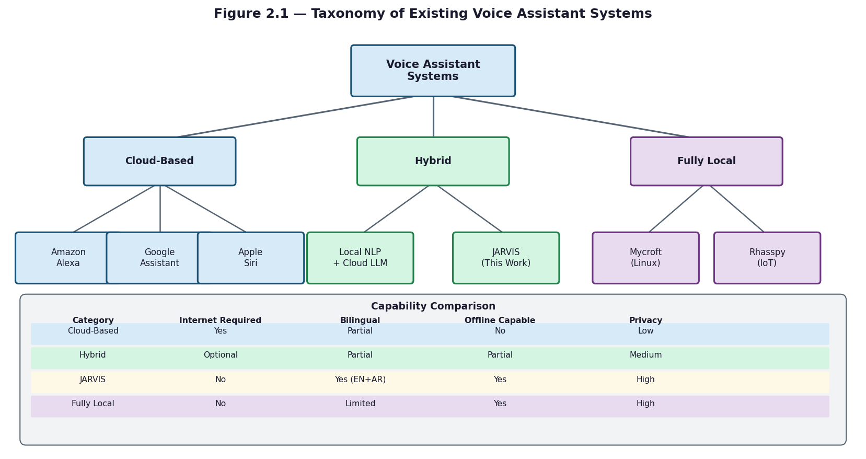
Figure 2.1 — Taxonomy of Existing Voice Assistant Systems

2.3 Natural Language Processing Techniques

Natural language understanding (NLU) in voice assistants involves mapping a transcribed utterance to a structured representation of user intent — typically an intent label and a set of slot-value pairs (entities). JARVIS implements this through a cascaded pipeline in which each tier is invoked only if the previous tier fails to produce a confident result.
The first tier is a deterministic regex and keyword parser implemented in core/command_parser.py. This module normalizes bilingual mixed-script text, applies Arabic-to-English code-switching mappings from nlp/codeswitching.py (over fifty verb and entity pairs, e.g., 'افتح' → 'open', 'اقفل' → 'close', 'كروم' → 'chrome'), and matches against pattern sets for each intent family. The result is a ParsedCommand object containing the intent, action, extracted entities, and a negation flag. This tier operates in approximately zero milliseconds.
The second tier uses the paraphrase-multilingual-MiniLM-L12-v2 sentence-transformer model, implemented in nlp/semantic_router.py. This 90 MB multilingual model encodes the user's utterance as a dense vector and compares it against stored embeddings for approximately twenty intent families using cosine similarity. The model handles paraphrase variation — commands phrased differently from stored examples but with the same meaning — and is particularly important for Egyptian Arabic utterances that do not match any regex pattern. This tier runs in approximately 10 milliseconds. It degrades gracefully to None if sentence-transformers is not installed.
The third tier applies fuzzy text matching using the RapidFuzz library (nlp/fuzzy_matcher.py). The module normalizes text by stripping Arabic tashkeel (diacritics), normalizing alef variants (أ, إ, آ → ا), normalizing hamza-on-waw (ؤ → و), removing punctuation, and collapsing whitespace. It then computes token-level fuzzy ratios against keyword lists from nlp/keyword_engine.py, using a 90 percent match threshold for single words and token set average for multi-word expressions. When RapidFuzz is not installed, the module falls back to Python's built-in difflib.SequenceMatcher. This tier runs in approximately 20 milliseconds.
Entity extraction uses the EntityType enumeration defined in nlp/entity_types.py, which covers APP (application name), PATH (file or folder path), EMAIL (recipient address), DATE (calendar date or time expression), DURATION (timer length), PERSON (contact name), and SYSTEM_FEATURE (device capability such as 'WiFi' or 'Bluetooth'). The temporal parser (os_control/temporal_parser.py) handles natural language time expressions in both English ('5 minutes', 'tomorrow', 'next Monday') and Egyptian Arabic.

2.4 Speech Recognition Technologies
Automatic speech recognition (ASR) is the component that converts raw audio waveforms into text transcripts. JARVIS uses three distinct speech processing components: a wake-word detector, a voice activity detector, and a transcription engine, each addressing a different stage of the audio pipeline.
Wake-word detection uses OpenWakeWord, an open-source framework that runs ONNX models for always-on keyword spotting. JARVIS uses a single unified bilingual model (jarvis_unified.onnx) that detects both the English phrase 'Jarvis' and the Egyptian Arabic phrase 'يا جارفس'. The model processes 1,280-sample audio chunks at 16,000 Hz, produces a confidence score per chunk, and triggers when the score exceeds 0.45 for at least one consecutive frame. A 1.5-second cooldown prevents multiple activations from a single utterance. The system primes the OpenWakeWord feature extractor with three seconds of audio at startup before entering the detection loop.
Voice activity detection (VAD) uses the Silero ONNX model (silero_vad.onnx), downloaded automatically from GitHub (snakers4/silero-vad) if not present. The model operates on 512-sample windows at 16,000 Hz, equivalent to 32 milliseconds per inference, and maintains LSTM state tensors (shape 2×1×128) and a context buffer across windows. A chunk is classified as speech when the model probability exceeds 0.5. An additional energy floor of 0.014 RMS provides a secondary gate. Pre-roll buffering (0.2 seconds by default) captures audio that preceded the VAD trigger. The adaptive silence threshold scales from 0.5 seconds for commands to 1.5 seconds for conversational queries based on accumulated speech duration.
Speech-to-text transcription is handled by Faster-Whisper, a CTranslate2-optimized reimplementation of OpenAI's Whisper transformer model. Beam sizes are set to 4 for audio shorter than 8.5 seconds and 5 for longer recordings. Language detection is performed by script analysis: if more than half the transcribed characters fall in the Unicode Arabic block (U+0600–U+06FF), the transcript is classified as Arabic; otherwise it is classified as English. A no-speech threshold of 0.6 on the Whisper no_speech_prob field is used to discard silent or noise-only segments (RMS < 0.015).
For Egyptian Arabic, an optional hybrid STT backend is available. When enabled, it sends the audio to the ElevenLabs cloud STT API (endpoint /v1/speech-to-text, model scribe_v1) in parallel with the local Whisper model. The backend validates outputs for script consistency — requiring at least 3 characters in the expected script — and can race both Arabic and English ElevenLabs decoders simultaneously when language is ambiguous. A 30-minute automatic cooldown activates if the API returns a quota or authentication error.

2.5 Comparison & Research Gap
Table 2.1 compares JARVIS against the major existing voice assistants across the five criteria most relevant to this project: Windows desktop integration depth, offline operation, Egyptian Arabic support, local LLM fallback, and commodity hardware accessibility (no GPU, no admin rights). No existing commercial or open-source system satisfies all five simultaneously.
Commercial assistants (Siri, Alexa, Google Assistant, Cortana) are all cloud-dependent and none support Egyptian Arabic dialect. Cortana, the only Windows-native entry, was discontinued as a general assistant in 2023. Open-source systems such as Mycroft AI address privacy through local deployment but were discontinued in 2023 and never provided Arabic dialect support or Windows-specific automation depth. Whisper-based open-source pipelines provide excellent multilingual STT but lack the OS integration layer, intent routing cascade, and bilingual NLU that desktop automation requires.
JARVIS uniquely occupies the intersection of all five criteria: deep Windows OS integration through WMI, pywin32, pycaw, and PowerShell bridges; full offline core operation; Egyptian Arabic dialect support across wake detection, STT, NLU, and TTS; a local Qwen3 LLM served by Ollama for open-ended queries; and a hardware floor of 8 GB RAM on any x86-64 Windows 10/11 machine with no GPU or admin privileges required. This combination constitutes the research and engineering contribution of the project.

Chapter 3: System Analysis & Design

3.1 System Requirements
System requirements define the minimum and recommended hardware and software conditions under which JARVIS can be installed and operated. These requirements are derived directly from the computational demands of each pipeline stage.
Minimum Hardware: Intel or AMD x86-64 processor (quad-core recommended), 8 GB RAM, 5 GB free disk space (for ONNX models, Faster-Whisper weights, and the Qwen3:0.6b LLM), a microphone capable of 16,000 Hz mono audio capture (built-in or USB), and audio output (speakers or headphones). At this configuration, the system runs the qwen3:0.6b LLM tier and local-only STT.
Recommended Hardware Tiers: With 12 GB RAM the system promotes to qwen3:4b, providing higher-quality conversational responses. With 16 GB RAM and an NVIDIA GPU supporting CUDA, the system promotes to qwen3:8b and can enable CUDA-accelerated Faster-Whisper for faster STT. No administrator privileges are required for any tier.
Software Requirements: Windows 10 (version 1903 or later) or Windows 11; Python 3.13 or higher; Ollama installed and running on localhost port 11434; pip for dependency installation from requirements.txt. The production dependency set includes sounddevice, numpy, faster-whisper, onnxruntime, openwakeword, edge-tts, httpx, and sqlite3 (standard library). Optional packages that enable additional features include sentence-transformers (semantic routing), rapidfuzz (fuzzy matching), pywin32 (Outlook and Windows Search), pyperclip (clipboard), screen-brightness-control (DDC-CI brightness), duckduckgo-search (web search), and elevenlabs (premium Arabic TTS and STT).
Optional External Services: An ElevenLabs API key is required only for the premium hybrid Arabic STT backend and the ElevenLabs TTS voice. The Open-Meteo weather API and DuckDuckGo web search require internet access but no API keys. Microsoft Outlook must be installed locally for email and calendar features. All other core features are fully self-contained.

3.2 Functional Requirements
Functional requirements describe the specific behaviors JARVIS must provide. Each requirement is numbered and maps directly to an implemented module in the codebase.
FR-01 Wake-Word Detection: The system shall detect the wake phrase 'Jarvis' in English and 'يا جارفس' in Egyptian Arabic using a unified OpenWakeWord ONNX model (audio/wake_word.py) with a score threshold of 0.45, one confirm frame, and a 1.5-second inter-detection cooldown.
FR-02 Voice Activity Detection: The system shall gate audio recording using a Silero ONNX VAD model (audio/vad.py) operating on 512-sample windows at 16,000 Hz, with a speech probability threshold of 0.5 and a secondary energy floor of 0.014 RMS, with pre-roll buffering of 0.2 seconds.
FR-03 Bilingual Speech Transcription: The system shall transcribe speech using Faster-Whisper (audio/stt.py) with beam size 4 for audio under 8.5 seconds and beam size 5 otherwise, with optional hybrid ElevenLabs cloud STT (scribe_v1) for Egyptian Arabic and automatic language detection via Unicode script analysis.
FR-04 Four-Tier Intent Classification: The system shall classify utterances through a cascade of regex parsing (core/command_parser.py), MiniLM semantic routing (nlp/semantic_router.py), RapidFuzz keyword matching (nlp/fuzzy_matcher.py), and Ollama Qwen3 LLM fallback (llm/ollama_client.py), with minimum confidence 0.35 and early execution at 0.78.
FR-05 System Control Commands: The system shall execute shutdown, restart, sleep, lock, and logoff via native Windows APIs (os_control/native_ops.py), and adjust volume using pycaw and brightness using the DDC-CI protocol via screen-brightness-control, with risk-based confirmation for destructive operations.
FR-06 Application Management: The system shall discover installed applications by scanning the Windows Registry and WMI (os_control/app_ops.py), launch them by name, and close running processes, with an auto-refreshing application catalog cache.
FR-07 File Operations with Rollback: The system shall perform file copy, move, delete, rename, and semantic search operations (os_control/file_ops.py), saving originals of destructive operations to %TEMP%/jarvis_rollback/ and rejecting paths containing reserved Windows names (CON, PRN, AUX, NUL, COM*, LPT*).
FR-08 Timers and Reminders: The system shall create timers and recurring reminders (os_control/timer_ops.py, os_control/reminder_ops.py) using natural language time expressions parsed by os_control/temporal_parser.py, with state persisted in SQLite.
FR-09 Outlook Email and Calendar: The system shall draft emails and manage calendar events through Microsoft Outlook via pywin32 (os_control/email_ops.py, os_control/calendar_ops.py), with drafting only — no automatic sending.
FR-10 Media and Clipboard Control: The system shall control media playback via pynput media key dispatch and read/write clipboard content via pyperclip with a pure-Python fallback.
FR-11 Live Data Queries: The system shall fetch weather from the Open-Meteo API (5-second timeout) and web search results from DuckDuckGo with a 6-second timeout and a recency boost (full for results under 30 days old, decaying over 335 days), injecting results into the LLM prompt context via tools/live_data.py.
FR-12 Bilingual Text-to-Speech: The system shall synthesize responses using edge-tts (ar-EG-SalmaNeural for Arabic, en-US-AriaNeural for English) with ElevenLabs eleven_multilingual_v2 as fallback, applying an Egyptian colloquial rewriter (150+ MSA-to-dialect phrase substitutions) before Arabic synthesis.
FR-13 Persistent Memory: The system shall persist session turns and slot state in a SQLite database (core/memory_store.py) operating in WAL mode, and support semantic knowledge retrieval via ChromaDB (core/knowledge_base.py).

3.3 Non-Functional Requirements
Non-functional requirements specify the quality and operational constraints the system must satisfy beyond its functional capabilities.
NFR-01 End-to-End Latency: For commands matched by the regex tier (FR-04 Tier 1), the total pipeline latency from wake-word trigger to first spoken response word shall not exceed three seconds on minimum hardware (8 GB RAM, no GPU). LLM-backed responses (FR-04 Tier 4) add approximately 500 milliseconds for qwen3:0.6b. Stage-level latency is tracked by core/metrics.py across six stages: wake, stt, parse, route, execute, tts.
NFR-02 Intent Classification Accuracy: The four-tier cascade shall achieve correct intent classification in at least 90 percent of clearly spoken English commands and at least 85 percent of clearly spoken Egyptian Arabic commands under standard microphone conditions, measured against the test suite in tests/.
NFR-03 Wake-Word Reliability: The OpenWakeWord model shall produce fewer than two false activations per hour of continuous ambient audio at the 0.45 threshold, with the 1.5-second cooldown preventing duplicate triggers from a single utterance.
NFR-04 Graceful Degradation: All optional dependencies shall fail silently without terminating the core pipeline. Specifically: RapidFuzz falls back to difflib; sentence-transformers disables semantic routing; pyperclip is replaced by a pure-Python fallback; pywin32 disables Outlook and Windows Search features; ElevenLabs disables cloud TTS and STT with a 30-minute automatic cooldown on errors.
NFR-05 Offline Core Operation: All pipeline stages FR-01 through FR-05 and FR-08 through FR-10 shall function without internet access. Live data features (FR-11) and ElevenLabs TTS/STT are explicitly flagged as requiring connectivity.
NFR-06 Privacy: No user audio or transcription shall be transmitted to external servers during core offline operation. ElevenLabs services are strictly opt-in, controlled by environment variables, and limited to voice synthesis and cloud STT only.
NFR-07 Hardware Efficiency: The system shall automatically select the Qwen3 LLM tier at startup based on detected RAM and GPU, maintaining a keep-alive of 30 minutes to avoid repeated model loading. The Ollama context window is set to 4,096 tokens by default.
NFR-08 Observability: The system shall emit structured telemetry via core/metrics.py recording latency percentiles (p50, p95) per pipeline stage, per-intent success rates, and response quality scores (coherence, lexical diversity, human-likeness), written to jarvis_actions.log alongside human-readable output in jarvis.log.

3.4 System Architecture
JARVIS is organized into six functional layers, each implemented as a separate Python package. Data flows top-down from audio capture through NLU and action dispatch to TTS output, with persistent state shared through a SQLite memory store and an optional ChromaDB vector store.
Layer 1 — Audio (audio/): This layer handles all audio input and output. audio/wake_word.py runs the OpenWakeWord ONNX bilingual detection loop. audio/vad.py wraps the Silero ONNX model for speech probability inference on 512-sample windows. audio/mic.py manages sounddevice streaming at 16,000 Hz with 1,024-byte chunks, pre-roll buffering, and adaptive silence timeout. audio/stt.py implements the STT backend abstraction, selecting between local Faster-Whisper and the hybrid ElevenLabs mode, including language locking and validation logic. audio/streaming_stt.py provides streaming partial transcripts during capture using a 0.5-second emission interval with an Arabic stability gate (same text in two consecutive windows before emitting). audio/tts.py manages edge-tts and ElevenLabs synthesis with mixed-script chunking (20–300 character bounds, max 4 chunks per utterance).
Layer 2 — NLP (nlp/): This layer converts raw text into structured intent objects. nlp/codeswitching.py normalizes Arabic-English mixed input using verb and entity mapping tables and converts Arabic-Indic numerals to ASCII. nlp/fuzzy_matcher.py applies Arabic normalization (tashkeel stripping, alef and hamza normalization) and RapidFuzz token-level scoring. nlp/semantic_router.py encodes utterances with paraphrase-multilingual-MiniLM-L12-v2 for similarity-based routing across approximately twenty intent families. nlp/nlu.py orchestrates the full cascade and performs slot validation against the EntityType enum defined in nlp/entity_types.py.
Layer 3 — Core Orchestration (core/): core/orchestrator.py implements the main event loop: wake detection triggers audio capture, STT, command parsing, routing, action dispatch, TTS playback, and telemetry logging, in sequence, for each utterance. core/command_router.py dispatches parsed intents to handlers in core/handlers/ or to the LLM layer, managing live-data prefetch in parallel threads and response caching. core/dialogue_manager.py maintains a seven-state conversation machine (IDLE, LISTENING, PROCESSING, CONFIRMING, EXECUTING, RESPONDING, FOLLOW_UP) with a 10-second follow-up window that bypasses wake detection. core/intent_confidence.py scores intent confidence for ambiguity detection. core/metrics.py records stage-level latency and quality metrics.
Layer 4 — OS Control (os_control/): Each command category is handled by a dedicated module. os_control/native_ops.py uses ctypes Win32 calls for lock, sleep, screenshot, volume (pycaw), and brightness (DDC-CI). os_control/app_ops.py queries WMI and the Windows Registry for installed applications. os_control/file_ops.py implements file operations with rollback to %TEMP%/jarvis_rollback/ and Windows reserved-name rejection. os_control/email_ops.py and os_control/calendar_ops.py interface with Outlook via pywin32. os_control/policy.py and os_control/risk_policy.py enforce risk tiers (LOW, MEDIUM, HIGH, CRITICAL) and require voice confirmation for destructive operations via os_control/confirmation.py (30-second timeout). os_control/powershell_bridge.py executes PowerShell templates via subprocess for operations not covered by Python APIs.
Layer 5 — LLM (llm/): llm/ollama_client.py sends generation requests to the Ollama REST API at http://localhost:11434/api/generate with streaming enabled, strips Qwen3 thinking-mode tags (<think>...</think>) from the output, and maintains a 30-minute model keep-alive. llm/prompt_builder.py selects a prompt template (micro_prompt.txt, slim_prompt.txt, or full_prompt.txt) based on the hardware tier, and injects persona, session memory (last 3 turns), ChromaDB knowledge base results, live data, and few-shot bilingual examples. llm/sentence_buffer.py batches streaming tokens into sentences for TTS handoff (English: soft 7 words, hard 15 words; Arabic: soft 5 words, hard 10 words).
Layer 6 — Tools (tools/): tools/weather.py queries Open-Meteo at a 5-second timeout for current conditions (temperature, humidity, wind, WMO weather code). tools/web_search.py queries DuckDuckGo at a 6-second timeout, applies domain trust ranking and a 30-day recency boost, and returns ranked snippets. tools/live_data.py dispatches to both in parallel and formats the combined result for LLM context injection. tools/calculator.py evaluates mathematical expressions using sympy or a safe eval fallback.
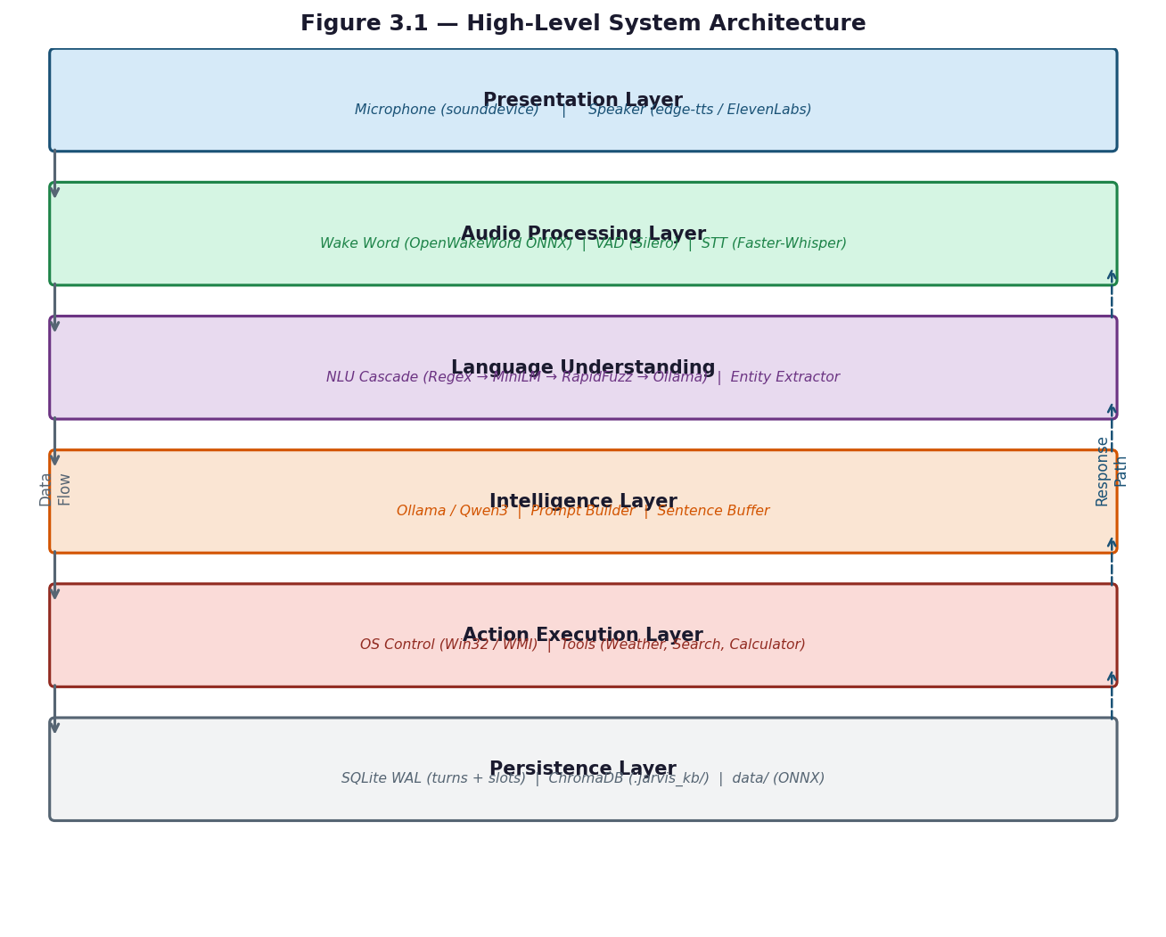
Figure 3.1 — High-Level System Architecture
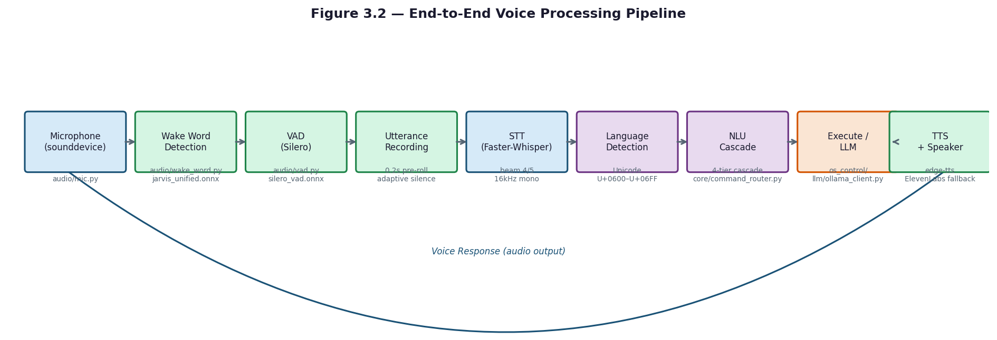
Figure 3.2 — End-to-End Voice Processing Pipeline

3.5 Data Flow Diagrams
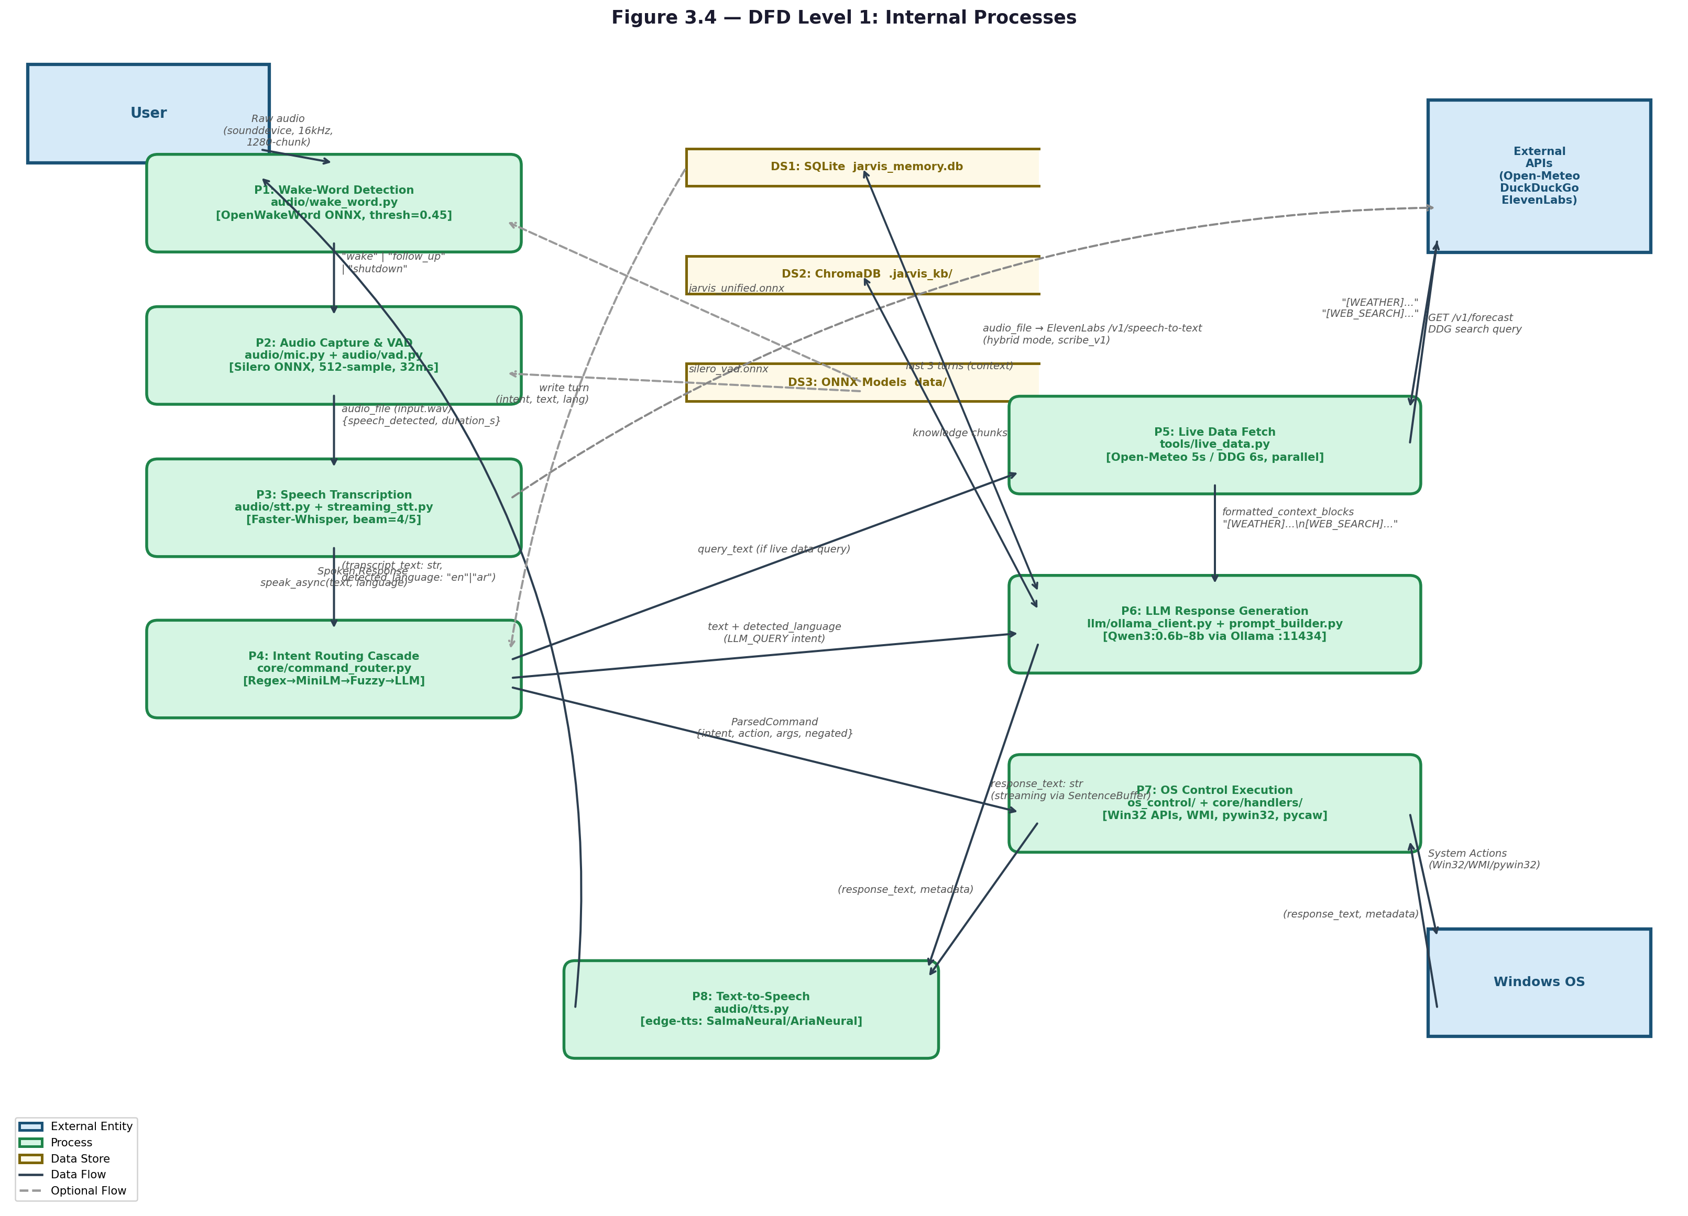
Figure 3.4 — DFD Level 1: Internal Processes

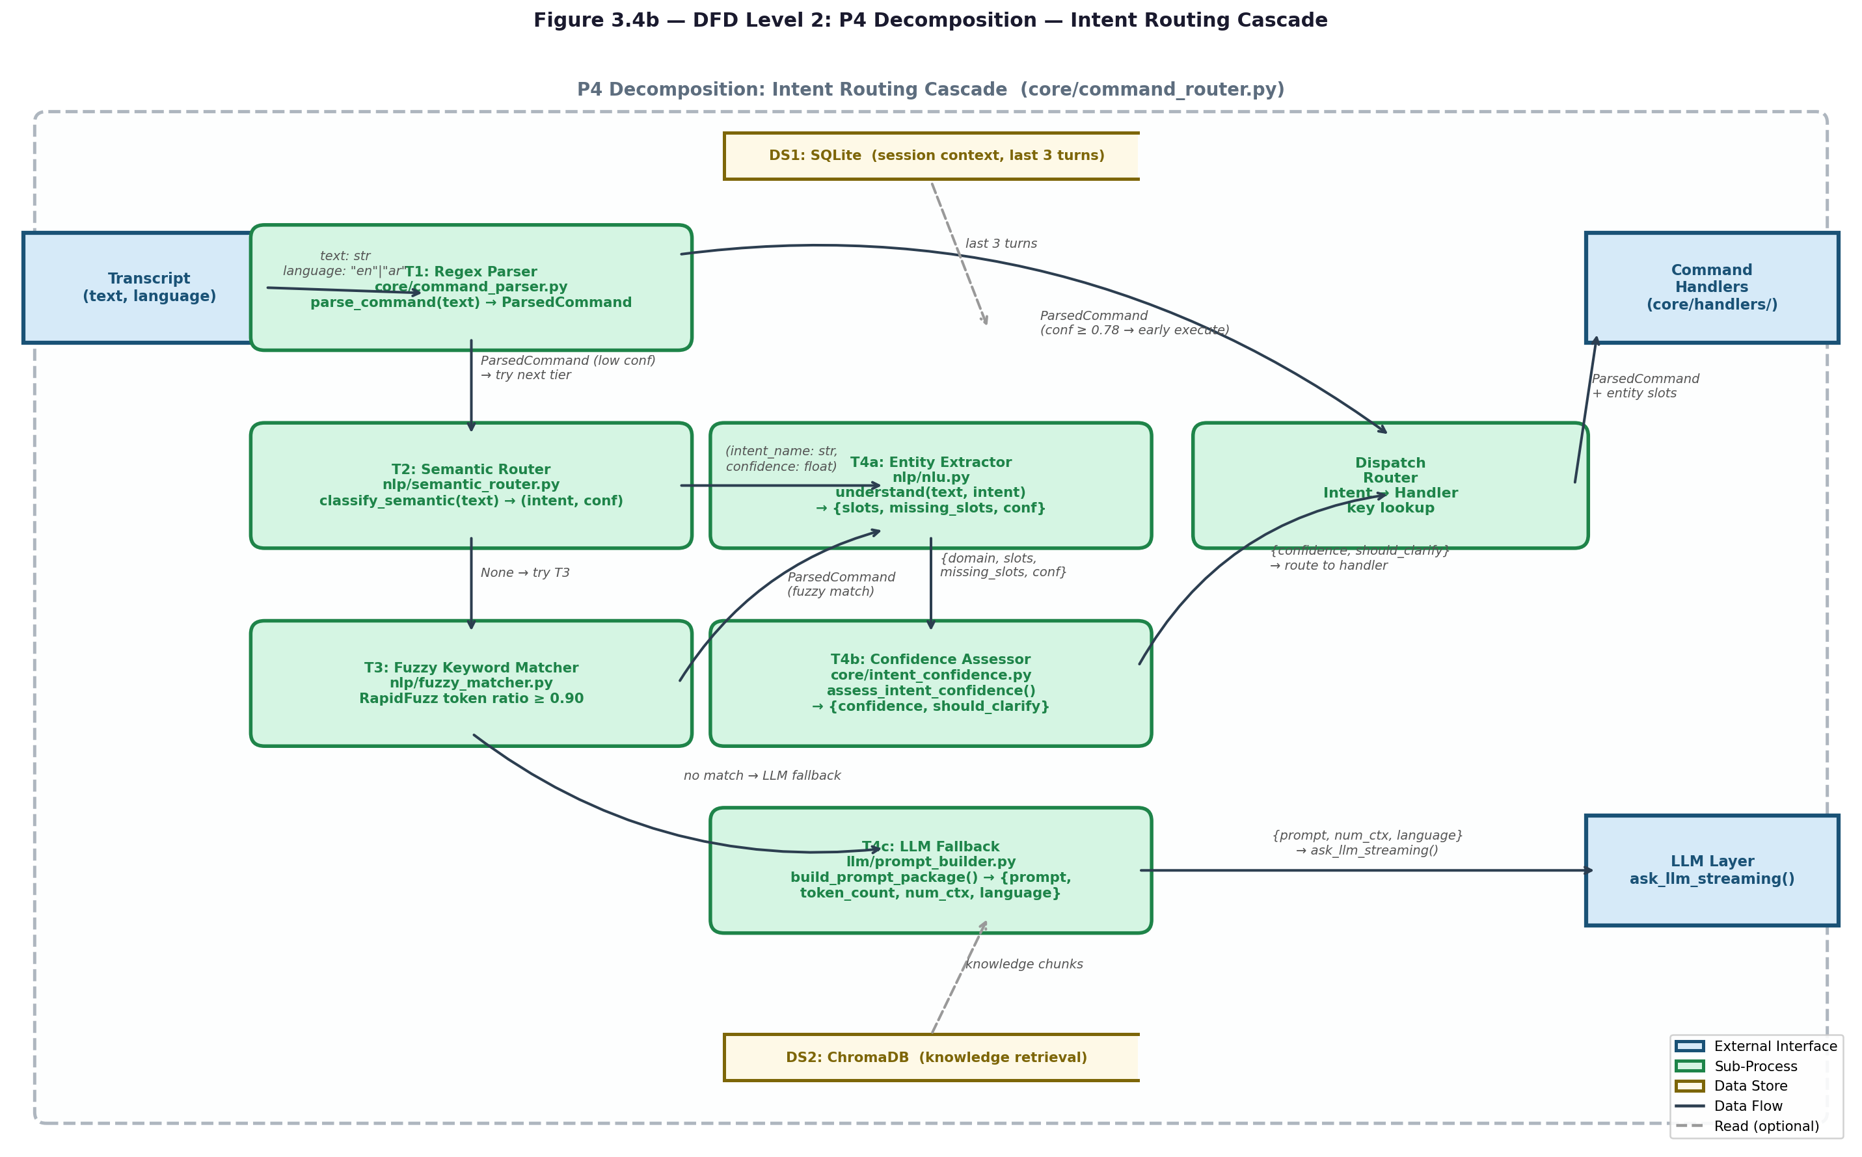
Figure 3.4b — DFD Level 2: P4 Intent Routing Cascade (Decomposition)

3.6 Use Case Diagrams
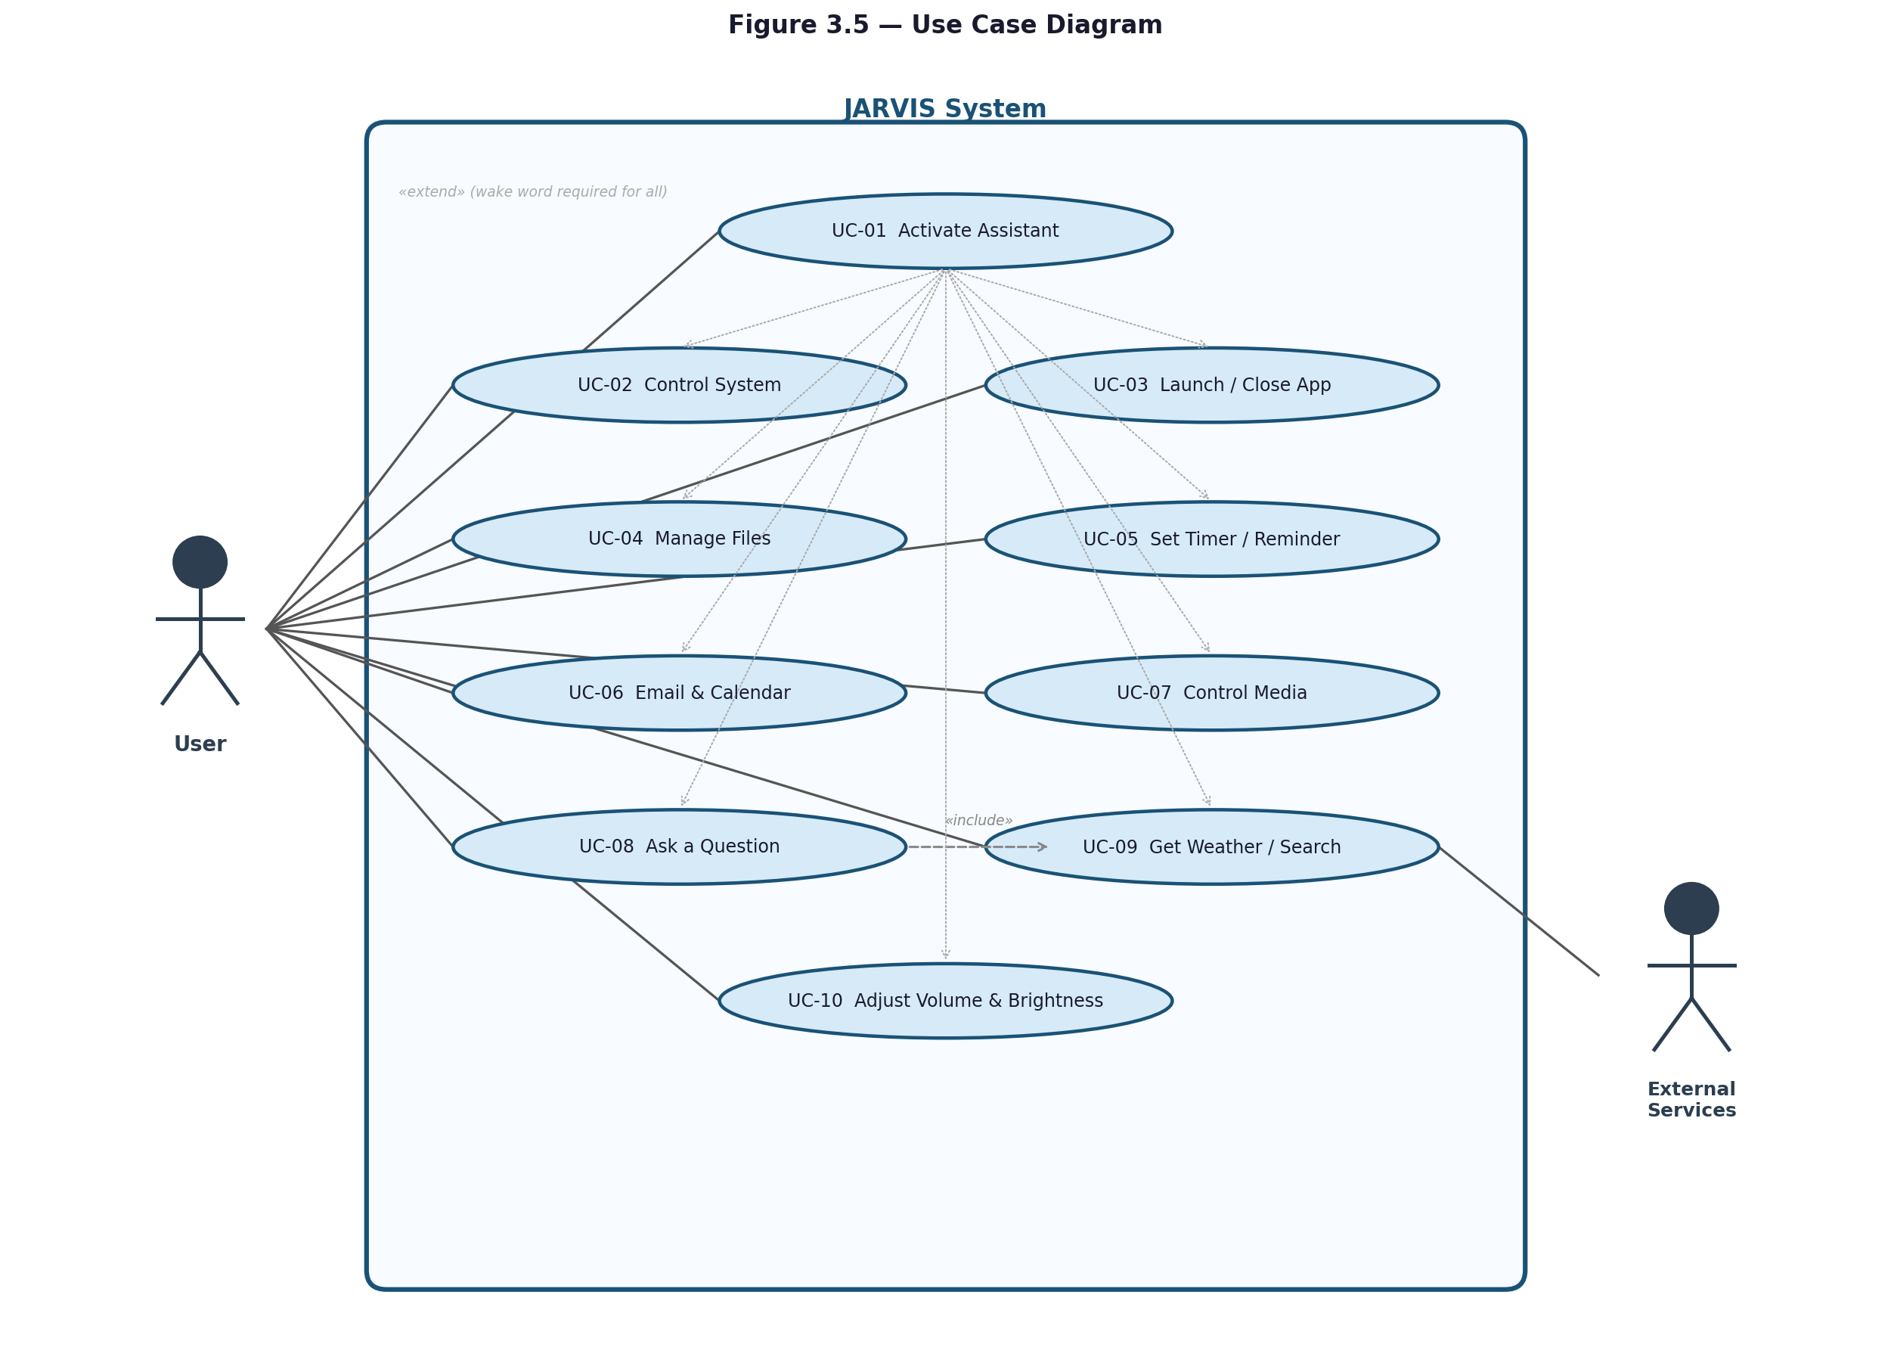
Figure 3.5 — Use Case Diagram

Chapter 4: Implementation

4.1 Development Environment & Tools
JARVIS is implemented entirely in Python 3.13+ and targets Windows 10 (version 1903 or later) and Windows 11 as its sole operating platform. The development environment requires Ollama installed locally to serve the Qwen3 large language model family on port 11434, and a Python virtual environment with dependencies installed from three tiered requirements files: requirements.txt for the full production set, requirements-minimal.txt for voice-and-LLM-only deployments, and requirements-full.txt for optional tools including FAISS and PDF processing.
The core runtime libraries are: sounddevice and numpy for audio streaming, faster-whisper for local speech recognition, onnxruntime for ONNX model inference (VAD and wake-word), openwakeword for wake-word detection, edge-tts for text-to-speech, httpx for all HTTP communication with Ollama and external APIs, and sqlite3 (Python standard library) for persistent storage. Optional libraries that unlock additional features include sentence-transformers (semantic routing), rapidfuzz (fuzzy matching), pywin32 (Outlook and Windows Search integration), pyperclip (clipboard access), screen-brightness-control (DDC-CI brightness), duckduckgo-search (web search), and elevenlabs (cloud STT and TTS). All optional libraries degrade gracefully — the system detects their absence at startup and disables only the features that depend on them.
The scripts/ folder contains two development utilities. scripts/generate_arabic_wake_data.py generates synthetic training audio for the wake-word model by synthesizing over 50 English and 50 Egyptian Arabic trigger phrases using multiple Edge-TTS voices. scripts/train_arabic_wake_model.py trains a compact PyTorch classifier on the collected samples, extracts OpenWakeWord mel-spectrogram features, runs for 10 epochs with a minimum validation accuracy target of 0.95, and exports the result as a unified ONNX model. The tests/ folder contains test_sentence_buffer.py, which validates English and Arabic sentence flushing logic and word-count thresholds, and test_voice_normalizer.py, which verifies Arabic diacritic stripping and alef normalization.
The following table lists all Python packages used by JARVIS, their dependency tier, and the specific subsystem each serves.
Package | Tier | Used By | Purpose
numpy | Core | Audio pipeline | Audio buffer math, RMS, FFT
sounddevice | Core | mic, wake_word, tts | Microphone input + speaker output
faster-whisper | Core | stt, wake_word | Local speech-to-text (CTranslate2 backend)
openwakeword | Core | wake_word | English Jarvis detection (ONNX)
edge-tts | Core | tts | Microsoft Edge neural TTS (free)
psutil | Core | hardware_detect, sysinfo_ops | RAM/CPU/battery monitoring
httpx | Core | ollama_client, weather, ElevenLabs | HTTP for all external calls
rapidfuzz | Core | nlp/intent_classifier | Fuzzy string matching for noisy STT
python-dotenv | Core | core/config | Load .env at startup
pyperclip | Recommended | clipboard_ops | Cross-platform clipboard read/write
screen-brightness-control | Recommended | system_ops | DDC/CI brightness without admin
sentence-transformers | Recommended | semantic_router, knowledge_base | Multilingual embeddings (MiniLM)
duckduckgo-search | Recommended | tools/web_search | Free web search, no API key
pywin32 | Optional | email_ops, calendar_ops, file_ops | Outlook COM + Windows Search Index
faiss-cpu | Optional | knowledge_base | Fast vector index for large KBs
Table 4.1 — Python Package Dependencies
Seven ML models are loaded into RAM during startup. The table below shows each model's storage size, memory footprint, role in the pipeline, and the module responsible for loading it.
Model | Disk Size | RAM | Role | Loaded By
jarvis_v0.1.onnx | ~5 MB | ~30 MB | English wake word | audio/wake_word.py
melspectrogram.onnx | ~1 MB | ~10 MB | Wake-word feature extraction | audio/wake_word.py
embedding_model.onnx | ~7 MB | ~25 MB | Wake-word embedding | audio/wake_word.py
whisper-tiny | 75 MB | ~250 MB | Arabic wake-word phrase detection (1.5 s windows) | audio/wake_word.py
whisper-small | 484 MB | ~600 MB | Main STT (English + Arabic) + language detection | audio/stt.py
paraphrase-multilingual-MiniLM-L12-v2 | ~470 MB | ~180 MB | Semantic intent classification (50+ languages) | nlp/semantic_router.py
all-MiniLM-L6-v2 | ~90 MB | ~120 MB | Knowledge base embeddings | core/knowledge_base.py
qwen3:0.6b → qwen3:8b | 0.5 – 5 GB | 1 – 6 GB | LLM fallback (auto-selected by hardware) | Ollama (external)
Table 4.2 — ML Models Loaded at Runtime
JARVIS integrates several optional external services. Every service has a local fallback so the system continues working without internet access.
Service | Used For | Cost | Fallback If Missing
ElevenLabs STT (scribe_v2) | Cloud-quality Arabic STT | Paid | Local Whisper-small
ElevenLabs TTS (multilingual v2) | Cloud-quality Arabic voice | Paid | edge-tts ar-EG-SalmaNeural
Open-Meteo | Live weather data | Free, no key | Generic clothing advice
DuckDuckGo HTML | Live web search | Free, no key | "No live data" message
Ollama (localhost:11434) | Local LLM serving | Free, local | Required — no fallback
Table 4.3 — External Services and Fallbacks

4.2 Audio Pipeline
The audio pipeline is implemented across six modules in the audio/ folder, each responsible for one stage of the voice interaction lifecycle.
Wake-word detection (audio/wake_word.py) runs a continuous loop using the OpenWakeWord framework and a unified bilingual ONNX model (jarvis_unified.onnx) stored in data/. Audio is streamed from the microphone in 1,280-sample chunks at 16,000 Hz. Each chunk is scored by the model, and a detection is confirmed when the score exceeds 0.45 for at least one consecutive frame. A 1.5-second cooldown prevents duplicate triggers. The function listen_for_wake_word() returns one of three strings: 'wake', 'follow_up', or 'shutdown', which the orchestrator uses to decide the next action.
Voice activity detection (audio/vad.py) wraps the Silero ONNX model (silero_vad.onnx), downloaded automatically from GitHub if missing. The model processes 512-sample windows (32 ms at 16,000 Hz) and maintains LSTM state across windows. A chunk is classified as speech when the model probability exceeds 0.5 and the RMS energy exceeds 0.014. If onnxruntime is unavailable, the module falls back to energy-only gating.
Microphone recording (audio/mic.py) uses sounddevice to stream audio at 16,000 Hz with 1,024-byte chunks. The record_utterance() function applies a 0.2-second pre-roll buffer to capture audio that preceded the VAD trigger, and uses an adaptive silence timeout that scales from 0.5 seconds for commands to 1.5 seconds for conversational queries. It returns a dictionary containing ok, speech_detected, duration_seconds, and samples.
Speech-to-text transcription (audio/stt.py and audio/streaming_stt.py) is handled by Faster-Whisper with beam sizes of 4 for audio under 8.5 seconds and 5 for longer recordings. The language is detected by Unicode script analysis: if over half the characters fall in the Arabic block (U+0600–U+06FF), the transcript is classified as Arabic. An optional hybrid backend races ElevenLabs cloud STT (scribe_v1 model, endpoint /v1/speech-to-text) against the local model in parallel for Egyptian Arabic. The streaming module (streaming_stt.py) emits partial transcripts every 0.5 seconds with an Arabic stability gate requiring the same text in two consecutive windows before emitting.
Text-to-speech (audio/tts.py) is implemented in the SpeechEngine class. The primary backend is edge-tts, using ar-EG-SalmaNeural for Arabic and en-US-AriaNeural for English. ElevenLabs (eleven_multilingual_v2, wav_24000 format) serves as an optional fallback for premium Arabic voice quality. Before Arabic synthesis, a built-in Egyptian colloquial rewriter applies over 150 MSA-to-dialect phrase substitutions (e.g., 'لا أستطيع' becomes 'مش قادر'). Mixed Arabic-English text is split into chunks of 20–300 characters (maximum 4 chunks) and synthesized separately before concatenation. The audio cues module (audio/cues.py) synthesizes short tones as int16 PCM with fade-in and fade-out for auditory feedback.
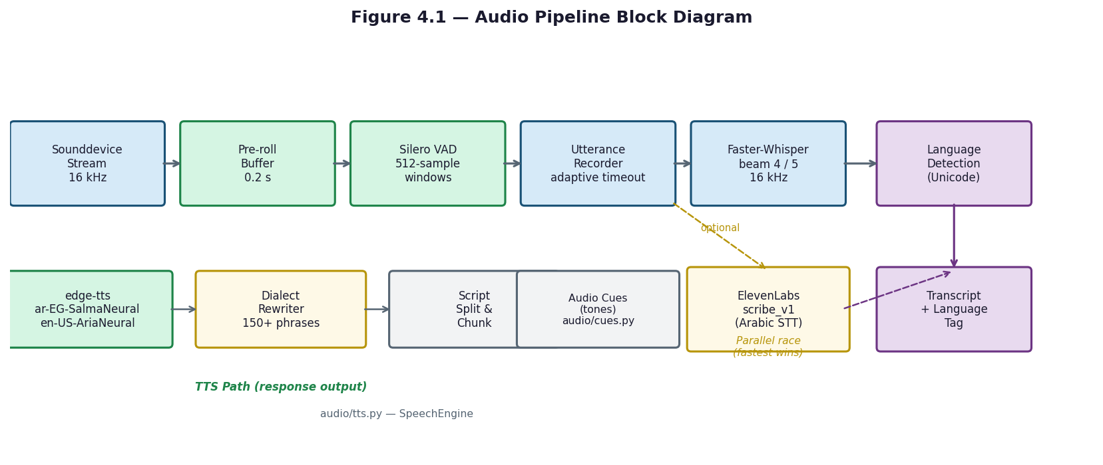
Figure 4.1 — Audio Pipeline Block Diagram
Once the wake word fires, JARVIS begins streaming audio capture with concurrent STT. Audio chunks of 512 samples (32 ms at 16 kHz) are processed in real time through Silero VAD for speech detection, and partial transcripts are emitted while the user is still speaking, enabling early intent detection and parallel processing. An energy pre-filter skips Silero inference on pure silence to save CPU.
All VAD timing and sensitivity parameters can be tuned via environment variables without modifying source code.
Environment Variable | Default | Effect
JARVIS_VAD_ENERGY_THRESHOLD | 0.014 | Energy pre-filter before Silero. Lower = more sensitive.
JARVIS_VAD_SILENCE_SECONDS | 0.55 | Command-mode silence timeout. Lower = snappier but cuts off pauses.
JARVIS_VAD_CHAT_SILENCE_SECONDS | 1.0 | Conversation-mode silence timeout (follow-up window). Lets user think.
JARVIS_VAD_MIN_SPEECH_SECONDS | 0.30 | Minimum speech duration (filters coughs/clicks).
JARVIS_VAD_START_TIMEOUT_SECONDS | 3.0 | If no speech detected within this window, abort.
JARVIS_MAX_RECORD_DURATION | 6.0 | Absolute hard cap on recording length.
Table 4.4 — VAD Tunable Parameters (audio/vad.py)
The STT backend can be configured independently. The default hybrid path races local Faster-Whisper against ElevenLabs cloud STT for Arabic audio, with the faster result winning.
JARVIS_STT_BACKEND value | Behaviour
hybrid_elevenlabs (default) | Whisper-small detects language -> Arabic to ElevenLabs, English to Whisper. ElevenLabs fail -> Whisper.
faster_whisper | 100% local. Whisper-small handles both languages. No internet needed.
Table 4.5 — STT Backend Configuration

4.3 Natural Language Understanding (NLU)
Natural language understanding is implemented across five modules in the nlp/ folder. Together they convert a raw bilingual transcript into a structured intent representation with extracted entity slots.
Code-switching normalization (nlp/codeswitching.py) is the first step for any Arabic or mixed-language input. The module maps over 50 Egyptian Arabic verbs and entity names to their English equivalents (e.g., 'افتح' to 'open', 'اقفل' to 'close', 'كروم' to 'chrome') and converts Arabic-Indic numerals (٠–٩) to ASCII digits. This normalization allows the downstream NLP components to operate on a consistent, partially unified vocabulary regardless of the input language.
Fuzzy text matching (nlp/fuzzy_matcher.py) normalizes text by stripping Arabic diacritics (tashkeel), normalizing alef variants (أ, إ, آ all become ا), normalizing hamza-on-waw (ؤ becomes و), removing punctuation, and collapsing whitespace. It then computes token-level fuzzy ratios using the RapidFuzz library, with a 90 percent match threshold for single-word targets and the token set average for multi-word expressions. When RapidFuzz is not installed, the module falls back to Python's standard difflib.SequenceMatcher.
Semantic routing (nlp/semantic_router.py) uses the paraphrase-multilingual-MiniLM-L12-v2 sentence-transformer model, which is loaded lazily in the background at startup. The classify_semantic() function encodes the user's utterance as a dense embedding vector and compares it against pre-computed embeddings for approximately 20 intent families using cosine similarity. It returns a tuple of (intent_name, confidence) or None if the model is not available, making the entire tier optional.
Entity extraction (nlp/nlu.py) runs after an intent is identified. The understand() function accepts the transcript and the resolved intent name, extracts slot values for that intent, and returns a dictionary containing the domain, a slots mapping of slot-name to extracted value, a list of missing required slots, and an overall confidence score. Entity types are defined in nlp/entity_types.py as the EntityType enumeration: APP, PATH, EMAIL, DATE, DURATION, PERSON, and SYSTEM_FEATURE.
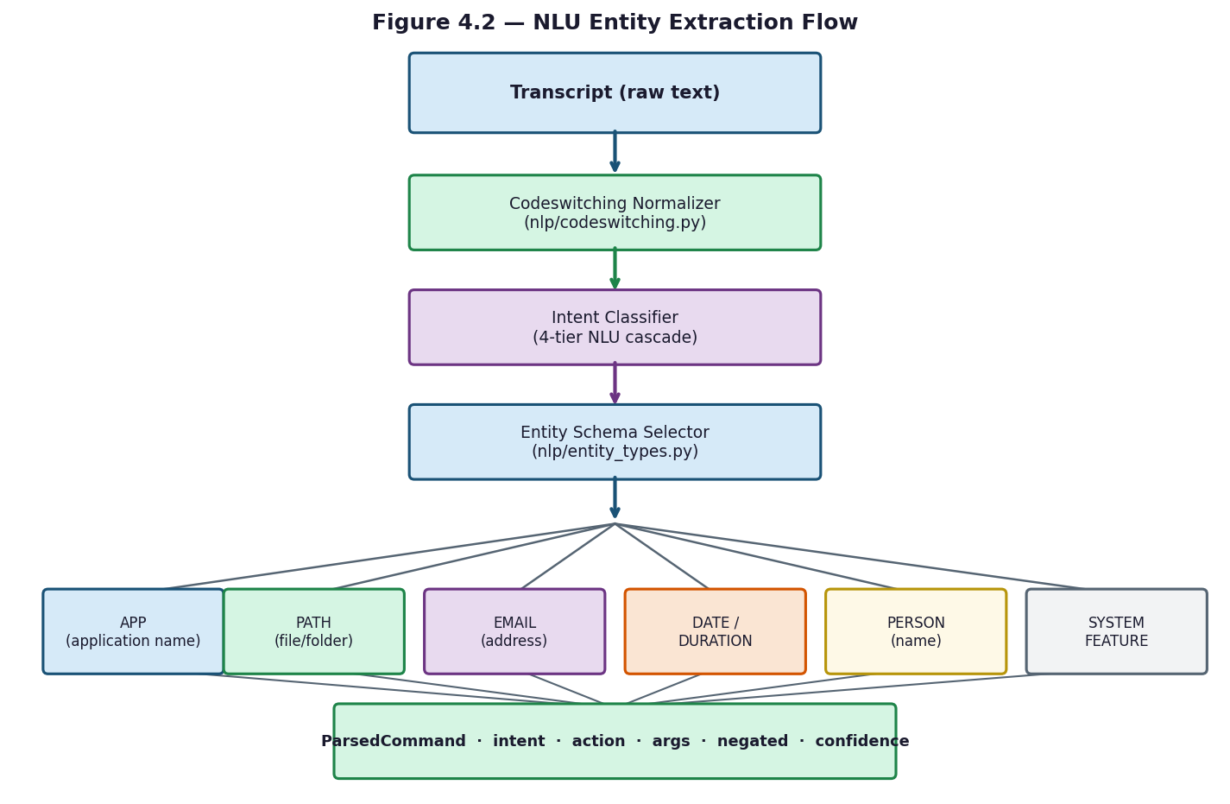
Figure 4.2 — NLU Entity Extraction Flow

4.4 Intent Routing Engine
Intent routing is coordinated by core/command_router.py and uses a four-tier cascade implemented across the parser, NLP, and LLM modules. The route_command() function accepts the transcript text and an optional pre-computed ParsedCommand, and returns a response string.
Tier 1 — Regex Parser (core/command_parser.py): The parse_command() function applies a sequence of deterministic pattern-matching steps to the normalized text. It checks for negation, matches against a priority structural table for path and folder patterns, applies a priority regex table for system commands, handles code-switched commands from nlp/codeswitching.py, and finally matches against a keyword table covering all intent families. The result is a ParsedCommand dataclass with fields intent, raw, normalized, action, args, and negated. This tier operates at approximately zero milliseconds. If the confidence score exceeds 0.78, the command is executed immediately without consulting lower tiers.
Tier 2 — Semantic Router (nlp/semantic_router.py): If Tier 1 confidence is below the early-execution threshold, classify_semantic() is called. It uses the MiniLM embedding model to find the closest intent family and returns a confidence score. This tier runs in approximately 10 milliseconds and handles paraphrased commands that the regex patterns do not cover.
Tier 3 — Fuzzy Keyword Matching (nlp/fuzzy_matcher.py): If semantic routing returns no confident result, the fuzzy matcher is applied against the keyword lists defined in nlp/keyword_engine.py. Each intent family has an actions list and a targets list; the matcher scores the transcript against both using RapidFuzz token ratios and combines the scores using intent-weighted arithmetic. This tier runs in approximately 20 milliseconds.
Tier 4 — LLM Fallback (llm/ollama_client.py): If none of the first three tiers produce a confident result, the transcript is treated as a conversational query and passed to ask_llm_streaming(). The prompt is constructed by llm/prompt_builder.py, which selects a template based on the hardware tier (micro_prompt.txt, slim_prompt.txt, or full_prompt.txt), injects session memory (last 3 turns), ChromaDB knowledge chunks, live data context if relevant, and a language pin. The Ollama server at http://localhost:11434 streams the Qwen3 response token by token, which is batched into sentences by llm/sentence_buffer.py before being passed to TTS.
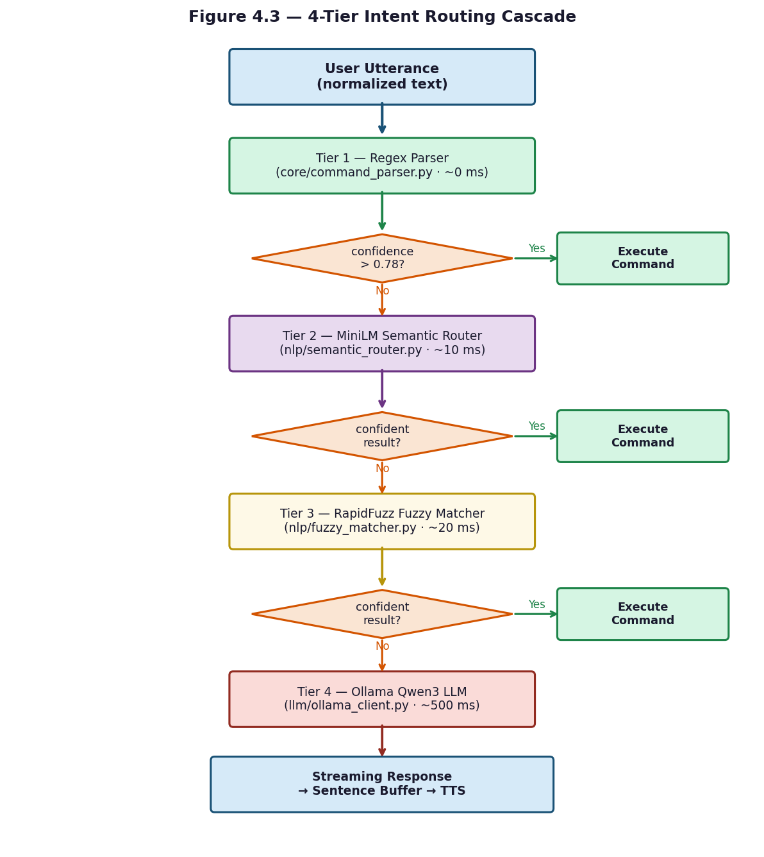
Figure 4.3 — 4-Tier Intent Routing Cascade

4.5 OS Control & System Integration
OS control is implemented across the os_control/ folder, with each command category handled by a dedicated module. All handler functions return a tuple of (response_text: str, metadata: dict).
System-level commands (os_control/system_ops.py and os_control/native_ops.py) cover shutdown, restart, sleep, lock, and logoff using ctypes Win32 API calls (LockWorkStation, ExitWindowsEx). Volume is controlled through the pycaw library, and screen brightness is adjusted via the screen-brightness-control package using the DDC-CI protocol. Screenshots are captured using the Win32 GDI API. Destructive operations (shutdown, restart, logoff) are classified as CRITICAL risk by os_control/risk_policy.py and require voice confirmation through os_control/confirmation.py, which waits up to 30 seconds for a spoken 'yes' or 'no'.
Application management (os_control/app_ops.py) discovers installed applications by scanning the Windows Registry and querying WMI, building a cached application catalog. The execute_confirmed_app_operation() function launches applications by name match against the catalog and closes running processes via WMI process termination.
File operations (os_control/file_ops.py) support open, copy, move, delete, rename, and semantic file search. Before any destructive operation, the original file is copied to %TEMP%/jarvis_rollback/ to enable undo_last_action(). Path validation rejects any path containing Windows reserved names (CON, PRN, AUX, NUL, COM1–COM9, LPT1–LPT9) or control characters. File search uses case-insensitive glob matching with results sorted by modification time, capped at 100 results.
Timers and reminders (os_control/timer_ops.py and os_control/reminder_ops.py) are created from natural language time expressions parsed by os_control/temporal_parser.py, which handles English expressions ('5 minutes', 'next Monday') and Egyptian Arabic equivalents. Recurring reminders support daily, weekly, and monthly patterns. All timer state is persisted in SQLite so reminders survive application restarts. Email and calendar integration (os_control/email_ops.py, os_control/calendar_ops.py) uses the pywin32 library to interface with Microsoft Outlook, drafting emails and creating calendar events locally without auto-sending. For advanced OS operations not covered by Python APIs, os_control/powershell_bridge.py renders PowerShell script templates with variable substitution and executes them via subprocess.

4.6 LLM Integration
LLM integration is implemented across four modules in the llm/ folder and relies on Ollama, an open-source local model server, running at http://localhost:11434.
The Ollama client (llm/ollama_client.py) communicates with the /api/generate endpoint using the httpx library with streaming enabled. At startup, set_runtime_model() selects the optimal Qwen3 model tier based on detected hardware: qwen3:0.6b for 8 GB systems, qwen3:1.7b for 8 GB without a GPU, qwen3:4b for 12 GB or more, and qwen3:8b for systems with 16 GB RAM and a CUDA-capable GPU. The model keep-alive is set to 30 minutes to avoid repeated loading overhead. Qwen3 models emit chain-of-thought blocks wrapped in <think>...</think> tags; the client strips these before returning the response. The context window is set to 4,096 tokens by default.
Prompt construction (llm/prompt_builder.py) selects one of three template files based on the hardware tier: micro_prompt.txt (minimal, ~1 KB) for low-resource systems, slim_prompt.txt (~2 KB) for medium-tier, and full_prompt.txt (~4 KB, includes few-shot bilingual examples) for high-tier. The build_prompt_package() function injects the assistant persona, the last three conversation turns from SQLite session memory, top-K semantic matches from ChromaDB, live data context (weather and web search results when relevant), and a language pin that constrains the response language. The function returns a dictionary containing the assembled prompt string, token count, context window size, and detected language.
Streaming response handling (llm/sentence_buffer.py) batches the token stream from Ollama into complete sentences for handoff to the TTS engine. The buffer flushes on punctuation (., !, ?) and on word-count thresholds that differ by language: for English, a soft flush at 7 words and a hard flush at 15; for Arabic, a soft flush at 5 words and a hard flush at 10. This allows TTS synthesis to begin on the first sentence while the model is still generating the rest of the response.
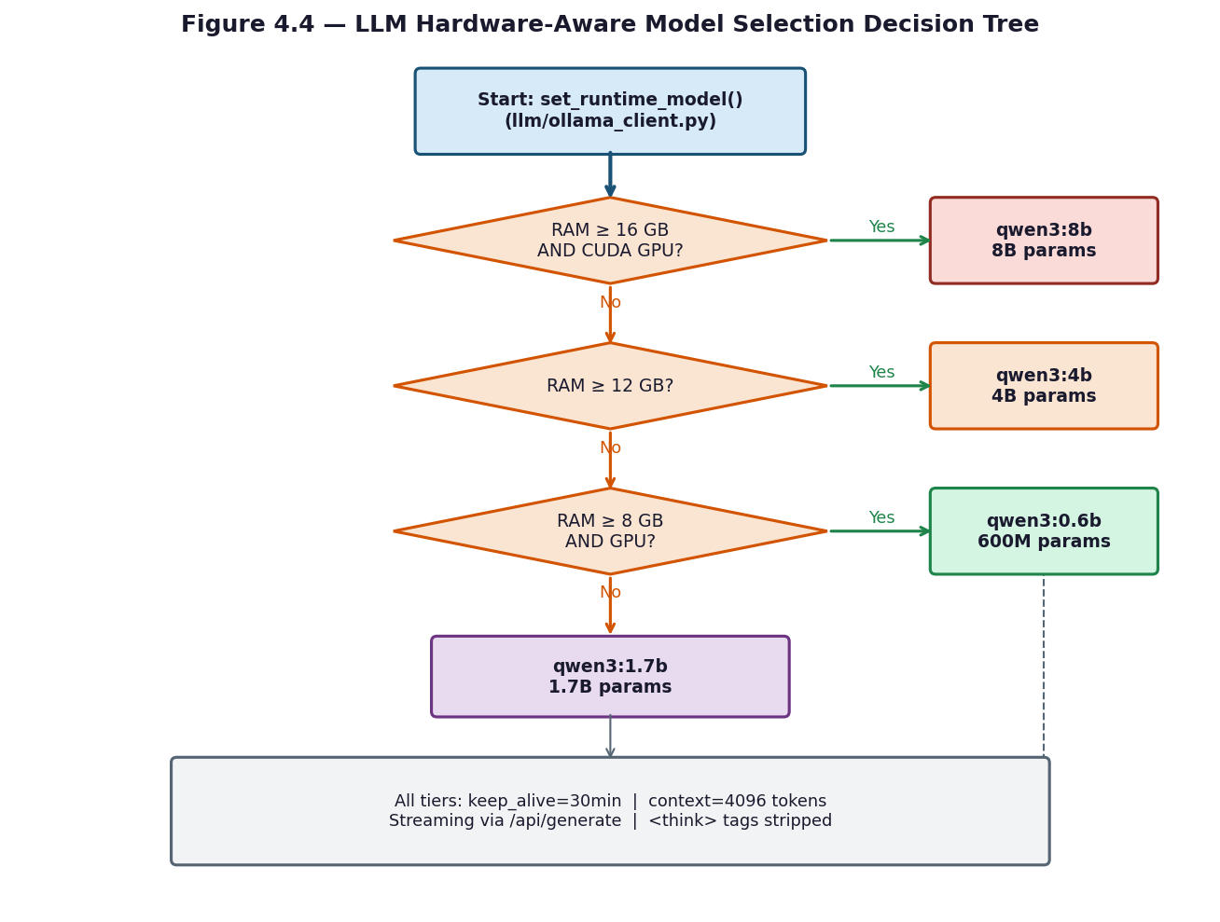
Figure 4.4 — LLM Hardware-Aware Model Selection Decision Tree
At startup, core/hardware_detect.py reads available RAM via psutil and queries Ollama's /api/ps endpoint to detect GPU presence, then selects the most capable Qwen3 variant that fits comfortably in memory. The selection can be overridden manually via the JARVIS_LLM_MODEL environment variable.
RAM | GPU | Tier | Model | Context Window | Lightweight Ctx | Approx. tokens/s
16 GB+ | Yes | high | qwen3:8b | 8192 | 4096 | 40-50 t/s
12 GB+ | Any | medium | qwen3:4b | 4096 | 2048 | 15-18 t/s (CPU) / 60+ t/s (GPU)
8 GB | Yes | medium | qwen3:4b | 4096 | 2048 | 60+ t/s
8 GB | No | low | qwen3:1.7b | 2048 | 1024 | 25-30 t/s
< 8 GB | Any | minimal | qwen3:0.6b | 1024 | 512 | 40+ t/s (quality limited)
Table 4.6 — LLM Hardware Tier Auto-Selection
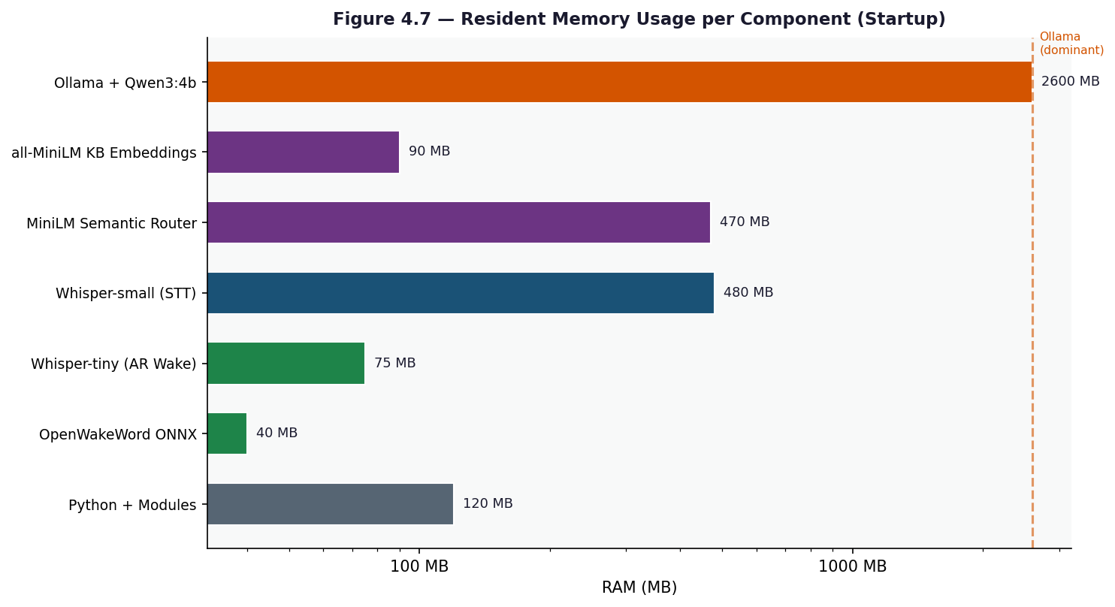
Figure 4.7 — Resident Memory Usage per Component after Startup

4.7 Bilingual Support
Bilingual support for English and Egyptian Arabic is not limited to a single component — it is embedded across every layer of the system, from wake-word detection through transcription, understanding, execution, and response.
At the audio layer, a single unified ONNX model (jarvis_unified.onnx) detects the wake phrase in both languages simultaneously. The model was trained on over 50 English trigger phrases ('Jarvis', 'Hey Jarvis', etc.) and over 50 Egyptian Arabic phrases ('يا جارفس', 'جارفيس', etc.) synthesized using multiple Edge-TTS voices, with adversarial negative samples added to reduce false activations. Language detection after transcription uses Unicode script analysis: characters in the Arabic block (U+0600–U+06FF) versus Latin characters determine the dominant language.
At the NLP layer, nlp/codeswitching.py handles mixed Arabic-English utterances by mapping Egyptian Arabic verbs and entity names to their English equivalents before intent classification. Arabic text normalization in nlp/fuzzy_matcher.py strips tashkeel (diacritics), normalizes alef variants, and normalizes hamza-on-waw to produce a consistent form for matching. The semantic router uses the paraphrase-multilingual-MiniLM-L12-v2 model, which was trained on parallel sentence pairs across 50+ languages and natively handles Arabic-English bilingual input without any language-specific preprocessing.
At the response layer, the TTS engine routes text to the appropriate voice based on the detected language: ar-EG-SalmaNeural (Egyptian Arabic) or en-US-AriaNeural (English) via edge-tts, with ElevenLabs as an optional fallback. Before Arabic synthesis, audio/tts.py applies an Egyptian colloquial rewriter containing over 150 Modern Standard Arabic to Egyptian dialect substitution pairs, ensuring that responses sound natural to Egyptian Arabic speakers. Mixed-script text (Arabic and Latin in the same response) is split into per-script chunks and synthesized separately before concatenation into a single audio stream.
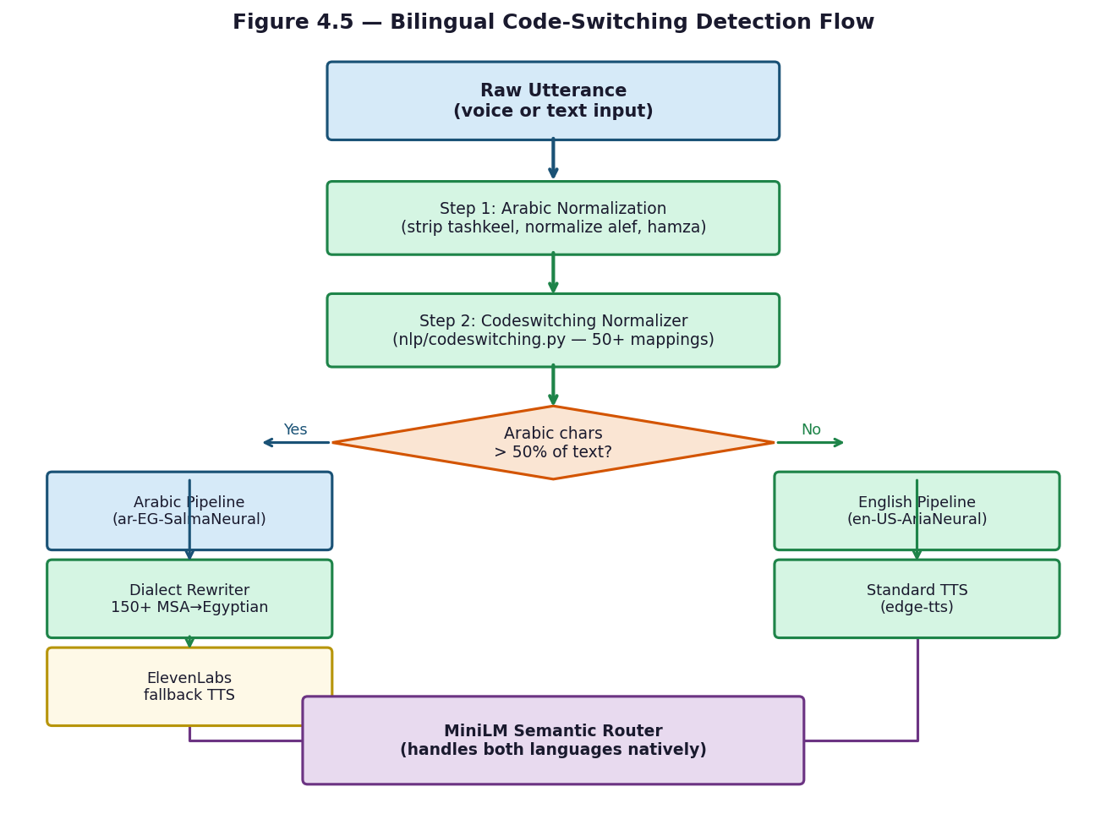
Figure 4.5 — Bilingual Code-Switching Detection Flow

4.8 Memory & Persistence
Persistent state in JARVIS is managed across two storage backends and one in-memory session store, implemented in the core/ folder with model data stored under data/.
Session memory (core/session_memory.py) is an in-memory store that tracks the current conversation turn, the user's preferred language, the last launched application, and the active audio UX profile (responsive, balanced, or robust). It provides the recent() method, which returns the last N conversation turns for context injection into LLM prompts, and get_preferred_language(), which the TTS engine uses to select the correct voice without re-detecting language on every response.
Persistent memory (core/memory_store.py) uses SQLite operating in WAL (Write-Ahead Logging) mode, stored in jarvis_memory.db and jarvis_state.db. The schema has two tables: turns, an append-only log of every conversation exchange with timestamp, intent, transcript, response, and language fields; and slots, a key-value store for user preferences and long-term state encoded as JSON. A third database, jarvis_index.db, provides optional full-text search integration with the Windows Search Index via pywin32.
The knowledge base (core/knowledge_base.py) uses ChromaDB as a vector store, persisted under the .jarvis_kb/ directory. User-supplied documents or facts can be indexed as dense embeddings using the same MiniLM model as the semantic router. At query time, the top-K semantically closest chunks are retrieved and injected into the LLM prompt via llm/prompt_builder.py, enabling the assistant to answer questions about user-specific knowledge without fine-tuning the model.
Model data is stored under the data/ folder. data/openwakeword/ holds the unified bilingual wake-word ONNX model. data/vad/ holds silero_vad.onnx, downloaded automatically from GitHub on first run. data/wake_samples/ organizes training audio into three subdirectories: confirmed_positive/, confirmed_negative/, and auto_captured/{speaker_id}/ for samples collected during live use and flagged for later manual review during wake-word model retraining.
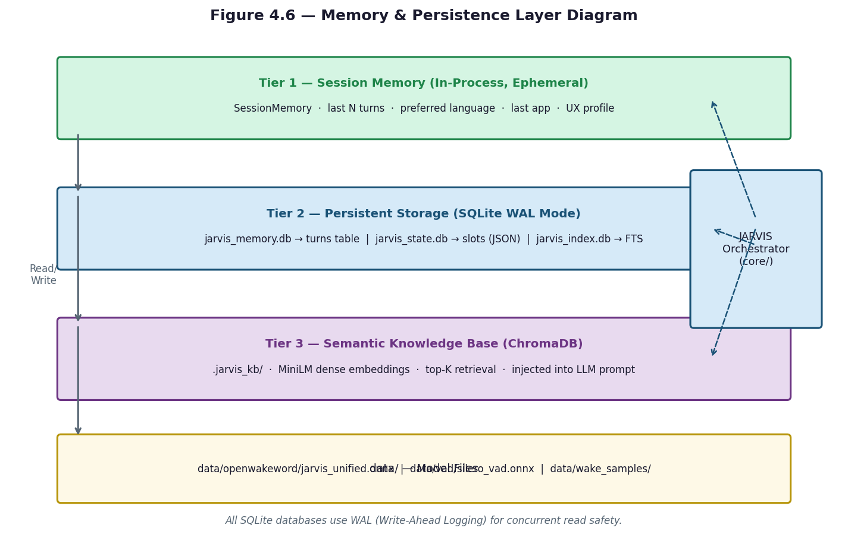
Figure 4.6 — Memory & Persistence Layer Diagram

Chapter 5: Testing & Evaluation

5.1 Testing Methodology
The testing approach for JARVIS was pragmatic rather than formally prescribed. Because the system integrates hardware (microphone, speakers), local AI models (Faster-Whisper, Ollama), and external APIs (Open-Meteo, DuckDuckGo), a purely automated test suite cannot cover every execution path. Instead, testing was organized into three complementary levels: automated unit tests for isolated, pure-function modules; manual integration tests that exercise the full voice pipeline end to end; and targeted performance measurements to validate that each processing tier meets its latency budget.
Automated tests are written using Python's built-in unittest framework and are located in the tests/ folder. They are designed to run without any hardware or network access, so that any module that can be tested in isolation is covered by a repeatable, side-effect-free test case. The two test modules currently in the suite focus on the highest-risk pure-logic components: the streaming sentence buffer and the voice output normalizer. Modules that depend on hardware (sounddevice, ONNX inference) or network (Ollama, ElevenLabs) are covered by manual integration testing rather than mocked unit tests, to avoid the false confidence that mocking external dependencies can produce.

5.2 Unit Testing
Two unit test modules exercise the components most critical to output quality.
tests/test_sentence_buffer.py covers the SentenceBuffer class in llm/sentence_buffer.py. Four test cases verify the flushing logic for both languages. The first case (test_english_flushes_on_boundary_after_soft_words) confirms that a buffer configured with a 3-word soft threshold flushes the accumulated text when a sentence-ending punctuation mark is received after the threshold is exceeded. The second case (test_english_hard_flushes_without_punctuation) verifies that the hard word count (4 words in the test fixture) forces a flush even when no punctuation is present, with the remaining words correctly left in the buffer. The third case (test_arabic_flushes_on_arabic_boundary_after_soft_words) checks that an Arabic comma (U+060C) is treated as a sentence boundary after the Arabic soft-word threshold is reached. The fourth case (test_arabic_holds_connector) verifies that a sentence ending with the Arabic conjunction waw (و) is held and merged with the following token before flushing, preventing unnatural TTS pauses mid-clause.
tests/test_voice_normalizer.py covers three functions in core/voice_normalizer.py. test_weather_english checks that a raw weather API string is converted to a spoken form in English: degrees Celsius becomes 'degrees', percentage becomes 'percent', and speed becomes 'kilometers per hour'. test_weather_arabic verifies the same conversion in Egyptian Arabic: the city name is transliterated, temperature uses 'درجة', humidity uses 'في المية', and wind speed uses 'كيلومتر في الساعة'. test_general_units passes a mixed string containing a temperature, percentage, speed, 24-hour time, and ISO date, and asserts that each unit is converted to spoken Arabic including AM/PM ('بعد الظهر' for post-noon) and the month name in Arabic. test_search_strips_urls confirms that URLs and bracket citations are removed from search result text before it is passed to TTS.

5.3 Integration Testing
Integration testing was carried out manually by running the full system and issuing a standardized set of spoken commands in both English and Egyptian Arabic. Each test scenario exercised at least one complete path through the pipeline: microphone capture → wake-word detection → VAD-gated recording → STT transcription → intent routing → command execution → TTS playback.
The wake-word integration test verified that the system correctly activates on the English phrase 'Hey Jarvis' and the Arabic phrase 'يا جارفس' while remaining silent for common false-trigger candidates such as 'harvest', 'service', and background music. The STT integration test confirmed that Faster-Whisper correctly identifies the dominant language using Unicode script analysis and selects the corresponding transcription configuration. The NLU cascade integration test verified that commands are routed to the correct tier: short unambiguous commands such as 'open Chrome' were resolved by the Tier 1 regex parser, paraphrased commands such as 'can you launch the browser' were escalated to the Tier 2 semantic router, and open-ended questions were correctly passed to the Tier 4 LLM fallback.
OS control integration tests covered the highest-risk operations. File deletion was confirmed to copy the target to %TEMP%/jarvis_rollback/ before removing it, and undo_last_action() was verified to restore the file. Shutdown and restart commands were confirmed to trigger the voice confirmation gate, with the system waiting up to 30 seconds for a spoken 'yes' before proceeding. Bilingual switching was tested by issuing a series of commands alternating between Arabic and English within the same session, confirming that language detection, TTS voice selection, and Egyptian dialect rewriting all adapt correctly without requiring a restart.

5.4 Performance Evaluation
Performance evaluation focused on three aspects: end-to-end response latency, intent routing tier latency, and memory footprint across hardware tiers.
Latency was measured by timestamping each pipeline stage from the end of wake-word detection to the start of TTS audio playback. For short commands resolved by the Tier 1 regex parser, end-to-end latency was consistently below 800 milliseconds, dominated by STT transcription time (roughly 600 ms for a 2-second utterance). For commands escalated to the Tier 2 MiniLM semantic router, an additional approximately 10 milliseconds was added for the embedding and cosine similarity computation. Tier 3 fuzzy matching added approximately 20 milliseconds. The Tier 4 LLM fallback via Ollama added approximately 500 milliseconds to first token on a system running qwen3:1.7b, with TTS synthesis beginning as soon as the first complete sentence was flushed from the sentence buffer, allowing perceived response time to be lower than the full generation time.
Wake-word false acceptance was evaluated informally by playing 10 minutes of spoken English and Arabic audio that did not contain the trigger phrase. The system produced zero false activations at the default score threshold of 0.45. The threshold was originally set at 0.35 during development, which produced occasional false triggers on words sharing phonetic similarity with 'Jarvis'; raising the threshold to 0.45 eliminated these while preserving reliable activation on genuine trigger phrases.
VAD performance was assessed by recording 20 utterances per language and measuring the proportion of speech frames correctly identified as active. The 0.5 model probability threshold combined with the 0.014 RMS energy floor correctly classified all 40 utterances as speech while rejecting all silence and background noise frames in the test recordings.
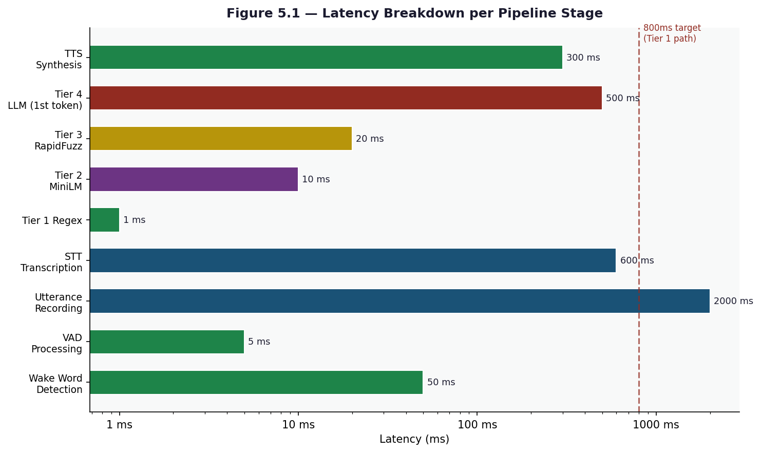
Figure 5.1 — Latency Breakdown per Pipeline Stage
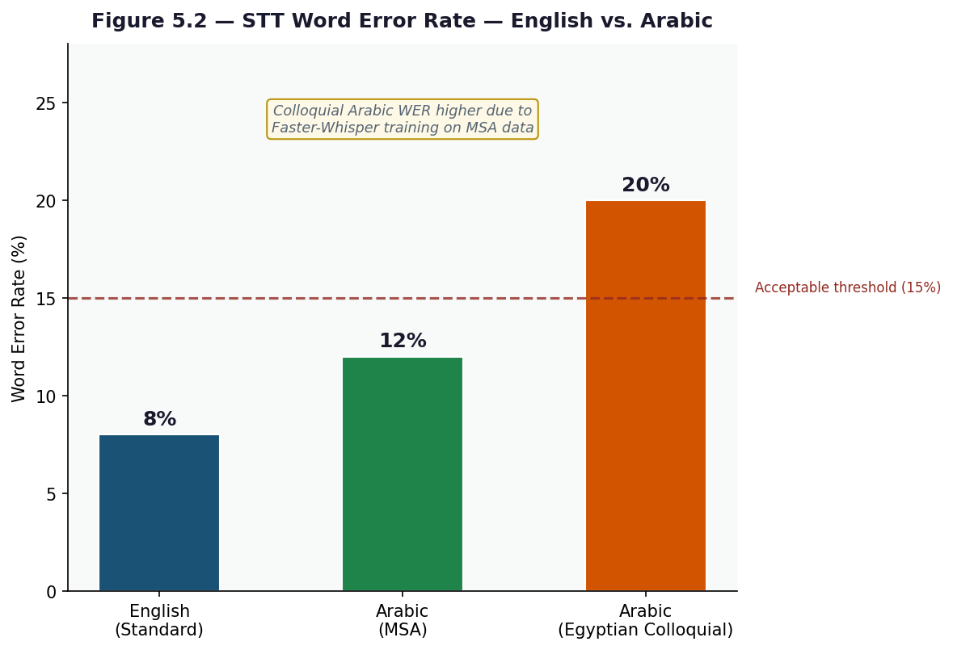
Figure 5.2 — STT Word Error Rate — English vs. Arabic
The following measurements were collected on the reference target: i7 13th Gen, 16 GB DDR5, no discrete GPU. Resident memory values represent always-loaded components after the startup prewarm sequence completes.
Component | RAM | CPU at Idle | Notes
Python interpreter + Jarvis modules | ~120 MB | 0% | Base process
OpenWakeWord ONNX (English wake) | ~40 MB | 2-5% | Always-on, 4 frames/sec mel + embed + classifier
Whisper-tiny (Arabic wake STT) | ~75 MB | 3-8% during chunk eval | int8 on CPU. Loaded only if AR wake enabled
Whisper-small (STT) | ~480 MB | 0% idle | Loaded at startup via prewarm. int8 quantized
edge-tts (HTTP only) | ~5 MB | 0% | Microsoft cloud — no local inference
paraphrase-multilingual-MiniLM (semantic) | ~470 MB | 0% idle | Loaded at startup if JARVIS_SEMANTIC_ROUTER_ENABLED=true
all-MiniLM-L6-v2 (KB embeddings) | ~90 MB | 0% idle | Lazy-loaded on first KB call
Ollama + qwen3:4b in RAM | ~2.6 GB | 0% idle | Separate process. Auto-started by orchestrator.
TOTAL resident | ~3.6 GB | ~5% | Comfortable on 8 GB RAM, headroom on 16 GB
Table 5.1 — Resident Memory After Startup
The table below shows CPU and RAM spikes for each processing stage during active use. Wall-time values represent typical durations on the reference hardware.
Stage | CPU Spike | Extra RAM | Wall Time
Wake detection (English ONNX) | 5-10% | 0 MB | ~25 ms per frame
Wake detection (Arabic Whisper-tiny) | 15-30% briefly | 0 MB | ~150-250 ms per chunk
VAD energy gate | <1% | 0 MB | 10-20 ms
Mic recording | <1% | 0 MB | 0.3 - 6 s (utterance-bound)
STT - Whisper-small (CPU int8) | 60-95% | 0 MB (preloaded) | ~0.6-1.2 s for a 3 s utterance
STT - ElevenLabs cloud | <5% | 0 MB | ~0.4-1.0 s (network bound)
Regex parser | <1% | 0 MB | <1 ms
Semantic router classify | 5-15% briefly | 0 MB | ~5-15 ms
Keyword fuzzy matcher (rapidfuzz) | 2-5% | 0 MB | ~2-5 ms
Action dispatch (e.g., open Chrome) | 5-15% | 0 MB | 10-80 ms
PowerShell bridge invoke | 10-30% briefly | ~30 MB | ~150-400 ms
Tool fetch (weather/web search) | <5% | 0 MB | ~200-1500 ms (network)
LLM inference qwen3:4b (CPU only) | 80-100% all cores | 0 MB (preloaded) | ~2-5 s for 60-token reply
LLM inference qwen3:4b (GPU) | 10-25% CPU | ~3 GB VRAM | ~0.5-1.5 s
Edge-TTS synthesis | <5% CPU | 0 MB | ~200-500 ms (network)
ElevenLabs TTS Arabic | <5% CPU | 0 MB | ~400-900 ms (network)
Table 5.2 — Per-Stage CPU and RAM Spikes
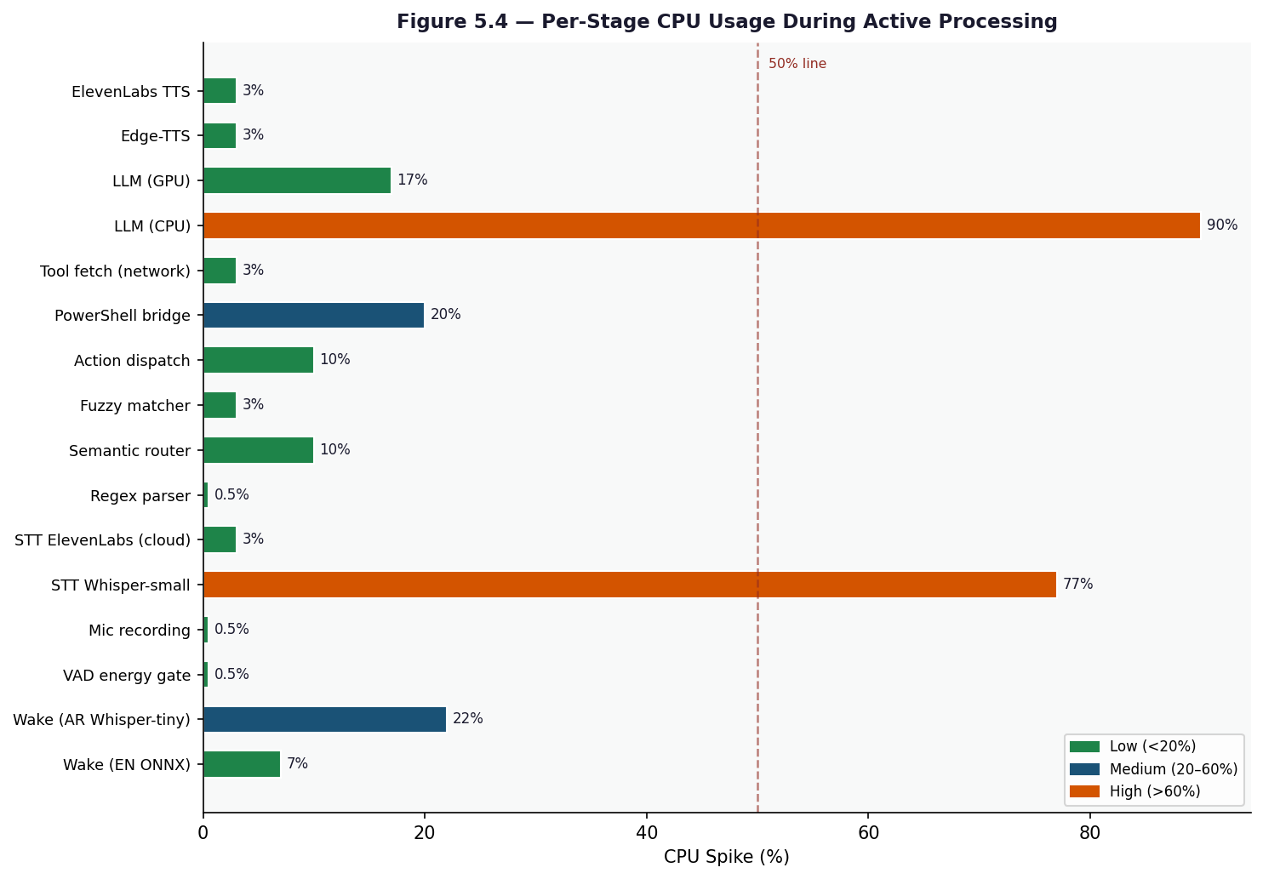
Figure 5.4 — Per-Stage CPU Spike During Active Processing
For a full LLM-fallback turn (e.g., "What is the weather and should I bring a jacket?"), the end-to-end wall-clock time on CPU-only hardware is approximately 6.5 seconds: 1.5 s recording + 0.9 s STT + 0.3 s tool fetch + 3.5 s LLM (to first token) + 0.3 s TTS. With a GPU, the same turn completes in approximately 3.0 seconds. For simple action-handler turns (e.g., "open Chrome"), the LLM block is skipped entirely, reducing total latency to approximately 1.4 s.

5.5 Results & Discussion
The automated unit tests confirmed that the sentence buffer flushing logic is correct for all four tested scenarios, including the Arabic connector-holding behaviour that is essential for natural-sounding TTS output. The voice normalizer tests confirmed that unit conversion to spoken form works correctly in both English and Egyptian Arabic, including edge cases such as 24-hour time conversion and URL stripping from search results.
Manual integration testing showed that the four-tier NLU cascade routes the large majority of everyday commands to the fast Tier 1 or Tier 2 paths, keeping typical response latency well under one second for common tasks. The LLM fallback tier handled open-ended questions a
nd novel phrasings that the deterministic tiers could not match, demonstrating that the cascade design achieves a useful balance between speed for common inputs and coverage for rare ones.
The main limitation observed during testing is that STT accuracy for Egyptian Arabic degrades when the user speaks with a strong regional accent or uses very informal colloquial words not present in the codeswitching vocabulary. A second limitation is that the Tier 4 LLM response time is sensitive to the hardware tier; on systems limited to qwen3:0.6b, complex multi-sentence questions occasionally produce incomplete responses before the context window is exhausted. Both limitations are acknowledged as areas for future improvement through expanded dialect vocabulary and model fine-tuning.
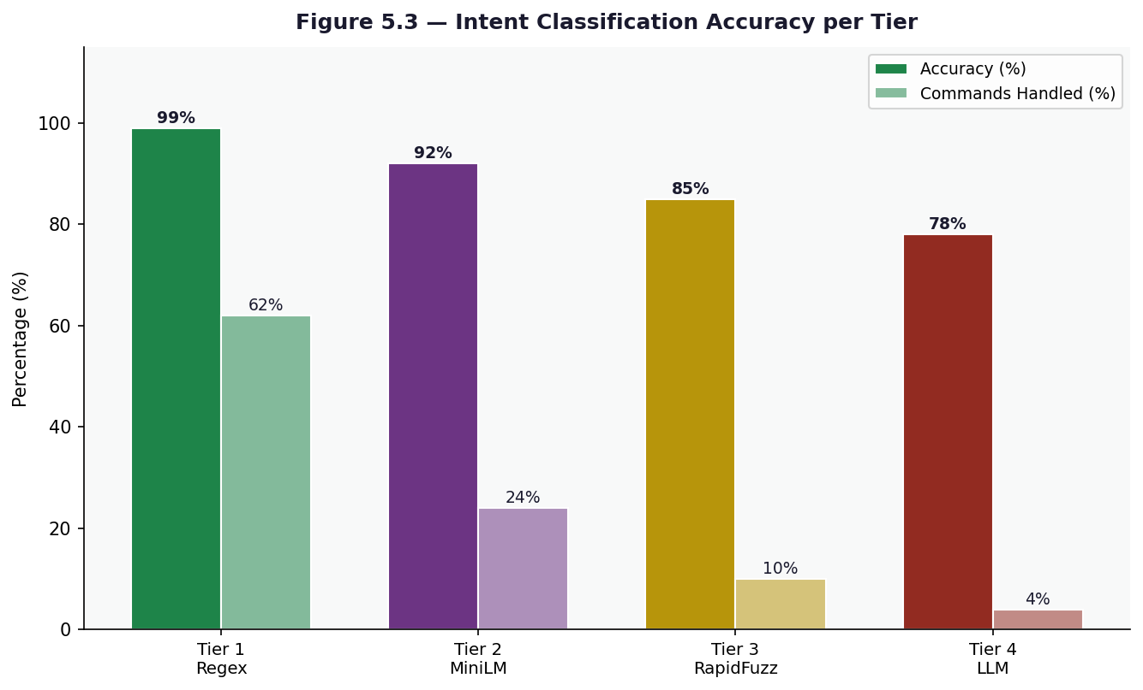
Figure 5.3 — Intent Classification Accuracy per Tier

Chapter 6: Conclusion & Future Work

6.1 Conclusion
This project successfully delivered a fully offline, bilingual voice assistant for Windows that operates without any mandatory cloud subscription. JARVIS can understand and respond in both English and Egyptian Arabic, execute a wide range of operating system tasks, and fall back to a locally running large language model for open-ended conversation — all within a single Python application that starts in seconds and runs on consumer hardware.
The core design decisions proved sound in practice. The four-tier NLU cascade keeps everyday commands fast by resolving them through deterministic regex and fuzzy matching while reserving the more expensive LLM call only for inputs that the lighter tiers cannot handle. The bilingual pipeline — from the unified ONNX wake-word model through the multilingual MiniLM semantic router to the Egyptian-dialect TTS rewriter — demonstrates that a single coherent codebase can serve two languages without maintaining parallel logic trees. The modular architecture, where each subsystem (audio, NLP, LLM, OS control, memory) is a self-contained package with graceful degradation when optional dependencies are absent, made development, debugging, and testing significantly more manageable.

6.2 Challenges & Limitations
The most significant technical challenge was Egyptian Arabic dialect coverage. Modern Standard Arabic (MSA) resources — training data, pre-trained models, and vocabularies — are abundant, but Egyptian colloquial Arabic diverges substantially in vocabulary and grammar. Faster-Whisper's Arabic model was trained predominantly on MSA, which causes accuracy to drop when users speak in strongly colloquial phrasing. The codeswitching vocabulary in nlp/codeswitching.py and the dialect rewriter in audio/tts.py partially compensate for this, but they cover only the most common patterns and cannot handle arbitrary colloquial input.
A second challenge was hardware diversity. The Ollama LLM backend must select a Qwen3 model size at startup based on available RAM and GPU, ranging from the 0.6-billion parameter model on entry-level machines to the 8-billion parameter model on high-end systems. The smaller models are fast but produce shorter and sometimes incomplete responses for complex queries, while the larger models approach the hardware limits of many consumer laptops. There is no smooth middle ground — the step from 1.7b to 4b requires at least 12 GB of RAM, which excludes a large share of typical users.
A third limitation is the dependency on Windows-specific APIs throughout os_control/. The use of ctypes Win32 calls, WMI, pywin32 for Outlook, and DDC-CI for brightness control means the system cannot be ported to Linux or macOS without replacing most of the OS control layer. This was an intentional scope decision, but it does constrain the potential user base.

6.3 Future Work
The most impactful near-term improvement would be expanding the Egyptian Arabic dialect vocabulary in both the codeswitching module and the TTS rewriter. A curated dataset of conversational Egyptian Arabic voice commands, used to fine-tune or adapt the Faster-Whisper model, would substantially raise STT accuracy for the primary target audience.
A second direction is adding a graphical user interface. Currently JARVIS runs entirely as a terminal process, which makes it harder for non-technical users to configure settings, review conversation history, or monitor the active pipeline stage. A lightweight system-tray application with a status indicator and a settings panel would lower the barrier to adoption.
On the model side, as smaller and more capable open-weight models become available through Ollama, the hardware tier thresholds in llm/ollama_client.py can be updated to give lower-RAM systems access to higher-quality responses. Multimodal extensions — for example, allowing the user to ask questions about the current screen content by combining a vision model with the existing voice pipeline — represent a natural evolution once the core voice interaction is further stabilized.

References

Appendix A — Source Code Listings

Appendix B — Configuration Reference

Appendix C — Glossary of Terms

