Platform Final Project
Comparison between Cornell Movie-Dialogs Corpus dataset by pytorch after 10000 iterations and tensor flow after 40 epochs according to accuracy, loss,evaluation metrics , visualization
Comparison | TensorFlow | Pytorch
Train Accuracy | 0.1574 | 0.4216
Train Loss | 0.6788 | 1.6707
Perplexity | 2.71 | 2.9141
F1Score | 0.49 | 0.3940
Hardware choice | GPU | TPU

Visualization
TensorFlow
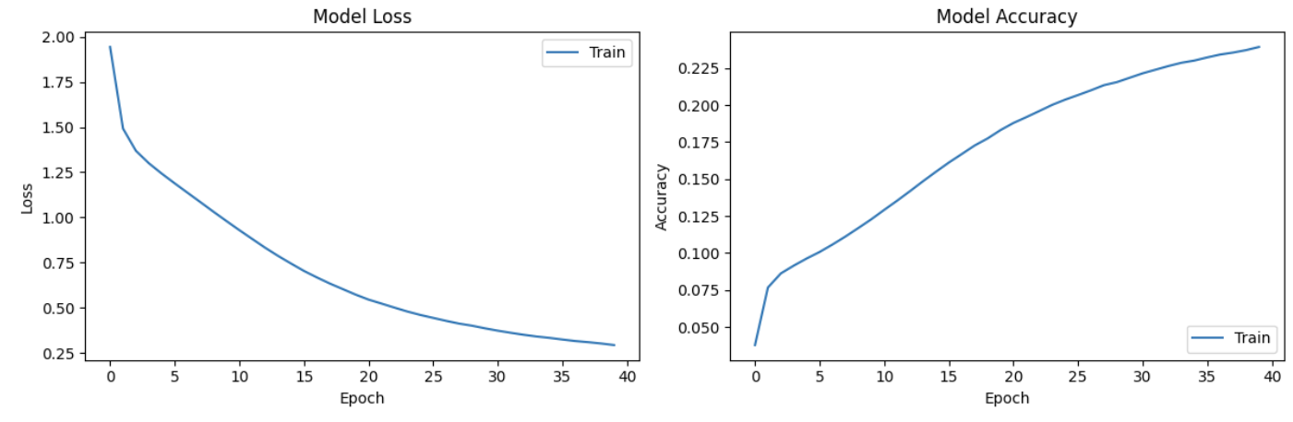

Pytorch
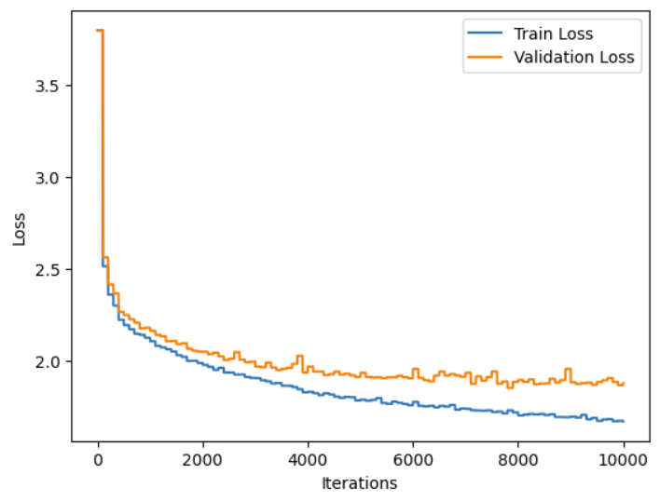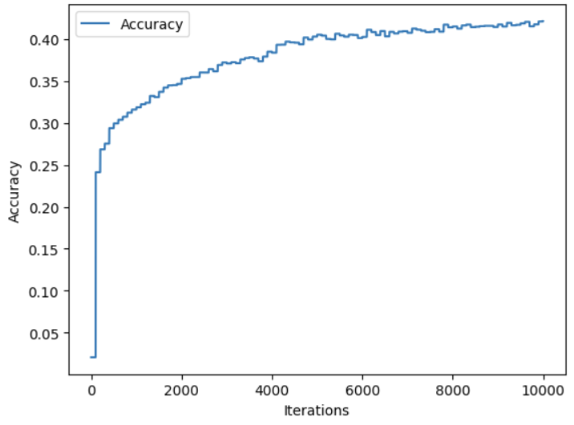

Comparison between tinyshakespeare dataset by pytorch after 10000 iterations and tensor flow after 40 epochs according to accuracy, loss,evaluation metrics , visualization
Comparison | TensorFlow | Pytorch
Train Accuracy | 0.2411 | 0.4708
Train Loss | 0.1372 | 1.4837
Perplexity | 2.7 | 2.7784
F1Score | 0.5 | 0.4601
Hardware choice | TPU | TPU

Visualization
TensorFlow
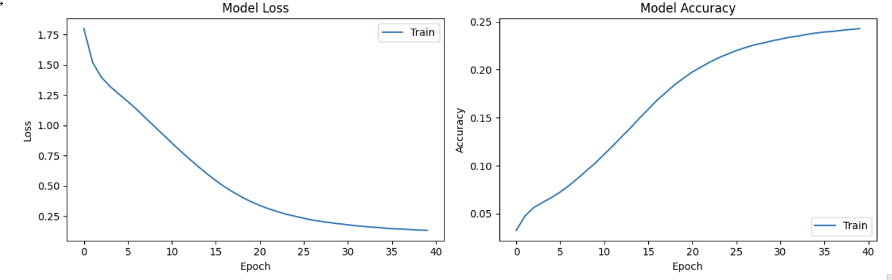

Pytorch
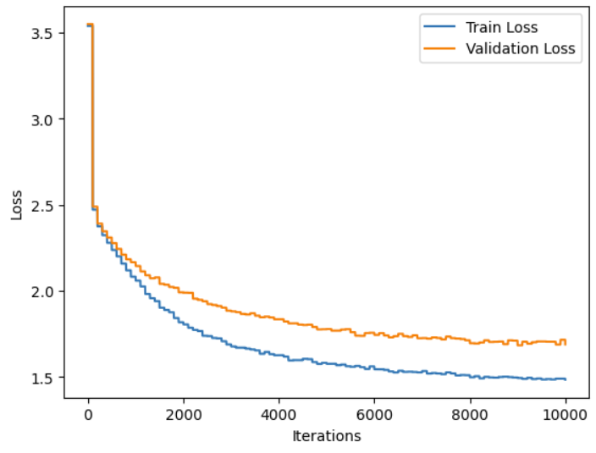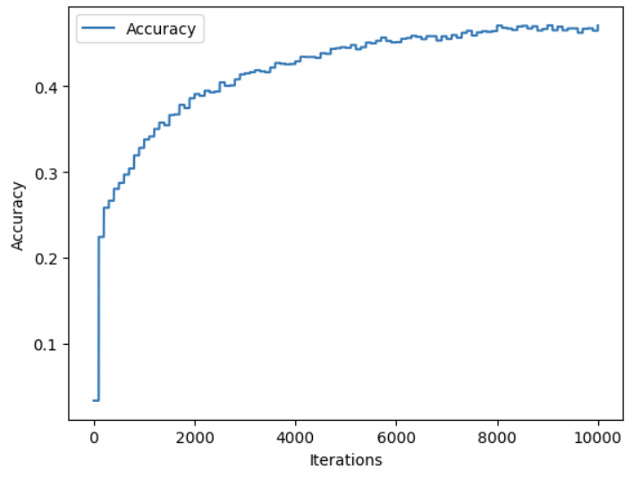

The choice of hardware for the Transformer chatbot project depends on various factors, including the scale of the project, available resources, and specific requirements. Let's discuss the three options: GPUs, TPUs, and CPUs….

GPUs (Graphics Processing Units):

GPUs are widely used for deep learning tasks due to their ability to parallelize computations.
TensorFlow and PyTorch both have excellent GPU support and can leverage GPUs for accelerated training and inference.
GPUs are suitable for medium to large-scale projects and can significantly speed up the training process compared to CPUs.
GPUs excel at processing large amounts of matrix computations, which are essential in neural network training.
Depending on the GPU model and configuration, training times can be significantly reduced compared to CPUs.

TPUs (Tensor Processing Units):

TPUs are Google's custom-designed hardware accelerators optimized for deep learning workloads.
TensorFlow has native support for TPUs, offering high-speed training and inference.
PyTorch also provides support for TPUs through third-party libraries like PyTorch/XLA.
TPUs can offer even faster training speeds compared to GPUs for certain workloads, especially with larger models and datasets.
TPUs are highly efficient at matrix multiplications and are specifically designed for neural network computations.
However, TPUs have limited availability and are typically found in cloud environments or specific research facilities.

CPUs (Central Processing Units):

CPUs are general-purpose processors and widely available in all computing devices.
TensorFlow and PyTorch support CPU computation, but it is generally slower compared to GPU and TPU acceleration.
CPUs are suitable for small-scale projects, experimentation, or scenarios where GPU or TPU resources are limited.
CPUs are less efficient at parallel computations compared to GPUs and TPUs, resulting in slower training and inference times for complex models.
In the context of the Transformer chatbot project, using GPUs or TPUs is recommended for faster training and inference speeds, especially when dealing with large models and datasets. GPUs offer a good balance between cost and performance, while TPUs can provide additional acceleration for specific use cases. However, if you have limited resources or are working on a small-scale project, CPUs can still be used, albeit with slower execution times.

It's important to note that the actual performance gains will depend on factors such as the specific hardware models, the size of the model and data, and the optimization of the code and frameworks used. It is recommended to benchmark and profile your specific setup to determine the best hardware configuration for your Transformer chatbot project.

