NLP PROJECT
Arabic News Category Prediction

Team Members
Name | ID
Abdelrhman Mohamed Abdelhady Hodib | 2022513643
AbdelRahman Tarek Zaki | 20221442265
Antonius Gerges | 20221903971

Introduction

The goal of the project
Predict the category of Arabic news articles based on their text content. This involves several steps, including data loading, text preprocessing, tokenization, model creation, training, and prediction.

The add value of project
This project involves employing natural language processing techniques to increase accuracy of predicting the categories of news articles written in the Arabic language this is because in the Arab world, the usage of NLP for the Arabic language has faced several challenges, commonly referred to as the 'Arabic NLP Leakage.' This leakage cause problems between the resources available for English NLP and those for Arabic, leading to a significant gap in the development of language models, tools, and datasets for effective Arabic NLP applications.

Data Description

Data Used
Arabic News Articles Dataset:
SANAD: Single-Label Arabic News Articles Dataset

Source
Kaggle

Data Description
SANAD Dataset is a large collection of Arabic news articles that can be used in different Arabic NLP tasks such as Text Classification and Word Embedding. The articles were collected using Python scripts written specifically for three popular news websites: AlKhaleej, AlArabiya and Akhbarona.
All datasets have seven categories [Culture, Finance, Medical, Politics, Religion, Sports and Tech], except AlArabiya which doesn’t have [Religion]. SANAD contains a total number of 190k+ articles.

Data Preprocessing
- Data Collection:
Gathered data from multiple directories or sources, each representing a different category or class.
- Text Extraction:
Accessed each file within the directories and Read the text content from these files.
- Text Labeling:
Assigned labels or categories to the texts based on the directory they were sourced from.
Then, Created labels to differentiate between different categories.

- Data Splitting:
Separated the dataset into training, validation, and test sets.
  - The training set is used to train the model.
  - The validation set is employed to optimize the model's parameters.
  - The test set evaluates the final model's performance.
- Encoding Labels :
Converted categorical labels into a numerical format suitable for model training.
Then, Encoded categorical labels into numerical representations using techniques like one-hot encoding or label encoding.
- Data Normalization or Standardization :
Performed data transformations to ensure all data features were within a similar scale.

Text Preprocessing
- Tokenization:
Breaking down each text document into individual words or tokens and Assign a unique numerical ID (index) to each word in the vocabulary.
- Limiting Vocabulary Size:
Choosing a maximum number of words to consider in the analysis.
- This helps control computational complexity and focuses on the most relevant words.
- Fit Tokenizer on Training Data:
Learn the vocabulary (unique words and their indices) based on the training text data.
- Texts to Sequences Conversion:
Converting each text document into a sequence of numbers using the learned vocabulary and Replacing each word in the text with its corresponding numerical index from the vocabulary.

- Padding Sequences:
- Ensure uniformity in sequence lengths.
- Add zeros (padding) to sequences shorter than a specified length and truncate longer sequences.
- Set a maximum sequence length to control the uniformity of sequences.
- Apply Padding to Training, Validation, and Test Data:
Perform the padding process consistently across all sets (training, validation, and test) using the maximum sequence length determined earlier.
- This guarantees that all sequences have the same length for model compatibility.

Model Architecture
Embedding layer: The model begins with an Embedding layer. This layer is responsible for converting text data into numerical vectors. It learns a dense representation for each word in the input text.
Bidirectional LSTM layer: The Embedding layer is followed by a Bidirectional Long Short-Term Memory (LSTM) layer. LSTM networks are a type of recurrent neural network (RNN) architecture capable of learning long-term dependencies. The bidirectional aspect allows the model to consider context from both past and future information, enhancing its ability to understand sequential data like text.
Dense output layer with softmax activation: After the LSTM layer, there's a Dense layer with a softmax activation function. This layer produces the final output of the model. The softmax activation function normalizes the outputs into probabilities, providing the likelihood of each class label for a given input.

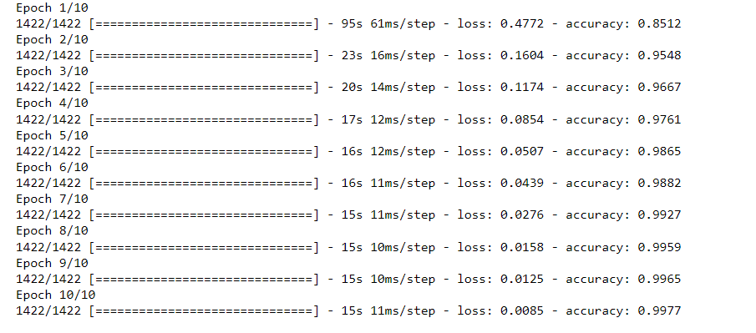

Lets analyze the results:
Loss: The loss decreases over epochs, indicating that the model is effectively learning the patterns in the data.
Accuracy Improvement: The accuracy improves with each epoch, reaching 99.77% by the final epoch. This indicates that the model is successfully capturing the features of the news articles.

Testing

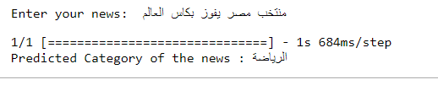
We entered : منتخب مصر يفوز بكأس العالم

The prediction was: رياضة
We entered a sentence that was indicating we are talking about sports, and the prediction was sports which means the model is working efficiently.

Conclusion
- The prediction example shows the effectiveness of the trained model in categorizing Arabic news articles.
- The model's ability to correctly identify the category of the provided news text supports its potential use in real-world applications for categorization of news content.
- The example we used serves as a practical illustration of the model's functionality and can be indicative of its performance on similar tasks in a production environment.

