Names

Khaled Waleed Ibrahim 20201495194

Yousef Moamen Nasr 20201080834

Abd-Elrhman Mohamed Abd-Elhady 2022513643

System request
Idea of the project:
A company sells and fixes the computer and it’s supply in a shop and wants to improve their business by setting up a new website to be reached by more people.
Project sponsor:
The stakeholders of the company.
Business needs:
- The name of the company be popular.
- Increase the rate of sales.
- Take the biggest share of the market.
- The company provide more people with computers.
- The company name spread among youth.
Business requirements:
- The website visited by more than 30,000 people in the month.
- A database about the customers that buy from us.
- Weekly reports about the most sold products and least ones.
- Questionnaires for the visitors to know their opinions about our services.
- The website should be secured and avoid failing.
- The website should be provided with customer service.
Business value:
- Ease the way of selling the products.
- The website will increase our sales rate.
- Take a share from the online shopping in this field.
- Raise our reputation in fixing the computer and its supply.
Special issue:
- Deadline on 10th of December.
- System can be visited by more than 10,000 people in the same time.

Feasibility study

Technical feasibility: | - The company has good computers can run the website fast.  - There are skilled people that can control the website.  - They don’t have a good network service.
Economic feasibility: | - The website will cost 50,000 L.E to be implemented.  - It will cost 1,000 L.E yearly wages as a regular maintenance.  - The system will be visited by approximately 50,000 user per month.
Operational feasibility: | - The website pages will be loaded in 0.01 sec for good networks.  - It will have a good design for youth people.  - The prices and installment conditions will be obvious.
Schedule feasibility: | - The system will be ready in 2 months and 10 days.  - There will be a trial for 1st version in 15 days.
Methodology
- We will use agile development as we want a continuous communication with the stakeholders about our versions.

Time estimation

- The percentage of phases time is:
  - Planning → 30%
  - Analysis → 20%
  - Design → 20%
  - Implementation → 30%

Scope Management Diagram
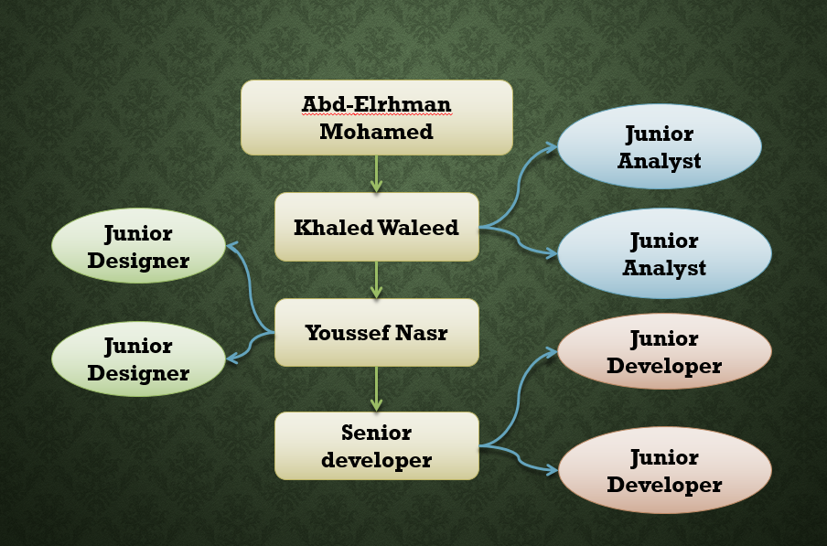

Task Identification

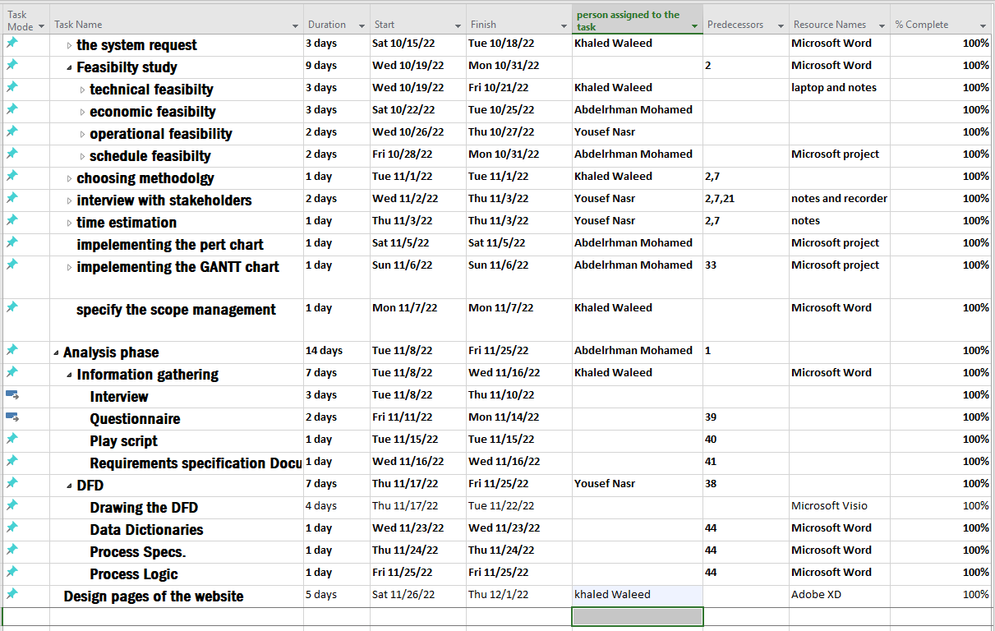

Gantt chart
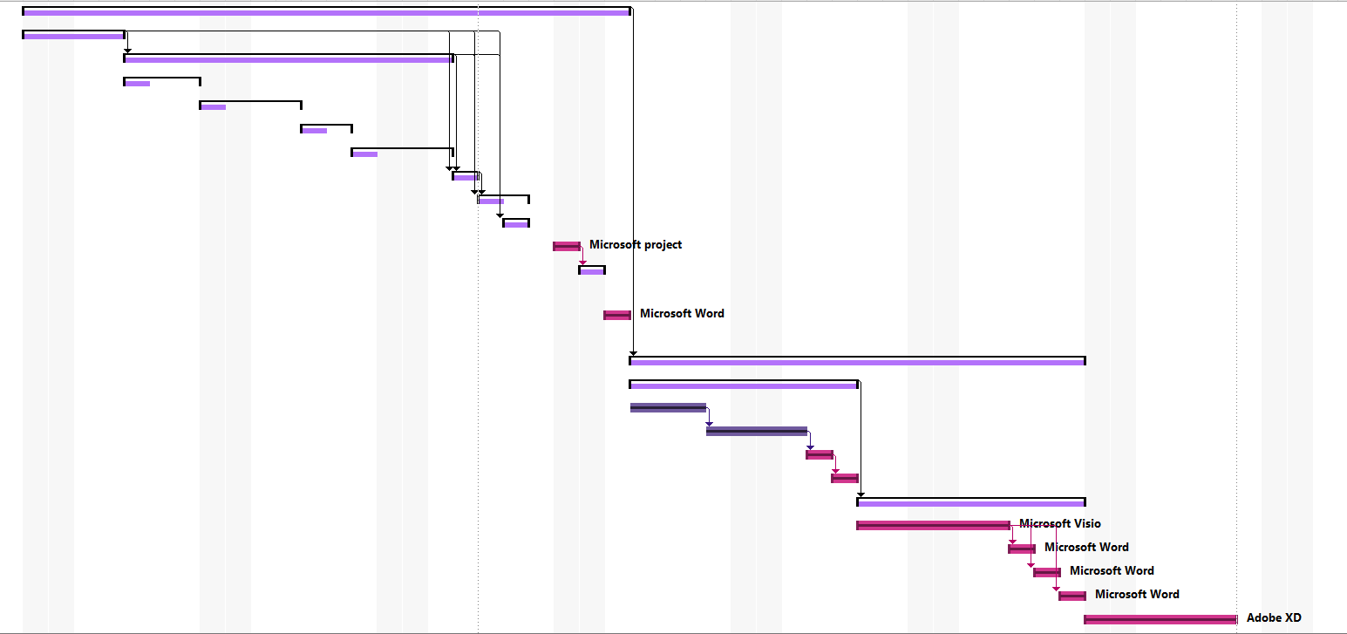

Network pert diagram
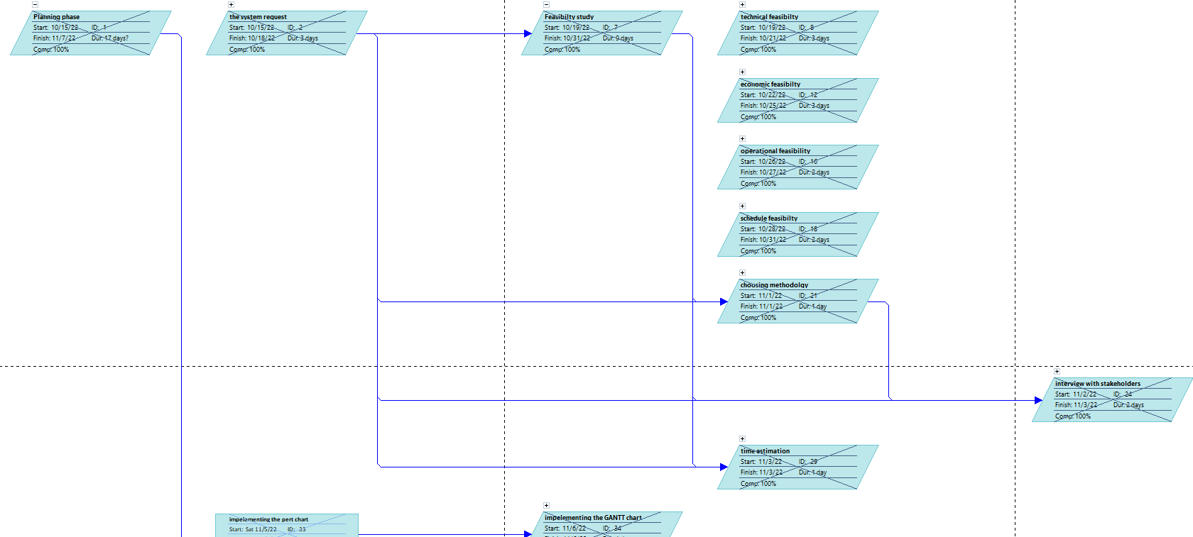
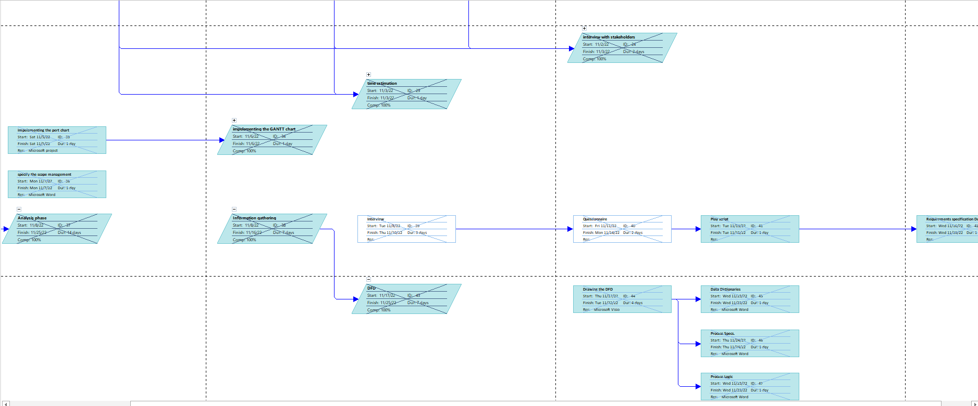

Interview Questions
- Do you have any idea about similar systems?
- Why do you want to build this system?
- Why do you see that the competitors are better than your company?
- What are the obstacles that you face in selling process in the company?
- What are your expectations about the benefits of the system in the future?
- In your opinion, what makes your company unique in the market?
- In your opinion, what is the period that you will need to take a bigger share in the market?
- Why did you prefer implementing a website not an app?
- What is the most important feature that the system must have?
- Why did you want the design of the website posed to the youth?
- What are the payment methods do you want?
- Do you want to provide the system with installment in the payment?
- Do you have skilled people already that will control the system?
- In your opinion, what is the predicted number of users that will visit the website monthly in the first year?
- Will we offer the fixing service in the website or not?
Summery
- we deduced from our interview that :
  - our client wants The name of the company be popular.
  - Increase the rate of sales.
  - The company provide more people with computers.
  - The company name spread among youth.

Questionnaire using google form
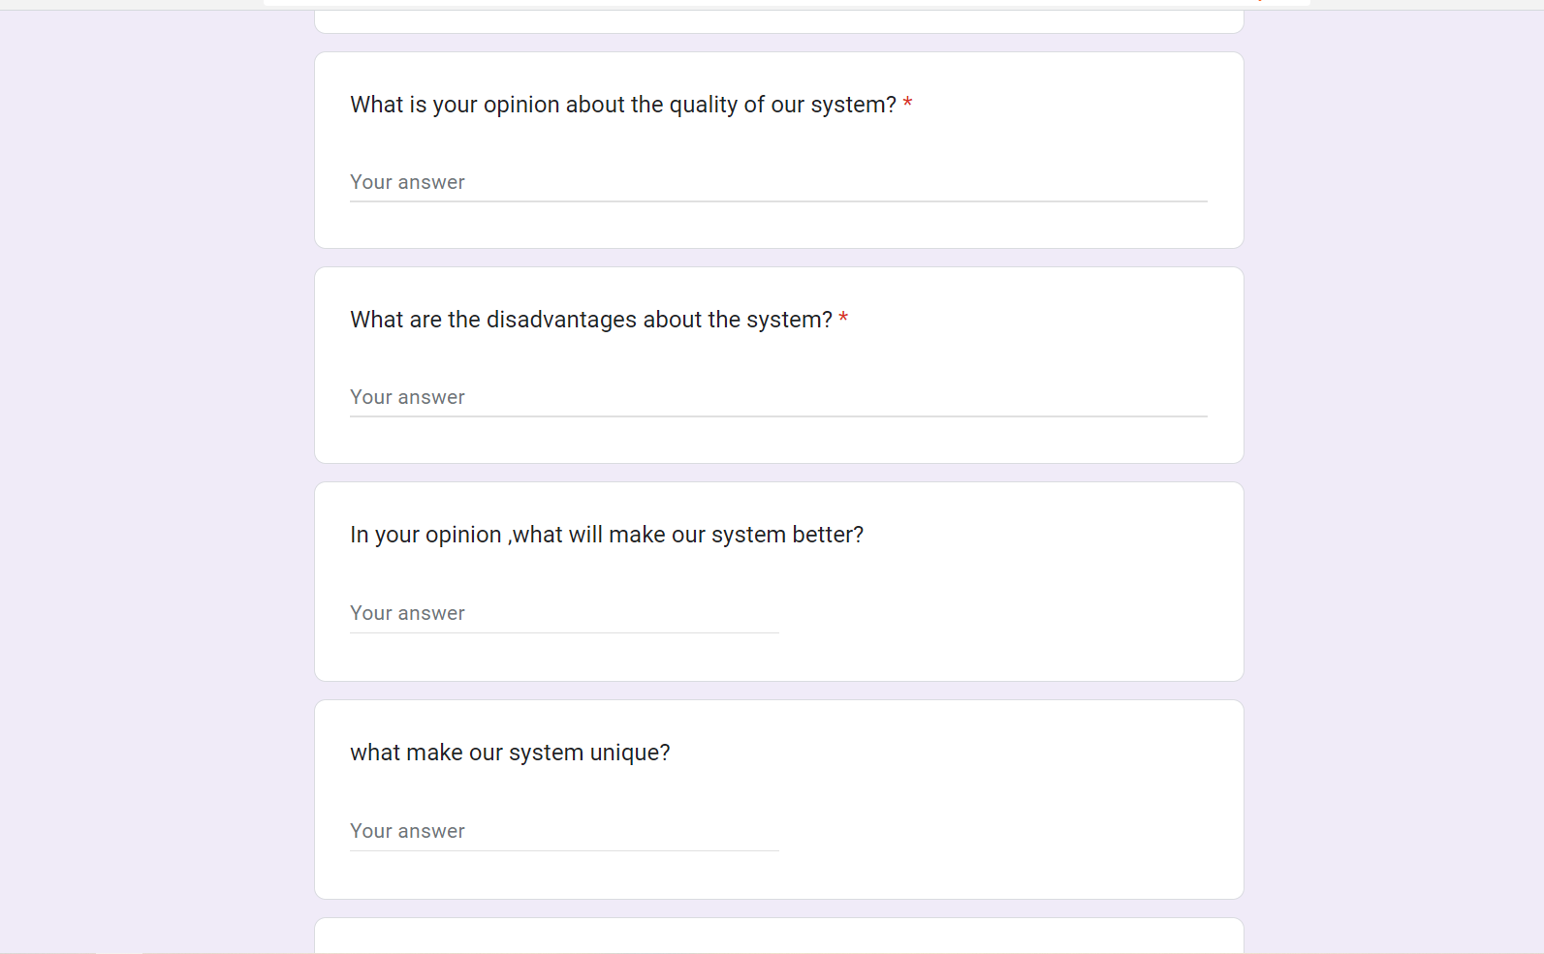

Questionnaire link: https://docs.google.com/forms/d/e/1FAIpQLSfMG0K2tzpZ8DKmZIykbbq6VNblx8aWHSIZOYfU4fyyOwxv4w/viewform

Play script

After we sit with the stakeholders, we deduced that we will have 5 main actors, we will discuss them:
- Fixers:
- They check the damaged computers and know what is the damage.
- They know if the problem about software or hardware.
- They decide what is the best spare parts for the damaged part.
- They fix the computers

2) Sales representatives:
- They marketing for the new accessories in the computer.
- They convince people to buy parts that will increase the speed and performance of their computers.
- They help in increasing the sales of the company.
- They take bonuses for the sales that they contribute in.
- Sellers:
  - They are responsible for the selling operation.
  - They present monthly reports about the sales.
  - They present detailed reports about fixing operations.
  - They present reports about gain and lose.
- Managers:
  - They supervise all the employees in the company.
  - They receive reports from all the departments.
  - They discuss gain and lose and the popularity of the company with stakeholders.
  - They put plans to increase the sales and popularity.
- Consultants:
  - They present creative ideas to increase popularity of the company periodically.
  - They use their experience to discuss the plans of the company.
  - They help the company to choose their new branches suitably.
  - They present solution for the problems that face the company.

Requirements specs.
1.Introduction
  - Purpose
Have a website for selling laptops and computer peripherals
  - Project Scope
Increase sales by reaching a large number of users
2.Overall Description
2.1 Product Perspective
It is a new website for company sells laptops and computer peripherals
2.2 Product Functions
1/ we need function to sign up for new users and sign in for current users
2/we need function for search for products
3/we need function for order product
4/we need function for payment
5/we need function for tracking Product after confirm it
6/We need function for layout
2.3 User Classes and Characteristics
Administrators
Administrators are people who add products
End Users
Customers who visits website and orders products
2.4 Operating Environment
The software will work in Computers and mobiles , so we need a server Online
2.5 Design and Implementation Constrains
-Only users have 18 years or more can use website
-Website should be design by using HTML ,CSS, JS
2.6 User Documentation
Document to guide user how to use website
3.External Interface Requirements
3.1 User Interfaces
We need a friendly interface and use buttons to make website ease for use and quick
3.2 Hardware Interfaces
Hardware requirements:
Processor: Dual core
Ram :2GB
3.3 Software Interfaces
Operating System: Windows , Mac , Linux
Database: MySQL
3.4 Communication Interface
The website should sent an email confirmation and mobile SMS after order confirmation
4. System Features
1/ we can use website from mobile
2/website have search function
3/website have a detailed description for each product
4/website accepts Customer reviews of the products

5.Function requirements and non-function requirement
5.1 Function Requirements
1/ The Products for sale must be listed on the system
2/ The system ought to generate a list of all laptops sold each day.
3/The Product information should be added to the system (price, no. of cores, laptop type)
4/ The website must have a variety of payment methods
5/ The system shouldn't put any users in conflict with one another
6/ The user's review and feedback could be added by the system
7/ The system would like to know how many visitors came each day
5.2 Non-Function Requirements
Efficiency
• Any page of Website should not take more than 6 seconds.
• The Website should be able to support 100 concurrent users without any performance degradation.
Usability
• The user interface of the system should be very friendly.
• It should not take more than 120 seconds for a new user to register for an account
Reliability
• In case of failure that leads to a system outrange, the matter should not take more than 2 hours.
Security
• Each person that goes to the system’s website will be required to register if they want to do more than just read.
Organization Rule:
• The system must follow the company policy of sale

DFD Diagram

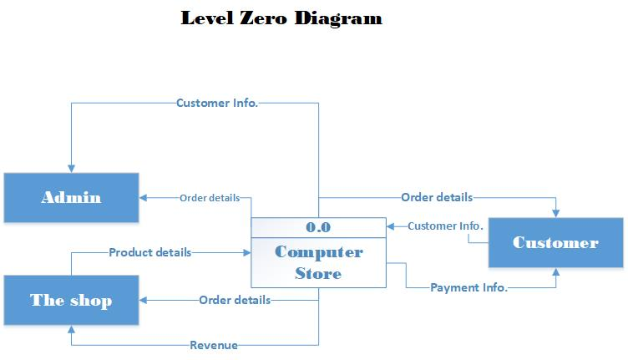
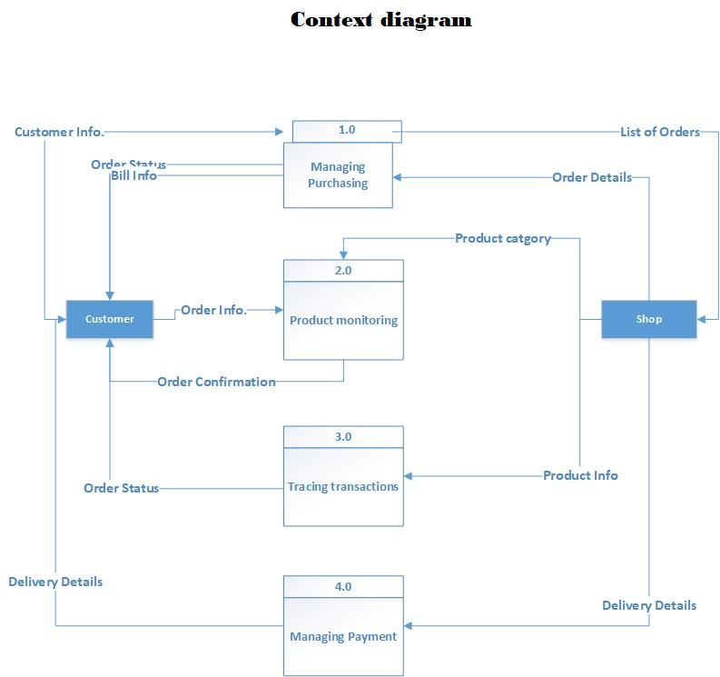

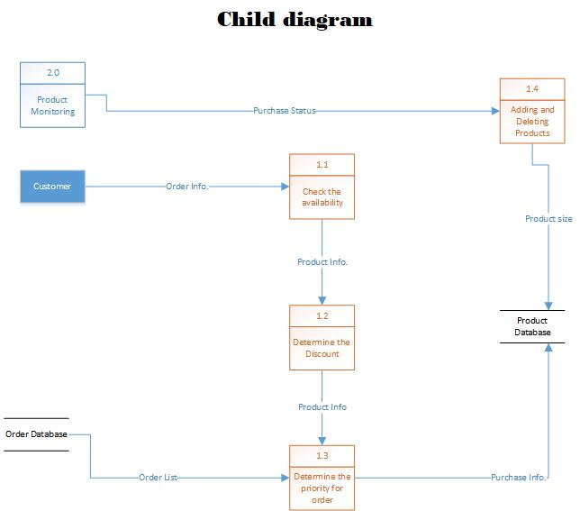

Data dictionaries
1st Data Flow:
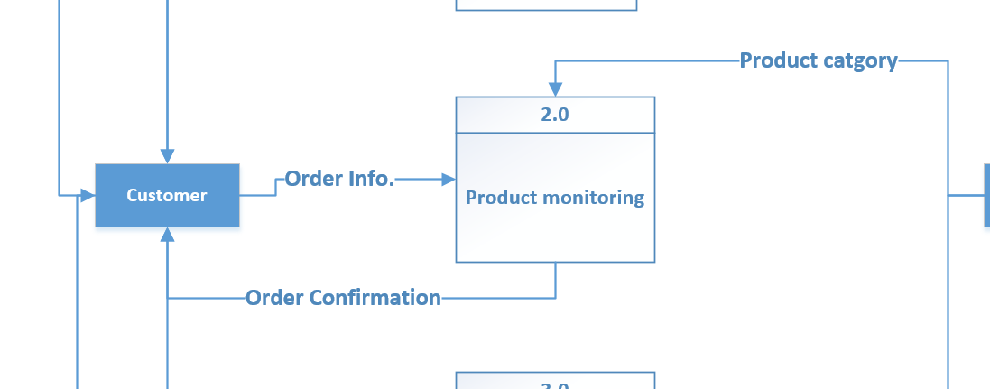

Description Form
- Id: 1
- Name: Order Info.
- Description: It contains all the data about the order from price, the number of the products, and the type of the order.
- Source: Customer.
- Destination: product Monitoring.
- Type of data flow: Form.
- Data structure: Order data.
- Volume/time: 5/day.
Data Structure
Order Info = price + No. of products + place of the order + (cash)
Place of order =City + Street+ building + apartment

Data Element
Name: price
Alias: product price
Description: it contains the price of the product
Type: Number
2nd Data Flow:
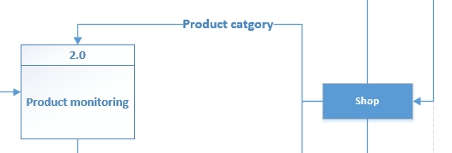

Description form
- Id: 2
- Name: Product category
- Description: It contains the category of the product.
- Source: Shop.
- Destination: product Monitoring.
- Type of data flow: Form.
- Data structure: The category data.

Data structure
Product category = the type of the product + size.

Type of the product = Model + release data + (modification in the product).

Data element
Name: Type of product
Alias: Product type
Description: It refers to the type of the product and its features.
Type: String

3rd Data Flow:
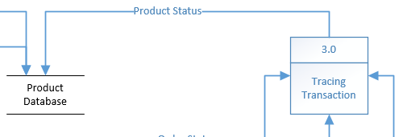

Description form
- Id: 3
- Name: Product status
- Description: It contains the status of the product, if it’s available or not.
- Source: Tracing transactions
- Destination: product Database
- Type of data flow: File
- Data structure: The product data

Data structure
Product status = status + category + size

Data element
Name: Status
Alias: Product status
Description: It refers to the Availability of the product and its size.
Type: String

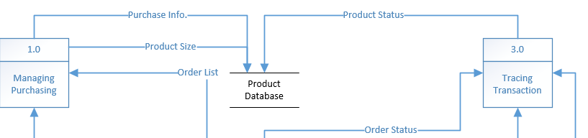
1st Data Store:

- Id: D1
- Name: Product Database
- Alias: The database of products.
- Description: It contains information about all the products of the shop.
- File type: Computer
- File format: Database
- Record size (Characters): 500
- Number of records: 3000
- Dataset name: Products
- Data structure: product data
- Primary key: product ID
- Comments: The database updated automatically by selling the products.

2nd Data Store:
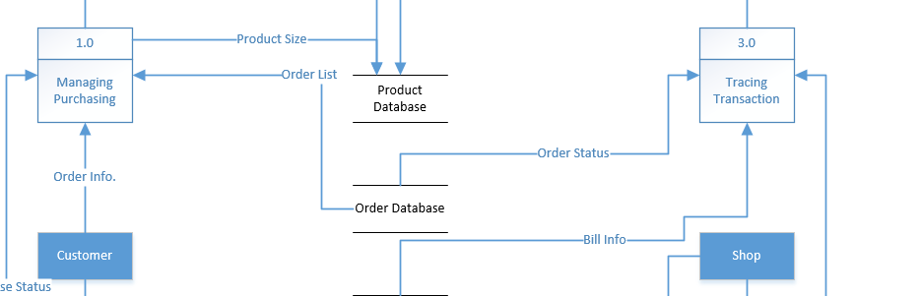

- Id: D2
- Name: Order Database
- Alias: The database of the orders
- Description: It contains all the orders that has come to the shop.
- File type: Computer
- File format: Database
- Record size (Characters): 500
- Number of records: 70000
- Dataset name: Orders
- Data structure: Order data
- Primary key: Order ID
Comments: The database is updated automatically when we get any order

Process Specifications and Logic

Process Specification Form
Number: 1.0
Name: Managing Purchasing
Description: Collect Order details and Customer Information and
Send Order status bills to customer
Input Data Flow:
(1) Customer Information from external Entity Customer
(2) Order Details from external entity Shop
Output Data Flow
(1) Order statuses Bill information
Type of Process: online
Unresolved Issues: no
Process Logic:
BEGIN IF
IF We have Customer Information:
Frist Name and Last Name and Customer ID and Location
And
We have Order details
Then
Send Order statuses Bill Information
END IF

Process Specification Form
Number: 3.0
Name: Tracking transactions
Description: Collect Product information from external entity shop and send order status to customer
Input Data Flow:
(1) Product information from External Entity Shop
Output Data Flow
(1) Order Statue
Type of Process: Online
Unresolved Issues: no
Process Logic:
BEGIN IF
IF We have Product Information:
Description of Product and Available amount
Then
Order statuses
END IF

Process Specification Form
Number: 2.0
Name: Product Monitoring
Description: Collect Product Category From External Entity Shop and
Order Information from External Entity Customer and
Send Order Confirmation to Customer
Input Data Flow:
- Product category From External Entity Shop
- Order Information from Customer
Output Data Flow
(1) Order Confirmation
Type of Process: Online
Refer to name: determine item quantity logic
Structured English Decision Table Decision Tree
Unresolved Issues: no
Process Logic:
BEGIN IF
IF We have Product Category And Order Information
Then
Send Order Confirmation
END IF

Adobe Xd

Homepage:
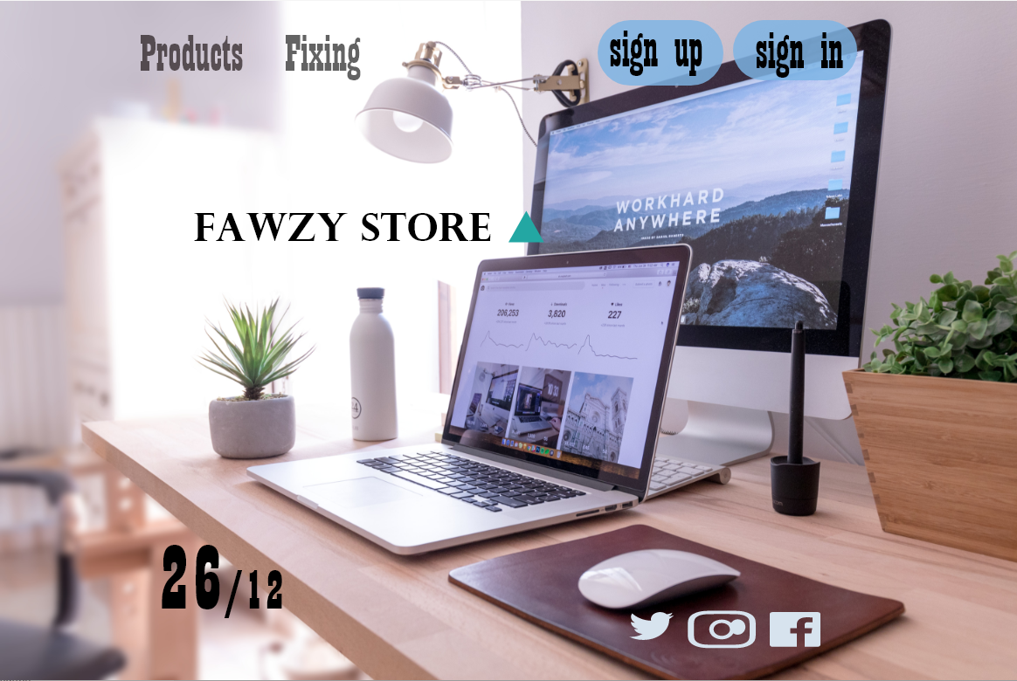

Products Page:
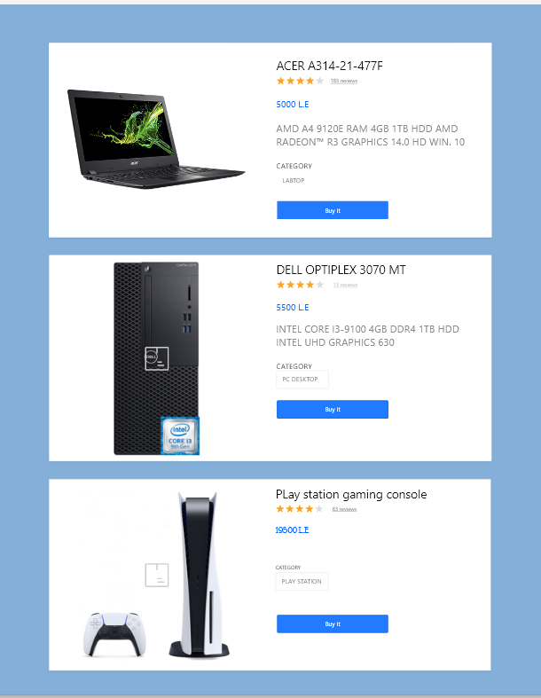

Checkout page:
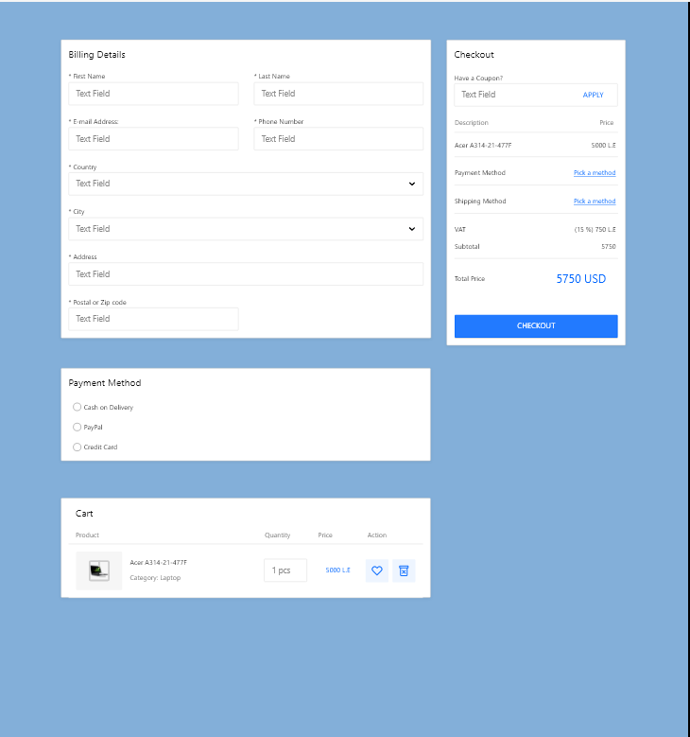

ER diagram

Diagram for the product database:
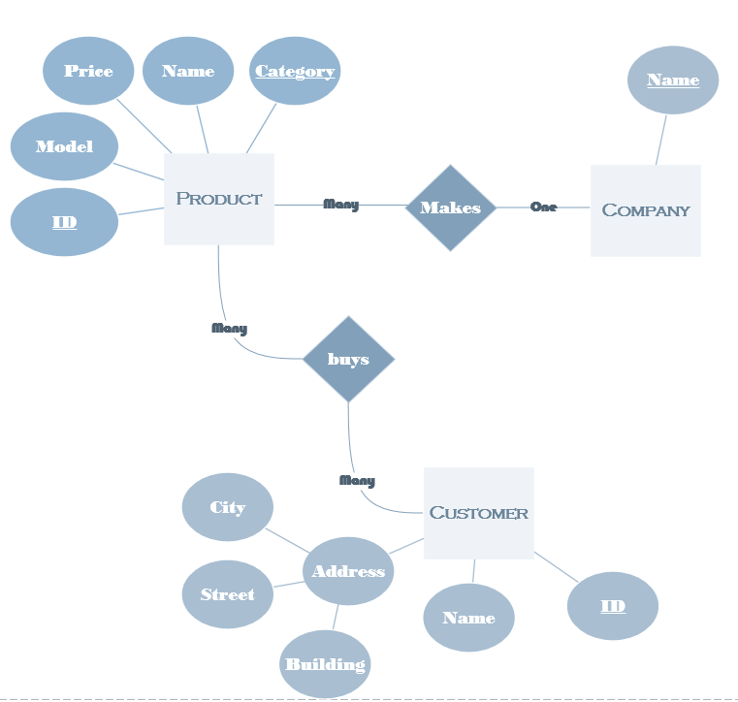

Diagram for the Order database:
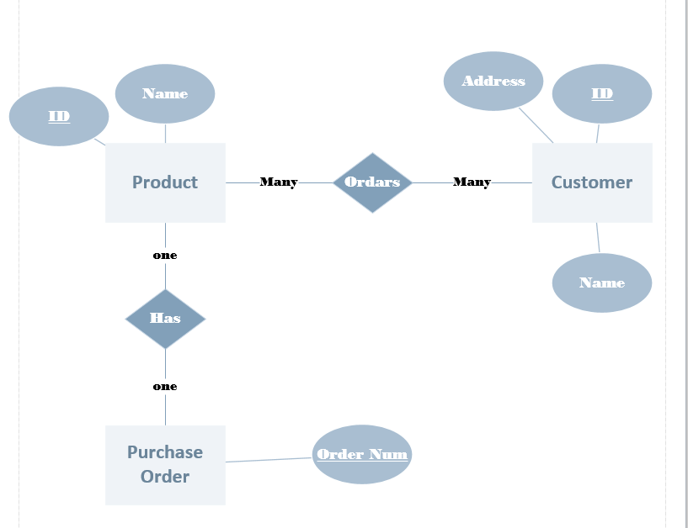

Project Charter
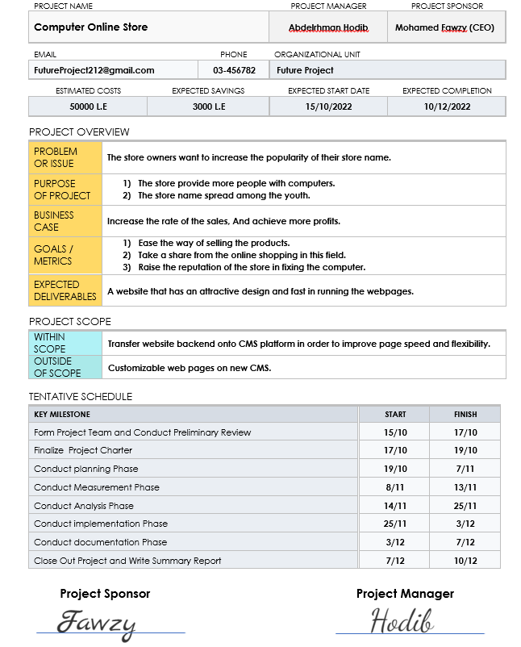
Work breakdown Structure
