Access phase

Investigation Phase

- We deduced that our data is clean and there are no null values in it.

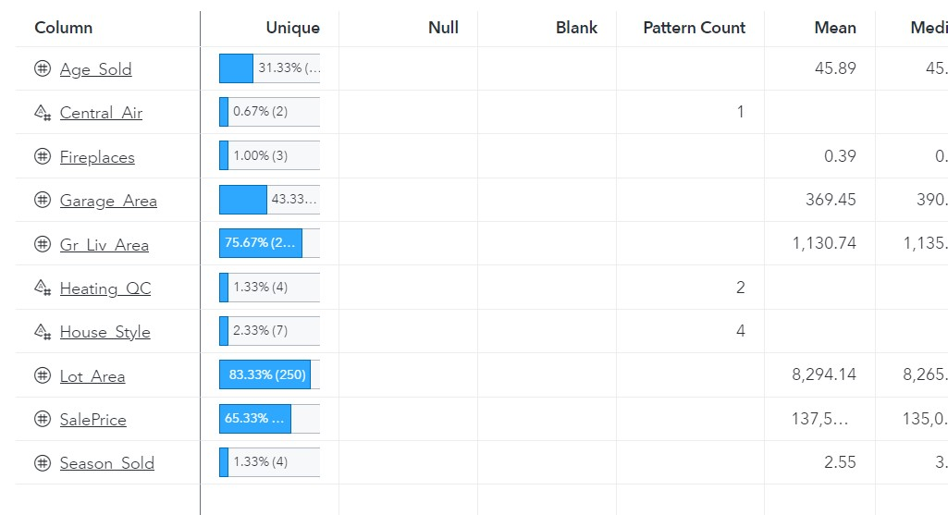
- We deduced from the correlation matrix between all measures that there is a strong relationship between saleprices and (ground living area, Age sold).
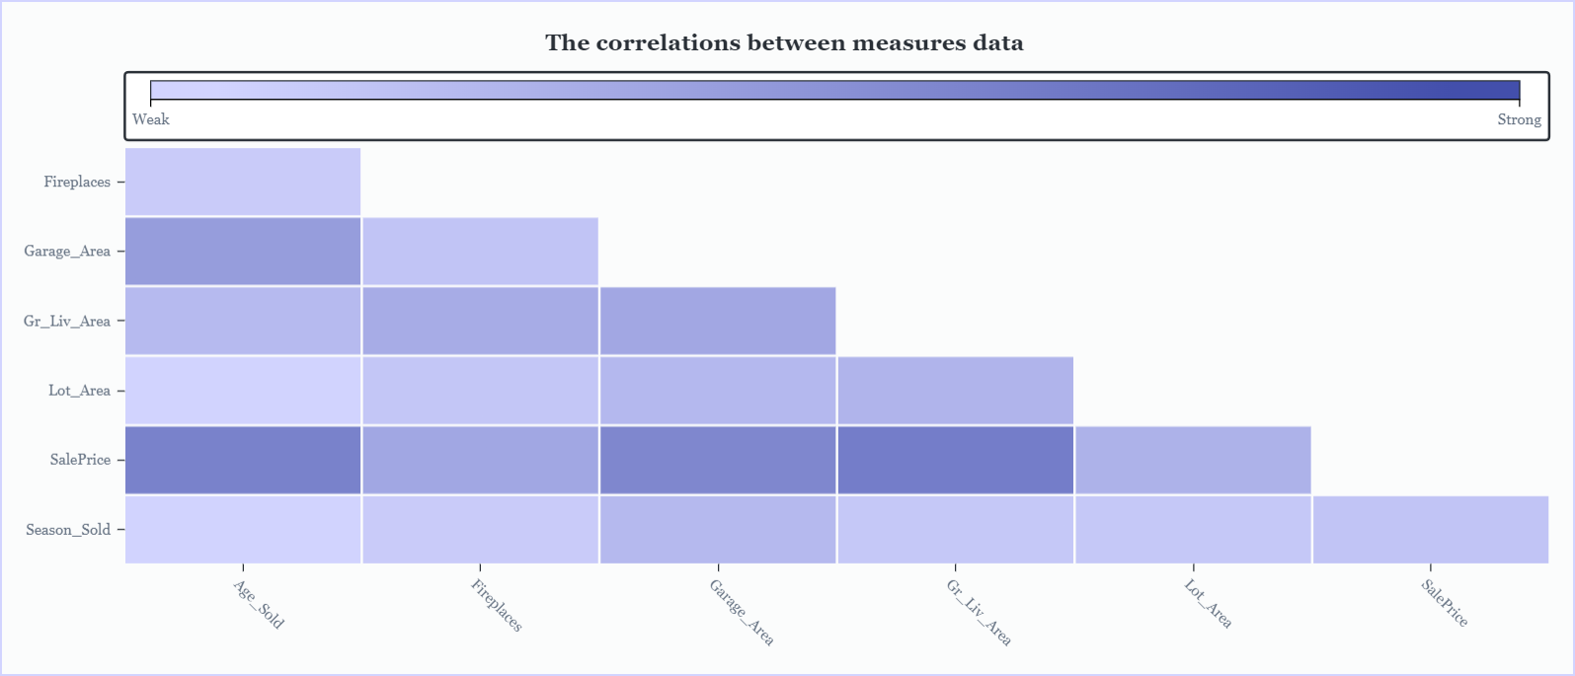
- We can add new category of ground living area to three categories(less than 500,from 500 to 1000, from 1000 to 1500).
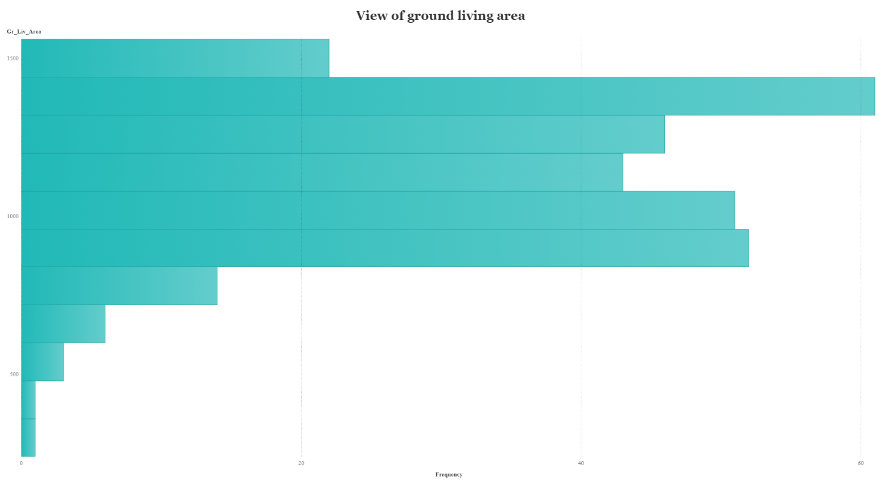

- We deduced that we can add new data category from the age sold measure that ranges from 0 to 135 into 4 categories (less than 10, from 10 to 30, from 30 to 50 , More than 50).
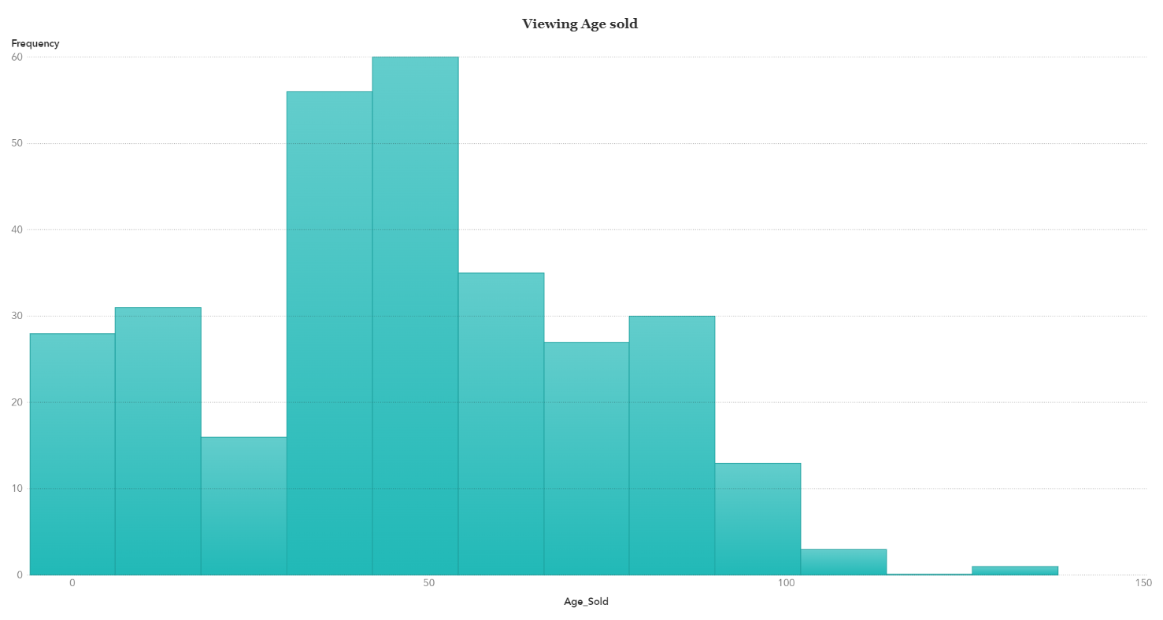

Preparation phase

- We deduced that we can add new data category from the saleprice that has 3 categories (low, Medium, High).

- We deduced that we can change the measure (season_sold) from (1,2,3,4) to (winter,spring,summer,fall).

- We can convert heating quality condition from (ex,fa,…) to Numbers.

Visualization phase

