Sales Forecast & Analysis Report

# Executive Summary

Total Revenue: 8,911,407.90

Top Product: PAPER CRAFT , LITTLE BIRDIE

Top Customer: 14646.0

Best Day: Thursday

Returns Count: 0

## Prophet Forecast

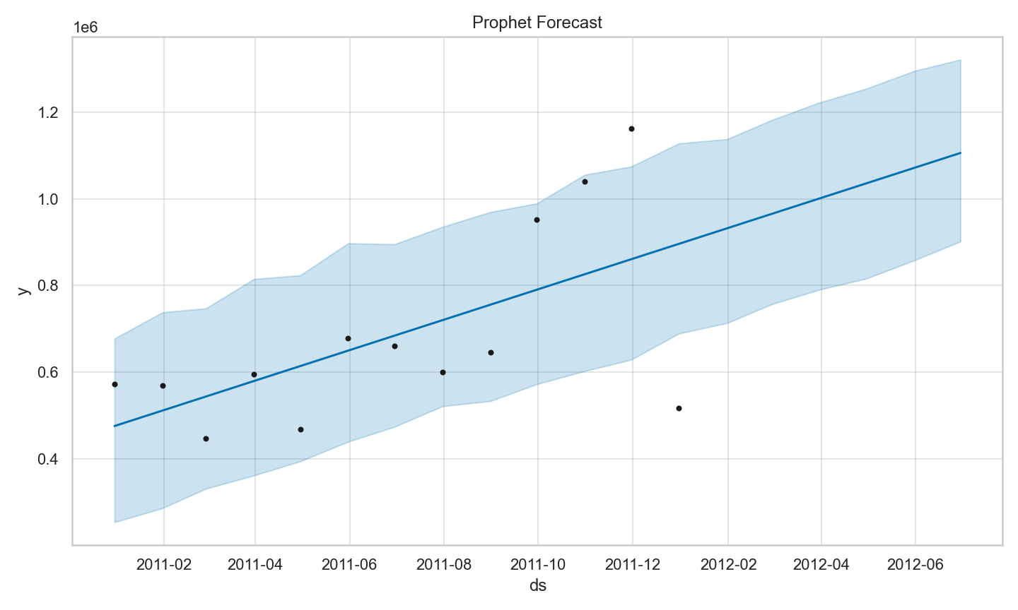

## ARIMA Forecast

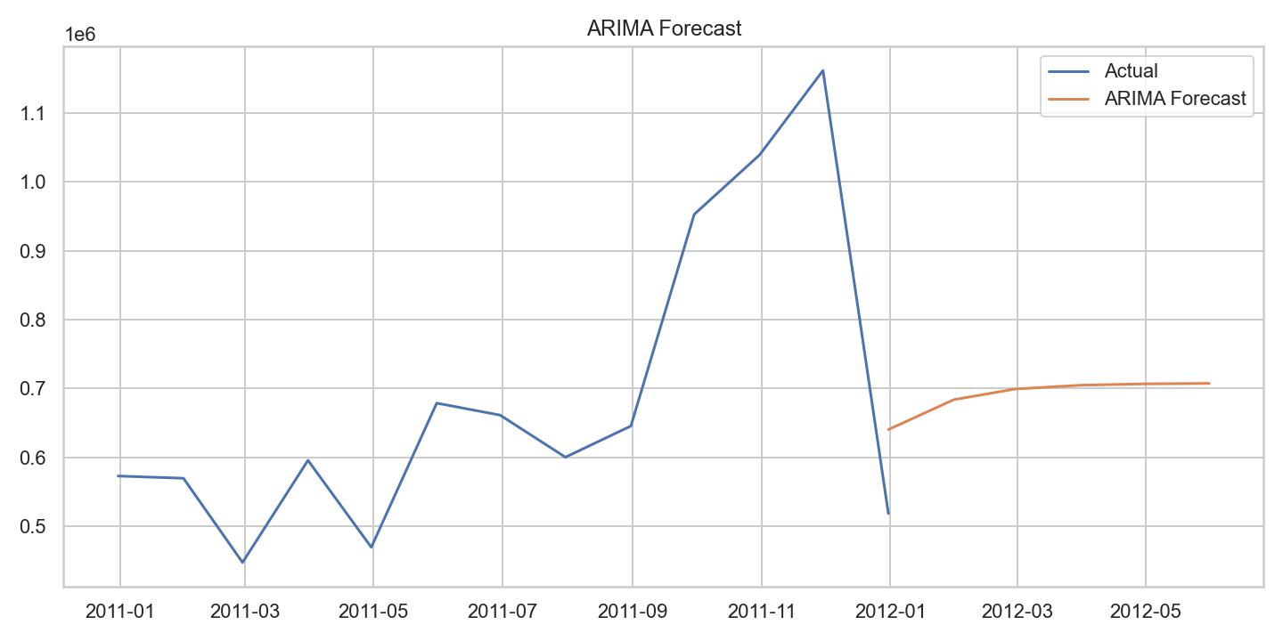

## SARIMAX Forecast

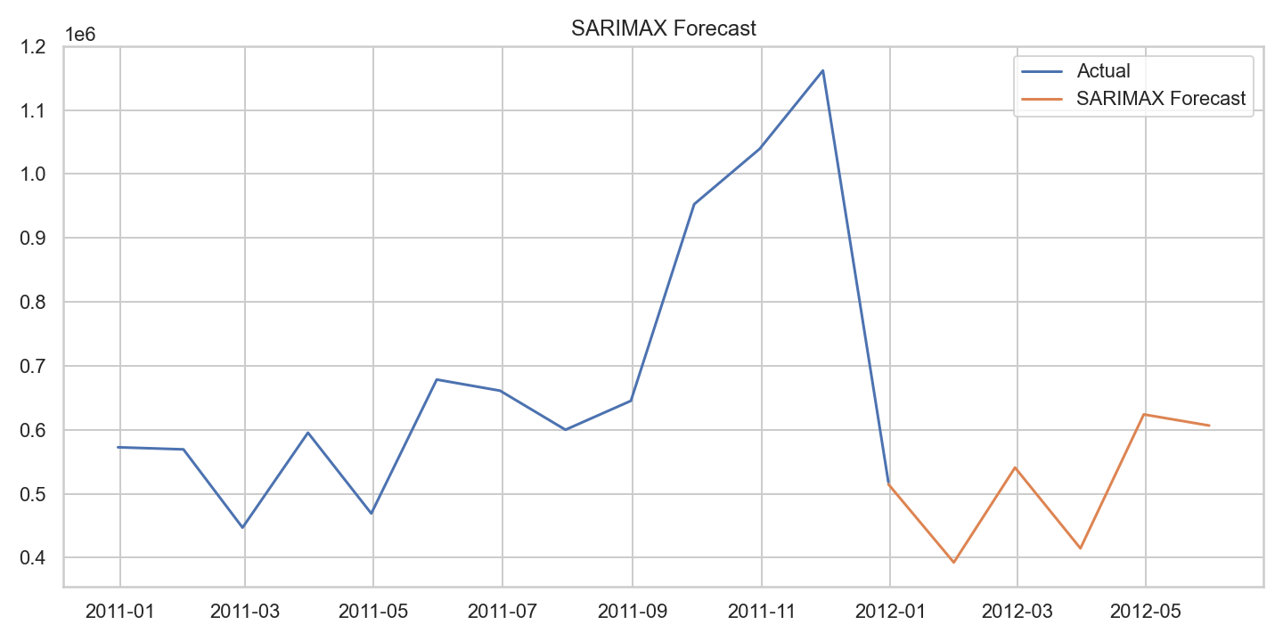

## Model Accuracy Comparison (RMSE vs MAE)

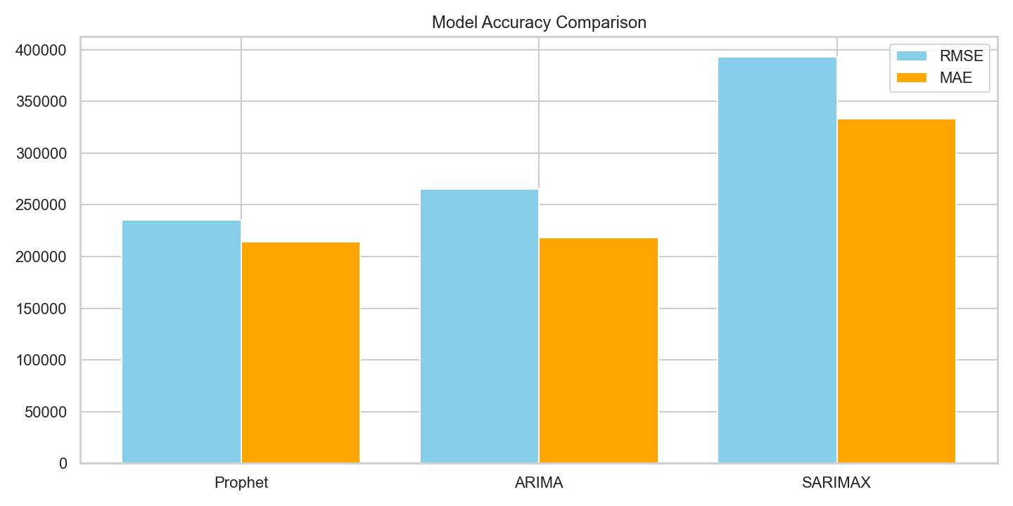

# Recommendation

Based on accuracy metrics and seasonal behavior, SARIMAX is the most suitable model for forecasting future revenue.

Prepared by: Eng. Abdelrhman Ahmed

Date: 2025-08-25