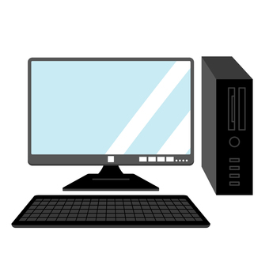

**Projet TIC**

**Nom : Likou**

**Prénom : Yani Anis**

**Section : ING A**

**Professeur : Redouane Bouchekir**

**Contents**

Technologies related to information and communication (TIC) 2

Introduction: 2

Information and Communication Technologies (TIC) 2

Importance of TIC 2

Google Services 4

1. Gmail 4

2. Google Drive 4

3. Google Workspace 4

4. Google Cloud Platform (GCP) 4

Microsoft Tools 5

1. Microsoft 365 5

2. Azure 5

3. Visual Studio 5

4. Power BI 5

Git and GitHub 5

1. Git 5

2. GitHub 6

Conclusion 6

# 

# **Technologies related to information and communication (TIC****)**

### Introduction:

Our present day, interconnected society depends intensely on Data and Communication Advances (TIC). This report digs into the complex world of TIC and investigates particular advances related with it, counting Google administrations, Microsoft devices, Git, and GitHub.

### Information and Communication Technologies (TIC)

TIC alludes to an endless cluster of advances that encourage the procurement, handling, capacity, and spread of data. These advances include equipment, program, systems, and broadcast communications frameworks, working in agreement to make a consistent stream of information over the globe.

### Importance of TIC

* **Enhanced Communication:**

TIC plays an essential part in changing the way we communicate from emails and moment informing to video conferencing, these advances empower real-time intuitive, cultivating collaboration and breaking down topographical barriers.

* **Information Administration:**

TIC encourages the successful organization, capacity, and recovery of data. Databases, substance administration frameworks, and information analytics devices enable businesses and people to tackle the control of data for key decision-making.

* **Global Network:**

The interconnected nature of TIC has made an all-inclusive associated society. Businesses can work on a worldwide scale, people can collaborate consistently over borders, and data can be shared universally in a moment.

* **Innovation and Robotization:**

TIC serves as a catalyst for development by giving devices and stages that streamline forms and empower inventiveness. Mechanization, driven by TIC, leads to expanded proficiency and efficiency over different industries.

Components of TIC

CLOUD COMPUTING

SOFTWARE

HARDWARE

TRANSACTIONS

COMMUNICATION TECHNOLOGY

INTERNET ACCESS

### Google Services

Google, an innovation mammoth, offers a suite of administrations that have ended up necessarily to the everyday lives of millions worldwide.

### 1. Gmail

Gmail, Google's e-mail stage, revolutionized electronic communication. Known for its user-friendly interface, strong spam channels, and capable look capabilities, Gmail has gotten to be the go-to mail arrangement for people and businesses alike.

### 2. Google Drive

Google Drive may be a cloud capacity benefit that permits clients to store, share, and collaborate on archives, spreadsheets, and introductions in real-time. The collaborative nature of Google Drive has changed the way groups work, empowering consistent collaboration notwithstanding of geological locations.

### 3. Google Workspace

Formerly known as G Suite, Google Workspace could be a collection of cloud-based efficiency instruments. Google Docs, Sheets, Slides, and other applications permit clients to make, alter, and share reports collaboratively. This cloud-based approach improves availability and guarantees that clients continuously work on the latest version of a document.

### 4. Google Cloud Platform (GCP)

Google Cloud Stage may be a comprehensive suite of cloud computing administrations. From framework as a benefit (IaaS) to machine learning and analytics, GCP gives an adaptable and adaptable cloud framework for businesses. It empowers organizations to use cutting-edge advances without the required for broad on-premises infrastructure.

**This image show as all Technologies used by Google for their clouds services**

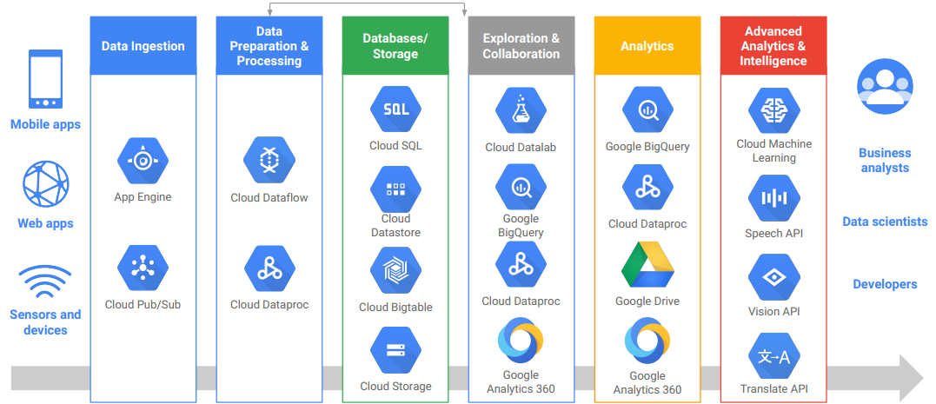

# **Microsoft Tools**

Microsoft, another technology powerhouse, offers a diverse set of tools and services that cater to various needs.

**1. Microsoft 365**

Microsoft 365 is a subscription service that integrates popular applications like Word, Excel, PowerPoint, and Outlook with cloud services such as OneDrive and Teams. This integrated approach enhances collaboration and productivity, allowing users to seamlessly switch between devices while maintaining access to their files and communication channels.

**2. Azure**

Azure, Microsoft's cloud computing platform, provides a wide array of services, including virtual computing, storage, analytics, and artificial intelligence. Azure's flexibility and scalability make it a preferred choice for businesses looking to migrate to the cloud or develop and deploy applications.

**3. Visual Studio**

Visual Studio is an integrated development environment (IDE) that supports various programming languages. It provides a robust set of tools for software development, including code editing, debugging, and collaboration features. Visual Studio's versatility makes it a preferred choice for developers working on a diverse range of projects.

**4. Power BI**

Power BI is a business analytics tool that enables users to visualize and share insights from their data. With interactive dashboards, reports, and data connectors, Power BI empowers organizations to make data-driven decisions. It integrates seamlessly with other Microsoft services, creating a cohesive ecosystem for business intelligence.

**All Microsoft apps for work**

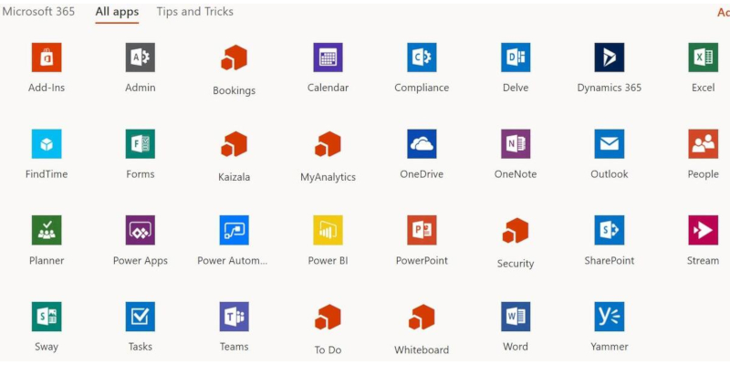

# **Git and GitHub**

Version control and collaborative development are essential aspects of modern software development, and Git and GitHub have emerged as the de facto tools for these purposes.

**1. Git**

Git is a distributed version control system that allows multiple developers to collaborate on a project. It tracks changes in source code, enables branching for parallel development, and facilitates the merging of contributions. Git's decentralized nature ensures that developers can work offline and merge changes efficiently.

**2. GitHub**

GitHub is a web-based platform built on Git, providing a collaborative environment for software development. Developers can host, review, and manage code repositories on GitHub. It introduces features like pull requests, issue tracking, and wikis, enhancing collaboration and project management. GitHub has become a central hub for open-source development and private repositories alike.

**The difference between Git & GitHub**

|  |  |
| --- | --- |
| **Git** | **GitHub** |
| It a software | It a service |
| It is installed locally on the system | It is hosted on web |
| It is a command line tool | It provides a graphical interface |
| It is a tool to manage different version of edits, made to files in a git repository | It is a space to upload a copy of git repository |
| It provides functionalities like version control system source code management | It provides functionalities of git like VCS, Source code management as well as adding few of its own features |

# **Conclusion**

In conclusion, Information and Communication Technologies, along with technologies like Google services, Microsoft tools, Git, and GitHub, are shaping the way we communicate, collaborate, and innovate. The continuous evolution of these technologies empowers individuals and organizations to thrive in the digital era. As we move forward, staying informed about the latest advancements in TIC and leveraging these tools strategically will be crucial for success in an increasingly connected and technologically-driven world.