Recap from Session 1

# ■ Initialize and Configure Git

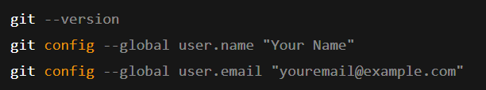

git --version git config --global user.name "Your Name" git config --global user.email "youremail@example.com"

# ■ Create a Project and Initialize Git

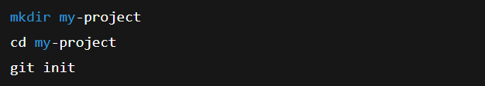

mkdir my-project cd my-project git init

# ■ Add and Commit Files

(Créer ou modifier le fichier manuellement avec un éditeur ou utiliser echo dans linux)

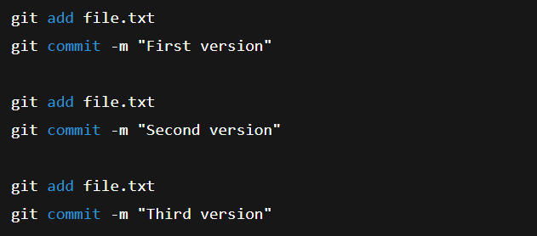

echo "Version 1" > file.txt git add file.txt git commit -m "First version" echo "Version 2" > file.txt git add file.txt git commit -m "Second version" echo "Version 3" > file.txt git add file.txt git commit -m "Third version"

# ■ Check History

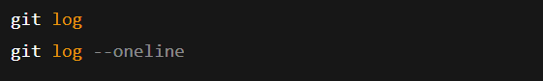

git log

git log --oneline

# ■■ Compare Versions

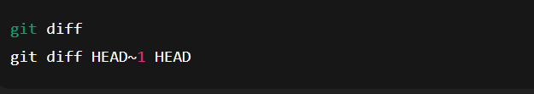

git diff git diff HEAD~1 HEAD

# ■ Branching and Merging

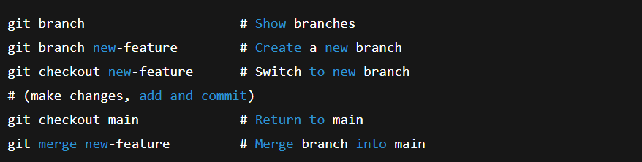

git branch # Show branches

git branch new-feature # Create a new branch

git checkout new-feature # Switch to new branch

# (make changes, add and commit)

git checkout main # Return to main

git merge new-feature # Merge branch into main