DNA Project
DNA Overview
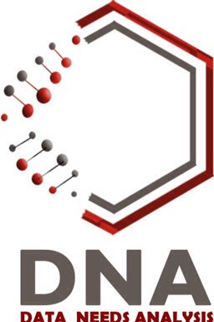

1. Objectives & Purpose

In This Document we are going to explain the problem that we are going to solve when we finally deliver this project, and the methods and tools that we used to achieve our objectives

1.1 Who are the stakeholders, and what are their roles and responsibility within this application

Stundents are facing so many difficulties to improve their results and inorder to do this they need to identify their identify their weakness , same for Academic they want know the reasons of failur and succes and take a better decision

Stakeholders Name | Roles & Responsibilty
Student, Academic | main customer
Product owner | Specify features

2. Methodology
2.1. Scrum :
Scrum is a framework that helps teams work together , maximizes responsiveness to changing customer needs

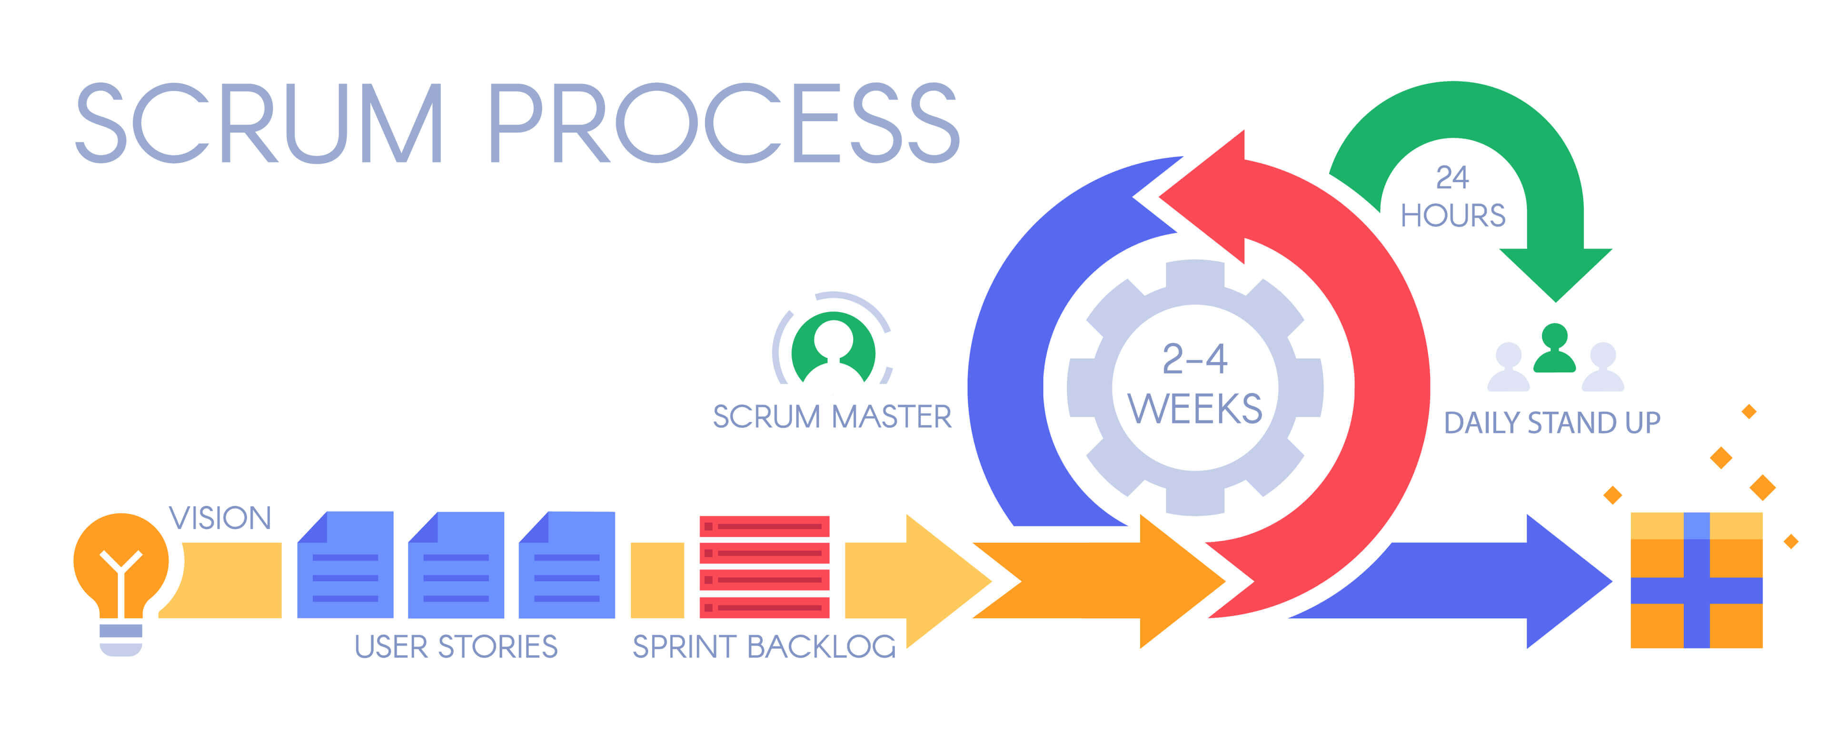Figure 1: scrum Process

3. Tools

3.1 Programming languages :
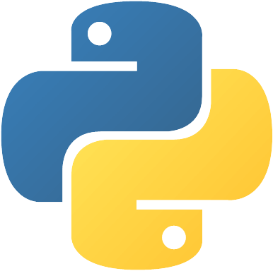Figure 3: python
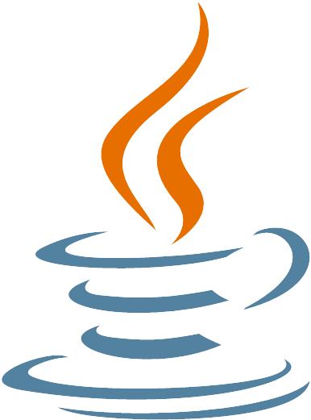Figure 4: java
Figure 2:javascript

3.2 database
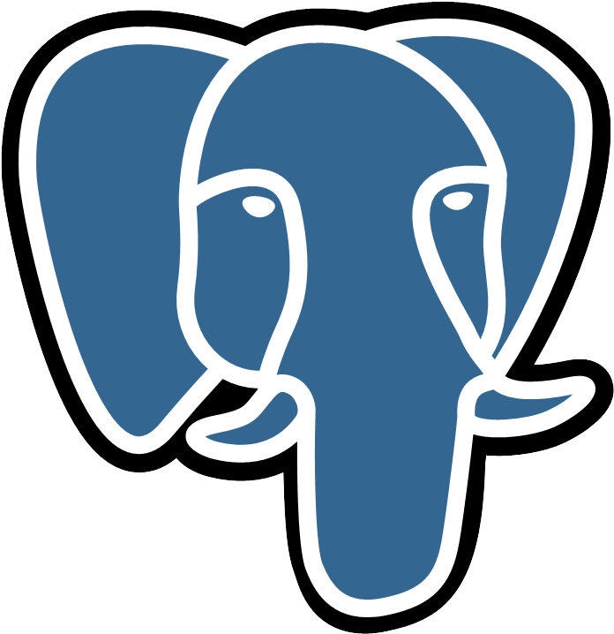Figure 5: postgresql

3.3 framework :
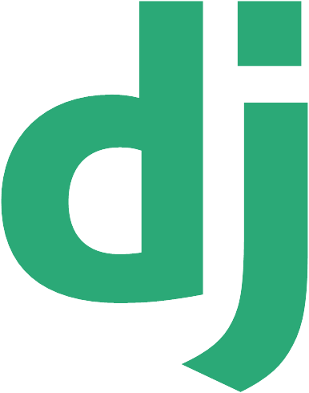Figure 6: django
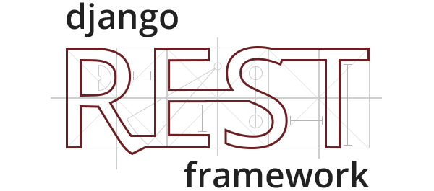Figure 7: django rest framework

3.4 More :
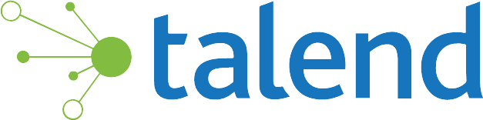Figure 8: talend

4. References :

https://seeklogo.com

scrum : .
https://www.atlassian.com/agile/scrum

tools :
https://www.python.org/
https://www.djangoproject.com/
https://www.django-rest-framework.org/
https://www.javascript.com/
https://www.java.com/en/
https://www.talend.com/products/data-integration/data-integration-open-studio/

