Algorithmic complexity mini project report github link

Search for similar images by text

Author:
Toumi Mustapha Abderrahmane

Under Supervision of :
Mr A.CHENINE



DEPARTMENT OF MATH AND COMPUTER SCIENCE

UNIVERSITY OF IBN KHALDOUNE TIARET

January 2020

Introduction:

Overview:
- This report discusses the work done in the development of pixabay image downloader and a search for a similar images by text usign python and kivy to create the user interface

Background and Motivation:
- Search for images by text can be found in a large variety of applications like search engines because this method give you a quick accesss to external search functions such as images

Objective:
- Download a 50 pictures from pixabay or unsplash , give each picture a name with the format studentid_pictureid.jpg for each picture there a file text with the same name studentid_pictureid.txt, put this pictures in a folder with the name Pictures
- Create a search form which enable the user to search for the images in Pictures Folder by typing a tag in the search form and display the first 10 pictures that have this tag in their text files

Tools:

Programming language:

Figure 1: Python

Framework:
Kivy Open source Python framework for rapid development of applications that make use of innovative user interfaces

Figure 2: Kivy

Text editor:
Figure 3: Visual Studio Code

Results :

Pixabay Photos downloader :
- This tool is uses a command line interface , implemented on python to communicate wih the user .
- Make it easy for any student to download the 50 pictures, give each picture and text file a name , put the pictures tags in the text file, and finally save them in Pictures Folder .
- Inorder to user this tool u should :
- install python
- get Pixabay API Key by creating an account on pixabayApi website Figure4 show this step
- Copy the api key and put it in pixaby.py Figure5 show this step
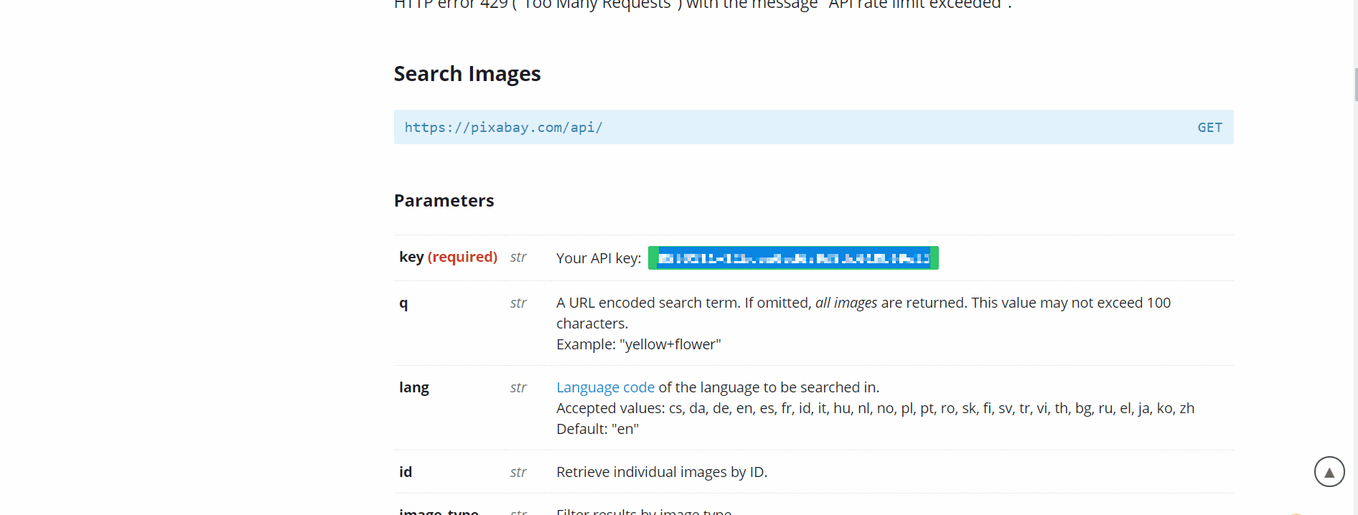Figure 4: pixabay api webpage after login and api Key
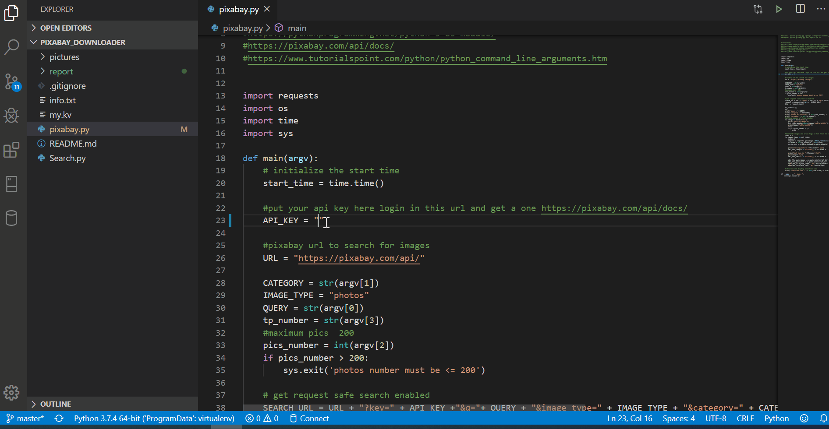Figure 5: copy your api key in pixabay downloader

- now execute :
python pixaby.py <query> <category> <number_of_pics <= 200 > <tp_num>
the Figure 6 show the result and the example
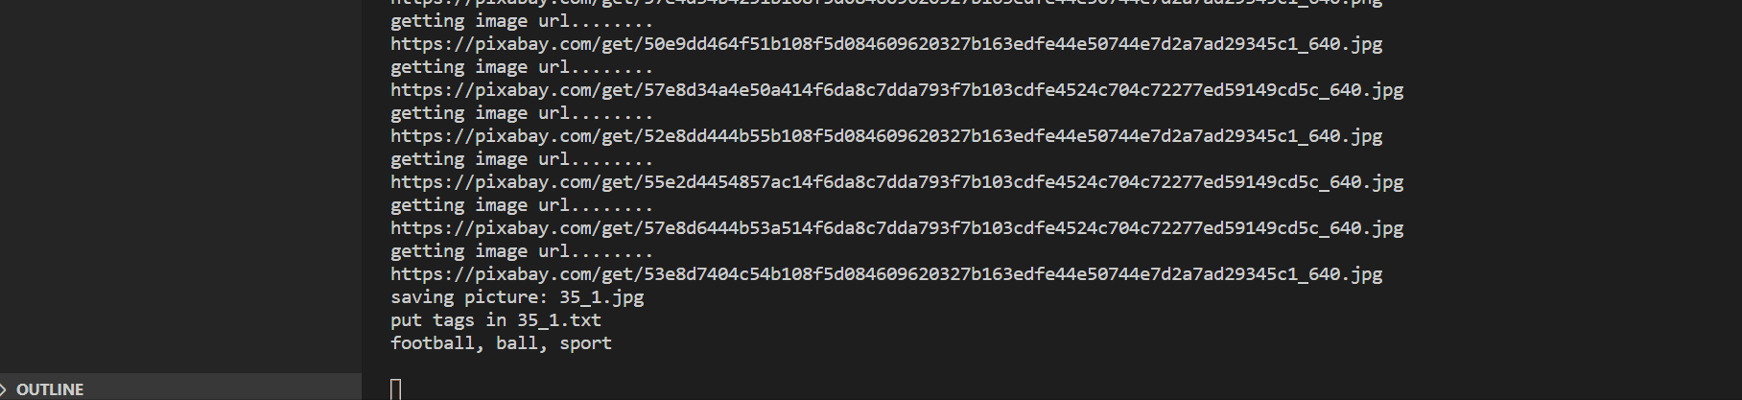Figure 6: How to run and execute pixaby downloader

Images Search:
- Create an Interface using Kivy
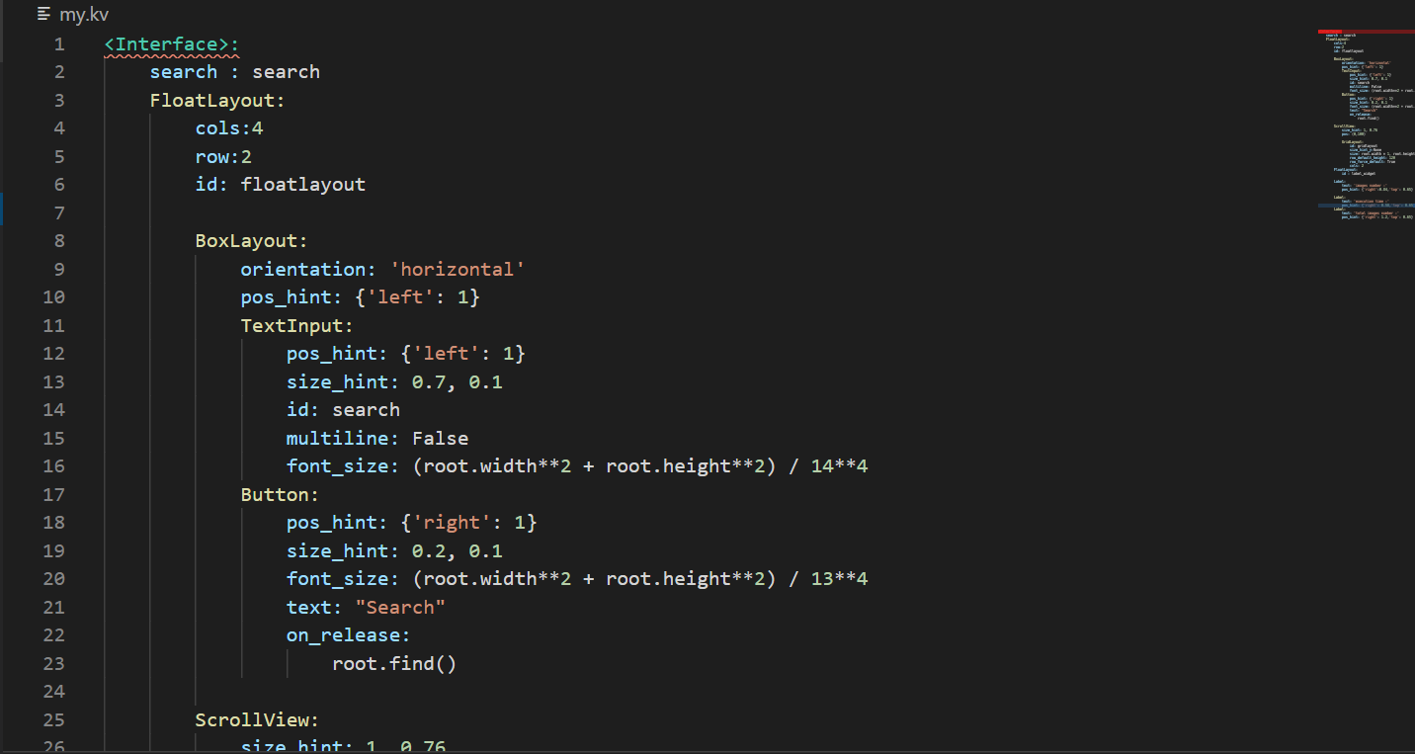Figure 7: Kivy User Interface Code
- call the Kivy Interface in my Python code
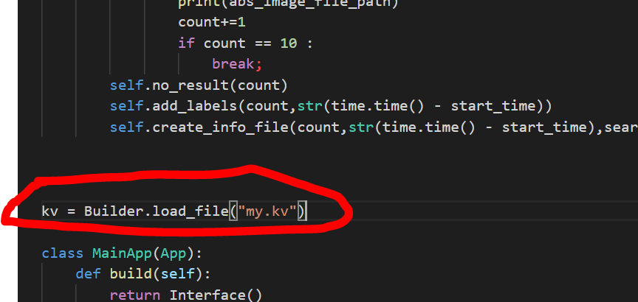Figure 8: call kivy interface in the python code
- find the 10 first pictures which contain the tag that the user searched for
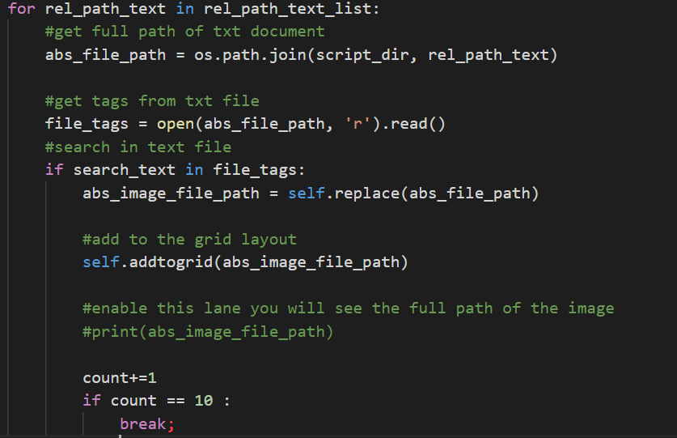Figure 9: find the 10 pictures

- Execution:
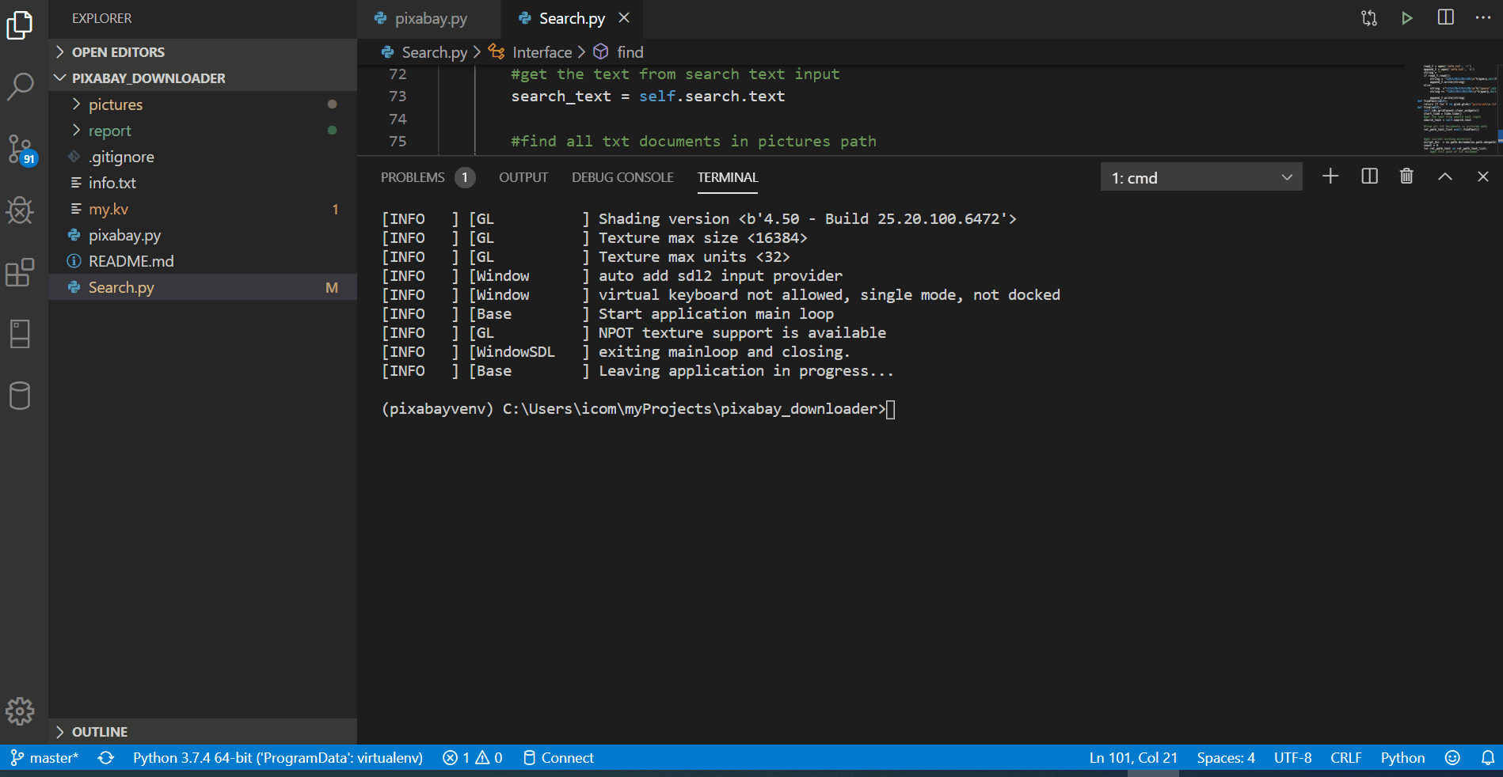
- save query info in reqtemps.txt
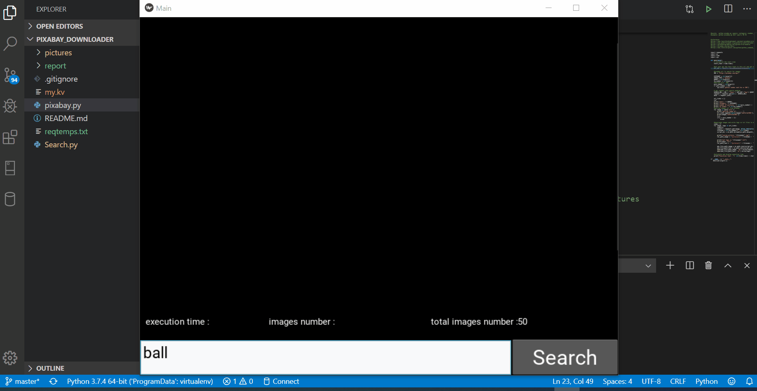

Complexity:
- In this mini project i prefer to use a Linear search to find words in text file because we have an unsorted files

- Find all text files function: Complexity of O(n) because “f” run through the hole pictures file and add the text files in a new list

- Search function: Complexity of O (n)
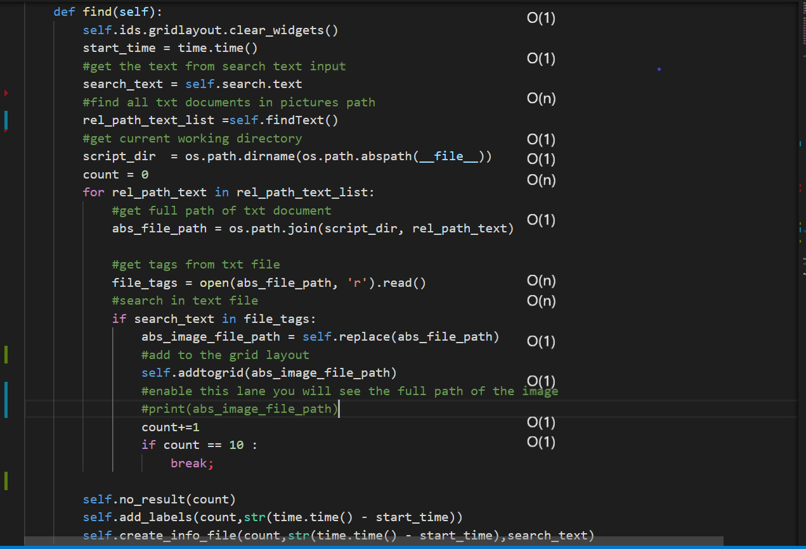
O(1)

Conlusion:
In computer science, analysis of algorithms is a very crucial part. It is important to find the most efficient algorithm for solving a problem. It is possible to have many algorithms to solve a problem, but the challenge here is to choose the most efficient one.

