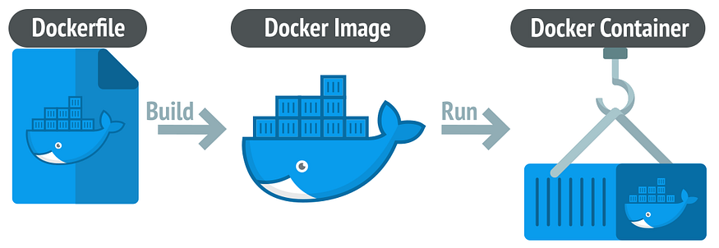
Dockerfile used to build image and when we run the image it generate a container and the volume is the persisting part where for example all of our data are stored.
- Architecture
Right now, our app work like this:
Browser
PostgreSQL
Spring Boot App

The frontend is already inside Spring Boot:
- src/main/resources/static

So when Spring Boot runs:
- backend APIs work
- frontend files are served automatically
This means:
- you only need ONE container for the app
- ONE container for PostgreSQL
So your Docker architecture becomes:
network
Sprinboot App (frontend + backend) ================> postgresql

- What is Docker Really?
Without Docker:
1. Your PC
2. ├── Java installed
3. ├── PostgreSQL installed
4. ├── Maven installed
5. ├── Node installed
6. └── Environment manually configured

Problem:
- "works on my machine"
- version conflicts
- difficult deployment
Docker packages:
- app
- runtime
- dependencies
- configuration
inside an isolated container.
Think of a container like mini isolated machine.
- Important Docker Concepts:
Concept | Meaning
Image | Blueprint/template
Container | Running instance of image
Dockerfile | Instructions to build image
Docker Compose | Run multiple containers together
Volume | Persistent storage
Network | Communication between containers

Before we start creating docker files we need first to build our spring boot project generate the jar file.

- Docker commands:
1. Docker –-version // Docker version 28.3.3, build 980b856
2. Docker compose --version // Docker Compose version v2.39.2-desktop.1

Create Docker file:
FROM eclipse-temurin:21-jdk // Start from an existing image containing Java 21
WORKDIR /app // equivalent to cd /app
COPY target/*.jar app.jar // copies your jar into your container
EXPOSE 8080 // Documents that app uses port 9090.(HOST_PORT:CONTAINER_PORT) so in this case we have spring run in 9090
ENTRYPOINT ["java", "-jar", "app.jar"] // Command executed when container starts.

Build docker image:
docker build --tag=chalouchi/complexsportif:latest . // tag and give the app name or repository name that will be in docker hub and . indicate the current folder which in this case have the Dockerfile that have comfig that we see in previous point.

List all images that you have:
docker images

so in this case we have postgresql so we need to Create docker-compose.yml that contain config for database postgris and we linked to our app so it create other image for our database
Create docker-compose.yml:
services:

postgres:
image: postgres:16
container_name: postgres-db

environment:
POSTGRES_DB: mydb
POSTGRES_USER: postgres
POSTGRES_PASSWORD: password

ports:
- "5432:5432"

volumes:
- postgres_data:/var/lib/postgresql/data

app:
build: .

container_name: spring-app

ports:
- "8080:8080"

depends_on:
- postgres

environment:
SPRING_DATASOURCE_URL: jdbc:postgresql://postgres:5432/mydb
SPRING_DATASOURCE_USERNAME: postgres
SPRING_DATASOURCE_PASSWORD: password

volumes:
postgres_data:

to shut down the containers :
docker compose down
to build and run:
docker compose up –build

To access to my database container we can use this:
docker exec -it postgres-db bash
psql -U postgres -d projetsr
// it will open postgress in terminal so we can execute postgres command to see or update something in db

NGINX:

Rootfolde/nginx/default.conf
server {
; Nginx listens on HTTP port 80. listen 80;
; all incoming routes in "/" location / {
; Nginx forwards requests to:
; Docker service name = app , Port = 9090 proxy_pass http://app:9090;
proxy_set_header Host $host;
proxy_set_header X-Real-IP $remote_addr;
proxy_set_header X-Forwarded-For $proxy_add_x_forwarded_for;
}
}

