Src: <https://www.w3schools.com/js/js_json_stringify.asp>

Doc: <https://developer.mozilla.org/en-US/docs/Web/JavaScript/Reference/Global_Objects/JSON/stringify>

Normal js object

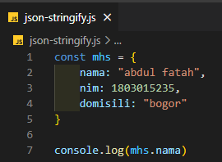

**JSON.stringify()**

JSON -> used to exchange data to/from a web server. The data has to be string.

Convert a js object into a string with JSON.stringif()

