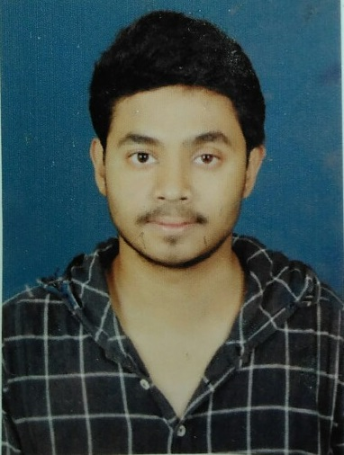**Curriculum Vitaé**

# Name : Abdullah Ghani

**Address : F.H.S. Road Raniganj , Burdwan , West Bengal**

**Pin:-713347**

**Mobile No : +919547998800**

# E-mail :[abdullah.ghani3@gmail.com](mailto:abdullah.ghani3@gmail.com)

**Website :agprojects.herokuapp.com**

**OBJECTIVES:**

*Entry level web development on JS platform/enviornment*

**Academic Qualifications:** Current academics: 4rd Year of B.Tech in Computer Science.

|  |  |  |  |  |  |
| --- | --- | --- | --- | --- | --- |
| **Degree / Certificate** | Qualification | Institute | Board /University | **Year** | **Aggregate % / CGPA** |
| Graduation | BTECH | NETAJI SUBHASH  ENGINEERING COLLEG | MAKAUT | 2015 | **8.19 CGPA** |
| 12th | SENIOR SECONDARY | HEM SHEELA MODEL SCHOOL | CBSE | 2013 | **89.6 %** |
| 10th | SECONDARY | HEM SHEELA MODEL SCHOOL | CBSE | 2011 | **9.4 CGPA** |

**Trainings Done:**

|  |  |  |
| --- | --- | --- |
| **Name of Institute / Organization** | **Training Title** | **Duration** |
| MONGODB UNIVERSITY | MongoDB for Node.js Developers | 7 WEEKS |
| MONGODB UNIVERSITY | Introduction To MongoDB using the MEAN Stack | 5 WEEKS |
| COURSERA | Server Side Development With NodeJs | 4 WEEKS |
| INFOSYS | Infosys Campus Commune | 81 HOURS |
| MYWBUT | Python Programming | 30 HOURS |
| ARDENT | BIG DATA -HADOOP | 5 WEEKS |
| NIIT | PROGRAMMING IN JAVA | 60 HOURS |

**Technical Abilities:**

Website Development Using MEAN Stack,LAMP Stack and Dango,

Entry Level Data Ananlysis , BigData Analysis using Pig and MapReduce

**Programming Languages Known:**

JAVA, C, C++ and Python

**Scripting Languages Known:**

Javascript(Nodejs), TypeScript, PHP

**Operating System:** Linux,Windows,

**PROJECT DONE:**

|  |  |  |
| --- | --- | --- |
| **TITLE / LINKS** | **TOPIC** | **DESCRIPTION** |
| cide-makepost.rhcloud.com | Online Ide for C | An easy to use online IDE for coding in c language made using mean Stack |
| makepost.co.in | Social NetWorking | An social networking based website made using PHP |
| Stack overflow data analysis | Big Data Analysis | A group project on stack overflow data set analysis using big data |

**Hobbies:**

* Coding
* Web development

**Personal Details:**

**Date of Birth :** 12/09/1995

**Gender** **:** MALE

**Languages Known :** ENGLISH, BENGALI and HINDI

I hereby declare that above mentioned particulars are true to the best of my knowledge and belief.



**Date: 18/09/2015 Signature :**