Lab 09 – Worksheet

Name: | ID: | Section:

Note: Assumptions and logics should be explained separately in tasks after the task results.

Task 1
Truth Table
a) Main Control Unit
b) ALU Control Unit

Main Control Unit — opcode decoding
Opcode | Type | Reg  Write | ALU  Src | Mem  Read | Mem  Write | Memto  Reg | Branch | ALUOp
0110011 | R-type | 1 | 0 | 0 | 0 | 0 | 0 | 10
0010011 | ADDI | 1 | 1 | 0 | 0 | 0 | 0 | 00
0000011 | Load | 1 | 1 | 1 | 0 | 1 | 0 | 00
0100011 | Store | 0 | 1 | 0 | 1 | X | 0 | 00
1100011 | BEQ | 0 | 0 | 0 | 0 | X | 1 | 01

ALU Control Unit — operation decoding
ALUOp | funct3 | funct7 | Instruction / purpose | ALUControl
00 | XXX | XXXXXXX | ADDI / Load / Store → ADD | 0000
01 | 000 | XXXXXXX | BEQ comparison | 0001
10 | 000 | 0000000 | ADD | 0000
10 | 000 | 0100000 | SUB | 0001
10 | 001 | 0000000 | SLL | 0101
10 | 101 | 0000000 | SRL | 0110
10 | 111 | 0000000 | AND | 0010
10 | 110 | 0000000 | OR | 0011
10 | 100 | 0000000 | XOR | 0100

Comments
The 7-bit opcode sets RegWrite, ALUSrc, MemRead, MemWrite, MemtoReg, Branch and ALUOp. R-type instructions use two registers; ADDI, loads and stores use an immediate. Loads read memory, stores write memory and BEQ enables Branch. The ALU decoder uses ALUOp, funct3 and funct7, retaining Lab 6 ALUControl encodings. For LB/LH/LW and SB/SH/SW, funct3 = 000/001/010 indicates byte/halfword/word width. ALUOp 00 = ADD, 01 = BEQ and 10 = R-type. X means don't care; safe values are used in Verilog.
Originally the truth table we designed had ALUCONTROL for BEQ 0111 and for SUB 0001, but since we are following a single path RISC-V cycle, it should be the same for both. So we redesigned the table and the fpga implementation.

Task 2

Design Module Codes for Main Control Unit, and ALU Control Unit.
MainControl.v
`timescale 1ns / 1ps

module MainControl(input [6:0] opcode,
output reg RegWrite, output reg [1:0] ALUOp,
output reg MemRead, MemWrite, ALUSrc, MemtoReg, Branch);
always @(*) begin
{RegWrite,ALUSrc,MemRead,MemWrite,MemtoReg,Branch,ALUOp}
= 8'b00000011; // safe default: ALUOp=11
case (opcode)
7'b0110011: {RegWrite,ALUSrc,MemRead,MemWrite,
MemtoReg,Branch,ALUOp} = 8'b10000010; // R-type
7'b0010011: {RegWrite,ALUSrc,MemRead,MemWrite,
MemtoReg,Branch,ALUOp} = 8'b11000000; // ADDI
7'b0000011: {RegWrite,ALUSrc,MemRead,MemWrite,
MemtoReg,Branch,ALUOp} = 8'b11101000; // LB/LH/LW
7'b0100011: {RegWrite,ALUSrc,MemRead,MemWrite,
MemtoReg,Branch,ALUOp} = 8'b01010000; // SB/SH/SW
7'b1100011: {RegWrite,ALUSrc,MemRead,MemWrite,
MemtoReg,Branch,ALUOp} = 8'b00000101; // BEQ
default: ;
endcase
end
endmodule
ALUControl.v

`timescale 1ns / 1ps

module ALUControlUnit(input [1:0] ALUOp,
input [2:0] funct3, input [6:0] funct7,
output reg [3:0] ALUControl);
always @(*) begin
ALUControl = 4'b1111; // unsupported
case (ALUOp)
2'b00: ALUControl = 4'b0000; // ADDI/load/store
2'b01: if (funct3==3'b000) ALUControl=4'b0111;
2'b10: case ({funct7,funct3})
{7'b0000000,3'b000}: ALUControl=4'b0000; // ADD
{7'b0100000,3'b000}: ALUControl=4'b0001; // SUB
{7'b0000000,3'b001}: ALUControl=4'b0101; // SLL
{7'b0000000,3'b101}: ALUControl=4'b0110; // SRL
{7'b0000000,3'b111}: ALUControl=4'b0010; // AND
{7'b0000000,3'b110}: ALUControl=4'b0011; // OR
{7'b0000000,3'b100}: ALUControl=4'b0100; // XOR
default: ALUControl = 4'b1111;
endcase
default: ALUControl = 4'b1111;
endcase
end
endmodule

Testbench:
ControlPath_tb.v (full self-checking Verilog testbench is provided below)
Connects MainControl and ALUControlUnit. For each vector, sets opcode,
funct3 and funct7, waits 10 ns, and checks all main signals and ALUControl.
Tests: ADD, SUB, SLL, SRL, AND, OR, XOR, ADDI, LW, LH, LB,
SW, SH, SB, BEQ; plus invalid opcode, R-type and branch encoding.
Expected: 18 test vectors, 0 failures, "ALL TESTS PASSED".
Vivado: set ControlPath_tb as Simulation Top, Run Behavioral Simulation.
ControlPath_tb.v:
`timescale 1ns / 1ps

module ControlPath_tb;

reg [6:0] opcode;
reg [2:0] funct3;
reg [6:0] funct7;

wire RegWrite, MemRead, MemWrite;
wire ALUSrc, MemtoReg, Branch;
wire [1:0] ALUOp;
wire [3:0] ALUControl;

wire [7:0] mainSignals = {
RegWrite, ALUSrc, MemRead,
MemWrite, MemtoReg, Branch, ALUOp
};

localparam [7:0] R_TYPE = 8'b10000010;
localparam [7:0] ADDI_T = 8'b11000000;
localparam [7:0] LOAD_T = 8'b11101000;
localparam [7:0] STORE_T = 8'b01010000;
localparam [7:0] BEQ_T = 8'b00000101;
localparam [7:0] BAD_T = 8'b00000011;

integer tests = 0;
integer errors = 0;

MainControl main_unit (
.opcode(opcode),
.RegWrite(RegWrite),
.ALUOp(ALUOp),
.MemRead(MemRead),
.MemWrite(MemWrite),
.ALUSrc(ALUSrc),
.MemtoReg(MemtoReg),
.Branch(Branch)
);

ALUControlUnit alu_unit (
.ALUOp(ALUOp),
.funct3(funct3),
.funct7(funct7),
.ALUControl(ALUControl)
);

task check_instruction;
input [8*16-1:0] name;
input [6:0] test_opcode;
input [2:0] test_funct3;
input [6:0] test_funct7;
input [7:0] expected_main;
input [3:0] expected_alu;

begin
opcode = test_opcode;
funct3 = test_funct3;
funct7 = test_funct7;

#10;

tests = tests + 1;

if ((mainSignals !== expected_main) ||
(ALUControl !== expected_alu)) begin

errors = errors + 1;

$display("FAIL %-16s main=%b expected=%b ALU=%b expected=%b",
name, mainSignals, expected_main,
ALUControl, expected_alu);

end else begin

$display("PASS %-16s main=%b ALU=%b",
name, mainSignals, ALUControl);

end
end
endtask

initial begin

opcode = 7'd0;
funct3 = 3'd0;
funct7 = 7'd0;

// R-Type Instructions

check_instruction("ADD",
7'b0110011, 3'b000, 7'b0000000,
R_TYPE, 4'b0000);

check_instruction("SUB",
7'b0110011, 3'b000, 7'b0100000,
R_TYPE, 4'b0001);

check_instruction("SLL",
7'b0110011, 3'b001, 7'b0000000,
R_TYPE, 4'b0101);

check_instruction("SRL",
7'b0110011, 3'b101, 7'b0000000,
R_TYPE, 4'b0110);

check_instruction("AND",
7'b0110011, 3'b111, 7'b0000000,
R_TYPE, 4'b0010);

check_instruction("OR",
7'b0110011, 3'b110, 7'b0000000,
R_TYPE, 4'b0011);

check_instruction("XOR",
7'b0110011, 3'b100, 7'b0000000,
R_TYPE, 4'b0100);

// ADDI

check_instruction("ADDI",
7'b0010011, 3'b000, 7'b0110101,
ADDI_T, 4'b0000);

// Load Instructions

check_instruction("LW",
7'b0000011, 3'b010, 7'b0000000,
LOAD_T, 4'b0000);

check_instruction("LH",
7'b0000011, 3'b001, 7'b0000011,
LOAD_T, 4'b0000);

check_instruction("LB",
7'b0000011, 3'b000, 7'b1010101,
LOAD_T, 4'b0000);

// Store Instructions

check_instruction("SW",
7'b0100011, 3'b010, 7'b0000000,
STORE_T, 4'b0000);

check_instruction("SH",
7'b0100011, 3'b001, 7'b1110010,
STORE_T, 4'b0000);

check_instruction("SB",
7'b0100011, 3'b000, 7'b1000110,
STORE_T, 4'b0000);

// Branch Instruction

check_instruction("BEQ",
7'b1100011, 3'b000, 7'b0000000,
BEQ_T, 4'b0111);

// Invalid Input Tests

check_instruction("BAD_OPCODE",
7'b1111111, 3'b000, 7'b0000000,
BAD_T, 4'b1111);

check_instruction("BAD_RTYPE",
7'b0110011, 3'b000, 7'b0000001,
R_TYPE, 4'b1111);

check_instruction("BAD_BRANCH",
7'b1100011, 3'b001, 7'b0000000,
BEQ_T, 4'b1111);

$display("TOTAL: %0d tests; %0d failures",
tests, errors);

if (errors == 0)
$display("ALL TESTS PASSED");
else begin
$display("TESTS FAILED");
$stop;
end

$finish;

end

endmodule

Waveforms:
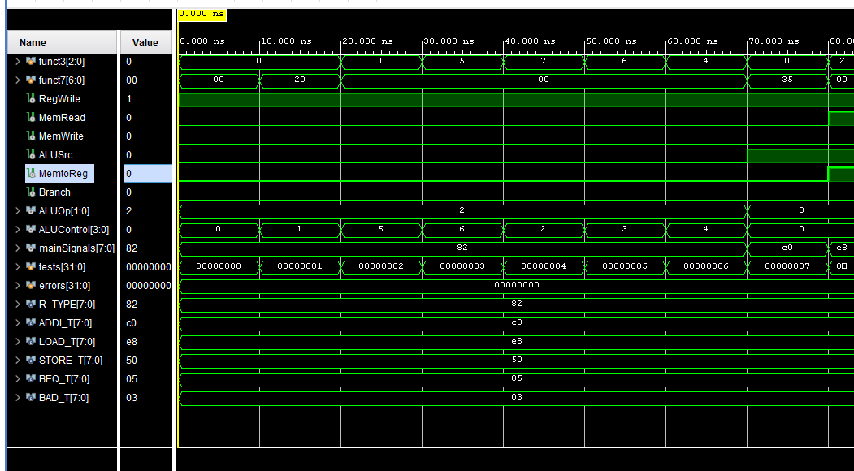
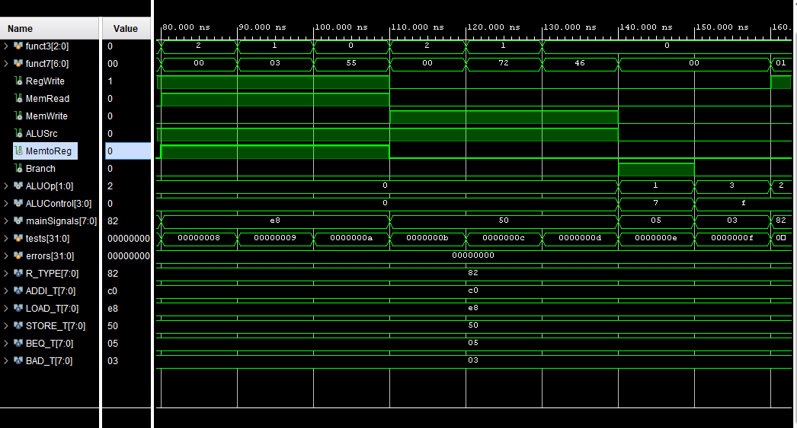
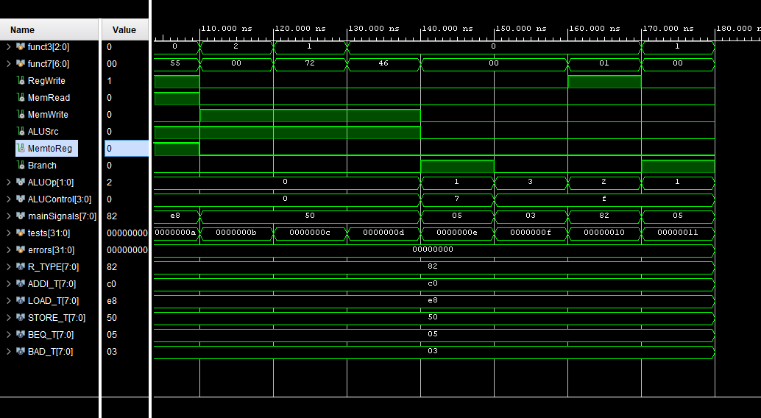
Waveform signals: opcode, funct3, funct7, RegWrite, ALUOp,
MemRead, MemWrite, ALUSrc, MemtoReg, Branch, ALUControl.
Expected checkpoints: ADD=0000; SUB=0001; SLL=0101;
SRL=0110; AND=0010; OR=0011; XOR=0100; BEQ=0111. Waveform succeeds as expected.

Task 3

Design module codes of top module:

`timescale 1ns / 1ps
module ControlPath_FPGA_Top(
input wire clk,
input wire pbin,
input wire [15:0] physical_sw,
output wire [15:0] physical_leds
);
wire btn_clean;
wire [31:0] switch_data;
wire [31:0] led_write_data;
wire [15:0] led_out;
reg [6:0] opcode_reg = 7'd0;
reg [2:0] funct3_reg = 3'd0;
reg [6:0] funct7_reg = 7'd0;
reg [1:0] state = 2'd0;
// WAIT_PRESS = 0; WAIT_RELEASE = 1
localparam WAIT_PRESS=2'd0, WAIT_RELEASE=2'd1;
wire RegWrite, MemRead, MemWrite, ALUSrc, MemtoReg, Branch;
wire [1:0] ALUOp;
wire [3:0] ALUControl;
wire invalid;

debouncer button_filter(.clk(clk),.pbin(pbin),.pbout(btn_clean));
// Names match the Lab 5 supplied interface modules.
leds switch_reader(
.clk(clk),.rst(1'b0),.btns(16'd0),.writeData(32'd0),
.writeEnable(1'b0),.readEnable(1'b1),.memAddress(30'd0),
.switches(physical_sw),.readData(switch_data)
);

always @(posedge clk) begin
if (switch_data[13]) begin
opcode_reg <= 7'b0110011;
funct3_reg <= 3'b000;
funct7_reg <= 7'b0000000;
state <= WAIT_PRESS;
end else begin
case(state)
WAIT_PRESS: if (btn_clean) begin
opcode_reg <= switch_data[6:0];
funct3_reg <= switch_data[9:7];
funct7_reg <= {1'b0, switch_data[10], 5'b00000};
state <= WAIT_RELEASE;
end
WAIT_RELEASE: if (!btn_clean) state <= WAIT_PRESS;
default: state <= WAIT_PRESS;
endcase
end
end

MainControl main_control(
.opcode(opcode_reg),.RegWrite(RegWrite),.ALUOp(ALUOp),
.MemRead(MemRead),.MemWrite(MemWrite),.ALUSrc(ALUSrc),
.MemtoReg(MemtoReg),.Branch(Branch)
);
ALUControlUnit alu_control(
.ALUOp(ALUOp),.funct3(funct3_reg),.funct7(funct7_reg),
.ALUControl(ALUControl)
);
assign invalid = (ALUOp == 2'b11) || (ALUControl == 4'b1111);
assign led_write_data = {16'd0,invalid,2'b00,
(state == WAIT_RELEASE),ALUControl,ALUOp,
Branch,MemtoReg,MemWrite,MemRead,ALUSrc,RegWrite};
switches led_writer(
.clk(clk),.rst(1'b0),.writeData(led_write_data),
.writeEnable(1'b1),.readEnable(1'b0),.memAddress(30'd0),
.readData(),.leds(led_out)
);
assign physical_leds = led_out;
endmodule

FSM:
FSM STATE TABLE:
Current State | Condition | Action | Next State
WAIT_PRESS | BTN_C = 0 | Wait | WAIT_PRESS
WAIT_PRESS | BTN_C = 1 | Get opcode, func3, func7 | WAIT_RELEASE
WAIT_RELEASE | BTN_C = 1 | Hold captured instruction | WAIT_RELESE
WAIT_RELEASE | BTN_C = 0 | Ready for next instruction | WAIT_PRESS
Any State | Reset = 1 | Load default instruction (ADD) | WAIT_PRESS

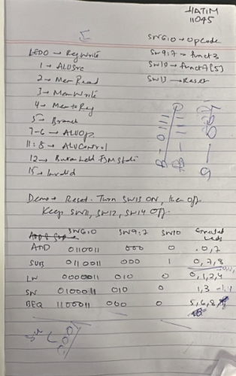

Constraints File:
set_property PACKAGE_PIN W5 [get_ports clk]
set_property IOSTANDARD LVCMOS33 [get_ports clk]
create_clock -period 10.000 -name sys_clk [get_ports clk]
set_property PACKAGE_PIN U18 [get_ports pbin]
set_property IOSTANDARD LVCMOS33 [get_ports pbin]
set_property PACKAGE_PIN V17 [get_ports {physical_sw[0]}]
set_property IOSTANDARD LVCMOS33 [get_ports {physical_sw[0]}]
set_property PACKAGE_PIN V16 [get_ports {physical_sw[1]}]
set_property IOSTANDARD LVCMOS33 [get_ports {physical_sw[1]}]
set_property PACKAGE_PIN W16 [get_ports {physical_sw[2]}]
set_property IOSTANDARD LVCMOS33 [get_ports {physical_sw[2]}]
set_property PACKAGE_PIN W17 [get_ports {physical_sw[3]}]
set_property IOSTANDARD LVCMOS33 [get_ports {physical_sw[3]}]
set_property PACKAGE_PIN W15 [get_ports {physical_sw[4]}]
set_property IOSTANDARD LVCMOS33 [get_ports {physical_sw[4]}]
set_property PACKAGE_PIN V15 [get_ports {physical_sw[5]}]
set_property IOSTANDARD LVCMOS33 [get_ports {physical_sw[5]}]
set_property PACKAGE_PIN W14 [get_ports {physical_sw[6]}]
set_property IOSTANDARD LVCMOS33 [get_ports {physical_sw[6]}]
set_property PACKAGE_PIN W13 [get_ports {physical_sw[7]}]
set_property IOSTANDARD LVCMOS33 [get_ports {physical_sw[7]}]
set_property PACKAGE_PIN V2 [get_ports {physical_sw[8]}]
set_property IOSTANDARD LVCMOS33 [get_ports {physical_sw[8]}]
set_property PACKAGE_PIN T3 [get_ports {physical_sw[9]}]
set_property IOSTANDARD LVCMOS33 [get_ports {physical_sw[9]}]
set_property PACKAGE_PIN T2 [get_ports {physical_sw[10]}]
set_property IOSTANDARD LVCMOS33 [get_ports {physical_sw[10]}]
set_property PACKAGE_PIN R3 [get_ports {physical_sw[11]}]
set_property IOSTANDARD LVCMOS33 [get_ports {physical_sw[11]}]
set_property PACKAGE_PIN W2 [get_ports {physical_sw[12]}]
set_property IOSTANDARD LVCMOS33 [get_ports {physical_sw[12]}]
set_property PACKAGE_PIN U1 [get_ports {physical_sw[13]}]
set_property IOSTANDARD LVCMOS33 [get_ports {physical_sw[13]}]
set_property PACKAGE_PIN T1 [get_ports {physical_sw[14]}]
set_property IOSTANDARD LVCMOS33 [get_ports {physical_sw[14]}]
set_property PACKAGE_PIN R2 [get_ports {physical_sw[15]}]
set_property IOSTANDARD LVCMOS33 [get_ports {physical_sw[15]}]
set_property PACKAGE_PIN U16 [get_ports {physical_leds[0]}]
set_property IOSTANDARD LVCMOS33 [get_ports {physical_leds[0]}]
set_property PACKAGE_PIN E19 [get_ports {physical_leds[1]}]
set_property IOSTANDARD LVCMOS33 [get_ports {physical_leds[1]}]
set_property PACKAGE_PIN U19 [get_ports {physical_leds[2]}]
set_property IOSTANDARD LVCMOS33 [get_ports {physical_leds[2]}]
set_property PACKAGE_PIN V19 [get_ports {physical_leds[3]}]
set_property IOSTANDARD LVCMOS33 [get_ports {physical_leds[3]}]
set_property PACKAGE_PIN W18 [get_ports {physical_leds[4]}]
set_property IOSTANDARD LVCMOS33 [get_ports {physical_leds[4]}]
set_property PACKAGE_PIN U15 [get_ports {physical_leds[5]}]
set_property IOSTANDARD LVCMOS33 [get_ports {physical_leds[5]}]
set_property PACKAGE_PIN U14 [get_ports {physical_leds[6]}]
set_property IOSTANDARD LVCMOS33 [get_ports {physical_leds[6]}]
set_property PACKAGE_PIN V14 [get_ports {physical_leds[7]}]
set_property IOSTANDARD LVCMOS33 [get_ports {physical_leds[7]}]
set_property PACKAGE_PIN V13 [get_ports {physical_leds[8]}]
set_property IOSTANDARD LVCMOS33 [get_ports {physical_leds[8]}]
set_property PACKAGE_PIN V3 [get_ports {physical_leds[9]}]
set_property IOSTANDARD LVCMOS33 [get_ports {physical_leds[9]}]
set_property PACKAGE_PIN W3 [get_ports {physical_leds[10]}]
set_property IOSTANDARD LVCMOS33 [get_ports {physical_leds[10]}]
set_property PACKAGE_PIN U3 [get_ports {physical_leds[11]}]
set_property IOSTANDARD LVCMOS33 [get_ports {physical_leds[11]}]
set_property PACKAGE_PIN P3 [get_ports {physical_leds[12]}]
set_property IOSTANDARD LVCMOS33 [get_ports {physical_leds[12]}]
set_property PACKAGE_PIN N3 [get_ports {physical_leds[13]}]
set_property IOSTANDARD LVCMOS33 [get_ports {physical_leds[13]}]
set_property PACKAGE_PIN P1 [get_ports {physical_leds[14]}]
set_property IOSTANDARD LVCMOS33 [get_ports {physical_leds[14]}]
set_property PACKAGE_PIN L1 [get_ports {physical_leds[15]}]
set_property IOSTANDARD LVCMOS33 [get_ports {physical_leds[15]}]

RTL Schematic:
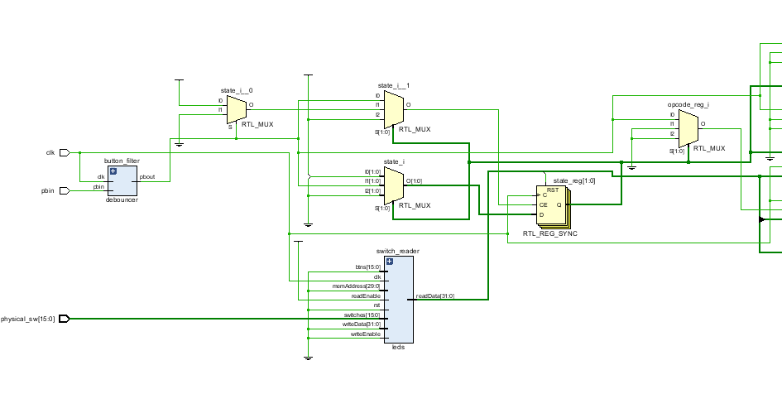 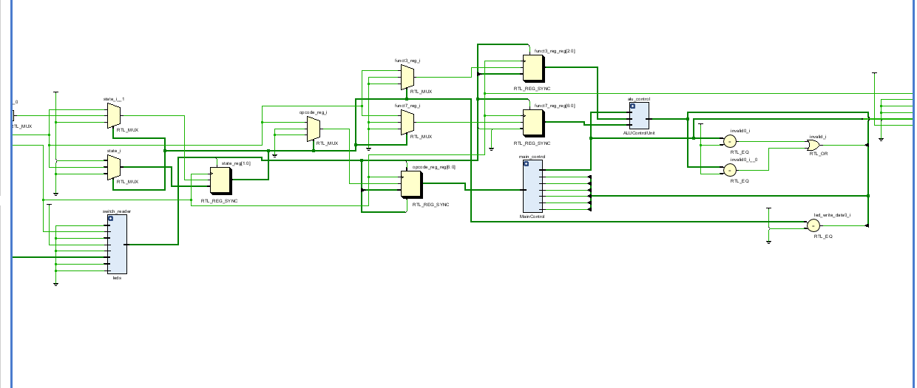
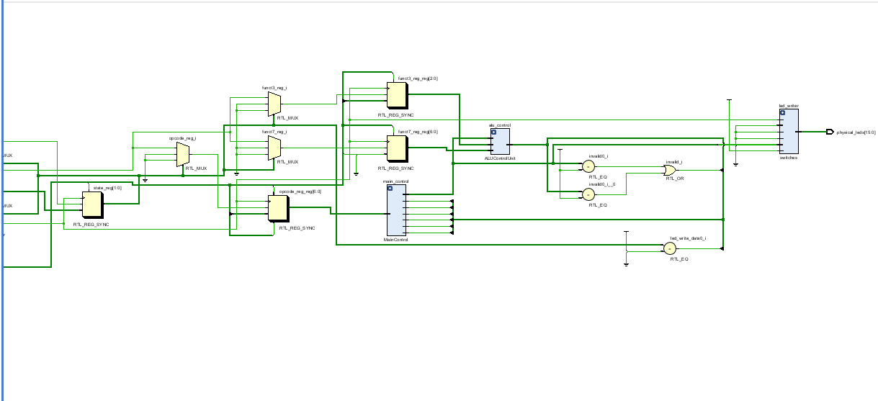

Lab 9: Design and FPGA Implementation of the Control Path for a Single-Cycle RISC-V Processor

Points Distribution
Task No. | LR2  Code | LR 5  Results | LR11  Design | AR7
Task 1 | - | - | /20 | /20
Task 2 | /20 | /15 |  | /20
Task 3 | /10 | /15 |  | /20
Total Points | /80 |  |  | /20
CLO Mapped | CLO 1
For description of different levels of the mapped rubrics, please refer the provided Lab Evaluation Assessment Rubrics and Affective Domain Assessment Rubrics.
# | Assessment Elements | Level 1: Unsatisfactory  Points 0-1 | Level 2: Developing  Points 2 | Level 3:Good  Points 3 | Level 4:Exemplary  Points 4
LR2 | Program/Code/ Simulation Model/ Network Model | Program/code/simulation model/network model does not implement the required functionality and has several errors. The student is not able to utilize even the basic tools of the software. | Program/code/simulation model/network model has some errors and does not produce completely accurate results. Student has limited command on the basic tools of the software. | Program/code/simulation model/network model gives correct output but not efficiently implemented or implemented by computationally complex routine. | Program/code/simulation /network model is efficiently implemented and gives correct output. Student has full command on the basic tools of the software.
LR5 | Results & Plots | Figures/ graphs / tables are not developed or are poorly constructed with erroneous results. Titles, captions, units are not mentioned. Data is presented in an obscure manner. | Figures, graphs and tables are drawn but contain errors. Titles, captions, units are not accurate. Data presentation is not too clear. | All figures, graphs, tables are correctly drawn but contain minor errors or some of the details are missing. | Figures / graphs / tables are correctly drawn and appropriate titles/captions and proper units are mentioned. Data presentation is systematic.
AR9 | Report | All the in-lab tasks are not included in report and / or the report is submitted too late. | Most of the tasks are included in report but are not well explained. All the necessary figures / plots are not included. Report is submitted after due date. | Good summary of most the in-lab tasks is included in report. The work is supported by figures and plots with explanations. The report is submitted timely. | Detailed summary of the in-lab tasks is provided. All tasks are included and explained well. Data is presented clearly including all the necessary figures, plots and tables.

