**Explore Weather Trends**

**Written by: Abdullah Alzubail**

Contents

**1.** **Problem Statement** 3

**2.** **Extraction of Data** 3

**3.** **Moving Average Calculation** 4

**4.** **Results and Discussion** 5

# **Problem Statement**

Comparative analysis between the local temperature in Riyadh in Saudi Arabia and the global overall temperature. Riyadh was selected for this comparison because it is the nearest city to me.

# **Extraction of Data**

Data was extracted using SQL commands:

SELECT * FROM city_data

SELECT * FROM city_list

SELECT * FROM global_data

The data was successfully extracted and downloaded as a CSV file (Figure 1)

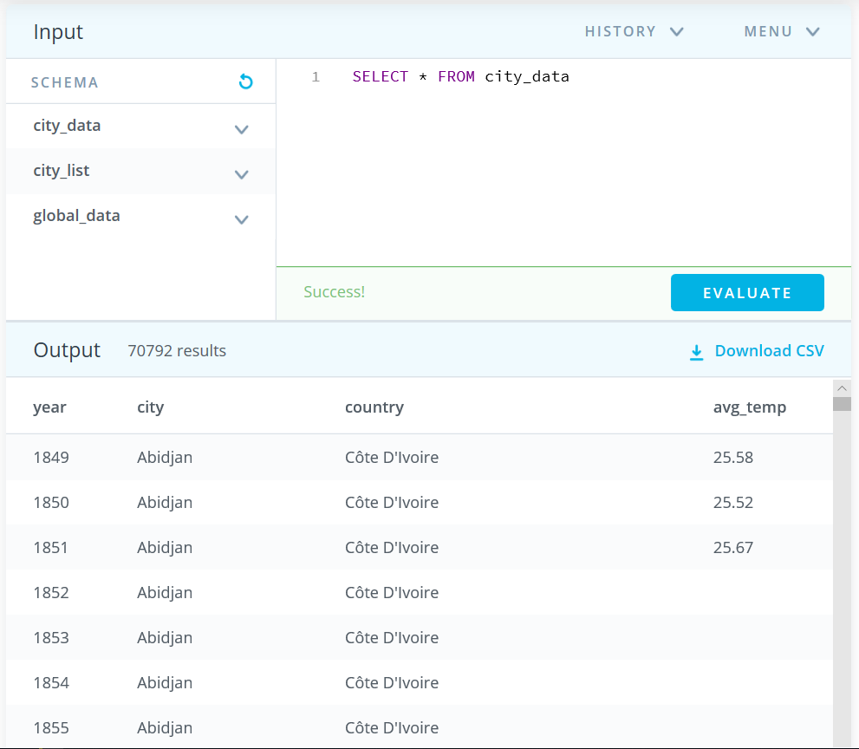 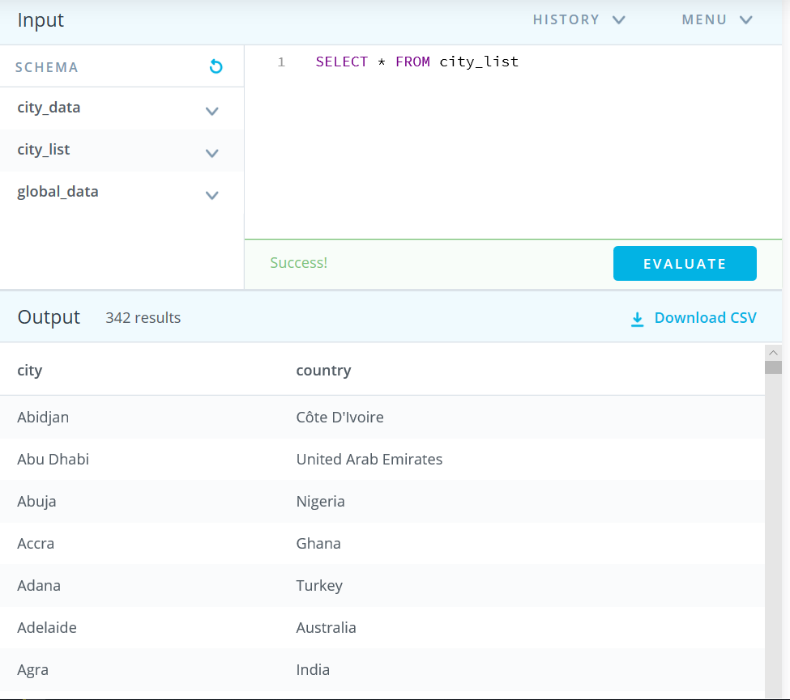

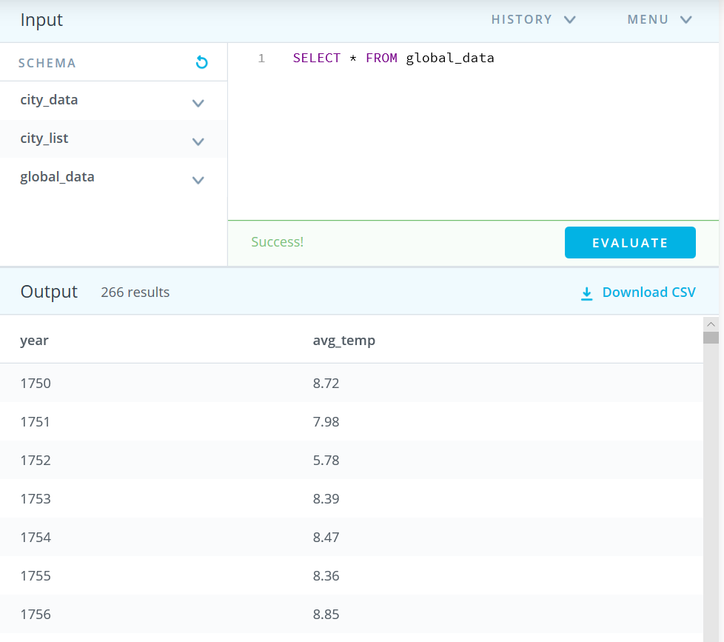

***Figure 1: Extracted SQL Data for City_Data, City_list and global_list***

* City_list is a list with cities that has available temperature data
* City_data includes the recorded annual average temperature of various cities. In the case of Riyadh, the data is available from 1843 to 2013.
* Global_list includes the worldwide annual average temperature.

# **Moving Average Calculation**

5 years moving average (5Y-MA) were calculated using the AVERAGE function in excel for the global and Riyadh temperatures (Figure 1). The following is a demonstration of the 5Y-MA computation for C7, C8, C9 and Cn in the excel sheet:

C7 =AVERAGE(B3:B7)

C8 =AVERAGE(B4:B8)

C9 =AVERAGE(B5:B9)

Cn =AVERAGE(B(n-4):B(n))

A similar computation was performed in excel for the 5Y-MA global temperatures and a sample results is shown in Figure 2.

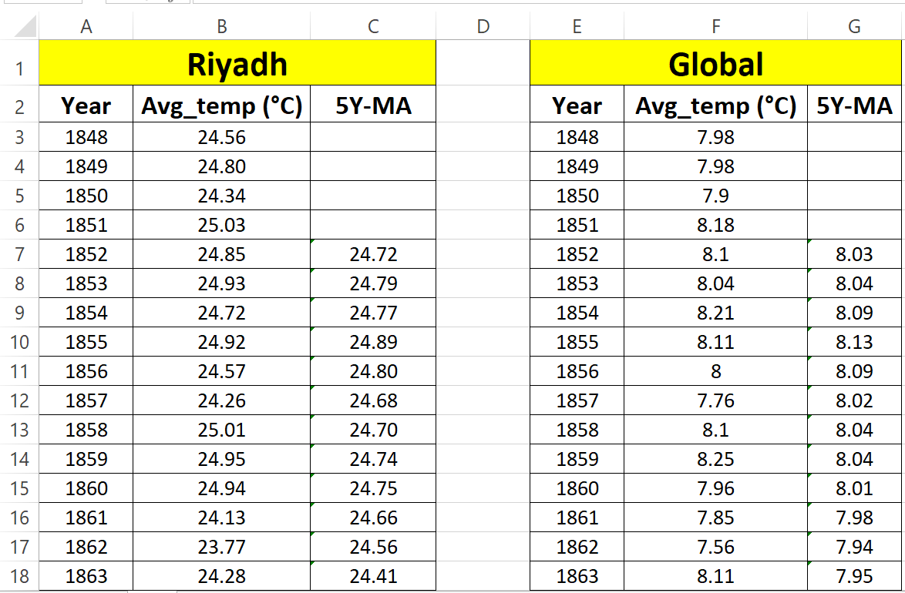

***Figure 2: A sample 5Y-MA results for Riyadh and global temperatures***

# **Results and Discussion**

The 5Y-MA was plotted for Riyadh and the world annual average temperatures between the years1852 to 2013 (Data is available only between these years in Riyadh). Note that Figure 3 & 4 for the 5Y-MA results are plotted in the same scale.

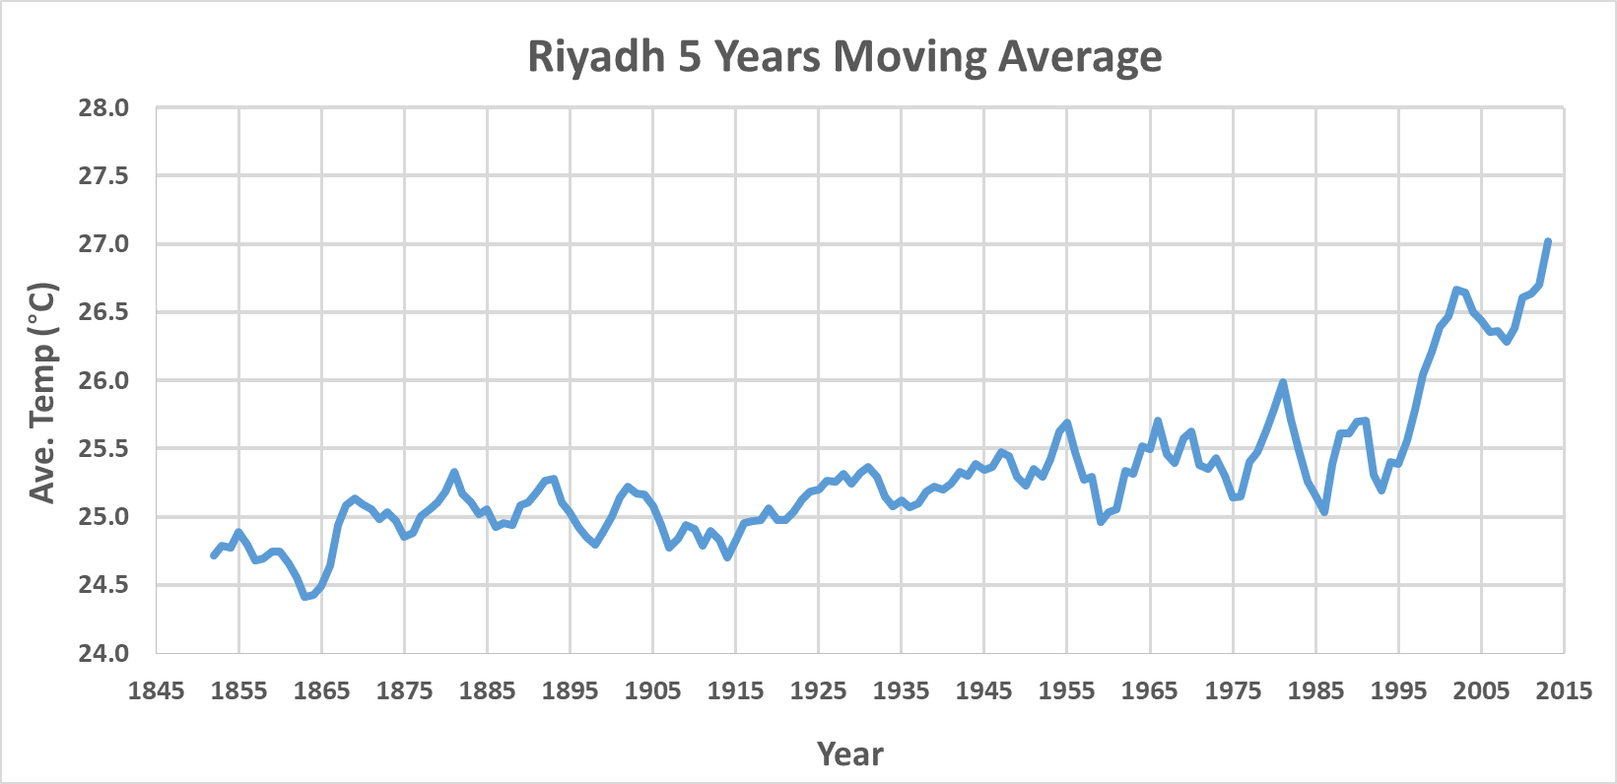

***Figure 3: 5 Years moving Average for Riyadh temperature***

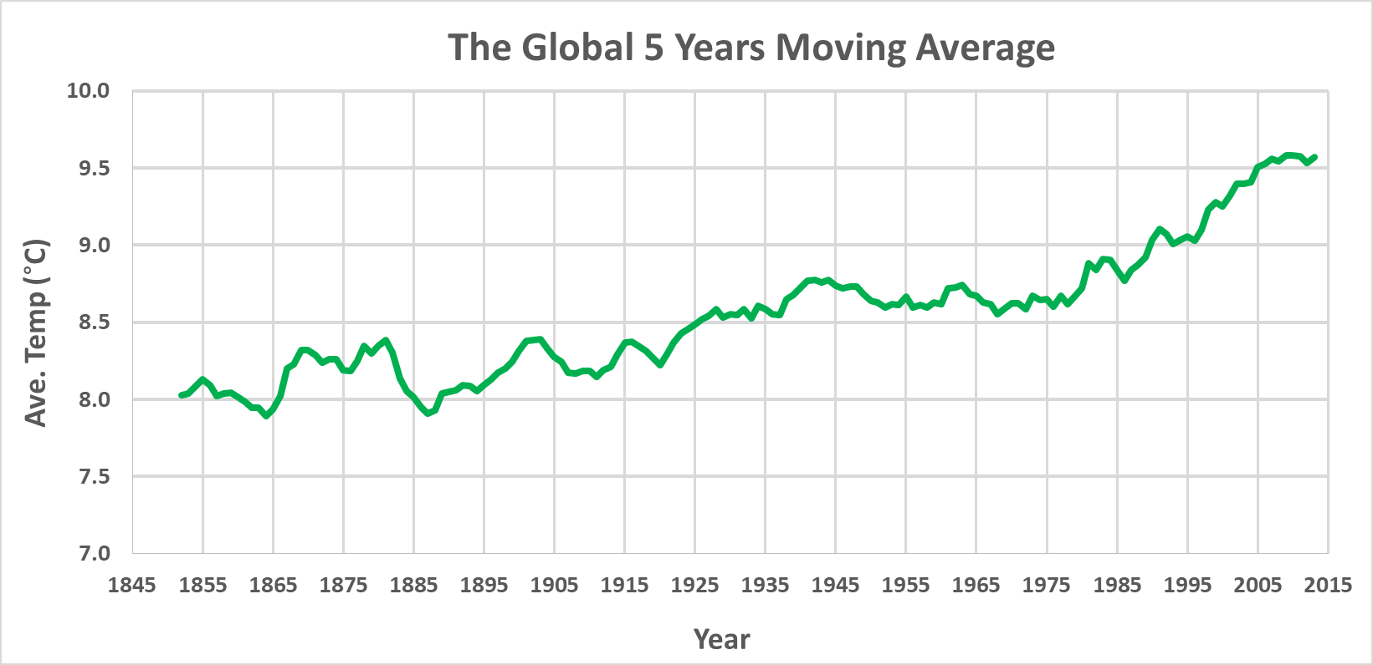

***Figure 4: 5 Years moving Average for the global temperature***

Several highlights can be concluded from Figure 3 & 4:

* Riyadh Temperature is higher than the global temperature throughout the years. This can be explained by either the combined global temperature entails of more cities/countries with relatively lower temperature or the average global temperature is skewed largely by regions of a very cold temperature (below zero ° C) such as Alaska and Antarctica.
* Both cases (Riyadh and world) show an overall increasing temperature trends. This is another indication of the global warming impact, as the results show that the world and the local weather temperatures are getting warmer.
* City and globe 5Y-MA show an oscillating trend with local maximum and minimum occurring around every 5 to 7 years. Moreover, there is a lot of clear similarities between the two trends as several local maximum and minimum temperatures coincide for a given year.
* The spread of temperature is higher in Riyadh City than the globe as the temperature ranges locally in Riyadh between 24.5 ° C to 27 C (a range of 2.5 ° C), while it is between 7.7 C to 9.5 ° C globally (a range of 1.8 ° C)