**Project Report**

**On**

**“Friendly Interactive Shell”**

Submitted in the Partial fulfillment of the requirement for the Award of Degree of

**Bachelor of Technology**

in

**INFORMATION TECHNOLOGY**

Batch

(2017-21)



|  |  |
| --- | --- |
| **Submitted to**  HOD(CSE)  Er. Vinod Sharma | **Submitted by**  Abdhesh Nayak ( 1701448)  Uday Kumar Sah ()  Bidhan Babu Gupta ( )  Amit Gupta ( ) |

**DEPARTMENT OF INFORMATION TECHNOLOY**

**Amritsar Group of Colleges, Amritsar**

**(Autonomous college under UGC Act – 1956[2(f) and 12(B)] )**

###### ACKNOWLEDGEMENTS

This is a humble effort to express our sincere gratitude towards those who have guided and helped us to complete this project

A project is major milestone during the study period of a student. As such this project was a challenge to us and was an opportunity to prove my caliber. we are highly grateful and obliged to each and everyone making us help out of problems being faced by us.

It would not have been possible to see through the undertaken project without the guidance of Er.Bhuvnesh Sir ,Er.Tejinder Mam, Er.Sarabjeet Sir. It was purely on the basis of their experience and knowledge that we able to clear all the theoretical and technical hurdles during the development phases of this project work.

Last but not the least we are very thankful to our Head of Department Er. Vinod sharma and all Members of Computer Science Deptt. who gave us an opportunity to face real time problems while fulfilling need of an organization by making projects for them.

**DECLARATION**

We Abdhesh Nayak,Uday Kumar Sah, Bidhan Babu Gupta, Amit Gupta hereby declare that the project work entitled **“Firendly Intractive Shell”** is an authentic record of my own work carried out as requirements of Institutional Training project for the award of degree of B.Tech(CSE), **Amritsar College of Engg. And Technology, Amritsar,** under the guidance of **Er.Tejinder Sharma.**

(Signature of student)

Abdhesh Nayak ( 1701448)

Uday Kumar Sah ()

Bidhan Babu Gupta ()

Amit Gupta ()

Certified that the above statement made by the student is correct to the best of our knowledge

and belief.

**Faculty Coordinator**

Er. Tejinder Sharma ( Associate Professor – CSE Department)

## INDEX PAGE

|  |  |  |
| --- | --- | --- |
| **Sr. No.** | **Contents** | **Page No.** |
| 1. | Introduction about the Language Used |  |
| 2. | Objectives of the project |  |
| 3. | Project Code |  |
| 4. | Screen Shots |  |

**Python**

## What is Python?

Python is a popular programming language. It was created by Guido van Rossum, and released in 1991.

It is used for:

* web development (server-side),
* software development,
* mathematics,
* system scripting.

### What can Python do?

* Python can be used on a server to create web applications.
* Python can be used alongside software to create workflows.
* Python can connect to database systems. It can also read and modify files.
* Python can be used to handle big data and perform complex mathematics.
* Python can be used for rapid prototyping, or for production-ready software development.

### Why Python?

* Python works on different platforms (Windows, Mac, Linux, Raspberry Pi, etc).
* Python has a simple syntax similar to the English language.
* Python has syntax that allows developers to write programs with fewer lines than some other programming languages.
* Python runs on an interpreter system, meaning that code can be executed as soon as it is written. This means that prototyping can be very quick.
* Python can be treated in a procedural way, an object-orientated way or a functional way.

### Good to know

* The most recent major version of Python is Python 3, which we shall be using in this tutorial. However, Python 2, although not being updated with anything other than security updates, is still quite popular.
* In this tutorial Python will be written in a text editor. It is possible to write Python in an Integrated Development Environment, such as Thonny, Pycharm, Netbeans or Eclipse which are particularly useful when managing larger collections of Python files.

### Python Syntax compared to other programming languages

* Python was designed for readability, and has some similarities to the English language with influence from mathematics.
* Python uses new lines to complete a command, as opposed to other programming languages which often use semicolons or parentheses.
* Python relies on indentation, using whitespace, to define scope; such as the scope of loops, functions and classes. Other programming languages often use curly-brackets for this purpose.

**GrapHql**

[GraphQL](https://graphql.org/) is a query language for our [API](https://medium.freecodecamp.org/what-is-an-api-in-english-please-b880a3214a82) that is nothing like we ever used before. Typically, if we wanted to fetch data from an API that holds book information, we would have a specific endpoint or URL that we are hitting, in this case it would be, exampleURL.com/book/:id. What would be returned is a title, a genre, and maybe some reviews. Now, if we wanted to pull in some data about an author we would have to make another request to another endpoint, exampleURL.com/author/:id, this would return an author name, age, biography, and BookIds. Lastly, if we wanted to receive information about books specific to an author other we would have to make another request. As we can see, we’ve already made three requests to receive basic information. This is the way its been done for a very long time.

**About The Project:**

**Project BBUSAN:**

**Introduction:**

Project bbusan is user oriented program. This program is made for user to work as companion and help the user when needed. Program lets user find anything when searched in query through the program. If the search query is not available ,report is sent to Admin to add the functionality in the program. It can be used in both ofline and online mode. If the program is ofline the function restricted to some contents available in computer in only.

Project bbusan has advantage even for the user. Admin can access user queries and if queries result is not found. This lets admin add the functnalities which are needed by user.Admin can analyze queries and store the queries and later use it to improve user experience.

**Objecitves Of The Project:**

* Project can be used by any normal user.
* Project is fully dynamic and can be maintained my the Admin from server.
* Can be run ofline or online both
* Admin can implement any function from server
* User can update any time by simply executing update command
* All wrong entries can be accessed by Admin
* User can command any thing

eg:- they can know wether,date,open yourube any thing that is currently avalilable.

**Source Code:**

***main.py***

import urllib.request

from executefun import *

import sqlite3 as sq

import requests

import os

st=''

def internet_on():

try:

urllib.request.urlopen('http://google.com',timeout=1)

return True

except Exception as e:

print ('\nI have facing Dificult To connect With Server\n\nPlease Report This Error To Adimin: ',e)

except urllib.request.URLError as err:

return False

print("\nWelcome Sir I am Bbusan. I am Always Ready To Help You..?")

while(st!='exit' and st!='close' and st!='bye'):

flt='''import sqlite3\ncon1 = sqlite3.connect('DATA/fault.db')\ncon1.execute("INSERT INTO FAULT (CMD) VALUES ('''

if(os.path.exists('DATA/query.db') and st!='update'):

conn = sq.connect('DATA/query.db')

cursor = conn.execute("SELECT PRG_CMD,CMD,NOT_CMD,NAME,IDD from INF")

#flt='''import sqlite3\ncon1 = sqlite3.connect('f/DATAault.db')\ncon1.execute("INSERT INTO FAULT (CMD) VALUES ('''

st=input('\nBBUSAN\nPlease Say My Task: ')

sts=st.lower()

if('?' in st):

sts=sts.replace('?','')

f1=open('DATA/tempdata.txt','w')

f1.write(st)

f1.close()

temp=sts.split()

flag=0

cnt=len(temp)

cursor = conn.execute("SELECT PRG_CMD,CMD,NOT_CMD,NAME,IDD from INF")

for row in cursor:

if(cnt>3):

if sts in row[1] and sts not in row[2]:

ex(row[0],sts)

flag=1

break

else:

if temp[0] in row[1] and temp[0] not in row[2]:

ex(row[0],sts)

flag=1

break

if flag==0:

print("I Have To Dificult To UnderStand You??\n\n Please Use Help Manual=>=> By Just Typing 'Help'")

if(os.path.exists('DATA/fault.db')):

flt=flt+"'"+st+"'"+')")\ncon1.commit()\ncon1.close()'

ex(flt,sts)

else:

fltt='''import sqlite3\ncon1 = sqlite3.connect('DATA/fault.db')\ncon1.execute("CREATE TABLE FAULT (CMD CHAR(50))")\ncon1.close()'''

ex(fltt,sts)

else:

if(internet_on()==True):

print('\tUpdating',end='\r')

if(st=='update'):

os.system('rm DATA/query.db')

else:

fltt='''import sqlite3\ncon1 = sqlite3.connect('DATA/fault.db')\ncon1.execute("CREATE TABLE FAULT (CMD CHAR(50))")\ncon1.close()'''

ex(fltt,st)

print("\n\n\tconnected\n\nPlease Wait Few Seconds While I Am Being Updating\n\n\n")

conn = sq.connect('DATA/query.db')

crt='''import sqlite3\nconn=sqlite3.connect('DATA/query.db')\nconn.execute("CREATE TABLE INF (PRG_CMD CHAR(400),CMD CHAR(300),NOT_CMD CHAR(300),NAME CHAR(20) PRIMARY KEY,IDD NUMBER)")\nconn.close()'''

ex(crt,st)

conn.close()

# api-endpoint

URL = "https://api-euwest.graphcms.com/v1/cjuelu4vk15dq01dqmsvwkc9y/master"

# location given here

# defining a params dict for the parameters to be sent to the API

PARAMS = {'query':'query{datas{prgCmd,cmd,notCmd,name,idd}}'}

try:

r = requests.post(url = URL, params = PARAMS)

r.raise_for_status()

except r.codes as e: # This is the correct syntax

print ("e")

pass

# extracting data in json format

data = r.json()

#print(data)

n=len(data['data']['datas'])

for i in range(n):

insrt='''import sqlite3\ncon1 = sqlite3.connect('DATA/query.db')\ncon1.execute(''\'INSERT INTO INF (PRG_CMD,CMD,NOT_CMD,NAME,IDD) VALUES ('''+'"'+data['data']['datas'][i]['prgCmd']+'"'+','+'"'+data['data']['datas'][i]['cmd']+'"'+','+'"'+data['data']['datas'][i]['notCmd']+'"'+','+'"'+data['data']['datas'][i]['name']+'"'+','+str(data['data']['datas'][i]['idd'])+")''')\ncon1.commit()\ncon1.close()"

ex(insrt,st)

x=round(((i+1)/n)*80)

print('Updating ',x,' % Completed',end='\r')

# print(data['data']['helloes'][i]['command'])

conf=sq.connect('DATA/fault.db')

URL = "https://api-euwest.graphcms.com/v1/cjue3w4uu0cez01dqr98ahjjk/master"

cursor = conf.execute("SELECT CMD from FAULT")

j=0

for row in cursor:

# print(row[0])

j+=j

x=80+(j-(j/0.6))

x=round(x)

print('\rUpdating ',x,' % Completed',end='\r')

PARAMS = {'query':'mutation{createHello(data:{command:"'+row[0]+'"}){id command}}'}

try:

r = requests.post(url = URL, params = PARAMS)

r.raise_for_status()

except r.codes as e: # This is the correct syntax

print ("Error Occuered Please Contact To Admin")

pass

fltt='''import sqlite3\nimport os\nos.system('rm DATA/fault.db')\ncon1 = sqlite3.connect('DATA/fault.db')\ncon1.execute("CREATE TABLE FAULT (CMD CHAR(50))")\ncon1.close()'''

ex(fltt,st)

print('\rUpdating 100 % Completed\n')

print("Now I Am Up To Date")

else:

print("Please Check Your Connection")

st=''

***Executefun.py***

import os

def ex(str1,st):

#print(str1)

f=open("DATA/temp.py",'w')

f.write(str1);

f.close()

#print("lskdflajseifa")

os.system('python DATA/temp.py')

***Analyze.py***

import requests

import urllib

def internet_on():

try:

urllib.request.urlopen('http://216.58.192.142', timeout=2)

return True

except Exception as e:

print ('\nI have facing Dificult To connect With Server\n\nPlease Report This Error To Adimin: ',e)

except urllib.request.URLError as err:

return False

st='y'

strmain=''

l1=[]

while(st=='y'):

if(internet_on()):

URL = 'https://api-euwest.graphcms.com/v1/cjue3w4uu0cez01dqr98ahjjk/master'

PARAMS = {'query':'query{helloes{command}}'}

try:

r = requests.post(url = URL, params = PARAMS)

r.raise_for_status()

except r.codes as e: # This is the correct syntax

print('r')

print ("Error Occuered Please Contact To Admin")

pass

data = r.json()

# print(data)

n=len(data['data']['helloes'])

for i in range(n):

str1=data['data']['helloes'][i]['command']

if(str1 not in strmain):

#print(str1)

l1=l1+[[str1,1]]

strmain=strmain+str1

else:

nn=len(l1)

for j in range(nn):

#print(l1[j][0])

if str1 == l1[j][0]:

l1[j][1]+=1

#print('\n',str1)

#print(l1)

l1=sorted(l1,key=lambda l:l[1], reverse=True)

for row in l1:

print(row[1],"\t",row[0],"\n")

else:

print("Please Check Your Connection")

st=input("contunue ?(y/n): ")

***Admin.py***

import requests

import urllib

def internet_on():

try:

urllib.request.urlopen('http://216.58.192.142', timeout=1)

return True

except urllib.request.URLError as err:

return False

if(internet_on()):

URL = 'https://api-euwest.graphcms.com/v1/cjuelu4vk15dq01dqmsvwkc9y/master'

PARAMS = {'query':'query{datas{prgCmd,cmd,notCmd,name,idd}}'}

try:

r = requests.post(url = URL, params = PARAMS)

r.raise_for_status()

except r.codes as e: # This is the correct syntax

print('r')

print ("Error Occuered Please Contact To Admin")

pass

data = r.json()

n=len(data['data']['datas'])

for i in range(n):

print('\n',data['data']['datas'][i]['name'],' => ',data['data']['datas'][i]['cmd'])

else:

print("Please Check Your Connection")

**Screen Shots:**

**Fig No.1: Executing Commands**

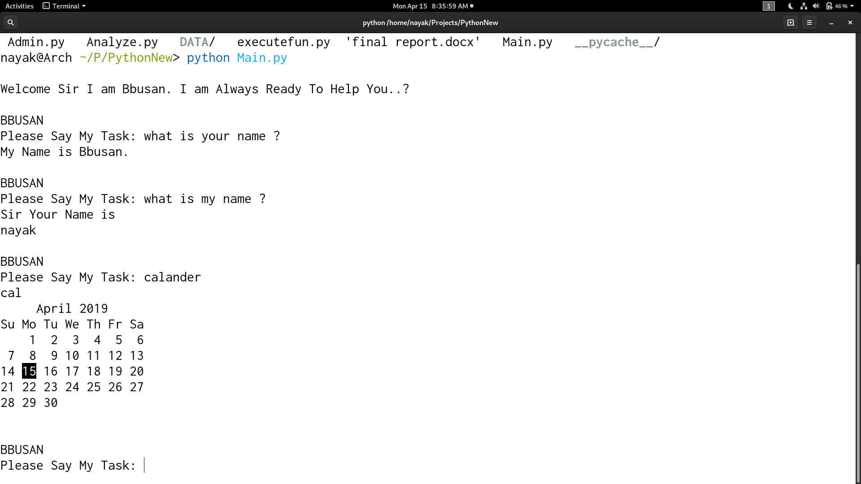

**Fig No.2 Updating the commands**

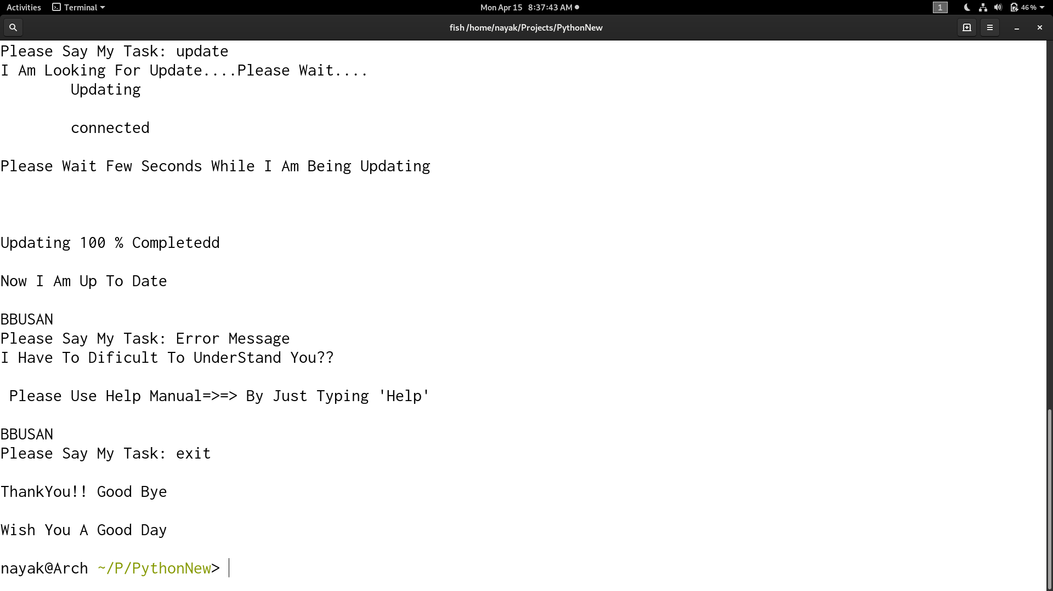

**fig:- Analyze Report of Errors**

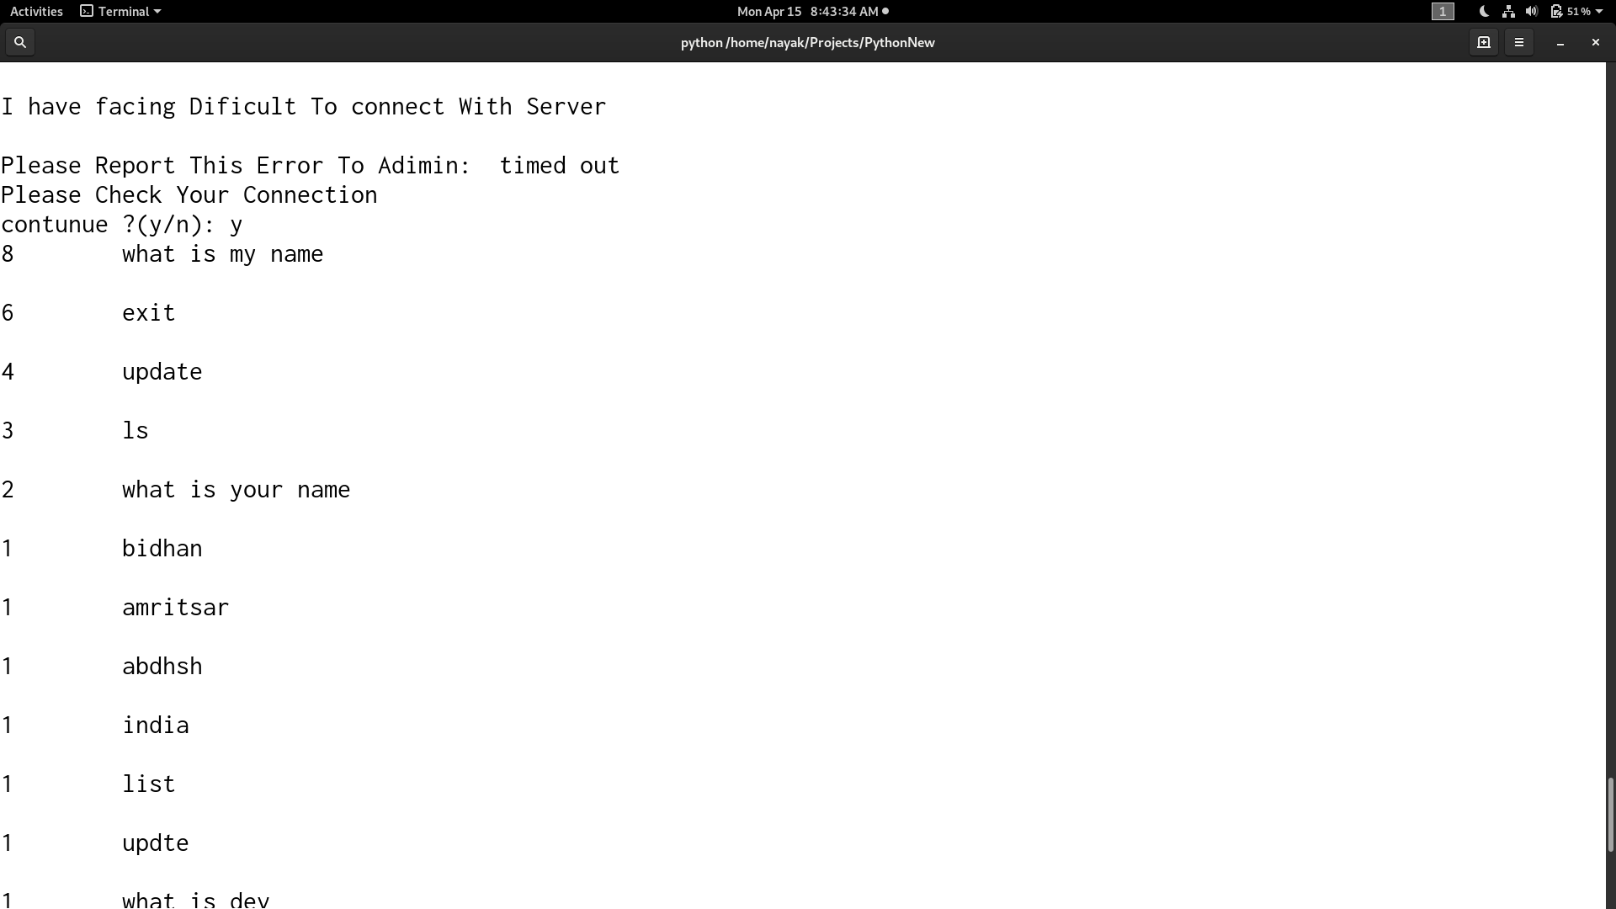

**Fig:- Server Reports**



