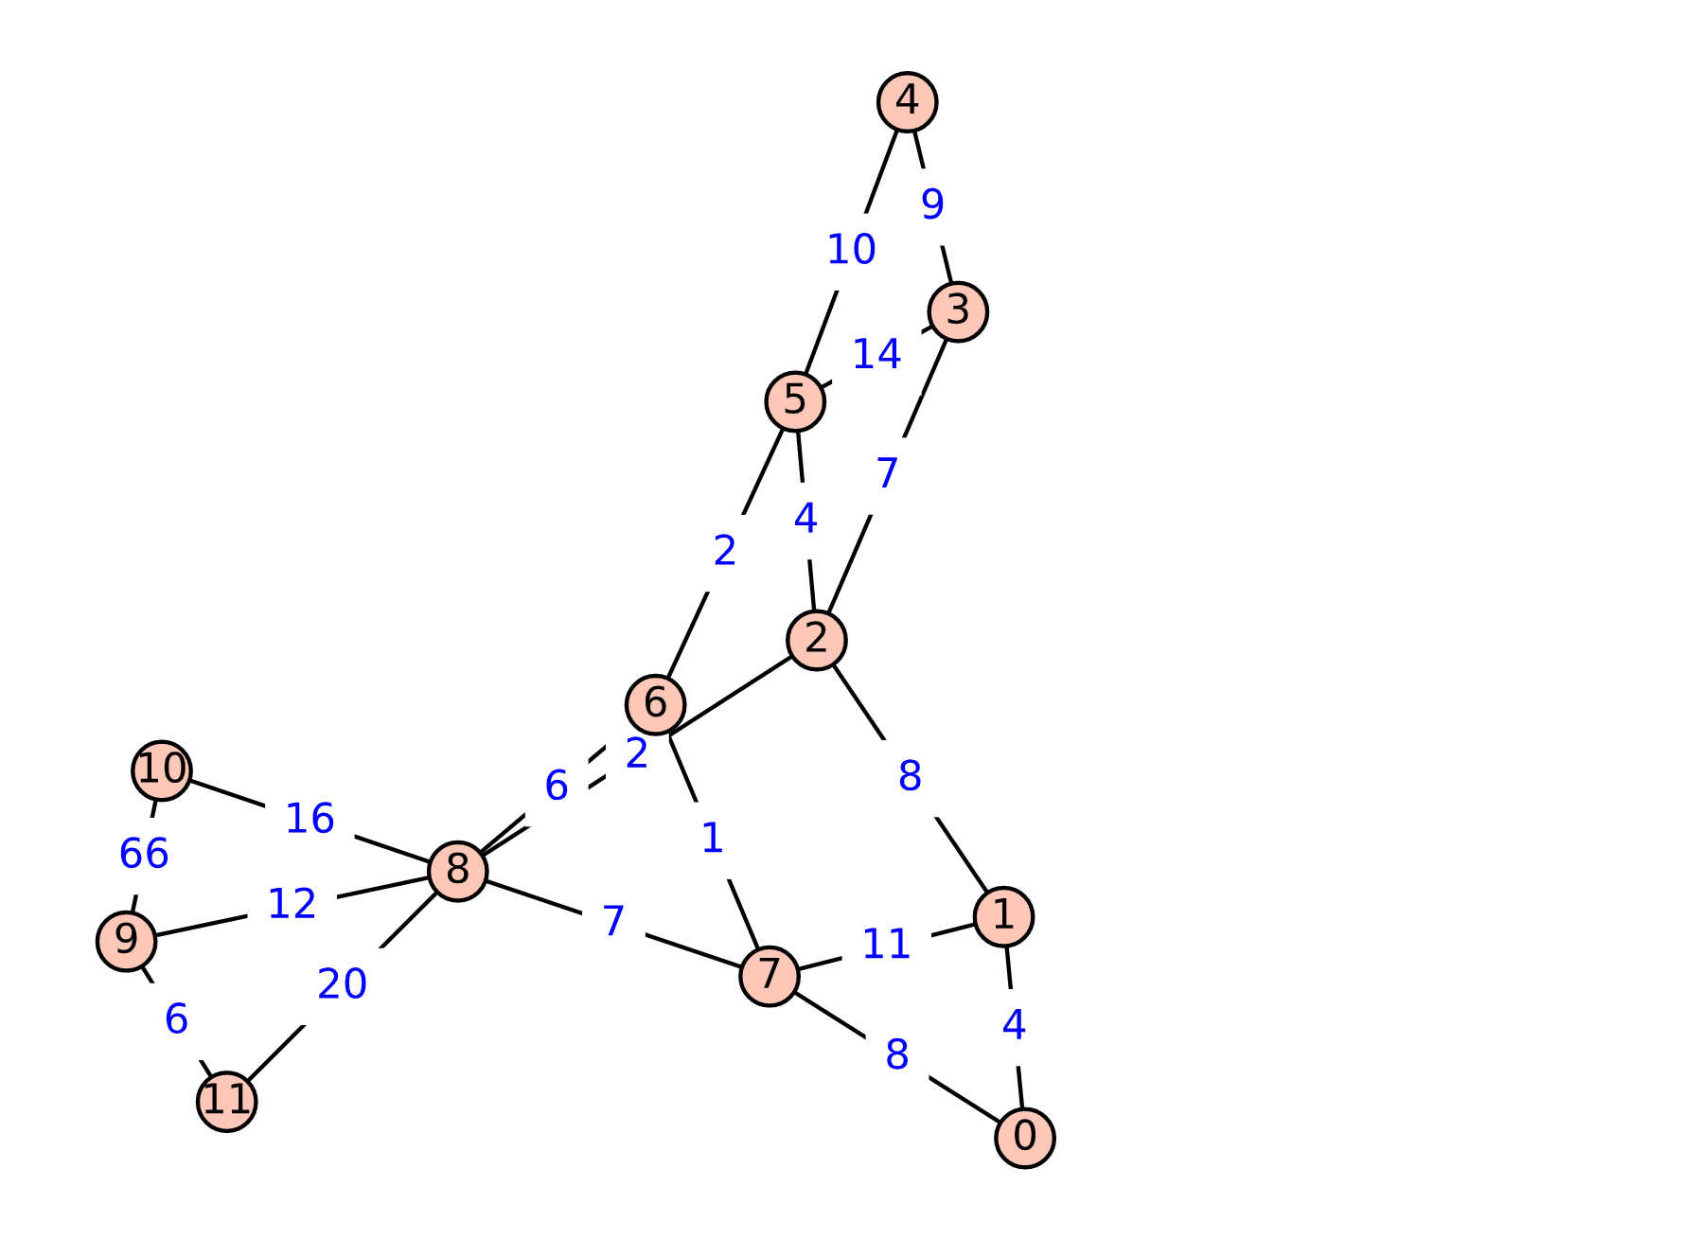The simple graph:

Best solution:

---------------------- BnB node<4> ----------------------

(parent=3) (not pruned) numVertices=5 LB=127.0 UB=127.0

Vertices: 9 10 8 7 11

Edges: (9,10) weight: 66 (8,11) weight: 20 (8,10) weight: 16 (8,9) weight: 12 (7,8) weight: 7 (9,11) weight: 6

-----------------------------------------------------------

