




Chapter One
- Introduction
  - Background of the Study
The final year (industrial) project is a vital academic component that allows students to apply theoretical and practical knowledge to solve real-world problems. In the Faculty of Informatics at Hawassa University which includes the Departments of Computer Science, Information Systems, and Information Technology.This project demonstrates student’s capacity for independent research, innovation, and technical problem-solving under academic supervision.
Currently, most coordination among students, advisors, and the faculty administration is handled manually and through informal communication channels. Students usually submit their project titles and progress updates via social media platforms like Telegram, while advisors must follow up either through Telegram or by meeting students in person to monitor progress and provide feedback. Although convenient, this approach lacks proper organization and official record-keeping. Consequently, important project information becomes scattered across multiple chat threads, easily lost, or inaccessible to department heads and supervisors, leading to inefficiencies and delayed communication.
To address these challenges, this project proposes the development of a Final (Industrial) Project Management System for the Faculty of Informatics, aimed at centralizing coordination, improving transparency, and streamlining communication between students, advisors, and administrators.
Previous studies support the use of web-based project management systems to improve coordination and record management. For example, Adeoye and Omidiora (2019) and Adebayo et al. (2020) demonstrated that centralized digital platforms streamline project supervision and reduce administrative workload. However, existing systems often lack customization for faculty-level structures like that of the Faculty of Informatics, where multiple departments and supervision roles exist.
This report is structured as follows: Chapter One presents the introduction of the study.Chapter Two describes description of existing system. Chapter Three outlines system feautures. Chapter Four discusses system design . Finally, the last chapter provides conclusions and recommendations for future work. Through these sections, the report documents the systematic development of an efficient, user-centered Final (Industrial) Project Management System for the Faculty of Informatics, Hawassa University.
  - Statement of The Problem
Background of the Problem
The final year (industrial) project is essential for undergraduate students in the Faculty of Informatics at Hawassa University, linking theoretical knowledge with practical problem-solving. Currently, project management relies on informal and manual channels like paper based, Telegram and in-person meetings, causing disorganized records, miscommunication, delayed approvals, and inefficient supervision.
Previous studies (Adeoye & Omidiora, 2019; Adebayo et al., 2020; Abdullahi & Sulaiman, 2021) show that web-based project management systems improve coordination, communication, and tracking of academic projects. However, existing systems are generally designed for broad university contexts and do not account for faculty specific structures, hierarchical roles, departmental sections.They also rarely provide integrated tracking for both Project I (Documentation) and Project II (Implementation), highlighting the need for a tailored system, which this study proposes to develop.
Anchor
To address the challenges identified, this study proposes the development of a centralized Final (Industrial) Project Management System for the Faculty of Informatics at Hawassa University. The system will automate key project management tasks, including student registration, group formation, project topic submission and approval, advisor and supervisor assignment, and progress tracking. By providing a structured and digital platform, the system will organize records, improve communication between students and advisors, reduce delays and ensure transparency and accountability across all stages of the final project process.

General Problem
The lack of a structured digital system affects the entire faculty, leading to inconsistent monitoring of student progress, inefficient communication between students and advisors, and limited oversight by administrators. These inefficiencies compromise academic standards and the overall quality of final year projects.
Specific Problems
- Manual Record-Keeping and Data Loss Risks:
Most project-related data such as titles, advisor assignments, and evaluations are recorded manually in physical files or spreadsheets, making them prone to damage, misplacement, or duplication. This practice undermines long-term data integrity and operational efficiency.
- Disorganized Project Submissions:
Students submit project titles and progress updates through Telegram, leading to scattered records that are difficult to track, retrieve, or archive.
- Increased Advisor Workload:
Advisors must meet physically with their assigned groups weekly or biweekly to monitor project progression. This not only increases their workload and administrative effort but also reduces the time available for providing quality, constructive feedback. Additionally, it limits the advisor’s ability to supervise multiple groups efficiently.
- Lack of Administrative Oversight:
Faculty administrators cannot efficiently track project submissions, group performance, or evaluation outcomes across departments and sections.
- Poor Progress Monitoring:
No integrated system exists to track both Project I (Documentation) and Project II (Implementation), making it difficult to evaluate student performance systematically.

- Reduced Transparency and Accountability:
Informal communication and unstructured record-keeping prevent clear documentation of approvals, feedback, and project milestones.
- Limited Data for Decision-Making:
Administrators lack centralized data for reporting, evaluating advisor workloads, or improving the final project process based on empirical evidence.
1.3 Objectives of The Project
1.3.1 General Objective
The general objective of this project is:
To design, develop, and deploy a centralized Final (Industrial) Project Management System for the Faculty of Informatics at Hawassa University that improves coordination, transparency, and efficiency in managing final-year projects, ensuring accurate record-keeping, structured communication, and systematic tracking of student progress by the end of this project(6 months later).

1.3.2 Specific Objectives
- Objective 1: Conducting Comprehensive Data Gathering
Collecting detailed information from students, advisors, supervisors, and administrators regarding their requirements, challenges, and preferences in final project management. This involves surveys, interviews, and reviewing previous project records to ensure all user needs are accurately captured by 7th November 2025 (1 week).
- Objective 2: Performing In-Depth Data Analysis
Analyzing the collected data to identify patterns, bottlenecks, and areas needing improvement, such as communication delays and supervision gaps. This analysis will guide the functional design of the system and will be completed by 14 th November 2025 (2 weeks).
- Objective 3: Identifying and Documenting Detailed System Requirements
Defining the functional and non-functional requirements, including user roles, modules (student registration, group formation, topic approval, advisor and supervisor assignment, progress tracking, notifications), and system constraints. Deliverables will include use-case diagrams and requirement specifications by 28th December 2025 (3 weeks).
- Objective 4: Developing Visual Prototypes for Design
Creating graphical wireframes and mockups for the system interface to demonstrate navigation, interaction flow, and usability for all actors. Prototypes will be finalized and approved by 19th January 2026 (3 weeks).
- Objective 5: System Implementation
Developing the system using React.js for the frontend and PHP or Node js with Express node js framework for the backend, integrating all modules including registration, group management, topic approval, advisor and supervisor assignment, and progress tracking. The system will be implemented and functional by 10th February 2026 (6 weeks).
- Objective 6: Implementing Robust Testing Strategies
Conducting unit testing, integration testing, system testing, and user acceptance testing to ensure functionality, security, and usability. Issues will be identified, fixed, and retested to meet quality standards by 22th March 2026 (4 weeks).
- Objective 7: System Deployment and Maintenance
Deploying the fully tested system on a local server environment, providing user manuals, and establishing maintenance and support protocols to ensure smooth operation for all actors. Deployment and initial maintenance will be completed by 20th August 2026 (1 week).
1.4 Scope of the Study
The scope of this study focuses on developing a centralized Final (Industrial) Project Management System for the Faculty of Informatics at Hawassa University, aimed at improving coordination among students, advisors, supervisors, and the faculty administration. The system will cover the registration of fourth-year students, automated group formation based on academic performance and departmental sections, submission and approval of project titles, assignment of advisors to groups and supervisors to department sections, and monitoring of progress for both Project I (Documentation) and Project II (Implementation). In addition, it will facilitate structured communication, recording of project milestones, and scheduling of semester presentations, providing accessible reports for all relevant actors. The study will use data collected from necessary stakeholders to define system requirements and ensure that the proposed solution meets user needs. The project is limited to the Faculty of Informatics and does not include financial management, integration with external social media platforms beyond notifications, development of mobile applications, or coordination of projects from other faculties or academic levels. By clearly defining these boundaries, the study ensures that the developed system is focused, achievable, and capable of effectively streamlining final project management, enhancing transparency, improving supervision, and providing a reliable, organized platform to support the successful completion of student projects.
1.5 Limitation of the Study
While the proposed Final (Industrial) Project Management System aims to streamline project management, improve communication, and enhance supervision and record-keeping for students, advisors, and administrators within the Faculty of Informatics at Hawassa University, several limitations may affect the scope, development, and implementation of the project. These limitations fall into two broad categories: personal (or project-specific) limitations and implementation-related constraints.
Personal Limitations:
- Resource Constraints
The project may be limited by available financial, human, and infrastructural resources. Budget constraints could restrict access to advanced hardware, software tools, or additional development support, which may affect system optimization and testing scenarios.
- Technical Expertise
The successful design, development, and deployment of the system depend on the developer’s proficiency in React.js, PHP, node js ,database management, and system architecture. Gaps in experience, particularly in full-stack integration or multi-user role management, may limit the implementation of certain advanced features.
- Lack of Programming Experience
The development team’s programming skills may limit the ability to implement complex modules efficiently, optimize performance, or conduct extensive testing. Continuous learning and iterative improvements will be necessary to mitigate this limitation.
- Shortage of Time
The project is conducted alongside other academic responsibilities within two semesters. This time constraint may impact the depth of implementation, comprehensive testing, and thorough refinement of all system modules.
- Limited Access to Reliable Data
Accurate records of previous final projects, student progress, and advisor supervision methods are essential for realistic system design. The fragmented manual based processes mean that some data may be incomplete, inconsistent, or unavailable, potentially affecting requirement analysis and testing.
Implementation Limitations:
- Integration with University IT Infrastructure
The system may face challenges integrating with Hawassa University’s existing IT systems, including authentication mechanisms, network policies, or centralized databases.
- Network and Power Reliability
System effectiveness depends on stable local network connectivity and power availability, which may occasionally be inconsistent.
- Security and Data Privacy
The system will store student,supervisor and advisor information, project submissions, and progress reports. Implementing robust data protection measures to prevent unauthorized access and ensure compliance with university data policies may be challenging within the scope of the project.
- Dependency on User Compliance
The success of the system relies on students, advisors, and supervisors consistently using the platform for submissions, feedback, and monitoring. Non-compliance or partial adoption may reduce overall effectiveness.
- Hardware Dependency
Although primarily a digital system, the availability and reliability of computers, servers, and network devices are critical. Hardware shortages or failures could limit system accessibility and performance.
1.6 Methodology
This project aims to design and develop a web-based Final (Industrial) Project Management System to address the challenges and inefficiencies of the current manual or semi-digital processes used for managing student projects within the Faculty of Informatics at Hawassa University. The central assumption is that a digital, user-centered platform built upon actual user needs and existing academic workflows can significantly enhance coordination between students, advisors, and supervisors, improve progress tracking, streamline communication, and reduce administrative overhead.
To ensure that the proposed system effectively meets stakeholder requirements, this study employs a qualitative, user-centered software development methodology. This approach aligns with established practices in applied software engineering and human-computer interaction (HCI), focusing on iterative design and feedback-based refinement. The methodology integrates systematic data collection, requirement analysis, structured system design, implementation, and validation, ensuring each stage builds upon real institutional needs. The project adopts an Agile-inspired development model, which emphasizes flexibility, stakeholder collaboration, and incremental delivery. Regular feedback from students, advisors, and administrators guides each phase of development, enabling continuous improvement and ensuring that the final system is both functional and user-friendly.

1.6.1 Data Collection Methodology
Given the nature of the problem rooted in workflow inefficiencies and institutional practices this study will employ three complementary qualitative data collection techniques:
- Observation
- Description:
The study will involve systematic field observation in advisor offices, departmental coordination offices, and laboratories where project supervision and evaluation activities occur.
- Purpose:
To gain firsthand insight into how project coordination is managed and identify workflow gaps or inefficiencies.
- Outcome:
The results will help define system requirements that reflect real practices and user needs.

2. Interviews
- Description:
Semi-structured interviews will be held with key stakeholders students, advisors and supervisors, and departmental administrators to gather diverse perspectives on project management challenges.
- Focus:
Discussions will center on difficulties in manual processes, expectations for automation, preferred communication tools, and suggestions for improvement.
- Outcome:
Responses will be transcribed and analyzed to extract both functional (e.g., project tracking, notifications) and non-functional (e.g., usability, reliability) requirements.

3. Documents and Records Review
- Description:
Relevant materials such as proposal forms, progress reports, evaluation sheets, and university policies will be examined.
- Purpose:
To validate insights from observations and interviews, identify recurring issues like submission delays, and inform the database structure.
- Outcome:
Findings will help define key data entities such as student ID, project title, advisor ID, and evaluation status for accurate system design.
1.6.2 System Analysis and Design Methodology
The Final Year Project Management System for the Faculty of Informatics, Hawassa University, will be developed using the Agile Software Development Methodolog an iterative, user-centered approach that emphasizes adaptability, stakeholder collaboration, and the progressive delivery of working system components.

Rationale for Selecting the Agile Model
The Agile model is selected as the most suitable framework for this project because it aligns with the dynamic and evolving nature of academic project management within the Faculty of Informatics. Unlike traditional linear models, Agile encourages flexibility, regular stakeholder engagement, and continuous refinement of system features based on real user feedback. The following points outline the key justifications for adopting this methodology:
- Evolving Requirements
At the beginning of the project, specific user needs such as project proposal submission, advisor assignment, progress tracking, and evaluation may not be fully defined. Agile accommodates these evolving requirements by allowing continuous refinement through iterative development cycles and user feedback, ensuring the system remains relevant and practical.
- Active Stakeholder Engagement
The system will serve three main stakeholder groups:
- Students, who propose, manage, and submit their final projects.
- Advisors and Supervisors, who provide continuous guidance and assessment.
- Departmental Administrators, who coordinate and oversee the project workflow.
Agile’s focus on stakeholder collaboration ensures that input from each group directly shapes the system’s design and functionality, promoting usability and acceptance across all levels of the faculty.
- Early and Continuous Delivery of Value
Through iterative development, functional modules such as student registration, group formation, topic approval, and progress monitoring will be delivered progressively. This approach allows early testing and validation, ensuring each component provides real value before integrating into the complete system.
- Adaptability to Change
As the project evolves, new insights may emerge from testing or stakeholder feedback. Agile’s flexibility enables the development team to adjust priorities, refine the interface, and enhance functionalities without disrupting the overall schedule or project objectives.
1.6.3 System Implementation Methodology
The Final (Industrial) Project Management System for the Faculty of Informatics Hawassa University, will be implemented using the Object-Oriented Programming (OOP) paradigm. OOP organizes the system into objects self-contained components that combine data (attributes) and behavior (methods) to represent real-world entities and processes.
This methodology is appropriate for the project due to the following reasons:
Realistic Modeling of Entities:
The system involves multiple interrelated components such as Admin(faculty),Student, Advisor, Supervisor,ProjectGroup, ProjectSubmission, and ProgressTracking. Using OOP allows these components to be modeled as classes and objects, providing a clear, logical, and intuitive structure aligned with actual faculty operations.
Modularity and Reusability:
Key functions like project registration, group management, topic approval, advisor assignment, and progress monitoring are developed as independent modules interacting through defined interfaces. This modularity simplifies testing, debugging, and future enhancements, such as adding new modules for other academic programs.
Efficiency through OOP Principles:
Core principles like encapsulation, inheritance, and polymorphism improve maintainability and reduce redundancy. For example, common functionalities such as login and notifications can be inherited by different user roles (students, advisors, administrators), while role-specific behaviors are maintained independently.

1.6.4 Testing and Deployment Methodology
Software testing ensures that the Final (Industrial) Project Management System functions correctly, is reliable, and meets both functional and non-functional requirements. Testing starts during coding and continues through deployment, providing stakeholders with evidence of quality and system readiness. The following testing levels and methods will be employed:

- Unit Testing
- Purpose: Verify the correctness of individual components or functions in isolation.
- Method: Each module (e.g., student registration, group formation, project submission) will be tested using manual inspection and automated test scripts.
- Dataset: Synthetic test cases including valid inputs (e.g., correct project submission dates), invalid inputs (e.g., missing advisor assignment), and edge cases (e.g., duplicate group creation).
2. Integration Testing
- Purpose: Ensure that modules interact correctly when combined.
- Method: Incremental integration starting with student and project modules, followed by advisor, supervisor, and admin components.
- Dataset: Realistic workflow scenarios (e.g., a student submits a project topic → advisor approves → progress is tracked → admin generates report).
3. System Testing
- Purpose: Validate the fully integrated system against the specified requirements.
- Method: Black-box testing from the user perspective, focusing on all core workflows.
- Dataset: Data from requirements and observation phases, including student IDs, project titles, advisor assignments, and evaluation statuses.
4. User Acceptance Testing (UAT)
- Purpose: Confirm the system meets the needs of all stakeholders and is ready for operational use.
- Method: Representatives from students, advisors, and departmental administrators will perform tasks such as submitting projects, assigning advisors, tracking progress, and generating reports in a controlled environment.
- Dataset: Simulated real-world data based on actual project submissions and faculty processes.
Deployment Methodology
Deployment ensures the system is operational in the faculty’s environment through a phased approach:
- Pre-Deployment Preparation:
Install the system on a local server at the Faculty of Informatics. Configure user accounts and roles based on institutional data.
- Pilot Deployment:
Launch the system in selected departments for testing, provide user manuals, monitor performance, and collect feedback for improvements.
- Full Deployment:
Expand the system to all departments within the faculty after successful pilot evaluation. Archive the final build, source code, and documentation as project deliverables.
1.6.5. Development Environment
The development environment refers to the complete set of hardware and software tools used by the development team to design, code, test, and deploy the projector facility management. A well-defined environment ensures consistency, efficiency, and compatibility throughout the software development lifecycle.
Software Tools
Component | Specification / Description
Integrated Development Environment (IDE) | Visual Studio Code (VS Code) with extensions for PHP, JavaScript, Node.js, and React
Frontend Framework | React.js
Styling Library | Bootstrap 5 for responsive, mobile-first design
Backend Framework | Node.js ,PHP for specific server-side tasks
Programming Languages | JavaScript (ES6+), HTML5, CSS3, PHP
Database Management System | MySQL
Browser Support | Google Chrome, Mozilla Firefox, Microsoft Edge (latest versions)
visual paradigm | to draw UML model diagram and other software diagrams in design phase
Microsoft office word 2019 and WPS | to edit the document and to prepare the presentation

Hardware Requirements
Component | Minimum Requirement | Recommended Requirement
Personal Computer | Laptop capable of running modern web browsers and development tools | High-performance Laptop optimized for multitasking, capable of running IDEs, browsers, and local servers simultaneously
Operating System | Microsoft Windows 10 (32- or 64-bit), | Microsoft Windows 11 Pro (64-bit)
RAM | 4 GB | 16 GB
Processor | Intel Core i3 / AMD Ryzen 3 or equivalent | Intel Core i5 / AMD Ryzen 5 or higher
Graphics / Display | 1280 × 800 screen resolution | 1920 × 1080 Full HD or higher
Internet Speed / Connectivity | Stable high-speed internet for updates and downloads | High-speed internet for development, SDK updates
Backup Storage | 500 GB external HDD | 1 TB external HDD

1.6.6 Feasibility Study
A feasibility study evaluates whether a proposed project can be successfully implemented by analyzing key factors that influence its success. For the Final (Industrial) Project Management System, this study assesses technical, operational, and economic feasibility to ensure that the project is viable, practical, and beneficial before significant time and resources are committed.
Technical Feasibility
The project is technically feasible as it leverages widely adopted, open-source technologies: React.js for the frontend interface, PHP,node js for server-side logic, and MySQL for database management. The development team is already familiar with these tools, and all components are freely available, well-documented, and widely supported. This ensures smooth implementation, maintainability, and scalability.

Operational Feasibility
The proposed system is operationally feasible as it resolves key inefficiencies in the current manual project management process by providing a centralized digital platform for tracking submissions, monitoring progress, and improving communication. Designed with stakeholder input and aligned with existing academic workflows, it ensures ease of adoption, enhances transparency, reduces administrative workload, and supports effective supervision and decision-making.
Economic Feasibility
The project is highly cost-effective, relying on existing university infrastructure, available development resources, and open-source technologies with no licensing or major hardware expenses. Despite its low implementation cost, the system delivers significant value by reducing administrative workload, improving project tracking and communication, and streamlining workflow management offering a strong return on the modest investment of time and effort.
1.6.8. Cost Estimation and Schedule Breakdown
Cost Estimation :Cost estimation for our project involves a meticulous analysis of various factors to determine the financial resources required for successful implementation.
Cost Category | Description | Estimated Amount
Software | All development tools (VS Code, React, Node.js, PHP, MySQL, Bootstrap) are free and open-source. | 0 birr
Hardware | Development done on personal laptops;b=no new equipments | 0 birr
Training | Informal peer learning and online tutorials; no external training required. | 0 birr
Deployment | System will be deployed on free server web hosting service or localhost; no server or cloud fees | 0 birr
Documentation & Printing | Printing final report, user manual, and presentation materials (approx. 85 pages). | 400 birr
Miscellaneous | Internet/data bundles, USB drives, backup storage, and minor operational expenses. | 4000 birr
Contingency (10%) | Reserved for unforeseen minor costs (e.g., extra printing, extended data, small accessories). | 240 birr
Total Estimated Cost |  | 4,640 birr

Schedule Breakdown
For the project, "Final (Industrial) Project Management System for the Faculty of Informatics, Hawassa University," the work breakdown structure (WBS) provides a hierarchical framework by decomposing the project into smaller, manageable tasks covering all phases, including requirements analysis, system design, development, testing, deployment, and maintenance. Each phase is further divided into detailed activities with defined start and end dates, dependencies, and milestones, allowing team members to effectively allocate resources and comprehend the project’s full scope. With the use of the work breakdown structure (WBS), team members may effectively allocate necessary ingredients and comprehend the project's scope. Better progress tracking, the identification of essential paths, and the mitigation of potential delays are made possible by this systematic approach to scheduling, which guarantees that the project will be completed on time and under budget.
Here is a Gantt chart that depicts the general timeline structure of works to be done in the
project:

CHAPTER TWO
DESCRIPTION OF EXISTING SYSTEM
2.1 Introduction to Existing System
The existing system for managing final year (Industrial) projects in the Faculty of Informatics at Hawassa University relies on informal, largely manual processes with minimal digital support. Coordination among students, advisors, supervisors, and administrators is conducted through unstructured channels primarily Telegram for title submissions and progress updates, supplemented by in-person meetings for supervision. This ad hoc approach lacks centralized documentation, standardized workflows, or reliable record-keeping, resulting in fragmented data, frequent miscommunication, and significant risks of information loss.
Project documentation (Project I) and implementation (Project II) are tracked inconsistently, if at all, and administrative oversight across departments remains limited due to the absence of a unified platform. Although these practices partially fulfill immediate coordination needs, they fail to ensure transparency, accountability, or systematic progress monitoring.
Recognizing these shortcomings, the development team conducted preliminary interviews, observations, and document reviews to understand how current requirements are met, map information flows, identify core problems, and lay the groundwork for defining new system requirements all while acknowledging the scarcity of formal system documentation, which necessitated deeper engagement with stakeholders to reconstruct an accurate picture of the operational reality
2.2 Proposed System Description

Overview
The Final year (Industrial) Project Management System is a modern, unified digital platform designed to transform how final-year academic projects are coordinated, monitored, and evaluated within the Faculty of Informatics at Hawassa University.
It replaces the fragmented, manual workflow with a centralized, role-based system that enhances:
- Transparency
- Accountability
- Operational efficiency
Built using modern web technologies and user-centered design principles, the system consolidates all major project management activities—student registration, group formation, topic submission, advisor assignment, milestone tracking, and evaluation for both Project I (Documentation) and Project II (Implementation).
This section outlines the system’s core components and the architecture that supports its functionality.

Key Components

Centralized Web-Based Platform
- A responsive web application accessible on desktops and mobile devices.
- Acts as a single source of truth for all project-related data.
- Eliminates scattered records, unstructured communication, and missing documentation.

Role-Based Access Control (RBAC)
Supports distinct user roles:
- Students
- Advisors
- Department heads
- Faculty head
Each role receives:
- Customized dashboards
- Privilege-restricted functionalities
- Ensures secure access, workflow segregation, and data integrity.

Automated Group Formation
Groups students automatically based on:
- Academic performance (CGPA)
- Department and section (CS, IS, IT)
Ensures:
- Fair distribution
- Efficiency
- Removal of manual grouping errors

Project Lifecycle Management
Supports the complete life cycle for both Project I and Project II:
- Topic selection and submission
- Approval workflows
- Milestone and delivery tracking
- Feedback logging
- Supervisor evaluation
- Presentation and defense scheduling
Ensures consistent, standardized documentation and progress monitoring.

Real-Time Communication & Notifications
- In-system messaging for structured communication.
- Automated notifications for:
- Deadlines
- Approvals
- Feedback
- System updates
- Replaces informal platforms (e.g., Telegram) with reliable, traceable communication.

Secure Authentication & Data Handling
- Secure login and session management.
- Best practices for data privacy and access control.
- While university-wide SSO integration is outside the current scope, the system provides:
- Strong role-based authentication
- Protection of academic and personal data

Reporting & Administrative Oversight
- Real-time analytics and reporting tools for administrators:
- Project progress summaries
- Advisor workload analysis
- Group performance tracking
- Department-level compliance reports
- Supports data-driven academic decisions.
Responsive and Intuitive User Interface
- Designed using React.js and Bootstrap 5.
- Prioritizes:
- Usability
- Clarity
- Accessibility
- Ensures smooth adoption by users with varied technical skill levels.

Vision for the User Experience
The proposed system aims to deliver a streamlined, transparent, and collaborative project management experience.
- Students gain structured guidance, organized submissions, and timely feedback.
- Advisors and Department heads benefit from reduced administrative workload and centralized monitoring tools.
- Faculty head obtain real-time visibility and faculty-wide oversight for improved academic governance.
The platform replaces inconsistent manual methods with a robust, purpose built digital infrastructure ensuring reliability, efficiency, and accountability throughout the entire project life cycle.

Addressing Weaknesses in the Existing System
The current semi-digital and manual workflow results in:
- Disorganized submissions
- Risks of data loss
- Limited administrative oversight
- Excessive advisor workload
- Poor progress tracking
The Final year (Industrial) Project Management System directly solves these issues through:
- Automation
- Centralization
- Structured workflows
- Real-time tracking
- Role-specific functionality
It also lays the foundation for future improvements, such as cross-faculty expansion or integration with wider university systems ensuring long-term scalability and academic value.
2.3 Stregnths of Existing System
Even though the current final year (Industrial) project management process in the Faculty of Informatics at Hawassa University is mostly manual and informal, it still shows several important strengths. These strengths come from the people, the academic structure, and the university’s working culture. Together, they have helped the faculty manage projects successfully and provide a strong base for moving to a digital system in the future.

Highly Skilled and Knowledgeable Staff
- The faculty has well-educated advisors and supervisors with strong backgrounds in Computer Science, Information Systems, and Information Technology.
- Their knowledge, experience, and commitment help maintain high academic standards, even without modern digital tools.

Clear and Stable Academic Process
- The final-year project follows a well-organized structure with two main parts:
- Project I (Documentation)
- Project II (Implementation)
- The evaluation criteria, supervision roles, and responsibilities are clearly defined.
- This consistency makes it easier to convert the existing process into a digital system.

Strong Advisor Student Mentorship
- Frequent face-to-face meetings allow advisors and students to build trust and communicate effectively.
- This personal guidance helps students learn better and improve the quality of their projects.
- The strong mentorship culture is a key asset that supports successful project outcomes.

Well-Organized Department Structure
- The Faculty of Informatics has three departments:
- Computer Science (CS)
- Information Systems (IS)
- Information Technology (IT)
- Each department has clear roles and responsibilities.
- This organization supports proper supervision, accountability, and smooth coordination features that can easily be built into a digital platform.

Active Use of Available Communication Tools
- Many students and advisors already use platforms like Telegram to communicate.
- This shows strong digital awareness and readiness to adopt new technology.
- Their willingness to use online tools will make it easier to accept a new system.

Strong Student Participation and Responsibility
- Students often take the lead in choosing topics, forming groups, and reporting progress.
- This shows high motivation, responsibility, and ownership of their work.
- With a better system, students can manage tasks even more effectively.

Focus on Practical, Real-World Learning
- The industrial project helps students connect what they learn in class with real-world practice.
- This approach matches global standards in informatics education.
- It also gives students valuable experience that prepares them for jobs and challenges after graduation.
2.4 weaknesses of Existing System
Lack of Centralized Data Management
The current project management process relies on scattered documents, Telegram messages, and in-person updates, making it difficult to store, track, or retrieve project information in one place.
Manual and Time Consuming Workflows
Most tasks, such as supervision, topic approval, and progress checking, are performed manually, causing delays, errors, and inconsistent follow-ups.
Poor Communication Reliability
Dependence on informal tools like Telegram leads to missed messages, loss of information, and unreliable coordination among students, advisors, and supervisors.
Limited Use of Technology
The absence of dedicated software, automated systems, and digital tools creates challenges in managing large numbers of students and maintaining accurate project records.
Lack of Real-Time Monitoring
Advisors and administrators have no structured way to track deadlines, milestones, or student progress, making it difficult to identify delays or problems early.
Insufficient Documentation and Record Keeping
Project reports, feedback, and approvals are not stored systematically, increasing the risk of document loss and making long-term academic referencing difficult.
High Advisor Workload
Advisors handle repetitive administrative tasks manually, leading to overload, slower responses, and reduced efficiency in supervising students.
Limited Resources and Technical Support
The system lacks proper infrastructure such as servers, backup mechanisms, and trained technical staff, which affects system reliability and performance.
No Standardized Workflow
Each advisor or department uses different approaches for supervision, scheduling, and evaluation, creating inconsistency across the three departments (CS, IS, IT).
Low System Scalability
As the number of students increases each year, the manual process becomes harder to manage, making the current system unsustainable for long-term growth.

CHAPTER THREE
SYSTEM FEATURES
3.1 Introduction
In Chapter Three, we examine the Final (Industrial) Project Management System in detail, focusing on its essential features and providing a clear overview of the core components that define the proposed academic management platform. This chapter represents an important stage in the documentation, offering a structured analysis of both functional and non-functional requirements. Through this analysis, readers gain a full understanding of the features that make the system effective and unique. The chapter explains the system’s workflows, user interactions, and analytical models that guide its design. It summarizes the main capabilities of the Final (Industrial) Project Management System and prepares the foundation for replacing informal Telegram communication and manual processes with a centralized digital platform. This new solution enhances visibility, accountability, and efficient project supervision across all departments within the Faculty of Informatics at Hawassa University.

3.2 System Requirements
The Final year(industrial) project management system requirements outline the essential features and functionalities that together determine the functionality, security, and overall performance of the suggested online platform. These specifications serve as the guide for creating and implementing a user-centered, dynamic system that aims to completely transform the conventional banking experience. These requirements, which include both functional and nonfunctional elements, are carefully designed to guarantee a smooth, safe, and user-friendly mobile banking environment.

3.2.1 Functional Requirements
The functional requirements, which describe the precise features and capabilities that enable users to interact with the Final (Industrial) Project Management System, constitute the foundation of the proposed platform. These specifications operate as the functional cornerstones that shape the academic project experience from student registration and group formation to project submission, advisor feedback, progress tracking, and submission of final project draft. Every functional requirement is an essential component that contributes to the comprehensive range of services provided by the system, giving students,advisors,department heads and faculty head the tools they need to efficiently manage the final-year project life cycle while maintaining academic integrity, fairness, and transparency.

1. Student Registration and Department Request
To register, students must provide their university ID, full name, CGPA, department (Computer Science, Information Systems, or Information Technology), and section. This information is securely stored and verified by department head. Students must also request to join a specific department, which requires approval from the corresponding Department Head.

2. Advisor Registration and Profile Setup
Advisors must register using their university email, full name, department, and areas of expertise (e.g., Machine Learning, Web Development, Cybersecurity). Department Heads can later set a maximum group limit per advisor to ensure balanced supervision workloads.

3. Department Head Assignment and Oversight
The Faculty Head assigns Department Heads for the three departments (CS, IS, IT). Department Heads can approve or reject student department requests, manage advisor, form student groups, assign evaluators, and monitor advisor-student interactions within their department.

4. Automated Group Formation
Department Heads can initiate automated group formation by specifying the maximum number of students allowed per group. The system then groups students by section, sorts them by CGPA (descending), assigns top scorers as group anchors, and randomly distributes remaining students while respecting the group size limit.

5. Project Title Submission
Student groups submit a project title, description, and domain (e.g., “AI-Based Attendance System – Domain: Machine Learning”). Submissions are stored in the system and become visible to advisors in the same department for self-selection.

6. Advisor Self-Selection of Projects (First-Come, First-Served)
Advisors can browse available project titles within their department and claim projects they wish to supervise. The system locks a project to other advisors once claimed and enforces the advisor’s group limit. Claims follow a first-come, first-served policy with atomic database updates to prevent conflicts.

7. Bi-Weekly Progress Submission and Tracking
Students submit progress reports (as PDFs) during faculty-published bi-weekly windows. The system tracks submission deadlines and blocks future submissions if the current report remains unapproved by the advisor after the deadline.

8. Advisor Progress Review and Feedback
Advisors review uploaded progress reports, provide written feedback, and approve or request revisions. Approved submissions unlock the next progress window; unapproved submissions are flagged as “Overdue” and trigger automatic notifications to students, advisors, and Department Heads.

9. Final Draft Submission and Automatic Escalation
After all progress reports are approved, student groups upload a final project report. Once the advisor approves the final draft, the system automatically forwards it to the Department Head for evaluation scheduling no manual intervention is required.

10. Faculty Head Scheduling of Presentations
The Faculty Head publishes final defense schedules, including date, time, and venue. This schedule is visible to all stakeholders and serves as the basis for evaluator assignment.

11. Evaluator Assignment by Department Head
Department Heads assign exactly two (2) evaluators per group from eligible faculty members. The system prevents assignment of the group’s current advisor as an evaluator.

12. Real-Time Notifications and Alerts
The system delivers in-app notifications for key events, including: project claim, progress approval/rejection, overdue deadlines, final draft approval, presentation scheduling, and evaluator assignment ensuring timely awareness across all roles.

13. Role-Based Dashboard Access
Each user role (Student, Advisor, Department Head, Faculty Head) accesses a customized dashboard displaying relevant tasks, reports, and action items ensuring focused and efficient interaction with the system.

14. Administrative Reporting and Data Export
Faculty Heads and Department Heads can generate and export comprehensive reports (PDF/Excel) on project statistics, advisor workloads, group performance, overdue submissions, and evaluator assignments supporting data-driven academic decisions and accreditation compliance.

15. System-Wide Record Archival
All project data including titles, progress reports, feedback, final drafts, and evaluations—is securely archived for at least five years to meet academic audit and institutional record-keeping requirements.

16. Secure User Management and Approval Workflow
All student and advisor registrations require approval by the Department Heads. The system supports account activation, deactivation, and profile updates while maintaining strict role-based access control.
3.2.2. Non-functional Requirements
The non-functional requirements establish the qualitative attributes that support and enhance the functional capabilities of the proposed system. These requirements define the standards for system performance, security, usability, and compliance that collectively determine the quality of the user experience and operational reliability. Non-functional requirements provide the essential framework for evaluating system effectiveness beyond basic functionality, ensuring the Final year (Industrial) Project Management System not only performs required tasks but does so with excellence, reliability, and in alignment with institutional standards and academic best practices.
1.Product (Software) Requirements
These define the specific quality attributes and performance criteria that the software must satisfy to deliver an exceptional academic project management experience. They establish benchmarks for security, usability, reliability, and performance essential to the system’s success.
- Security and Data Privacy
The system implements role-based access control (RBAC), password hashing using the bcrypt algorithm, and HTTPS communication to protect student information and project details. All sensitive operations are logged for audit purposes to maintain data integrity and prevent unauthorized access.
- Scalability
The system is designed to handle increasing numbers of users and growing workloads during peak activity periods. It can be expanded to support additional units, departments, or future features without requiring significant architectural changes.
- Usability
The interface follows responsive design principles with intuitive navigation, ensuring that key tasks such as project submission, report generation, and feedback management can be completed within three clicks. Contextual help features and tool tips support users with varying levels of technical experience.

- Reliability
The system ensures consistent availability with minimal downtime. It incorporates automated backups and recovery mechanisms to protect data and maintain smooth operation in case of unexpected failures.

- Performance
The system is optimized for fast and responsive operation. Pages load quickly under normal usage, and essential system tasks process efficiently to provide a smooth user experience.
- Accessibility
The systems interface are designed to be accessible to users with varying abilities, fostering inclusivity in the final year project management experience.

2.Organizational Requirements
These requirements define internal policies, development standards, and operational procedures to ensure the system aligns with the Faculty of Informatics’ institutional environment and long-term maintenance capabilities.
- Compliance
The system adheres to Hawassa University’s data protection policies regarding the handling and storage of student information. All project-related documents are archived for at least five years after completion to meet academic audit requirements.
- Continuous Improvement
The system architecture supports modular upgrades and feature enhancements based on feedback collected at the end of each semester. Standardized documentation and version control practices ensure smooth maintenance and knowledge transfer.
3.External Requirements
These requirements address external constraints such as regulatory standards, interoperability needs, and compatibility expectations with existing university systems.
- Interoperability
Ensuring the system can work seamlessly with other external systems or platforms.

- Regulatory Compliance
Adherence to external regulations beyond the organization's policies, specifically related to the educational sector like regulations from ministry of education.

These functional and non-functional requirements collectively define the capabilities and
characteristics of the proposed system, ensuring a robust, secure, and user-centric mobile
banking experience.

3.3. Analysis Models
Overview
Unified Modeling Language (UML) as a Framework
The Unified Modeling Language (UML) is a widely recognized framework in software engineering and system analysis that helps visualize, design, and document complex systems. By providing graphical representations of system components, interactions, and behaviors, UML facilitates clear communication and collaboration among stakeholders. Applying UML during the analysis stage of the Final year (Industrial) Project Management System enables the development team to establish a common understanding of the system’s architecture, features, and interactions, ensuring that students, advisors, and administrators share a unified view of how the system operates.
Purpose of UML
The modeling and depiction of many parts of a system, from high-level architecture to complex behavioral details, is made easier by the flexible language known as UML. Using UML in system analysis is primarily done to improve communication, encourage clarity, and expedite the development process. Through the use of a standardized visual language, UML facilitates comprehension of the goals and needs of the project among all stakeholders, including developers, designers, and end users. This helps stakeholders understand the complexities of the system design.
Why to use UML in System Analysis?
1. Visual Representation
UML provides a visual representation of system components, relationships, and
behaviors, offering a more intuitive and accessible way to communicate complex
concepts compared to textual descriptions.
2. Communication and Collaboration
UML diagrams serve as a common language that bridges the communication gap
between technical and non-technical stakeholders.
3. System Understanding and Design
UML aids in creating a holistic view of the system, allowing analysts and designers
to understand its architecture, functionalities, and interactions.

4. Documentation
UML diagrams serve as effective documentation tools, providing a visual archive of
the system's structure and behavior. This documentation aids in knowledge transfer,
future development, and system maintenance.

UML Diagrams in System Analysis
The Final (Industrial) Project Management System utilizes several UML diagrams, including use case diagrams, sequence diagrams, activity diagrams and class diagrams, to represent various system components and their interactions. Each UML diagram serves a specific purpose, and together they provide a comprehensive analytical model that guides the system development process. The functions and contributions of these UML diagrams during the analysis phase of the project are detailed in the following subsections, helping to ensure clarity, consistency, and accuracy in understanding the system’s design.

3.3.1 Use-Case Diagram
Use case modeling is an important part of the analysis phase. It shows how different users interact with the Final year (Industrial) Project Management System. This technique explains what the system does and how users use it by identifying different situations, or “use cases,” where students, advisors, department heads and faculty heads perform tasks in the system. Use case diagrams help make the system’s functions clear and define the limits of what users can do. They give all stakeholders a complete picture of the system’s purpose, main features, and the ways users can interact with it, which is useful for planning the design and development of the system.

Actors
Final year(Industrial project) system has three fundamental actors playing distinct roles in shaping user interactions and system functionalities:
- faculty head
- Department heads
- Advisors
- Students

1 .Use Case Diagram
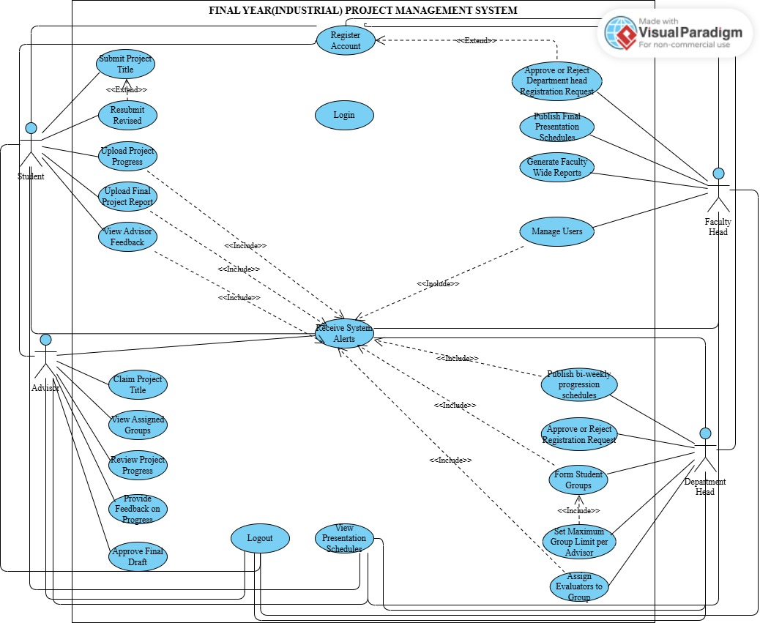

- Use Case Diagram Description
1.Register Account
Aspect | Description
Use Case Code | SUC01
Short Description | New users create an account to access the system.
Preconditions | User has opened the registration page and has access to required personal details.
Post Conditions | A new account is created and stored; the account require approval depending on the user role.
Error Situation | • Required fields (name, email, password) are left empty.  • Email already exists in the system.  • Password does not meet minimum security rules (e.g., too short).  • System cannot connect to the database during registration.  • Network interruption prevents successful submission.
System State on Occurrence of Error | Account is not created; the system displays a specific error message explaining the issue (missing data, duplicate email, weak password, or connection error).
Primary Actors | Department heads,Students, Advisors
Trigger | User clicks "Register" and fills the form.
Standard Process | 1. User enters all required personal details (name, email, password, department).  2. System validates that inputs are complete and correctly formatted.  3. System checks whether the email is unique.  4. System stores the new account in the database.  5. System displays a confirmation message or sends a confirmation email.
Alternative Process | If required fields are empty:  • System highlights missing areas and prompts user to complete the form.  If email already exists:  • System notifies user that the email is already registered.  • User must enter another email address.  If database or network error occurs:  • System displays “Registration Failed Please Try Again”.  • User can retry after the issue is resolved.

2.login
Aspect | Description
Use Case Code | SUC02
Short Description | User logs into the system using valid credentials.
Preconditions | -User must have a registered account.  - Account must be active.
Post Conditions | -User is successfully authenticated.  - User is redirected to their role-based dashboard.  - User session is created.
Error Situation | Incorrect username/password, inactive account, or system error.
System State on Occurrence of Error | - No changes made to the system.  - Error message shown.  - User remains on login page
Primary Actors | Faculty head,Department heads,Advisors,Students
Trigger | User enters login credentials and submits the login form.
Standard Process | 1. User enters username and password.  2. System validates input format.  3. System checks credentials in the database.  4. If valid, system identifies role.  5. User is redirected to the corresponding dashboard.  6. System confirms login success.
Alternative Process | If credentials are incorrect:  1. System displays an error message.  2. User stays on the login page.  3. User is prompted to try again.

3.Submit Project title
Aspect | Description
Use Case Code | SUC03
Short Description | Student submits a project topic for advisor review.
Preconditions | Student is logged in.
Post Conditions | Topic is successfully submitted, saved, and forwarded for advisor review.
Error Situation | • Required fields are left blank (e.g., topic title, description).  • System fails to connect to the database.  • Network interruption interrupts the submission process..
System State on Occurrence of Error | Topic is not saved; the system displays an error message showing the specific issue (missing information, server error, or connection error).
Primary Actors | Student
Trigger | Student clicks "Submit Topic" after entering topic details.
Standard Process | 1. Student enters project topic title and description.  2. System validates that all required fields are filled.  3. System saves the topic to the database.  4. System notifies the advisor.
Alternative Process | If required fields are blank:  • System highlights missing fields.  • Student must fill in and resubmit.  If database or network error occurs:  • System displays “Submission Failed Please Try Again”.  • Student retries after the issue is resolved.

4.Approve or Reject Topic
Aspect | Description
Use Case Code | SUC04
Short Description | Department head approves or rejects a submitted project topic.
Preconditions | Department head is logged in and at least one topic has been submitted by a student.
Post Conditions | Topic status is successfully updated to either Approved or Rejected, and the student receives notification.
Error Situation | • Database connection failure preventing status update.  • System fails to load topic details.  • Network interruption occurs during status update.
System State on Occurrence of Error | Topic status remains unchanged, and an error message informs the admin(faculty) that the action could not be completed.
Primary Actors | Department head
Trigger | Advisor selects a specific submitted topic to review.
Standard Process | 1. Department head opens the list of submitted topics.  2. Department head views topic details.  3.Department head clicks Approve or Reject.  4. System updates the topic status in the database.  5. System notifies the student of the updated status.
Alternative Process | If system fails to update status due to database or network error:  • System displays “Action Failed Please Try Again”.  • Department head reattempts the approval/rejection once the issue is resolved.  If topic details cannot be loaded:  • System alerts advisor that the topic data is unavailable.  • Department head is prevented from taking action until the data is accessible.

- Upload Project Progression
Aspect | Description
Use Case Code | SUC05
Short Description | Student uploads project related documents chapter by chapter, interms of the name of progression.
Preconditions | • Student is logged in.  • Student’s project topic has been approved.  • Student has a valid document ready for upload.  • System storage server is online.
Post Conditions | Document is successfully uploaded, stored in the system, and forwarded for advisor access and review.
Error Situation | • Student attempts to upload an unsupported file type (e.g., .exe, .zip).  • File size exceeds the allowed system limit.  • Internet connection is unstable or interrupted during upload.  • System is unable to save the file due to server/storage error.  • File name contains invalid characters causing upload failure.
System State on Occurrence of Error | File is not uploaded; system displays a clear error message identifying the issue (invalid format, file too large, network failure, or storage error). Student remains on the upload page.
Primary Actors | Student
Trigger | Student selects a document file and clicks the “Upload” button.
Standard Process | 1. Student selects the document file.  2. System checks file type, size, and validity.  3. System uploads the file to the server.  4. System confirms successful upload.  5. Advisor receives upload notification.
Alternative Process | If file type is invalid:  • System displays “Unsupported File Type.”  • Student must choose a valid file and try again.  If file size exceeds limit:  • System displays “File Too Large.”  • Student must compress or upload a smaller file.  If network error occurs during upload:  • System displays “Upload Failed Check Your Connection.”  • Student retries after connection is restored.  If server/storage error occurs:  • System displays “System Error Try Again Later.”  • Student attempts upload again once issue is resolved.

- Review Project Progress
Aspect | Description
Use Case Code | SUC06
Short Description | Advisor reviews the document uploaded by the student (chapter by chapter, or full project).
Preconditions | • Advisor is logged in.  • Student has already uploaded a project document.  • The document exists in the system storage.  • System file viewer/reader is functioning.
Post Conditions | Advisor successfully opens and reviews the document; the system logs the review action for record-keeping.
Error Situation | • The uploaded file is corrupted or unreadable.  • The document is missing or was not correctly uploaded.  • System viewer fails due to server or storage error.  • Network interruption prevents the file from loading.
System State on Occurrence of Error | Document is not opened; system displays an error message stating the reason (missing file, corrupted file, viewer error, or network problem). No data is changed.
Primary Actors | Advisor
Trigger | Advisor selects and opens a student’s uploaded project document.
Standard Process | 1. Advisor selects the uploaded document from the student’s list.  2. System validates the existence and accessibility of the document.  3. System loads and displays the document in the viewer.  4. Advisor reads/reviews the content.
Alternative Process | If the document is missing:  • System shows “Document Not Found.”  • Advisor requests the student to re-upload.  If the file is corrupted/unreadable:  • System shows “File Cannot Be Opened.”  • Advisor notifies student to upload a correct version.  If system error occurs (viewer/storage/server):  • System displays “System Error Try Again Later.”  • Advisor retries viewing once the issue is resolved.

- Provide Feedback on Student’s Progression
Aspect | Description
Use Case Code | SUC07
Short Description | Advisor writes and submits comments, corrections, or suggestions based on the student’s uploaded project document.
Preconditions | • Advisor is logged in.  • Advisor has successfully opened and reviewed the student’s uploaded document.  • The feedback input form/page is accessible.  • System database and notification services are functioning.
Post Conditions | Feedback is successfully saved in the system, linked to the student’s submission, and a notification is sent to the student.
Error Situation | • Advisor attempts to submit without entering any feedback text.  • Database error prevents feedback from being saved.  • Network interruption occurs during submission.  • System crashes or times out before saving feedback.
System State on Occurrence of Error | Feedback is not saved; system displays an error message indicating the cause (empty input, server error, or connection problem). Advisor remains on the feedback page.
Primary Actors | Advisor
Trigger | Advisor writes comments/corrections and clicks the “Send Feedback” button.
Standard Process | 1. Advisor enters feedback text in the feedback form.  2. System checks that feedback is not empty and validates input.  3. System saves the feedback in the database.  4. System sends a notification to the student informing them that new feedback is available.
Alternative Process | If feedback text is empty:  • System highlights the empty field and displays “Feedback cannot be empty.”  • Advisor must enter text and resubmit.  If network or database error occurs:  • System displays “Feedback Submission Failed Please Try Again.”  • Advisor retries submission once the issue is resolved.

- View Advisor’s Feedback
Aspect | Description
Use Case Code | SUC08
Short Description | Student views the feedback, comments, or corrections provided by the advisor on their submitted project document.
Preconditions | • Student is logged in.  • Advisor has already submitted feedback for the student’s document.  • Feedback exists in the system database.  • System feedback page is accessible.
Post Conditions | Student successfully views and reads the advisor’s feedback; the system marks the feedback as “Viewed” (if applicable).
Error Situation | • Feedback record is missing or not yet submitted.  • System fails to retrieve the feedback due to database error.  • Network interruption prevents loading of the feedback page.  • Feedback viewer fails to load due to server issue.
System State on Occurrence of Error | Feedback is not displayed; the system remains on the same page and shows a clear error message (e.g., “Feedback Not Found” or “Unable to Load Feedback”).
Primary Actors | Student
Trigger | Student clicks “View Feedback” from the project dashboard or notifications.
Standard Process | 1. Student navigates to the feedback section and selects “View Feedback.”  2. System retrieves the feedback from the database.  3. System displays the advisor’s comments, corrections, or notes.  4. Student reads and acknowledges the feedback.
Alternative Process | If feedback is missing:  • System displays “No Feedback Available Yet.”  • Student waits for advisor to submit feedback.  If system or network error occurs:  • System displays “Error Loading Feedback Please Try Again.”  • Student attempts to reload the page after the issue is resolved.

9.Publish Final Presentation schedules
Aspect | Description
Use Case Code | SUC09
Short Description | Faculty head schedules the student’s project presentation by assigning the date, time, and venue.
Preconditions | • Faculty head is logged into the system.  • The student has completed all required submissions (e.g., proposal, chapters).  • Presentation scheduling module is accessible.  • Available dates and venues exist in the system.
Post Conditions | The presentation schedule (date, time, venue) is successfully saved in the system and a notification is sent to the student.
Error Situation | • Selected date or time conflicts with another scheduled presentation.  • Venue is unavailable or already booked.  • Invalid date format or missing required fields.  • System/server error prevents schedule from being saved.  • Network interruption during scheduling.
System State on Occurrence of Error | Presentation schedule is not saved; the system shows an error message indicating the specific problem (date conflict, invalid input, or system error). The admin stays on the scheduling page.
Primary Actors | Faculty head
Trigger | Faculty head clicks “Schedule Presentation” to assign presentation details.
Standard Process | 1. Faculty head selects the presentation date, time, and venue.  2. System validates that all inputs are filled and conflict-free.  3. System saves the presentation schedule to the database.  4. System sends a notification to the student with the scheduled details.
Alternative Process | If date/time/venue conflict occurs:  • System displays “Selected slot is unavailable.”  • Faculty head selects a different date, time, or venue.  If system or network error occurs:  • System shows “Unable to Save Schedule Please Try Again.”  • Faculty head retries after the issue is resolved.

10.Upload Final Project Report
Aspect | Description
Use Case Code | SUC10
Short Description | Student uploads the final version of the project report for final evaluation.
Preconditions | • Student is logged in.  • Advisor has approved all previous submissions (proposal, chapters, corrections).  • Student has a valid final report file ready for upload.  • System file storage is available and functioning.
Post Conditions | The final project report is successfully uploaded, stored in the system, and marked as “Final Report Submitted.” Advisor receives a notification
Error Situation | • The file exceeds the maximum allowed size.  • Student uploads an unsupported file format (e.g., .exe, .zip).  • Upload fails due to network interruption.  • System/server error prevents the file from being stored.  • File name contains invalid characters causing the upload to fail.
System State on Occurrence of Error | File is not saved; system displays an error message indicating the cause (large file, invalid format, upload failure, or system error). Student remains on the upload page.
Primary Actors | Student
Trigger | Student clicks “Upload Final Report” and selects the file.
Standard Process | 1. Student selects the final project report file.  2. System checks file type, size, and validity.  3. System uploads and stores the file in the database/storage server.  4. System confirms successful upload.  5. Advisor receives a notification about the final report submission.
Alternative Process | If file format or size is invalid:  • System displays the appropriate error message (e.g., “Unsupported File Type” or “File Too Large”).  • Student selects a valid file and re-uploads.  If network or server error occurs:  • System displays “Upload Failed Please Try Again.”  • Student retries once the issue is resolved.

11.Generate Faculty Wide Reports
Aspect | Description
Use Case Code | SUC11
Short Description | Faculty head generates various system activity reports to monitor student submissions, advisor actions, project progress, and system usage.
Preconditions | • Faculty head is logged in.  • Reporting module is accessible.  • Required system data (submissions, documents, schedules, user activity) exists in the database.  • Faculty head has the privilege to access the reporting section.
Post Conditions | The selected report is successfully generated, displayed to the Faculty head, and optionally exportable (PDF, Excel, etc., depending on system capability).
Error Situation | • Missing or incomplete data required for the selected report.  • Database connection failure or SQL error during data retrieval.  • System processing error while generating the report.  • Network interruption delaying or halting report generation  • Upload fails due to network interruption.  • System/server error prevents the file from being stored.  • File name contains invalid characters causing the upload to fail.
System State on Occurrence of Error | Report is not generated; the system shows a clear error notification (e.g., “Unable to load report data” or “Report generation failed”). The Faculty head remains on the report generation page.
Primary Actors | Faculty head
Trigger | Faculty head clicks “Generate Report” and selects a specific report type.
Standard Process | 1. Faculty head selects the type of report to generate.  2. System retrieves the required data from the database.  3. System compiles and generates the report.  4. System displays the completed report and allows the admin to view, print, or download it.
Alternative Process | If data is missing or incomplete:  • System displays “Insufficient Data Cannot Generate Report.”  • Faculty head may select a different report type or update required data.  If system or database error occurs:  • System displays “Report Generation Failed – Please Try Again.”  • Faculty head may retry after the issue is resolved.

12.Resubmit Revised Title
Aspect | Description
Use Case Code | SUC12
Short Description | Student Resubmits project titles after rejection after first time rejection
Preconditions | • Student is logged in.  • Project title submission module is accessible.  • Student has a prepared project title proposal.  • Student has the privilege to submit or resubmit project titles.  • If the previous project title submission was rejected, the student is allowed to resubmit a revised title
Post Conditions | Submitted project title is saved in the system; student can view the submission status and any advisor feedback or comments
Error Situation | • Project title is missing, incomplete, or not formatted properly.  • Database connection failure during submission.  • System/server error prevents submission.  • Network interruption during submission.
System State on Occurrence of Error | Submission fails; the system displays a clear error message (e.g., “Submission Failed – Please Try Again”). Student remains on the project title submission page
Primary Actors | Student
Trigger | Student clicks “Submit Project Title”and enters the proposed title.
Standard Process | 1. Student enters or updates the project title.  2. System validates the title (non-empty, appropriate length, formatting rules).  3. System saves the title in the database.  4. System confirms successful submission and displays status and feedback if available.
Alternative Process | If title is missing or invalid:  • System displays “Invalid or Missing Project Title – Please Correct and Submit Again.”  • Student edits and resubmits the title.  If system/database error occurs:  • System displays “Submission Failed Please Try Again.”  • Student retries after issue is resolved.

13.View Presentation Schedules
Aspect | Description
Use Case Code | SUC13
Short Description | User (Student, Evaluator, or Department Head) views scheduled dates and details for final project presentations, including time, venue, assigned group, project title, and co-evaluator (if applicable).
Preconditions | • User is logged in.  • Presentation schedule module is accessible.  • Presentation schedule has been published by the Faculty Head.  • Relevant assignment exists (e.g., Student has a final draft approved; Evaluator has been assigned to a group; Department Head oversees the department)
Post Conditions | • Student can prepare for their defense.  • Evaluator can confirm participation and review assigned group details.  • Department Head can monitor departmental presentation logistics.  • All users can note date, time, venue, and participants for coordination.
Error Situation | • No presentation schedule has been published yet.  • Database connection failure when retrieving schedules.  • System/server error prevents schedule display.  • Network interruption during access.  • User tries to view schedules without being assigned (e.g., unassigned evaluator).
System State on Occurrence of Error | Schedule is not displayed; the system shows a clear, role-specific error message such as:  – “Presentation Schedule Not Published Yet”  – “Unable to Load Schedule  – “No presentations assigned to you”  User remains on the schedule page.
Primary Actors | Student, Evaluator, Department Head
Trigger | User clicks “View Presentation Schedule” from their role-specific dashboard.
Standard Process | - User navigates to the presentation schedule page.  - System retrieves schedule data filtered by user role: – Student: Only their own group’s defense details  – Evaluator: All groups they are assigned to evaluate  – Department Head: All groups in their department (CS/IS/IT)  - System displays: date, time, venue, project title, group members, and co-evaluator(s).  4. User views and uses the information for preparation or oversight.
Alternative Process | If schedule is not yet available:  • System displays “Presentation Schedule Not Published Yet.”  • User may check back later.  If system or database error occurs:  • System displays “Unable to Load Schedule. Please Try Again.”  • User retries after the issue is resolved.  If user has no assigned schedule (e.g., evaluator not yet assigned):  • System displays “No presentation schedules assigned to you.”

14.View Assigned Groups
Aspect | Description
Use Case Code | SUC14
Short Description | Advisor views the list of student groups assigned to them, including project titles
Preconditions | • Advisor is logged into the system using valid credentials.  • The department has assigned at least one student group to the advisor.  • The student registration and grouping process is already completed.
Post Conditions | Assigned group information is successfully displayed, allowing the advisor to monitor member details, project titles, and progress updates.
Error Situation | • Database connection failure server is offline, or database service is temporarily down.  • Corrupted or incomplete group data some student profiles or project records are missing due to incorrect data entry or system malfunction.  • Slow network or timeout advisor’s internet connection is poor, causing data retrieval delay beyond system limits.  • Unauthorized access attempt advisor session expired or has insufficient access privileges (rare but possible).
System State on Occurrence of Error | Group information is not displayed; instead, the system shows a clear message such as:  • “No assigned group available.”  • “Unable to load group details. Please check your connection.”  • “System error please try again later.”
Primary Actors | Advisor
Trigger | Advisor clicks “View Assigned Group” or “My Group” from the dashboard menu.
Standard Process | 1. Advisor logs into the system.  2. Advisor navigates to the dashboard and selects Assigned Group.  3. System checks advisor ID and retrieves all related group records.  4. System displays student names, group members, project title, submission status, and general progress indicators.
Alternative Process | If no group is assigned:  • System shows: “You have no assigned group at the moment.”  If database or connection failure occurs:  • System shows: “Unable to fetch group details. Please try again later.”  If incomplete data is found:  • System displays a warning: “Some student information is missing. Contact admin for correction.”

15.Receive System Alerts
Aspect | Description
Use Case Code | SUC15
Short Description | Faculty Admin, Department Head, Advisor, and Student receive system-generated alerts related to project activities, deadlines, approvals, feedback, evaluator assignments, schedule updates, or system notifications relevant to their role and responsibilities.
Preconditions | • Actor is logged in.  • A relevant system event has occurred (e.g., new feedback, topic approval, final draft submission, evaluator assignment, presentation schedule publication, overdue progress).  • Actor’s notification settings permit receiving alerts (enabled by default).
Post Conditions | System alert is successfully displayed to the actor through the in-app notification panel or dashboard banner. If email integration is enabled (future scope), a copy may also be sent. The actor is informed and can take timely action.
Error Situation | • Notification service fails due to server downtime.  • Network interruption prevents alert retrieval or display.
System State on Occurrence of Error | No alert is loaded or marked as read. The system displays a clear, user-friendly message such as: “Unable to load notifications,” “Connection problem,” “Session expired. Please log in again.” The user remains on the current page.
Primary Actors | Faculty Head, Department Head, Advisor, Student
Trigger | Actor clicks the “Notifications” icon in the top navigation bar, or the system automatically displays a real-time popup or banner when a new alert is generated.
Standard Process | - System detects a qualifying event (e.g., Student submits progress, Advisor approves final draft, Faculty Admin publishes schedule, Department Head assigns evaluators).  - System generates a role-specific alert and assigns it to the relevant actor(s).  - Actor is already logged in or logs in during the session.  - Actor accesses the notification panel or views an auto-displayed banner.  5. System retrieves and displays all relevant unread and read alerts, sorted by time and priority.
Alternative Process | If notifications fail to load due to service unavailability:  • System displays “Notification service unavailable.”  • Actor may retry after a few seconds.  If the user session has expired:  • System redirects the actor to the login page with the message “Session expired. Please log in again.”  If a network error occurs during alert retrieval:  • System shows “Offline: Unable to load notifications. Retrying…” and attempts to reload once connectivity is restored.

16.Approve or Reject Registration Requests
Aspect | Description
Use Case Code | SUC16
Short Description | Faculty Head reviews and approves or rejects newly submitted registration requests from Students and Advisors.
Preconditions | Faculty head is logged in.  • At least one registration request (student or advisor) has been submitted.  • User details are stored in the database with status = “Pending Approval”.  •Faculty head has full user management privileges.
Post Conditions | The user account status is updated to Approved or Rejected. If approved, the user can log in and access role-specific features.
Error Situation | • Database connection failure during status update.  • Submitted data is incomplete or invalid (e.g., missing department, invalid email).  • Network interruption during approval.  •
System State on Occurrence of Error | User account remains unchanged (status = “Pending”). System displays a clear error message such as:  • “Failed to update approval status.”  • “User data is incomplete.”  • “This request has already been processed.”
Primary Actors | Faculty Head
Trigger | Admin clicks “Review Pending Registrations” and selects a pending student or advisor request.
Standard Process | - Admin opens the Pending Registrations page.  - System displays a list of pending requests, labeled by type (Student / Advisor).  - Admin selects a specific request.  - Admin reviews user details (name, email, role, department, CGPA for students).  - Admin clicks Approve or Reject.  - System updates the account status in the database.  7. System sends a notification to the user.
Alternative Process | If data is incomplete: System blocks approval and displays “Incomplete registration. Request user to resubmit.”  If request already processed: System shows “This request has already been handled.”  If network/database error: System displays “Approval Failed – Please Try Again.”  If rejected: System updates status to Rejected and notifies user (e.g., “Registration rejected: invalid department selection”).

17.Manage Users
Aspect | Description
Use Case Code | SUC17
Short Description | Faculty Head manages user accounts, including viewing, editing, activating, deactivating, and deleting records for Students, Advisors, and Department Heads.
Preconditions | • Faculty Head is logged in with full system privileges.  • User records (Students, Advisors, or Department Heads) exist in the database.  • The user management module is accessible and functioning.  • Faculty Head has authorization to perform user management actions.
Post Conditions | The selected user account is successfully updated (edited, activated, deactivated, or deleted), and changes are permanently stored in the database. Affected users are notified if access is revoked or modified.
Error Situation | • Database connection failure during retrieval or update of user records.  • Network interruption during the update process.  • Invalid or incomplete input when editing (e.g., empty email, invalid department, missing role).
System State on Occurrence of Error | No changes are saved to the user record. The system displays a clear, actionable error message such as:  • “Failed to update user information.  • “User does not exist.”  • “Cannot connect to server. Please try again later.”  The Faculty Head remains on the user management page.
Primary Actors | Faculty head
Trigger | Faculty Head clicks “Manage Users” from the dashboard or selects a specific user to perform an action (edit, activate, deactivate, or delete).
Standard Process | - Faculty Head navigates to the User Management section.  - System retrieves and displays a complete list of registered users with their roles (Student/Advisor/Department Head), departments, and account status (Active/Pending/Inactive).  - Faculty Head selects a specific user account.  - Faculty Head chooses an action: Edit, Activate, Deactivate, or Delete.  - System validates the action (e.g., checks for valid email during edit, confirms deletion).  - System updates the user record in the database.  7. System logs the action (for audit) and confirms success to the Faculty Head.
Alternative Process | If editing and data is invalid: System highlights errors (e.g., missing email) and prompts Faculty Head to correct inputs before saving.  If deactivating a user: System updates status to Inactive, prevents future logins, and may notify the user.  If reactivating a user: System restores status to Active and grants access.  If deleting a user: System removes the account permanently or archives it (per policy), ensuring data consistency (e.g., removes from groups).  If database or network error occurs: System displays “Operation Failed Please Try Again” and allows retry after resolution.

18.Approve or Reject Department Head Registration Request
Aspect | Description
Use Case Code | SUC18
Short Description | Faculty Head reviews and approves or rejects registration requests submitted by individuals seeking to serve as Department Heads for Computer Science, Information Systems, or Information Technology.
Preconditions | • Faculty Head is logged in.  • At least one user has submitted a registration request with the role “Department Head” for specific departments.  • The request is stored in the database with status = “Pending Approval”.  • Faculty Head has full administrative privileges to manage user roles.
Post Conditions | The Department Head account status is updated to Approved or Rejected. If approved, the user gains access to department-level functionalities (e.g., group formation, advisor management, evaluator assignment). The user receives a system notification of the decision.
Error Situation | • Database connection failure during status update.  • Submitted registration data is incomplete (e.g., missing department, name, or email).  • Network interruption during the approval process.  • Faculty Head attempts to process a non-existent or already handled request.
System State on Occurrence of Error | The Department Head registration request remains unchanged (status = “Pending”). The system displays a clear error message such as:  • “Failed to update approval status.”  • “Department Head registration data is incomplete.”  • “This request has already been processed.”  No changes are saved to the database.
Primary Actors | Faculty head
Trigger | Faculty Head clicks “Review Pending Registrations” and selects a pending Department Head request from the list.
Standard Process | - Faculty Head navigates to the Pending Registrations page.  - System filters and displays all pending requests with role = “Department Head”.  - Faculty Head selects a specific request.  - Faculty Head reviews the applicant’s details (name, email, target department, qualifications).  - Faculty Head clicks Approve or Reject.  - System updates the account role and status in the database.  7. System sends a notification to the applicant.
Alternative Process | If registration data is incomplete: System blocks approval and displays “Incomplete Department Head registration. Request applicant to resubmit.”  If request already processed: System shows “This request has already been handled.”  If network/database error occurs: System displays “Approval Failed – Please Try Again.”  If Faculty Head chooses Reject: System updates status to Rejected and notifies the applicant

19.Logout
Aspect | Description
Use Case Code | SUC19
Short Description | User logs out from the system to end the current session securely.
Preconditions | • User (Faculty head,Department head,Student, Advisor) is logged into the system.  • An active session exists.  • The logout option is available on the interface.
Post Conditions | The user is successfully logged out, the session is terminated, and the user is redirected to the login page.
Error Situation | • Session timeout occurs before logout request is processed.  • System fails to destroy session due to server error.  • Network interruption prevents completion of logout request.
System State on Occurrence of Error | User may remain on the same page or be forced to re authenticate. System displays messages such as:  • “Logout Failed Please Try Again.”  • “Session Expired Please Log In Again.”  No changes to user data occur.
Primary Actors | Faculty head,Department head,Student, Advisor
Trigger | User clicks the “Logout” button or selects the logout option from the system menu.
Standard Process | 1. User selects the logout option.  2. System invalidates the current session and clears authentication tokens.  3. System safely destroys session data from the server.  4. User is redirected to the login page with a confirmation message like “Logged Out Successfully.”
Alternative Process | If the session is already expired:  • System redirects user to the login page with the message “Session Expired.”  If server fails to destroy session:  • System shows “Logout Failed” and prompts user to retry.  If network interruptions occur:  • System attempts again or instructs user to reload the page and re login.

3.3.2 Sequence Diagram
Sequence diagrams have been used to illustrate the flow of interactions during key system functionalities, providing a comprehensive and dynamic perspective of the system’s behavior. These diagrams are essential for depicting the chronological sequence in which different actors such as Students, Advisors, Department Heads, and the Faculty Head interact with the system and with one another to accomplish specific tasks.
Within the Final (Industrial) Project Management System for the Faculty of Informatics at Hawassa University, sequence diagrams serve as a critical analytical tool to clarify how core academic workflows operate in practice. They visually capture the order of messages exchanged between users and system components, highlighting both synchronous operations (e.g., form submission, approval actions) and system-triggered events (e.g., notifications, status updates).
The system supports a wide range of use cases including User registration, department assignment, automated group formation, project title submission, advisor self-selection, bi-weekly progress tracking, final draft approval, evaluator assignment, and schedule publication. While the system encompasses numerous functionalities, this study focuses on presenting sequence diagrams for a selected set of essential and representative use cases that best reflect the system’s hierarchical structure, role-based interactions, and end-to-end academic project lifecycle.
- Registration Account
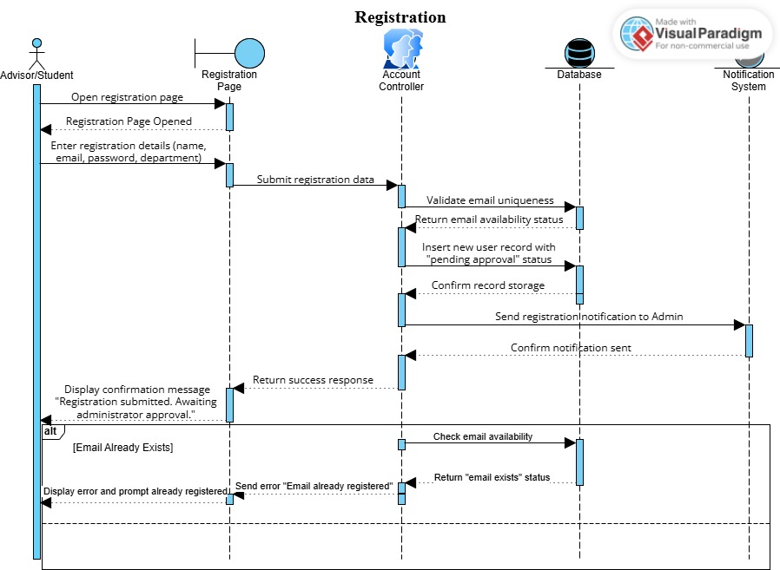
- Login
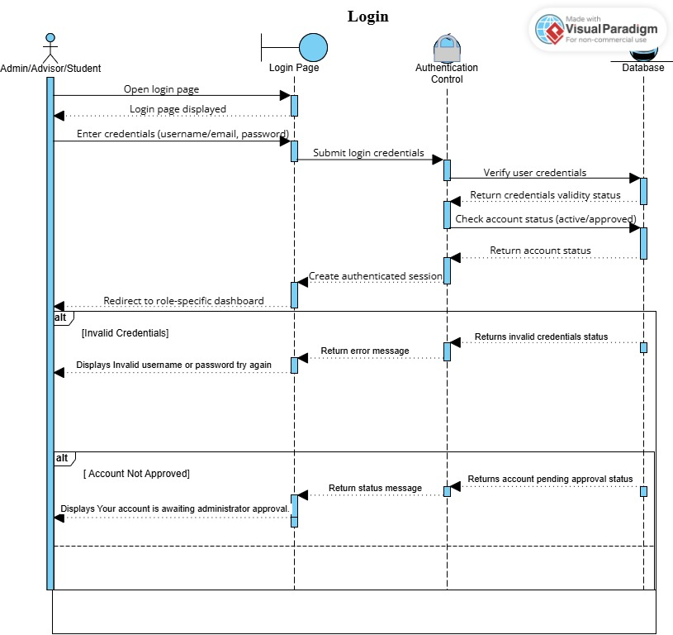

- Advisor View Assigned Groups
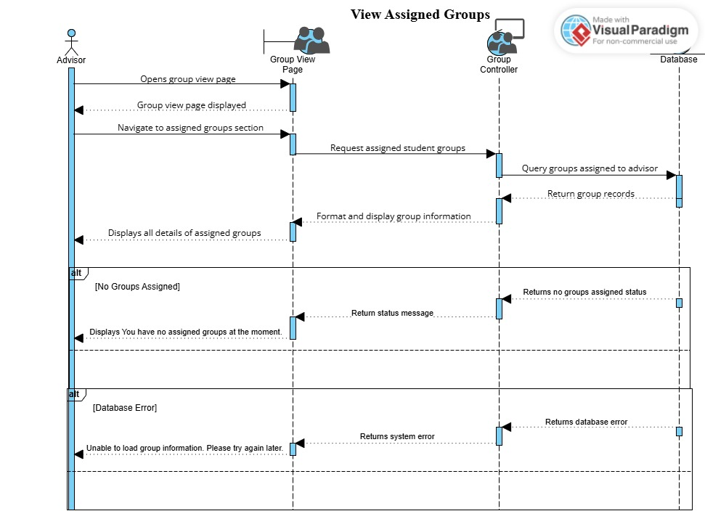
- Student Submit Project Title
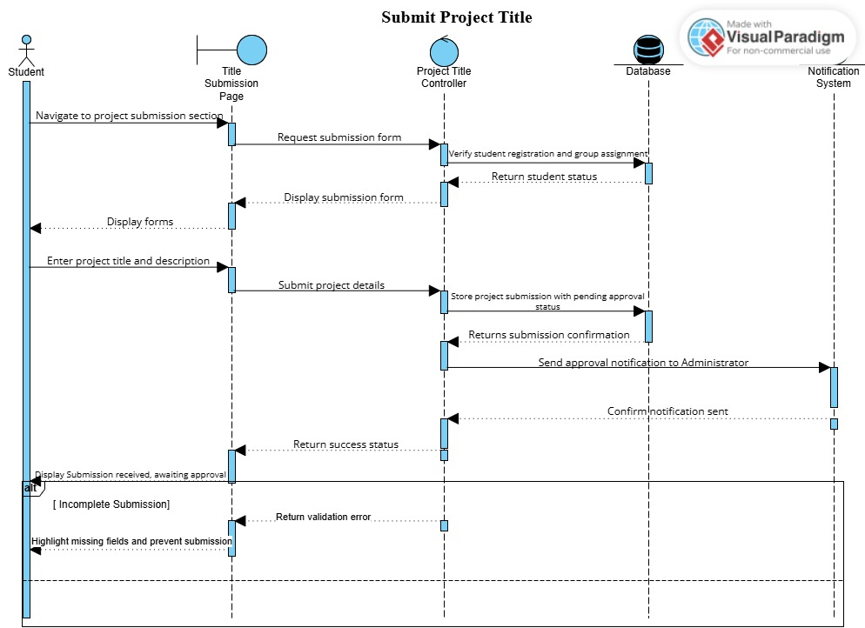

- Department Head Approve or Reject Topic
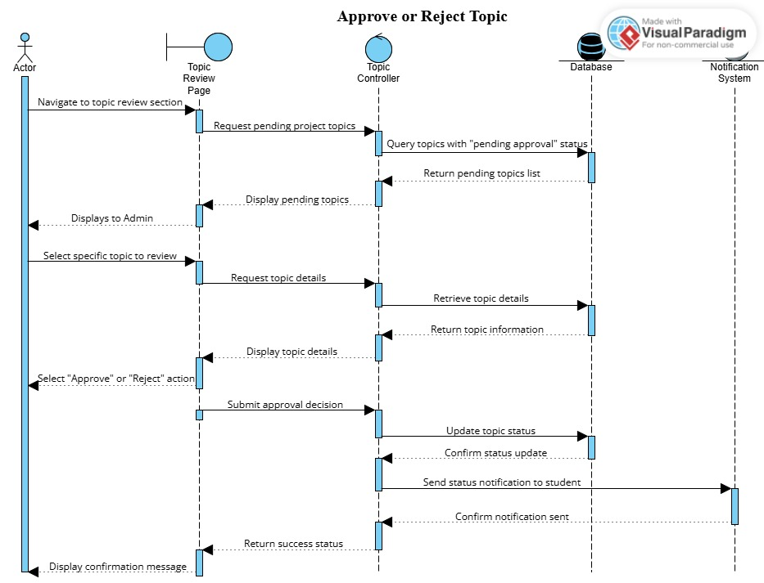
- Advisor Review Project Progress
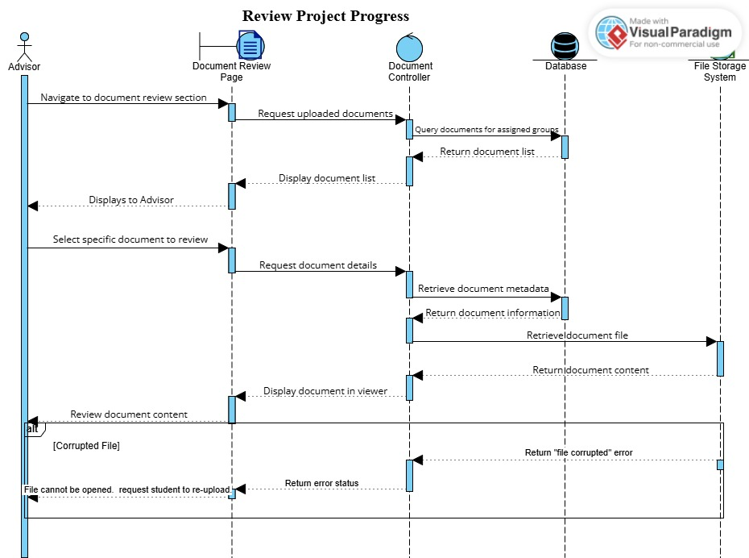

3.3.3 Activity Diagram
An essential part of the Unified Modeling Language (UML) is activity diagrams, which are effective tools for modeling and visualizing the dynamic aspects of a system’s behavior. Activity diagrams are vital in the context of the Final (Industrial) Project Management System because they depict the sequence and flow of academic activities from registration and group formation to project submission, advisor feedback, and evaluation. These diagrams provide a high-level view of the system’s workflow by illustrating how control passes between activities and actors.

While the system encompasses numerous processes, this analysis focuses on a select a few to maintain clarity and coherence, offering a thorough examination of the core features that define the user experience for students, advisors, Department Heads, and the Faculty Head.
1.Login
