 SUNU Park 
BANJUL CITY COUNCIL PREPARED BY INNOVII
FUNCTIONAL REQUIREMENTS — FOR DEVELOPERS
Street parking for Banjul,
on every phone.
What the SUNU Park prototype does, user by user: the driver and attendant apps, SMS and USSD, and the web portal for administrators, organisations, the police and the Council, and the technology it is built with.
Prototype release v1.2.50 · 4 October 2026 · Built by INNOVII for Banjul City Council · Demo server

Try it on the web
Home page · Administrator /admin · Organisation /org
Police /police · Council /council · SMS & USSD simulator /sms

Install the Android apps
SUNU Park (drivers) APK · SUNU Park Officer (attendants) APK
All releases & server package · Source code
Open the APK links in Chrome and allow "Install unknown apps" once.


02 — OVERVIEW

Six kinds of users, five channels
Drivers pay for street parking from any phone; attendants check plates on their road; the Council sees the money. Drivers and attendants never use the web. Four kinds of staff and partners sign in to the portal.
USER | WHO THEY ARE | CHANNELS | SIGN-IN
Driver | Anyone parking in a marked SUNU Park bay; pays for any plate | Driver app · SMS 7275 · USSD *7275# | Phone number + 6-digit SMS code
Parking attendant | Council attendant on a fixed road and shift | Officer app · SMS · USSD from the registered number | Registered number + SMS code
Organisation | Bank, ministry or company covering its fleet | Web /org | Billing contact's phone + SMS code
Administrator | SUNU Park / Council staff running the service | Web /admin | Username + password
Police | Officers following up unpaid fines | Web /police (read-only) | Username + password
Council | Banjul City Council revenue office | Web /council (read-only) | Username + password

Business rules (the same in every channel)
PRICE | AMOUNT | RULE
Daily pass | 200 GMD | Valid till 7pm the day it is paid. The pass follows the plate.
Monthly pass | 4,000 GMD | 20 paid days; reminder SMS 3 days before it ends.
Fine | 1,880 GMD | Added when a warning is not paid within 24 hours.
Organisations | 48,000 GMD | Per car per year, paid upfront (less any discount); cars added later pay the months left.

- Paid hours 7am–7pm, Monday–Saturday; free otherwise.
- Warnings: an unpaid car gets a warning; the driver pays the daily fee within 24 h, after that fee + fine.
- Fines first: a phone with an unpaid warning on any plate settles it before buying a new pass.
- Offender history: first-time or repeat offender, shown to attendants and police.
- Renewal invoice 30 days before an organisation's year ends, 5 days' grace. Revenue share 60% Council, 40% operator.
- Prices always come from the tariff, never hard-coded; tariff changes need a Council authority reference.

03 — DRIVERS

Pay the way you prefer
No cash and no account to open. Payment by Wave, Afrimoney, APS or QMoney (simulated on the demo server; switched off in production until providers are connected).
ID | DRIVER APP (ANDROID) | PRIORITY
DRV-01 | Launch screen: navy brand screen that splits open into the app; Android splash matches its first frame. | Must
DRV-02 | Onboarding & sign-in: three intro screens, phone number, 6-digit SMS code (expires in 5 min, 5 tries). | Must
DRV-03 | Terms gate: read the terms to the end and accept before first use and after every new version. | Must
DRV-04 | Home: status of each plate (PAID daily / monthly / organisation, or UNPAID), free hours, Council announcements. | Must
DRV-05 | Pay: daily or monthly pass for any plate with a mobile-money provider; receipt with ticket number. | Must
DRV-06 | Warnings: open warnings, amount owed and deadline; pay them (offered first, other payments blocked). | Must
DRV-07 | Plates: add and remove plates; see which are covered by an organisation. | Must
DRV-08 | Activity & messages: payments, receipts and every SMS sent to the number. | Should
DRV-09 | Profile: number, version, terms, support contacts, sign out. | Should

SMS line 7275
- Text a plate BJL1234 → reply 1 daily pass or 2 monthly pass → reply 1–4 to choose the provider.
- M BJL1234 goes straight to the monthly pass · HELP · TERMS.
- Receipts, warning notices and reminders by SMS (under 160 characters where possible).

USSD *7275#
- Menu: 1 Daily pass · 2 Monthly pass · 3 Check a plate · 4 Pay a warning · 5 My plates · 6 Terms.
- An unpaid warning is shown first. Works on any phone without internet.
- Gateway: POST /api/ussd (CON / END convention).

04 — PARKING ATTENDANTS

Check plates, not cash
ID | OFFICER APP (ANDROID) · ALSO BY SMS AND USSD FROM THE REGISTERED NUMBER | PRIORITY
ATT-01 | Sign-in only for numbers registered in the back office; switched-off attendants are refused. | Must
ATT-02 | Shift: start and end (START / END); the reply names the fixed road and shift (7am–1pm or 1pm–7pm). | Must
ATT-03 | Check a plate: PAID (daily, monthly, organisation) or NOT PAID, with first-time / repeat-offender history. | Must
ATT-04 | Issue a warning to an unpaid car (W BJL1234); the driver gets an SMS and an in-app notice. | Must
ATT-05 | Checks & messages: today's checks, targets, messages. Attendants never take money. | Should
04 — ORGANISATIONS · WEB /ORG

One invoice a year, every car covered
ID | ORGANISATION PORTAL | PRIORITY
ORG-01 | Sign-in by the billing contact's phone and SMS code; no self sign-up (set up by the account manager). | Must
ORG-02 | Overview: cars covered vs agreed, cover end date, open invoices, attendant checks this month. | Must
ORG-03 | Fleet: add or remove cars one by one or upload a CSV list; added cars pay the months left. | Must
ORG-04 | Invoices: yearly upfront per car, bank-transfer details, "I have paid" with reference; renewal 30 days before, 5 days' grace. | Must
ORG-05 | Reports: statements of paid invoices (print / PDF) and checks per car. | Should

How the users connect · a warning, end to end
- 1 · Attendant checks BJL8080: NOT PAID, first-time offender, and issues a warning.
- 2 · Driver gets an SMS and an app notice: pay 200 GMD within 24 hours.
- 3 · After 24 h unpaid: 200 + 1,880 GMD; reminder SMS; other passes blocked until paid.
- 4 · Police see the overdue plate and its linked phone in Fines tracking.
- 5 · Council sees the payment in the revenue report, 60% Council share.

05 — ADMINISTRATOR · WEB /ADMIN

Parking for Banjul, run from one place
ID | PAGE | REQUIREMENT
ADM-01 | Dashboard | Live roads, attendants on shift, payments and checks today; items that need attention.
ADM-02 | Attendants | Register (name, staff no., number, road, shift), move, switch off; welcome SMS.
ADM-03 | Organisations | Create with billing contact, agreed cars and discount; see fleets and invoices.
ADM-04 | Payments | Match bank transfers to invoices; record and refer payment exceptions.
ADM-05 | Warnings | Record a warning paid at the Council office (receipt no.); cancel one issued by mistake.
ADM-06 | Tariffs & rules | Daily price, yearly price per car, fine; Council authority reference required; history kept.
ADM-07 | Announcements | Publish, show or hide notices in the driver app.
ADM-08 | Terms & conditions | Edit and publish versions; every app asks to accept again; optional SMS with the link.
ADM-09 | Staff & audit | Create Administrator, Police or Council accounts (temporary password shown once), reset, switch off; audit log.

Police · /police (read-only)
- Fines tracking: open warnings, overdue fines (24 h passed) first.
- Plate record: first-time or repeat offender, every warning and its status.
- Phone numbers linked to a plate, for follow-up. No receipts or wallets.
- Cannot change anything; every sign-in recorded.

Council · /council (read-only)
- Revenue report: collected today, Council share 60%, operator share 40%.
- By source (daily, monthly, organisations, warnings) and by road, with the unpaid rate.
- Fines tracking and the terms in force; print or save as PDF.
- Cannot change anything; every sign-in recorded.

06 — FOR EVERY USER

Shared requirements

Sign-in & security
- Phone users: 6-digit SMS code, valid 5 minutes, 5 tries; one code per minute.
- Staff: the first password is temporary and must be changed (10+ characters); 5 wrong passwords → 15-minute wait; sessions last 12 hours.
- Every action is checked on the server against the user's role and own number.

Privacy
- Each role receives only its own data (server-side views per role): drivers their plates and receipts, attendants their shift and checks, organisations their fleet, police warnings and linked numbers.
- Nobody but staff sees other people's phone numbers.

Terms & conditions
- Versioned by administrators; public at /terms (sunupark.gm/terms). Apps: scroll to the end and tick before continuing. SMS/USSD: paying means accepting; TERMS sends the link.

Audit, live updates & notifications
- Every sign-in and change is written to the audit log with the person's name.
- A check, payment or announcement reaches every open screen within seconds; the release number shows in the apps, portal and /api/health.
- Receipts after every payment; warning SMS with deadline; warning reminder the next day; monthly pass reminder 3 days before; organisation renewal invoice; new terms by SMS (optional).

Demo & testing tools
- SMS & USSD simulator at /sms: act as any phone, 18 ready-made use cases. Demo clock and reset on demo servers only.
- Production mode starts empty, follows real time, payments off until providers are connected.

Look & language
- Pale blue #F6FBFE, navy #0B2E63, SUNU yellow #FEDB46, Plus Jakarta Sans; the Banjul scene as vector art; plain words; prices always from the tariff.

07 — HOW THE PROTOTYPE IS BUILT

Technology
Apps (Android, Capacitor) · web portal · phones (SMS 7275, USSD *7275#) → Nginx and the SMS/USSD gateway → Tomcat 10.1 (parkna.war, Java 17) → MariaDB.
LAYER | TECHNOLOGY | WHY
Apps | HTML/CSS/vanilla JavaScript wrapped with Capacitor into Android APK/AAB | One small codebase, no framework, fast on low-end phones
Web | Static HTML/CSS/JS pages served by Nginx; vector SVG art; Plus Jakarta Sans | Sharp on every screen, nothing to install
Rules | engine.js and ParkingEngine.java, kept identical by parity tests | Same answers on server, apps and SMS
Server | Java 17 servlets on Tomcat 10.1, Maven, Jackson, SLF4J/Log4j2 | INNOVII standard stack on Rocky Linux
Data | MariaDB, versioned SQL migrations applied on start | Simple upgrades, nightly backups
Messaging | Kannel (SMPP) for SMS; Africa's Talking-style USSD endpoint; simulated mode for demos | Works with Gambian telcos
Payments | Wave, Afrimoney, APS, QMoney (simulated now); organisations by bank transfer | Real APIs once agreements are in place
Quality | GitHub Actions: back-end tests with MariaDB, Playwright browser tests, CodeQL, Dependabot | Every merge is tested and released automatically
Releases | 1.2.<build>: server package + both APKs on GitHub; one-command deploy and rollback | Repeatable installs

Demo sign-ins
- Police: police / police-demo
- Council: council / council-demo
- Organisation: Demo Bank, phone 7101234 (the code shows on screen)
- Administrator: account from INNOVII

Next steps to go live
- Mobile-money provider APIs and real payments.
- Telco SMS short code and USSD gateway.
- HTTPS domain (sunupark.gm) and Play Store upload key.
- Production server, backups and staff training.

Code & docs: github.com/abdiMuhamud/parkna-demo · README, docs/ARCHITECTURE.md, docs/DEPLOYMENT.md

08 — SCREENS · WEB

The web portal today
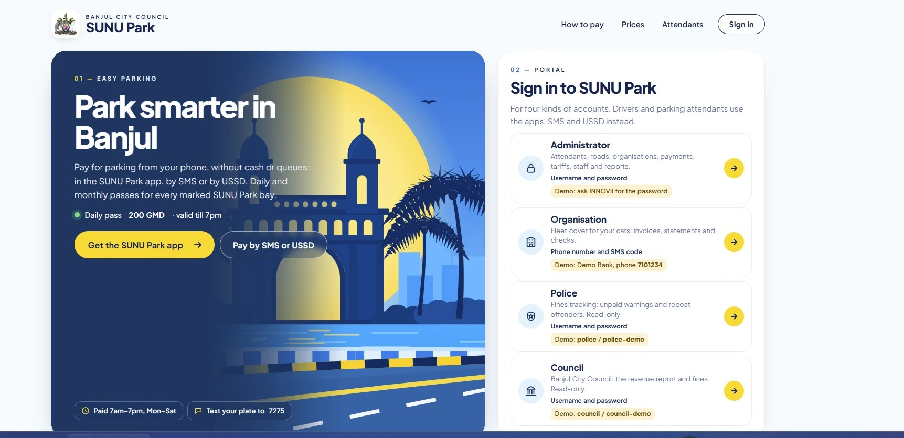
Home page landscape: the hero beside the four portal sign-ins
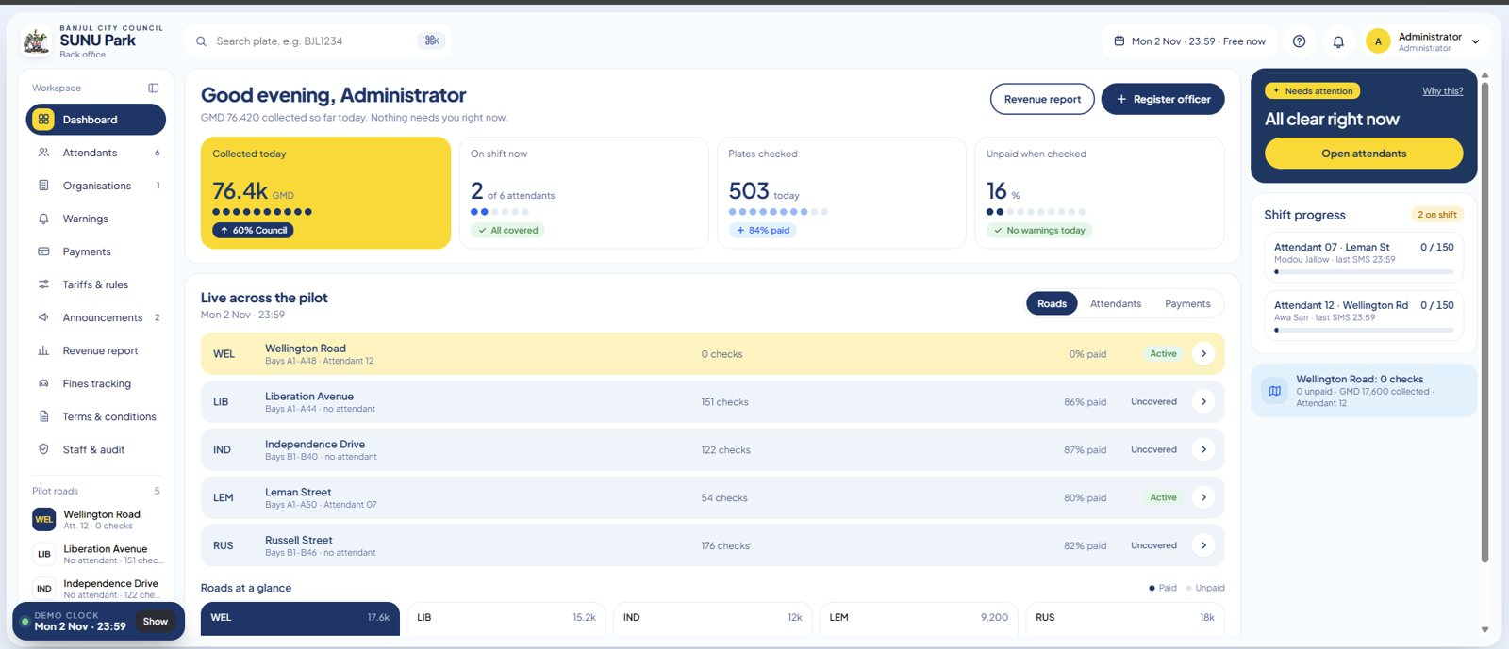
Administrator dashboard /admin: live roads, attendants, payments
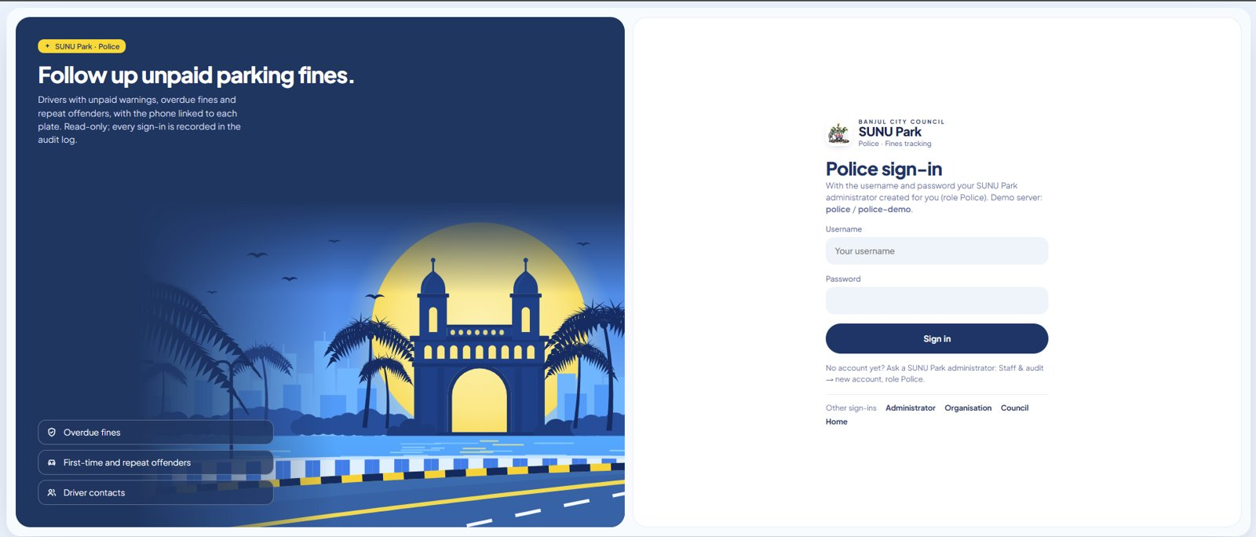  Police sign-in · /police | 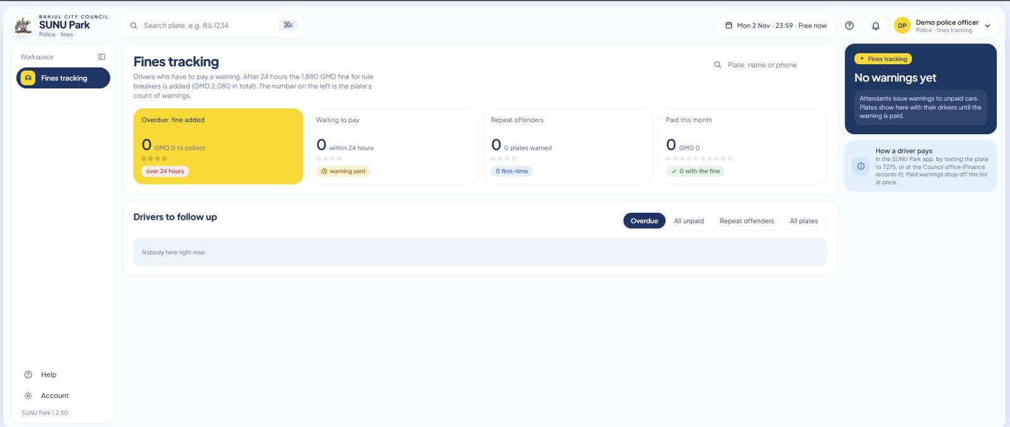  Fines tracking · read-only

09 — SCREENS · ANDROID APPS

The two apps

SUNU Park · drivers
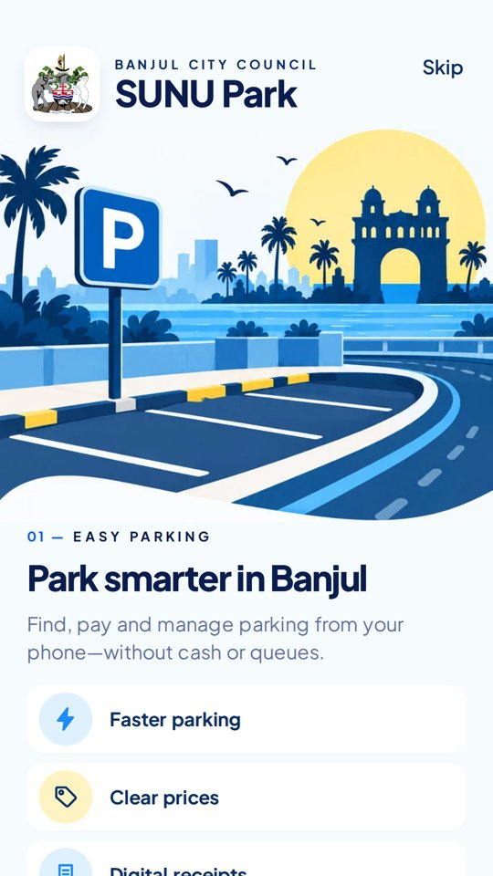  Welcome | 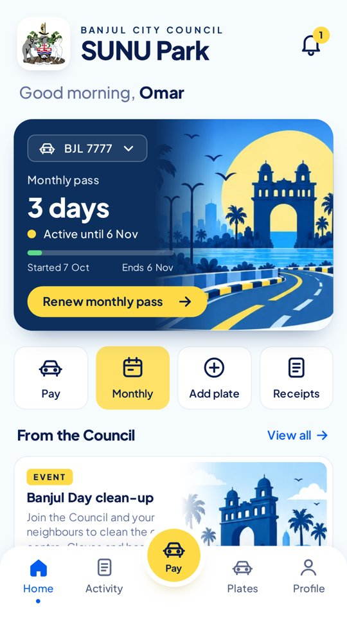  Home · monthly pass | 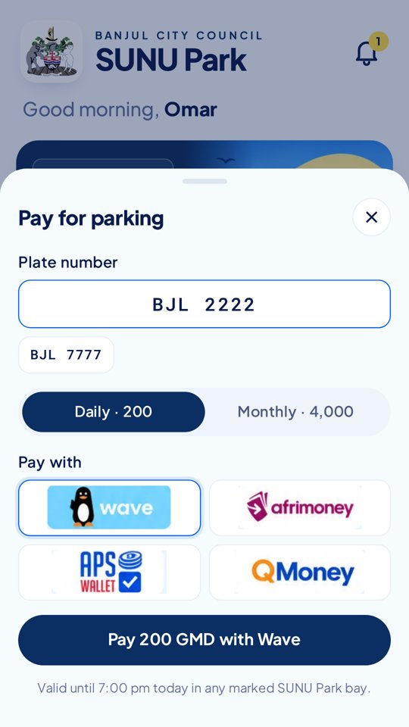  Pay | 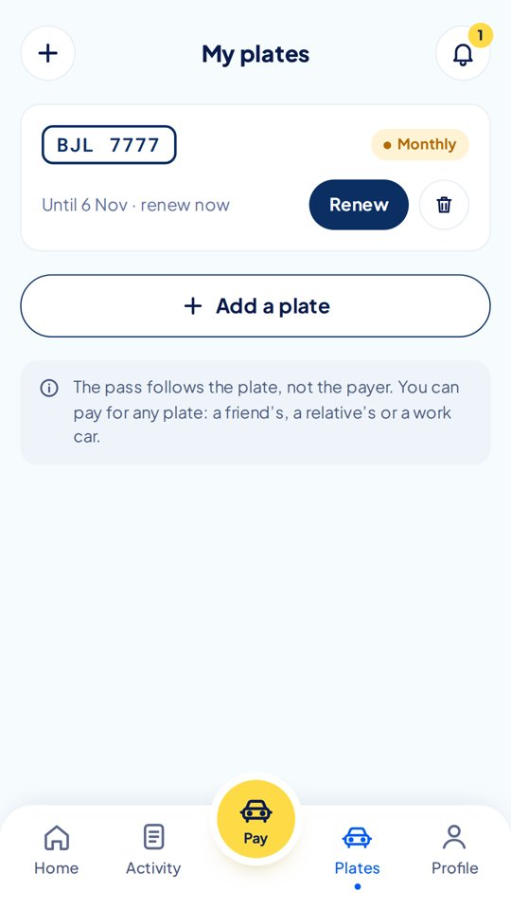  Plates

SUNU Park Officer · attendants
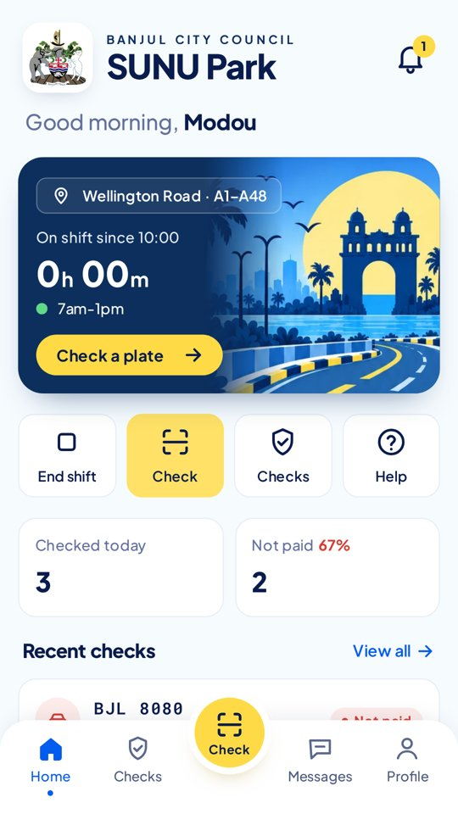  On shift | 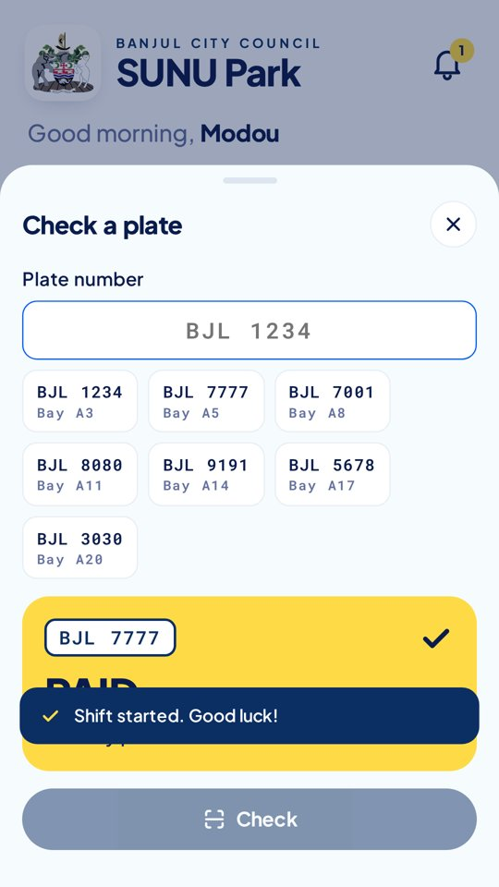  Check · PAID | 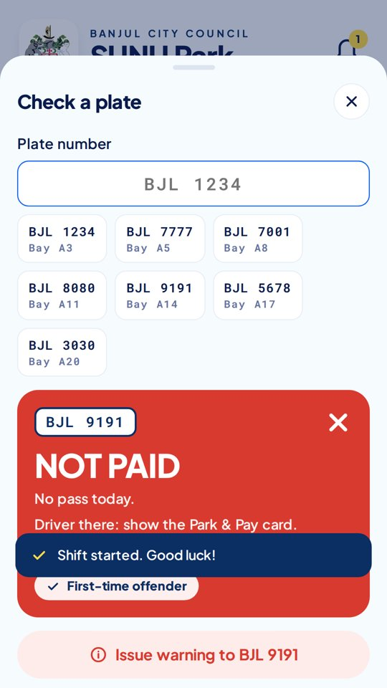  Check · NOT PAID | 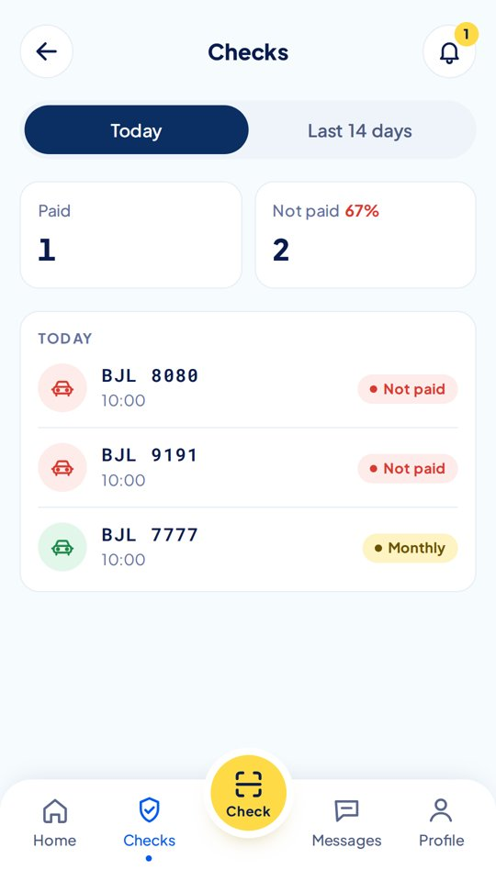  Today's checks

10 — CUSTOMER JOURNEYS ACROSS EVERY CHANNEL

One service, four ways in
Every journey runs on the same rules engine, so a pass bought by SMS shows in the app, the attendant check and the Council report. Screens below are real replies from the demo server.
JOURNEY | APP | SMS 7275 | USSD *7275# | WEB
Pay a daily pass | Pay sheet | Text the plate → 1 Daily → provider 1–4 | 1 Daily pass | —
Buy a monthly pass | Monthly tab | Text the plate → 2 Monthly → provider 1–4 (or M BJL1234) | 2 Monthly pass | —
Settle a warning (fines first) | Warning offered first | Text the plate → warning first → provider 1–4 | 4 Pay a warning | Council office (admin records it)
Check if a plate is paid | Home / Plates | Text the plate | 3 Check a plate | Police: Fines tracking
See my plates & receipts | Plates, Activity | Receipts by SMS | 5 My plates | —
Read and accept the terms | Terms gate (scroll + tick) | TERMS → link | 6 Terms | /terms page
Fleet cover for an organisation | — | Contact texts a car: covered | — | /org: fleet, invoices
Attendant shift & checks | Officer app | START · plate · W plate · END | Attendant menu 1–4 | Admin: attendants page

SMS: pay, monthly, and a warning end to end
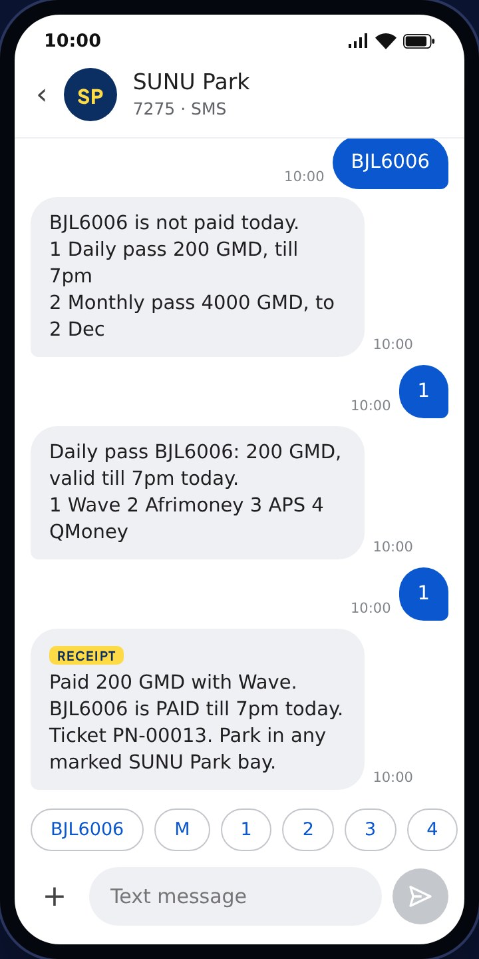  Plate → 1 Daily → 1 Wave | 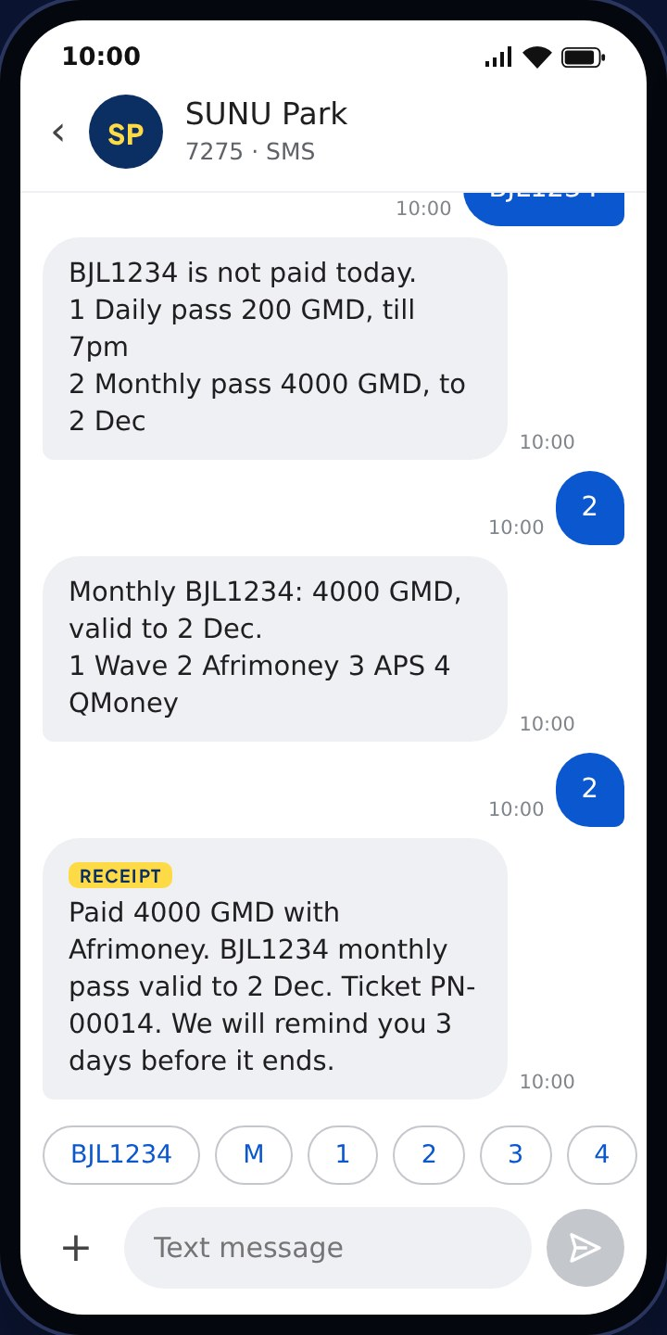  Plate → 2 Monthly → 2 Afrimoney | 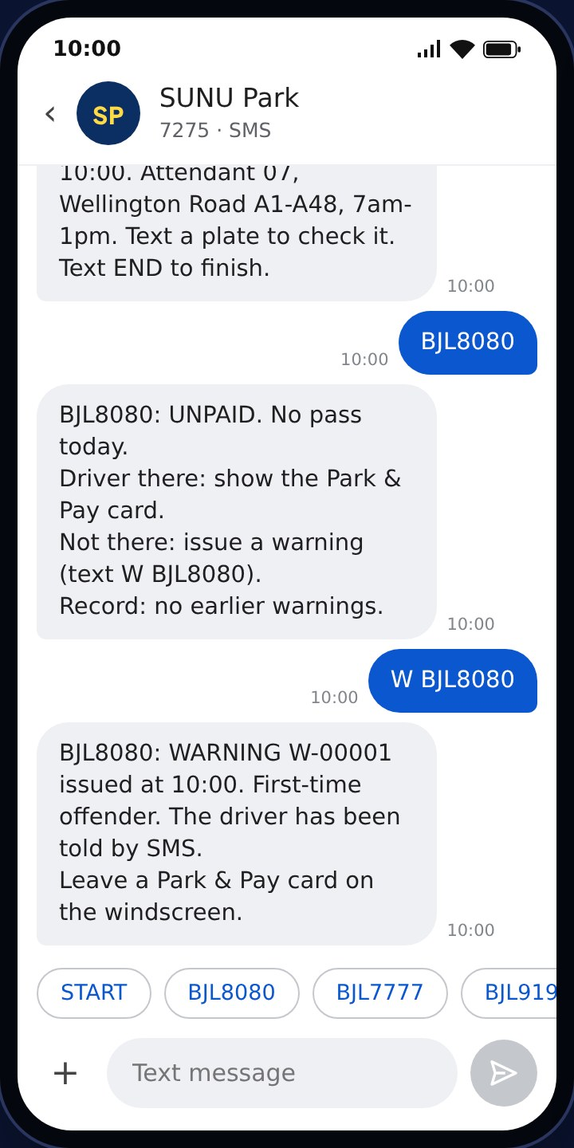  Attendant: START, check, warning | 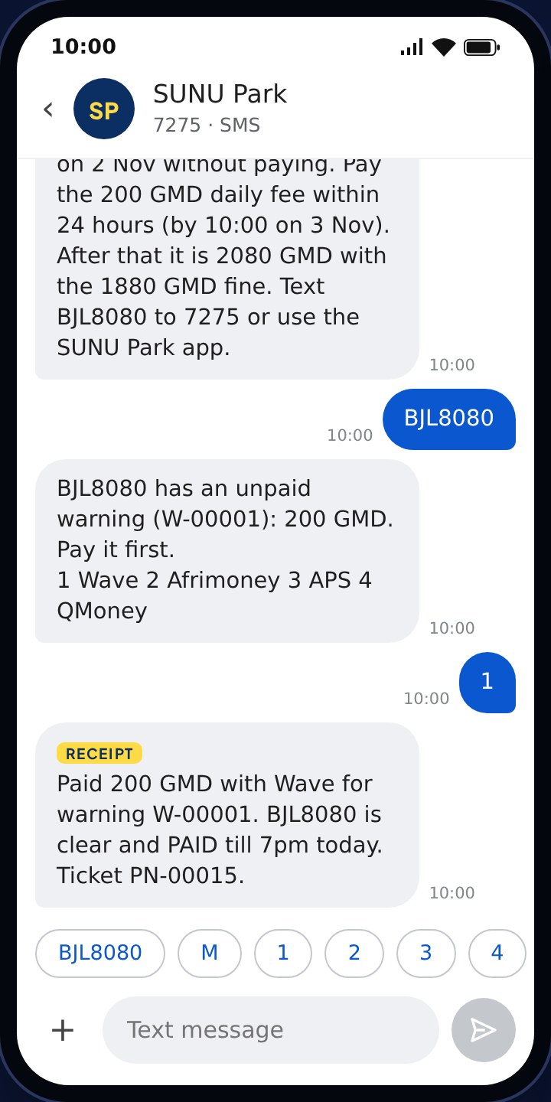  Driver settles the warning

11 — CUSTOMER JOURNEYS · USSD AND WEB

No smartphone needed
USSD works on any phone without internet: each screen is one request to POST /api/ussd (CON = show and wait, END = close). A daily pass in four screens.
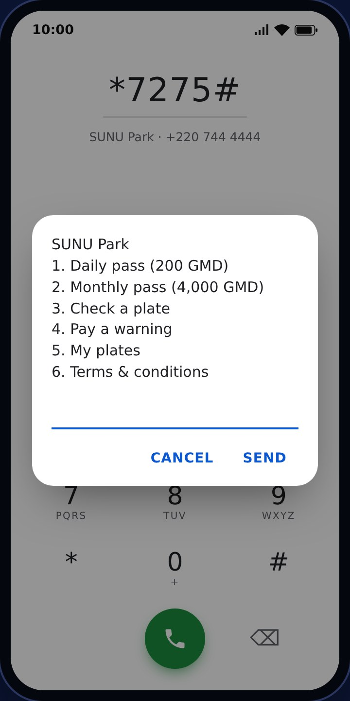  1 · Dial *7275#: menu | 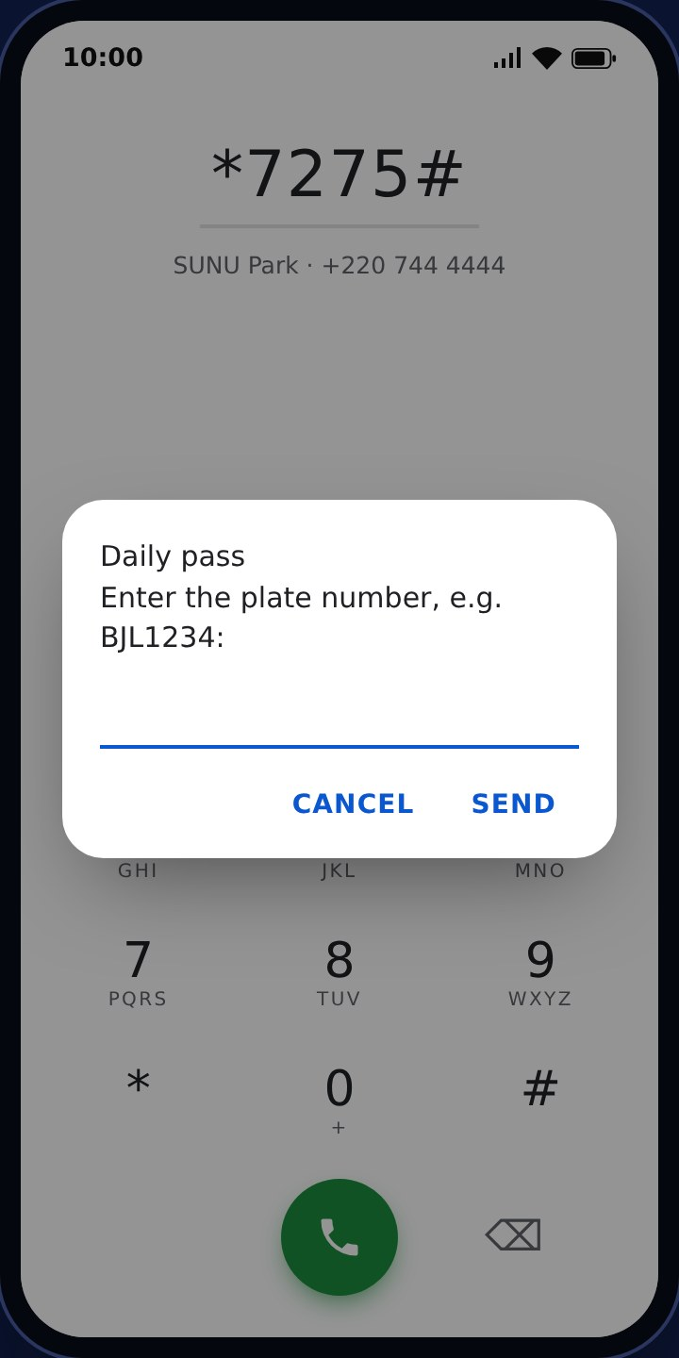  2 · Daily pass: plate | 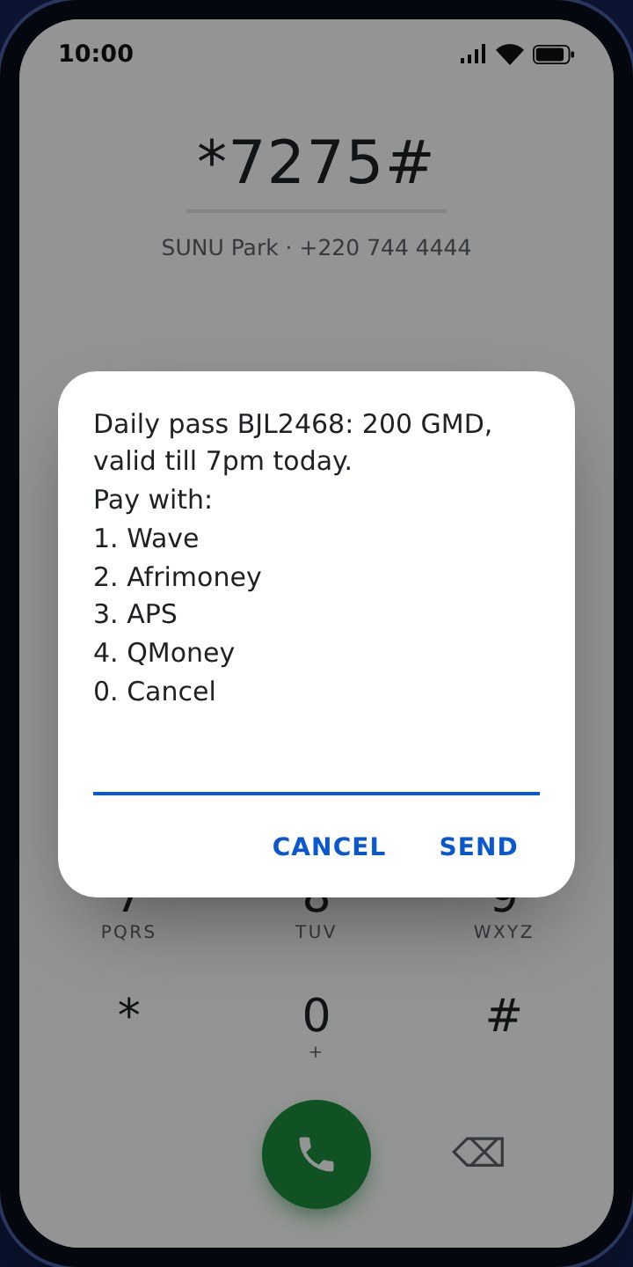  3 · Price & provider | 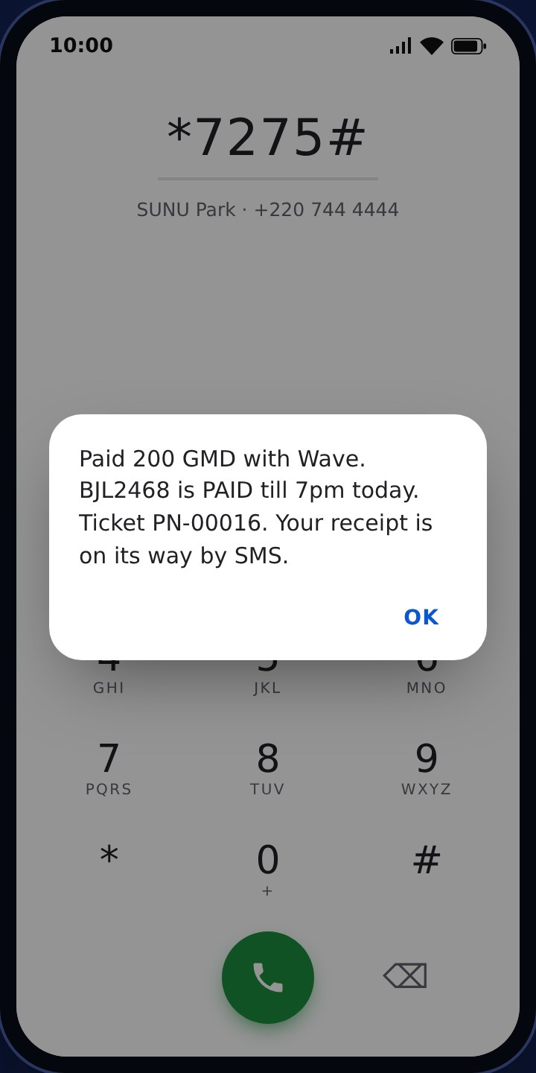  4 · Paid, receipt by SMS
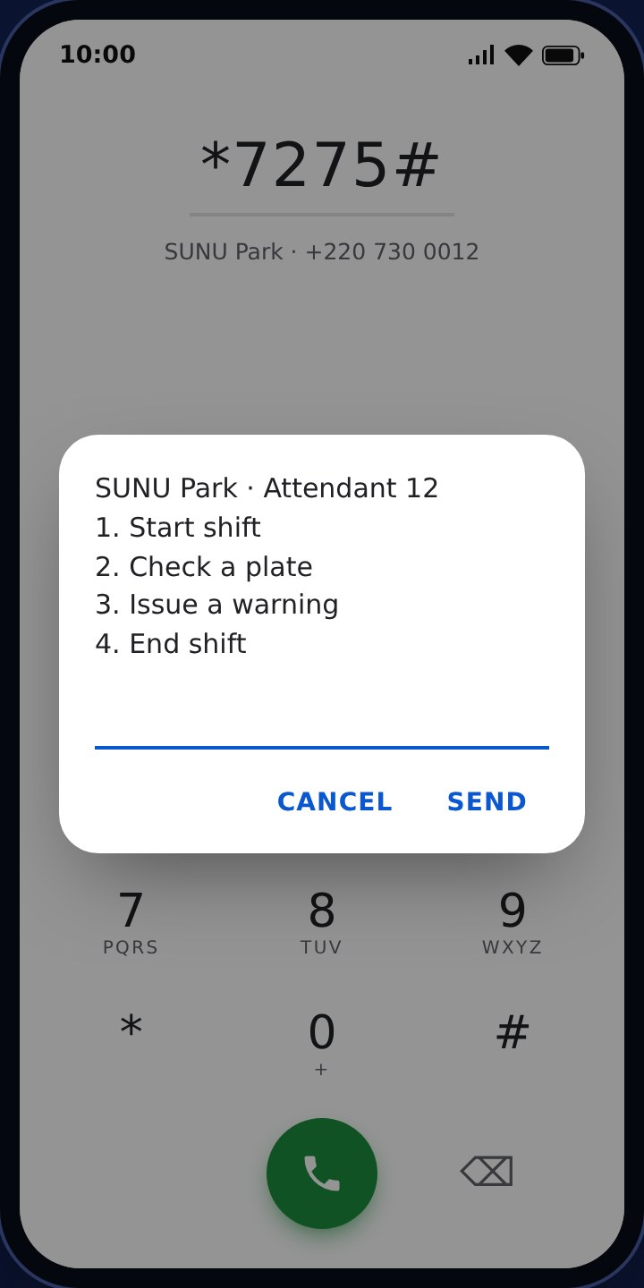
Attendant menu (registered number)
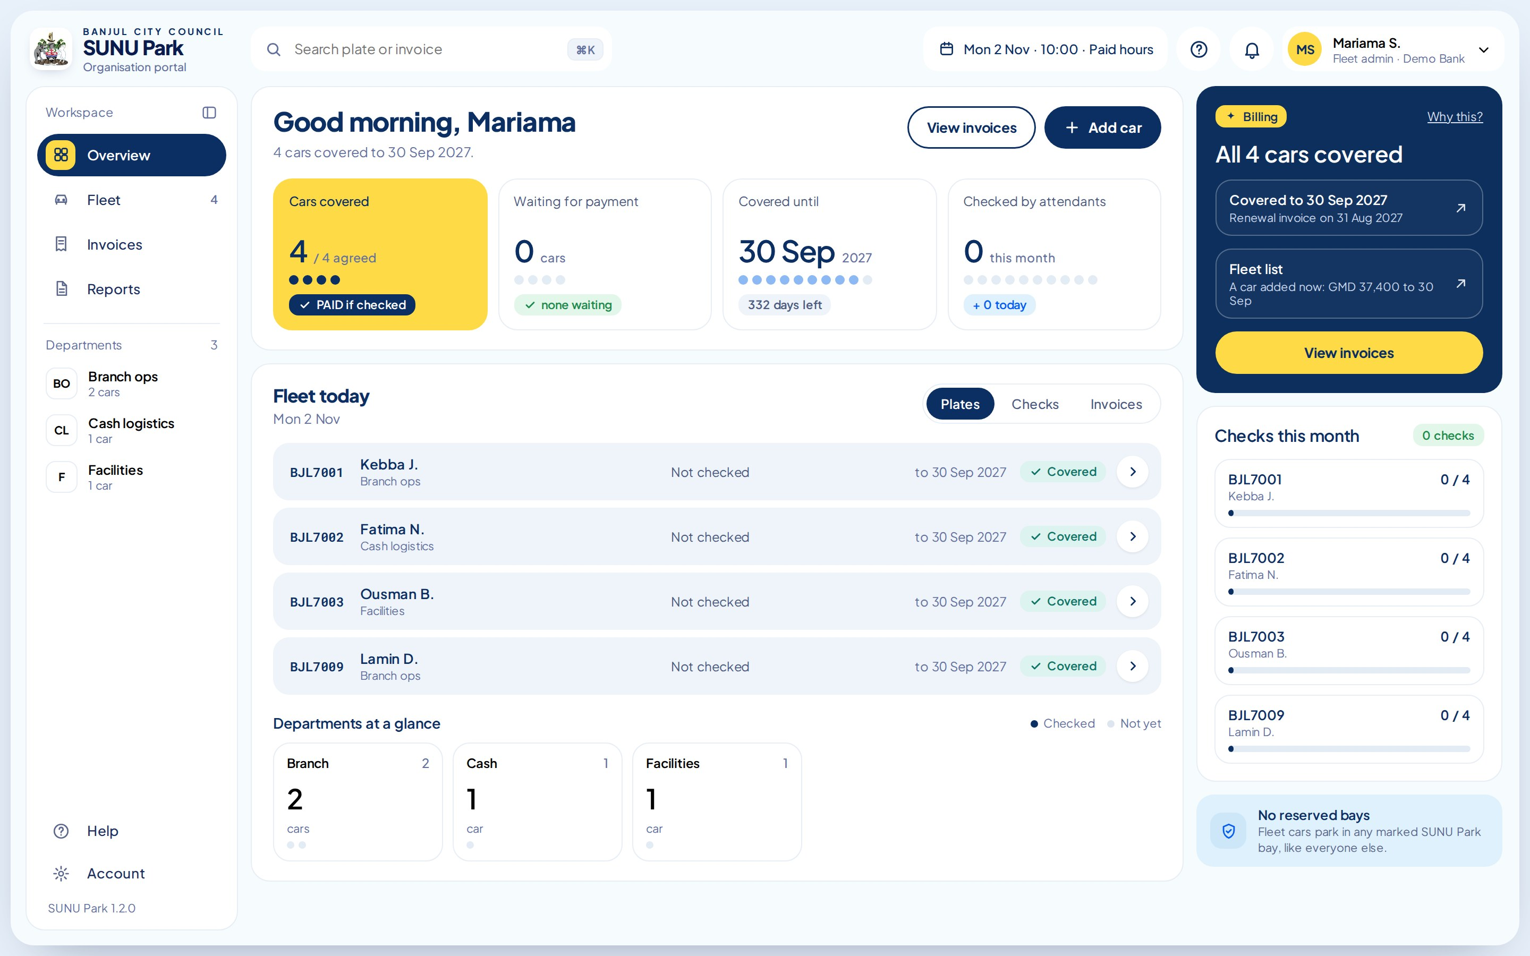
Organisation portal /org: Demo Bank's fleet, cover and invoices (sign-in by SMS code)

