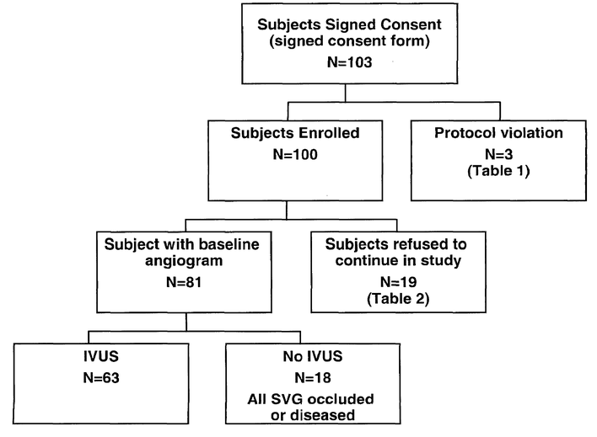
DWRITE 045518
Source: https://www.industydocuments.ucsf.edu/docs/nnvw0217

