Predictive Model Development & Validation Pack
Referral No-Show Risk Model for Jigjiga University Sheikh Hassan Yabare
Comprehensive Specialized Hospital (JJUSHYCSH) — Sprint 2 of 3

BAN6800 Business Analytics Capstone Module 4 Assignment
Abdi Farah Ahmed
Nexford University
October 2026

1. Business Need and Target Definition
JJUSHYCSH is the only tertiary referral hospital for Ethiopia's Somali Region, serving six to seven million largely rural and pastoralist people (CURE Ethiopia, 2023); a missed follow-up delays care and wastes a specialist slot someone else travelled far for. The Module 1 Vision Document (Ahmed, 2026a) set two KPIs, at least 15% fewer no-shows and at least 70% recall of high-risk appointments, so that limited SMS, phone and community-health-worker capacity is targeted. Module 2 (Ahmed, 2026b) planned the architecture and four sprints; Module 3 delivered Sprint 1, the governed data pipeline. This report is Sprint 2: the model, its validation and its explanation, built on the Module 3 data.
The task is binary classification. The unit of analysis is one scheduled appointment; the target no_show equals 1 when the patient did not attend (Module 3 data dictionary). The prediction horizon is 24 to 72 hours before the appointment, matching Module 3's daily 18:00 pipeline run. Success criteria from Module 1: (1) recall of at least 70% on no-shows at the High-tier threshold; (2) a gain of at least 0.02 ROC-AUC over a transparent lead-time rule; (3) no protected group outside the fairness tolerance below.
Fairness objectives come from Module 2, Section 6: because the intervention is outreach and, by the Module 1 charter, a score can never reduce care, the governing criterion is equal opportunity, with a release threshold of a true-positive-rate gap no greater than 0.1 across monitored groups (Hardt et al., 2016). False-positive-rate gaps (equalized odds) and selection-rate ratios (four-fifths rule, disparate impact ≥ 0.8; Feldman et al., 2015) are diagnostics, which Module 2 says are not sufficient evidence of fairness alone. The protected attributes are the four groups the Module 3 bias suite monitors: gender, age band (0-5, 6-17, 18-34, 35-54, 55-69, 70+), welfare enrolment as a socioeconomic marker, and recorded disability; distance bands follow once local data are approved.

2. Data Readiness and Feature Set
The modelling dataset is the pseudonymised model table published by the Module 3 pipeline (ingest → validate → clean → anonymise → features → validate → publish) from the Kaggle Medical Appointment No Shows data (Hoppen, 2016), a disclosed proxy for JJUSHYCSH records. Module 3's quality report shows 110,527 records received and 109,899 model-ready rows after cleaning; the split files hold 77,155 training, 16,245 validation and 16,499 test appointments (2016-04-29 to 2016-06-08). The MD5 hash of the input files (8b87e2989f1b…) is tagged on every MLflow run, so each result traces to the exact Module 3 output; no model saw data that bypassed the Module 3 gates.
Features reuse the Module 3 definitions rather than re-deriving them: lead time in days, same-day flag, weekday, chronic-condition count, and the leakage-safe history (prior visits, prior no-shows, prior no-show rate, first-visit flag) that Module 3 computes only from earlier visits. Inside the scikit-learn pipeline (Pedregosa et al., 2011) numeric features are standardised and the weekday one-hot encoded, both fitted on training folds only.
Table 1. Final feature set and preprocessing.
Feature (Module 3 name) | Type | Treatment
age | numeric | standardised (top-coded at 90 in Module 3)
lead_days | numeric (derived) | standardised
prior_visits, prior_no_shows, prior_no_show_rate | numeric (history, past-only) | standardised
chronic_count | numeric (derived) | standardised
scholarship, hypertension, diabetes | binary | passthrough
same_day, first_visit | binary (derived) | passthrough
appt_weekday | categorical (derived) | one-hot

Four exclusions prevent leakage or unfairness: sms_received, because the SMS is the intervention the model targets and encodes scheduling policy rather than risk; area_code, so geography cannot become a penalty (the first Module 1 risk); gender, audit-only with no outreach rationale; and appt_month, a calendar proxy in six weeks of data.
The Module 2 data dictionary marked Alcoholism and Handcap for a necessity review and Module 3 handed them over as an open item. The review is a data-minimisation test under Proclamation No. 1321/2024: a gradient-boosting model was cross-validated with and without each flag (Table 2). removing alcoholism changed cross-validated PR-AUC by +0.0006, so it is dropped as an input and kept for the fairness audit only; removing has_disability changed cross-validated PR-AUC by -0.0013, so it is dropped as an input and kept for the fairness audit only. As chronic_count in Module 3 sums hypertension, diabetes and alcoholism, the count was rebuilt without alcoholism, so the dropped flag does not survive inside another feature.
Table 2. Necessity review of sensitive health flags (tolerance 0.005 PR-AUC).
Sensitive flag | CV PR-AUC with | CV PR-AUC without | Δ | Decision
alcoholism | 0.381 | 0.380 | +0.0006 | drop as input (audit only)
has_disability | 0.381 | 0.382 | -0.0013 | drop as input (audit only)

Table 3. Data bias check on the training split (continuation of the Module 3 bias suite).
Attribute | Group | Share of training split | No-show rate
gender | F | 65.0% | 20.2%
gender | M | 35.0% | 19.7%
age_band | 0-5 | 10.7% | 18.5%
age_band | 18-34 | 21.8% | 24.0%
age_band | 35-54 | 27.1% | 19.4%
age_band | 55-69 | 17.9% | 16.2%
age_band | 6-17 | 14.1% | 24.1%
age_band | 70+ | 8.4% | 15.1%
scholarship | 0 | 90.3% | 19.7%
scholarship | 1 | 9.7% | 23.3%
has_disability | 0 | 97.9% | 20.1%
has_disability | 1 | 2.1% | 18.2%

The Module 3 bias suite raised: has_disability 1 under-represented; the disability group's small share means its error rates are checked separately in Section 6. Base rates differ by age (6-17: 24.1%; 70+: 15.1%), so equal flag rates across age bands would be neither expected nor desirable, which is why demographic parity is reported but equal opportunity governs.

3. Train/Test Protocol and Baselines
The split is the patient-grouped 70/15/15 split produced by Module 3 (GroupShuffleSplit on patient_key, seed 42), so no patient appears in more than one set and history features cannot leak across sets; this run asserts zero overlap. The training split (77,155; no-show 20.0%) serves hyperparameter search with stratified 3-fold cross-validation grouped by patient; the validation split (16,245; 20.0%) selects the champion and fixes the thresholds; the test split (16,499; 20.5%) is scored once and informs no decision.
Two baselines anchor the comparison. A majority-class classifier predicts that everyone attends, giving 79.5% accuracy but zero recall, so accuracy cannot be the headline metric. A transparent rule a scheduler could apply by hand (flag if lead_days >= 5, cut chosen on validation for the same recall target) reached a test ROC-AUC of 0.699, recall 72.2% and precision 31.1%.

4. Model Development
Following Module 2 tickets S2-01 and S2-02, three algorithms span the interpretability–flexibility range: regularised logistic regression (the transparent baseline Module 2 requires as a comparison point), random forest (non-linear interactions, robust to outliers) and gradient-boosted trees (XGBoost; Chen & Guestrin, 2016), typically the strongest on tabular data. Class imbalance (one no-show in five) was handled with class weights rather than resampling, which keeps probabilities interpretable for the tiers. Each algorithm was tuned by randomized search (3 candidates, coarse ranges) with 3-fold patient-grouped stratified cross-validation optimising PR-AUC, the metric most sensitive to the minority class.
Every candidate was logged to MLflow (Zaharia et al., 2018) as a nested run with its hyperparameters and cross-validated scores, and each best pipeline with its model artefact; 35 runs sit in experiment 'jjushycsh-noshow-m4'. The champion was chosen on validation PR-AUC; its operating threshold is the highest threshold still reaching 70% validation recall, and a second threshold at 90% recall defines the Medium tier. Both are stored with the model.

Table 4. Tuned hyperparameters, cross-validation and validation scores.
Model | Best hyperparameters | CV PR-AUC | Val PR-AUC | Val ROC-AUC | Fit (s)
logistic regression | C=0.2481; penalty=l1 | 0.362 ± 0.002 | 0.344 | 0.720 | 10.8
random forest | n_estimators=200; min_samples_leaf=5; max_features=sqrt; max_depth=8 | 0.380 ± 0.003 | 0.368 | 0.732 | 24.3
xgboost | subsample=0.7; n_estimators=400; min_child_weight=1; max_depth=3; learning_rate=0.05; colsample_bytree=0.85 | 0.382 ± 0.002 | 0.367 | 0.734 | 22.3

Random Forest was selected with a validation PR-AUC 0.024 above logistic regression. This margin justifies the added complexity despite Module 1's preference for simpler models, provided the SHAP explanations in Section 6 travel with every score and the logistic baseline stays in the registry as the fallback.

5. Performance Evaluation and Validation
Metrics match the business risk: with one no-show in five, PR-AUC drove model selection and recall at the fixed threshold is the operational measure, while ROC-AUC, precision, F1, accuracy and the Brier score are reported for completeness and calibration. A false positive costs one reminder and a false negative a specialist slot, so recall outweighs precision.
Table 5. Module 3 test-split performance at each model's operating threshold.
Model | Threshold | Accuracy | Precision | Recall | F1 | ROC-AUC | PR-AUC | Brier | Flag rate
baseline majority | 0.500 | 0.795 | 0.000 | 0.000 | 0.000 | 0.500 | 0.205 | 0.205 | 0.0%
baseline lead time rule | 5.000 | 0.614 | 0.311 | 0.722 | 0.434 | 0.699 | 0.310 | n/a | 47.7%
logistic regression | 0.562 | 0.650 | 0.334 | 0.709 | 0.454 | 0.733 | 0.379 | 0.213 | 43.6%
random forest | 0.560 | 0.658 | 0.340 | 0.708 | 0.459 | 0.742 | 0.384 | 0.210 | 42.8%
xgboost | 0.561 | 0.662 | 0.342 | 0.704 | 0.461 | 0.745 | 0.398 | 0.210 | 42.2%

The champion, Random Forest, achieved a test ROC-AUC of 0.742 and PR-AUC of 0.384 against a prevalence of 20.5%, a gain of 0.043 ROC-AUC over the lead-time rule. At its threshold (0.560) it recovers 70.8% of no-shows with precision 34.0% while flagging 42.8% of appointments (validation recall 70.0%). The recall target therefore holds on patients the model has never seen. Modest precision is acceptable because the cost asymmetry favours reach.
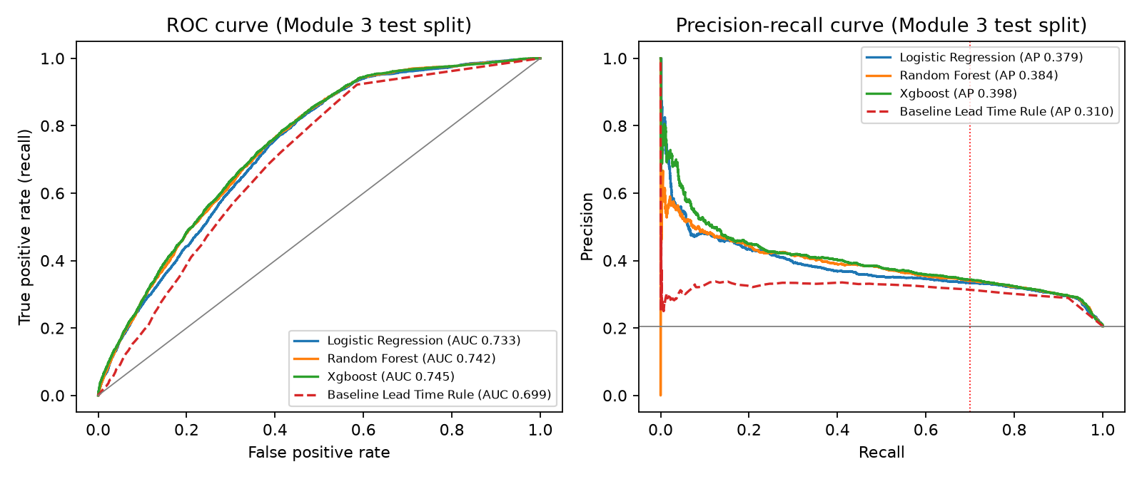
Figure 1. ROC and precision–recall curves on the Module 3 test split; dashed = lead-time rule, red dotted = recall target.
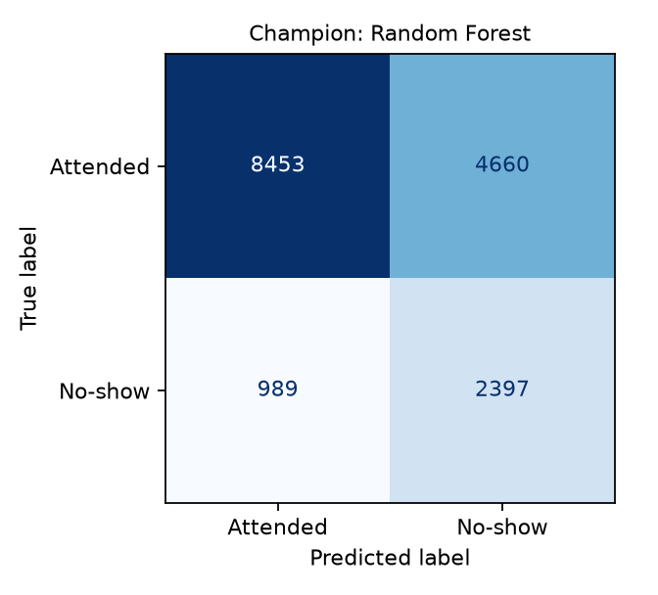
Figure 2. Confusion matrix of the champion (Random Forest) at the operating threshold.
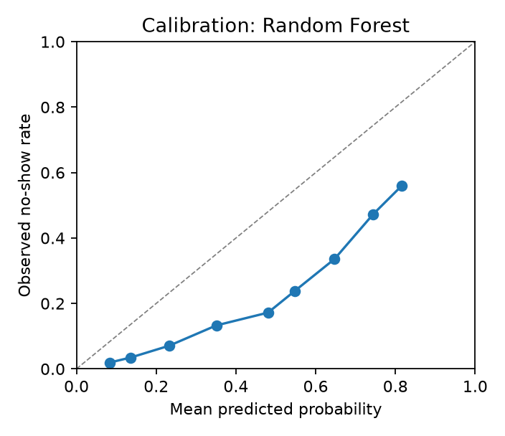
Figure 3. Reliability diagram of the champion's probabilities (test split).
Leakage confirmation: no patient overlap across sets; scaling and encoding fitted inside the pipeline; history features use only earlier visits (Module 3 test_features.py); sms_received excluded; cross-validated, validation and test ROC-AUC are close and no score is suspiciously perfect. A forward-in-time check (champion configuration refitted on dates before 2016-06-01, scored on the latest 22,414 appointments) gave ROC-AUC 0.734 and recall 68.6% at the earlier threshold: the drift signal the monitoring plan tracks.

6. Explainable AI and Fairness Analysis

6.1 Global explanations (SHAP)
Following the Module 2 explainability framework, SHAP values (Lundberg & Lee, 2017) were computed with TreeExplainer on 2,000 test appointments in real units. The three strongest drivers are Lead time (days booked ahead), Same-day appointment and Patient age.
- Lead time (days booked ahead): higher values raise predicted risk — the longer the gap between booking and the visit, the more time for a referred patient's travel plans, money or caregiving arrangements to fall through.
- Same-day appointment: being in this category lower predicted risk — same-day bookings are made by patients already at or near the facility, so they are rarely missed.
- Patient age: higher values lower predicted risk — age reflects life-stage barriers: adolescents and young adults miss more often, older patients with chronic follow-up attend more reliably.
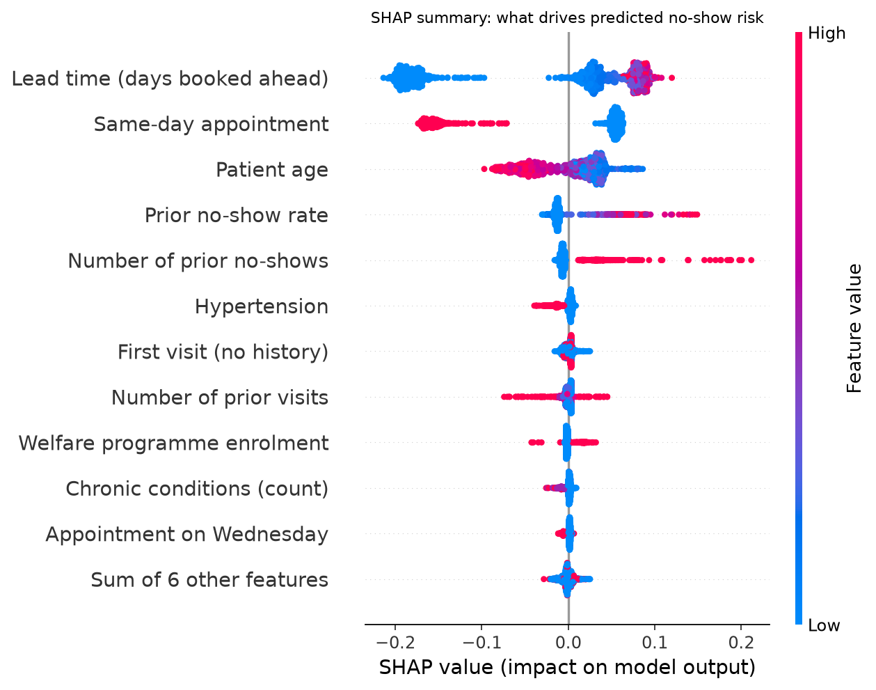
Figure 4. SHAP summary plot: each dot is one appointment; colour shows the feature value.
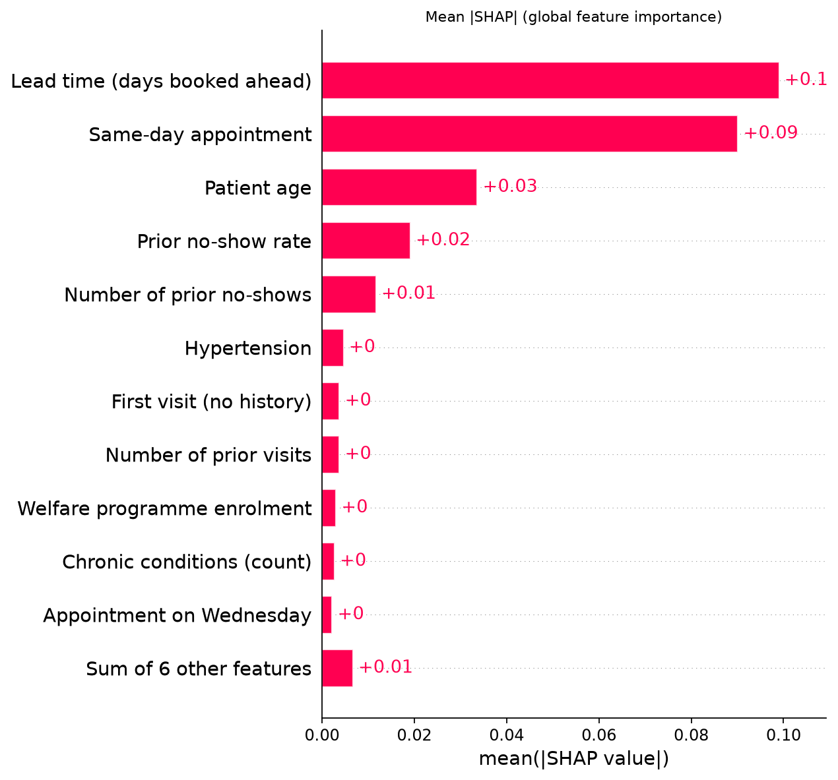
Figure 5. Global feature importance (mean absolute SHAP value).

6.2 Local explanations
For the high-risk example (predicted probability 0.85) the largest contributions were: Number of prior no-shows (+0.198), Prior no-show rate (+0.149), Lead time (days booked ahead) (-0.101). A coordinator receives this as a reason to call, not just a score; the notebook adds a borderline case.
For the low-risk example (predicted probability 0.06) the largest contributions were: Lead time (days booked ahead) (-0.184), Same-day appointment (-0.151), Number of prior visits (-0.051).
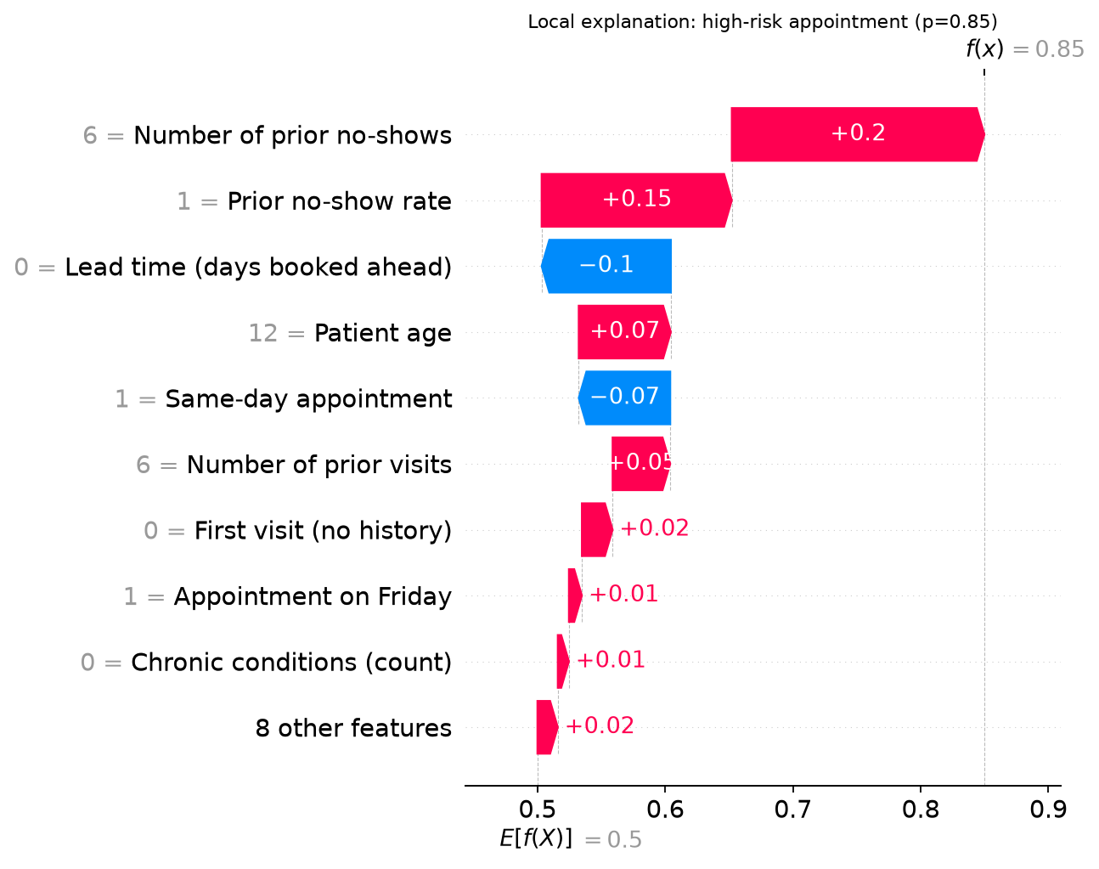
Figure 6. SHAP waterfall for the highest-risk sampled appointment.

6.3 Counterfactual explanations
Table 6. Actionable counterfactuals for correctly flagged no-shows (only lead time and weekday may change).
Age | Lead days | Weekday | Risk | Change needed | New risk
0 | 7 | Monday | 0.65 | book 0 days ahead (Monday) | 0.17
24 | 41 | Tuesday | 0.77 | book 0 days ahead (Tuesday) | 0.23
44 | 17 | Monday | 0.60 | book 7 days ahead (Thursday) | 0.55
24 | 28 | Monday | 0.69 | book 0 days ahead (Monday) | 0.14
30 | 6 | Tuesday | 0.71 | book 0 days ahead (Tuesday) | 0.22

Counterfactuals answer 'what would need to change for a different outcome?' (Wachter et al., 2018; Mothilal et al., 2020). Only levers the hospital controls may vary; age, health and history are fixed. For 5 of 5 cases a shorter lead time alone moved the appointment below the threshold, supporting one action: offer earlier slots or a confirmation call close to the visit. Method: DiCE (random) counterfactuals saved to outputs/counterfactuals_dice.csv.

6.4 Fairness metrics
Table 7. Fairness metrics on the test split at the operating threshold (group tables in Appendix B).
Attribute | DP diff | DI ratio | TPR gap | FPR gap | EO diff | DI ≥ 0.8 (diag.) | TPR gap ≤ 0.1 (release)
gender | 0.007 | 0.984 | 0.003 | 0.010 | 0.010 | Yes | Yes
age_band | 0.589 | 0.093 | 0.828 | 0.510 | 0.828 | No | No
scholarship | 0.187 | 0.686 | 0.194 | 0.150 | 0.194 | No | No
has_disability | 0.214 | 0.504 | 0.335 | 0.172 | 0.335 | No | No

Metrics were computed per group (ticket S2-04) and cross-checked with Fairlearn (Weerts et al., 2023). The Module 2 release threshold (TPR gap ≤ 0.1) was exceeded for: age_band, scholarship, has_disability. The four-fifths diagnostic was below 0.8 for age_band, scholarship, has_disability. Where a flag-rate gap mirrors a real difference in base rates, as with age, a low disparate impact ratio reflects need, not bias; the recall gap is decisive. The disability group's estimates rest on 276 test appointments and carry wider uncertainty, as Module 3 anticipated.
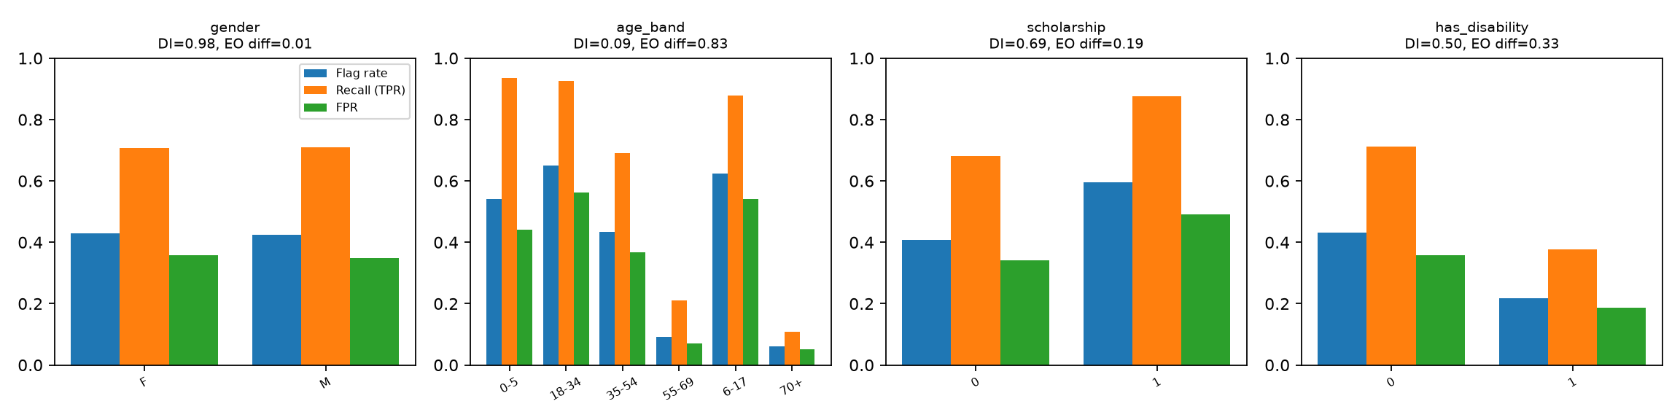
Figure 7. Flag rate, recall and false-positive rate by group before mitigation.

6.5 Bias mitigation
The largest recall gap was on age_band (TPR gap 0.828). Post-processing with group-specific thresholds chosen on the validation split so that each group reaches 70% recall (Hardt et al., 2016) reduced the gap to 0.076 on the test split. Overall recall became 71.9% and precision 32.5%, with 45.4% of appointments flagged. The trade-off is that the attribute is used at decision time, acceptable only because the decision adds support, and subject to ethics-committee approval.
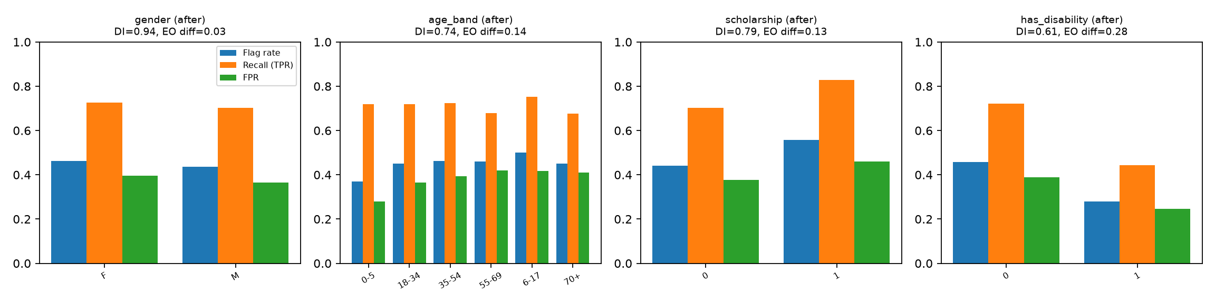
Figure 8. Group metrics after threshold-based mitigation.

6.6 Sensitivity analysis
Table 8. Robustness of predictions to input perturbations (test sample).
Scenario | Mean |Δ risk| | High-tier flips | ROC-AUC
unchanged | 0.000 | 0.0% | 0.741
lead_days +3 | 0.151 | 22.6% | 0.658
lead_days -3 (floor 0) | 0.056 | 7.1% | 0.713
lead_days x1.2 | 0.003 | 0.8% | 0.742
age +5 years | 0.010 | 3.6% | 0.738
age -5 years (floor 0) | 0.010 | 3.9% | 0.741
prior no-show rate +0.10 | 0.010 | 0.7% | 0.741
welfare flag flipped | 0.019 | 6.7% | 0.739
Gaussian noise (10% SD) on age and lead time | 0.073 | 11.3% | 0.695

The model is most sensitive to 'lead_days +3', which changes the High-tier decision for 22.6% of appointments, as expected for a real driver. Random 10% noise barely moves discrimination (ROC-AUC 0.695 vs 0.741), so small data-entry errors in a DHIS2 extract will not destabilise the tiers. Figure 9 shows how recall and workload move with the threshold, letting the hospital trade reach against outreach capacity.
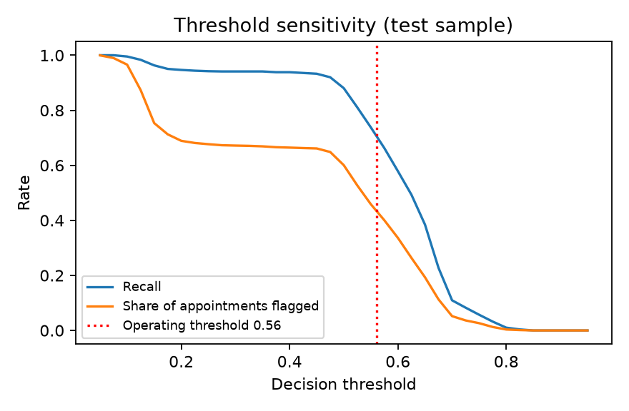
Figure 9. Recall and share of appointments flagged across decision thresholds.
The Model Card (Mitchell et al., 2019) is Appendix A; the full Fairness Metrics Report is Appendix B.

7. Interpretation, Risks and Monitoring
In business terms the model has learned that no-show risk is driven mainly by lead time (days booked ahead) and same-day appointment: the circumstances under which a referral is booked matter more than the diagnosis. For JJUSHYCSH this means concentrating confirmation calls on long-lead bookings and patients with missed visits in their history, offering earlier slots where capacity allows, and reaching first visits, which have no history, by default.
Limitations and risks, linked to the Module 1 risk register and Module 2 RAID log: (1) the data come from a different health system (R-02), so this is a validated method, not a deployable JJUSHYCSH model, until retrained on local records; (2) six weeks of history cannot capture seasonality; (3) distance and transport, likely decisive in the Somali Region, are absent until the local data contract adds distance bands; (4) scores could be misused to deprioritise patients (R-04), which policy forbids and the API states; (5) the disability group is too small for precise fairness estimates; and (6) pseudonymised data remains personal data under Proclamation No. 1321/2024 (R-05), so the Module 3 access tiers apply to scores too.

Table 9. Acceptance criteria and post-deployment monitoring hooks.
Signal | Acceptance criterion / trigger | Frequency
Recall on no-shows | ≥ 0.70; retrain if < 0.65 | Monthly
Precision / flag rate | Flag rate within outreach capacity; alert if +50% vs baseline | Weekly
Per-group TPR gap (4 attributes) | ≤ 0.1; governance committee review if exceeded | Monthly
Input drift (lead time, age, history) | Population stability index < 0.2 | Monthly
Calibration (Brier score) | Within 10% of validation value (0.210) | Quarterly
Override log | Staff overrides and reasons reviewed | Quarterly

Acceptance decision: on the proxy data the champion meets 2 of the three Module 1 success criteria (recall target met; gain over the rule baseline met; fairness tolerances not met). It is registered at Staging as a validated method, not Production: Module 2's Gate 3 (performance, calibration, fairness, explainability) passes on proxy data, but Gate 4 needs retraining on JJUSHYCSH records, a repeat of this validation pack, and AI & Data Governance Committee sign-off. The Module 5 dashboard will consume the same scores and monitoring signals.

8. Deployment Artefacts
The champion is serialised as module4/outputs/model/noshow_model.joblib (pipeline, thresholds, features, data hash) and registered in the MLflow Model Registry as 'jjushycsh_noshow_risk' version 1, alias 'champion', stage Staging. A FastAPI service (module4/api/main.py) exposes POST /predict, returning the probability, the Low/Medium/High tier, the Module 1 outreach action and plain-language reason codes, and it builds features with the Module 3 definitions to avoid training–serving skew. The SHAP notebook, Fairness Metrics Report, Model Card and MLflow export sit in the repository beside the Module 3 pipeline.

References
Ahmed, A. F. (2026a). Project vision document [Unpublished BAN6800 Module 1 assignment]. Nexford University.
Ahmed, A. F. (2026b). Business analytics project overview report [Unpublished BAN6800 Module 2 assignment]. Nexford University.
Ahmed, A. F. (2026c). Designing a data pipeline for referral no-show analytics [Unpublished BAN6800 Module 3 assignment]. Nexford University.
Chen, T., & Guestrin, C. (2016). XGBoost: A scalable tree boosting system. Proceedings of the 22nd ACM SIGKDD International Conference on Knowledge Discovery and Data Mining, 785–794. https://doi.org/10.1145/2939672.2939785
CURE Ethiopia. (2023, August 29). New mobile clinic in Jigjiga. https://ethiopia.cure.org/news/new-mobile-clinic-in-jigjiga/
Dantas, L. F., Fleck, J. L., Cyrino Oliveira, F. L., & Hamacher, S. (2018). No-shows in appointment scheduling – a systematic literature review. Health Policy, 122(4), 412–421. https://doi.org/10.1016/j.healthpol.2018.02.002
Federal Ministry of Justice, Ethiopia. (2024). Personal Data Protection Proclamation No. 1321/2024. https://justice.gov.et/en/law/personal-data-protection-proclamation/
Feldman, M., Friedler, S. A., Moeller, J., Scheidegger, C., & Venkatasubramanian, S. (2015). Certifying and removing disparate impact. Proceedings of the 21st ACM SIGKDD International Conference on Knowledge Discovery and Data Mining, 259–268. https://doi.org/10.1145/2783258.2783311
Hardt, M., Price, E., & Srebro, N. (2016). Equality of opportunity in supervised learning. Advances in Neural Information Processing Systems, 29, 3315–3323.
Hoppen, J. (2016). Medical appointment no shows [Data set]. Kaggle. https://www.kaggle.com/datasets/joniarroba/noshowappointments
Lundberg, S. M., & Lee, S.-I. (2017). A unified approach to interpreting model predictions. Advances in Neural Information Processing Systems, 30, 4765–4774.
Mitchell, M., Wu, S., Zaldivar, A., Barnes, P., Vasserman, L., Hutchinson, B., Spitzer, E., Raji, I. D., & Gebru, T. (2019). Model cards for model reporting. Proceedings of the Conference on Fairness, Accountability, and Transparency, 220–229. https://doi.org/10.1145/3287560.3287596
Mothilal, R. K., Sharma, A., & Tan, C. (2020). Explaining machine learning classifiers through diverse counterfactual explanations. Proceedings of the 2020 Conference on Fairness, Accountability, and Transparency, 607–617. https://doi.org/10.1145/3351095.3372850
Pedregosa, F., Varoquaux, G., Gramfort, A., Michel, V., Thirion, B., Grisel, O., Blondel, M., Prettenhofer, P., Weiss, R., Dubourg, V., Vanderplas, J., Passos, A., Cournapeau, D., Brucher, M., Perrot, M., & Duchesnay, É. (2011). Scikit-learn: Machine learning in Python. Journal of Machine Learning Research, 12, 2825–2830.
Wachter, S., Mittelstadt, B., & Russell, C. (2018). Counterfactual explanations without opening the black box: Automated decisions and the GDPR. Harvard Journal of Law & Technology, 31(2), 841–887.
Weerts, H., Dudík, M., Edgar, R., Jalali, A., Lutz, R., & Madaio, M. (2023). Fairlearn: Assessing and improving fairness of AI systems. Journal of Machine Learning Research, 24(257), 1–8.
Zaharia, M., Chen, A., Davidson, A., Ghodsi, A., Hong, S. A., Konwinski, A., Murching, S., Nykodym, T., Ogilvie, P., Parkhe, M., Xie, F., & Zumar, C. (2018). Accelerating the machine learning lifecycle with MLflow. IEEE Data Engineering Bulletin, 41(4), 39–45.

Appendix A. Model Card
Version: 1 (Staging) · Algorithm: random forest · Date: 2026-10-01 · Owner: Abdi Farah Ahmed (BAN6800, Nexford University)
Intended use
Advisory decision support for JJUSHYCSH outpatient/referral coordinators: score each scheduled follow-up 24–72 h ahead and prioritise reminder outreach (SMS → phone call → community health worker). Out of scope: cancelling, overbooking against, or deprioritising any patient; any clinical decision. Rule from the Module 1 charter: a flag can add support, never reduce care.
Training data
Module 3 pseudonymised model table built from the public Kaggle *Medical Appointment No Shows* data (Hoppen, 2016; Brazil), used as a disclosed proxy for JJUSHYCSH records. Patient-grouped 70/15/15 split (Module 3, seed 42): train 77,155 / validation 16,245 / test 16,499; test no-show rate 20.5%. Data hash 8b87e2989f1b… (route: module3_splits).
Features
age, lead_days, prior_visits, prior_no_shows, prior_no_show_rate, chronic_count, scholarship, hypertension, diabetes, same_day, first_visit, appt_weekday.
Excluded on purpose: sms_received, area_code, gender, appt_month, lead_band, patient_key / appointment_key / dates.
Necessity review of sensitive health flags (Module 3 hand-over): alcoholism: Δ CV PR-AUC +0.0006 → drop as input (audit only); has_disability: Δ CV PR-AUC -0.0013 → drop as input (audit only).
Performance (Module 3 test split, threshold 0.560)
ROC-AUC | PR-AUC | Recall | Precision | F1 | Accuracy | Brier | Flag rate
0.742 | 0.384 | 0.708 | 0.340 | 0.459 | 0.658 | 0.210 | 0.428

Forward-in-time check (refit on earliest 80 % of dates, scored on latest 20 %): ROC-AUC 0.734, recall 0.686.
Top drivers (mean |SHAP|)
- Lead time (days booked ahead): 0.0990
- Same-day appointment: 0.0901
- Patient age: 0.0337
- Prior no-show rate: 0.0191
- Number of prior no-shows: 0.0117
Fairness (Module 3 test split)
- gender: DI ratio 0.984, EO difference 0.010, TPR gap 0.003
- age_band: DI ratio 0.093, EO difference 0.828, TPR gap 0.828
- scholarship: DI ratio 0.686, EO difference 0.194, TPR gap 0.194
- has_disability: DI ratio 0.504, EO difference 0.335, TPR gap 0.335
- Mitigation: group-specific thresholds chosen on validation (equal opportunity)
Limitations
- Proxy data from a different health system; must be re-validated on JJUSHYCSH/DHIS2 records before any real use.
- Only ~6 weeks of history; no seasonality, distance-to-facility, transport or rainy-season signals.
- The disability group is 2 % of records (Module 3 flag), so its fairness estimates are less precise.
- Modest discrimination: many flagged patients would have attended (a false positive costs only a reminder).
Ethical considerations
Gender and geography are not model inputs; fairness is monitored by gender, age band, welfare status and disability. Pseudonymised data remains personal data under Ethiopia's Personal Data Protection Proclamation No. 1321/2024. Oversight: the Hospital Research & Ethics Review Committee and AI & Data Governance Committee proposed in Module 1.
Monitoring
Monthly: recall and precision vs. acceptance criteria, per-group TPR gap, input drift (lead time, age), flag rate vs. outreach capacity. Retrain if recall < 0.65 or any TPR gap > 0.1.

Appendix B. Fairness Metrics Report
Generated 2026-10-01 by Abdi Farah Ahmed from the Module 3 test split (16,499 appointments). Favourable outcome = being flagged High risk (it triggers extra outreach support, never reduced care).
Criteria (Module 2 plan): disparate impact ratio >= 0.8; equalized-odds difference <= 0.1. Primary criterion: equal opportunity (recall parity), because the aim is to reach at-risk patients equally in every group. Protected attributes are the Module 3 bias-audit groups.
gender
Group | n | No-show base rate | Flag rate | Recall (TPR) | FPR | Precision
F | 10,878 | 0.205 | 0.430 | 0.707 | 0.359 | 0.336
M | 5,621 | 0.207 | 0.423 | 0.710 | 0.349 | 0.346

- Demographic parity difference: 0.007
- Disparate impact ratio: 0.984 (meets 0.8)
- Equalized-odds difference: 0.010 (meets 0.1); TPR gap 0.003, FPR gap 0.010
- Fairlearn cross-check: DP diff 0.007, EO diff 0.010
age_band
Group | n | No-show base rate | Flag rate | Recall (TPR) | FPR | Precision
0-5 | 1,683 | 0.203 | 0.541 | 0.936 | 0.441 | 0.351
18-34 | 3,607 | 0.242 | 0.650 | 0.925 | 0.562 | 0.344
35-54 | 4,606 | 0.205 | 0.434 | 0.691 | 0.368 | 0.326
55-69 | 2,919 | 0.156 | 0.091 | 0.211 | 0.069 | 0.360
6-17 | 2,326 | 0.245 | 0.624 | 0.879 | 0.542 | 0.344
70+ | 1,358 | 0.150 | 0.060 | 0.108 | 0.052 | 0.268

- Demographic parity difference: 0.589
- Disparate impact ratio: 0.093 (below 0.8)
- Equalized-odds difference: 0.828 (exceeds 0.1); TPR gap 0.828, FPR gap 0.510
- Fairlearn cross-check: DP diff 0.589, EO diff 0.828
scholarship
Group | n | No-show base rate | Flag rate | Recall (TPR) | FPR | Precision
0 | 14,825 | 0.198 | 0.409 | 0.682 | 0.341 | 0.330
1 | 1,674 | 0.270 | 0.596 | 0.876 | 0.492 | 0.397

- Demographic parity difference: 0.187
- Disparate impact ratio: 0.686 (below 0.8)
- Equalized-odds difference: 0.194 (exceeds 0.1); TPR gap 0.194, FPR gap 0.150
- Fairlearn cross-check: DP diff 0.187, EO diff 0.194
has_disability
Group | n | No-show base rate | Flag rate | Recall (TPR) | FPR | Precision
0 | 16,223 | 0.206 | 0.431 | 0.712 | 0.358 | 0.340
1 | 276 | 0.163 | 0.217 | 0.378 | 0.186 | 0.283

- Demographic parity difference: 0.214
- Disparate impact ratio: 0.504 (below 0.8)
- Equalized-odds difference: 0.335 (exceeds 0.1); TPR gap 0.335, FPR gap 0.172
- Fairlearn cross-check: DP diff 0.214, EO diff 0.335
Mitigation
Applied on age_band: group-specific thresholds chosen on validation (equal opportunity).
Group thresholds: 0-5=0.618, 18-34=0.622, 35-54=0.554, 55-69=0.506, 6-17=0.610, 70+=0.500.
TPR gap 0.828 -> 0.076; DI ratio 0.093 -> 0.739.
Overall after mitigation: recall 0.719, precision 0.325, flag rate 0.454.
Fairlearn ThresholdOptimizer comparison: TPR gap 0.081, recall 0.901, flag rate 0.618.
Data bias carried forward from Module 3
- Module 3 flag: has_disability 1 — under-represented (share=0.0201)

Appendix C. AI Disclosure
See the separately submitted NXU AI Disclosure Form (Module 4).

