Module 6 Assignment
Otomoto Marketing Segmentation Model Optimization
Artificial Neural Network Optimization Report

Dataset | teleconnect(3).csv: 7,043 customer records and 21 fields
Analytical goal | Improve customer segmentation for marketing retention and campaign prioritization
Target variable | Churn: Yes/No, modeled as customer churn-risk probability
Best operational model | Adam + regularization + early stopping with threshold optimization

Executive Summary
A key part of Otomoto’s marketing strategy is dividing all of their customers up and targeting different segments of customers in different ways. I built a baseline artificial neural network (ANN) to which I applied three types of training: stochastic gradient descent (SGD) with momentum, Adam with regularization and early stopping, and L-BFGS quasi-Newton optimization. Churn risk was the business goal as the most critical group of customers for retention marketing are those with the highest predicted probabilities of churn.
When using Adam with L2 regularization and early stopping, and when the decision threshold was set using a validation set, the optimized ANN achieved the best F1 score of 0.617. The F1 score of the baseline ANN was 0.552. Most of the improvement came from an increase in recall from 0.471 to 0.775, meaning the optimized model was able to find more of the customers predicted to churn. On the other hand, the accuracy of the optimized model was 0.797, which was lowered to 0.745. Because the model was designed to find more of the customers predicted to churn, this drop in accuracy was acceptable. From a marketing perspective, the risk would have been been much greater to not find a predicted churn customer than to lose a predicted churn customer and have to offer retention marketing to customers who are not considered at risk of churning.
The final output of the segmentation exercise split the entire customer base into three groups: the 4,551 low-risk customers who would be targeted for retention and upsell, the 1,567 medium-risk customers who would be targeted for nurturing campaigns, and the 925 high-risk customers who would be targeted for retention or win-back offers.
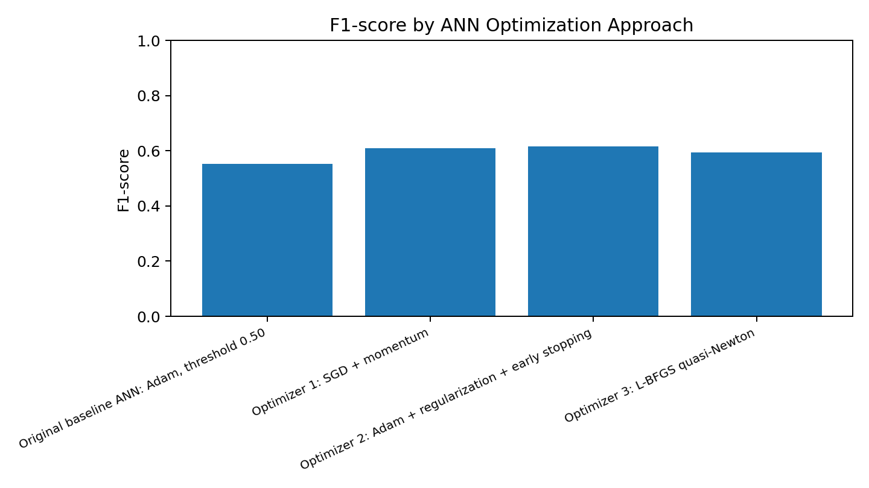

1. Data Understanding and Business Framing
The dataset includes variables describing customer profiles and service use that consist of gender, senior citizen, partner/dependent status, tenure duration, phone and internet service, online service, contract type, billing, payment method, monthly and total charges, and churn status. The customerID field was removed from modeling because it is an identifier and does not contain information describing customer behavior.

The modeling problem was framed as a supervision binary classification problem. Rather than using an ANN only to predict if a customer would churn (Yes/No), the predicted churn probability was translated into different marketing segments. This guides campaign design and allows Otomoto to focus retention efforts on high-risk customers, uses an educational strategy on medium-risk customers, and targets low-risk customers with loyalty and upselling campaigns.

Item | Value | Modeling decision | Reason
Records | 7,043 | Use all valid records | Sufficient size for a small tabular ANN
Features | 20 predictors after removing customerID | Encode categorical variables and scale numeric variables | ANNs require numeric and scaled inputs
Target | Churn: Yes/No | Map Yes=1 and No=0 | Supports churn-risk segmentation
Data cleaning | TotalCharges converted to numeric; blanks filled with 0 | Treat blank total charges as zero for new customers | Avoids losing observations during training

2. Recreated Existing ANN Model
The recreated existing model was a standard feed-forward ANN with an input layer, a single hidden layer with 16 neurons, and 5 output nodes. This version also utilized the Adam optimizer, with a default learning rate of 0.001, and a fixed 0.50 classification threshold. This model was a good starting baseline because the Adam optimizer is a good general purpose optimizer for neural networks, and it is less tedious to tune a learning rate for the Adam optimizer as opposed to standard gradient descent. However, the baseline also had a few drawbacks for a marketing segmentation use-case: a fixed threshold was used, early stopping was absent, and it was not optimized to increase recall (and the F1-score) for the churn class.
Some of the baseline positives were stable training, good overall accuracy, and an ROC-AUC of 0.842. The baseline was also not good at identifying churn customers as it identified 176 of 374 churn customers from the test set. In the marketing world, this is bad since there is a large set of customers that would be eligible for retention marketing activities that would not be selected.

3. Selected Optimization Algorithms and Justification
Optimization approach | Why selected | Expected marketing impact
SGD + momentum | Provides a classical gradient-descent benchmark. Momentum helps the ANN move through shallow areas of the loss surface and adaptive learning rate reduces stagnation. | Expected to improve churn detection while keeping the model simple and explainable.
Adam + regularization + early stopping | Adam adapts learning rates by parameter. L2 regularization reduces overfitting, while early stopping prevents unnecessary training once validation performance stops improving. | Best suited for campaign segmentation because it balances probability ranking, recall, and generalization.
L-BFGS quasi-Newton | Uses curvature information to optimize the network weights. It can perform well for smaller tabular datasets. | Useful as a non-stochastic comparison to determine whether a second-order optimizer improves segmentation stability.

4. Implementation Process
- Loaded teleconnect(3).csv and inspected the customer profile structure.
- Converted TotalCharges to numeric and filled blank values with 0.
- Removed customerID from predictors and mapped Churn values to 0/1.
- Applied one-hot encoding to categorical variables and standard scaling to numeric variables.
- Split data into training, validation, and test sets using stratification to preserve churn class balance.
- Trained the baseline ANN and three optimized ANN models.
- For optimized models, selected the decision threshold that maximized validation F1-score.
- Evaluated all models on the untouched test set using accuracy, precision, recall, F1-score, ROC-AUC, log loss, and confusion matrices.
- Used the best model to score all customers and assign marketing segments.

5. Performance Evaluation Results
Model | Decision threshold | Accuracy | Precision | Recall | F1-score | ROC-AUC | Log loss | Confusion Matrix
Original baseline ANN: Adam, threshold 0.50 | 0.500 | 0.797 | 0.667 | 0.471 | 0.552 | 0.842 | 0.421 | [[947, 88], [198, 176]]
Optimizer 1: SGD + momentum | 0.350 | 0.769 | 0.552 | 0.679 | 0.609 | 0.836 | 0.429 | [[829, 206], [120, 254]]
Optimizer 2: Adam + regularization + early stopping | 0.280 | 0.744 | 0.512 | 0.775 | 0.617 | 0.832 | 0.431 | [[759, 276], [84, 290]]
Optimizer 3: L-BFGS quasi-Newton | 0.350 | 0.764 | 0.546 | 0.652 | 0.594 | 0.825 | 0.452 | [[832, 203], [130, 244]]
The best performing model in terms of the F1-Score and Recall was the optimized Adam model. With a recall of 0.775, this model was able to capture 290 of the 374 churn customers in the given test set, as opposed to the original baseline model which only captured 176 churn customers. The original baseline model performed with a higher accuracy as it labeled a greater number of customers as non-churning. Although, in terms of a retention campaign, this is not ideal as missed churn customers indicates missed opportunities for targeted marketing.
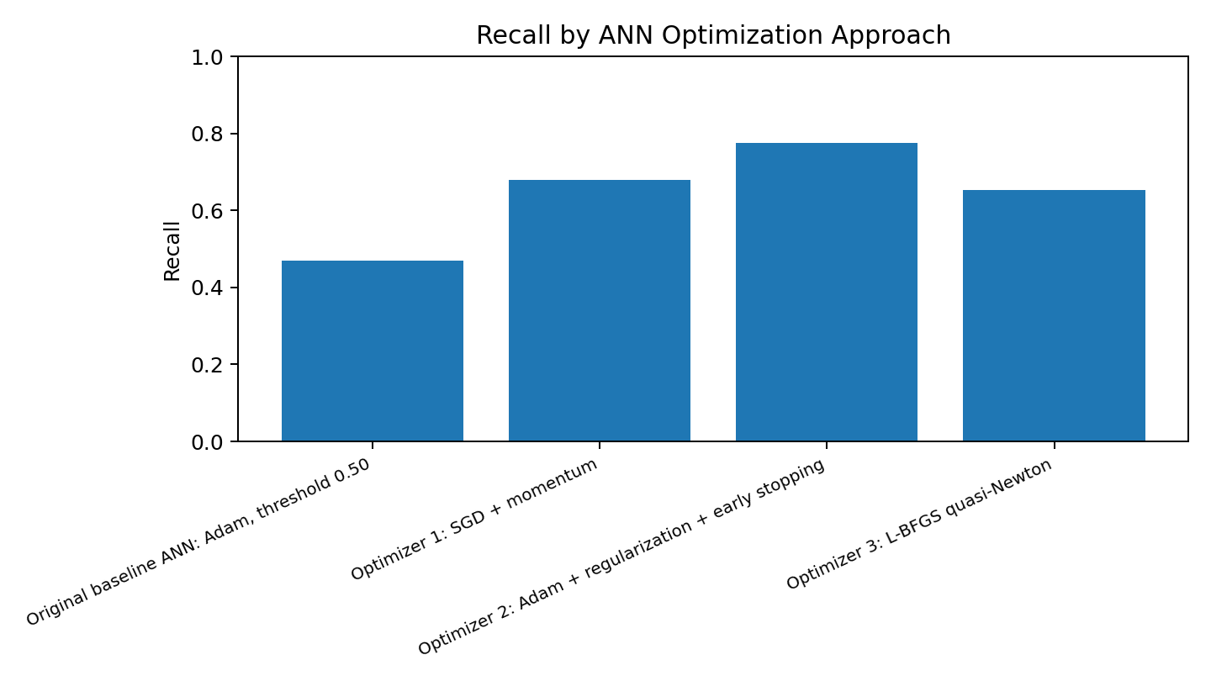
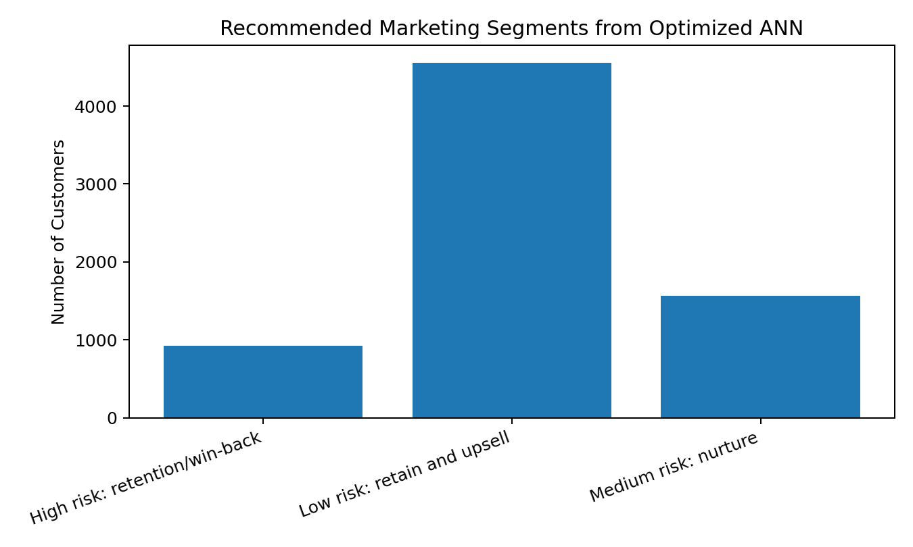

6. Impact on Marketing Segmentation
Marketing segment | Customers | Recommended campaign action
Low risk: retain and upsell | 4,551 | Protect satisfaction, cross-sell additional services, and maintain loyalty messaging.
Medium risk: nurture | 1,567 | Use benefit education, contract upgrade nudges, and service-quality follow-up.
High risk: retention/win-back | 925 | Prioritize retention calls, discount offers, problem resolution, and contract conversion campaigns.
The segmentation model serves best as a campaign prioritization tool instead of making the final call for the business. Retention efforts should be directed toward the high-risk customer group first. Risk group customers should be targeted with cost-efficient nurturing and education campaigns. Customers in the low-risk group should be prioritized last. Since they tend to not leave the business as quickly, campaigns for loyalty and referrals, as well as upselling, should be directed toward those customers.

7. Recommendations for Future Improvements
- Add campaign-response history so the model can learn which retention offers actually change customer behavior.
- Evaluate cost-sensitive thresholds by estimating the cost of false positives and false negatives.
- Test additional ANN architectures and compare them with tree-based models such as random forest and gradient boosting.
- Monitor model drift monthly because customer behavior, pricing, and competitor offers may change over time.
- Connect the churn-risk segments to marketing dashboards so campaign managers can filter by risk level, contract type, tenure, payment method, and monthly charge.

8. Documentation of Submitted Model File
The accompanying Python file, otomoto_ann_model_optimization.py, recreates the original ANN, trains three optimized ANN variants, evaluates all models, exports the model-comparison metrics, and creates a customer-level marketing segmentation file. The code is structured into functions for data loading, preprocessing, threshold selection, evaluation, and final scoring. The outputs are otomoto_ann_optimizer_results.csv and otomoto_customer_segments.csv.

Conclusion
The optimization process transformed the ANN from an overall churn classifier to an even more valuable marketing segmentation model. The chosen optimized model strikes a balance between accuracy and usefulness, as it identifies churning customer segments, catering to retention marketing needs. For loss mitigation, Otomoto should execute retention actions for the high-risk segment, nurture campaigns for the medium-risk segment, and invest in loyalty programs and upselling for the low-risk segment.

References
[1] Chicco, D., & Jurman, G. (2020). The advantages of the Matthews correlation coefficient over F1 score and accuracy in binary classification evaluation. BMC Genomics, 21, 6.
[2] Kingma, D. P., & Ba, J. (2015). Adam: A method for stochastic optimization. International Conference on Learning Representations.
[3] Pedregosa, F., Varoquaux, G., Gramfort, A., Michel, V., Thirion, B., Grisel, O., et al. (2011). Scikit-learn: Machine learning in Python. Journal of Machine Learning Research, 12, 2825–2830.
[4] Ruder, S. (2016). An overview of gradient descent optimization algorithms. arXiv preprint arXiv:1609.04747.
[5] Goodfellow, I., Bengio, Y., & Courville, A. (2016). Deep learning. MIT Press.

