**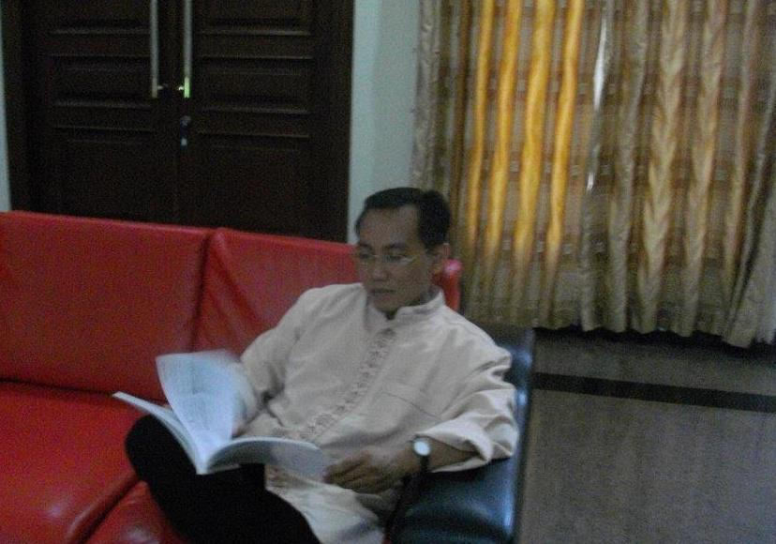*The Undersigned:***

***Curriculum Vitae***

**Name : EDYK SUPRIYANTO,**

**Address : Jalan Kertanegara no 56 G**

**Sawotratap, Sidoarjo,**

**JAWA TIMUR 61254**

**Recidential Phone : 031-8530190**

**Mobile Phone : 081133335858 , 082134971100**

**Citizen : Indonesian**

**E- Mail :** [**edyk8888@gmail.com**](mailto:edyk8888@gmail.com)

***JOB REFERENCES :***

**1. Finance Hotel Tunjungan Surabaya (1995-1998)**

**2. Marketing Manager PT. Kudamas Forexindo (1998-2005)**

**3. Operasional manager PT. Insia Timber Nabire (2005-2009)**

**4. Marketing Manager PT. Agel Indonesia (2009-2010)**

**5. Make Company, Owner PT. Fokus Berjaya (2010-2012)**

**6. Back Office PT Bimasakti Berjangka (2012-2014)**

**7. Marketing Manager PT.BUMSS (2014-2019)**

**7.1 Ketua Koperasi KOPISTRA.co.id**

**7.2 Konseptor (Share Stocks) Robot Aladin78.com**

***FORMAL EDUCATION :***

**GRATUATION FROM S1 ECONOMIC UPB d/h UNIVERSITAS PELITA HARAPAN**

**IPK : 3,3**

***EXPERT :***

**Motivator, Capital Bugedting, Excel, Power Point, SEO, GA Marketing System, Training Marketing, Web Design, Internet Marketing, Stock Exchange, Power Point, Exam from Index Forex on BAPPEPTI etc**

**I make this Curriculum Vitae truly and I will responsible.**

**Your Truly**

**Edyk Supriyanto**

**General Affairs Manager**

**TIFIA**

**Jenderal Sudirman Kav 52-53**

**JAKARTA**

**Dear Chairman,**

**I have got the information from  that your company Tifia has been growing up and your company will be recruiting. Now I am submitting my application.**

**I would like to point on Business Manager position which suitable with my experiences, and I believe I could concentrate and mastering in this field.**

**I could be ready to be placed anywhere in Indonesian Area.**

**The enclosed application forms for consideration :**

**1.         Curriculum Vitae  
2.         Recent Photograph  
3.         Job Experiences  
4.         Certificate of Bachelor Degree ( S1 Economic )  
5.         Identity of Recidency Card**

**Besides it, I have experiences and mastering Ms Office Word, Excel, Power Point, Outlook XP, Others Applied, Internet, Mass Presentation, PDB Marketing System, Motivator, Training , and graduated from Trader on Index and Forex.**

**That is all my application. If you should require further information I shall be happy to provide it, I would welcome the opportunity to have a personal interview.**

**Your Truly**

**Edyk Supriyanto**