Abdirahman Omar xuseen
ID: C6240328

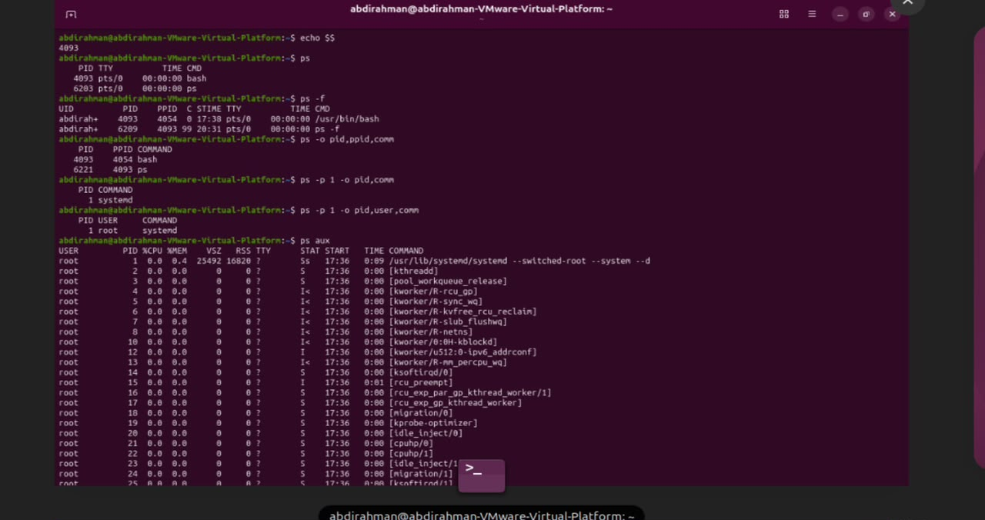

1. echo $$
- This command prints the Process ID (PID) of the current shell session.

- It helps users identify the unique identifier assigned to their active terminal process.

- In the image, the command successfully outputs the PID number 4093.

- It is a quick way to check your current shell's system identification number.

2. ps
- The ps command stands for "process status" in Linux and Unix operating systems.

- It displays information about the currently running processes associated with the terminal.

- In this screenshot, it lists the bash shell and the ps command itself.

- System administrators frequently use it to monitor active tasks in a user session.

3. ps -f
- The -f flag stands for "full format" listing in the ps command.

- It provides detailed information including UID, PID, PPID, CPU usage, and start time.

- It shows the hierarchical relationship between the user and running processes.

- This view gives a comprehensive look at how processes are executed in the terminal.

4. ps -o pid,ppid,comm
- The -o option allows users to customize the output format of the ps command.

- It specifically filters the display to show only PID, Parent PID (PPID), and command name.

- This makes the output cleaner and focused strictly on process hierarchy identifiers.

- It helps track which parent process spawned a specific child command.

5. ps -p 1 -o pid,comm
- The -p 1 parameter targets a specific process ID, which in this case is process number 1.

- It restricts the customized output columns to only show the PID and command name.

- Process 1 is universally recognized as the init or systemd process in Linux.

- This command is useful for checking the fundamental root process of the system.

6. ps -p 1 -o pid,user,comm
- This command queries process ID 1 with an expanded custom output format.

- It includes the process owner (USER) alongside the PID and command name.

- The output clearly shows that process 1 is owned and run by the root user.

- It provides security and ownership context for core system processes.

7. ps aux
- The ps aux command displays detailed information about all running processes across the entire system.

- It lists every process regardless of which user or terminal session started them.

- Key metrics shown include user, PID, CPU percentage, memory usage, and execution status.

- It is one of the most popular commands for system monitoring and troubleshooting.
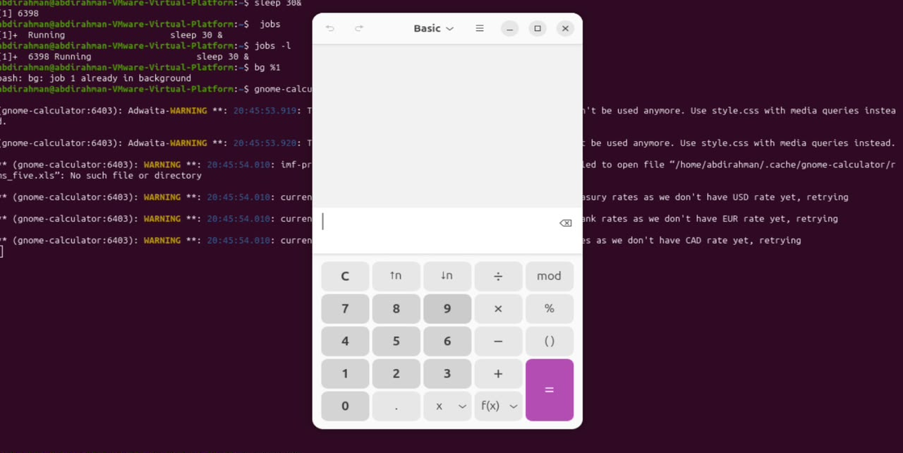

1. sleep 30 &
- This command pauses execution for 30 seconds while placing the task in the background using the ampersand (&) symbol.
- It immediately assigns a Process ID (PID), which is 6398 in this specific image session.
- Running a command in the background frees up the terminal prompt to accept other inputs right away.
- It is useful for executing non-interactive, time-delayed tasks without locking up the active shell window.
2. jobs
- The jobs command lists all active background and stopped jobs associated with the current shell session.
- In this image, it shows job number 1 ([1]+ Running) executing the sleep 30 & command.
- It helps users keep track of processes they have sent to the background.
- The plus sign (+) indicates the current job that would be affected by default background/foreground commands.
3. jobs -l
- The -l flag stands for "long format" when used with the jobs command.
- It displays extra details, specifically showing the Process ID (PID 6398) alongside the job status.
- This allows users to easily match background job numbers with their actual system PIDs.
- It provides a clearer overview of background tasks for process management.
4. bg %1
- The bg command resumes a suspended or background job to keep it running in the background.
- The argument %1 specifies job number 1 in the shell's job table.
- The terminal responds with bash: bg: job 1 already in background because the task was already running there.
- This command is typically used to resume jobs that were previously paused using the shortcut Ctrl+Z.
5. gnome-calculator
- This command launches the graphical GNOME Calculator application on the Linux desktop.
- In the screenshot, it successfully opens the calculator window over the terminal interface.
- The terminal logs several background warnings related to GTK themes and currency rate fetching files.
- Launching GUI apps from the terminal allows users to see debugging messages and error logs directly.
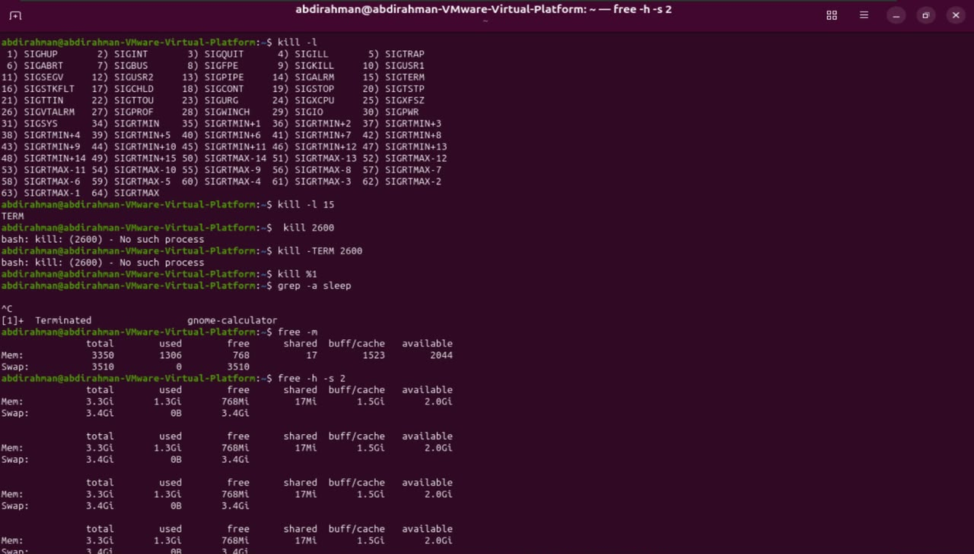

1. kill -l
- This command lists all the available signal names and numbers that can be used with the kill command.
- In this image, it displays a numbered table of signals ranging from 1 (SIGHUP) up to 64 (SIGRTMAX).
- It helps users identify which signal number corresponds to a specific system action.
- System administrators use this reference list when sending customized termination signals to processes.
2. kill -l 15
- This command translates signal number 15 to its corresponding signal name.
- The terminal output shows that signal number 15 stands for TERM (SIGTERM).
- SIGTERM is the standard signal used to politely ask a process to terminate gracefully.
- It allows applications to save their data and clean up resources before shutting down.
3. kill 2600
- This command attempts to terminate a process using its Process ID (PID), which is 2600.
- The terminal returns an error saying bash: kill: (2600) - No such process.
- This error occurs because there is no active process currently running with that specific PID.
- Users must check active PIDs using commands like ps before attempting to kill them.
4. kill -TERM 2600
- This command attempts to send the specific termination signal (-TERM) to process ID 2600.
- It results in the same error (No such process) because PID 2600 does not exist.
- Specifying the signal explicitly ensures that a precise termination method is sent if the target exists.
- It demonstrates how to combine signal flags with target process IDs in Linux.
5. kill %1
- This command terminates a background job by referencing its job number (%1) instead of its PID.
- In the output, it successfully terminates job 1 (gnome-calculator), showing [1]+ Terminated gnome-calculator.
- Job specifiers are a convenient shortcut in bash when managing active shell background tasks.
- It instantly stops the running application and frees up the associated resources.
6. free -m
- The free command displays the total amount of free and used physical and swap memory in the system.
- The -m flag specifies that the memory statistics should be shown in megabytes (MB).
- It outlines total memory, used space, free space, shared memory, buffer/cache, and available memory.
- It is a quick and efficient tool for checking system memory consumption.
7. free -h -s 2
- The -h flag formats the memory output into a human-readable format (e.g., gigabytes/megabytes).
- The -s 2 flag enables continuous monitoring, refreshing the output every 2 seconds.
- It continuously updates the memory status table on the terminal screen in real-time.
- This is extremely useful for tracking memory usage fluctuations over a period of time.
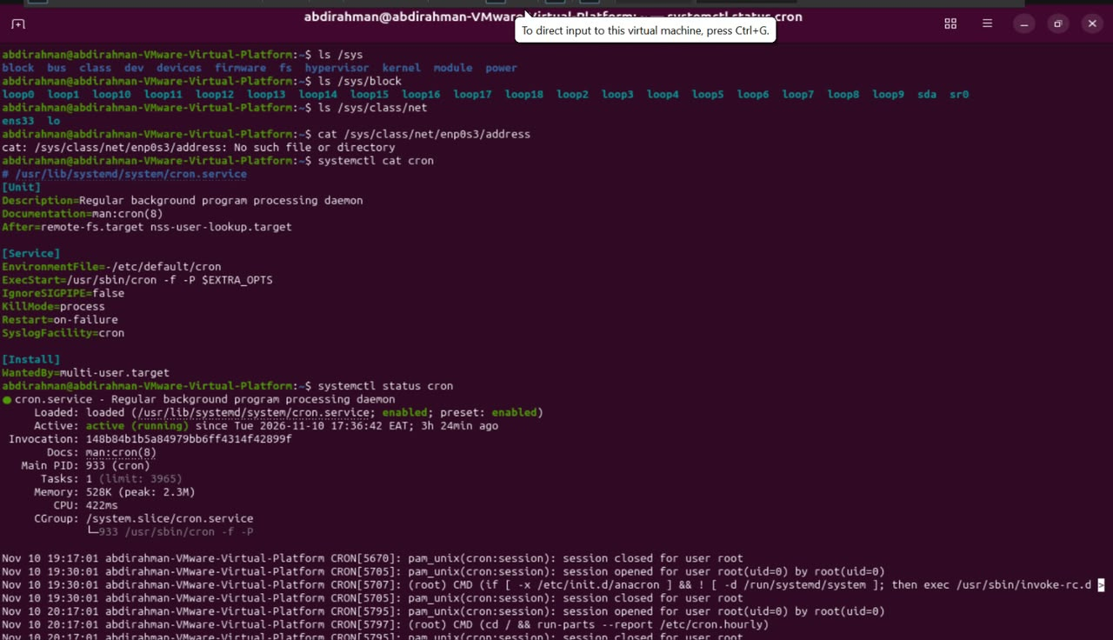

1. ls /sys
- This command lists the subdirectories inside the Linux kernel's virtual /sys file system.
- It provides access to virtual files containing information about kernel drivers, hardware devices, and system modules.
- The output lists directories like block, bus, class, dev, devices, firmware, and power.
- System administrators use it to inspect device structures and hardware configurations exposed by the system.
2. ls /sys/block
- This command specifically lists the block storage devices registered in the system kernel.
- The resulting output displays virtual loop devices (loop0 through loop18), along with physical drives (sda and sr0).
- Loop devices are used to mount files as file systems, while sda represents the primary hard disk.
- It allows users to quickly view all attached disk-based storage hardware and loopback mounts.
3. ls /sys/class/net
- This command lists all active network interface devices detected by the operating system.
- The terminal output shows two specific network interfaces available on the system: ens33 and lo.
- ens33 is the main Ethernet network adapter, while lo represents the internal loopback adapter.
- It provides a simple way to verify which network controllers the Linux kernel has recognized.
4. cat /sys/class/net/enp0s3/address
- This command attempts to view the MAC address of an interface named enp0s3.
- The terminal returns No such file or directory because the interface specified is not present on this VM.
- The correct interface name listed in the previous command was ens33 instead of enp0s3.
- It demonstrates how file paths under /sys correspond directly to existing hardware names.
5. systemctl cat cron
- This command outputs the raw unit file configuration of the cron system service.
- It displays service parameters such as Description, ExecStart, KillMode, and Restart conditions.
- The output reveals that the service binary runs from /usr/sbin/cron -f -P $EXTRA_OPTS.
- Administrators use this command to inspect service definitions without locating the service file path manually.
6. systemctl status cron
- This command checks the current running status, activity state, and logs of the cron daemon.
- It indicates that the cron service is active (running) with a main Process ID of 933.
- It also provides memory usage, CPU usage, process details, and recent log messages from the system journal.
- It is essential for verifying whether scheduled task automation services are currently active and healthy.
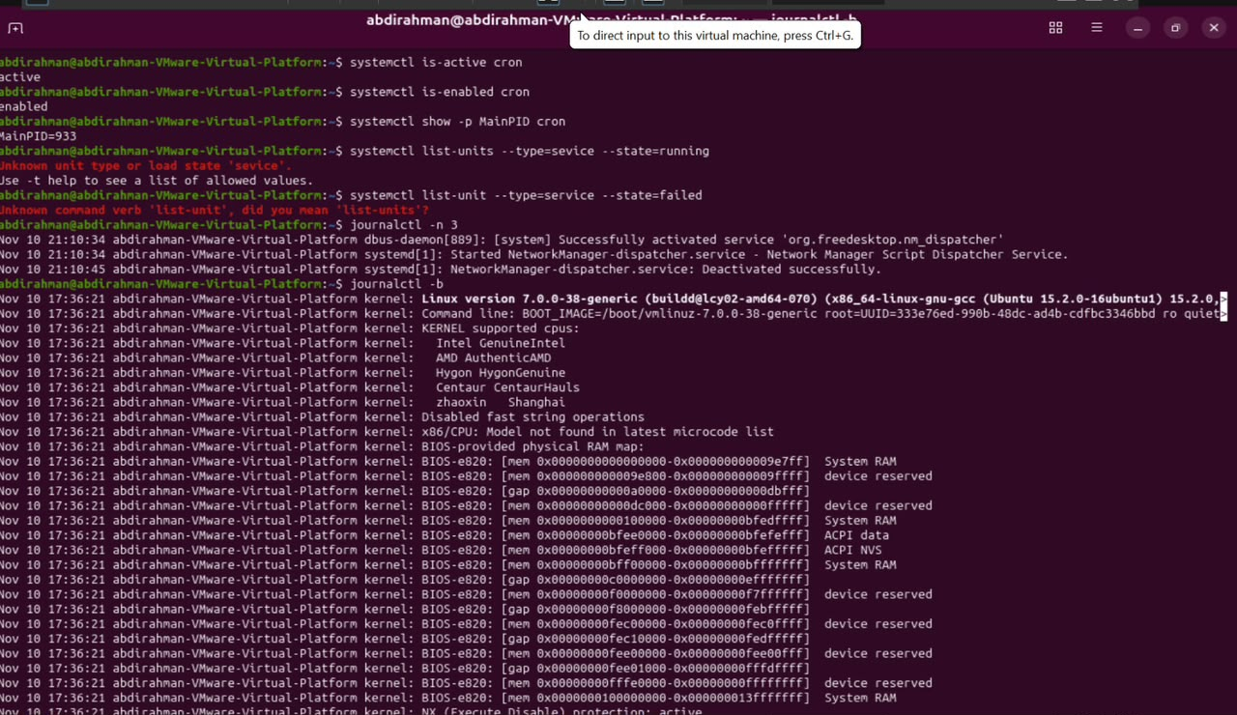

1. systemctl is-active cron
- This command checks whether the cron service is currently running.
- The terminal output displays active, confirming that the service is running successfully.
- It is a quick and straightforward way to verify service activity in systemd.
- System administrators use it in scripts to test service status before running automated tasks.
2. systemctl is-enabled cron
- This command checks if the cron service is configured to start automatically at system boot.
- The output returns enabled, indicating that the service will launch upon startup.
- It helps verify the persistence and configuration state of services across reboots.
- This prevents unexpected service failures after a system restart.
3. systemctl show -p MainPID cron
- This command queries specific properties of a service using the -p flag.
- It specifically requests the Main Process ID (MainPID) of the cron service.
- The terminal returns MainPID=933, showing the exact process ID assigned to the daemon.
- It is useful for monitoring or managing specific service processes directly.
4. systemctl list-units --type=sevice --state=running
- This command attempts to list active services, but contains a typo in --type=sevice.
- The terminal outputs an error stating Unknown unit type or load state 'sevice'.
- It suggests using -t help to see a list of allowed unit types.
- This demonstrates how command-line syntax errors are caught by systemctl.
5. systemctl list-unit --type=service --state=failed
- This command contains a typo in the subcommand, using list-unit instead of list-units.
- The terminal returns an error saying Unknown command verb 'list-unit', did you mean 'list-units?'.
- Systemctl provides helpful suggestions when users misspell command verbs.
- Correcting it to list-units would normally display failed services in the system.
6. journalctl -n 3
- This command queries the system journal logs for recent entries.
- The -n 3 flag limits the output to display only the last 3 log entries.
- It shows recent events such as NetworkManager dispatcher activations and deactivations.
- This allows administrators to quickly review recent system activities without scrolling through logs.
7. journalctl -b
- This command displays system log messages recorded since the last system boot (-b).
- The output streams extensive kernel initialization logs, CPU details, and BIOS memory maps.
- It lists the Linux version (7.0.0-38-generic) and hardware support information.
- It is an essential tool for troubleshooting boot-up sequences and kernel-level errors.

1. systemctl is-active cron
- This command checks whether the cron service is currently running.
- The terminal output displays active, confirming that the service is running successfully.
- It is a quick and straightforward way to verify service activity in systemd.
- System administrators use it in scripts to test service status before running automated tasks.
2. systemctl is-enabled cron
- This command checks if the cron service is configured to start automatically at system boot.
- The output returns enabled, indicating that the service will launch upon startup.
- It helps verify the persistence and configuration state of services across reboots.
- This prevents unexpected service failures after a system restart.
3. systemctl show -p MainPID cron
- This command queries specific properties of a service using the -p flag.
- It specifically requests the Main Process ID (MainPID) of the cron service.
- The terminal returns MainPID=933, showing the exact process ID assigned to the daemon.
- It is useful for monitoring or managing specific service processes directly.
4. systemctl list-units --type=sevice --state=running
- This command attempts to list active services, but contains a typo in --type=sevice.
- The terminal outputs an error stating Unknown unit type or load state 'sevice'.
- It suggests using -t help to see a list of allowed unit types.
- This demonstrates how command-line syntax errors are caught by systemctl.
5. systemctl list-unit --type=service --state=failed
- This command contains a typo in the subcommand, using list-unit instead of list-units.
- The terminal returns an error saying Unknown command verb 'list-unit', did you mean 'list-units?'.
- Systemctl provides helpful suggestions when users misspell command verbs.
- Correcting it to list-units would normally display failed services in the system.
6. journalctl -n 3
- This command queries the system journal logs for recent entries.
- The -n 3 flag limits the output to display only the last 3 log entries.
- It shows recent events such as NetworkManager dispatcher activations and deactivations.
- This allows administrators to quickly review recent system activities without scrolling through logs.
7. journalctl -b
- This command displays system log messages recorded since the last system boot (-b).
- The output streams extensive kernel initialization logs, CPU details, and BIOS memory maps.
- It lists the Linux version (7.0.0-38-generic) and hardware support information.
- It is an essential tool for troubleshooting boot-up sequences and kernel-level errors.
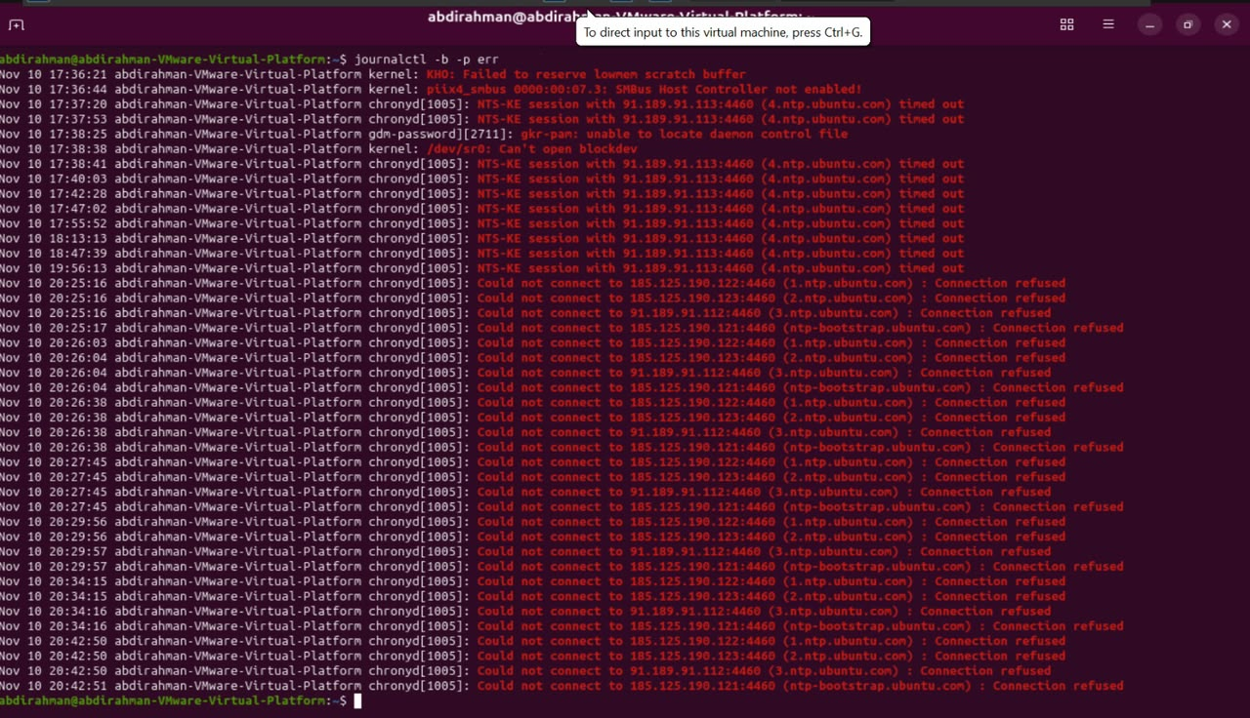

1. journalctl -b -p err
- This command queries the system journal logs recorded since the current boot (-b).
- The -p err flag filters the output to display only error-level (err or priority 3) log entries.
- The terminal displays various boot warnings and critical issues, such as failed SMBus controllers and block device errors.
- It also shows multiple time-out and connection-refused errors generated by the chronyd time synchronization daemon.

1. journalctl -b -p err
- This command queries the system journal logs recorded since the current system boot (-b).
WhatsApp Image 2026-11-11 at 2.26.08 AM.jpeg
- The -p err flag filters the output to display only error-level (err or priority 3) log entries.
WhatsApp Image 2026-11-11 at 2.26.08 AM.jpeg
- The terminal displays various boot warnings and critical issues, such as failed SMBus controllers and block device errors.
WhatsApp Image 2026-11-11 at 2.26.08 AM.jpeg
- It also shows multiple time-out and connection-refused errors generated by the chronyd time synchronization daemon.
WhatsApp Image 2026-11-11 at 2.26.08 AM.jpeg
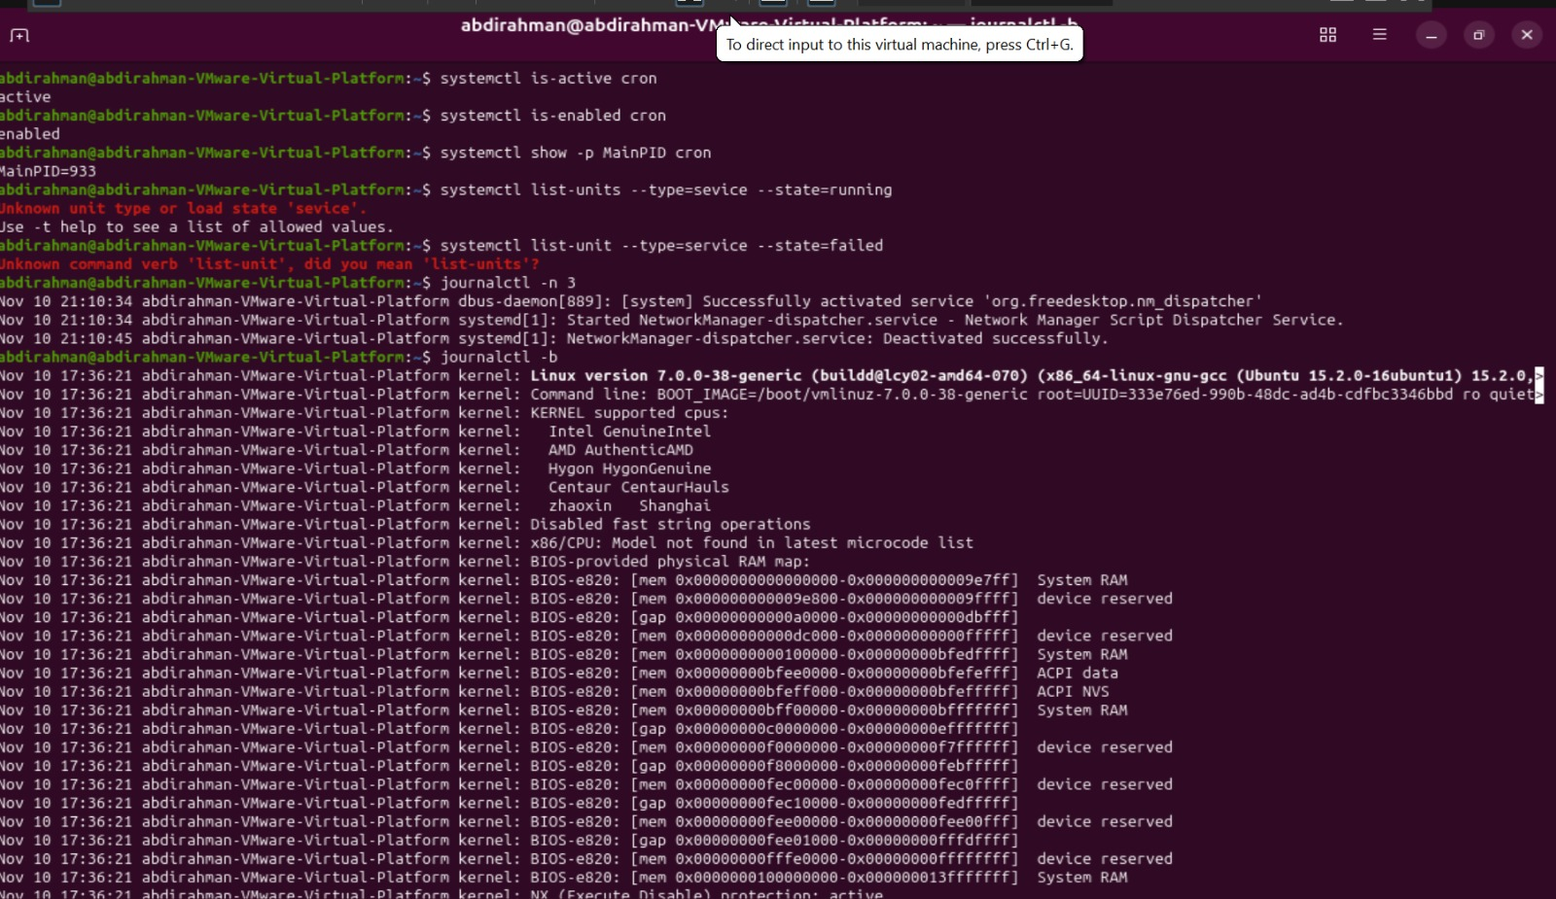

1. systemctl is-active cron
- This command checks whether the cron service is currently running.
- The terminal output displays active, confirming that the service is running successfully.
- It is a quick and straightforward way to verify service activity in systemd.
- System administrators use it in scripts to test service status before running automated tasks.
2. systemctl is-enabled cron
- This command checks if the cron service is configured to start automatically at system boot.
- The output returns enabled, indicating that the service will launch upon startup.
- It helps verify the persistence and configuration state of services across reboots.
- This prevents unexpected service failures after a system restart.
3. systemctl show -p MainPID cron
- This command queries specific properties of a service using the -p flag.
- It specifically requests the Main Process ID (MainPID) of the cron service.
- The terminal returns MainPID=933, showing the exact process ID assigned to the daemon.
- It is useful for monitoring or managing specific service processes directly.
4. systemctl list-units --type=sevice --state=running
- This command attempts to list active services, but contains a typo in --type=sevice.
- The terminal outputs an error stating Unknown unit type or load state 'sevice'.
- It suggests using -t help to see a list of allowed unit types.
- This demonstrates how command-line syntax errors are caught by systemctl.
5. systemctl list-unit --type=service --state=failed
- This command contains a typo in the subcommand, using list-unit instead of list-units.
- The terminal returns an error saying Unknown command verb 'list-unit', did you mean 'list-units?'.
- Systemctl provides helpful suggestions when users misspell command verbs.
- Correcting it to list-units would normally display failed services in the system.
6. journalctl -n 3
- This command queries the system journal logs for recent entries.
- The -n 3 flag limits the output to display only the last 3 log entries.
- It shows recent events such as NetworkManager dispatcher activations and deactivations.
- This allows administrators to quickly review recent system activities without scrolling through logs.
7. journalctl -b
- This command displays system log messages recorded since the last system boot (-b).
- The output streams extensive kernel initialization logs, CPU details, and BIOS memory maps.
- It lists the Linux version (7.0.0-38-generic) and hardware support information.
- It is an essential tool for troubleshooting boot-up sequences and kernel-level errors.

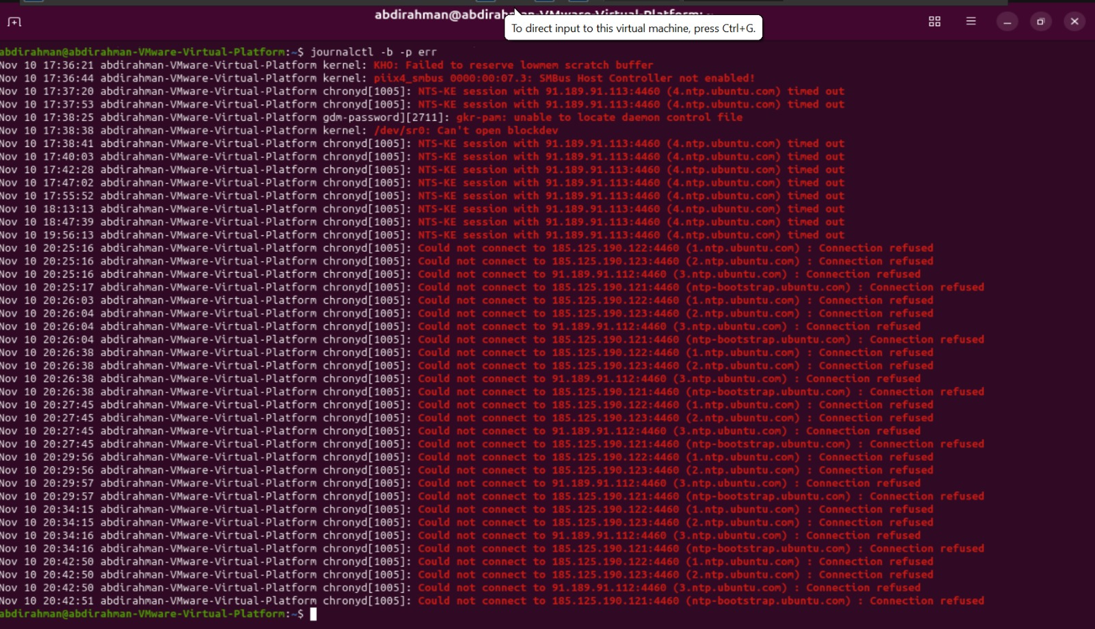
1. journalctl -b -p err
- This command queries the system journal logs recorded since the current system boot (-b).
- The -p err flag filters the output to display only error-level (err or priority 3) log entries.
- The terminal displays various boot warnings and critical issues, such as failed SMBus controllers and block device errors.
- It also shows multiple time-out and connection-refused errors generated by the chronyd time synchronization daemon

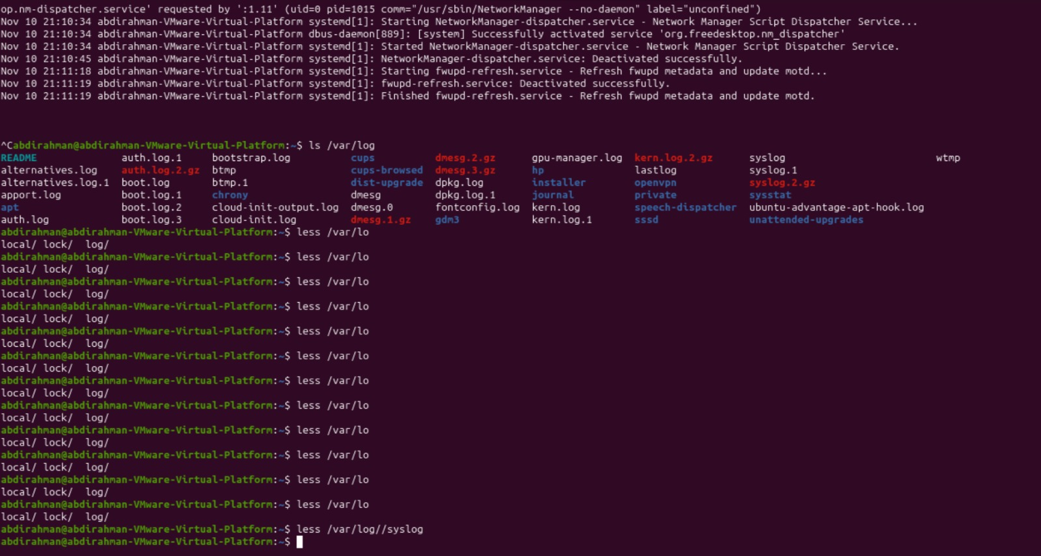

1. ls /var/log
- This command lists all system log files and directories stored inside the /var/log directory.
- It shows critical log files such as auth.log, boot.log, dpkg.log, kern.log, and syslog.
- Administrators use this command to find log files necessary for auditing system activity and software behavior.
- It helps locate both current active logs and compressed archive files like .gz files.
2. Tab Completion Attempts (less /var/lo...)
- The series of incomplete less /var/lo entries represents multiple tab-completion attempts in the command line.
- Pressing the Tab key auto-completed options into paths like local/, lock/, or log/.
- It shows the user navigating shell directory suggestions until reaching the target destination.
- Tab completion is a common feature in Linux shells used to speed up typing and avoid path typos.
3. less /var/log//syslog
- This command opens the main system log file (syslog) using the less file viewer page-by-page.
- The double slash (//) is automatically normalized by the Linux shell path parser to a single slash.
- Using less allows users to scroll through large log files backward and forward interactively.
- It is commonly used to investigate general system events, background operations, and service warnings.
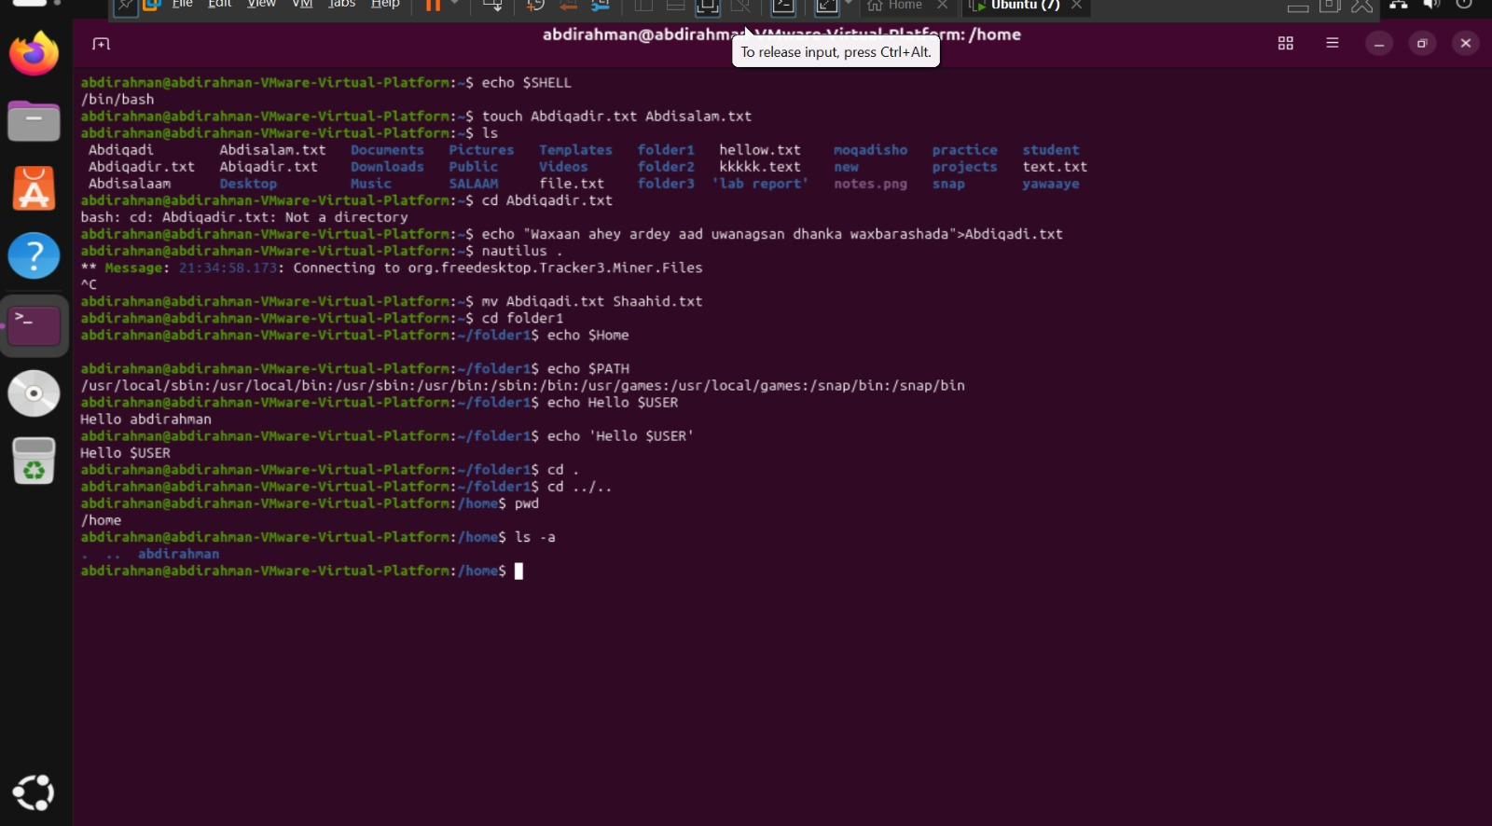

1. echo $SHELL
- This command prints the path of the default login shell currently used by the user.
- The terminal output returns /bin/bash, indicating that the Bourne Again SHell is active.
- It helps users quickly verify their active command interpreter environment.
- This environment variable is configured per user in system account settings.
2. touch Abdiqadir.txt Abdisalam.txt
- The touch command is used to create new, empty files or update file timestamps.
- It successfully creates two files named Abdiqadir.txt and Abdisalam.txt in the current directory.
- It is a quick and efficient way for users to initialize empty files via the terminal.
- Multiple file names can be passed sequentially in a single command line.
3. ls
- The ls command lists the contents, files, and directories within the current working folder.
- The image output shows various files and directories such as Documents, Pictures, and the newly created text files.
- It uses color-coding to distinguish between regular files and directories.
- This is one of the most frequently used commands for navigating file systems in Linux.
4. cd Abdiqadir.txt
- The cd command is used to change the current working directory.
- The terminal responds with an error stating bash: cd: Abdiqadir.txt: Not a directory.
- This error happens because Abdiqadir.txt is a text file, not a folder that can be entered.
- The cd command can only target valid directory paths.
5. echo "Waxaan ahey ardey aad uwanagsan dhanka waxbarashada">Abdiqadir.txt
- The echo command prints text, while the > operator redirects that text into a file.
- It writes the Somali phrase into the file Abdiqadir.txt, replacing any existing content.
- This method is a quick way to add or overwrite text content inside files directly from the shell.
- If the file does not exist, the shell will automatically create it before writing the text.
6. nautilus .
- The nautilus command launches the GNOME graphical file manager application.
- Providing the dot (.) argument instructs it to open the current working directory in the GUI window.
- The terminal displays status messages regarding desktop background services during execution.
- It bridges the command-line interface with the graphical user interface for file management.
7. mv Abdiqadir.txt Shaahid.txt
- The mv command moves or renames files and directories in Linux.
- It renames the file Abdiqadir.txt to a new filename called Shaahid.txt.
- This operation keeps the file content intact while changing its title identifier.
- It is a fundamental command for file organization and management.
8. echo $Home (or $HOME)
- This command prints the value of the environment variable representing the user's home directory.
- Note that variable names in Linux are case-sensitive, so Homemaynotevaluateproperlyunlesswritteninuppercase(HOME).
- Environment variables store system-wide or user-specific configuration paths.
- They can be accessed across any folder location within the active terminal session.
9. echo $PATH
- This command prints the system PATH environment variable containing executable directory paths.
- The output lists directories like /usr/local/sbin, /usr/bin, and /snap/bin separated by colons.
- The shell searches these directories automatically when a user runs a command.
- It ensures that system binaries can be executed without typing their absolute file paths.
10. echo $USER vs echo 'Hello $USER'
- Using double quotes with echo $USER evaluates the variable, outputting the active username (abdirahman).
- Using single quotes with echo 'Hello $USER' treats the text literally, outputting Hello $USER without substitution.
- Single quotes prevent the shell from interpreting special characters and variables inside them.
- This demonstrates how bash handles quote types during string evaluation.
11. cd . and cd ../..
- cd . changes directory to the current folder, effectively keeping the user in the same location.
- cd ../.. moves the working directory two levels up in the file system hierarchy.
- The double dot (..) represents the parent directory of the current location.
- These shortcuts allow for rapid navigation through directory structures.
12. pwd
- The pwd command stands for "print working directory".
- It outputs the absolute file path of the directory the user is currently inside (/home).
- It helps users verify their exact location within the Linux file system hierarchy.
- This is especially useful after navigating with multiple cd commands.
13. ls -a
- The ls command lists directory contents, while the -a flag reveals all hidden files.
- Hidden files in Linux typically start with a dot prefix (such as . and ..).
- It displays system configuration files that are normally invisible in standard ls views.
- It is a vital tool for examining complete directory contents during system administration.

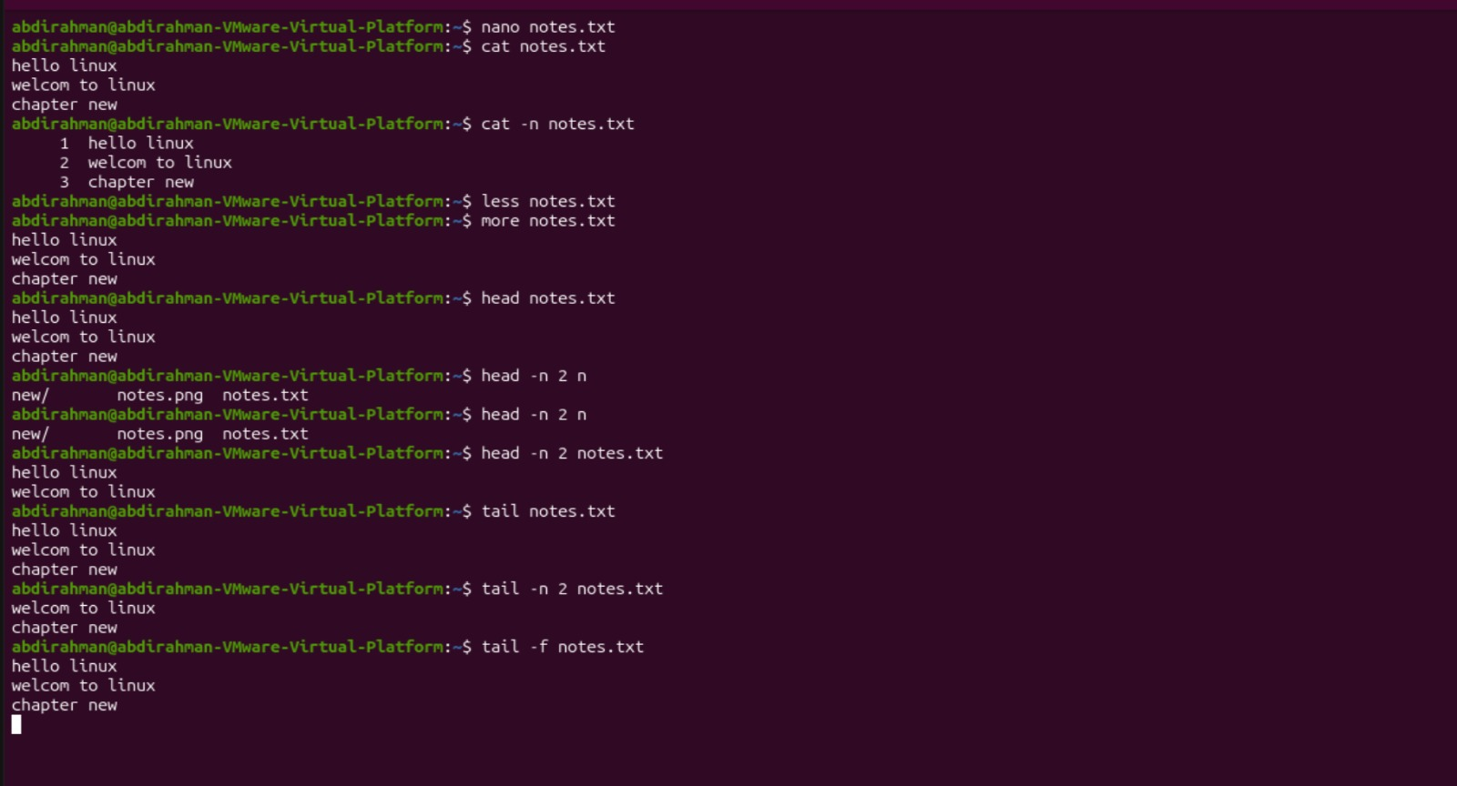

- nano notes.txt
- This command opens the notes.txt file inside the nano terminal-based text editor.
- It allows users to conveniently create, modify, and save text files directly from the command line.
- The editor provides helpful keyboard shortcut hints at the bottom of the screen for easy navigation.
- It is widely used by beginners and administrators for quick file editing tasks.
- cat notes.txt
- The cat command reads text files and outputs their complete contents directly onto the terminal screen.
- In this example, it displays the full text written inside notes.txt all at once.
- It is a fast and efficient tool for viewing small configuration or text files without opening an editor.
- It can also be used to combine or redirect file contents to other files.
- cat -n notes.txt
- This command combines the cat utility with the -n flag to add line numbers.
- It outputs the contents of notes.txt with sequential numbers printed on the left side.
- This numbering makes it much easier to reference specific lines during troubleshooting or code review.
- It applies numbering to every single line, including empty lines or text headers.
- less notes.txt
- The less command opens text files inside an interactive, scrollable viewing interface.
- Unlike cat, it allows users to scroll both forward and backward through large files page-by-page.
- It prevents terminal clutter by loading only what fits on the screen instead of dumping everything at once.
- Users can easily exit the viewer by pressing the q key on their keyboard.
- more notes.txt
- This command opens text files in a basic, page-by-page text viewer interface.
- It outputs the contents of notes.txt incrementally as the user presses the spacebar to move forward.
- Historically, it was one of the earliest tools designed to read lengthy text files without overwhelming the terminal.
- Unlike less, it traditionally only allows forward scrolling rather than moving backward.
- head notes.txt
- The head command is designed to output the beginning section of text files.
- By default, it automatically displays the first 10 lines of the specified file.
- It is extremely useful for checking the structure or headers of large logs and data files quickly.
- Users can customize how many lines are displayed by combining it with number flags.
- head -n 2 notes.txt
- This command restricts the head output using the -n 2 flag.
- It specifically targets notes.txt and displays strictly the first 2 lines from the top.
- It prevents extra information from showing when you only need a quick glance at the header.
- This precise filtering is helpful in shell scripts where exact output lines matter.
- tail notes.txt
- The tail command outputs the final section of files, showing the bottom lines.
- By default, it displays the last 10 lines of the target file.
- System administrators rely on it heavily to check the most recent entries in system logs.
- It helps users immediately see recent updates without scrolling through historical data.
- tail -n 2 notes.txt
- Combining tail with the -n 2 flag limits the output to a specific line count.
- It displays strictly the last 2 lines from the bottom of notes.txt.
- This allows users to filter out older file text and focus exclusively on the final entries.
- It is a precise way to extract tail-end data in automated command-line workflows.
- tail -f notes.txt
- The -f flag puts the tail command into a dynamic "follow mode".
- It keeps the terminal active to monitor and display new lines as they are added to notes.txt in real-time.
- This capability is essential for tracking live system logs and debugging active applications.
- Users can exit this live monitoring mode at any time by pressing Ctrl + C.
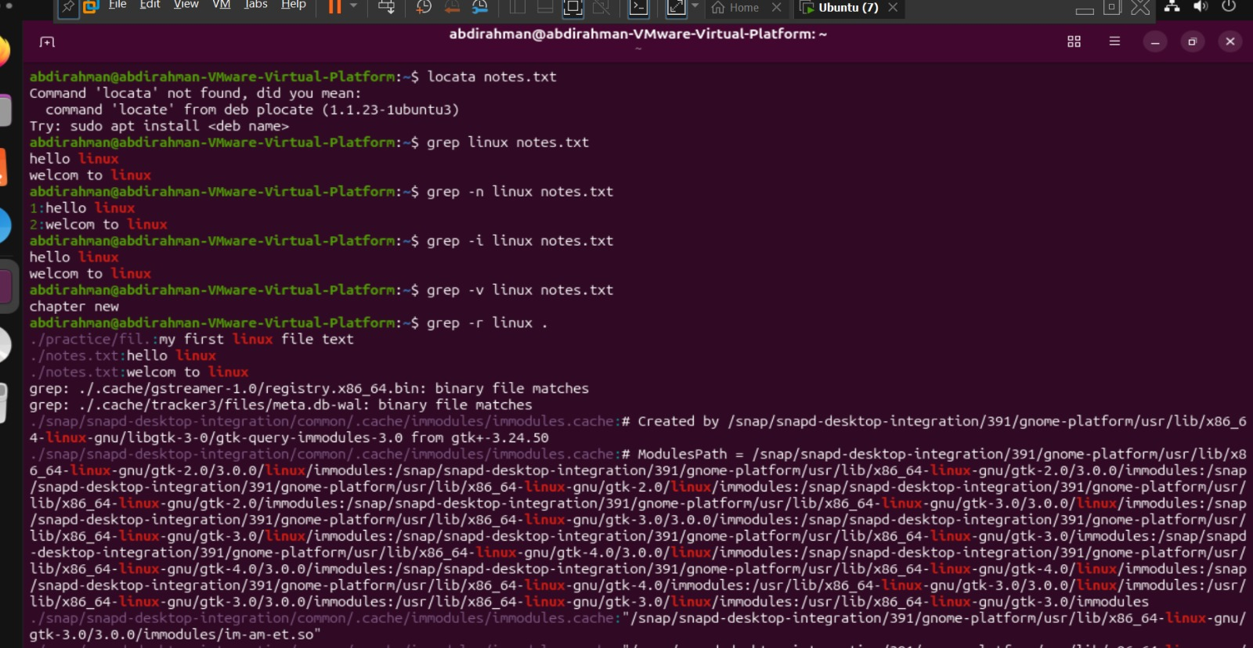

- locata notes.txt
- This command attempts to search for the location of notes.txt, but it contains a typo (locata instead of locate).
- The terminal responds with an error stating Command 'locata' not found.
- It suggests installing the package plocate using sudo apt install plocate to obtain the correct locate binary.
- This error demonstrates how Linux shells handle misspelled command utilities.
- grep linux notes.txt
- The grep command searches for matching text patterns inside specified files.
- It scans notes.txt for lines containing the exact term "linux" in lowercase.
- The terminal displays the matching lines (hello linux and welcom to linux) with the keyword highlighted.
- It is one of the most widely used text-filtering tools in Linux system administration.
- grep -n linux notes.txt
- This command uses the -n flag with grep to print line numbers alongside the matched search results.
- It displays 1:hello linux and 2:welcom to linux, indicating their exact line locations inside notes.txt.
- Showing line numbers makes it easy to pinpoint matching text within large configuration files or logs.
- It helps users navigate directly to specific positions in a file during editing.
- grep -i linux notes.txt
- The -i flag performs a case-insensitive search across the target file.
- It matches the search pattern regardless of whether the text is written in uppercase, lowercase, or mixed case.
- In this example, it successfully finds and highlights matching lines regardless of capitalization.
- This flag is essential when you are unsure about the exact letter casing used in a document.
- grep -v linux notes.txt
- The -v flag inverts the search logic to output only the lines that do not match the specified pattern.
- It scans notes.txt and filters out all lines containing the word "linux".
- The output displays only chapter new, which is the only line without the search keyword.
- It is useful for filtering out known log entries or unwanted data from terminal output.
- grep -r linux .
- The -r flag enables recursive searching through all files and subdirectories starting from the current directory (.).
- It scans every text and configuration file present in the directory tree for the keyword "linux".
- The output lists each matching file path followed by the specific line where the pattern was found.
- It is an invaluable tool for searching through entire project folders or system configuration trees.
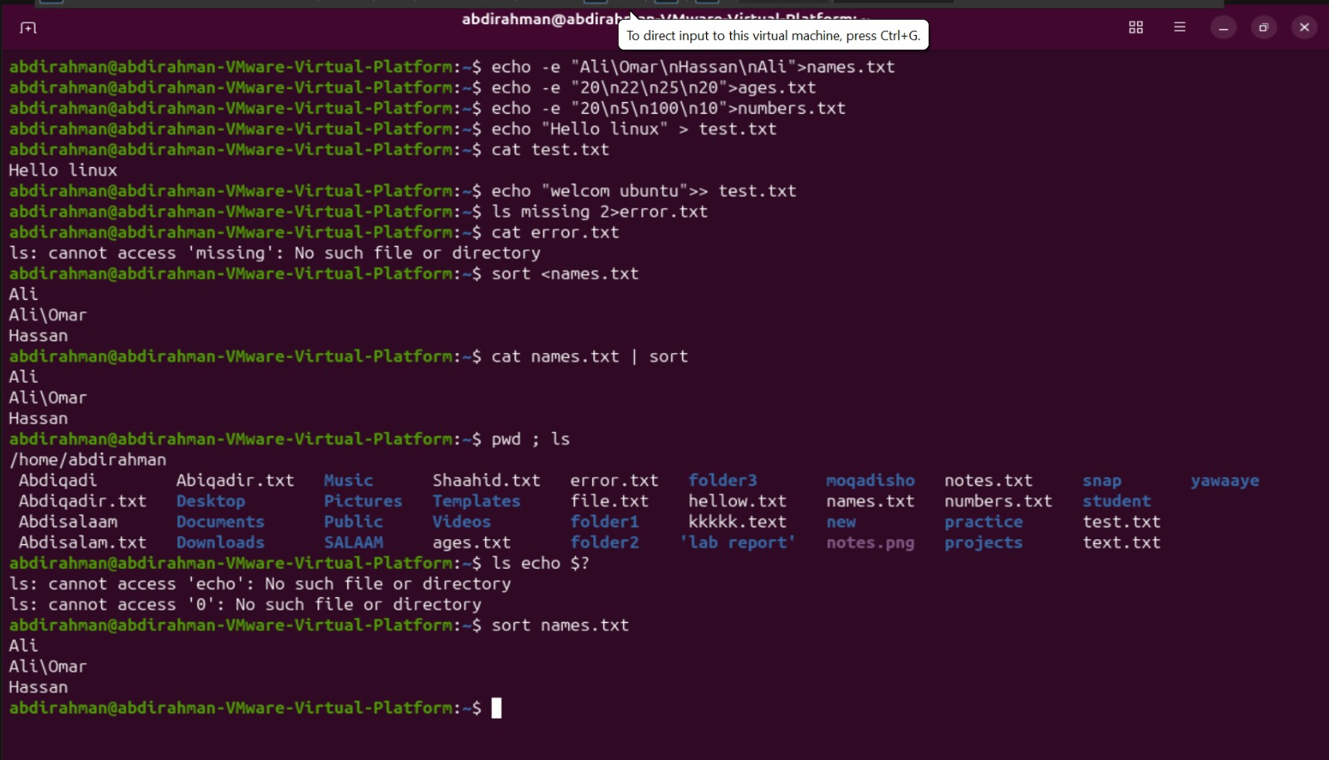

- echo -e "Ali\Omar\nHassan\nAli">names.txt
- The echo command prints text, while the -e flag enables the interpretation of backslash escapes like \n for newlines.
- The > redirection operator sends this formatted string directly into the file names.txt, creating or overwriting it.
- It structures multiple lines of names into a single file in one terminal step.
- This technique is commonly used to generate structured text files quickly from standard output.
- echo -e "20\n22\n25\n20">ages.txt
- This command uses echo -e to process backslash escape characters (\n) for newline breaks.
- It writes a list of age values (20, 22, 25, 20) into the file ages.txt.
- The > operator ensures that any previous contents inside ages.txt are replaced.
- It provides a clean way to populate numeric data files directly from the command line.
- echo -e "20\n5\n100\n10">numbers.txt
- This command processes the escape sequence \n to format each number on a separate line.
- It redirects the numeric sequence (20, 5, 100, 10) into a new file named numbers.txt.
- Using redirection allows instant creation of sample dataset files for testing sorting commands.
- It eliminates the need to open an external text editor like nano to create short files.
- echo "Hello linux" > test.txt
- This command prints the string "Hello linux" and redirects it into test.txt.
- The single > operator creates the file test.txt if it does not exist or overwrites it if it does.
- It initializes the file content with a simple greeting line.
- It is a quick and standard method for writing initial lines of text to a file.
- cat test.txt
- The cat command reads the target file and outputs its full contents directly to the screen.
- The terminal displays Hello linux, confirming the text written by the previous command.
- It is one of the most basic utilities for inspecting file contents in Linux.
- Users frequently use cat to verify that file writing operations succeeded.
- echo "welcom ubuntu">> test.txt
- The >> operator appends text to the end of an existing file without deleting its original content.
- It adds the string "welcom ubuntu" as a new line inside test.txt below "Hello linux".
- Unlike >, using >> preserves existing data while appending new entries.
- It is ideal for adding new records or appending entries to log files.
- ls missing 2>error.txt
- The 2> operator specifically redirects standard error (stderr) messages away from the screen and into a file.
- Since the file or directory missing does not exist, ls generates an error message.
- Instead of displaying on the terminal, the error message is written directly into error.txt.
- This redirection method is essential for capturing script error logs for troubleshooting.
- cat error.txt
- This command displays the error log saved inside the error.txt file.
- The terminal outputs ls: cannot access 'missing': No such file or directory.
- It verifies that the standard error redirection from the previous command functioned correctly.
- It allows administrators to inspect captured error logs at a later time.
- sort <names.txt
- The < operator redirects the contents of names.txt as standard input into the sort command.
- The sort command arranges the lines alphabetically and prints the sorted result to the screen.
- It displays the names in alphabetical order (Ali, Ali\Omar, Hassan).
- Input redirection allows commands to process file contents without needing explicit file arguments.
- cat names.txt | sort
- The pipe operator (|) redirects the output of cat names.txt directly as input into sort.
- It produces the exact same alphabetically sorted output as input redirection.
- Piping is a fundamental Linux concept used to chain multiple commands together seamlessly.
- It allows data to pass from one processing utility to another in a single line.
- pwd ; ls
- The semicolon (;) allows users to execute multiple commands sequentially on a single line.
- The shell first executes pwd to print the current directory (/home/abdirahman).
- Immediately afterward, it executes ls to list all files and directories in that location.
- Combining commands with semicolons saves time when performing sequential terminal checks.
- ls echo $?
- The $? variable holds the exit status code of the most recently executed command.
- Since $? evaluated to 0 (success), bash expanded the command into ls echo 0.
- ls attempted to find files named echo and 0, resulting in No such file or directory errors.
- To view the exit status properly, one should use echo $? instead of passing it to ls.
- sort names.txt
- Passing a file directly to sort reads and sorts its content alphabetically by default.
- It outputs the ordered list of names directly to the terminal screen.
- It demonstrates the standard usage of sort without using pipes or redirection operators.
- The original names.txt file remains unchanged while displaying the sorted output.

