Task 1.1: Superkey & Candidate Key
Relation A: Employee
- Superkeys (6 examples): {EmpID}, {SSN}, {Email}, {Phone}, {EmpID, SSN}, {Email, Phone}
- Candidate keys: {EmpID}, {SSN}, {Email}, {Phone}
- Primary key choice: {EmpID} – stable, business-controlled, non-changing.
- Phone: In sample data, unique → no two employees can share the same number.
Relation B: Course Registration
- Primary key: {StudentID, CourseCode, Section, Semester, Year}
- Roles of attributes:
  - StudentID → identifies student
  - CourseCode → identifies course
  - Section → distinguishes multiple course offerings
  - Semester, Year → when the course was taken
- Additional candidate key: Surrogate {RegistrationID}.

Task 1.2: Foreign Keys
- Student.AdvisorID → Professor.ProfID
- Department.ChairID → Professor.ProfID
- Course.DepartmentCode → Department.DeptCode
- Enrollment.StudentID → Student.StudentID
- Enrollment.CourseID → Course.CourseID
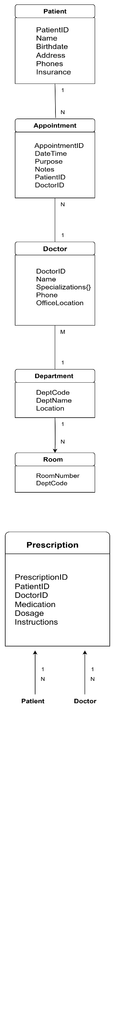
Task 2.1
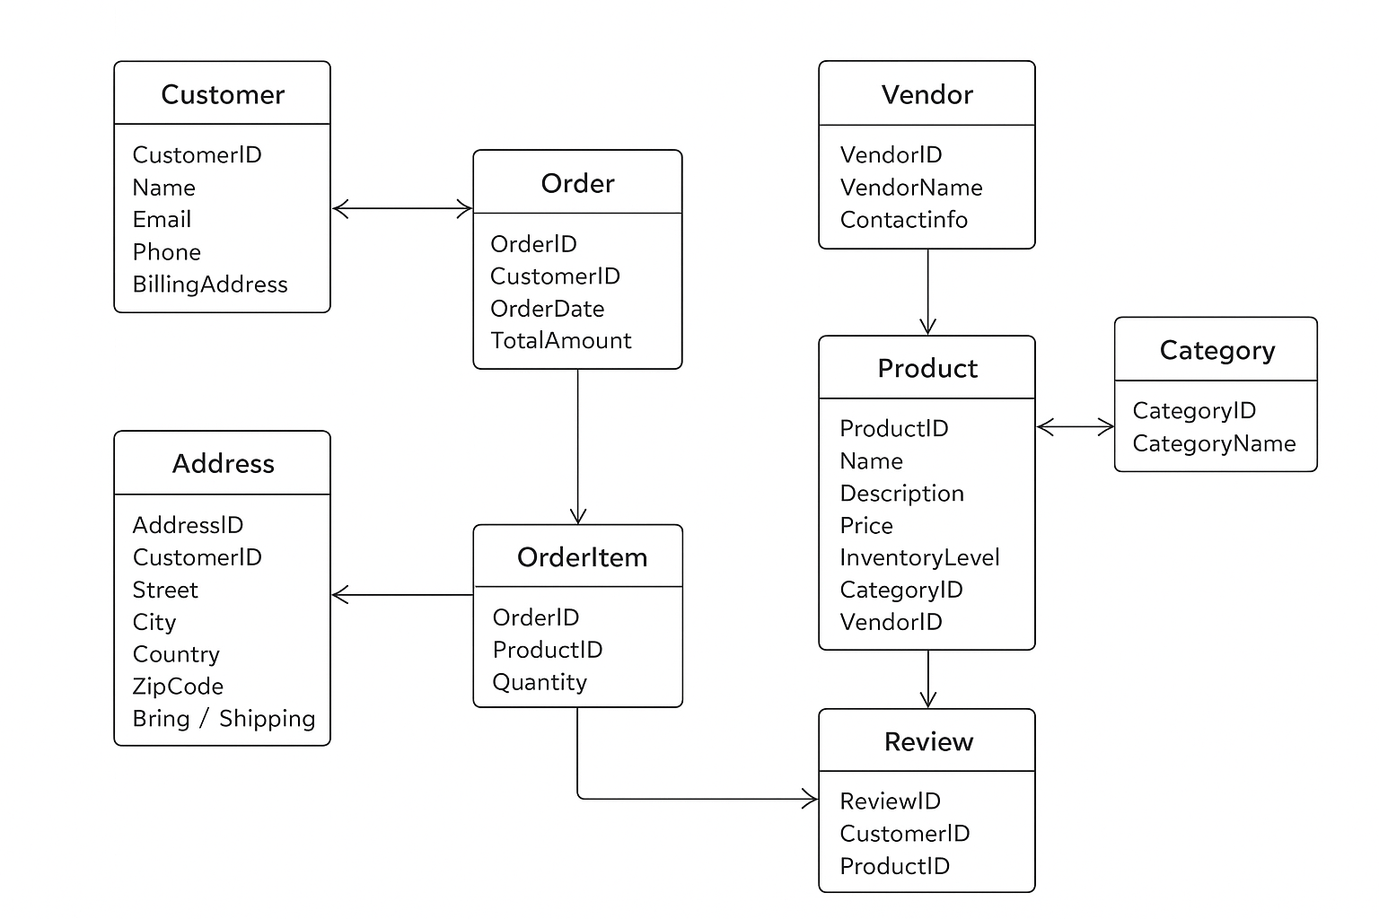
Task 2.2

Task 4.1 — StudentProject
FDs:
- StudentID → StudentName, StudentMajor
- ProjectID → ProjectTitle, ProjectType, SupervisorID, StartDate, EndDate
- SupervisorID → SupervisorName, SupervisorDept
- (StudentID, ProjectID) → Role, HoursWorked
Проблема: қайталану, update/insert/delete аномалиялары.
1NF: атомарлы.
2NF:
- PK = (StudentID, ProjectID)
- Partial deps бар (StudentID → StudentName, ProjectID → ProjectTitle).
- Декомпозиция:
  - Student(StudentID, StudentName, StudentMajor)
  - Supervisor(SupervisorID, SupervisorName, SupervisorDept)
  - Project(ProjectID, ProjectTitle, ProjectType, SupervisorID, StartDate, EndDate)
  - StudentProject(StudentID, ProjectID, Role, HoursWorked)
3NF: транзитивті тәуелділіктер жойылды, финалдық схема ↑.

Task 4.2 — CourseSchedule
PK: (StudentID, CourseID, TimeSlot).
FDs:
- StudentID → StudentMajor
- CourseID → CourseName
- InstructorID → InstructorName
- Room → Building
- (CourseID, TimeSlot) → InstructorID, Room
BCNF: бұзылған (determinant-тар суперкілт емес).
Декомпозиция (BCNF):
- Student(StudentID, StudentMajor)
- Course(CourseID, CourseName)
- Instructor(InstructorID, InstructorName)
- Room(Room, Building)
- Section(CourseID, TimeSlot, InstructorID, Room)
- Enrollment(StudentID, CourseID, TimeSlot)
Lossless, dependency preserved.
