CA612 Natural Language Computing
Project Report- Nov 2019

Title of the Project: INTERACTIVE CHATBOT APPLICATION FOR COMPUTER SCIENCE DOMAIN USING NLTK

Input data: we have created 9 files related to computer science domain from Wikipedia

Libraries used:
import io
import random
import string
import warnings
import numpy as np
from sklearn.feature_extraction.text import TfidfVectorizer
from sklearn.metrics.pairwise import cosine_similarity
import warnings
warnings.filterwarnings('ignore')

import nltk
from nltk.stem import WordNetLemmatizer
import openpyxl

Pre-processing tasks:
- Case Folding (Lower Case)
- Sentence Tokenization
- Word Tokenization
- Lemmatization
- Stop word Removal

Dataset Description:
Name: extracted from wikipedia
URL: https://en.wikipedia.org/
No of words:9 documents(2626+1037+1748+351+1403+1324+354+1049+379)
No of unique words: (1028+457+675+171+531+528+189+344+200)

Block Diagram:
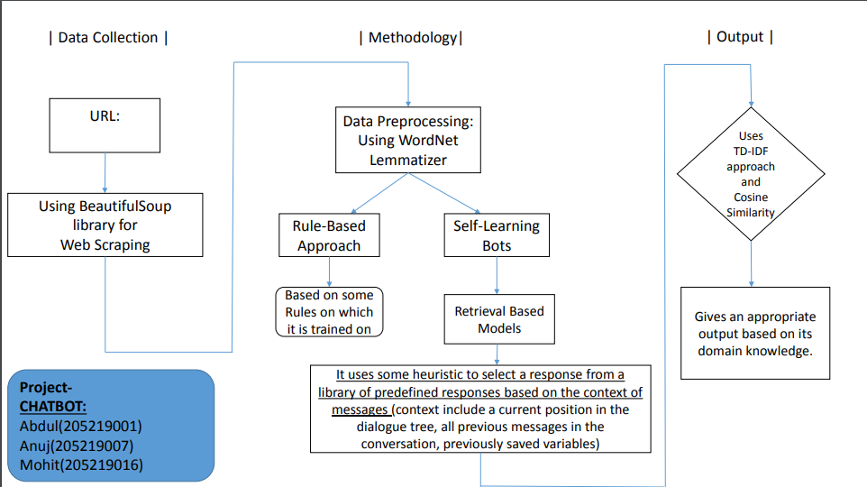

Description
This project is aimed to implement a web-based chat bot to assist students to learn the computer science related subjects using tools that expose artificial intelligence methods such as natural language understanding. Allowing users to interact with the chat bot using natural language input and to train the chat bot using appropriate methods so it will be able to generate a response. The prototype was mainly implemented using NLTK library.

Output:
Description of output:
User will start with a greeting and proceed with their query regarding computer science related domain. Bot will take this query and search in the dataset and corresponding output is displayed. If the query doesn’t match in the data set it will give appropriate message to handle the query.

Actual output (Screen shot):
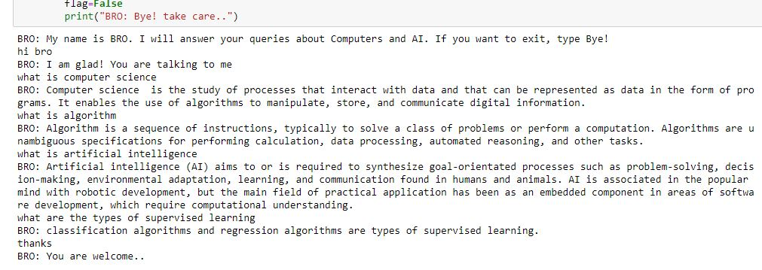

Project Team:
Roll no | Name | Role in the Project | Signature
205219001 | Abdul Jamsheed V | Implementation, documentation
205219007 | Anuj Kumar Jha | Implementation, documentation
205219016 | Mohit verma | Implementation, documentation

