
2024
Université des sciences et de la technologie Houari-Boumédiène (USTHB)

Report on : INFORMATION AND COMMUNICATION TECHNOLOGIES (TIC)

Prepared by :
Tarek azzouz benaziza
guerza sidahmed
hattab hamza riadh
mohamed amine baziz
aichaoui abdelatif

Summary :

- Definition of TIC
- Importance of TIC
- Google Services
- Overview of Google Services
- Integration of Google Services
- Microsoft Tools
- Overview of Microsoft Tools
- Microsoft Word
- Microsoft Excel
- Microsoft PowerPoint
- Latex
- Overview of Latex
- Integration of Latex
- Git and GitHub
- Understanding Version Control with Git
- Collaboration with GitHub
- Comparative Table of Git vs. GitHub Features
- Conclusion

- Definition of TIC :
Tic covers a wide array of technologies that facilitate the gathering, storage, processing, and sharing of information. It defines TIC (Technology and Information Communication) and examines its applications across different domains.

- Importance of TIC :
In the contemporary digital environment, Technology and Information Communication (TIC) are pivotal for improving communication, managing data, and enhancing overall efficiency. This section delves into the importance of TIC in today's world.

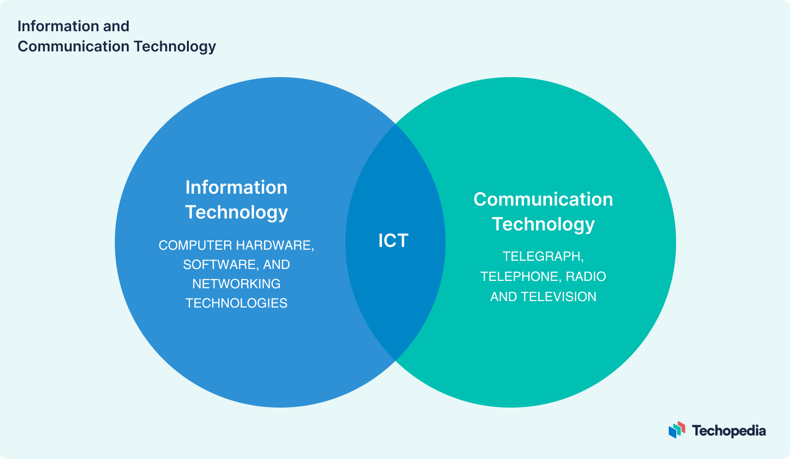

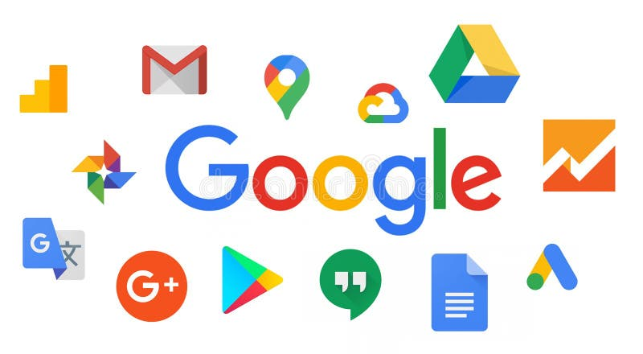
- Google Services :

- Overview of Google Services :

Google provides a suite of services such as Gmail, Google Drive, and Google Workspace. This section presents an overview of these services along with their functionalities.

- Integration of Google Services :

Google Services comprise numerous tools and features that seamlessly integrate to provide a unified digital experience. Among the key services are:

Google Search | La pierre angulaire des services Google, offrant un accès à l'information à travers le web
Gmail | Service de messagerie électronique doté de fonctionnalités puissantes pour la communication et la productivité.
Google Drive | Stockage en ligne pour les fichiers, offrant des outils de collaboration tels que Google Docs, Sheets et Slides.
Google Calendar | Un outil pour planifier des événements, des réunions et des rappels.
Google Maps | Service de navigation et de cartographie offrant des directions, des informations de localisation, et plus encore.
Google Photos | Service de stockage et de gestion de photos basé sur le cloud.
Google Chrome | Navigateur web développé par Google, offrant des capacités de synchronisation avec le compte Google.
Google Assistant | Assistant virtuel activé par la voix disponible sur les smartphones et les appareils intelligents.
Google Play | Plateforme de distribution numérique de Google pour les applications Android, les jeux, la musique, les films, et plus encore.
Google Store | Plateforme d’installation d’applications et de jeux pour Android.
Google Ads | Advertising service to promote products or services across Google's networks.

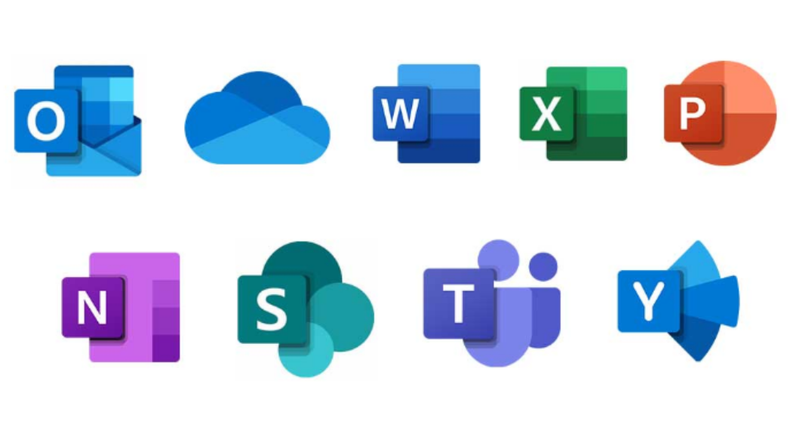
- Microsoft Tools :
- Overview of Microsoft Tools :

Microsoft provides a comprehensive suite of tools, serving diverse purposes in personal and professional settings. This section offers an in-depth overview of key tools, focusing on Microsoft Word, Excel, and PowerPoint.

- Microsoft Word :
Microsoft Word is a versatile word processing application, widely used for document creation and editing. It boasts a range of formatting tools, styles, and templates, making it suitable for various tasks from simple letters to complex reports.

Key Features :

Document Formatting | Easily format text, paragraphs, and pages.
Templates | Access a variety of templates for different document types.
Collaboration | Enable real-time collaboration with others on the same document.
Review and Editing | Track changes, add comments, and utilize spelling and grammar check.

- Microsoft Excel :
Microsoft Excel is a powerful spreadsheet application designed for data analysis, manipulation, and visualization. Widely used for budgeting, financial analysis, and complex calculations.

Key Features:

Cell-based Calculation | Perform mathematical calculations using formulas and functions.
Data Analysis Tools | Utilize pivot tables, charts, and graphs for data visualization.
Data Validation | Ensure data accuracy through validation rules.
Collaboration | Share and collaborate on Excel sheets in real-time.

- Microsoft PowerPoint :

Microsoft PowerPoint is presentation software allowing users to create dynamic and visually appealing slideshows. Commonly used for business presentations , educational lectures , and more.

Key Features:

Slide Design | Choose from a variety of themes and layouts for professional-looking slides.
Media Integration | Embed images, videos, and audio for engaging presentations.
Transitions and Animations | Add transitions and animations to enhance visual appeal.
Presenter View | Access presenter tools for smoother presentations.

- Latex:

- Overview of Latex :

Latex is a typesetting system used to create high-quality documents in academic, technical and scientific fields, it's based on the TeX typesetting language developed by Donald Knuth and offers a powerful way to structure and format documents.

- Integration of Latex:

Integration of Latex refers to its incorporation or utilization within various systems, platforms, or workflows to enhance document creation, processing, or dissemination. Here are a few aspects of LaTeX integration:

Text Editors and IDEs | Many text editors and integrated development environments (IDEs) offer plugins or built-in support for LaTeX. These tools provide features like syntax highlighting, auto-completion, and compiling LaTeX documents within the editor.
Collaboration Platforms | Integration with collaboration platforms like Overleaf allows multiple users to collaborate on LaTeX documents in real-time, providing version control, commenting, and sharing functionalities
Publishing Systems | Academic publishing systems often accept LaTeX submissions for articles, research papers, and journals. Integration involves preparing manuscripts using LaTeX that adhere to the publication's style guidelines.
Version Control Systems | LaTeX files, being text-based, are compatible with version control systems like Git. Integration allows for efficient management of changes, collaborative writing, and tracking document history.
Document Conversion | Tools and services can convert LaTeX documents to various formats like PDF, HTML, or Word, allowing compatibility with different platforms or requirements.
Automated Workflows | LaTeX can be integrated into automated workflows for document generation. For instance, using scripts or tools to compile LaTeX documents automatically upon certain triggers or changes.
Web Development | Integration with web development workflows for generating mathematical equa-tions, symbols, or formatted text within web pages or applications.
Educational Platforms | Educational platforms or learning management systems might support LaTeX for creating mathematical equations, technical documents, or assignments.

- Git and GitHub :
- Understanding Version Control with Git :
This section elucidates the concept of version control and the pivotal role played by Git in effectively managing changes in code.

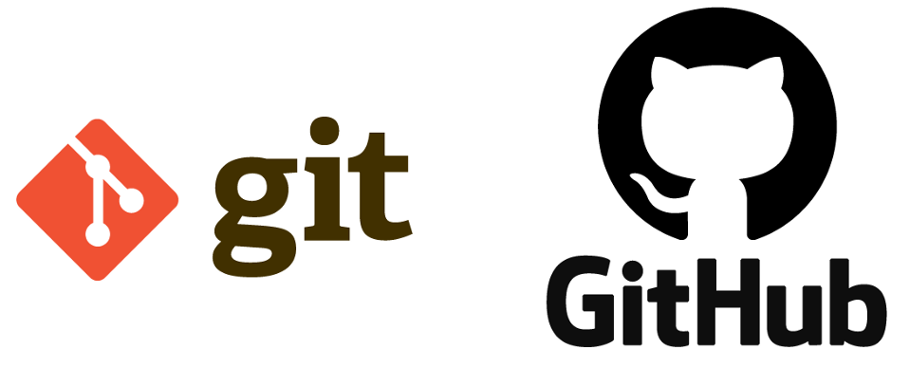

- Collaboration with GitHub :
GitHub serves as a platform for streamlined collaboration and code management. This section delves into the collaborative features of GitHub, providing insights into its functionalities.

- Comparative Table of Git vs. GitHub Features :

Relationship | Git is the version control system, while GitHub is a platform that uses Git for version control and provides additional collaboration and project management features.
Usage | Git can be used locally or in a private network, while GitHub is a cloud-based service accessible to anyone. Other similar services exist, like GitLab and Bitbucket, offering similar functionalities but with different features and hosting options.
Purpose | Git is primarily for version control and managing code changes, while GitHub extends this functionality by providing a platform for collaboration, community engagement, and project management.

- Conclusion :
In summary, this report has explored the realm of Information and Communication Technologies and related tools, underscoring the influence of TIC on communication and productivity. The seamless integration of Google services, Microsoft tools, Latex, Git, and GitHub contributes to an enhanced digital experience, offering efficient solutions across diverse domains.

