The HER and OER performance with different catalytic environment

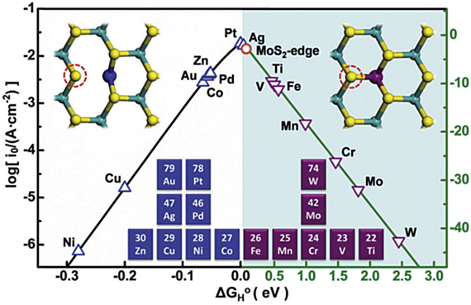
Abstract
A crucial step in fuel cell technology, the hydrogen evolution reaction (HER) is essential to the efficient and clean conversion of energy. This thesis article offers a thorough examination of catalysis in the HER domain, exploring the developments, difficulties, and new directions that are influencing the field of fuel cell hydrogen production. The paper opens with a summary of the fundamental concepts of HER, clarifying the electrochemical mechanisms involved in proton reduction at the cathode. The importance of catalysts in accelerating HER kinetics is emphasized, with particular attention paid to problems such overpotential and slow reaction rates. Various types of catalysts, including transition metal-based catalysts, metal alloys, and non-metal materials, are thoroughly reviewed, highlighting their catalytic activities, stability, and structure-activity connections. Additionally, the thesis compares acidic and alkaline settings to examine the impact of reaction environments on catalytic performance. The unique electrochemical characteristics of various circumstances are investigated, providing information on factors to be taken into account when designing catalysts for particular pH ranges. Furthermore, the effects of concentration and composition of electrolytes on HER catalysis are investigated in detail, providing insight into the complex interactions that occur between catalysts and the surrounding electrochemical environment. The article discusses the main obstacles to the broad use of HER in fuel cells, including as cost concerns, durability problems, and catalyst poisoning. To offer a guide for future research paths, strategies to lessen these difficulties are investigated, including the creation of innovative catalyst support materials and the application of sophisticated characterization methods. Recent developments in the subject are also covered in the thesis, including the use of computational methods for catalyst design and the investigation of novel materials, such as 2D materials and nanostructures, to improve catalytic performance. Furthermore, new developments in earth-abundant and sustainable catalysts are emphasized, suggesting that HER in fuel cells will have a more favorable future in terms of both the environment and the bottom line. This thorough analysis concludes by compiling the most recent research on catalysis in the HER domain for fuel cells. The study is a useful resource for researchers, engineers, and policymakers working towards the development of effective and sustainable hydrogen generation methods by analyzing catalyst design, performance, and problems.
Keywords: Hydrogen evolution, TOF, OER, energy.
- Introduction
Hydrogen evolution reaction (HER) has become a hot topic in fuel cell technology development due to the drive for clean, sustainable energy alternatives. HER is essential to electrochemical energy conversion and is the key to utilizing hydrogen as a green fuel. The goal of this review paper is to present a thorough analysis of catalysis in the HER domain and clarify the complex interactions that occur between catalysts and the basic electrochemical mechanisms that control the production of hydrogen. Fuel cells are emerging as viable options for effective and ecologically friendly energy conversion as the world's attention shifts to reducing carbon emissions and combating climate change [1]. The hydrogen evolution reaction (HER) is one of the key mechanisms that drives fuel cell technology. It affects the overall performance and sustainability of hydrogen-based energy systems. Catalysts play a major role in controlling the kinetics and efficiency of HER, and knowing their design principles, mechanisms, and constraints is crucial for improving the research. In order to provide a solid grasp of HER, this paper first examines the fundamental ideas behind proton reduction at the cathode. The succeeding sections go into a comprehensive investigation of numerous catalysts, ranging from traditional transition metal-based catalysts to new materials such as 2D structures and Nano architectures [2]. The role of reaction settings, including both acidic and alkaline circumstances, is studied, revealing insights into the subtle aspects affecting catalytic activity. The purpose of this review is to offer a road map for academics, engineers, and policymakers to fully utilize HER catalysis in fuel cell applications as we traverse current developments, obstacles, and opportunities. In both acidic and alkaline settings, the electrochemical reactions occurring at the anode (OER domain) and the cathode (HER domain) are generally represented as follows:
The anode and cathode are essential components in enabling electrochemical reactions that produce hydrogen through water electrolysis in fuel cells. Both acidic and alkaline conditions can support the process, and each has unique electrochemical responses.
Anode (OER):
Water is oxidized at the anode, which is the oxygen evolution reaction (OER) domain, releasing oxygen gas. The following graphic represents the overall response:
2H₂O → O₂ + 4H⁺ + 4e⁻
Water molecules are broken down into oxygen, protons (H⁺), and electrons (e⁻) in this reaction. An external circuit is then used to send the electrons produced during this process in the direction of the cathode.
The HER cathode:
Protons and electrons mix at the cathode, which is the hydrogen evolution reaction (HER) region, to form hydrogen gas. The general response can be shown as follows:
4H⁺ + 4e⁻ → 2H₂
This stage creates hydrogen gas by reuniting protons and electrons produced at the anode.
Anode (OER):
The OER domain also includes the oxidation of water in an alkaline environment, albeit with a somewhat different reaction. In alkaline circumstances, the total reaction at the anode is shown as follows:
4OH⁻ → O₂ + 2H₂O + 4e⁻
Here, oxygen gas, water, and electrons are produced through the oxidation of hydroxide ions (OH⁻). The total charge balance of the electrochemical cell depends on this mechanism.
The HER domain cathode:
Similar to an acidic environment, protons and electrons combine at the cathode in an alkaline environment to form hydrogen gas. The general response is shown as:
4H₂O + 4e⁻ → 2H₂ + 4OH⁻
This stage involves the combination of protons and electrons to create hydrogen gas and the production of hydroxide ions. It is important to remember that the total anodic and cathodic reactions are what drive the overall water electrolysis reaction in both acidic and alkaline environments:
2H₂O → 2H₂ + O₂
This process, which produces hydrogen that may be used as a fuel in a variety of applications, is clean, sustainable, and powered by an external electrical potential. In summary, the oxidation of water molecules at the anode and the reduction of protons at the cathode are the electrochemical reactions that occur at the anode and cathode for the creation of hydrogen in both acidic and alkaline conditions [3]. Together, these reactions support the fuel cell's entire water electrolysis process, providing a viable path toward the production of efficient and pure hydrogen.

- Various effective HER catalysts
Cobalt selenide has become a very popular electrocatalyst for electrochemical water splitting in recent years [4]. An ideal Oxygen Evolution Reaction (OER) electrocatalyst should include transition metal cations with electron occupancy in the e.g. orbital that is close to unity, in accordance with Yang Shao-Horn's principle. With an electron configuration of t₂^{g}₆e_{g}¹, the cubic structure of CoSe₂ is almost perfect for catalyzing OER. Furthermore, the excellent electrical conductivity and metallic behavior of CoSe₂ are confirmed by both experimental and theoretical data. Low catalytic activity, however, is a consequence of insufficiently exposed active sites in the pure form of CoSe₂ [5]. Liu et al. have created unaltered ultrathin CoSe₂ nanosheets in order to solve this problem. Compared to bulk CoSe₂, these nanosheets' atomic thickness and abundance of VCo vacancies provide extra active sites[6]. In a pH 13 solution, the resultant catalyst reached a low OER overpotential of 320 mV at 10 mA cm⁻². It has been determined that nonstoichiometric cobalt selenide is a feasible choice for a composite catalyst. Jiang et al. created the Pt/np-Co_{0.85}Se model, which consists of single-atom platinum supporting nanoporous Co₀.₈₅Se, in order to investigate the fundamental elements affecting the Hydrogen Evolution Reaction (HER) activity [7]. According to their research, atomic Pt optimizes the active surface sites of Co_{0.85}Se, lowering energy barriers and promoting hydrogen adsorption/desorption. An onset overpotential near zero was produced by the Pt atoms' and np-Co_{0.85}Se's synergistic interaction [8]. In a neutral solution, the turnover frequency peaked at 3.93 s⁻¹ at −100 mV and the Tafel slope attained an exceptionally low value of 35 mV dec⁻¹, outperforming the performance of Pt/C and other transition metal electrocatalysts available for sale. Zhao et al. have made recent developments [9]. used a vacuum-sealed ampoule to calcine Co foil and Se powder, resulting in the formation of three-dimensional, freestanding cobalt selenide electrodes made of phases CoSe and Co₉Se₈.
Analyzing and contrasting catalytic activity requires taking into account a number of established parameters [10]. We examine the benefits and drawbacks of each of these parameters in this section of the review, beginning with Overpotential (η). Because of kinetic obstacles, electrochemical reactions seldom take place at the potential that thermodynamic calculations alone predict. Consequently, in order to enable certain kinds of electrochemical processes, an extra driving force called overpotential (represented by η)[11] is required. Three factors can cause overpotential in both the Oxygen Evolution Reaction (OER) and Hydrogen Evolution Reaction (HER): concentration overpotential, activation overpotential, and overpotential owing to uncompensated resistance (Ru), which is the resistance imposed by the electrochemical interfaces. distinct catalyst materials have distinct intrinsic properties that facilitate the electrode reaction, such as activation overpotential[12]. Therefore, this overpotential can be reduced by using an effective catalyst. Stirring the solution can help reduce concentration overpotential, which is caused by a fast reduction in concentration near the interfaces at the beginning of the electrode response [13]. The conclusion is a potential (E), and the associated drop in potential, known as the iR drop, needs to be subtracted from the experimental potential [14]. Because the kinetics of the Hydrogen Evolution Reaction (HER) are faster than those of the Oxygen Evolution Reaction (OER), the activation overpotential, often referred to as the onset overpotential, is more important in the context of the HER than other components [15]. By examining the polarization curve, which plots the overpotential versus the current density, one can ascertain the onset overpotential [16]. On the other hand, the OER requires that more factors be taken into account when calculating overpotential.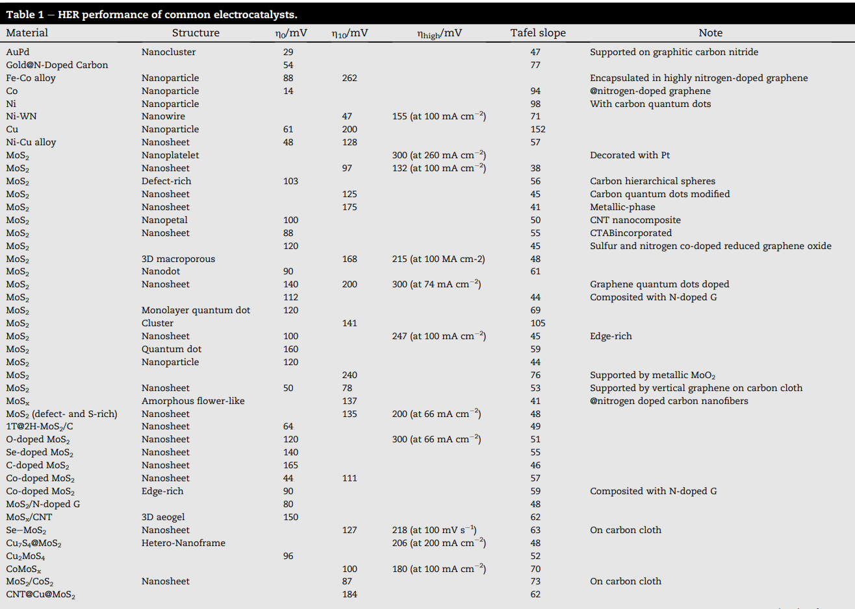 As previously stated, every mechanism for the OER that has been suggested starts with the basic step of water coordination in acidic solutions or hydroxide ion coordination in alkaline situations, and then goes through a series of other simple processes.
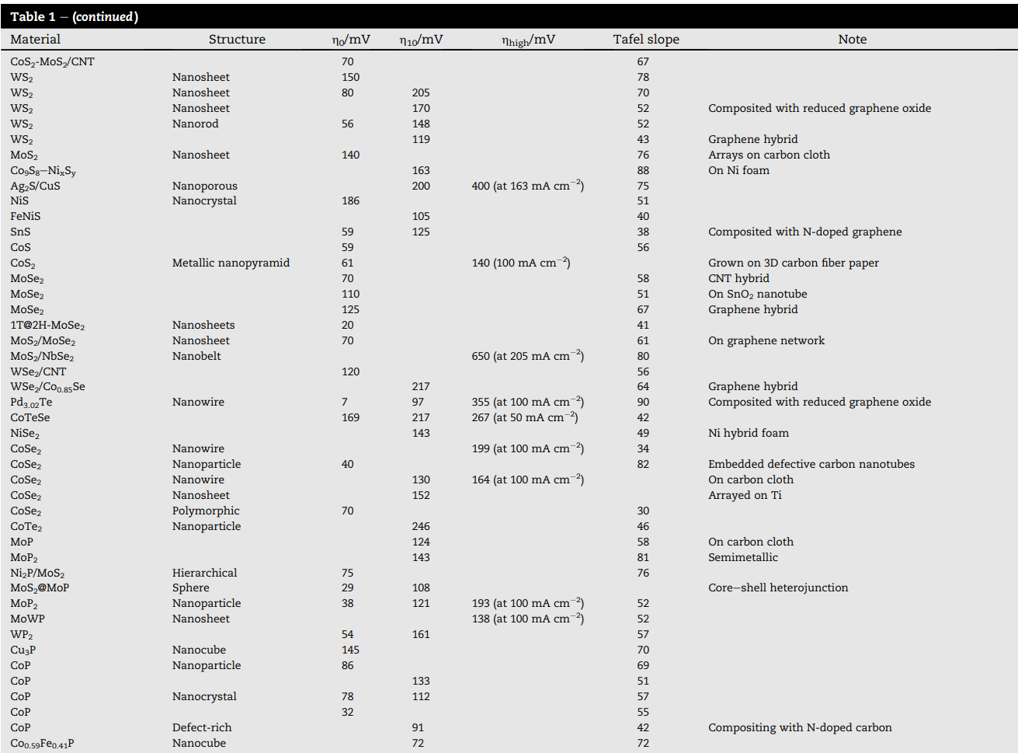
The table depicts almost every known electrocatalysts in the past years which has been reported by different researchers. This table was produced by Ali Eftekhari in 2017[6].
2.1 Efficiency of reaction
An electrocatalyst is normally tested for durability using an accelerated degradation test, which involves applying cyclic voltammetry (CV) at a high scan rate [17]. This evaluation also entails completing chronoamperometric or chrono potentiometric analyses [18]. In the case of the Hydrogen Evolution Reaction (HER), the accelerated deterioration test spans several thousand cycles, initiating polarization from 0 V vs N_{HE} [19]. When it comes to the Oxygen Evolution Reaction (OER), the number of cycles in the accelerated degradation test that have been recorded ranges from 250 to 1000. It is rare for OER catalysts to show remarkable stability above 1000 cycles [20]. Stability characteristics, such as the change in onset overpotential (η₀) (cathodic for HER and anodic for OER) and the overpotential at a specified current density of 10 mA/cm² (η₁₀), are assessed after the accelerated deterioration test. Higher stability is indicated by a smaller increase in overpotential [21]. For periods varying from few minutes to hours, stability is evaluated in further detail when subjected to a constant potential (chronoamperometry) or a constant current density (chronopotentiometry). Nowadays, it is generally accepted that finding an effective electrocatalyst for both the OER and HER requires either keeping a steady current density (for example, 10 mA/cm²) for more than 12 hours using chronoamperometry or showing a small increase in overpotential at a current density of 10 mA/cm² for more than 12 hours using chronopotentiometry. Other current densities, like 50 or 100 mA/cm² and their matching potentials, can also be used in prolonged chrono potentiometric and chronoamperometric investigations when dealing with high-performance materials and catalysts with strong redox peaks [22].

2.3 Variables impact the individual potential
The reaction is being impacted by Faradaic Efficiency in Catalysis for Hydrogen Evolution Reaction. A key component of fuel cell technology is the effective transformation of electrical energy into hydrogen gas via the Hydrogen Evolution Reaction (HER)[23]. One important indicator for evaluating how well catalytic processes facilitate the synthesis of hydrogen is faradaic efficiency. In the context of catalysis for hydrogen evolution reaction (HER) in fuel cells, the idea of faradaic efficiency is examined in this debate, with a focus on its importance, influencing factors, and consequences for the development of clean energy technologies[24]. The degree to which electrons contributed to the electrochemical process are used for the intended reaction—in this case, the conversion of protons into hydrogen gas during the HER—is measured by the term "faradic efficiency." It is represented as the ratio of the actual moles of hydrogen evolved to the theoretically calculated moles based on the consumed electrons, providing insights into the effectiveness of the catalyst in boosting the intended reaction while minimizing side reactions[25]. Achieving high faradaic efficiency is crucial for HER catalysis in order to maximize hydrogen output and minimize energy losses. A 100% Faradaic efficiency would mean that every electron added to the system is used just to reduce protons to create hydrogen gas, which is the optimal situation[26]. Nonetheless, the overall faradaic efficiency may be impacted by pragmatic factors including catalyst degradation, competing reactions, and undesirable byproducts. In HER catalysis, a number of parameters affect faradaic efficiency, with catalyst design and material selection being crucial[27]. Its capacity to specifically catalyze the HER above competing reactions, guaranteeing a better faradaic efficiency, is greatly influenced by the catalyst selection. Furthermore, catalyst deterioration over time might result in decreased efficiency, therefore the catalyst's stability and endurance under working circumstances are vital. Another important factor in determining faradaic effectiveness is the electrolyte's pH. Both acidic and alkaline conditions can cause HER, and the pH selection can affect the kinetics of the reaction and the possibility of adverse reactions[28]. For fuel cell applications that are realistic, faradaic efficiency must be optimized with careful consideration of the electrolyte conditions. Moreover, the electrode potential and applied voltage directly effect the faradaic efficiency of HER catalysis. Achieving high faradaic efficiency requires operating the fuel cell in a way that both promotes and suppresses competing reactions [29]. This calls for a sophisticated comprehension of the interactions between the catalyst and the environment as well as the electrochemical processes[30]. To sum up, faradaic efficiency is an important parameter to consider when evaluating how well fuel cells' catalysis of the Hydrogen Evolution Reaction works[31]. To maximize the production of pure hydrogen while reducing energy losses and unwanted byproducts, high faradaic efficiency must be achieved. To maximize the potential of hydrogen as a sustainable energy carrier in fuel cell applications and to increase the faradaic efficiency of HER catalysis, further research and development in the fields of catalyst design, material science, and electrolyte optimization are essential.

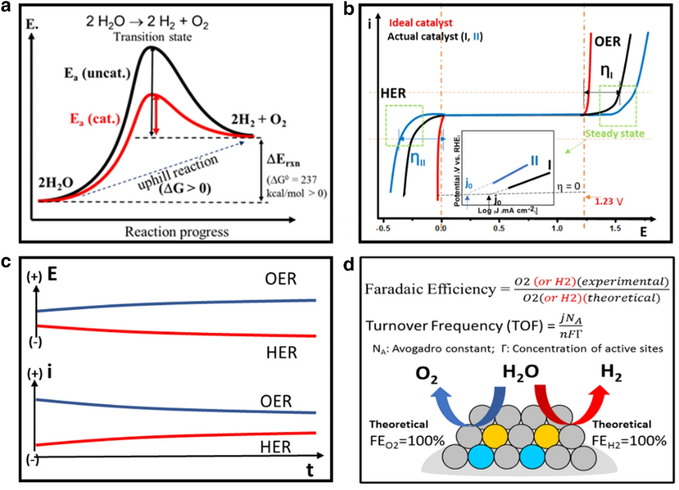
Fig 1. a Schematic illustration of the catalyst’s role in lowering the activation energy barrier; b–d schematic illustrations of the performance evaluation parameters of electrocatalyst, including, b activity in terms of overpotential, Tafel slope, and exchange current density, c stability in terms of current- and potential-time curves, and d efficiency in terms of faradaic efficiency and turnover frequency.
Another quantitative metric used to evaluate an electrocatalyst at a given overpotential is the Turnover Frequency (TOF). The Turnover Frequency (TOF) is a crucial metric in the field of catalysis for the Hydrogen Evolution Reaction (HER) in fuel cells, providing a quantitative assessment of the catalytic activity of an electrocatalyst [32]. The number of hydrogen molecules produced by each active site in a unit of time at a certain overpotential is represented by it, providing information on how well the catalyst promotes the HER. The TOF indicates how fast the electrocatalyst promotes the conversion of protons into hydrogen gas at a given overpotential[33]. It is computed by dividing the number of active sites on the catalyst surface by the reaction's current density [34].
Given that it denotes a higher rate of hydrogen production at the designated overpotential, a larger TOF suggests an electrocatalyst with higher efficiency. To find materials with better catalytic performance, researchers and engineers use TOF as a critical metric for assessing and contrasting various catalysts[35]. By maximizing energy losses and speeding up HER, TOF optimization is crucial for improving fuel cell efficiency overall. The design of the catalyst, the choice of material, and structural factors all have a significant impact on TOF. Researchers are working to create electrocatalysts with high activity and stability under practical operating conditions[36]. Comprehending TOF within the framework of HER catalysis offers a useful method for customizing electrocatalysts to satisfy fuel cell performance specifications. Scientists are still investigating novel materials and design approaches to push TOF limits, which could lead to more sustainable and effective hydrogen production for fuel cell applications[37]. The TOF continues to be a crucial parameter driving the search for greener and more efficient energy conversion methods as catalyst development advances.
2.4 Catalysts' impact on the reactions
The mass and particular activities of an electrocatalyst should be supplied at a predetermined overpotential, much like the Turnover Frequency (TOF). In-depth information about particular and mass activities is provided in section [38]. The overpotential, Tafel slope, and stability characteristics are considered to be crucial among the six parameters that are mentioned to describe the catalytic activity of an electrocatalyst [39].
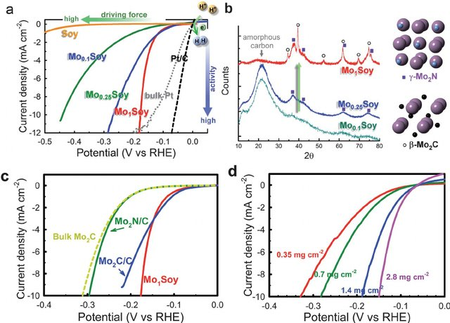
Fig. 2 (a) The polarization curves for the hydrogen evolution reaction on Mo x Soy catalysts, bulk Pt (grey dotted curve), and the Pt/C catalyst (black dashed curve) in H 2 purged 0.1 M HClO₄ solutions (scan rate 2 mV s À 1 ). The potential was referenced to the reversible hydrogen electrode. The sample made by annealing pristine soybeans.
Combining the two is therefore a workable strategy for overall water splitting. CoSe and Co(OH)₂ were simply coupled to form the dual function catalyst CC@Co(OH)₂@CoSe produced on carbon cloth, as discovered by Duan et al. [41]. Its improved electron transport capability was shown by a DOS that is closer to the Fermi level. The water electrolysis performance was even greater than CC@Pt/C//CC@RuO₂ at high current densities. Given that catalysts frequently undergo phase transitions or reconfigurations during electrolysis, there has been debate on whether the active ingredients in HER or OER are original catalysts. Chen et al. conducted a number of in situ operations to trace the dynamic changes of materials in the catalytic process and identify the real reaction species of carbon-based cobalt selenides. They also studied structural changes of phosphate CoSe1$26P1.42 in HER and OER. It's interesting to note that after 150 seconds in KOH, the smooth surface of CoSe1$26P1.42 became packed with tiny nanoparticles, and its lattice spacing shifted from 0.36 nme0.28 nm, which corresponded to the Co(OH)₂ (010) plane. but Pesubstituted CoSe₂ did not alter significantly. Furthermore, the oxidation state of CoSe1$26P1.42 was brought closer to Co foil by the alkaline HER process, as demonstrated by X-ray absorption near edge structure. Raman spectroscopy has also revealed the related phase transition. Duan claims that CoSe1$26P1. only functions as a pre catalyst in the alkaline electrolyte. The active species in HER is metal Co, whereas in OER it is Coo OH. P doping, meanwhile, encouraged the production of active ingredients.
Figure 3. (a) Alkaline HER activity toward the Volmer step as a function of ΔEOH*. (b) Free energy diagram of alkaline HER on Mo@ Ni₂P(001). Insets show the optimized structures at each reaction state.

The electrocatalytic activity of carbon-based nickel selenides is still severely constrained by issues like low electrical conductivity and a small effective surface area, even if the purposeful design of single Ni species can produce amazing results. As such, it may occasionally be difficult to do the intended task using just one species. The development of multi-metal doping has provided a way around these restrictions. Co has emerged as a popular option among the different metals used for doping and has been thoroughly studied in recent studies. Wang et al. used Prussian blue analogues to successfully manufacture NiCoSe₂ attached on a graphene aerogel. The resulting (Ni,Co)Se₂ showed a low potential of 1.6 V at 10 mA cm-2 for overall water splitting. It was distinguished by a distinctive cubic shape and a significant Co doping content (the atomic ratio of Ni and Co being 3:2). The doping of Mo and Fe metals has also been studied, in addition to Co. In an effort to increase the Oxygen Evolution Reaction (OER) activity of selenides, efforts have been undertaken to integrate these metals in a compatible manner with NiFe layered double hydroxide (NiFe LDH). By demonstrating exceptional OER and Hydrogen Evolution Reaction (HER) performance in 1.0 M KOH with high electrolytic stability of 100 hours, Li et al. proved the viability of Ni₂Se₄@NiFe LDH on carbon cloth. The development of SWCNTs/MoSe₂: MO₂C by Bonaccorso et al. demonstrated that combining the active components of OER and HER resulted in significant improvements in both HER and OER performance, particularly in 1.0 M KOH. Fe-based catalysts have shown promise as non-precious metal materials for OER, but their HER activity is still lacking. Sampath et al. produced a multilayer FePSe₃ loaded on reduced graphene oxide (rGO) as a HER electrocatalyst, attaining an onset potential of 30 mV. Iron selenides' electrocatalytic performance is still being refined, nevertheless, in contrast to cobalt/nickel selenides. As a class of non-precious metal catalysts, carbon-based selenides have shown encouraging characteristics, and several species have been created. Nonetheless, there is still a significant knowledge vacuum on the mechanisms involved, and we still don't fully grasp the active sites that are essential. As a result, considerable time and work are needed to improve water electrolysis's performance even further.
Results and Discussion
HER definitely plays a crucial role in the future of renewable energy, and thus finding inexpensive and practical electrocatalysts is an active area of research. Platinum is an ideal HER electrocatalyst, but its cost makes it impractical. Moreover, since platinum should be employed along with carbon catalyst support, the mechanical stability of the nanocomposite isa factor which can increase the operation cost. If utilizing the HER in portable devices, then, Pt recycling is also an issue. Therefore, shifting to inexpensive electrocatalysts seems to be mandatory rather than an option; though, improving the current Pt electrocatalysts can significantly reduce the operation cost. Although new possibilities are introduced on a regular basis as a result of numerous works devoted to this area of research, the general features of promising electrocatalysts can be summarized as:
- The need for a high surface area carbon catalyst support is evident. Even in the case of Pt, it is necessary to employ an appropriate carbon catalyst support to achieve an acceptable performance (not only a low overpotential). However, the carbon physical and chemical structure undoubtedly play a substantial role in the electrocatalytic performance.
- The most promising candidates are compounds based on transition metals such as molybdenum and tungsten in the form of sulfide, selenide, phosphide, and carbide.
- Core/shell architecture seems to be a practical approach for increasing the active sites for the HER electrocatalysis while making the material suitable for the practical development. Increasing the active sites on the edges of 2D layered structures is very effective, but the overall structure is not suitable for the industrial performance.
- Doping is an efficient method to redistribute the charge to activate the catalytic sites. Double doping can further improve the catalytic properties. This does not target the electroactive material but the carbon catalyst support. Doping can make the carbon electrochemically active to better participate in the charge transfer process while having a better interaction with the catalyst. Note that the role of an electrocatalyst support is slightly different from that of a catalyst support. In the latter, the support duty is to distribute the catalyst over a wide range of area. In addition to this function, an electrocatalyst support should assist in the flow of electrons to the current collector.
- Similar to doping, utilizing multiple transition metals in the electrocatalyst architecture can be beneficial. This may result in a new mechanism for the HER as the adsorption energies on various metals are different.
Conclusion
This thorough analysis has delved into the complex field of fuel cell catalysis for the Hydrogen Evolution Reaction (HER), illuminating significant developments, obstacles, and potential paths forward in the search for sustainable energy sources. It is impossible to exaggerate the significance of HER in fuel cell technology because it is a critical stage in the transformation of electrical energy into clean hydrogen gas. The importance of catalysts in promoting HER efficiency has been emphasized throughout the review. Electrocatalyst performance is largely determined by a number of essential parameters, including catalytic design, material selection, and structural concerns. The sector has seen a wide range of catalysts with differing degrees of activity, stability, and efficiency, from conventional transition metal-based catalysts to novel materials including 2D structures and Nano architectures. The paper also discussed the difficulties encountered in achieving the best possible HER catalysis. Degradation of catalysts, competitive reactions, and the requirement for inexpensive, readily available materials are persistent problems that call for creative solutions. Through developments in catalyst support materials, computational design techniques, and an increasing focus on sustainability, researchers have worked to overcome these issues. Future research efforts are expected to be guided by the focus on Faradaic efficiency and Turnover Frequency (TOF) as crucial parameters in catalyst evaluation. High Faradaic efficiency is sought after, which emphasizes the necessity for effective and selective electrocatalysts. Optimizing TOF seeks to increase the rate at which hydrogen is produced. Progress in the sector will be fueled by the integration of computational approaches for enhanced characterization techniques, catalyst design, and the investigation of new materials. Research on highly efficient, reliable, and affordable electrocatalysts for hydrogen evolution reaction (HER) is still at the forefront, since it will pave the way for the widespread use of fuel cell technology and aid in the world's shift to clean and sustainable energy sources. This review aims to provide a thorough overview of the current state and future possibilities of catalysis for hydrogen evolution reaction (HER) in fuel cells, acting as a guide for researchers, engineers, and regulators.

References

[1] M. Zang et al., “Cobalt Molybdenum Oxide Derived High-Performance Electrocatalyst for the Hydrogen Evolution Reaction,” ACS Catal., vol. 8, no. 6, pp. 5062–5069, Jun. 2018, doi: 10.1021/acscatal.8b00949.
[2] P. Qin, S.-Q. Zhang, K.-K.-L. Yung, Z.-F. Huang, and B. Gao, “Disclosure of charge storage mechanisms in molybdenum oxide nanobelts with enhanced supercapacitive performance induced by oxygen deficiency,” Rare Met., vol. 40, no. 9, pp. 2447–2454, Sep. 2021, doi: 10.1007/s12598-021-01722-3.
[3] S. Anantharaj et al., “Precision and correctness in the evaluation of electrocatalytic water splitting: revisiting activity parameters with a critical assessment,” Energy Environ. Sci., vol. 11, no. 4, pp. 744–771, 2018, doi: 10.1039/C7EE03457A.
[4] X. Zhao et al., “Engineering the Electrical Conductivity of Lamellar Silver‐Doped Cobalt(II) Selenide Nanobelts for Enhanced Oxygen Evolution,” Angew. Chemie, vol. 129, no. 1, pp. 334–338, Jan. 2017, doi: 10.1002/ange.201609080.
[5] H. Liu et al., “Accelerating hydrogen evolution in Ru-doped FeCoP nanoarrays with lattice distortion toward highly efficient overall water splitting,” Catal. Sci. Technol., vol. 10, no. 24, pp. 8314–8324, 2020, doi: 10.1039/D0CY01727B.
[6] W. Li et al., “Hydrothermal Synthesis of Monolithic Co 3 Se 4 Nanowire Electrodes for Oxygen Evolution and Overall Water Splitting with High Efficiency and Extraordinary Catalytic Stability,” Adv. Energy Mater., vol. 7, no. 17, Sep. 2017, doi: 10.1002/aenm.201602579.
[7] K. Jiang et al., “Single platinum atoms embedded in nanoporous cobalt selenide as electrocatalyst for accelerating hydrogen evolution reaction,” Nat. Commun., vol. 10, no. 1, p. 1743, Apr. 2019, doi: 10.1038/s41467-019-09765-y.
[8] P. Wang et al., “Coupling NiSe2-Ni2P heterostructure nanowrinkles for highly efficient overall water splitting,” J. Catal., vol. 377, pp. 600–608, Sep. 2019, doi: 10.1016/j.jcat.2019.08.005.
[9] Y. Ge et al., “Insight into the hydrogen evolution reaction of nickel dichalcogenide nanosheets: activities related to non-metal ligands,” Nanoscale, vol. 9, no. 17, pp. 5538–5544, 2017, doi: 10.1039/C6NR09977G.
[10] T. Shinagawa and K. Takanabe, “Towards Versatile and Sustainable Hydrogen Production through Electrocatalytic Water Splitting: Electrolyte Engineering,” ChemSusChem, vol. 10, no. 7, pp. 1318–1336, Apr. 2017, doi: 10.1002/cssc.201601583.
[11] H.-W. Seo and J.-S. Kim, “Hydrogen Production by Photoelectrochemical Water Splitting,” Appl. Sci. Converg. Technol., vol. 27, no. 4, pp. 61–64, Jul. 2018, doi: 10.5757/ASCT.2018.27.4.61.
[12] J. Yu, L. Qi, and M. Jaroniec, “Hydrogen Production by Photocatalytic Water Splitting over Pt/TiO 2 Nanosheets with Exposed (001) Facets,” J. Phys. Chem. C, vol. 114, no. 30, pp. 13118–13125, Aug. 2010, doi: 10.1021/jp104488b.
[13] S. Sampath and K. Sellappa, “Visible-light-driven photocatalysts for hydrogen production by water splitting,” Energy Sources, Part A Recover. Util. Environ. Eff., vol. 42, no. 6, pp. 719–729, Mar. 2020, doi: 10.1080/15567036.2019.1602194.
[14] G. Zhu et al., “Black Titania for Superior Photocatalytic Hydrogen Production and Photoelectrochemical Water Splitting,” ChemCatChem, vol. 7, no. 17, pp. 2614–2619, Sep. 2015, doi: 10.1002/cctc.201500488.
[15] X. Chen and W. Shangguan, “Hydrogen production from water splitting on CdS-based photocatalysts using solar light,” Front. Energy, vol. 7, no. 1, pp. 111–118, Mar. 2013, doi: 10.1007/s11708-012-0228-4.
[16] A. Mukherji et al., “N‐Doped CsTaWO 6 as a New Photocatalyst for Hydrogen Production from Water Splitting Under Solar Irradiation,” Adv. Funct. Mater., vol. 21, no. 1, pp. 126–132, Jan. 2011, doi: 10.1002/adfm.201000591.
[17] Y. Miseki and K. Sayama, “Photocatalytic Water Splitting for Solar Hydrogen Production Using the Carbonate Effect and the Z‐Scheme Reaction,” Adv. Energy Mater., vol. 9, no. 23, Jun. 2019, doi: 10.1002/aenm.201801294.
[18] T. Hisatomi, T. Minegishi, and K. Domen, “Kinetic Assessment and Numerical Modeling of Photocatalytic Water Splitting toward Efficient Solar Hydrogen Production,” Bull. Chem. Soc. Jpn., vol. 85, no. 6, pp. 647–655, Jun. 2012, doi: 10.1246/bcsj.20120058.
[19] B. Rhimi, C. Wang, and D. W. Bahnemann, “Latest progress in g-C 3 N 4 based heterojunctions for hydrogen production via photocatalytic water splitting: a mini review,” J. Phys. Energy, vol. 2, no. 4, p. 042003, Oct. 2020, doi: 10.1088/2515-7655/abb782.
[20] A. Demont, S. Abanades, and E. Beche, “Investigation of Perovskite Structures as Oxygen-Exchange Redox Materials for Hydrogen Production from Thermochemical Two-Step Water-Splitting Cycles,” J. Phys. Chem. C, vol. 118, no. 24, pp. 12682–12692, Jun. 2014, doi: 10.1021/jp5034849.
[21] E. Liu et al., “Plasmonic Ag deposited TiO 2 nano-sheet film for enhanced photocatalytic hydrogen production by water splitting,” Nanotechnology, vol. 25, no. 16, p. 165401, Apr. 2014, doi: 10.1088/0957-4484/25/16/165401.
[22] C. Wei et al., “Recommended Practices and Benchmark Activity for Hydrogen and Oxygen Electrocatalysis in Water Splitting and Fuel Cells,” Adv. Mater., vol. 31, no. 31, Aug. 2019, doi: 10.1002/adma.201806296.
[23] J. Qi, W. Zhang, and R. Cao, “Solar‐to‐Hydrogen Energy Conversion Based on Water Splitting,” Adv. Energy Mater., vol. 8, no. 5, Feb. 2018, doi: 10.1002/aenm.201701620.
[24] Z. Yu, Y. Duan, X. Feng, X. Yu, M. Gao, and S. Yu, “Clean and Affordable Hydrogen Fuel from Alkaline Water Splitting: Past, Recent Progress, and Future Prospects,” Adv. Mater., vol. 33, no. 31, Aug. 2021, doi: 10.1002/adma.202007100.
[25] J. P. Torella et al., “Efficient solar-to-fuels production from a hybrid microbial–water-splitting catalyst system,” Proc. Natl. Acad. Sci., vol. 112, no. 8, pp. 2337–2342, Feb. 2015, doi: 10.1073/pnas.1424872112.
[26] X. Li et al., “Water Splitting: From Electrode to Green Energy System,” Nano-Micro Lett., vol. 12, no. 1, p. 131, Dec. 2020, doi: 10.1007/s40820-020-00469-3.
[27] S. Y. Tee et al., “Recent Progress in Energy‐Driven Water Splitting,” Adv. Sci., vol. 4, no. 5, May 2017, doi: 10.1002/advs.201600337.
[28] Z. Han and R. Eisenberg, “Fuel from Water: The Photochemical Generation of Hydrogen from Water,” Acc. Chem. Res., vol. 47, no. 8, pp. 2537–2544, Aug. 2014, doi: 10.1021/ar5001605.
[29] B. You and Y. Sun, “Innovative Strategies for Electrocatalytic Water Splitting,” Acc. Chem. Res., vol. 51, no. 7, pp. 1571–1580, Jul. 2018, doi: 10.1021/acs.accounts.8b00002.
[30] C. L. Muhich, B. D. Ehrhart, I. Al‐Shankiti, B. J. Ward, C. B. Musgrave, and A. W. Weimer, “A review and perspective of efficient hydrogen generation via solar thermal water splitting,” WIREs Energy Environ., vol. 5, no. 3, pp. 261–287, May 2016, doi: 10.1002/wene.174.
[31] C. Acar, I. Dincer, and G. F. Naterer, “Review of photocatalytic water-splitting methods for sustainable hydrogen production,” Int. J. Energy Res., vol. 40, no. 11, pp. 1449–1473, Sep. 2016, doi: 10.1002/er.3549.
[32] J. R. McKone, N. S. Lewis, and H. B. Gray, “Will Solar-Driven Water-Splitting Devices See the Light of Day?,” Chem. Mater., vol. 26, no. 1, pp. 407–414, Jan. 2014, doi: 10.1021/cm4021518.
[33] Y. Yang, S. Niu, D. Han, T. Liu, G. Wang, and Y. Li, “Progress in Developing Metal Oxide Nanomaterials for Photoelectrochemical Water Splitting,” Adv. Energy Mater., vol. 7, no. 19, Oct. 2017, doi: 10.1002/aenm.201700555.
[34] S. Anantharaj, S. R. Ede, K. Sakthikumar, K. Karthick, S. Mishra, and S. Kundu, “Recent Trends and Perspectives in Electrochemical Water Splitting with an Emphasis on Sulfide, Selenide, and Phosphide Catalysts of Fe, Co, and Ni: A Review,” ACS Catal., vol. 6, no. 12, pp. 8069–8097, Dec. 2016, doi: 10.1021/acscatal.6b02479.
[35] S. Chu et al., “Roadmap on solar water splitting: current status and future prospects,” Nano Futur., vol. 1, no. 2, p. 022001, Sep. 2017, doi: 10.1088/2399-1984/aa88a1.
[36] Y. Wang et al., “Mimicking Natural Photosynthesis: Solar to Renewable H 2 Fuel Synthesis by Z-Scheme Water Splitting Systems,” Chem. Rev., vol. 118, no. 10, pp. 5201–5241, May 2018, doi: 10.1021/acs.chemrev.7b00286.
[37] L. Yuan, C. Han, M.-Q. Yang, and Y.-J. Xu, “Photocatalytic water splitting for solar hydrogen generation: fundamentals and recent advancements,” Int. Rev. Phys. Chem., vol. 35, no. 1, pp. 1–36, Jan. 2016, doi: 10.1080/0144235X.2015.1127027.
[38] J. Mo et al., “Discovery of true electrochemical reactions for ultrahigh catalyst mass activity in water splitting,” Sci. Adv., vol. 2, no. 11, Nov. 2016, doi: 10.1126/sciadv.1600690.
[39] P. F. Liu, S. Yang, B. Zhang, and H. G. Yang, “Defect-Rich Ultrathin Cobalt–Iron Layered Double Hydroxide for Electrochemical Overall Water Splitting,” ACS Appl. Mater. Interfaces, vol. 8, no. 50, pp. 34474–34481, Dec. 2016, doi: 10.1021/acsami.6b12803.
[40] B. Rausch, M. D. Symes, G. Chisholm, and L. Cronin, “Decoupled catalytic hydrogen evolution from a molecular metal oxide redox mediator in water splitting,” Science (80-. )., vol. 345, no. 6202, pp. 1326–1330, Sep. 2014, doi: 10.1126/science.1257443.
[41] S. Anantharaj, S. Noda, M. Driess, and P. W. Menezes, “The Pitfalls of Using Potentiodynamic Polarization Curves for Tafel Analysis in Electrocatalytic Water Splitting,” ACS Energy Lett., pp. 1607–1611, Mar. 2021, doi: 10.1021/acsenergylett.1c00608.

