Project with git hub

1. Connect to the GitHub and create repository (mlproject ) by clicking the upper right site corner icon
2. Create a folder(mlproject) on the: home/meteo/mlproject
3. Command prompt go to the folder home/meteo/mlproject and type : code .
4. when VScode start go to terminal and click open new terminal, you Will get like this: home/meteo/mlproject
5. type command (base) meteo@meteo:~/mlproject$ conda create -p venv python==3.8 -y
Now you will notice the 'venv' folder get created where you can find every parameters belong to the project like 'env' in laravel
Retrieving notices: done
Channels:
- conda-forge
- defaults
Platform: linux-64
Collecting package metadata (repodata.json): /

6. a new folder 'venv' is cloned on the navigator for the VScode under the foler mlproject
7. activate the venv envirement: base) meteo@meteo:~/mlproject$ conda activate venv/
answer: (/home/meteo/mlproject/venv) meteo@meteo:~/mlproject$

8. execute all command git having them when you create the 'repository mlproject':
…or create a new repository on the command line

echo "# mlproject" >> README.md
8.1 git init
8.2 git add README.md
8.3 git commit -m "first commit"
8.4 git branch -M main
8.5 git remote add origin https://github.com/abdmet74gmailcom/mlproject.git
8.6 git push -u origin main

8.1-
(/home/meteo/mlproject/venv) meteo@meteo:~/mlproject$ git init
Reinitialized existing Git repository in /home/meteo/mlproject/.git/
(/home/meteo/mlproject/venv) meteo@meteo:~/mlproject$

8.2-
git add README.md: create it manually from the naivigator VScode by selecting + icon create file
add this file to git hub repository: (/home/meteo/mlproject/venv) meteo@meteo:~/mlproject$ git add README.md

8.3- git commit -m "first commit":
(/home/meteo/mlproject/venv) meteo@meteo:~/mlproject$ git config --list

(/home/meteo/mlproject/venv) meteo@meteo:~/mlproject$ git config --global user.email "abdmet74@gmail.com"
(/home/meteo/mlproject/venv) meteo@meteo:~/mlproject$ git commit -m "First commit"
[master (root-commit) 2bab85d] First commit
1 file changed, 1 insertion(+)
create mode 100644 README.md
(/home/meteo/mlproject/venv) meteo@meteo:~/mlproject$

-) check the git status:
(/home/meteo/mlproject/venv) meteo@meteo:~/mlproject$ git status
On branch master
Untracked files:
(use "git add <file>..." to include in what will be committed)
Document
venv/

nothing added to commit but untracked files present (use "git add" to track)
(/home/meteo/mlproject/venv) meteo@meteo:~/mlproject$

8.4-
git branch -M main:
(/home/meteo/mlproject/venv) meteo@meteo:~/mlproject$ git branch -M main
(/home/meteo/mlproject/venv) meteo@meteo:~/mlproject$

8.5-
git remote add origin https://github.com/abdmet74gmailcom/mlproject.git:
(/home/meteo/mlproject/venv) meteo@meteo:~/mlproject$ git remote add origin https://github.com/abdmet74gmailcom/mlproject.git
(/home/meteo/mlproject/venv) meteo@meteo:~/mlproject$

-) chech the remote link again:
(/home/meteo/mlproject/venv) meteo@meteo:~/mlproject$ git remote -v
origin https://github.com/abdmet74gmailcom/mlproject.git (fetch)
origin https://github.com/abdmet74gmailcom/mlproject.git (push)
(/home/meteo/mlproject/venv) meteo@meteo:~/mlproject$

8.6-
git push -u origin main:
(/home/meteo/mlproject/venv) meteo@meteo:~/mlproject$ git push -u origin main
Enumerating objects: 3, done.
Counting objects: 100% (3/3), done.
Writing objects: 100% (3/3), 241 bytes | 241.00 KiB/s, done.
Total 3 (delta 0), reused 0 (delta 0), pack-reused 0
To https://github.com/abdmet74gmailcom/mlproject.git
* [new branch] main -> main
Branch 'main' set up to track remote branch 'main' from 'origin'.
(/home/meteo/mlproject/venv) meteo@meteo:~/mlproject$

-) reload: https://github.com/abdmet74gmailcom/mlproject
you Will get the the READMEmd get added to the dashboard github

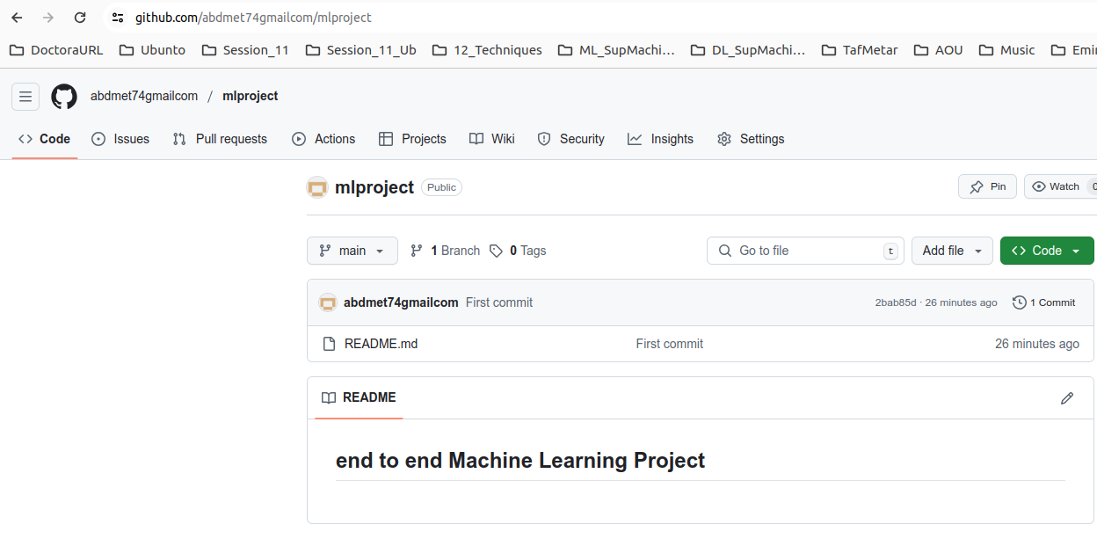

9. Create file .getignore then you will get which programming language you must ignore::

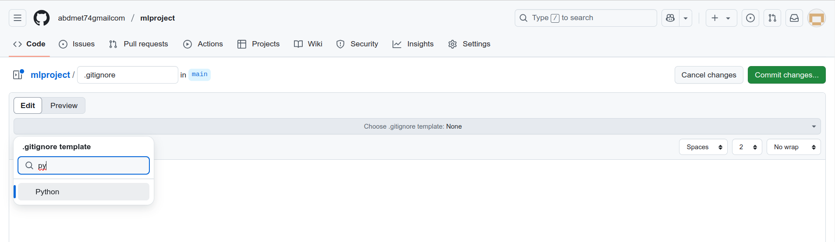

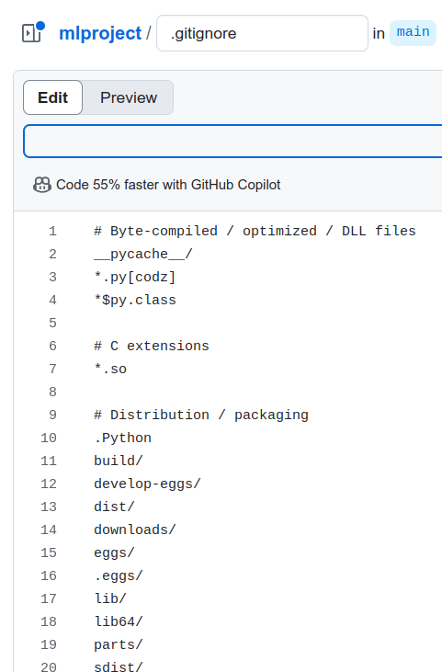

10. committed the change:
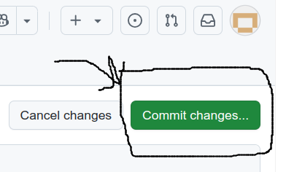

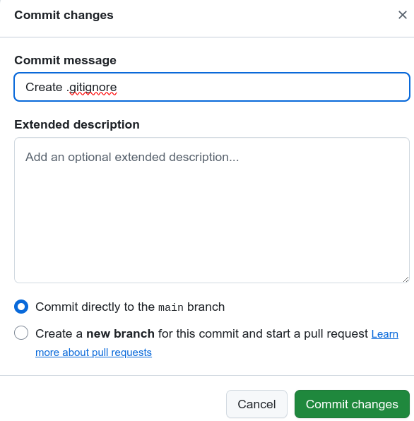
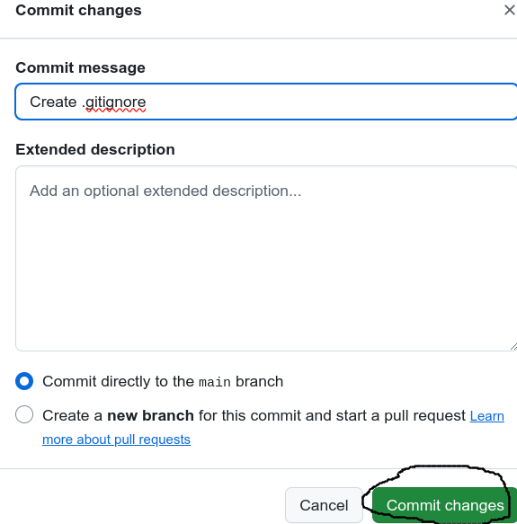

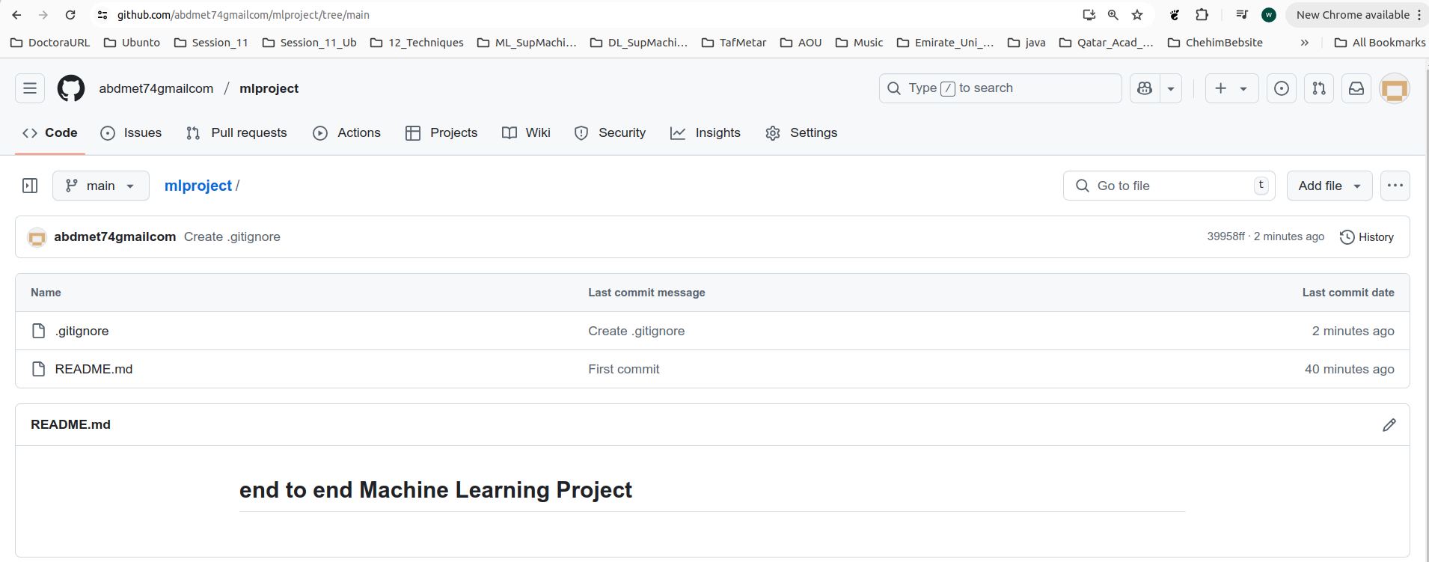

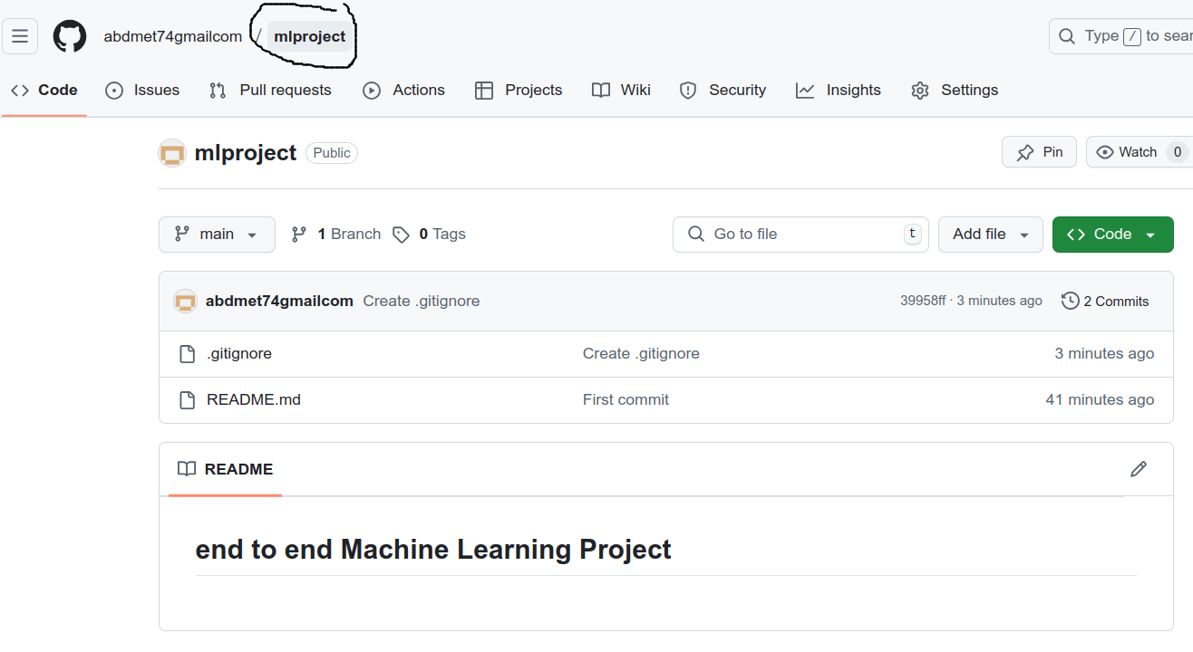

11. verify from VScode if the files were cloned properly:
(/home/meteo/mlproject/venv) meteo@meteo:~/mlproject$ git pull
remote: Enumerating objects: 4, done.
remote: Counting objects: 100% (4/4), done.
remote: Compressing objects: 100% (3/3), done.
remote: Total 3 (delta 0), reused 0 (delta 0), pack-reused 0 (from 0)
Unpacking objects: 100% (3/3), 2.79 KiB | 2.79 MiB/s, done.
From https://github.com/abdmet74gmailcom/mlproject
2bab85d..39958ff main -> origin/main
Updating 2bab85d..39958ff
Fast-forward
.gitignore | 207 ++++++++++++++++++++++++++++++++++++++++++++++++++++++++++++++++++++++++++++++++++++++++++++++++++++++++++++++++++++++++++++++++++++++++++++++++++++++++++++++++++++++++++++++++
1 file changed, 207 insertions(+)
create mode 100644 .gitignore
(/home/meteo/mlproject/venv) meteo@meteo:~/mlproject$

12. Create setup.py manually from VScode

13. Create requirements.txt manually from VScode

14. Create folder src inside which create: __init__.py

15. run the command:
1. 🔁 Retry with Increased Timeout
Run the install command with an increased timeout:
pip install -r requirements.txt --timeout 100

2. 📡 Check Your Internet Speed
Make sure your internet connection is stable. If you’re on a slow connection, consider:
Switching to a faster network. Running the command at a different time

3. 🚀 Use a Mirror (like a faster PyPI mirror)
If PyPI is slow for your region, use a mirror (e.g., Aliyun, Tsinghua, etc.).
Example:
pip install -r requirements.txt -i https://pypi.org/simple --timeout 100

or try a faster mirror: pip install -r requirements.txt -i https://pypi.tuna.tsinghua.edu.cn/simple --timeout 100

4. 🌐 Temporarily Disable IPv6 (Linux)
Sometimes disabling IPv6 can help if DNS is slow:
sudo sysctl -w net.ipv6.conf.all.disable_ipv6=1

To re-enable later:
sudo sysctl -w net.ipv6.conf.all.disable_ipv6=0

16. A new folder for packaged get created in the navigator check it: mlproject.egg-info

17.
a. synchronize the git by adding the new files and folder that you have created
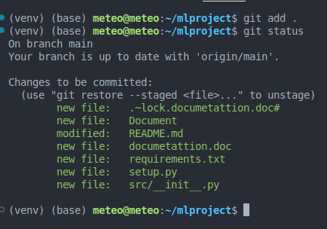

b. Commit the new files:
(venv) (base) meteo@meteo:~/mlproject$ git commit -m "setup"
[main 5f97c2d] setup
7 files changed, 215 insertions(+), 1 deletion(-)
create mode 100644 .~lock.documetattion.doc#
create mode 100644 Document
create mode 100644 documetattion.doc
create mode 100644 requirements.txt
create mode 100644 setup.py
create mode 100644 src/__init__.py
(venv) (base) meteo@meteo:~/mlproject$

c. push the new files to from origin(vScode) to main(gitHub) repository
(venv) (base) meteo@meteo:~/mlproject$ git push -u origin main
Enumerating objects: 12, done.
Counting objects: 100% (12/12), done.
Delta compression using up to 4 threads
Compressing objects: 100% (7/7), done.
Writing objects: 100% (10/10), 497.58 KiB | 10.15 MiB/s, done.
Total 10 (delta 0), reused 0 (delta 0), pack-reused 0
To https://github.com/abdmet74gmailcom/mlproject.git
39958ff..5f97c2d main -> main
Branch 'main' set up to track remote branch 'main' from 'origin'.

d. refresh now the git
