1. Create folder components inside the folder src

1.2. Create file __init__.py inside components

1.3. Create file data_ingestion.py inside components

1.4. Create file data_transformation.py inside components

1.5. Create file model_trainer.py inside components

2. Create folder pipeline inside th folder src
2.1 Create file train_pipeline.py inside pipeline
2.2 Create file predict_pipeline.py inside pipeline
1.2. Create file __init__.py inside pipeline

3. Create file logger.py inside the folder src

4. Create file exception.py inside the folder src

5. Create file utils.py inside the folder src

6. write the code inside exception.py

7. write the code inside logger.py

8. write the code inside utils.py

9. Go to terminal and check the logger: python src/logger.py
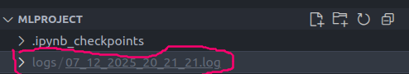

Logs folder has been successful created
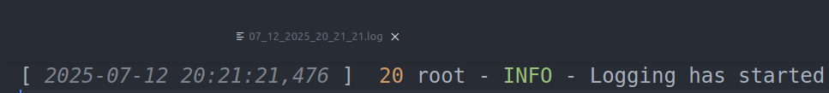

log-file also has been successfully creates as well
20: mean line number mentioned in logger.py

10. back to exeption and add:
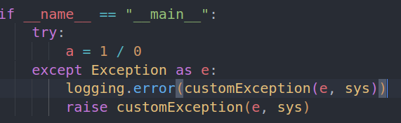

11. Go to terminal and check the logger: python src/exception.py

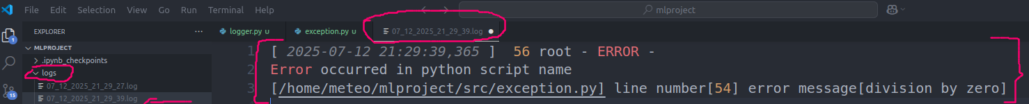
12. check the logs directory were the exception ha been recorded via log file

12 push all the work to the repository guthub

