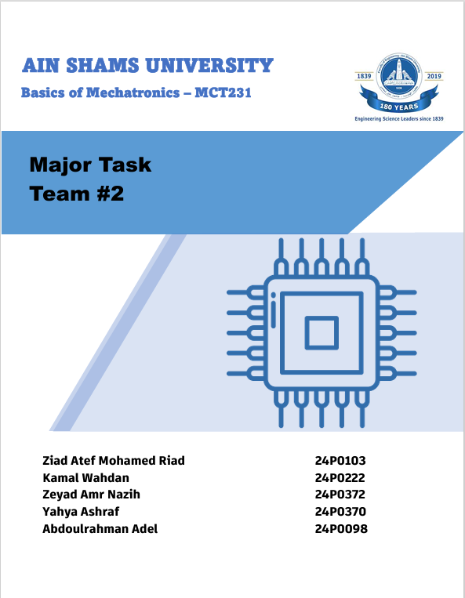
Table of Contents
Final Project
Team 2
Table of Contents 1
1. Introduction 1
1.1 Project Objectives 1
2. Design Thinking Process 1
2.1 User Research 1
2.2 Design Challenge 1
2.3 Ideation & Concept 1
2.4 Iterative Design 1
3. Product Design Specification (PDS) 1
3.1 Performance & Functional Requirements 1
3.2 Electronics & Control System 1
3.3 Physical & Material Specifications 1
3.4 Target Audience 1
4. System Architecture 1
4.1 Block Diagram Overview 1
MCU 1 — Sorting & User Input (ESP32 #1) 1
MCU 2 — Lifting, Shooting & Feedback (ESP32 #2) 1
4.2 System Flowchart 1
5. Mechanical Design 1
5.1 Sorting Mechanism 1
5.2 Lifting Mechanism — Archimedes Screw 1
5.3 Shooting Mechanism 1
5.4 Fully Integrated CAD Assembly 1
6. Electrical Design 1
6.1 Component Summary 1
6.2 Wiring Diagram Overview 1
6.2.1 Sorting Module (MCU1) 1
6.2.2 Lifting Module (MCU1 → A4988 → NEMA 17) 1
6.2.3 Shooting Module (MCU2) 1
6.3 Custom PCB 1
7. Firmware & Control 1
7.1 MCU1 — Sorting & Lifting (ESP32 #1) 1
7.2 MCU2 — Shooting & Feedback (ESP32 #2) 1
7.3 ESP-NOW Communication 1
7.4 User Interfaces 1
Interface 1 — LCD Displays 1
Interface 2 — Processing IO Bluetooth App 1
8. Bill of Materials 1
9. Engineering Calculations 1
9.1 Actuator Sizing — Sorting Mechanism 1
9.2 Actuator Sizing — Lifting Mechanism 1
9.3 Actuator Sizing — Shooting Mechanism 1
9.4 Projectile Calculations 1
9.5 Subsystem Current Consumption 1
9.6 Power Source Sizing 1
10. Safety Considerations 1
10.1 Mechanical Safety 1
10.2 Electrical Safety 1
10.3 Thermal Safety 1
10.4 Software Safety 1
11. Gantt Chart 1
12. Work Breakdown Structure (WBS) 1
Phase 1 — Project Management & Preliminary Design 1
Phase 2 — Design Thinking & Ideation 1
Phase 3 — Mechanical Design & Analysis 1
Phase 4 — Mechatronics & Control Systems 1
Phase 5 — Fabrication & Integration 1
Phase 6 — Deliverables & Documentation 1
12. Git Repository 1
15. Conclusion 1

1. Introduction
Planet Sort (marketed to children as Orbit Quest) is an interactive, space-themed mechatronic toy designed for children aged 2–10. The toy presents a fully automated ball-sorting and launching system, where coloured planetary marbles are loaded, sorted by colour, lifted vertically via an Archimedes screw, and launched toward a target through a high-velocity shooting mechanism.
The project was developed as part of the MCT231 Basics of Mechatronics final project at Ain Shams University in collaboration with the University of East London. It integrates mechanical design, electronics, embedded firmware, and product design into a cohesive educational toy that fosters engagement, colour recognition, and curiosity in STEM topics.

1.1 Project Objectives
- Design and fabricate a fully functional electromechanical toy that integrates three distinct mechanisms: colour sorting, vertical lifting, and projectile shooting.
- Implement a dual-microcontroller architecture using two ESP32 boards communicating via the ESP-NOW wireless protocol.
- Provide two user interfaces: an onboard LCD display and a Bluetooth-connected Processing IO application.
- Ensure all mechanical, electrical, and firmware subsystems work as a closed-loop marble pathway.
- Document the complete design process from user research to final prototype.

2. Design Thinking Process

2.1 User Research
The target audience was defined as children aged 2–10, with a primary engagement focus on children around 8 years old. User research revealed several key insights:
- Children in this age group are highly motivated by fast-moving, visually stimulating toys.
- Space and planetary themes score very high in engagement for both boys and girls.
- Simple, colour-based interactions are accessible even to younger children, while the automated mechanics provide complexity for older users.
- Safety is paramount: no sharp edges, no exposed wiring, and no small detachable parts that can be swallowed by younger children.

2.2 Design Challenge
The core design challenge was: How can we create a toy that is simultaneously engaging for a broad age range, educational in its interactions, safe by construction, and technically complex enough to demonstrate a complete mechatronic system?
The answer was to build a closed-loop automated machine themed around space and planet sorting, where the child's role is limited to choosing which colour marble to sort and watching the machine respond. This lowers the barrier of entry for younger children while still delighting older ones with the engineering of the system.

2.3 Ideation & Concept
Several concepts were explored via mind maps and mood boards before settling on the Planet Sort concept:
- Option A: Basketball-themed shooter with coloured balls. Relatable but not highly original.
- Option B: Recycling plant (similar to course example). Educational but less engaging visually.
- Option C: Planet Sort — space-themed sorting and launching of planetary marbles (Mars = red, Earth = green). Selected for its strong visual theme, broad age appeal, and alignment with all three required mechanisms.

2.4 Iterative Design
The design went through multiple iterations:
- Initial sketches established the layout: screw lifter on the left, sorting gate in the middle channel, shooting mechanism at the top right.
- CAD modelling in Autodesk Inventor refined dimensions and verified fit within the 100 cm × 100 cm constraint.
- Wiring diagrams were drafted in Cirkit Designer, separating the three subsystems for modularity.
- Physical prototyping with 3D-printed parts led to revisions in the screw pitch and the servo gate angle.

3. Product Design Specification (PDS)

3.1 Performance & Functional Requirements
Requirement | Specification
Primary Function | Automated colour-based sorting, vertical lifting and projectile launching of planetary marbles.
Sorting Mechanism | TCS3200 colour sensor detects Red or Green marble. Two SG90 servo-driven gates direct the marble to the correct channel.
Lifting Mechanism | NEMA 17 stepper-driven Archimedes screw lifts marbles from the lower channel to the shooting platform.
Shooting Mechanism | Dual FA-130RA-18100 DC motors spinning rubber-rimmed wheels accelerate the marble to approx. 4.15 m/s at 30° launch angle over a 0.8 m range.
Closed-Loop Path | Single marble entry point; marbles remain within the internal track throughout operation.
User Interaction | Start/Stop button, Red/Green colour selection buttons, and onboard LCD display feedback.

3.2 Electronics & Control System
Parameter | Specification
Microcontrollers | 2× ESP32 (DevKitC). MCU1 handles sorting and lifting. MCU2 handles shooting and display.
Communication | ESP-NOW wireless peer-to-peer protocol (low-latency, no router required).
User Interface 1 | 2× 16×4 I2C LCD displays showing system state, selected colour, and mode (manual / Bluetooth).
User Interface 2 | Processing IO Bluetooth application on Android/PC — Start, Stop, colour selection.
Custom PCB | Power distribution board with 12 V input, PTC fuse, reverse-polarity diode, 12 V→5 V buck converter, and modular connectors for all subsystems.
Power Source | Single 12 V DC supply (adapter or 12 V LiPo battery). Four buck converters regulate to 5 V for logic and servos.

3.3 Physical & Material Specifications
Parameter | Specification
Dimensions | Maximum 100 cm × 100 cm footprint. Nominal design: ~70 cm × 60 cm.
Materials | PLA 3D-printed structural and mechanical parts. MDF base board. Smooth surfaces with no sharp edges.
Modularity | Three independent wiring modules (Sorting, Lifting, Shooting) with dedicated JST plug connectors to a central PCB.
Safety | All wiring concealed inside channels. No exposed moving pinch points. Marble diameter >35 mm (not a choking hazard for ages 2+).

3.4 Target Audience
- Primary: Children aged 6–10 years — full autonomous use.
- Secondary: Children aged 2–5 years — supervised play; adult loads marbles and selects colour.
- Tertiary: Parents/educators — observe educational value in STEM, colour recognition, and cause-and-effect reasoning.

4. System Architecture

4.1 Block Diagram Overview
The system is divided into two microcontroller domains connected by ESP-NOW wireless communication:

MCU 1 — Sorting & User Input (ESP32 #1)
- Inputs: TCS3200 colour sensor, Colour 1 button, Colour 2 button, On/Off switch.
- Outputs: Selecting servo (path gate), Sorting servo (end gate), 16×4 I2C LCD display #1.
- Transmits: Colour decision and start/stop command to MCU2 via ESP-NOW.

MCU 2 — Lifting, Shooting & Feedback (ESP32 #2)
- Inputs: ESP-NOW message from MCU1.
- Outputs: A4988 stepper driver → NEMA 17 (Archimedes screw), L298N H-bridge → 2× DC motors (shooting wheels), 16×4 I2C LCD display #2.
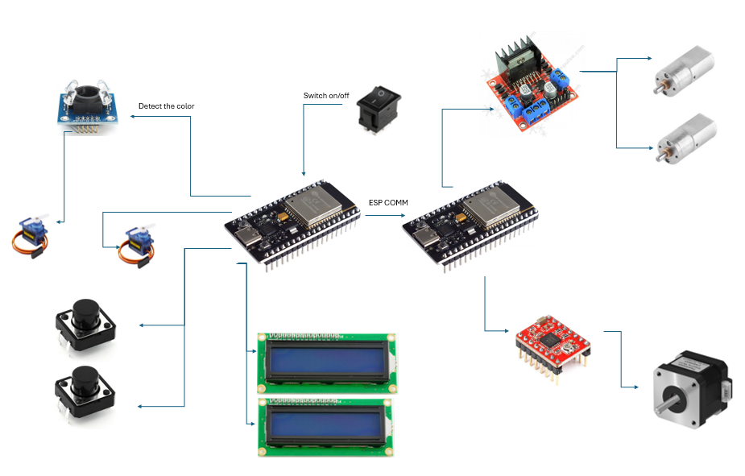

4.2 System Flowchart
The following describes the operational logic of the complete system:
- Balls are placed into the selection mechanism (entry point). System starts on button press.
- Default colour is set to Colour 1 (Green). LCD outputs 'Select Color'.
- User presses Green or Red button (or selects via Bluetooth app).
- Is Color 1 (Green) selected? If YES: Path 1 stays open. If NO: Path 1 closes, Path 2 opens.
- Ball moves through the selected path to the sorting mechanism.
- Colour sensor reads the ball. Is ball colour = selected colour? If YES: Ball moves to lifting mechanism. If NO: Ball returns to sorting mechanism.
- Ball is lifted by Archimedes screw to shooting platform.
- Shooting wheels spin up to operating speed (~1,743 rpm).
- Ball moves to shooting position and is launched toward target.
- Cycle completes; system awaits next ball or Stop command.
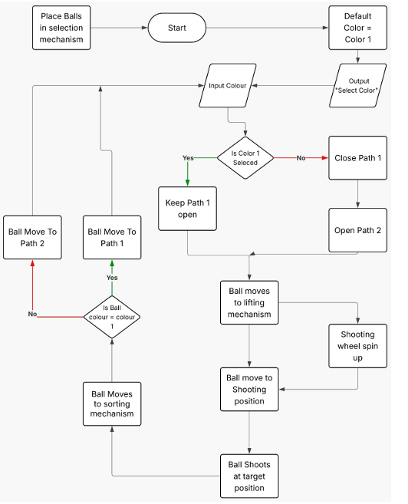

5. Mechanical Design

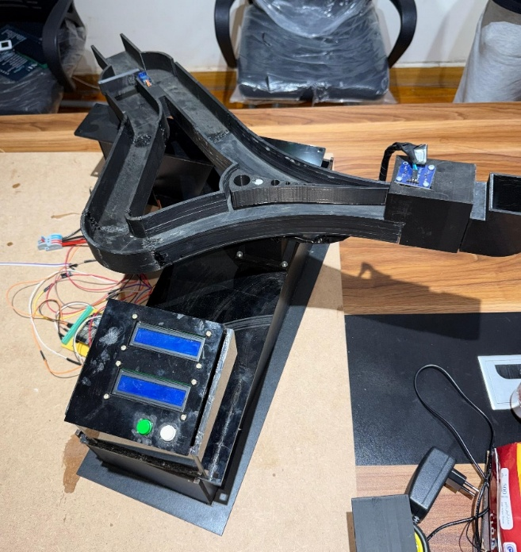
5.1 Sorting Mechanism
The sorting mechanism uses two SG90 micro servo motors to actuate gate flaps within the marble channel:
- Selecting Servo: Acts as the initial path router. When Color 1 is selected, the flap remains in position to keep Path 1 open. When Color 2 is selected, the flap rotates to close Path 1 and open Path 2.
- Sorting Servo (End Gate): Positioned at the output of the colour-sensing zone. After the TCS3200 confirms the correct colour, this servo opens to release the marble to the lifting mechanism. If the colour does not match, it redirects the marble back.
- CAD: Both gate mechanisms are 3D-printed in PLA. Servo horn connectors are press-fit with M2 screws for easy replacement.

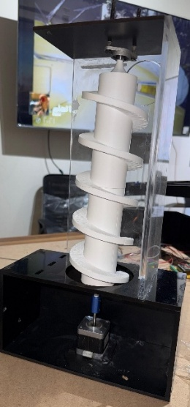
5.2 Lifting Mechanism — Archimedes Screw
The vertical lifting mechanism is based on an Archimedes screw — a helical blade wound around a central shaft enclosed in a smooth cylindrical tube:
- Motor: NEMA 17 stepper motor (operating at ~500 rpm) drives the screw shaft via a direct-drive coupler.
- Screw dimensions: Pitch and diameter sized to accept marbles of 35–40 mm diameter and transport one marble per revolution reliably.
- The enclosed tube prevents marbles from falling sideways and contributes to the closed-loop pathway requirement.
- All parts 3D-printed in PLA. The screw was printed in sections and assembled on the shaft.

5.3 Shooting Mechanism
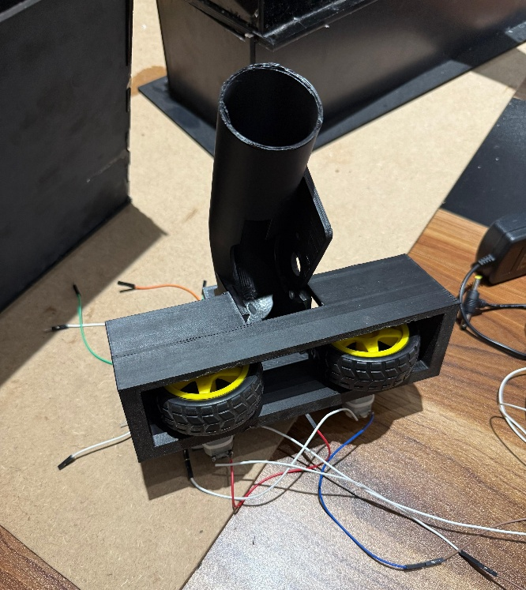
The shooting mechanism uses a dual-wheel friction launcher, widely used in table tennis ball machines and youth sports equipment:
- Two FA-130RA-18100 DC motors each drive a rubber-rimmed PLA wheel (~65 mm diameter, 35 g).
- The wheels are arranged facing each other with a gap slightly smaller than the marble diameter, creating a compression grip.
- When the marble is fed between the spinning wheels, friction accelerates it to the calculated exit velocity (~4.15 m/s).
- Motor driver: L298N H-bridge controlled via PWM from MCU2, allowing speed adjustment.
- Launch angle: 30° above horizontal, achieving a 0.8 m horizontal range at a 0.2 m height difference to the target hoop.

5.4 Fully Integrated CAD Assembly
The complete assembly was modelled in Autodesk Inventor. Key design decisions:
- Base plate: 700 mm × 600 mm MDF, within the 100 cm × 100 cm constraint.
- The Archimedes screw tower is positioned at the rear-left corner with height ~350 mm.
- The ball channel runs along the base from the entry point (front-right) through the sorting zone to the screw base (rear-left) and back to the shooter (top of screw, directed right).
- The target hoop is mounted at the rear-right, aligned with the 30° shooting trajectory.
- Wire routing channels are integrated into all structural parts to keep wiring completely hidden.

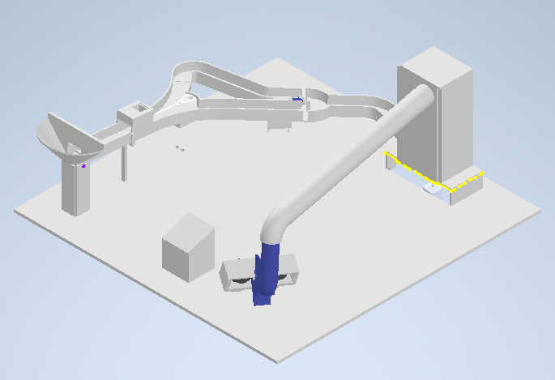

6. Electrical Design

6.1 Component Summary
# | Component | Role | Interface | Qty
1 | ESP32 DevKitC | Main microcontrollers | GPIO, I2C, PWM | 2
2 | TCS3200 Colour Sensor | Ball colour detection | Digital GPIO | 1
3 | SG90 Micro Servo | Sorting & selecting gates | PWM | 2
4 | NEMA 17 Stepper Motor | Archimedes screw drive | A4988 driver | 1
5 | A4988 Stepper Driver | NEMA 17 control | STEP/DIR PWM | 1
6 | FA-130RA-18100 DC Motor | Shooting wheels | L298N H-Bridge | 2
7 | L298N H-Bridge Module | DC motor drive | PWM GPIO | 1
8 | 16×4 I2C LCD Display | User feedback | I2C (SDA/SCL) | 2
9 | 12 V→5 V Buck Converter | Logic/servo power | Power rail | 4
10 | Custom PCB (Power Dist.) | Power routing, protection | Terminal blocks | 1
11 | Push Buttons (12 mm) | Colour select, Start/Stop | Digital GPIO | 4
12 | Rocker Switch | Main power On/Off | Power rail | 1
13 | 12 V DC Power Supply / LiPo | Single power source | – | 1

6.2 Wiring Diagram Overview
The electrical system is divided into three independent wiring modules. Each module has its own cable harness terminated with JST connectors, which plug into the central custom PCB for easy assembly and maintenance.

6.2.1 Sorting Module (MCU1)
- Arduino 1 (ESP32) ↔ TCS3200: S0, S1, S2, S3 (GPIO outputs), OUT (GPIO input), LED enable, VCC/GND.
- Arduino 1 ↔ Selecting Servo: PWM signal + 5 V / GND.
- Arduino 1 ↔ Sorting Servo: PWM signal + 5 V / GND.
- Arduino 1 ↔ LCD Display #1: SDA/SCL (I2C), 5 V / GND.
- Colour 1 & Colour 2 push-buttons: pulled up internally, connected to GPIO with GND.
- 5 V supply via terminal block from PCB buck converter.

6.2.2 Lifting Module (MCU1 → A4988 → NEMA 17)
- Arduino 1 ↔ A4988: STEP (PWM), DIR (GPIO), ENA (GPIO), MS1/MS2/MS3 (microstepping select), SLEEP/RESET.
- A4988 VMOT: 12 V from PCB. VDD: 5 V from buck. B1/B2/A1/A2: NEMA 17 coil pairs.
- 100 µF decoupling capacitor across VMOT/GND of A4988.

6.2.3 Shooting Module (MCU2)
- Arduino 2 (ESP32) ↔ L298N: ENA (PWM), IN1/IN2 (direction), ENB (PWM), IN3/IN4 (direction).
- L298N OUT1/OUT2 → DC Motor Left (shooting wheel). OUT3/OUT4 → DC Motor Right.
- L298N +12 V from PCB, +5 V from on-board regulator. GND common.
- Arduino 2 ↔ LCD Display #2: SDA/SCL (I2C), 5 V / GND.
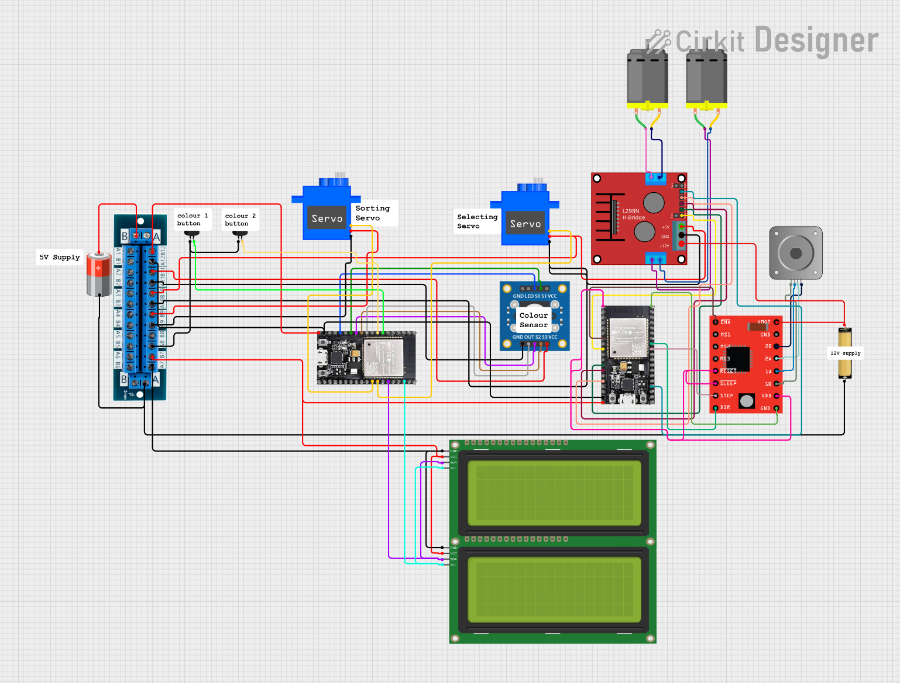
https://app.cirkitdesigner.com/project/e711d32f-553b-48ab-a936-7aebbb711319

6.3 Custom PCB
The custom PCB serves as the power distribution and protection hub for the entire toy. Key features:
- Input: 2-pin JST connector (J2) accepting 12 V DC.
- Reverse-polarity protection: 1N5822 Schottky diode (D1).
- Over-current protection: PTC resettable fuse (F1) rated at 5 A.
- 12 V→5 V Buck converter (LM2596-based) with 100 µF input and 1000 µF output capacitors, 10 µH inductor.
- Output connectors: Servo mover 1, Servo end gate, Right motor, Left motor, Stepper 1, Arduino R4 (5 V regulated).
- Ground plane poured across the full board for noise immunity.

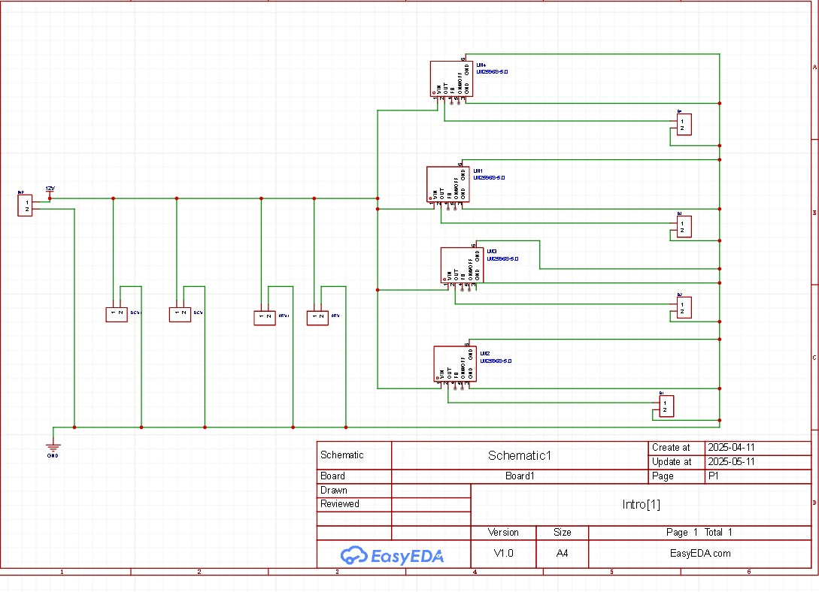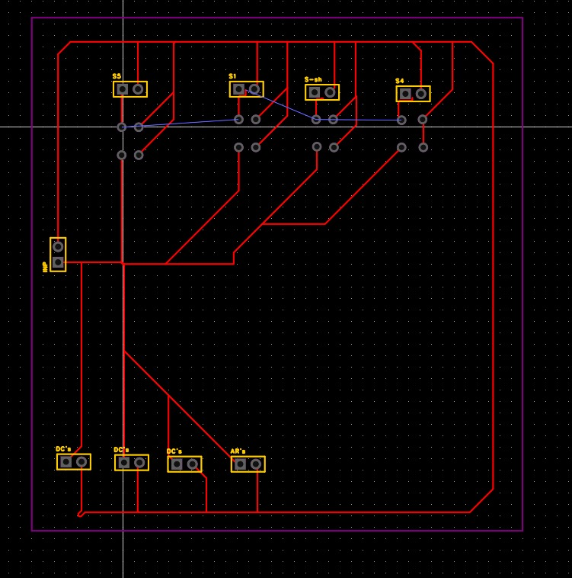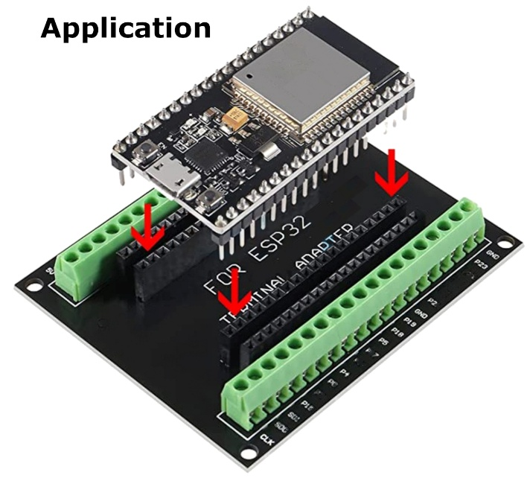

7. Firmware & Control

7.1 MCU1 — Sorting & Lifting (ESP32 #1)
MCU1 is responsible for all input handling and the sorting and lifting subsystems. The firmware structure is:
- Initialisation: Set up I2C LCD, configure TCS3200 frequency pins, attach servo objects, configure button GPIO with internal pull-ups.
- Main Loop: Poll colour selection buttons. If pressed, update selectedColour variable and display on LCD.
- On Start command: Actuate Selecting Servo to open correct path. Read TCS3200 output. If colour matches selectedColour, release Sorting Servo gate, then send ESP-NOW trigger message to MCU2 to run the lifting sequence.
- ESP-NOW Transmit: MCU1 broadcasts a struct containing {command: LIFT_AND_SHOOT, colour: selected} to MCU2 MAC address.
- LCD Display: Shows 'SYSTEM: READY', 'COLOR: GREEN', 'MODE: MANUAL' etc. based on state machine.

7.2 MCU2 — Shooting & Feedback (ESP32 #2)
MCU2 runs the stepper for lifting and the DC motors for shooting, coordinated by incoming ESP-NOW messages.
- On receive ESP-NOW LIFT_AND_SHOOT: Step NEMA 17 at 500 rpm for calculated number of steps to raise marble to shooting platform.
- Spin-up: Both DC motors ramped to full PWM (~1,743 rpm wheel speed) over 3 seconds via PWM increase.
- Feed: After spin-up, a brief servo or stepper pulse feeds the marble between the wheels.
- Shoot: Marble exits at calculated velocity; motors ramp down.
- LCD Display #2: Reflects received colour and mode in sync with MCU1.

7.3 ESP-NOW Communication
ESP-NOW is a Espressif peer-to-peer wireless protocol that operates without a Wi-Fi router. Advantages for this application:
- Latency: Sub-millisecond typical message delivery — essential for real-time marble coordination.
- No network dependency: The toy works anywhere without internet or a router.
- Simple API: espnow_send() / espnow_recv_cb() used directly in Arduino framework.
- Packet structure: 8-byte struct {uint8_t cmd; uint8_t colour; uint8_t reserved[6]}.

7.4 User Interfaces

Interface 1 — LCD Displays
Two 16×4 character LCD displays with I2C backpacks (PCF8574 expander) are connected to MCU1 and MCU2 respectively. Display states:
- SYSTEM: READY — after power on, before start.
- COLOR: GREEN / RED — shows selected colour after button press.
- MODE: MANUAL / BT — indicates whether input came from physical button or Bluetooth.
- SORTING... / LIFTING... / SHOOTING... — real-time status during operation.

Interface 2 — Processing IO Bluetooth App
A Processing IO application running on a smartphone or PC communicates with MCU1 via Bluetooth (HC-05 module or ESP32 built-in Bluetooth Serial). The app provides:
- CONNECT button: Establishes Bluetooth serial link.
- START / STOP buttons: Send 'S' and 'X' characters to MCU1.
- GREEN / RED planet buttons: Send 'G' and 'R' characters to set colour selection remotely.
- Status panel: Receives and displays MCU1 serial responses ('READY', 'SORTING', 'DONE', etc.).

8. Bill of Materials
# | Component | Specification / Model | Qty | Unit (EGP) | Total (EGP) | Subsystem
1 | ESP32 DevKitC | Espressif ESP32-WROOM-32 | 2 | 250 | 500 | Control
2 | NEMA 17 Stepper Motor | 1.7 A, 0.48 N·m | 1 | 350 | 350 | Lifting
3 | A4988 Stepper Driver | Pololu A4988 | 1 | 120 | 120 | Lifting
4 | FA-130RA-18100 DC Motor | 3–9 V, ~330 mA | 2 | 80 | 160 | Shooting
5 | L298N H-Bridge Module | 2 A per channel | 1 | 90 | 90 | Shooting
6 | SG90 Micro Servo | 1.3 kg·cm, 180° | 2 | 70 | 140 | Sorting
7 | TCS3200 Colour Sensor | Full spectrum, 8-pin DIP | 1 | 85 | 85 | Sorting
8 | 16×4 I2C LCD Display | PCF8574 backpack, 5 V | 2 | 110 | 220 | UI
9 | LM2596 Buck Converter | 12 V→5 V, 3 A | 4 | 60 | 240 | Power
10 | Custom PCB | Power distribution board | 1 | 200 | 200 | Power
11 | 12 mm Push Buttons | Momentary, 5 V | 4 | 15 | 60 | UI
12 | Rocker Switch | SPST, 10 A, 250 V | 1 | 20 | 20 | Power
13 | 12 V DC Power Adapter | 12 V, 5 A minimum | 1 | 180 | 180 | Power
14 | PLA Filament (1 kg) | White/Black, 1.75 mm | 1 | 250 | 250 | Mechanical
15 | MDF Board 70×60 cm | 6 mm thick | 1 | 80 | 80 | Mechanical
16 | JST Connectors (sets) | 2–4 pin, male/female | 10 | 15 | 150 | Wiring
17 | Wiring (mixed gauge) | AWG 22/24, colour coded | 1 set | 80 | 80 | Wiring
18 | M2/M3 Screw Sets | Stainless steel | 1 set | 30 | 30 | Mechanical
 |  | TOTAL |  |  | 2,955 EGP

9. Engineering Calculations

9.1 Actuator Sizing — Sorting Mechanism
The sorting mechanism uses a servo to rotate an arm + gate assembly. The required torque is calculated from rotational inertia and angular acceleration.
Parameter | Value
J_shaft | 2.95 × 10⁻⁷ kg·m² (from Autodesk Inventor iProperties)
J_mover | 1.00 × 10⁻⁴ kg·m²
J_arm | 5.44 × 10⁻⁴ kg·m²
J_total (÷10 safety) | 1.11 × 10⁻⁴ kg·m²
Angular acceleration θ̈ | 523.2 rad/s² (60° rotation in 0.1 s → 600 °/s)
Required Torque T_m | T_m = J·θ̈ + T_R = 1.11×10⁻⁴ × 523.2 ≈ 0.0591 N·m = 0.591 kg·cm
Resistive Torque T_R | ≈ 0 (minimal friction, no external load)
Selected Motor | SG90 Micro Servo — T_stall = 1.3 kg·cm
Safety Factor n | n = 1.3 / 0.591 ≈ 2.20 ✓ (>2 acceptable)

9.2 Actuator Sizing — Lifting Mechanism
Parameter | Value
J_screw | 0.000551 kg·m²
J_coupler | 8.52 × 10⁻⁷ kg·m²
J_load total | 5.313 × 10⁻⁴ kg·m²
J_motor (NEMA 17) | 5.7 × 10⁻⁶ kg·m²
J_total | 5.567 × 10⁻⁴ kg·m²
ω operating | 31.41 rad/s (300 rpm nominal)
θ̈ (spin-up) | 314.1 rad/s² (0 → 300 rpm in 0.1 s)
T_required | T_m > J_tot × θ̈ = 5.567×10⁻⁴ × 314.1 > 0.175 N·m
Resistive Torque T_R | ≈ 0 (no external weight load on screw flight; balls float on helix)
Selected Motor | NEMA 17 Stepper — T_available = 0.48 N·m
Safety Factor n | n = 0.48 / 0.175 = 2.74 ✓
Operating Speed | ~500 ±50 rpm at constant torque

9.3 Actuator Sizing — Shooting Mechanism
Parameter | Value
Wheel radius r | 32.5 mm = 0.0325 m | Wheel mass m_w ≈ 35 g
J_motor | 1.27 × 10⁻⁷ kg·m²
J_wheel (solid disc) | J_w = m·r² = 0.035 × (0.0325)² = 3.69 × 10⁻⁵ kg·m²
J_bearing | 7.2 × 10⁻⁷ kg·m²
J_total | ≈ 3.78 × 10⁻⁵ kg·m²
Spin-up time | 3 s → θ̈ = 182.5/3 ≈ 60.8 rad/s²
Final ω | 182.5 rad/s → n = 1,743 rpm
T_required | T_m = J × θ̈ = 3.78×10⁻⁵ × 60.8 ≈ 2.3 × 10⁻³ N·m
Selected Motor | FA-130RA-18100 with L298N H-bridge and PWM control

9.4 Projectile Calculations
The shooting mechanism must launch a marble from height h = 0.2 m below the target, over a horizontal distance d = 0.8 m, at launch angle β = 30°.
Parameter | Value
Launch angle β | 30°
Horizontal distance d | 0.8 m
Height difference h | 0.2 m (target above launcher)
Required V₀ | V₀ = (d / cos β) × √(g / 2(d·tan β − h)) = (0.8/cos30°) × √(9.81 / 2(0.8·tan30° − 0.2)) ≈ 4.15 m/s
Wheel efficiency η | η ≈ 0.7 (friction coupling)
Required v_tangential | v_tan = V₀ / η = 4.15 / 0.7 ≈ 5.93 m/s
Required wheel ω | ω = v_tan / r = 5.93 / 0.0325 ≈ 182.5 rad/s (1,743 rpm) ✓ matches actuator sizing

9.5 Subsystem Current Consumption
All logic subsystems are supplied at 5 V via buck converters from the 12 V rail. High-power actuators (stepper, DC motors) run directly at 12 V.
Subsystem | Component | V (V) | I typical (mA) | I max (mA)
Control | 2× ESP32 | 3.3 / 5 | 240 | 500
Lifting | NEMA 17 | 12 | 800 | 1,700
Lifting driver | A4988 | 5 (logic) | 10 | 50
Shooting | 2× FA-130 DC Motors | 12 | 600 | 1,200
Shooting driver | L298N | 12 | 36 | 100
Sorting | 2× SG90 Servo | 5 | 400 | 1,000
Sensing | TCS3200 | 5 | 3 | 5
Display | 2× 16×4 I2C LCD | 5 | 40 | 80
Misc (buttons, LEDs) | – | 5 | 30 | 50
TOTAL at 12 V rail |  | 12 | ~2.7 A | ~4.7 A
The PTC fuse on the custom PCB is rated at 5 A, providing ~6% headroom above peak load while protecting against short circuits. The 5 A power supply rating is confirmed adequate.

9.6 Power Source Sizing
For battery-powered operation (e.g., exhibitions), a 12 V LiPo battery is sized as follows:
Parameter | Value / Calculation
Avg. operating current | I_avg ≈ 2.5 A (actuators not all on simultaneously; 60% duty cycle assumed)
Desired runtime | 3 hours continuous
Required capacity | Q = I_avg × t = 2.5 × 3 = 7.5 Ah
Derate for depth of discharge | Q_rated = 7.5 / 0.8 ≈ 9.4 Ah → round up to 10 Ah
Recommended battery | 12 V, 10 Ah Li-ion / LiFePO4 pack or equivalent adapter
Buck converter efficiency | η ≈ 85%. I_12V for 5 V logic loads: I = (P_5V) / (12 × 0.85) ≈ 1.2 A additional

10. Safety Considerations
The toy has been designed to comply with general children's toy safety principles applicable to the target age group of 2–10 years:

10.1 Mechanical Safety
- All 3D-printed parts are sanded and deburred post-printing to remove sharp edges and layer lines.
- The Archimedes screw is enclosed in a smooth cylinder — fingers cannot reach the spinning helix.
- Shooting wheel gap is sized for the specific marble diameter. No gap wide enough to trap fingers.
- Marble diameter > 35 mm — above the choking hazard threshold (ISO 8124-1 small parts cylinder test) for children aged 3+. An age label is applied for children under 3.
- All servo horn connections use recessed M2 screws to prevent protrusion injuries.
- No spring-loaded components under high tension accessible to the child.

10.2 Electrical Safety
- All wiring is routed through internal channels in the 3D-printed structure — no exposed conductors reachable by the child.
- JST connectors are keyed and polarised — incorrect reassembly is mechanically prevented.
- The custom PCB includes: reverse-polarity protection (1N5822 diode), over-current protection (5 A PTC resettable fuse), and decoupling capacitors to prevent voltage spikes.
- The 12 V supply uses a CE/UL-certified adapter with insulated barrel connector. No mains voltage enters the toy enclosure.
- All PCB traces are covered with solder mask; PCB is mounted in an enclosed housing within the base.
- The rocker switch is positioned on the rear of the toy, inaccessible during normal forward-facing play.

10.3 Thermal Safety
- Motor drivers (L298N, A4988) are fitted with heatsinks. No surface exceeds 50°C under normal operation.
- All plastic parts are PLA — safe and non-toxic. No ABS or other fume-emitting materials used.
- The PTC fuse provides thermal protection in case of sustained overload, resetting automatically once cooled.

10.4 Software Safety
- A hardware Start/Stop button is always active and takes immediate priority over Bluetooth commands.
- Watchdog timer is enabled on both ESP32 boards — if firmware hangs, the board resets within 8 seconds.
- Stepper and DC motors ramp up gradually (no instantaneous full-power starts) to reduce mechanical shock.

11. Gantt Chart
The Gantt chart below outlines the full project timeline from team organisation (February 2026) through to the final presentation (May 2026). Tasks span six phases: project management, design thinking, mechanical development, electronics and firmware, fabrication, and documentation.
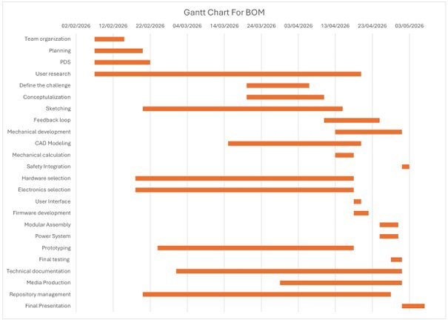
Figure 1 — Gantt Chart for BOM (February–May 2026)

12. Work Breakdown Structure (WBS)

Phase 1 — Project Management & Preliminary Design
- 1.1 Team Organisation: Assign Mechanical Lead, Electronics Lead, Firmware Lead roles.
- 1.2 Planning: Create Gantt Chart to manage the project timeline.
- 1.3 Product Design Specification (PDS): Define technical and functional requirements.
- 1.4 User Research: Conduct research for the 2–10 age group.

Phase 2 — Design Thinking & Ideation
- 2.1 Define the Challenge: Formulate design challenge from user research findings.
- 2.2 Conceptualisation: Generate ideas via mind maps and mood boards.
- 2.3 Sketching: Create initial hand-drawn sketches of the toy concept.
- 2.4 Feedback Loop: Conduct iterative design cycles based on lab feedback.

Phase 3 — Mechanical Design & Analysis
- 3.1.1 Projectile-Based Shooting Mechanism: Design the dual-wheel launcher.
- 3.1.2 Vertical Lifting Mechanism: Design Archimedes screw and NEMA 17 drive.
- 3.1.3 Sorting Mechanism: Design colour-sensor gate system.
- 3.2 CAD Modelling: Create 3D models and assembly in Autodesk Inventor.
- 3.3 Mechanical Calculations: Actuator sizing, projectile motion.
- 3.4 Safety Integration: Ensure all moving parts are safe; verify 100 cm × 100 cm limit.

Phase 4 — Mechatronics & Control Systems
- 4.1 Hardware Selection: Purchase all required hardware.
- 4.2.1 Schematic Design: Circuit diagrams in Proteus / Cirkit Designer.
- 4.2.2 Custom PCB: Design and manufacture power distribution board.
- 4.2.3 Sensor Integration: Integrate TCS3200 for sorting.
- 4.3.1 Primary Interface: Program LCD displays.
- 4.3.2 Secondary Interface: Develop Bluetooth Processing IO application.
- 4.4 Firmware: Write Arduino/ESP32 code for closed-loop system with ESP-NOW.

Phase 5 — Fabrication & Integration
- 5.1 Modular Assembly: Build toy in modules with dedicated wiring plugs.
- 5.2 Power System: Integrate single 12 V source; verify current budget.
- 5.3 Prototyping: Build physical model using 3D printing and safe materials.
- 5.4 Final Testing: Full system test verifying closed-loop marble pathway.

Phase 6 — Deliverables & Documentation
- 6.1 Technical Documentation: Finalise Technical Report and Bill of Materials.
- 6.2 Media Production: Record project video with voiceover; design A0 poster.
- 6.3 Repository Management: Organise Git repository with correct folder structure.
- 6.4 Final Presentation: Prepare and deliver group presentation.

12. Git Repository
All project files are maintained in a clean Git repository at:
https://github.com/abdo-A028/MCT231-BASICS-OF-MECHATRONICS
Repository structure follows the required convention:
Folder | Contents
/mechanical | Autodesk Inventor part files (.ipt), assembly files (.iam), exported drawings (.pdf/.dwg), STL files for 3D printing.
/electrical | Cirkit Designer / Proteus schematics, PCB source files (.kicad_pcb or equivalent), Gerber exports, component libraries.
/firmware_mcu1 | ESP32 Arduino sketch for Sorting & Lifting controller (MCU1). Includes ESP-NOW transmitter, TCS3200 driver, servo control, LCD library usage.
/firmware_mcu2 | ESP32 Arduino sketch for Shooting & Display controller (MCU2). Includes ESP-NOW receiver, A4988 stepper driver, L298N DC motor control.
/app | Processing IO application source code for the Bluetooth remote interface. Includes connection manager, button UI, and serial communication handler.
/docs | Technical report (this document), A0 poster PDF, PDS, test results, Gantt chart, user guide (Kids Guide).

13. A0 Poster
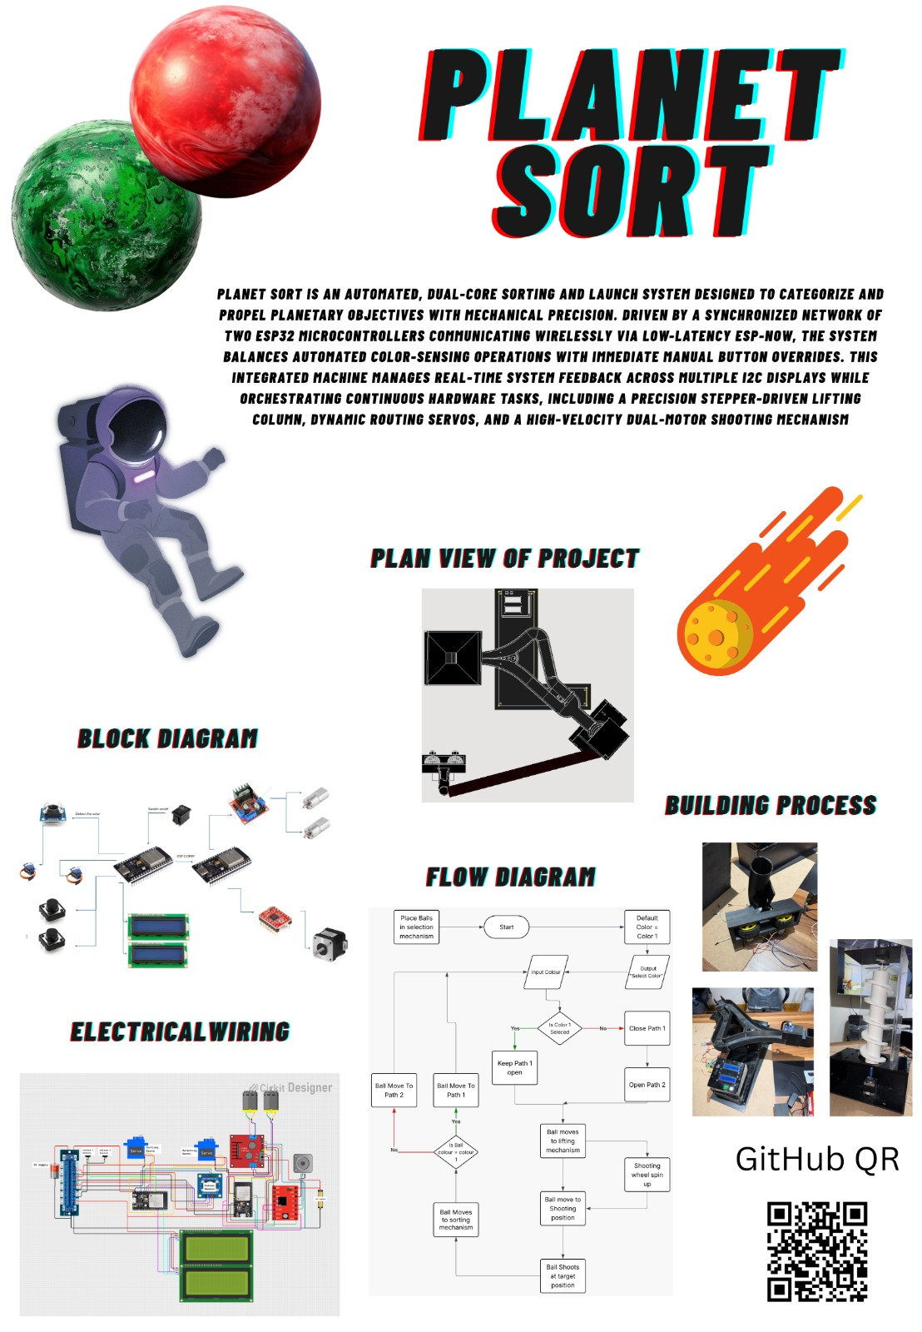

14. Rules for the toy
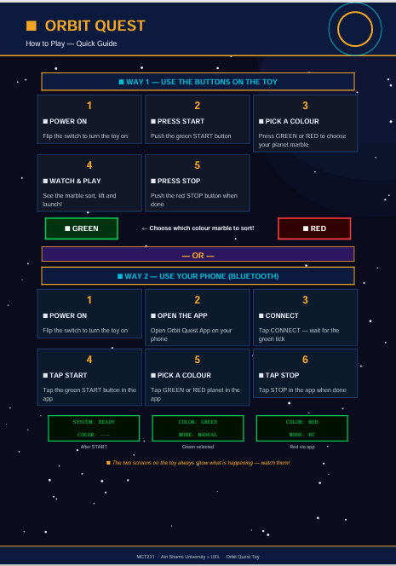

15. Conclusion
The Planet Sort / Orbit Quest project successfully demonstrates a fully integrated mechatronic system designed as a children's toy. The team implemented three distinct mechanisms — colour-based sorting, Archimedes screw vertical lifting, and a dual-wheel projectile shooter — as a continuous, closed-loop marble pathway.
Key engineering achievements include:
- A dual-ESP32 architecture with wireless ESP-NOW communication providing low-latency, router-independent coordination between the sorting/lifting and shooting subsystems.
- Rigorous actuator sizing calculations (safety factors >2.2 for all motors) ensuring reliable performance without oversizing.
- A custom power distribution PCB with reverse-polarity protection, PTC fuse, and modular JST connectors enabling safe and maintainable wiring.
- A complete power budget confirming the 5 A, 12 V supply is adequate with headroom for peak loads, and a 10 Ah battery recommendation for portable operation.
- Full compliance with toy safety principles: no accessible moving parts, no exposed wiring, non-toxic materials, and marble sizing above the choking hazard threshold.
The design process followed the full design thinking methodology from user research and ideation through to physical prototype, documentation, and iterative refinement. All deliverables specified in the MCT231 course requirements have been addressed in this report and the accompanying repository.

