FCAI

ML Project # 2

**Team Members:**

Abdelrahman Mohamed Mansour (20210527)

Khaled Waleed Salah (20210127)

Ahmed Wessam (20210046)

Mohamed Mohsen (20210353)

**Model Results:**

After testing with multiple values for the Central Moments, the one with the best performance time wise and accuracy wise it was order of **5**.

* **SVM**:

Starting with the SVM, we tried to experiment with multiple hyper parameters which included:

* Kernal: [linear , rbt, poly]
* C (Regularization Parameter)
* Decision function shape : [ovo , ovr]
* Gamma for rbf
* Degree for poly

The result of is the following:



Which produced the following Accuracy,

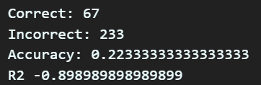

* **KNN**

Next, we chose to use the K- Nearest Neighbor classifier, which was faster and far easier in training than its previous counterpart (SVM). The hyperparameter we experimented on was the

* k (the number of neighbors to consider).

The result of is the following:



Which produced the following Accuracy:

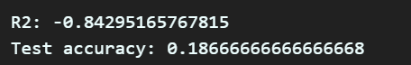

Considering the training time it took, the accuracy is somewhat close to SVM.

* **Gaussian Naïve Bayesian**

Finally, we got the gaussian distribution classifier. We tried to fine tune some parameters but we failed at doing so. Therefore, we just turned to just using the default model.

Surprisingly, even though the it took the fraction of time to train the SVM, it got a comparable accuracy to SVM



**Model Error**

* **SVM**

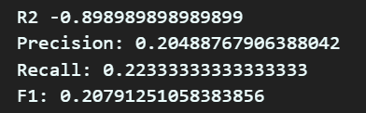

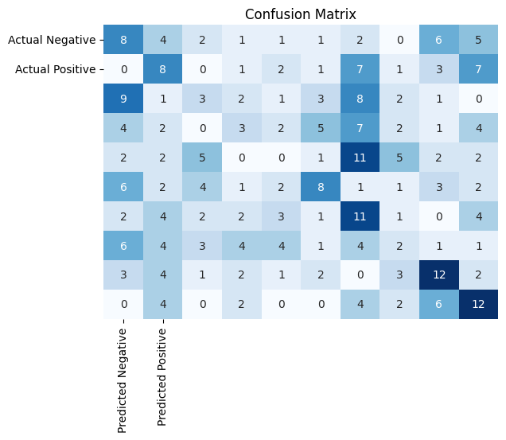

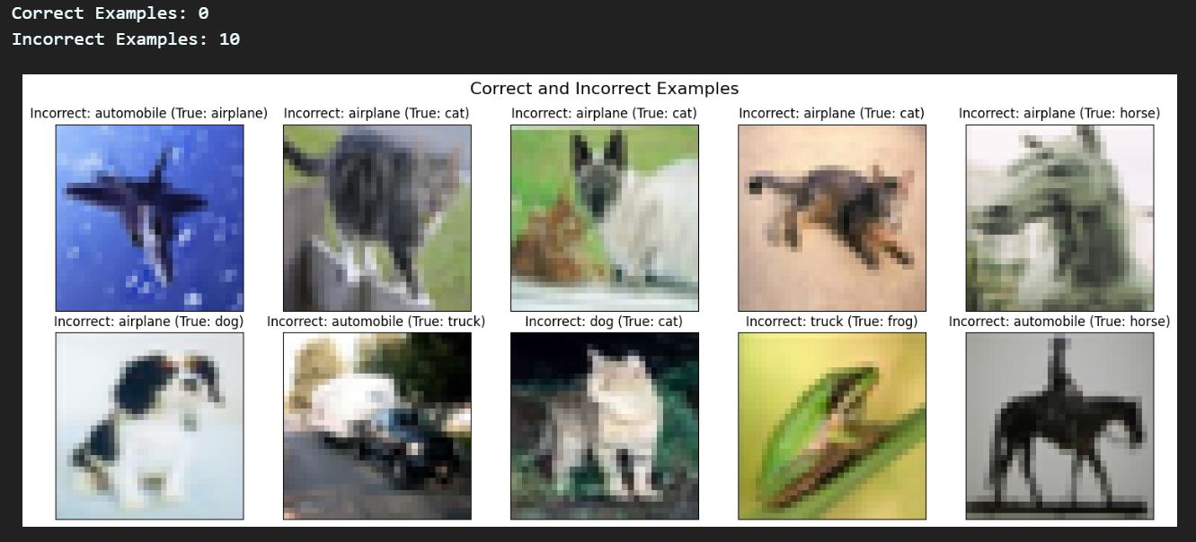

* **KNN**

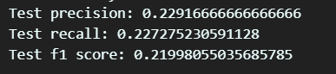

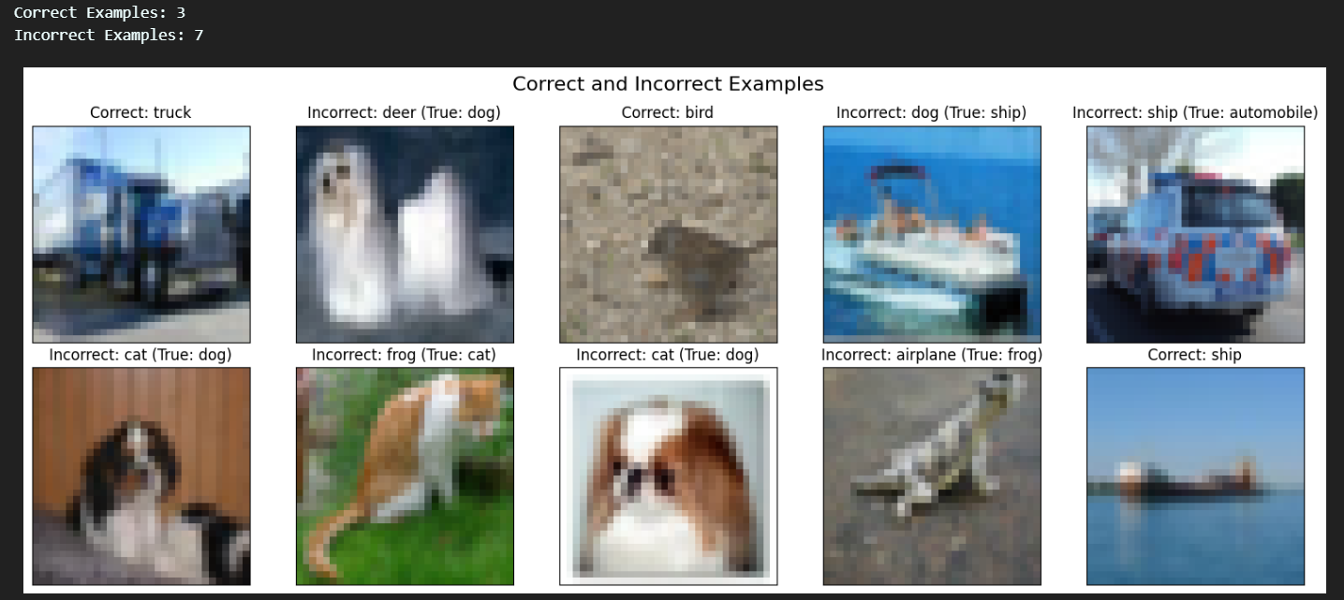

* **Gaussian Naïve Bayesian**

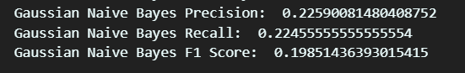

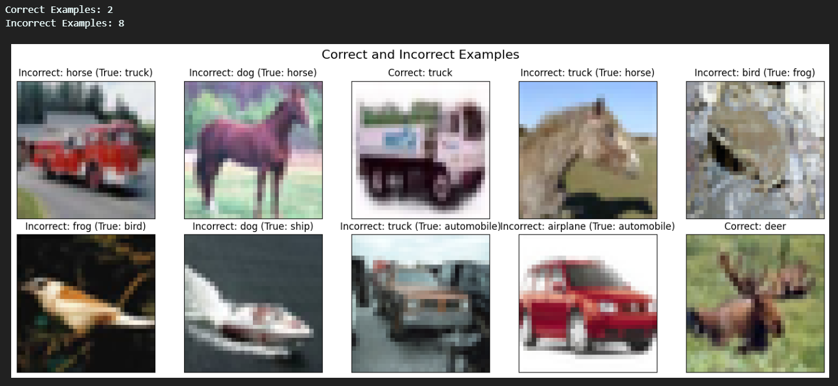

**-Precision:** focuses on the accuracy of positive predictions.

**-Recall:** focuses on capturing all actual positive instances.

**-F1:** balances precision and recall.

Based on the previous values in the precision, recall, and F1, including the given examples and the accuracy, it is apparent that the classifying models weren’t that successful. It is even worse than the just taking the mean.

Which brings us to an important question:

**What might be the reason for such a thing and how might we improve upon it?**

Ans: A plausible reason would be that the Central Moments weren’t able to capture the right features in its full breadth, limiting the model’s potential to accurately model it. A better feature extractor would help.

Another reason might that the models aren’t good fit for the dataset causing an underfit model. Therefore, using a better model like Neural Network will improve the results.