Project Report: Retail Buyer Segmentation & Prediction System
1. Project Overview
This project develops an end-to-end machine learning system designed for the retail sector. Its primary objective is to move from raw, unstructured transactional data to actionable customer profiles. By identifying distinct groups of customers based on demographics and purchasing behavior, the system enables automated, scalable, and personalized marketing strategies to reduce waste and improve campaign performance.
The workflow is divided into three key stages:
- Data Preparation: EDA, cleaning, and feature engineering.
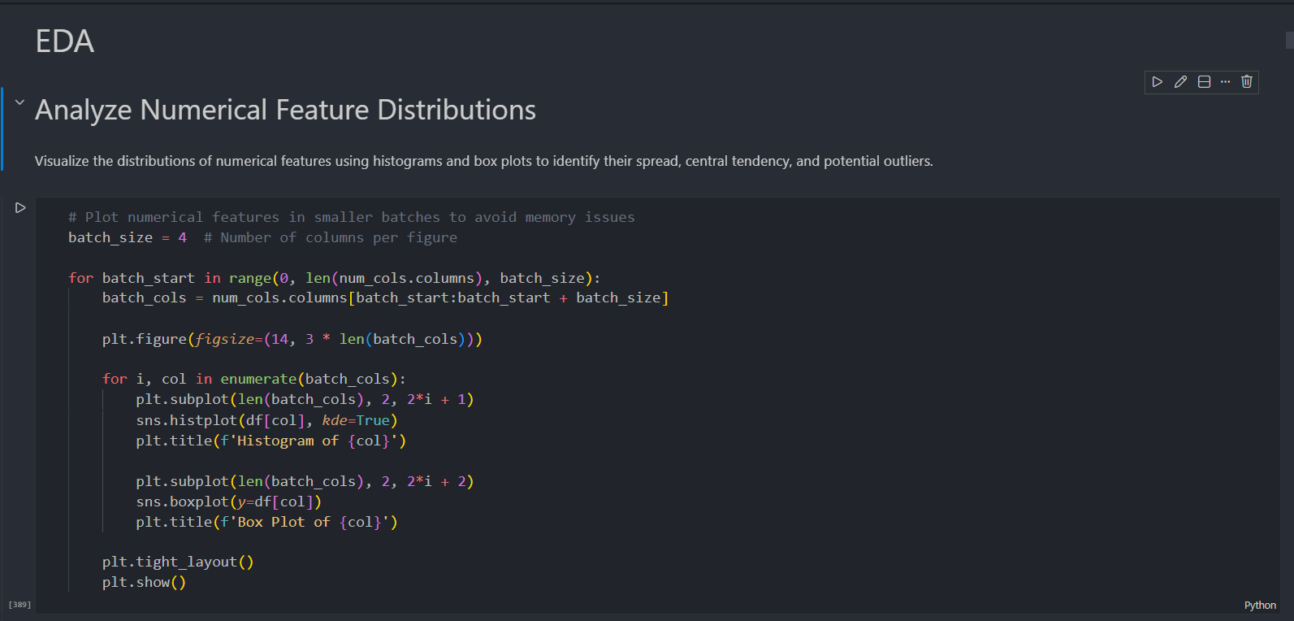
- Unsupervised Learning: Discovering natural segments via clustering.
- 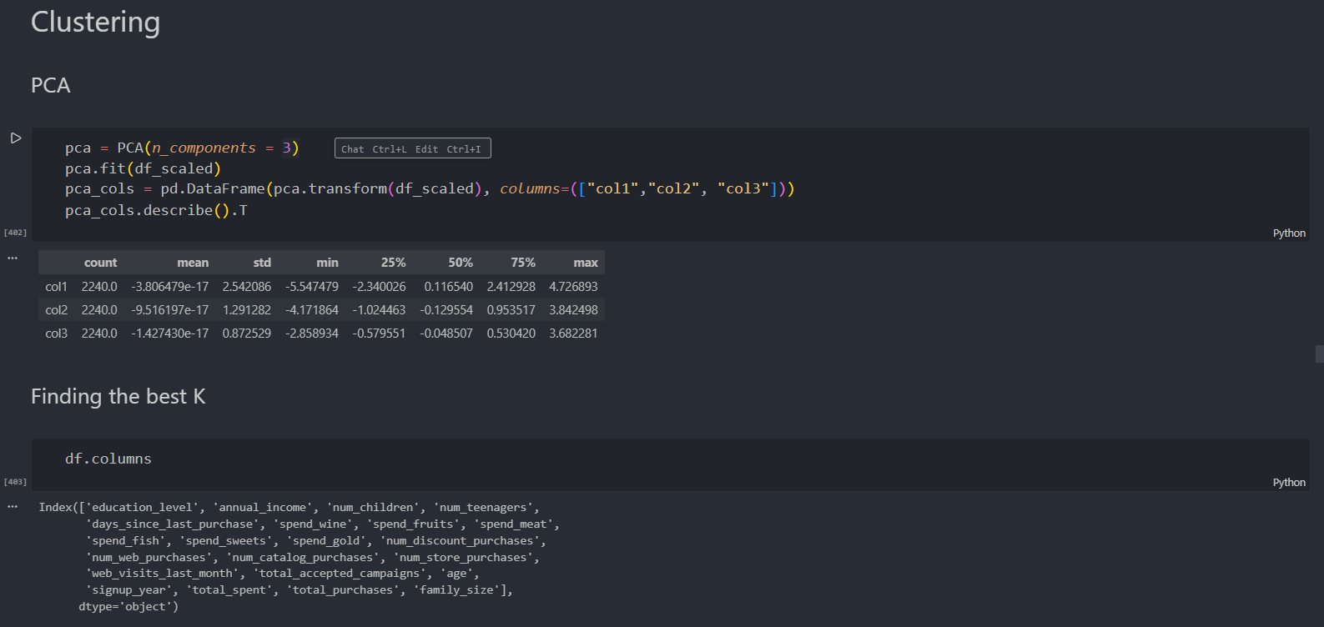
- Supervised Learning: Training classifiers to predict segment membership for new customers.

2. Dataset Overview
The system analyzes data from 2,240 individual customers, uniquely identified by customer_id. The dataset consists of 27 features covering:
- Demographics: Birth year, education level, marital status, and annual income.
- Household Structure: Number of children and teenagers living at home.
- Customer Engagement: Signup date, days since last purchase, and recent complaints.
- Spending Behavior: Expenditure across six product categories (Wine, Fruits, Meat, Fish, Sweets, and Gold).
- Purchase Channels: Activity through web, catalog, and in-store channels, along with discount usage.
- Campaign Responses: Binary indicators for response to five previous campaigns and the most recent offer.

3. Data Preprocessing Techniques
The project employs a robust preprocessing pipeline to transform raw data into a model-ready format:
A. Data Cleaning
- Missing Value Imputation: * annual_income and num_teenagers were filled using Median Imputation to handle outliers.
  - education_level was filled using Mode Imputation (most frequent value).
- Integrity Checks: Verified that the dataset contains zero duplicate records.
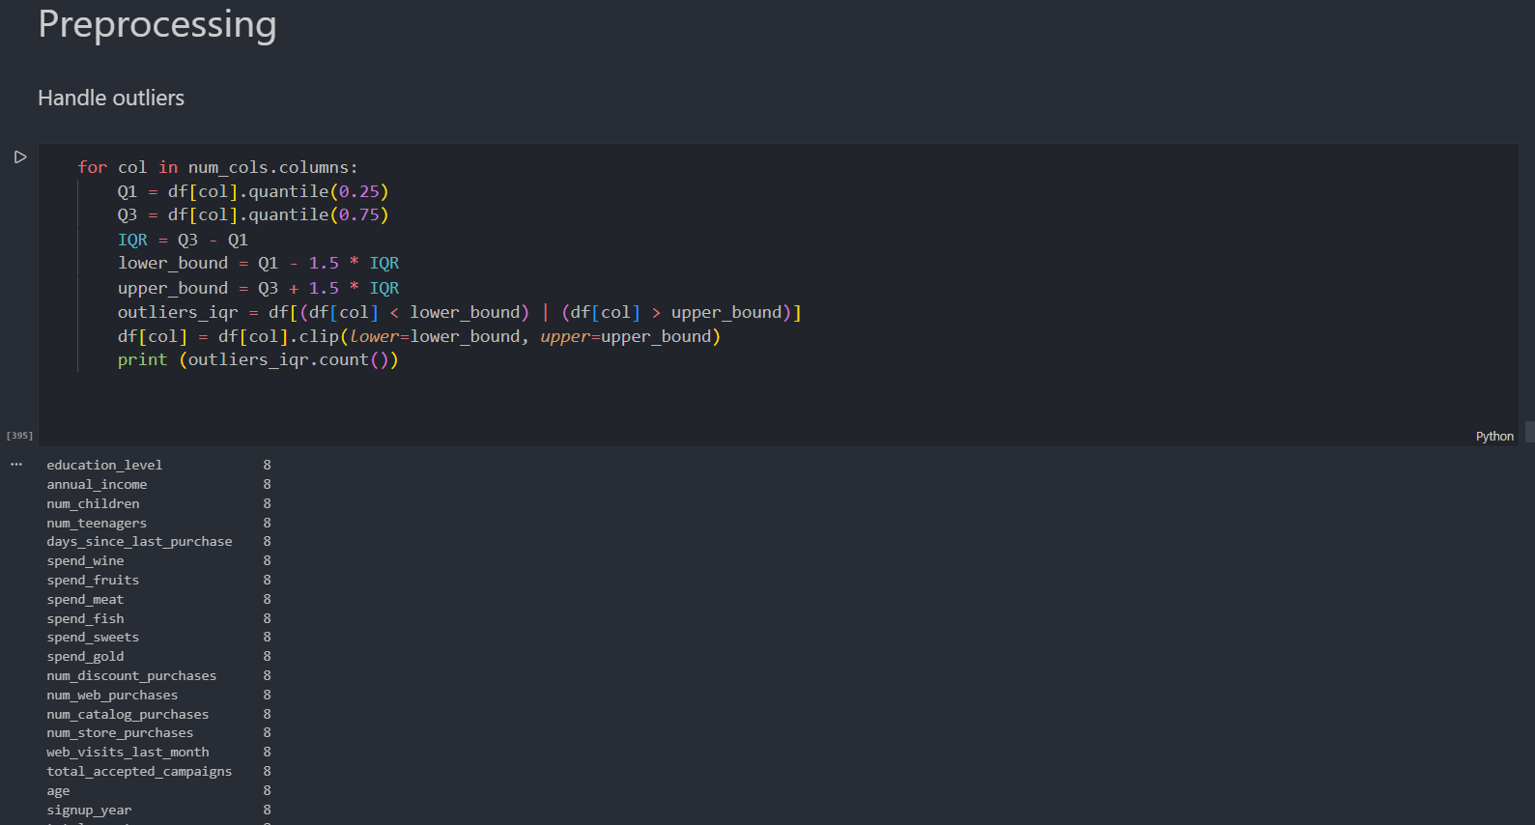
B. Advanced Feature Engineering
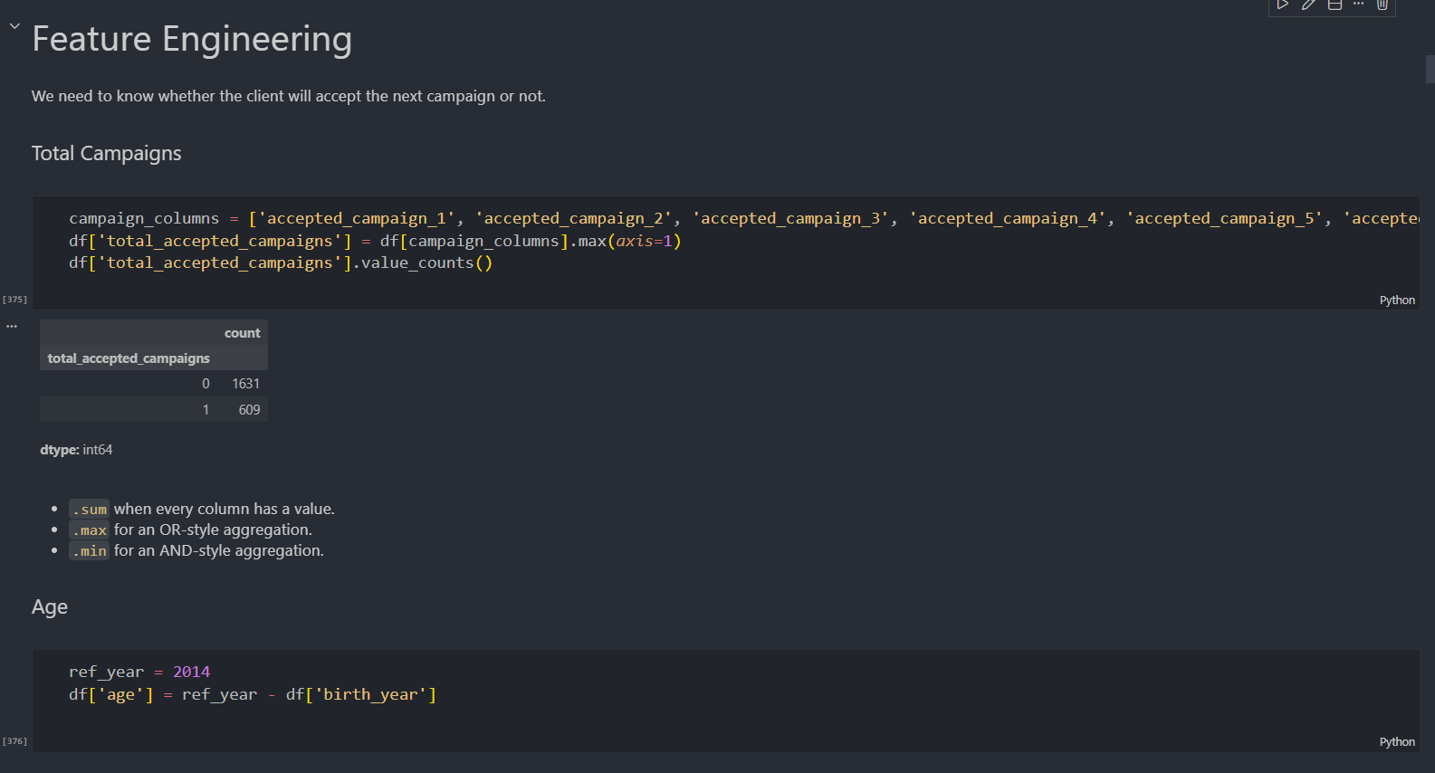
- Behavioral Indicators:
  - Age: Calculated from birth_year relative to the dataset's reference year (2014).
  - Total Spent: An aggregate feature summing spending across all six product categories.
  - Total Purchases: A composite frequency metric for all sales channels.
  - Total Accepted Campaigns: A binary "OR-style" aggregation indicating if a customer accepted any historical campaign.
- Categorical Consolidation:
  - Education: Reduced five granular levels into "Undergraduate," "Graduate," and "Postgraduate".
  - Family Size: Created by simplifying marital_status into "Alone" or "Partner" and adding the total count of children and teenagers.
C. Dimensionality Reduction
- PCA (Principal Component Analysis): Reduced the high-dimensional data into three principal components. This reduction facilitates 3D visualization of the segments and improves clustering efficiency by focusing on the most variant features.

4. Methodology & Modeling
Stage I: Clustering (Unsupervised Learning)
The project compared two distinct clustering approaches to identify customer segments:
- K-Means Clustering: Used to group customers into a predefined number of spherical clusters.
- DBSCAN: A density-based algorithm used to find clusters of arbitrary shapes and identify outliers as "noise".
- 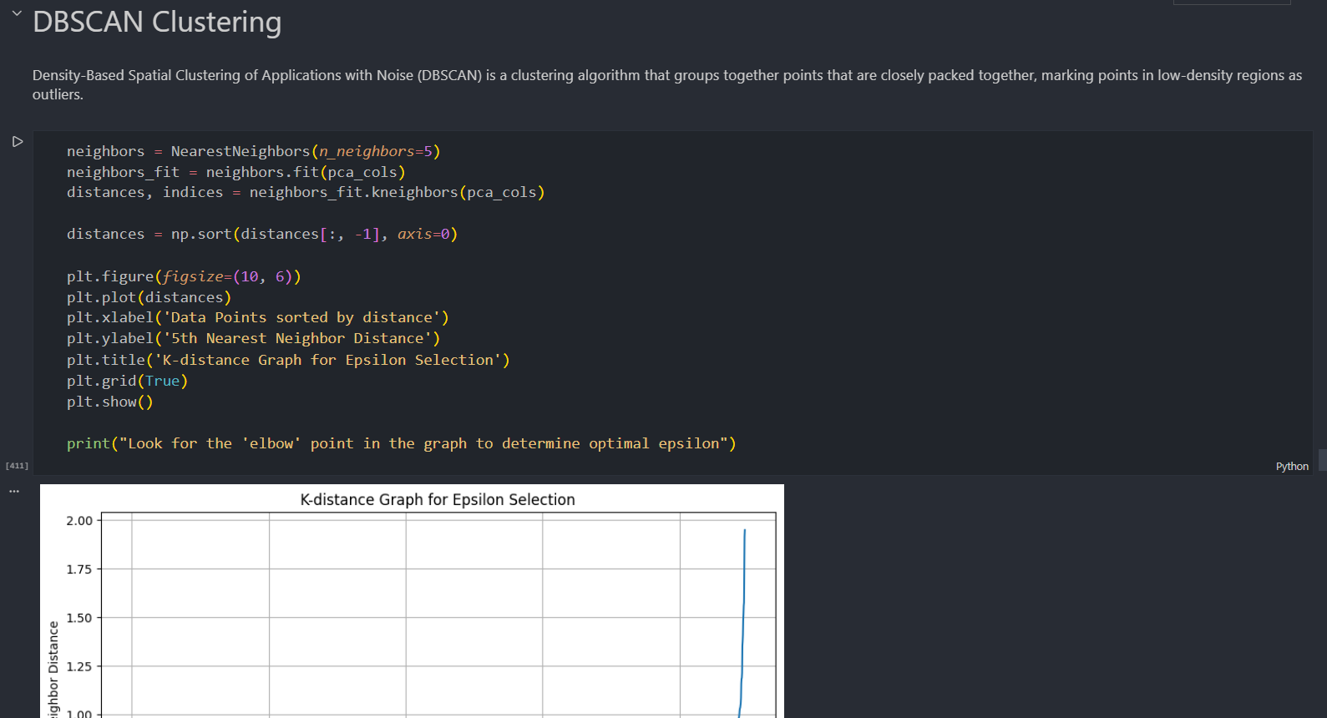
- Visualization: The results were visualized in a 3D PCA space to observe structural differences and determine optimal cluster boundaries.
Stage II: Prediction (Supervised Learning)
To automate the classification of new customers, several predictive models were imported and evaluated:
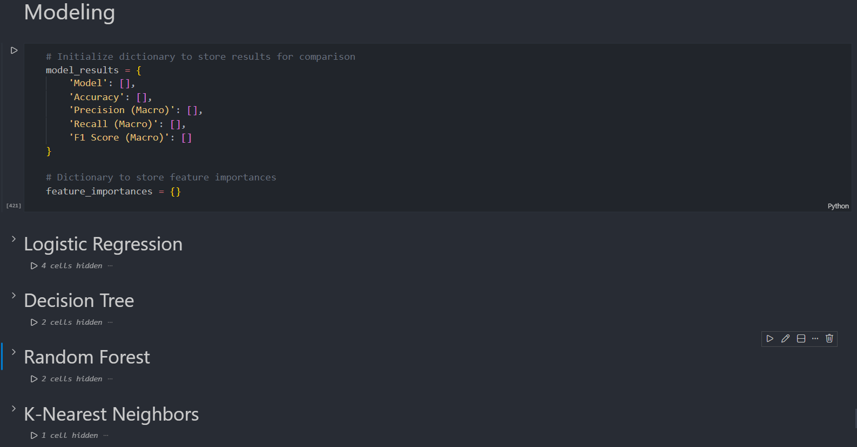
- Ensemble Models: Random Forest, Gradient Boosting, and XGBoost.
- Linear & Probabilistic: Logistic Regression and Gaussian Naive Bayes.
- Distance & Support Models: K-Nearest Neighbors (KNN) and Support Vector Classifier (SVC).
- Tree-based: Decision Trees.

5. Key Insights & Conclusion
The project demonstrates that retail customers are not a monolithic group but consist of varied behavioral segments (e.g., high-income wine enthusiasts vs. discount-focused families).
Business Impact:
- Personalization: Tailoring marketing messages based on the total_spent and preferred num_web_purchases.
- Retention: Targeting customers with high days_since_last_purchase values before they churn.
- Automation: Instantly classifying a new signup into a specific behavioral segment to trigger relevant welcome campaigns.

