Select one of this Figma designs and build it
https://www.figma.com/design/HetLmgxXycVoBMonViJPj6/%F0%9F%8E%A8-Personal-Portfolio-Template--Community-?node-id=0-1&p=f&t=rs93ynxfbjwfstwW-0

https://www.figma.com/design/5OwCy2c5EKFstgQDK87E2D/trafalgar-landing-page-for-figma--Copy-?node-id=0-1&p=f
https://www.figma.com/design/tJyJ9w3BM7aGDtAoRarhnG/123-Restaurant-Landing-Page--Community---Copy-?node-id=0-1&p=f
<!-- declare an array of objects products (image, name, stock, price) in JavaScript and show it using horizontal cards of bootstrap-->
const products =[
{img:"",name:"",stock:10,price:1000},
{img:"",name:"",stock:10,price:1000},
{img:"",name:"",stock:10,price:1000},
{img:"",name:"",stock:10,price:1000},
]
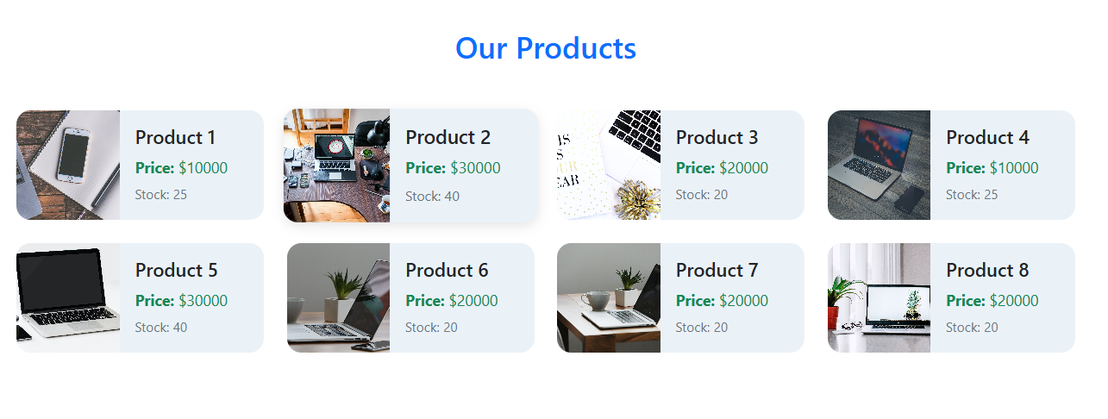
--------------------------------------------------------------------------------------------------

<!-- Make registration form with form validation of bootstrap and validate inputs using js-->
-------------------------Try and use this from documentation ------------------------
<!-- card tabs , card-pills , scroll spy, loading, pagination , progress-->
- Toast
- Navs & Tabs
- Tooltips & Popovers
<!-- Dropdown menu position-->

